NTU SPACE DATA CENTER
SDTwin POWER MODULE
Power Module Software Test Report
Solar Array Battery Response Power Allocation Protection Simulink Comparison
Institute | College of Computing and Data Science, Nanyang Technological University
Author | Automated verification and report generation
Reviewer
Issue date | 7 October 2026
College of Computing and Data Science, Nanyang Technological University

Version Control
Abstract | This report records the framework, inputs, criteria and individual comparisons of the Power model with independent Simulink simulation. All 20 numerical comparisons pass; 17 cases pass design acceptance and 3 fail due to the full-charge constraint.
Keywords | Power model; Simulink; test cases; numerical comparison; acceptance records
Change Record
Revision | Change Request | Date | Author | Description
1.0 | Test execution | 2026-10-07 |  | Executed 20 model comparisons with Simulink and retained all results.
1.1 | Standard format | 2026-10-07 |  | Applied the Orbit seven-chapter layout, case records and landscape summary; data and criteria unchanged.

TABLE OF CONTENTS
1 Overview 1
1.1 Identification 1
1.2 Software and Document Overview 1
1.3 Abbreviations and Conventions 1
2 Test Content 2
2.1 Functional Requirement and Test Case Traceability 2
2.2 Comparison Framework 3
3 Detailed Test Projects 4
3.1 Solar Array and Battery Components 4
3.1.1 Test Project 1 Solar irradiance and panel attitude 4
3.1.2 Test Project 2 Open circuit voltage and initial charge 7
3.1.3 Test Project 3 Charge and discharge voltage versus temperature 9
3.1.4 Test Project 4 Battery heat and reversible heat sign 12
3.1.5 Test Project 5 Cell to series and parallel pack scaling 14
3.2 Power Allocation and Protection Interfaces 16
3.2.1 Test Project 6 Solar and battery power allocation 16
3.2.2 Test Project 7 Distribution efficiency and loss 19
3.2.3 Test Project 8 Charge limits and solar curtailment 21
3.2.4 Test Project 9 Discharge capability and supply shortfall 23
3.2.5 Test Project 10 Charging boundary at full state of charge 25
3.2.6 Test Project 11 Protection commands and latched states 27
3.2.7 Test Project 12 Invalid inputs and state boundaries 29
3.3 Dynamic Supply and Electrothermal Processes 31
3.3.1 Test Project 13 Charging under continuous sunlight 31
3.3.2 Test Project 14 Eclipse entry and exit 33
3.3.3 Test Project 15 Compute load steps 35
3.3.4 Test Project 16 Dynamic charge curtailment 37
3.3.5 Test Project 17 Supply loss latch and explicit restart 39
3.3.6 Test Project 18 Battery electrothermal feedback 41
3.3.7 Test Project 19 Energy balance over three orbit cycles 43
3.4 Numerical Accuracy Review 45
3.4.1 Test Project 20 Solver convergence and accuracy review 45
4 Test Content Sufficiency Analysis 47
5 Test Conditions and Requirements 48
5.1 Execution Environment and Acceptance Criteria 48
5.2 Baseline Scenario and Input Requirements 48
6 Test Data 50
6.1 Battery Material Parameters 50
6.2 Data Inventory and Reproduction 51
6.3 Integrated Energy Comparison Data 52
6.4 Numerical Convergence Data 53
7 Test Summary 54
7.1 Anomalies and Conclusion 56

1 Overview

1.1 Identification
Platform: SDTwin. Module: Power. Document revision: 1.1. Test date: 7 October 2026.
Purpose: record repeatable comparison tests of the project model against Simulink and the actual acceptance verdicts.

1.2 Software and Document Overview
This report compares the project Power model with Simulink under identical parameters, states and inputs. Tests cover array power, cell voltage and heat, pack scaling, allocation, protection commands, dynamic trajectories, conservation and numerical precision.
Table 1. System Under Test and Reference Implementation
Object | Implementation and boundary
Project model | Thermal/sdtwin_sim/power_stand_in.py
Implementation status | A test implementation of the Power design report, not production EPS software. The source under test is unchanged.
Simulink | Independent MATLAB equations in a Level 2 S-function in a real .slx model, with continuous states integrated by Simulink ode45.
Independence | Only input parameters are shared. MATLAB does not call Python; Python does not take Simulink outputs as its state trajectory.
Parameter provenance | Existing illustrative array and battery assets, including illustrative electrode polynomials, not fitted to a selected physical cell.
Supported conclusion | Cross-implementation verification under common physics assumptions and selected design behavior checks. This is neither measured validation nor a comparison against a factory Simscape battery block.
Observed conclusion
All 20 projects executed and passed numerical comparison. CT-003, DY-002 and DY-007 fail full-charge behavior requirements. Both implementations constrain current, voltage and material fractions but omit the configured 100% usable-charge endpoint from the charging constraint.
Failed cases retain their inputs and raw results. The model under test was not changed, tolerances were not relaxed, and SOC was not clipped to hide the failures.

1.3 Abbreviations and Conventions
Table 2. Abbreviations and Symbols
Term | Definition
SOC | Usable charge fraction: zero is empty and one is full.
PDU | Power distribution unit; losses follow the specified efficiency.
RMSE | Root mean square error at identical samples.
G / cos θ | Irradiance including eclipse and panel incidence cosine.
i / PB | Positive for discharge, negative for charge.

2 Test Content
Twenty projects form four capability groups. Each maps to one detailed case record and one final summary record. Numerical agreement and design behavior are evaluated and recorded separately.

2.1 Functional Requirement and Test Case Traceability
Table 3. Functional Requirement and Test Case Traceability
No. | Case ID | Function | Test Name | Basis | Status
1 | PV-001 | solar_power | Solar irradiance and panel attitude | P2 | Pass
2 | BT-001 | battery_response | Open circuit voltage and initial charge | P4–P8, P10 | Pass
3 | BT-002 | battery_response | Charge and discharge voltage versus temperature | P4–P8, P10 | Pass
4 | BT-003 | battery_response | Battery heat and reversible heat sign | P4–P8, P10 | Pass
5 | BT-004 | battery_response | Cell to series and parallel pack scaling | P4–P8, P10 | Pass
6 | PD-001 | solve_power_allocation | Solar and battery power allocation | P1, P3, P11 | Pass
7 | PD-002 | solve_power_allocation | Distribution efficiency and loss | P1, P3, P11 | Pass
8 | CT-001 | solve_power_allocation | Charge limits and solar curtailment | P1, P3, P11 | Pass
9 | CT-002 | solve_power_allocation | Discharge capability and supply shortfall | P1, P3, P11 | Pass
10 | CT-003 | solve_power_allocation | Charging boundary at full state of charge | P1, P3, P11 | Fail
11 | PR-001 | apply_power_event | Protection commands and latched states | 5 | Pass
12 | IV-001 | PowerInputs / PowerState | Invalid inputs and state boundaries | 5 | Pass
13 | DY-001 | solve_power_allocation / state integration | Charging under continuous sunlight | P1–P11 | Pass
14 | DY-002 | solve_power_allocation / state integration | Eclipse entry and exit | P1–P11 | Fail
15 | DY-003 | solve_power_allocation / state integration | Compute load steps | P1–P11 | Pass
16 | DY-004 | solve_power_allocation / state integration | Dynamic charge curtailment | P1–P11 | Pass
17 | DY-005 | solve_power_allocation / state integration | Supply loss latch and explicit restart | P1–P11 | Pass
18 | DY-006 | solve_power_allocation / state integration | Battery electrothermal feedback | P1–P11 | Pass
19 | DY-007 | solve_power_allocation / state integration | Energy balance over three orbit cycles | P1–P11 | Fail
20 | NU-001 | DOP853 / ode45 | Solver convergence and accuracy review | P1–P11 | Pass

2.2 Comparison Framework
Table 4. Test Framework and Execution Contract
Stage | Execution contract
Shared inputs | suite.json stores device parameters, initial conditions, input combinations, event times, numerical settings and thresholds, bound by SHA256.
Independent execution | Python calls the existing API with SciPy DOP853 integration; MATLAB independently evaluates cell and allocation equations while Simulink ode45 integrates states.
Events and time | Scheduled discontinuities split integration intervals exactly. Both left and right values are retained at each boundary. Protection is applied only at accepted boundaries.
Signal comparison | Subtract values at the same time, side and unit. No interpolation crosses an event. Invalid results compare validity and event flags without replacing missing ports by zero.
Independent acceptance | In addition to numerical agreement, check power and lithium conservation, solar feasibility, usable SOC range, full-charge stopping and expected protection behavior.
Evidence and report | Retain both CSV trajectories, direct difference CSVs, event JSON, check verdicts and source hashes. Every case includes an input table, error table and comparison figure.
Physical relations and states
Ppv + PB = Pload + QD PB = Ns Np i v Pload = ηD Pbus
dxn/dt = −i/Qn dxp/dt = i/Qp SOC = (xn − xn,0)/(xn,100 − xn,0)
Positive cell current and battery power denote discharge; negative values denote charging. QB is internal battery heat and is not subtracted again from terminal-power balance. Battery temperature is integrated once in the thermal domain.
Electrothermal cases use CB dTB/dt = QB − (TB − Tsink)/R. Other dynamic cases prescribe a constant temperature and do not run a second temperature model.

3 Detailed Test Projects
Every project uses the Orbit test report record fields. Input tables specify the scenario; result pages retain both outputs, direct differences and error tables. Human signature fields are intentionally blank.

3.1 Solar Array and Battery Components

3.1.1 Test Project 1 Solar irradiance and panel attitude
Table 5. PV-001 Test Case
Case ID | PV-001 | Case Name | Solar irradiance and panel attitude
Test Objective | Verify how irradiance and panel orientation determine available power. Zero irradiance denotes full eclipse; a negative incidence cosine places the Sun behind the active face. Both must produce zero power.
Preconditions | Use the frozen section 5 inputs and environment; execute both implementations independently. Design basis: P2.
Input Data | All irradiances are crossed with seven incidence cosines. Python rotates the panel normal with a quaternion; Simulink receives the cosine of the same geometry. An analytical area times efficiency times front-face irradiance check is also applied. Exact values appear in the input table for this case.
Procedure | 1. Load this case and run the project model and Simulink independently.  2. Save outputs and events in input order or at the prescribed times.  3. Check validity, same-sample differences and case behavior; retain check records.
Expected Results | Rear illumination and eclipse yield zero power; other outputs equal active area times efficiency times front-face irradiance.
Acceptance Criteria | All applicable signals meet section 5.1 limits, flags and events match expectations, and the expected results in this form hold.
Case Designer |  | Executor / Date | Automated test 2026-10-07
Actual Results | Completed 21 input combinations. Output availability, discrete status and applicable numerical difference checks pass. 42 checks recorded; evidence: results/PV-001.json.
Recorded By |  | Test Conclusion | [X] Pass [ ] Fail [ ] Not Executed
Anomalies | No anomaly against this case criteria.

PV-001 Scenario Inputs and Initial Conditions
Table 6. PV-001 Scenario Inputs
Index | G W/m² | cos θ
1 | 0 | −1
2 | 0 | −0.5
3 | 0 | 0
4 | 0 | 0.25
5 | 0 | 0.5
6 | 0 | 0.866025
7 | 0 | 1
8 | 680.5 | −1
9 | 680.5 | −0.5
10 | 680.5 | 0
11 | 680.5 | 0.25
12 | 680.5 | 0.5
13 | 680.5 | 0.866025
14 | 680.5 | 1
15 | 1361 | −1
16 | 1361 | −0.5
17 | 1361 | 0
18 | 1361 | 0.25
19 | 1361 | 0.5
20 | 1361 | 0.866025
21 | 1361 | 1
Parameters not overridden here use sections 5.2 and 6.1.

PV-001 Comparison Results
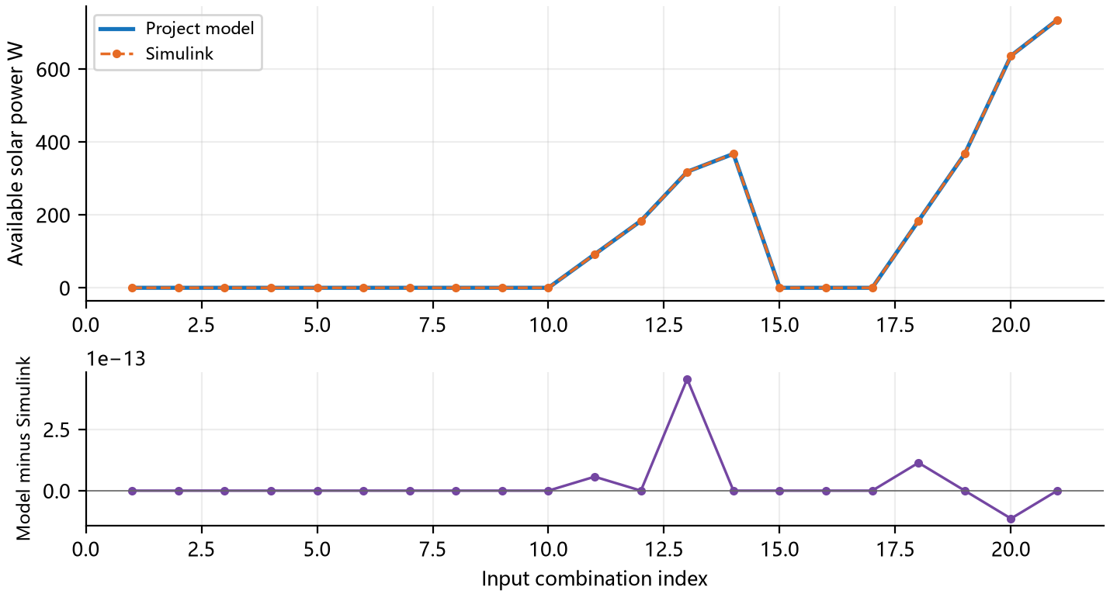
Figure 1 PV-001: Available solar power W. Top panels show both outputs at identical samples; lower panels show project model minus Simulink in the same units.
Horizontal indices match the input table for this case. Connecting lines aid reading and do not imply a dynamic trajectory between independent samples.
Table 7. PV-001 Numerical Errors and Limits
Signal | Max absolute error | RMSE | Limit
Available solar power W | 4.55e−13 | 1.06e−13 | 1.00e−06
State of charge fraction | 4.44e−16 | 4.44e−16 | 1.00e−06
Battery temperature K | 0 | 0 | 0.001
Numerical comparison passes; overall acceptance: Pass. Recorded 42 checks.
Completed 21 input combinations. Output availability, discrete status and applicable numerical difference checks pass.

3.1.2 Test Project 2 Open circuit voltage and initial charge
Table 8. BT-001 Test Case
Case ID | BT-001 | Case Name | Open circuit voltage and initial charge
Test Objective | Verify open circuit voltage at different initial charge levels. At zero cell current there is no charge transfer or current-induced heat; terminal voltage is the difference between electrode equilibrium potentials.
Preconditions | Use the frozen section 5 inputs and environment; execute both implementations independently. Design basis: P4–P8, P10.
Input Data | Sweep the negative-electrode mean fraction and derive the positive fraction from lithium inventory conservation. Temperature is 293.15 K or 20 degrees Celsius. The samples are independent states, not a charging trajectory. Exact values appear in the input table for this case.
Procedure | 1. Load this case and run the project model and Simulink independently.  2. Save outputs and events in input order or at the prescribed times.  3. Check validity, same-sample differences and case behavior; retain check records.
Expected Results | Zero current yields zero heat and fraction derivatives; terminal voltage equals the electrode equilibrium-potential difference.
Acceptance Criteria | All applicable signals meet section 5.1 limits, flags and events match expectations, and the expected results in this form hold.
Case Designer |  | Executor / Date | Automated test 2026-10-07
Actual Results | Completed 9 input combinations. Output availability, discrete status and applicable numerical difference checks pass. 58 checks recorded; evidence: results/BT-001.json.
Recorded By |  | Test Conclusion | [X] Pass [ ] Fail [ ] Not Executed
Anomalies | No anomaly against this case criteria.
BT-001 Scenario Inputs and Initial Conditions
Table 9. BT-001 Scenario Inputs
Index | xn | xp | TB K | i A | Ns × Np
1 | 0.1 | 0.773163 | 293.15 | 0 | 8 × 6
2 | 0.2 | 0.710267 | 293.15 | 0 | 8 × 6
3 | 0.3 | 0.647372 | 293.15 | 0 | 8 × 6
4 | 0.4 | 0.584477 | 293.15 | 0 | 8 × 6
5 | 0.5 | 0.521581 | 293.15 | 0 | 8 × 6
6 | 0.6 | 0.458686 | 293.15 | 0 | 8 × 6
7 | 0.7 | 0.395791 | 293.15 | 0 | 8 × 6
8 | 0.8 | 0.332895 | 293.15 | 0 | 8 × 6
9 | 0.88 | 0.282579 | 293.15 | 0 | 8 × 6
Parameters not overridden here use sections 5.2 and 6.1.

BT-001 Comparison Results
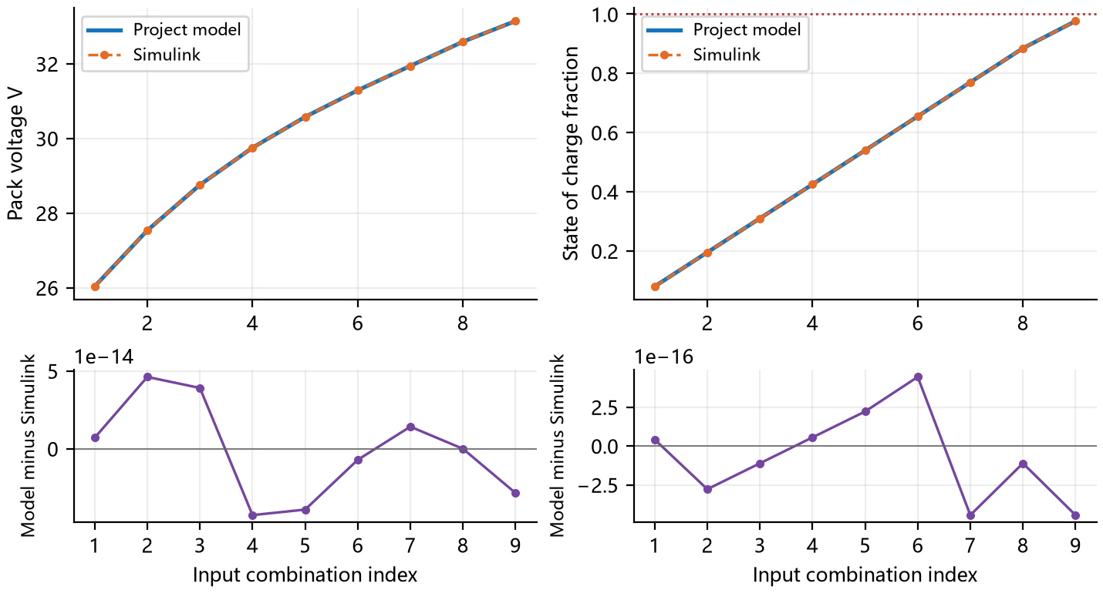
Figure 2 BT-001: Pack voltage V and State of charge fraction. Top panels show both outputs at identical samples; lower panels show project model minus Simulink in the same units.
Horizontal indices match the input table for this case. Connecting lines aid reading and do not imply a dynamic trajectory between independent samples.
Table 10. BT-001 Numerical Errors and Limits
Signal | Max absolute error | RMSE | Limit
Pack voltage V | 4.62e−14 | 3.00e−14 | 1.00e−04
State of charge fraction | 4.44e−16 | 2.88e−16 | 1.00e−06
Pack current A | 0 | 0 | 1.00e−04
Pack heat W | 0 | 0 | 1.00e−06
Battery temperature K | 0 | 0 | 0.001
Numerical comparison passes; overall acceptance: Pass. Recorded 58 checks.
Completed 9 input combinations. Output availability, discrete status and applicable numerical difference checks pass.

3.1.3 Test Project 3 Charge and discharge voltage versus temperature
Table 11. BT-002 Test Case
Case ID | BT-002 | Case Name | Charge and discharge voltage versus temperature
Test Objective | Verify charge and discharge voltage response and the effect of temperature on kinetics and diffusion. Positive current is discharge and negative current is charge. Temperature is the battery temperature, not ambient air in space.
Preconditions | Use the frozen section 5 inputs and environment; execute both implementations independently. Design basis: P4–P8, P10.
Input Data | Cross three cell temperatures with six cell currents at a common lithium state. Direct cell evaluation retains negative constraint margins for boundary diagnostics; not every sample is a feasible power-allocation operating point. Exact values appear in the input table for this case.
Procedure | 1. Load this case and run the project model and Simulink independently.  2. Save outputs and events in input order or at the prescribed times.  3. Check validity, same-sample differences and case behavior; retain check records.
Expected Results | Voltage, polarization and margins agree; infeasible current samples retain diagnostics and are not labeled feasible supply states.
Acceptance Criteria | All applicable signals meet section 5.1 limits, flags and events match expectations, and the expected results in this form hold.
Case Designer |  | Executor / Date | Automated test 2026-10-07
Actual Results | Completed 18 input combinations. Output availability, discrete status and applicable numerical difference checks pass. 58 checks recorded; evidence: results/BT-002.json.
Recorded By |  | Test Conclusion | [X] Pass [ ] Fail [ ] Not Executed
Anomalies | No anomaly against this case criteria.

BT-002 Scenario Inputs and Initial Conditions
Table 12. BT-002 Scenario Inputs
Index | xn | xp | TB K | i A | Ns × Np
1 | 0.6 | 0.458686 | 273.15 | −1 | 8 × 6
2 | 0.6 | 0.458686 | 273.15 | −0.5 | 8 × 6
3 | 0.6 | 0.458686 | 273.15 | 0 | 8 × 6
4 | 0.6 | 0.458686 | 273.15 | 0.5 | 8 × 6
5 | 0.6 | 0.458686 | 273.15 | 1 | 8 × 6
6 | 0.6 | 0.458686 | 273.15 | 2 | 8 × 6
7 | 0.6 | 0.458686 | 293.15 | −1 | 8 × 6
8 | 0.6 | 0.458686 | 293.15 | −0.5 | 8 × 6
9 | 0.6 | 0.458686 | 293.15 | 0 | 8 × 6
10 | 0.6 | 0.458686 | 293.15 | 0.5 | 8 × 6
11 | 0.6 | 0.458686 | 293.15 | 1 | 8 × 6
12 | 0.6 | 0.458686 | 293.15 | 2 | 8 × 6
13 | 0.6 | 0.458686 | 313.15 | −1 | 8 × 6
14 | 0.6 | 0.458686 | 313.15 | −0.5 | 8 × 6
15 | 0.6 | 0.458686 | 313.15 | 0 | 8 × 6
16 | 0.6 | 0.458686 | 313.15 | 0.5 | 8 × 6
17 | 0.6 | 0.458686 | 313.15 | 1 | 8 × 6
18 | 0.6 | 0.458686 | 313.15 | 2 | 8 × 6
Parameters not overridden here use sections 5.2 and 6.1.

BT-002 Comparison Results
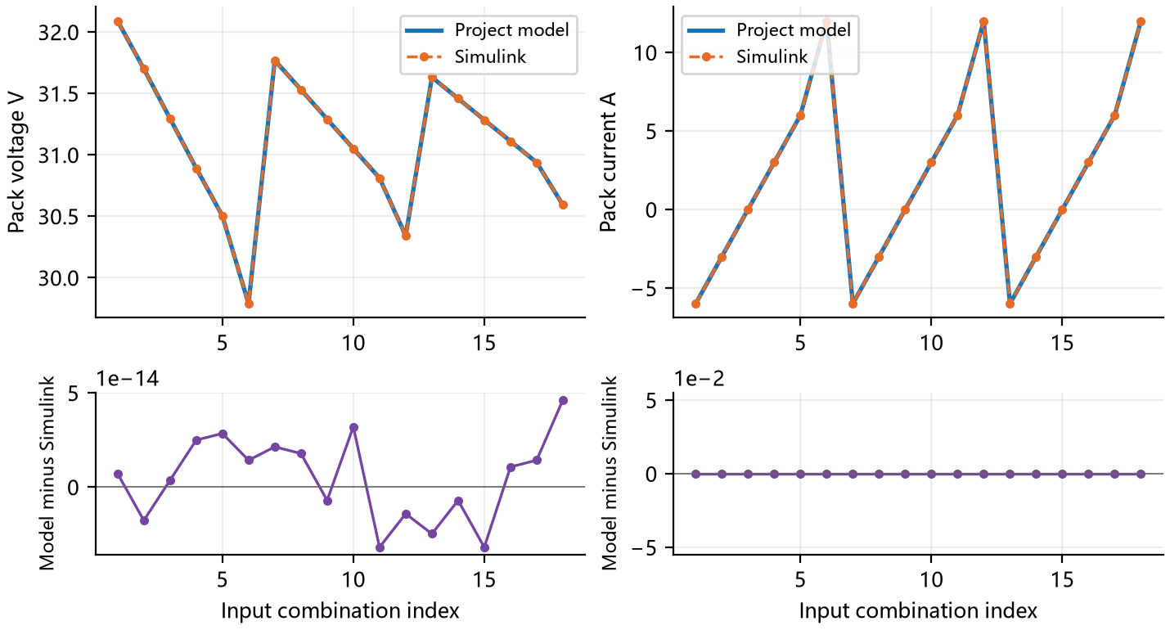
Figure 3 BT-002: Pack voltage V and Pack current A. Top panels show both outputs at identical samples; lower panels show project model minus Simulink in the same units.
Horizontal indices match the input table for this case. Connecting lines aid reading and do not imply a dynamic trajectory between independent samples.
Table 13. BT-002 Numerical Errors and Limits
Signal | Max absolute error | RMSE | Limit
Pack voltage V | 4.62e−14 | 2.26e−14 | 1.00e−04
Pack current A | 0 | 0 | 1.00e−04
Pack heat W | 3.20e−14 | 7.78e−15 | 1.00e−06
State of charge fraction | 4.44e−16 | 4.44e−16 | 1.00e−06
Battery temperature K | 0 | 0 | 0.001
Numerical comparison passes; overall acceptance: Pass. Recorded 58 checks.
Completed 18 input combinations. Output availability, discrete status and applicable numerical difference checks pass.

3.1.4 Test Project 4 Battery heat and reversible heat sign
Table 14. BT-003 Test Case
Case ID | BT-003 | Case Name | Battery heat and reversible heat sign
Test Objective | Verify reaction heat, ohmic heat and signed reversible heat. Reversible heat can make total heat negative at low current; this denotes net heat absorption in the model and must not be clipped to zero.
Preconditions | Use the frozen section 5 inputs and environment; execute both implementations independently. Design basis: P4–P8, P10.
Input Data | Hold both lithium fractions fixed and scan small positive and negative currents at 283.15 K and 303.15 K. Compare pack heat and cell reversible heat separately. Exact values appear in the input table for this case.
Procedure | 1. Load this case and run the project model and Simulink independently.  2. Save outputs and events in input order or at the prescribed times.  3. Check validity, same-sample differences and case behavior; retain check records.
Expected Results | Reaction, ohmic and reversible heat sum consistently; negative reversible heat and total heat are retained.
Acceptance Criteria | All applicable signals meet section 5.1 limits, flags and events match expectations, and the expected results in this form hold.
Case Designer |  | Executor / Date | Automated test 2026-10-07
Actual Results | Pack heat ranges from −0.0320434 to 3.23576 W; negative heat is retained. 60 checks recorded; evidence: results/BT-003.json.
Recorded By |  | Test Conclusion | [X] Pass [ ] Fail [ ] Not Executed
Anomalies | No anomaly against this case criteria.
BT-003 Scenario Inputs and Initial Conditions
Table 15. BT-003 Scenario Inputs
Index | xn | xp | TB K | i A | Ns × Np
1 | 0.6 | 0.458686 | 283.15 | −0.5 | 8 × 6
2 | 0.6 | 0.458686 | 283.15 | −0.1 | 8 × 6
3 | 0.6 | 0.458686 | 283.15 | 0 | 8 × 6
4 | 0.6 | 0.458686 | 283.15 | 0.1 | 8 × 6
5 | 0.6 | 0.458686 | 283.15 | 0.5 | 8 × 6
6 | 0.6 | 0.458686 | 283.15 | 1 | 8 × 6
7 | 0.6 | 0.458686 | 303.15 | −0.5 | 8 × 6
8 | 0.6 | 0.458686 | 303.15 | −0.1 | 8 × 6
9 | 0.6 | 0.458686 | 303.15 | 0 | 8 × 6
10 | 0.6 | 0.458686 | 303.15 | 0.1 | 8 × 6
11 | 0.6 | 0.458686 | 303.15 | 0.5 | 8 × 6
12 | 0.6 | 0.458686 | 303.15 | 1 | 8 × 6
Parameters not overridden here use sections 5.2 and 6.1.

BT-003 Comparison Results
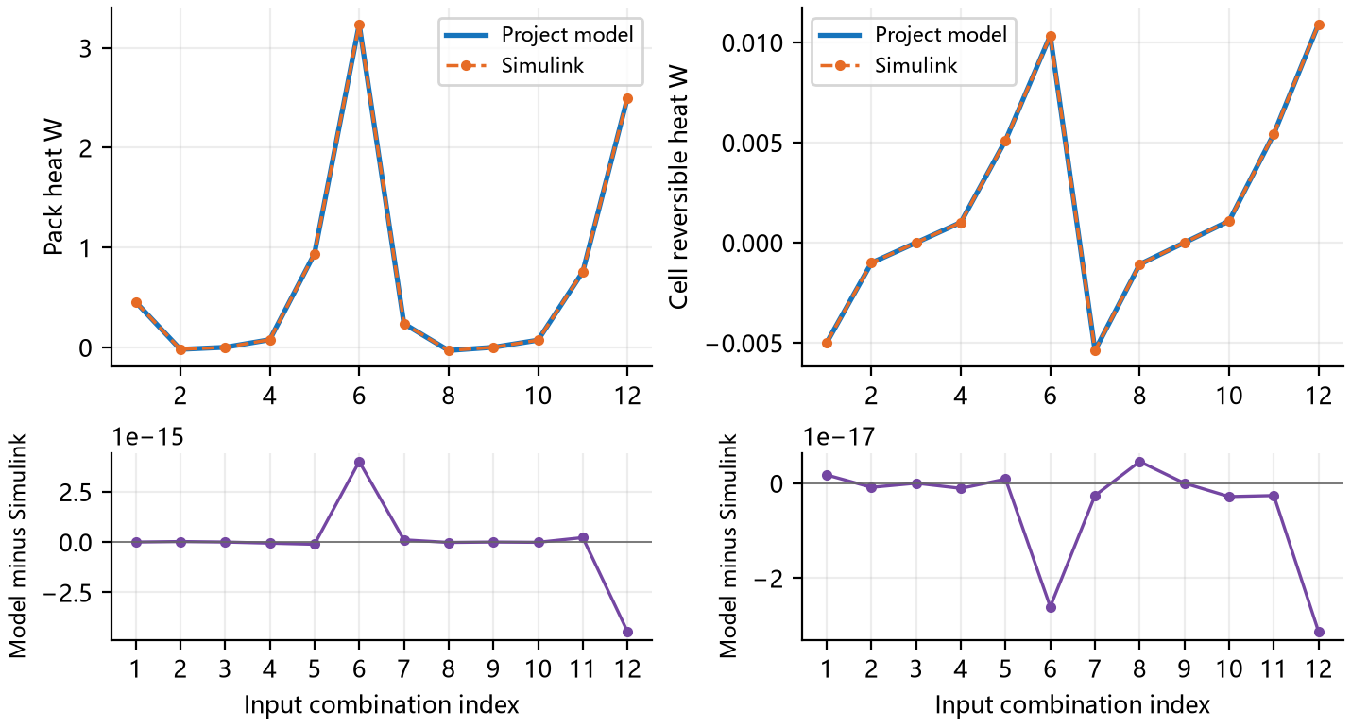
Figure 4 BT-003: Pack heat W and Cell reversible heat W. Top panels show both outputs at identical samples; lower panels show project model minus Simulink in the same units.
Horizontal indices match the input table for this case. Connecting lines aid reading and do not imply a dynamic trajectory between independent samples.
Table 16. BT-003 Numerical Errors and Limits
Signal | Max absolute error | RMSE | Limit
Pack heat W | 4.44e−15 | 1.73e−15 | 1.00e−06
Cell reversible heat W | 3.12e−17 | 1.19e−17 | 1.00e−06
Pack voltage V | 4.26e−14 | 2.32e−14 | 1.00e−04
Pack current A | 1.11e−16 | 6.41e−17 | 1.00e−04
State of charge fraction | 4.44e−16 | 4.44e−16 | 1.00e−06
Battery temperature K | 0 | 0 | 0.001
Numerical comparison passes; overall acceptance: Pass. Recorded 60 checks.
Pack heat ranges from −0.0320434 to 3.23576 W; negative heat is retained.

3.1.5 Test Project 5 Cell to series and parallel pack scaling
Table 17. BT-004 Test Case
Case ID | BT-004 | Case Name | Cell to series and parallel pack scaling
Test Objective | Verify cell-to-pack conversion. Series count scales pack voltage, parallel count scales pack current, and their product scales pack power and heat. Scaling must be applied once.
Preconditions | Use the frozen section 5 inputs and environment; execute both implementations independently. Design basis: P4–P8, P10.
Input Data | Five series and parallel configurations share the same cell state, 0.5 A cell discharge current and 293.15 K temperature. Cells have identical states and temperature, with equal parallel current sharing. Exact values appear in the input table for this case.
Procedure | 1. Load this case and run the project model and Simulink independently.  2. Save outputs and events in input order or at the prescribed times.  3. Check validity, same-sample differences and case behavior; retain check records.
Expected Results | Pack voltage scales with series count, current with parallel count, and power and heat with total cell count.
Acceptance Criteria | All applicable signals meet section 5.1 limits, flags and events match expectations, and the expected results in this form hold.
Case Designer |  | Executor / Date | Automated test 2026-10-07
Actual Results | Completed 5 input combinations. Output availability, discrete status and applicable numerical difference checks pass. 58 checks recorded; evidence: results/BT-004.json.
Recorded By |  | Test Conclusion | [X] Pass [ ] Fail [ ] Not Executed
Anomalies | No anomaly against this case criteria.
BT-004 Scenario Inputs and Initial Conditions
Table 18. BT-004 Scenario Inputs
Index | xn | xp | TB K | i A | Ns × Np
1 | 0.6 | 0.458686 | 293.15 | 0.5 | 1 × 1
2 | 0.6 | 0.458686 | 293.15 | 0.5 | 8 × 1
3 | 0.6 | 0.458686 | 293.15 | 0.5 | 1 × 6
4 | 0.6 | 0.458686 | 293.15 | 0.5 | 8 × 6
5 | 0.6 | 0.458686 | 293.15 | 0.5 | 12 × 4
Parameters not overridden here use sections 5.2 and 6.1.

BT-004 Comparison Results
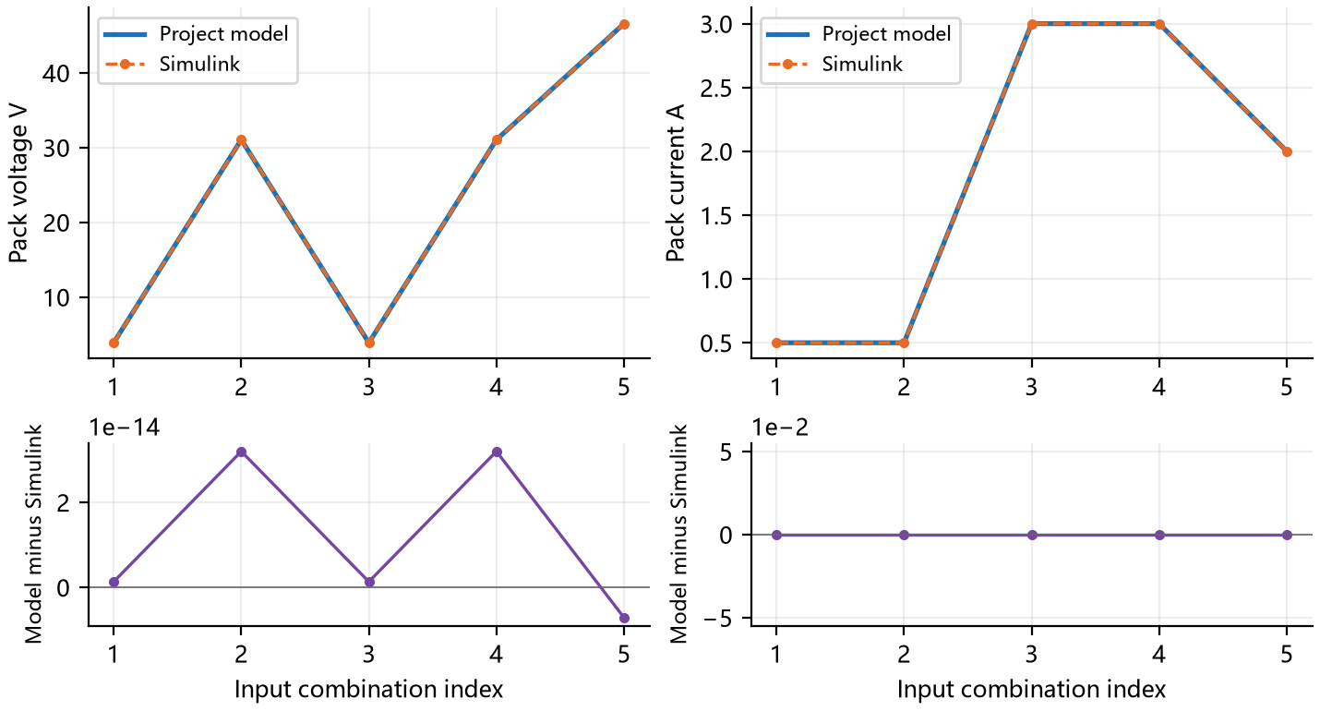
Figure 5 BT-004: Pack voltage V and Pack current A. Top panels show both outputs at identical samples; lower panels show project model minus Simulink in the same units.
Horizontal indices match the input table for this case. Connecting lines aid reading and do not imply a dynamic trajectory between independent samples.
Table 19. BT-004 Numerical Errors and Limits
Signal | Max absolute error | RMSE | Limit
Pack voltage V | 3.20e−14 | 2.05e−14 | 1.00e−04
Pack current A | 0 | 0 | 1.00e−04
Pack heat W | 3.33e−16 | 2.46e−16 | 1.00e−06
State of charge fraction | 4.44e−16 | 4.44e−16 | 1.00e−06
Battery temperature K | 0 | 0 | 0.001
Numerical comparison passes; overall acceptance: Pass. Recorded 58 checks.
Completed 5 input combinations. Output availability, discrete status and applicable numerical difference checks pass.

3.2 Power Allocation and Protection Interfaces

3.2.1 Test Project 6 Solar and battery power allocation
Table 20. PD-001 Test Case
Case ID | PD-001 | Case Name | Solar and battery power allocation
Test Objective | Verify power allocation among array, battery and load. Surplus solar charges the battery; a deficit calls for battery discharge. A request beyond the allowed battery capability must report supply shortfall.
Preconditions | Use the frozen section 5 inputs and environment; execute both implementations independently. Design basis: P1, P3, P11.
Input Data | Cross four irradiances with six load requests. Distribution efficiency is 0.95, so bus-side demand exceeds load demand. Shortfall samples compare status flags and must not publish artificial zero heat as a valid result. Exact values appear in the input table for this case.
Procedure | 1. Load this case and run the project model and Simulink independently.  2. Save outputs and events in input order or at the prescribed times.  3. Check validity, same-sample differences and case behavior; retain check records.
Expected Results | Surplus solar charges the battery; a deficit discharges it; infeasible requests explicitly report shortfall.
Acceptance Criteria | All applicable signals meet section 5.1 limits, flags and events match expectations, and the expected results in this form hold.
Case Designer |  | Executor / Date | Automated test 2026-10-07
Actual Results | Completed 24 input combinations. Output availability, discrete status and applicable numerical difference checks pass. 57 checks recorded; evidence: results/PD-001.json.
Recorded By |  | Test Conclusion | [X] Pass [ ] Fail [ ] Not Executed
Anomalies | No anomaly against this case criteria.

PD-001 Scenario Inputs and Initial Conditions
Table 21. PD-001 Scenario Inputs
Index | G W/m² | Demand W | TB K | Override
1 | 0 | 0 | 293.15 | Baseline
2 | 0 | 50 | 293.15 | Baseline
3 | 0 | 200 | 293.15 | Baseline
4 | 0 | 400 | 293.15 | Baseline
5 | 0 | 900 | 293.15 | Baseline
6 | 0 | 2500 | 293.15 | Baseline
7 | 300 | 0 | 293.15 | Baseline
8 | 300 | 50 | 293.15 | Baseline
9 | 300 | 200 | 293.15 | Baseline
10 | 300 | 400 | 293.15 | Baseline
11 | 300 | 900 | 293.15 | Baseline
12 | 300 | 2500 | 293.15 | Baseline
13 | 800 | 0 | 293.15 | Baseline
14 | 800 | 50 | 293.15 | Baseline
15 | 800 | 200 | 293.15 | Baseline
16 | 800 | 400 | 293.15 | Baseline
17 | 800 | 900 | 293.15 | Baseline
18 | 800 | 2500 | 293.15 | Baseline
19 | 1361 | 0 | 293.15 | Baseline
20 | 1361 | 50 | 293.15 | Baseline
21 | 1361 | 200 | 293.15 | Baseline
22 | 1361 | 400 | 293.15 | Baseline
23 | 1361 | 900 | 293.15 | Baseline
24 | 1361 | 2500 | 293.15 | Baseline
Parameters not overridden here use sections 5.2 and 6.1.

PD-001 Comparison Results
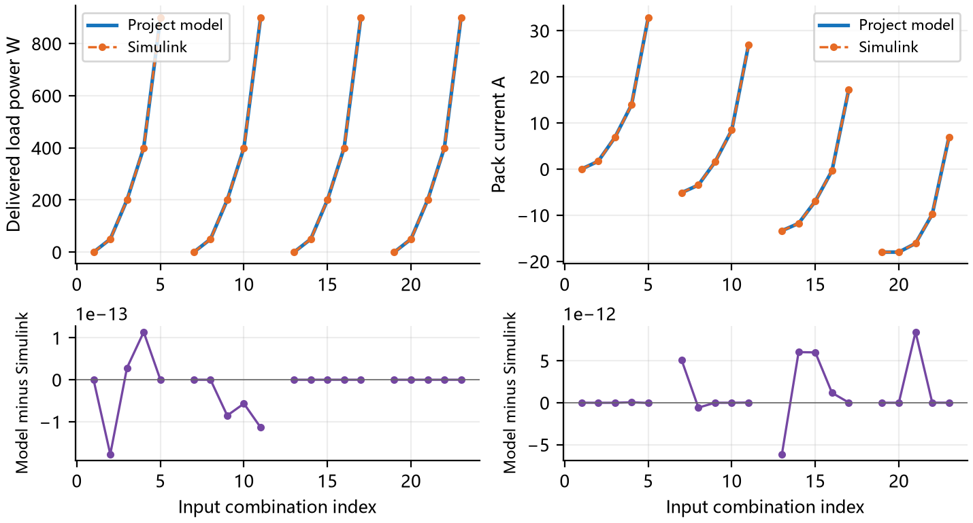
Figure 6 PD-001: Delivered load power W and Pack current A. Top panels show both outputs at identical samples; lower panels show project model minus Simulink in the same units.
Horizontal indices match the input table for this case. Connecting lines aid reading and do not imply a dynamic trajectory between independent samples.
Table 22. PD-001 Numerical Errors and Limits
Signal | Max absolute error | RMSE | Limit
Delivered load power W | 1.78e−13 | 5.86e−14 | 1.00e−06
Pack current A | 8.43e−12 | 3.23e−12 | 1.00e−04
Actual solar power W | 2.85e−10 | 1.07e−10 | 1.00e−06
Pack voltage V | 5.97e−13 | 2.46e−13 | 1.00e−04
Pack heat W | 1.58e−11 | 4.70e−12 | 1.00e−06
State of charge fraction | 4.44e−16 | 4.44e−16 | 1.00e−06
Battery temperature K | 0 | 0 | 0.001
Numerical comparison passes; overall acceptance: Pass. Recorded 57 checks.
Completed 24 input combinations. Output availability, discrete status and applicable numerical difference checks pass.

3.2.2 Test Project 7 Distribution efficiency and loss
Table 23. PD-002 Test Case
Case ID | PD-002 | Case Name | Distribution efficiency and loss
Test Objective | Verify that distribution input splits into load power and distribution heat, with no omitted or double-counted loss.
Preconditions | Use the frozen section 5 inputs and environment; execute both implementations independently. Design basis: P1, P3, P11.
Input Data | Set solar input to zero and supply the load from the battery at efficiencies 0.80, 0.95 and 1.00. The ideal 1.00 boundary must have zero distribution heat. Exact values appear in the input table for this case.
Procedure | 1. Load this case and run the project model and Simulink independently.  2. Save outputs and events in input order or at the prescribed times.  3. Check validity, same-sample differences and case behavior; retain check records.
Expected Results | Load plus distribution heat equals distribution input; unit efficiency produces zero distribution heat.
Acceptance Criteria | All applicable signals meet section 5.1 limits, flags and events match expectations, and the expected results in this form hold.
Case Designer |  | Executor / Date | Automated test 2026-10-07
Actual Results | Completed 9 input combinations. Output availability, discrete status and applicable numerical difference checks pass. 57 checks recorded; evidence: results/PD-002.json.
Recorded By |  | Test Conclusion | [X] Pass [ ] Fail [ ] Not Executed
Anomalies | No anomaly against this case criteria.
PD-002 Scenario Inputs and Initial Conditions
Table 24. PD-002 Scenario Inputs
Index | G W/m² | Demand W | TB K | Override
1 | 0 | 0 | 293.15 | eta=0.8
2 | 0 | 100 | 293.15 | eta=0.8
3 | 0 | 300 | 293.15 | eta=0.8
4 | 0 | 0 | 293.15 | eta=0.95
5 | 0 | 100 | 293.15 | eta=0.95
6 | 0 | 300 | 293.15 | eta=0.95
7 | 0 | 0 | 293.15 | eta=1
8 | 0 | 100 | 293.15 | eta=1
9 | 0 | 300 | 293.15 | eta=1
Parameters not overridden here use sections 5.2 and 6.1.

PD-002 Comparison Results
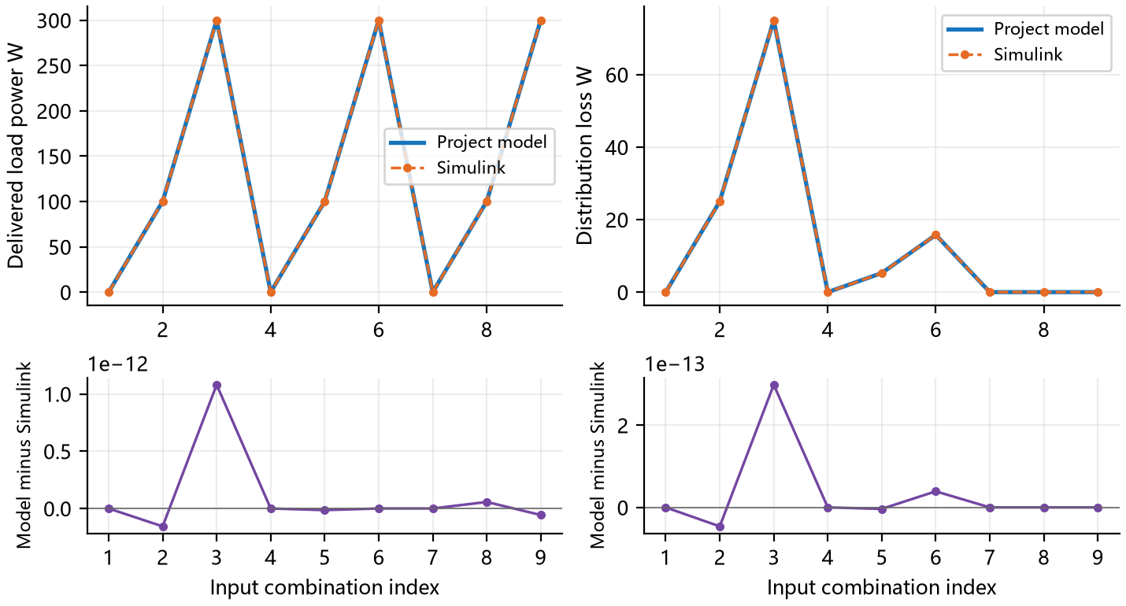
Figure 7 PD-002: Delivered load power W and Distribution loss W. Top panels show both outputs at identical samples; lower panels show project model minus Simulink in the same units.
Horizontal indices match the input table for this case. Connecting lines aid reading and do not imply a dynamic trajectory between independent samples.
Table 25. PD-002 Numerical Errors and Limits
Signal | Max absolute error | RMSE | Limit
Delivered load power W | 1.08e−12 | 3.65e−13 | 1.00e−06
Distribution loss W | 2.98e−13 | 1.02e−13 | 1.00e−06
Actual solar power W | 0 | 0 | 1.00e−06
Pack voltage V | 4.26e−14 | 2.15e−14 | 1.00e−04
Pack current A | 4.44e−14 | 1.68e−14 | 1.00e−04
Pack heat W | 4.62e−14 | 1.55e−14 | 1.00e−06
State of charge fraction | 4.44e−16 | 4.44e−16 | 1.00e−06
Battery temperature K | 0 | 0 | 0.001
Numerical comparison passes; overall acceptance: Pass. Recorded 57 checks.
Completed 9 input combinations. Output availability, discrete status and applicable numerical difference checks pass.

3.2.3 Test Project 8 Charge limits and solar curtailment
Table 26. CT-001 Test Case
Case ID | CT-001 | Case Name | Charge limits and solar curtailment
Test Objective | Verify curtailment when solar surplus exceeds the battery charge capability. Current, voltage and particle center or surface fractions can constrain charging.
Preconditions | Use the frozen section 5 inputs and environment; execute both implementations independently. Design basis: P1, P3, P11.
Input Data | Use an artificial 1800 W/m² irradiance and a 25 W load to guarantee surplus. This is a boundary stress test, not a solar constant assigned to a real orbit. Tighten charge current or voltage limits, or lower battery temperature. Exact values appear in the input table for this case.
Procedure | 1. Load this case and run the project model and Simulink independently.  2. Save outputs and events in input order or at the prescribed times.  3. Check validity, same-sample differences and case behavior; retain check records.
Expected Results | Honor charge limits and curtail solar while satisfying feasible load and terminal-power conservation.
Acceptance Criteria | All applicable signals meet section 5.1 limits, flags and events match expectations, and the expected results in this form hold.
Case Designer |  | Executor / Date | Automated test 2026-10-07
Actual Results | Completed 6 input combinations. Output availability, discrete status and applicable numerical difference checks pass. 57 checks recorded; evidence: results/CT-001.json.
Recorded By |  | Test Conclusion | [X] Pass [ ] Fail [ ] Not Executed
Anomalies | No anomaly against this case criteria.
CT-001 Scenario Inputs and Initial Conditions
Table 27. CT-001 Scenario Inputs
Index | G W/m² | Demand W | TB K | Override
1 | 1800 | 25 | 293.15 | imin=−0.2
2 | 1800 | 25 | 293.15 | vmax=4.03
3 | 1800 | 25 | 253.15 | Baseline
4 | 1800 | 25 | 273.15 | Baseline
5 | 1800 | 25 | 313.15 | Baseline
6 | 1800 | 25 | 293.15 | Baseline
Parameters not overridden here use sections 5.2 and 6.1.

CT-001 Comparison Results
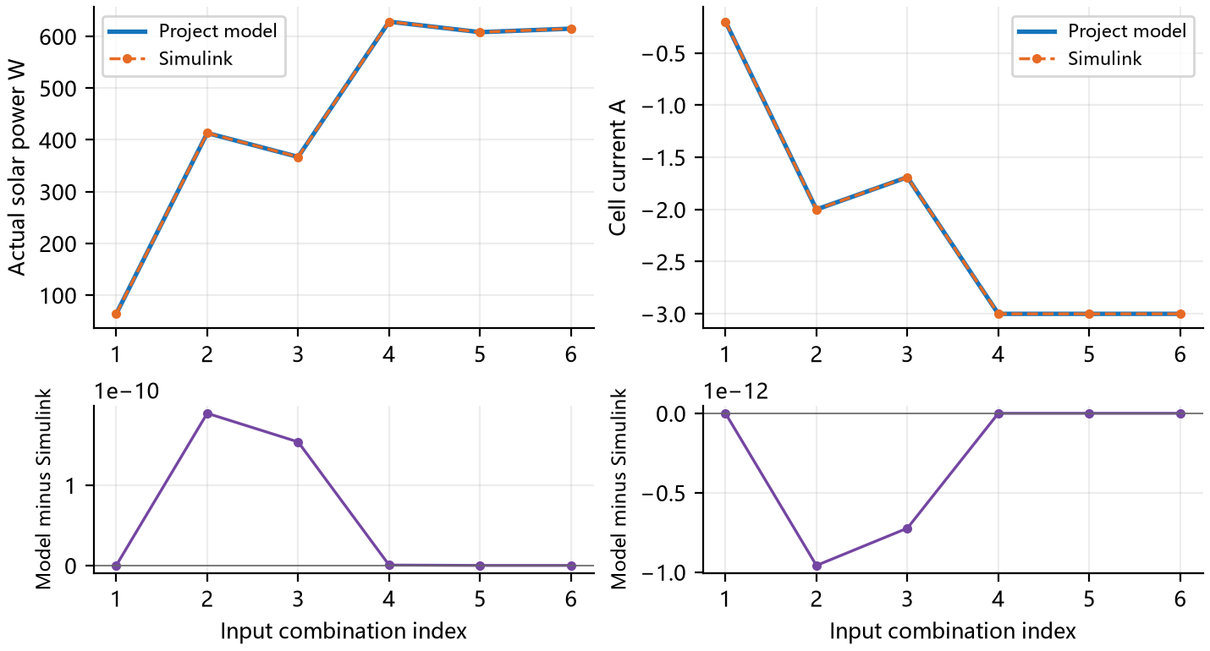
Figure 8 CT-001: Actual solar power W and Cell current A. Top panels show both outputs at identical samples; lower panels show project model minus Simulink in the same units.
Horizontal indices match the input table for this case. Connecting lines aid reading and do not imply a dynamic trajectory between independent samples.
Table 28. CT-001 Numerical Errors and Limits
Signal | Max absolute error | RMSE | Limit
Actual solar power W | 1.90e−10 | 9.97e−11 | 1.00e−06
Cell current A | 9.58e−13 | 4.90e−13 | 1.00e−04
Delivered load power W | 0 | 0 | 1.00e−06
Pack voltage V | 7.60e−13 | 3.59e−13 | 1.00e−04
Pack current A | 5.75e−12 | 2.94e−12 | 1.00e−04
Pack heat W | 1.02e−11 | 5.30e−12 | 1.00e−06
State of charge fraction | 4.44e−16 | 4.44e−16 | 1.00e−06
Battery temperature K | 0 | 0 | 0.001
Numerical comparison passes; overall acceptance: Pass. Recorded 57 checks.
Completed 6 input combinations. Output availability, discrete status and applicable numerical difference checks pass.

3.2.4 Test Project 9 Discharge capability and supply shortfall
Table 29. CT-002 Test Case
Case ID | CT-002 | Case Name | Discharge capability and supply shortfall
Test Objective | Verify discharge limits and supply shortfall classification. A physically infeasible request must request an event and must not be mislabeled as a numerical solver failure.
Preconditions | Use the frozen section 5 inputs and environment; execute both implementations independently. Design basis: P1, P3, P11.
Input Data | With no solar input, cross three requests with four battery settings: baseline, reduced discharge current, higher minimum voltage and low temperature. Each sample solves its own allowed current interval. Exact values appear in the input table for this case.
Procedure | 1. Load this case and run the project model and Simulink independently.  2. Save outputs and events in input order or at the prescribed times.  3. Check validity, same-sample differences and case behavior; retain check records.
Expected Results | Infeasible demand returns shortfall and an event request, distinguished from numerical failure.
Acceptance Criteria | All applicable signals meet section 5.1 limits, flags and events match expectations, and the expected results in this form hold.
Case Designer |  | Executor / Date | Automated test 2026-10-07
Actual Results | Completed 12 input combinations. Output availability, discrete status and applicable numerical difference checks pass. 57 checks recorded; evidence: results/CT-002.json.
Recorded By |  | Test Conclusion | [X] Pass [ ] Fail [ ] Not Executed
Anomalies | No anomaly against this case criteria.
CT-002 Scenario Inputs and Initial Conditions
Table 30. CT-002 Scenario Inputs
Index | G W/m² | Demand W | TB K | Override
1 | 0 | 20 | 293.15 | Baseline
2 | 0 | 100 | 293.15 | Baseline
3 | 0 | 1000 | 293.15 | Baseline
4 | 0 | 20 | 293.15 | imax=0.25
5 | 0 | 100 | 293.15 | imax=0.25
6 | 0 | 1000 | 293.15 | imax=0.25
7 | 0 | 20 | 293.15 | vmin=3.9
8 | 0 | 100 | 293.15 | vmin=3.9
9 | 0 | 1000 | 293.15 | vmin=3.9
10 | 0 | 20 | 253.15 | Baseline
11 | 0 | 100 | 253.15 | Baseline
12 | 0 | 1000 | 253.15 | Baseline
Parameters not overridden here use sections 5.2 and 6.1.

CT-002 Comparison Results
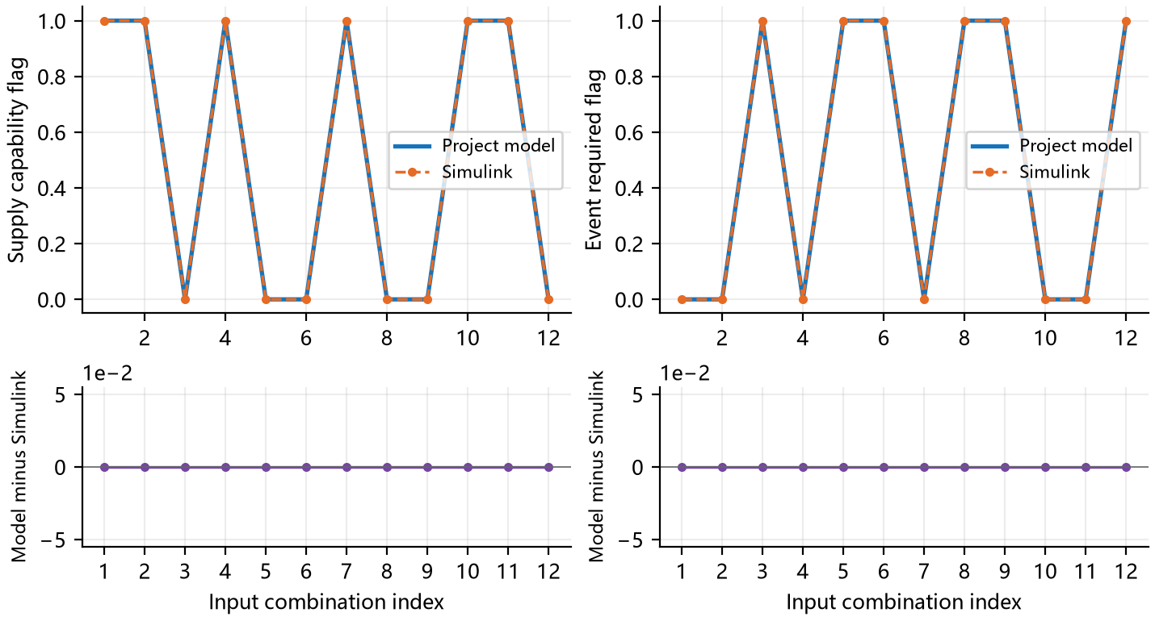
Figure 9 CT-002: Supply capability flag and Event required flag. Top panels show both outputs at identical samples; lower panels show project model minus Simulink in the same units.
Horizontal indices match the input table for this case. Connecting lines aid reading and do not imply a dynamic trajectory between independent samples.
Table 31. CT-002 Numerical Errors and Limits
Signal | Max absolute error | RMSE | Limit
Supply capability flag | 0 | 0 | 0
Event required flag | 0 | 0 | 0
Actual solar power W | 0 | 0 | 1.00e−06
Delivered load power W | 1.11e−10 | 4.52e−11 | 1.00e−06
Pack voltage V | 2.59e−13 | 1.11e−13 | 1.00e−04
Pack current A | 3.74e−12 | 1.53e−12 | 1.00e−04
Pack heat W | 6.34e−13 | 2.59e−13 | 1.00e−06
State of charge fraction | 4.44e−16 | 4.44e−16 | 1.00e−06
Numerical comparison passes; overall acceptance: Pass. Recorded 57 checks.
Completed 12 input combinations. Output availability, discrete status and applicable numerical difference checks pass.

3.2.5 Test Project 10 Charging boundary at full state of charge
Table 32. CT-003 Test Case
Case ID | CT-003 | Case Name | Charging boundary at full state of charge
Test Objective | Verify the design requirement to limit charging at full charge. The configured 100% SOC point is negative fraction 0.90 and positive fraction 0.27. Solar surplus at this state should not continue charging the battery.
Preconditions | Use the frozen section 5 inputs and environment; execute both implementations independently. Design basis: P1, P3, P11.
Input Data | Set initial SOC to 1, request 25 W, and apply three irradiances. Coverage review added this case after orbital runs exceeded SOC 1; the original numerical comparison tolerances were not relaxed. Exact values appear in the input table for this case.
Procedure | 1. Load this case and run the project model and Simulink independently.  2. Save outputs and events in input order or at the prescribed times.  3. Check validity, same-sample differences and case behavior; retain check records.
Expected Results | At SOC one, stop further charging and curtail surplus solar.
Acceptance Criteria | All applicable signals meet section 5.1 limits, flags and events match expectations, and the expected results in this form hold.
Case Designer |  | Executor / Date | Automated test 2026-10-07
Actual Results | All three full-charge samples continue charging, with minimum cell current −0.544984 A. Numerical agreement passes, but the full-charge requirement fails. 59 checks recorded; evidence: results/CT-003.json.
Recorded By |  | Test Conclusion | [ ] Pass [X] Fail [ ] Not Executed
Anomalies | All three full-charge samples continue charging, with minimum cell current −0.544984 A. Numerical agreement passes, but the full-charge requirement fails.
CT-003 Scenario Inputs and Initial Conditions
Table 33. CT-003 Scenario Inputs
Index | G W/m² | Demand W | TB K | Override
1 | 800 | 25 | 293.15 | Baseline
2 | 1361 | 25 | 293.15 | Baseline
3 | 1800 | 25 | 293.15 | Baseline
xn = 0.90; xp = 0.27; SOC = 1; cos θ = 1.
Parameters not overridden here use sections 5.2 and 6.1.

CT-003 Comparison Results
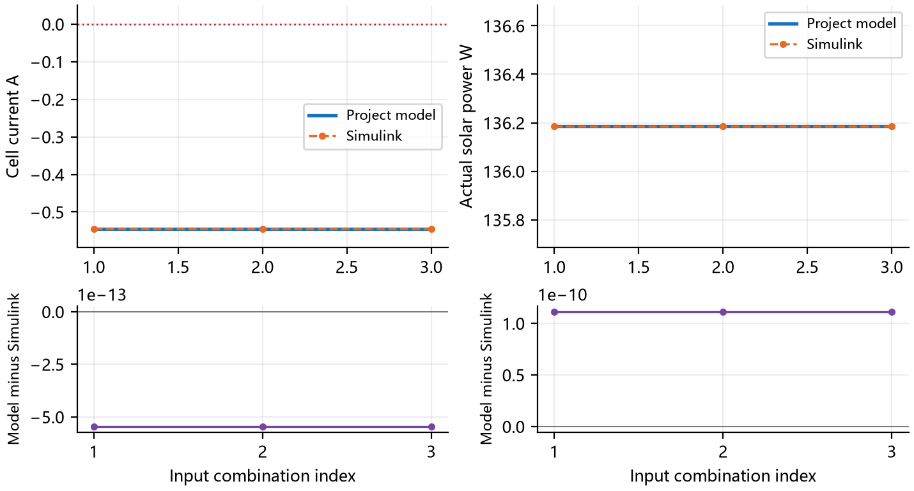
Figure 10 CT-003: Cell current A and Actual solar power W. Top panels show both outputs at identical samples; lower panels show project model minus Simulink in the same units.
Horizontal indices match the input table for this case. Connecting lines aid reading and do not imply a dynamic trajectory between independent samples.
Table 34. CT-003 Numerical Errors and Limits
Signal | Max absolute error | RMSE | Limit
Cell current A | 5.46e−13 | 5.46e−13 | 1.00e−04
Actual solar power W | 1.11e−10 | 1.11e−10 | 1.00e−06
Delivered load power W | 0 | 0 | 1.00e−06
Pack voltage V | 2.98e−13 | 2.98e−13 | 1.00e−04
Pack current A | 3.27e−12 | 3.27e−12 | 1.00e−04
Pack heat W | 1.48e−12 | 1.48e−12 | 1.00e−06
State of charge fraction | 0 | 0 | 1.00e−06
Battery temperature K | 0 | 0 | 0.001
Numerical comparison passes; overall acceptance: Fail. Recorded 59 checks.
All three full-charge samples continue charging, with minimum cell current −0.544984 A. Numerical agreement passes, but the full-charge requirement fails.

3.2.6 Test Project 11 Protection commands and latched states
Table 35. PR-001 Test Case
Case ID | PR-001 | Case Name | Protection commands and latched states
Test Objective | Verify start and stop commands, loss-of-supply latching, denied restart, simultaneous command priority and duplicate commands. Restored sunlight alone must not restart a latched load.
Preconditions | Use the frozen section 5 inputs and environment; execute both implementations independently. Design basis: 5.
Input Data | Eight configurations cover stop, feasible and infeasible start, supply loss, simultaneous stop and start, duplicate stop, and an unaccepted trial event. A trial event must be rejected without changing state. Exact values appear in the input table for this case.
Procedure | 1. Load this case and run the project model and Simulink independently.  2. Save outputs and events in input order or at the prescribed times.  3. Check validity, same-sample differences and case behavior; retain check records.
Expected Results | Start, stop, latching, command priority and trial-event rejection match the prescribed event sequence.
Acceptance Criteria | All applicable signals meet section 5.1 limits, flags and events match expectations, and the expected results in this form hold.
Case Designer |  | Executor / Date | Automated test 2026-10-07
Actual Results | Completed 8 input combinations. Output availability, discrete status and applicable numerical difference checks pass. 59 checks recorded; evidence: results/PR-001.json.
Recorded By |  | Test Conclusion | [X] Pass [ ] Fail [ ] Not Executed
Anomalies | No anomaly against this case criteria.
PR-001 Scenario Inputs and Initial Conditions
Table 36. PR-001 Scenario Inputs
Index | G W/m² | Demand W | Connected / latched | Command
1 | 1361 | 200 | 1 / 0 | stop
2 | 1361 | 200 | 0 / 0 | start
3 | 0 | 2500 | 0 / 1 | start
4 | 1361 | 200 | 0 / 1 | start
5 | 0 | 2500 | 1 / 0 | supply_loss
6 | 1361 | 200 | 1 / 0 | stop_start
7 | 1361 | 200 | 1 / 0 | repeat_stop
8 | 0 | 2500 | 1 / 0 | trial_supply_loss
Parameters not overridden here use sections 5.2 and 6.1.

PR-001 Comparison Results
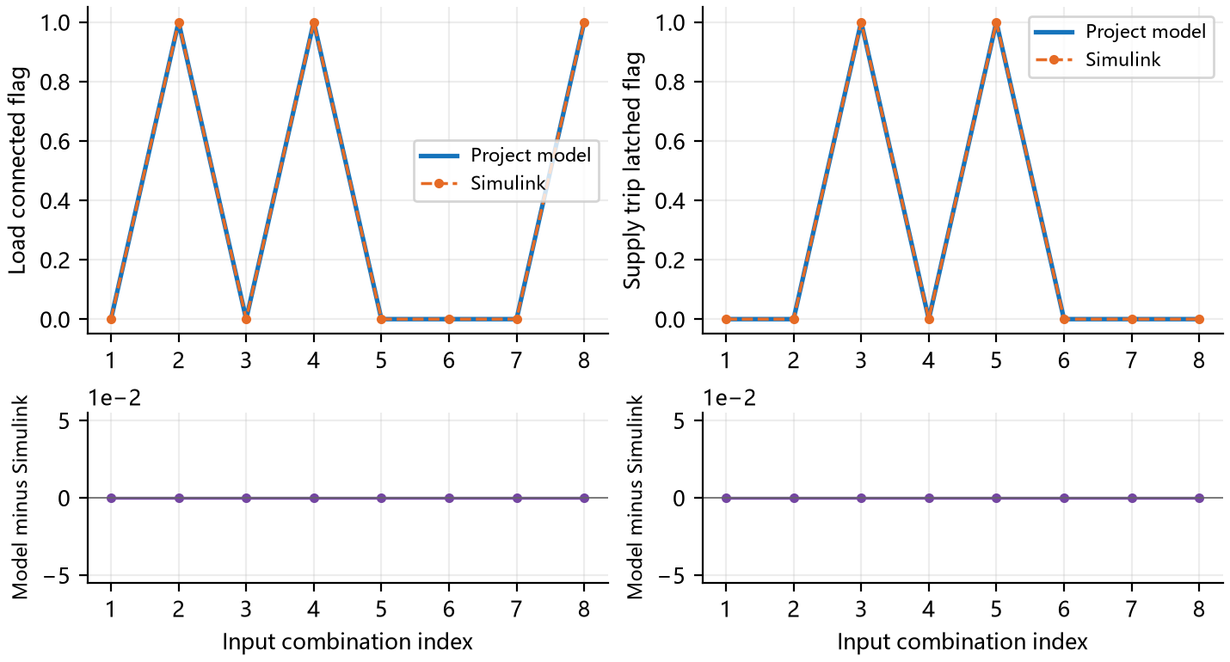
Figure 11 PR-001: Load connected flag and Supply trip latched flag. Top panels show both outputs at identical samples; lower panels show project model minus Simulink in the same units.
Horizontal indices match the input table for this case. Connecting lines aid reading and do not imply a dynamic trajectory between independent samples.
Table 37. PR-001 Numerical Errors and Limits
Signal | Max absolute error | RMSE | Limit
Load connected flag | 0 | 0 | 0
Supply trip latched flag | 0 | 0 | 0
Actual solar power W | 2.85e−10 | 1.52e−10 | 1.00e−06
Delivered load power W | 0 | 0 | 1.00e−06
Pack voltage V | 5.97e−13 | 3.19e−13 | 1.00e−04
Pack current A | 8.43e−12 | 4.51e−12 | 1.00e−04
Pack heat W | 1.58e−11 | 8.45e−12 | 1.00e−06
State of charge fraction | 4.44e−16 | 4.44e−16 | 1.00e−06
Numerical comparison passes; overall acceptance: Pass. Recorded 59 checks.
Completed 8 input combinations. Output availability, discrete status and applicable numerical difference checks pass.

3.2.7 Test Project 12 Invalid inputs and state boundaries
Table 38. IV-001 Test Case
Case ID | IV-001 | Case Name | Invalid inputs and state boundaries
Test Objective | Distinguish invalid input from a physical state boundary. Invalid input must not drive protection; a trial state outside material limits must report a device boundary requiring handling.
Preconditions | Use the frozen section 5 inputs and environment; execute both implementations independently. Design basis: 5.
Input Data | Test 240 K battery temperature, mismatched run identity, mismatched time, unsupported frame, zero Sun direction and an out-of-range mean lithium fraction. The first five are invalid; the last is a valid boundary-event report. Exact values appear in the input table for this case.
Procedure | 1. Load this case and run the project model and Simulink independently.  2. Save outputs and events in input order or at the prescribed times.  3. Check validity, same-sample differences and case behavior; retain check records.
Expected Results | The first five inputs are invalid; the sixth is a valid device-boundary event. Invalid results do not fabricate port values.
Acceptance Criteria | All applicable signals meet section 5.1 limits, flags and events match expectations, and the expected results in this form hold.
Case Designer |  | Executor / Date | Automated test 2026-10-07
Actual Results | Completed 6 input combinations. Output availability, discrete status and applicable numerical difference checks pass. 40 checks recorded; evidence: results/IV-001.json.
Recorded By |  | Test Conclusion | [X] Pass [ ] Fail [ ] Not Executed
Anomalies | No anomaly against this case criteria.
IV-001 Scenario Inputs and Initial Conditions
Table 39. IV-001 Scenario Inputs
Index | Input change | Expected class
1 | temperature | Invalid input
2 | identity | Invalid input
3 | time | Invalid input
4 | frame | Invalid input
5 | zero_sun | Invalid input
6 | mean_boundary | Boundary event
Parameters not overridden here use sections 5.2 and 6.1.

IV-001 Comparison Results
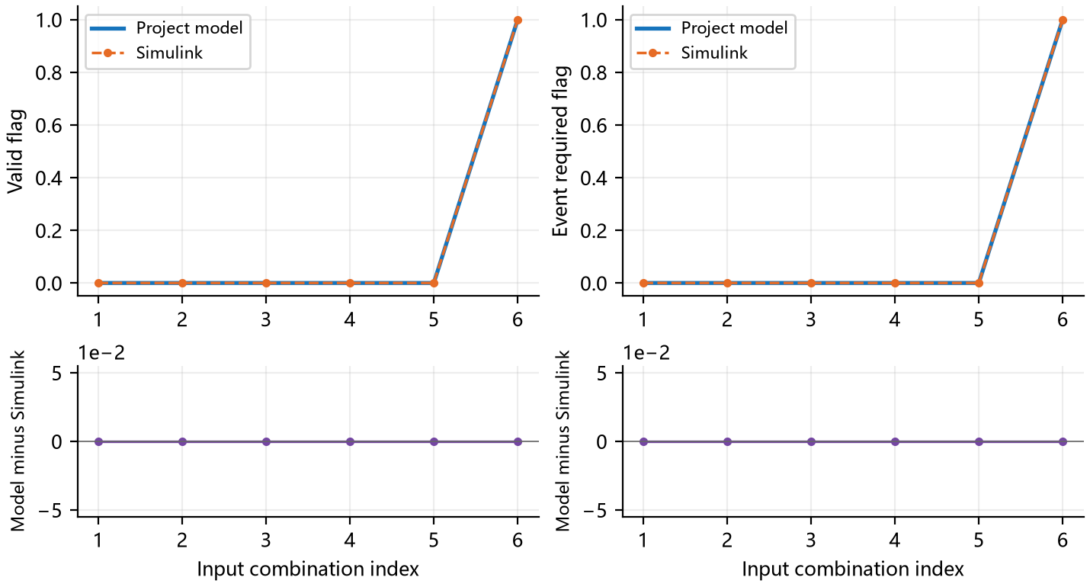
Figure 12 IV-001: Valid flag and Event required flag. Top panels show both outputs at identical samples; lower panels show project model minus Simulink in the same units.
Horizontal indices match the input table for this case. Connecting lines aid reading and do not imply a dynamic trajectory between independent samples.
Table 40. IV-001 Numerical Errors and Limits
Signal | Max absolute error | RMSE | Limit
Valid flag | 0 | 0 | 0
Event required flag | 0 | 0 | 0
State of charge fraction | 4.44e−16 | 4.44e−16 | 1.00e−06
Numerical comparison passes; overall acceptance: Pass. Recorded 40 checks.
Completed 6 input combinations. Output availability, discrete status and applicable numerical difference checks pass.

3.3 Dynamic Supply and Electrothermal Processes

3.3.1 Test Project 13 Charging under continuous sunlight
Table 41. DY-001 Test Case
Case ID | DY-001 | Case Name | Charging under continuous sunlight
Test Objective | Verify gradual charging in continuous sunlight and agreement of SOC, current, voltage and heat between the independent integrators.
Preconditions | Use the frozen section 5 inputs and environment; execute both implementations independently. Design basis: P1–P11.
Input Data | Normal solar incidence at 1361 W/m², a 200 W load and a prescribed 293.15 K battery temperature for 900 s. Save results every 10 s. Exact values appear in the input table for this case.
Procedure | 1. Load this case and run the project model and Simulink independently.  2. Save outputs and events in input order or at the prescribed times.  3. Check validity, same-sample differences and case behavior; retain check records.
Expected Results | SOC rises continuously within zero to one, power is conserved, and dynamic outputs agree within tolerance.
Acceptance Criteria | All applicable signals meet section 5.1 limits, flags and events match expectations, and the expected results in this form hold.
Case Designer |  | Executor / Date | Automated test 2026-10-07
Actual Results | SOC changes from 65.517% to 88.654%; battery temperature changes from 293.150 K to 293.150 K. 87 checks recorded; evidence: results/DY-001.json.
Recorded By |  | Test Conclusion | [X] Pass [ ] Fail [ ] Not Executed
Anomalies | No anomaly against this case criteria.
DY-001 Scenario Inputs and Initial Conditions
Table 42. DY-001 Scenario Inputs
Time s | G W/m² | Demand W | Start command
0 to 900 | 1361 | 200 | none
Initial xn = 0.60, xp = 0.458686001; initial temperature 293.15 K; incidence cosine 1; output interval 10 s.
Parameters not overridden here use sections 5.2 and 6.1.

DY-001 Comparison Results
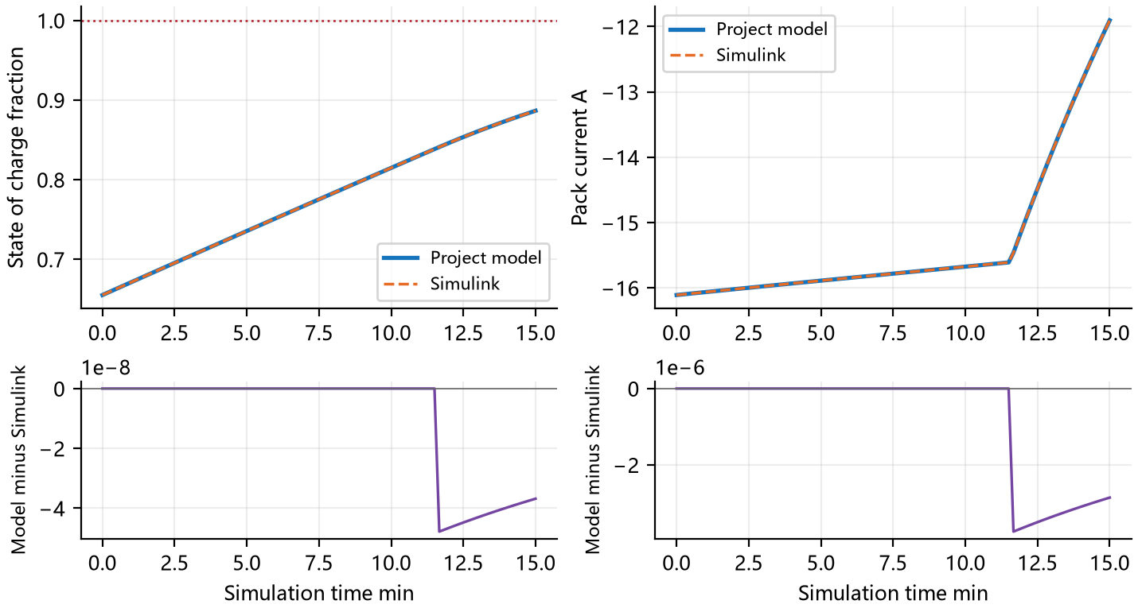
Figure 13 DY-001: State of charge fraction and Pack current A. Top panels show both outputs at identical samples; lower panels show project model minus Simulink in the same units.
The horizontal axis is minutes. Vertical changes retain both sides of a discontinuity at the same time; no interpolation spans that discontinuity.
Table 43. DY-001 Numerical Errors and Limits
Signal | Max absolute error | RMSE | Limit
State of charge fraction | 4.78e−08 | 2.03e−08 | 1.00e−06
Pack current A | 3.75e−06 | 1.58e−06 | 1.00e−04
Actual solar power W | 1.26e−04 | 5.32e−05 | 0.001
Delivered load power W | 0 | 0 | 0.001
Pack voltage V | 1.57e−12 | 7.88e−13 | 1.00e−04
Pack heat W | 6.81e−06 | 2.61e−06 | 0.001
Battery temperature K | 0 | 0 | 0.001
Numerical comparison passes; overall acceptance: Pass. Recorded 87 checks.
SOC changes from 65.517% to 88.654%; battery temperature changes from 293.150 K to 293.150 K.

3.3.2 Test Project 14 Eclipse entry and exit
Table 44. DY-002 Test Case
Case ID | DY-002 | Case Name | Eclipse entry and exit
Test Objective | Verify transitions from sunlight into eclipse and back. Solar output is zero in eclipse and the battery supplies the load; sunlight recovery restores array power and possible charging.
Preconditions | Use the frozen section 5 inputs and environment; execute both implementations independently. Design basis: P1–P11.
Input Data | Use a controlled 5400 s cycle with full eclipse from 1800 to 3800 s and 1361 W/m² otherwise. Load stays at 200 W. This fixture is neither ISS telemetry nor orbit-propagator output. Exact values appear in the input table for this case.
Procedure | 1. Load this case and run the project model and Simulink independently.  2. Save outputs and events in input order or at the prescribed times.  3. Check validity, same-sample differences and case behavior; retain check records.
Expected Results | Battery supplies the eclipse interval; array supply resumes in sunlight; SOC stays within zero to one.
Acceptance Criteria | All applicable signals meet section 5.1 limits, flags and events match expectations, and the expected results in this form hold.
Case Designer |  | Executor / Date | Automated test 2026-10-07
Actual Results | Peak SOC is 100.6153%, above the configured 100% point. Both implementations exhibit this behavior, so overall acceptance fails. 87 checks recorded; evidence: results/DY-002.json.
Recorded By |  | Test Conclusion | [ ] Pass [X] Fail [ ] Not Executed
Anomalies | Peak SOC is 100.6153%, above the configured 100% point. Both implementations exhibit this behavior, so overall acceptance fails.
DY-002 Scenario Inputs and Initial Conditions
Table 45. DY-002 Scenario Inputs
Time s | G W/m² | Demand W | Start command
0 to 1800 | 1361 | 200 | none
1800 to 3800 | 0 | 200 | none
3800 to 5400 | 1361 | 200 | none
Initial xn = 0.60, xp = 0.458686001; initial temperature 293.15 K; incidence cosine 1; output interval 20 s.
Parameters not overridden here use sections 5.2 and 6.1.

DY-002 Comparison Results
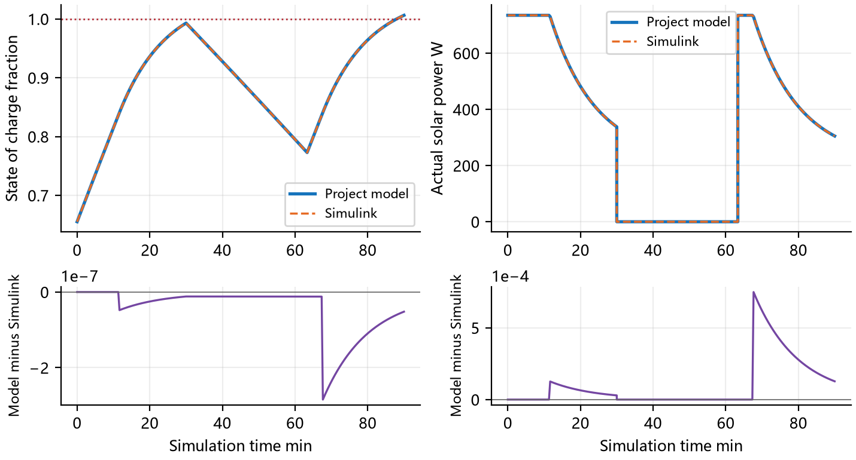
Figure 14 DY-002: State of charge fraction and Actual solar power W. Top panels show both outputs at identical samples; lower panels show project model minus Simulink in the same units.
The horizontal axis is minutes. Vertical changes retain both sides of a discontinuity at the same time; no interpolation spans that discontinuity.
Table 46. DY-002 Numerical Errors and Limits
Signal | Max absolute error | RMSE | Limit
State of charge fraction | 2.84e−07 | 7.69e−08 | 1.00e−06
Actual solar power W | 7.49e−04 | 1.98e−04 | 0.001
Delivered load power W | 1.89e−10 | 2.35e−11 | 0.001
Pack voltage V | 7.15e−08 | 4.38e−08 | 1.00e−04
Pack current A | 2.23e−05 | 5.90e−06 | 1.00e−04
Pack heat W | 4.04e−05 | 8.05e−06 | 0.001
Battery temperature K | 0 | 0 | 0.001
Numerical comparison passes; overall acceptance: Fail. Recorded 87 checks.
Peak SOC is 100.6153%, above the configured 100% point. Both implementations exhibit this behavior, so overall acceptance fails.

3.3.3 Test Project 15 Compute load steps
Table 47. DY-003 Test Case
Case ID | DY-003 | Case Name | Compute load steps
Test Objective | Verify battery compensation and charge or discharge transitions when compute demand changes. A step is a sudden change of requested power, not a switching-waveform experiment.
Preconditions | Use the frozen section 5 inputs and environment; execute both implementations independently. Design basis: P1–P11.
Input Data | Hold irradiance at 800 W/m² and request 100, 350, 550 and 100 W in consecutive 200 s intervals. Temperature is fixed. Segment boundaries retain both pre-step and post-step values. Exact values appear in the input table for this case.
Procedure | 1. Load this case and run the project model and Simulink independently.  2. Save outputs and events in input order or at the prescribed times.  3. Check validity, same-sample differences and case behavior; retain check records.
Expected Results | Power and current respond to demand steps while lithium states remain continuous at each event.
Acceptance Criteria | All applicable signals meet section 5.1 limits, flags and events match expectations, and the expected results in this form hold.
Case Designer |  | Executor / Date | Automated test 2026-10-07
Actual Results | SOC changes from 65.517% to 71.390%; battery temperature changes from 293.150 K to 293.150 K. 87 checks recorded; evidence: results/DY-003.json.
Recorded By |  | Test Conclusion | [X] Pass [ ] Fail [ ] Not Executed
Anomalies | No anomaly against this case criteria.
DY-003 Scenario Inputs and Initial Conditions
Table 48. DY-003 Scenario Inputs
Time s | G W/m² | Demand W | Start command
0 to 200 | 800 | 100 | none
200 to 400 | 800 | 350 | none
400 to 600 | 800 | 550 | none
600 to 800 | 800 | 100 | none
Initial xn = 0.60, xp = 0.458686001; initial temperature 293.15 K; incidence cosine 1; output interval 5 s.
Parameters not overridden here use sections 5.2 and 6.1.

DY-003 Comparison Results
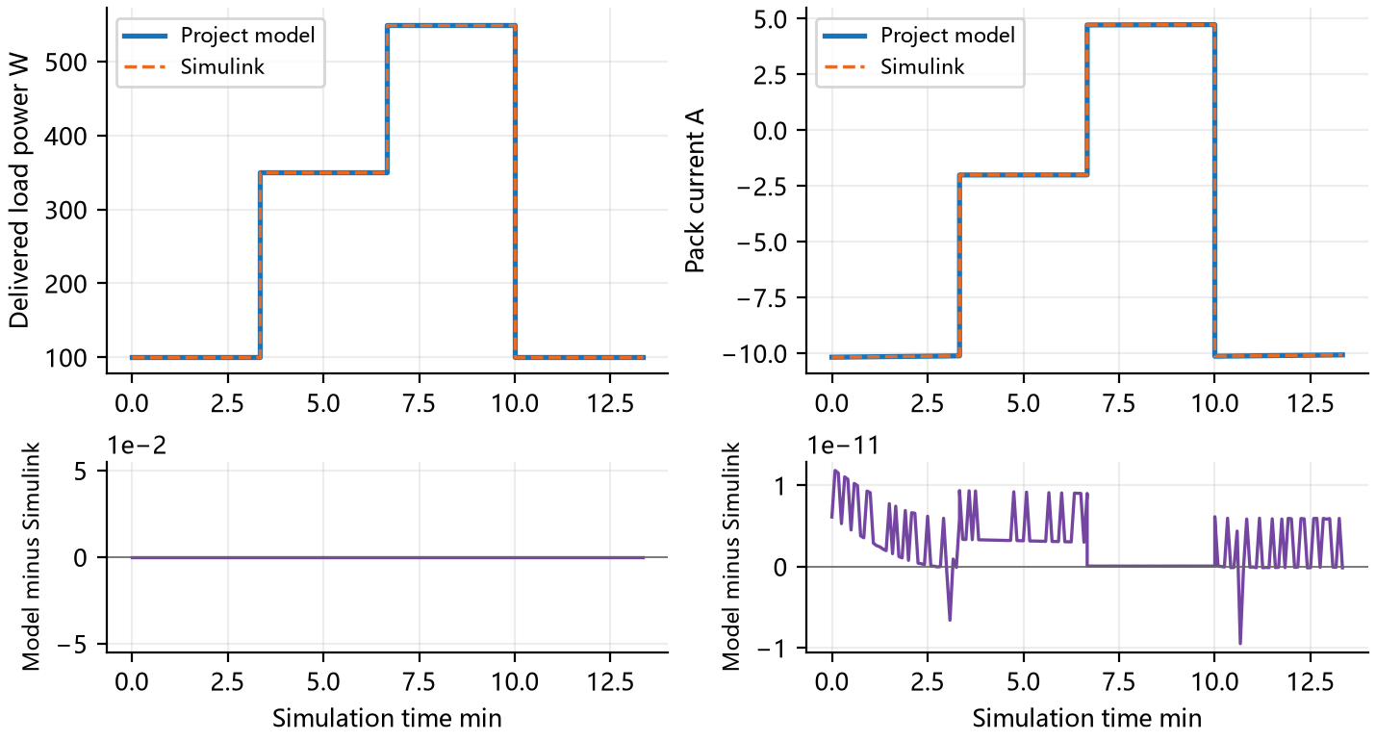
Figure 15 DY-003: Delivered load power W and Pack current A. Top panels show both outputs at identical samples; lower panels show project model minus Simulink in the same units.
The horizontal axis is minutes. Vertical changes retain both sides of a discontinuity at the same time; no interpolation spans that discontinuity.
Table 49. DY-003 Numerical Errors and Limits
Signal | Max absolute error | RMSE | Limit
Delivered load power W | 0 | 0 | 0.001
Pack current A | 1.18e−11 | 4.50e−12 | 1.00e−04
Actual solar power W | 3.88e−10 | 1.47e−10 | 0.001
Pack voltage V | 1.13e−12 | 5.61e−13 | 1.00e−04
Pack heat W | 1.40e−11 | 4.34e−12 | 0.001
State of charge fraction | 6.98e−14 | 5.17e−14 | 1.00e−06
Battery temperature K | 0 | 0 | 0.001
Numerical comparison passes; overall acceptance: Pass. Recorded 87 checks.
SOC changes from 65.517% to 71.390%; battery temperature changes from 293.150 K to 293.150 K.

3.3.4 Test Project 16 Dynamic charge curtailment
Table 50. DY-004 Test Case
Case ID | DY-004 | Case Name | Dynamic charge curtailment
Test Objective | Verify actual solar output and battery heat as the battery state evolves under a charge current limit.
Preconditions | Use the frozen section 5 inputs and environment; execute both implementations independently. Design basis: P1–P11.
Input Data | Run for 900 s at 1800 W/m² and 25 W demand, with cell current bounded below by minus 0.2 A. Other parameters are unchanged; the limit applies to a cell, not the pack current. Exact values appear in the input table for this case.
Procedure | 1. Load this case and run the project model and Simulink independently.  2. Save outputs and events in input order or at the prescribed times.  3. Check validity, same-sample differences and case behavior; retain check records.
Expected Results | Charging respects limits, curtailment follows charge capability, and both trajectories agree.
Acceptance Criteria | All applicable signals meet section 5.1 limits, flags and events match expectations, and the expected results in this form hold.
Case Designer |  | Executor / Date | Automated test 2026-10-07
Actual Results | SOC changes from 65.517% to 67.326%; battery temperature changes from 293.150 K to 293.150 K. 87 checks recorded; evidence: results/DY-004.json.
Recorded By |  | Test Conclusion | [X] Pass [ ] Fail [ ] Not Executed
Anomalies | No anomaly against this case criteria.
DY-004 Scenario Inputs and Initial Conditions
Table 51. DY-004 Scenario Inputs
Time s | G W/m² | Demand W | Start command
0 to 900 | 1800 | 25 | none
Initial xn = 0.60, xp = 0.458686001; initial temperature 293.15 K; incidence cosine 1; output interval 10 s.
Overrides imin = −0.2
Parameters not overridden here use sections 5.2 and 6.1.

DY-004 Comparison Results
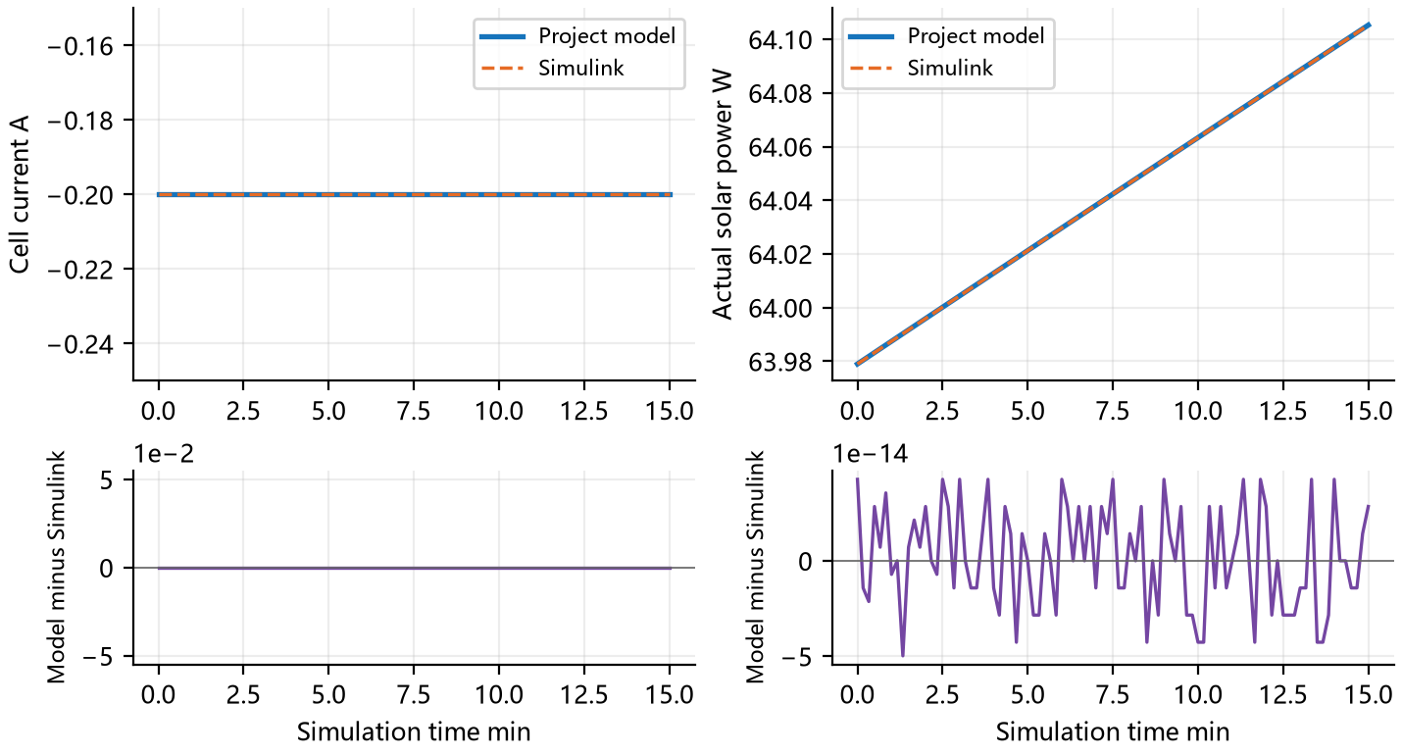
Figure 16 DY-004: Cell current A and Actual solar power W. Top panels show both outputs at identical samples; lower panels show project model minus Simulink in the same units.
The horizontal axis is minutes. Vertical changes retain both sides of a discontinuity at the same time; no interpolation spans that discontinuity.
Table 52. DY-004 Numerical Errors and Limits
Signal | Max absolute error | RMSE | Limit
Cell current A | 0 | 0 | 1.00e−04
Actual solar power W | 4.97e−14 | 2.64e−14 | 0.001
Delivered load power W | 0 | 0 | 0.001
Pack voltage V | 4.97e−14 | 2.77e−14 | 1.00e−04
Pack current A | 0 | 0 | 1.00e−04
Pack heat W | 7.89e−17 | 1.52e−17 | 0.001
State of charge fraction | 4.44e−16 | 2.88e−16 | 1.00e−06
Battery temperature K | 0 | 0 | 0.001
Numerical comparison passes; overall acceptance: Pass. Recorded 87 checks.
SOC changes from 65.517% to 67.326%; battery temperature changes from 293.150 K to 293.150 K.

3.3.5 Test Project 17 Supply loss latch and explicit restart
Table 53. DY-005 Test Case
Case ID | DY-005 | Case Name | Supply loss latch and explicit restart
Test Objective | Verify supply loss, latching, sunlight recovery, explicit restart and a subsequent stop. Protection must change load connectivity while allowing charging with the load disconnected.
Preconditions | Use the frozen section 5 inputs and environment; execute both implementations independently. Design basis: P1–P11.
Input Data | At 100 s remove sunlight and request 2500 W. Restore normal sunlight at 200 s without a start command; start at 300 s, stop at 400 s and start again at 500 s. End at 600 s. Exact values appear in the input table for this case.
Procedure | 1. Load this case and run the project model and Simulink independently.  2. Save outputs and events in input order or at the prescribed times.  3. Check validity, same-sample differences and case behavior; retain check records.
Expected Results | Trip at 100 s; sunlight at 200 s causes no restart; start at 300 s, stop at 400 s, and restart at 500 s.
Acceptance Criteria | All applicable signals meet section 5.1 limits, flags and events match expectations, and the expected results in this form hold.
Case Designer |  | Executor / Date | Automated test 2026-10-07
Actual Results | Supply trips at 100 s; the load remains disconnected after sunlight returns at 200 s. Explicit start at 300 s, stop at 400 s and restart at 500 s agree with expectations. 88 checks recorded; evidence: results/DY-005.json.
Recorded By |  | Test Conclusion | [X] Pass [ ] Fail [ ] Not Executed
Anomalies | No anomaly against this case criteria.
DY-005 Scenario Inputs and Initial Conditions
Table 54. DY-005 Scenario Inputs
Time s | G W/m² | Demand W | Start command
0 to 100 | 1361 | 200 | none
100 to 200 | 0 | 2500 | none
200 to 300 | 1361 | 200 | none
300 to 400 | 1361 | 200 | start
400 to 500 | 1361 | 200 | stop
500 to 600 | 1361 | 200 | start
Initial xn = 0.60, xp = 0.458686001; initial temperature 293.15 K; incidence cosine 1; output interval 5 s.
Parameters not overridden here use sections 5.2 and 6.1.

DY-005 Comparison Results
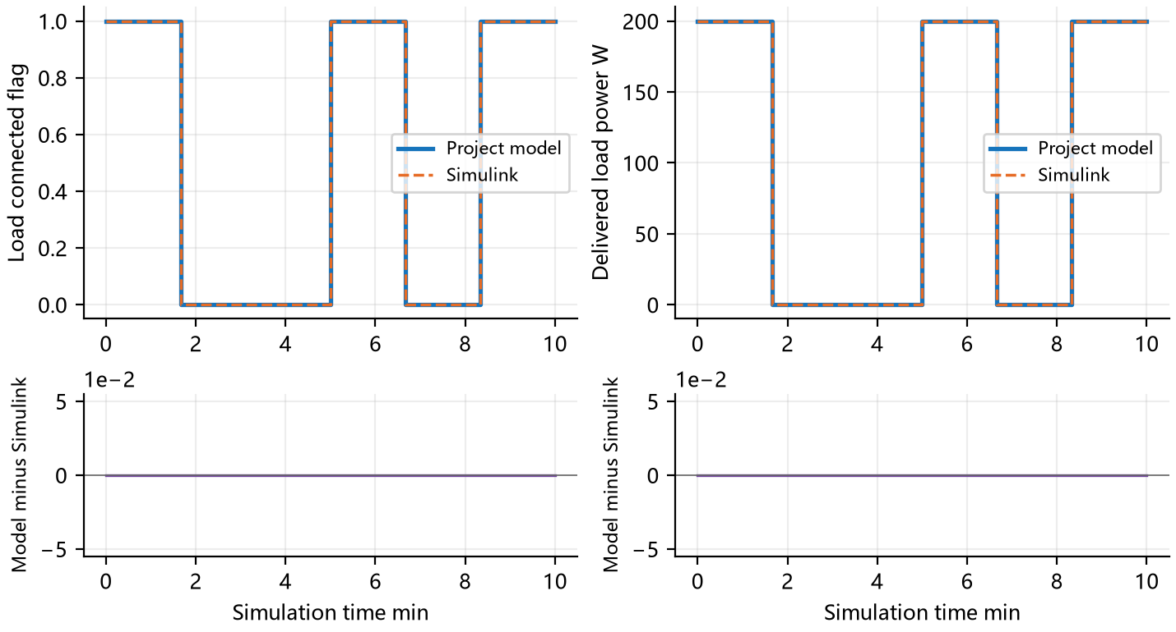
Figure 17 DY-005: Load connected flag and Delivered load power W. Top panels show both outputs at identical samples; lower panels show project model minus Simulink in the same units.
The horizontal axis is minutes. Vertical changes retain both sides of a discontinuity at the same time; no interpolation spans that discontinuity.
Table 55. DY-005 Numerical Errors and Limits
Signal | Max absolute error | RMSE | Limit
Load connected flag | 0 | 0 | 0
Delivered load power W | 0 | 0 | 0.001
Actual solar power W | 6.55e−10 | 1.57e−10 | 0.001
Pack voltage V | 1.44e−12 | 3.47e−13 | 1.00e−04
Pack current A | 1.92e−11 | 4.61e−12 | 1.00e−04
Pack heat W | 3.63e−11 | 8.72e−12 | 0.001
State of charge fraction | 1.93e−14 | 6.18e−15 | 1.00e−06
Battery temperature K | 0 | 0 | 0.001
Numerical comparison passes; overall acceptance: Pass. Recorded 88 checks.
Supply trips at 100 s; the load remains disconnected after sunlight returns at 200 s. Explicit start at 300 s, stop at 400 s and restart at 500 s agree with expectations.

3.3.6 Test Project 18 Battery electrothermal feedback
Table 56. DY-006 Test Case
Case ID | DY-006 | Case Name | Battery electrothermal feedback
Test Objective | Verify the loop in which battery heat changes temperature, which in turn changes voltage and current. The thermal boundary is a prescribed heat-sink temperature, not ambient-air convection.
Preconditions | Use the frozen section 5 inputs and environment; execute both implementations independently. Design basis: P1–P11.
Input Data | Use no solar power, a 200 W load, initial battery temperature 283.15 K, heat capacity 5000 J/K, thermal resistance 0.8 K/W and a 273.15 K sink for 1800 s. This is a one-node battery thermal test, not full six-node Thermal integration. Exact values appear in the input table for this case.
Procedure | 1. Load this case and run the project model and Simulink independently.  2. Save outputs and events in input order or at the prescribed times.  3. Check validity, same-sample differences and case behavior; retain check records.
Expected Results | Temperature is integrated once; heat generation and rejection determine temperature and feed back into voltage and current.
Acceptance Criteria | All applicable signals meet section 5.1 limits, flags and events match expectations, and the expected results in this form hold.
Case Designer |  | Executor / Date | Automated test 2026-10-07
Actual Results | SOC changes from 65.517% to 44.282%; battery temperature changes from 283.150 K to 280.874 K. 85 checks recorded; evidence: results/DY-006.json.
Recorded By |  | Test Conclusion | [X] Pass [ ] Fail [ ] Not Executed
Anomalies | No anomaly against this case criteria.
DY-006 Scenario Inputs and Initial Conditions
Table 57. DY-006 Scenario Inputs
Time s | G W/m² | Demand W | Start command
0 to 1800 | 0 | 200 | none
Initial xn = 0.60, xp = 0.458686001; initial temperature 283.15 K; incidence cosine 1; output interval 10 s.
CB = 5000 J/K; R = 0.8 K/W; Tsink = 273.15 K.
Parameters not overridden here use sections 5.2 and 6.1.

DY-006 Comparison Results
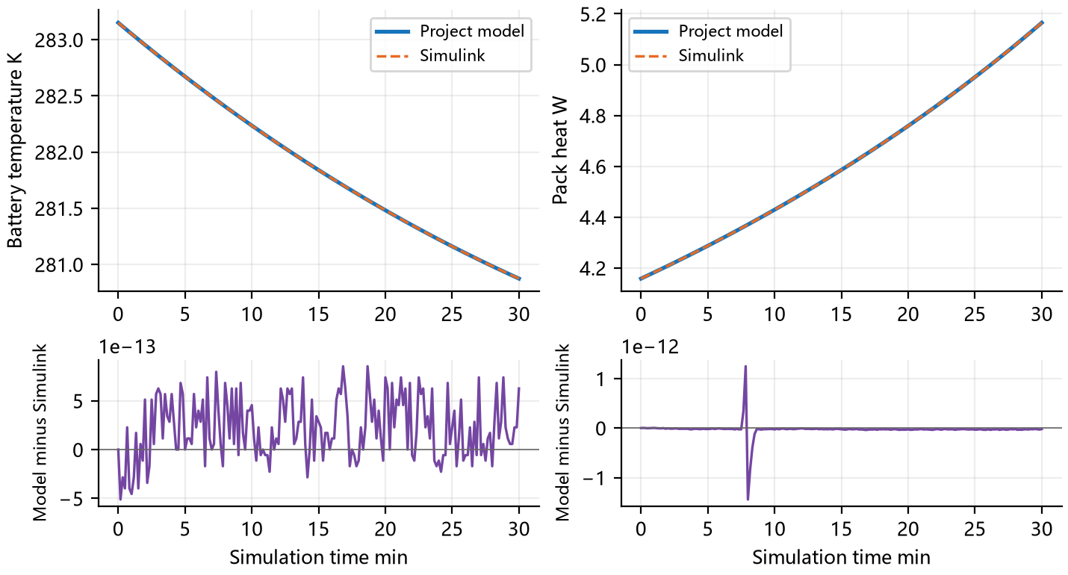
Figure 18 DY-006: Battery temperature K and Pack heat W. Top panels show both outputs at identical samples; lower panels show project model minus Simulink in the same units.
The horizontal axis is minutes. Vertical changes retain both sides of a discontinuity at the same time; no interpolation spans that discontinuity.
Table 58. DY-006 Numerical Errors and Limits
Signal | Max absolute error | RMSE | Limit
Battery temperature K | 8.53e−13 | 3.79e−13 | 0.001
Pack heat W | 1.44e−12 | 1.62e−13 | 0.001
Actual solar power W | 0 | 0 | 0.001
Delivered load power W | 3.48e−11 | 3.90e−12 | 0.001
Pack voltage V | 8.53e−14 | 3.20e−14 | 1.00e−04
Pack current A | 1.24e−12 | 1.39e−13 | 1.00e−04
State of charge fraction | 9.99e−16 | 4.34e−16 | 1.00e−06
Numerical comparison passes; overall acceptance: Pass. Recorded 85 checks.
SOC changes from 65.517% to 44.282%; battery temperature changes from 283.150 K to 280.874 K.

3.3.7 Test Project 19 Energy balance over three orbit cycles
Table 59. DY-007 Test Case
Case ID | DY-007 | Case Name | Energy balance over three orbit cycles
Test Objective | Verify cumulative energy and state drift over repeated sunlight and eclipse cycles. Long trajectories can expose missing charge boundaries despite correct instantaneous power balance.
Preconditions | Use the frozen section 5 inputs and environment; execute both implementations independently. Design basis: P1–P11.
Input Data | Repeat the controlled DY-002 cycle three times for 16200 s. Save every 30 s and retain both sides of all eclipse entry and exit boundaries. Exact values appear in the input table for this case.
Procedure | 1. Load this case and run the project model and Simulink independently.  2. Save outputs and events in input order or at the prescribed times.  3. Check validity, same-sample differences and case behavior; retain check records.
Expected Results | Conservation holds over three cycles, integrated energies agree, and SOC stays within zero to one.
Acceptance Criteria | All applicable signals meet section 5.1 limits, flags and events match expectations, and the expected results in this form hold.
Case Designer |  | Executor / Date | Automated test 2026-10-07
Actual Results | Peak SOC is 104.2070%, above the configured 100% point. Both implementations exhibit this behavior, so overall acceptance fails. 87 checks recorded; evidence: results/DY-007.json.
Recorded By |  | Test Conclusion | [ ] Pass [X] Fail [ ] Not Executed
Anomalies | Peak SOC is 104.2070%, above the configured 100% point. Both implementations exhibit this behavior, so overall acceptance fails.
DY-007 Scenario Inputs and Initial Conditions
Table 60. DY-007 Scenario Inputs
Time s | G W/m² | Demand W | Start command
0 to 1800 | 1361 | 200 | none
1800 to 3800 | 0 | 200 | none
3800 to 5400 | 1361 | 200 | none
5400 to 7200 | 1361 | 200 | none
7200 to 9200 | 0 | 200 | none
9200 to 10800 | 1361 | 200 | none
10800 to 12600 | 1361 | 200 | none
12600 to 14600 | 0 | 200 | none
14600 to 16200 | 1361 | 200 | none
Initial xn = 0.60, xp = 0.458686001; initial temperature 293.15 K; incidence cosine 1; output interval 30 s.
Parameters not overridden here use sections 5.2 and 6.1.

DY-007 Comparison Results
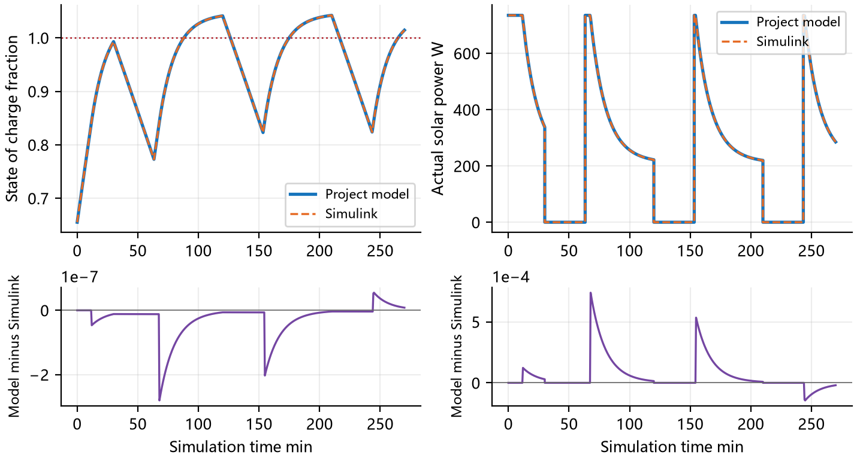
Figure 19 DY-007: State of charge fraction and Actual solar power W. Top panels show both outputs at identical samples; lower panels show project model minus Simulink in the same units.
The horizontal axis is minutes. Vertical changes retain both sides of a discontinuity at the same time; no interpolation spans that discontinuity.
Table 61. DY-007 Numerical Errors and Limits
Signal | Max absolute error | RMSE | Limit
State of charge fraction | 2.81e−07 | 5.56e−08 | 1.00e−06
Actual solar power W | 7.39e−04 | 1.43e−04 | 0.001
Delivered load power W | 1.80e−10 | 2.08e−11 | 0.001
Pack voltage V | 7.15e−08 | 2.95e−08 | 1.00e−04
Pack current A | 2.20e−05 | 4.26e−06 | 1.00e−04
Pack heat W | 3.94e−05 | 5.66e−06 | 0.001
Battery temperature K | 0 | 0 | 0.001
Numerical comparison passes; overall acceptance: Fail. Recorded 87 checks.
Peak SOC is 104.2070%, above the configured 100% point. Both implementations exhibit this behavior, so overall acceptance fails.

3.4 Numerical Accuracy Review

3.4.1 Test Project 20 Solver convergence and accuracy review
Table 62. NU-001 Test Case
Case ID | NU-001 | Case Name | Solver convergence and accuracy review
Test Objective | Check whether numerical precision explains the observed difference. Independently tighten both solvers and reduce the maximum step, requiring changes below one tenth of the original acceptance limit.
Preconditions | Use the frozen section 5 inputs and environment; execute both implementations independently. Design basis: P1–P11.
Input Data | Run 1200 s with no solar input, a 200 W load, initial battery temperature 293.15 K and a 283.15 K sink. Tighten relative tolerance from 10 to the power minus 8 to 10 to the power minus 10 and reduce maximum step from 10 s to 2 s. Exact values appear in the input table for this case.
Procedure | 1. Load this case and run the project model and Simulink independently.  2. Save outputs and events in input order or at the prescribed times.  3. Check validity, same-sample differences and case behavior; retain check records.
Expected Results | Each solver changes by less than one tenth of the corresponding comparison limit under independent refinement.
Acceptance Criteria | All applicable signals meet section 5.1 limits, flags and events match expectations, and the expected results in this form hold.
Case Designer |  | Executor / Date | Automated test 2026-10-07
Actual Results | SOC changes from 65.517% to 51.553%; battery temperature changes from 293.150 K to 291.345 K. 95 checks recorded; evidence: results/NU-001.json.
Recorded By |  | Test Conclusion | [X] Pass [ ] Fail [ ] Not Executed
Anomalies | No anomaly against this case criteria.
NU-001 Scenario Inputs and Initial Conditions
Table 63. NU-001 Scenario Inputs
Time s | G W/m² | Demand W | Start command
0 to 1200 | 0 | 200 | none
Initial xn = 0.60, xp = 0.458686001; initial temperature 293.15 K; incidence cosine 1; output interval 10 s.
CB = 5000 J/K; R = 0.8 K/W; Tsink = 283.15 K.
Parameters not overridden here use sections 5.2 and 6.1.

NU-001 Comparison Results
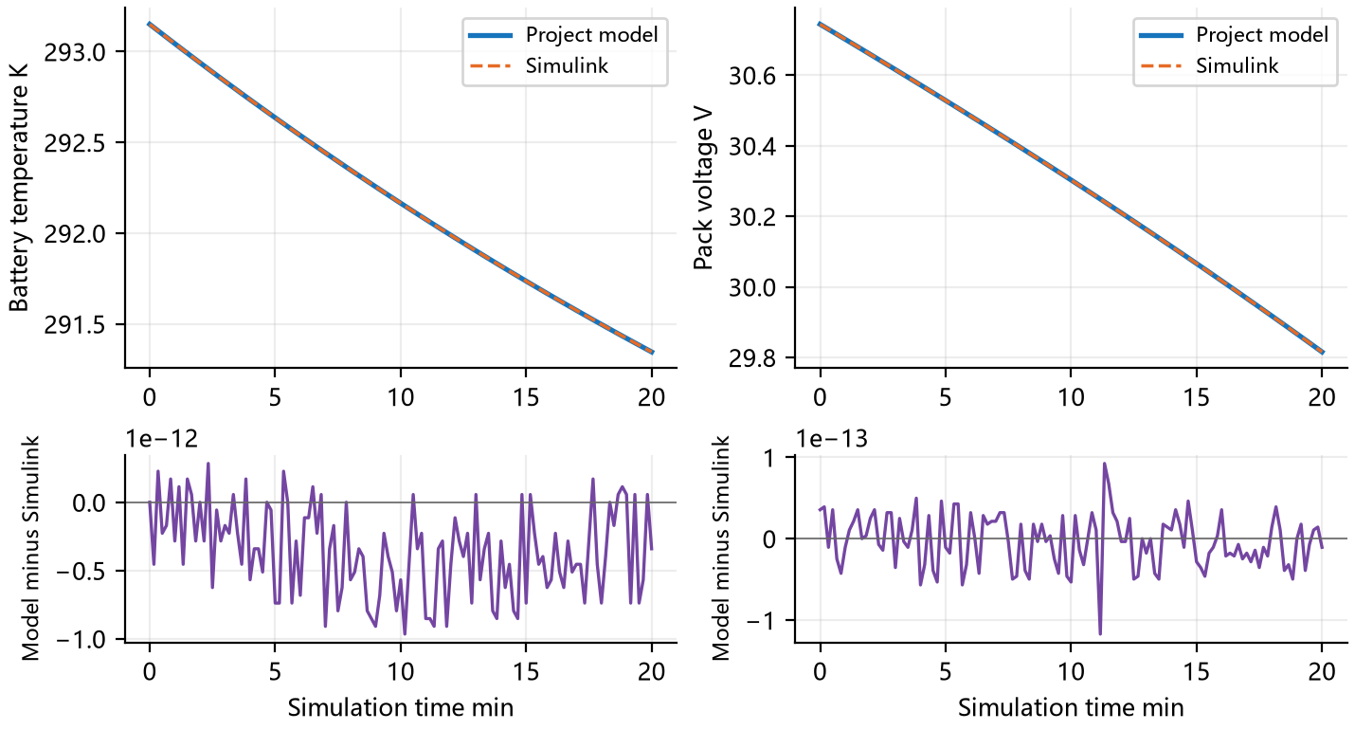
Figure 20 NU-001: Battery temperature K and Pack voltage V. Top panels show both outputs at identical samples; lower panels show project model minus Simulink in the same units.
The horizontal axis is minutes. Vertical changes retain both sides of a discontinuity at the same time; no interpolation spans that discontinuity.
Table 64. NU-001 Numerical Errors and Limits
Signal | Max absolute error | RMSE | Limit
Battery temperature K | 9.66e−13 | 4.79e−13 | 0.001
Pack voltage V | 1.17e−13 | 3.25e−14 | 1.00e−04
Actual solar power W | 0 | 0 | 0.001
Delivered load power W | 3.43e−11 | 4.32e−12 | 0.001
Pack current A | 1.22e−12 | 1.53e−13 | 1.00e−04
Pack heat W | 1.18e−12 | 1.51e−13 | 0.001
State of charge fraction | 1.11e−15 | 4.88e−16 | 1.00e−06
Numerical comparison passes; overall acceptance: Pass. Recorded 95 checks.
SOC changes from 65.517% to 51.553%; battery temperature changes from 293.150 K to 291.345 K.

4 Test Content Sufficiency Analysis
Table 65. Test Coverage
Capability | Cases | Verified Focus
Solar Array and Battery Components | PV-001, BT-001, BT-002, BT-003, BT-004 | Component response, boundary inputs and independent comparison
Power Allocation and Protection Interfaces | PD-001, PD-002, CT-001, CT-002, CT-003, PR-001, IV-001 | Component response, boundary inputs and independent comparison
Dynamic Supply and Electrothermal Processes | DY-001, DY-002, DY-003, DY-004, DY-005, DY-006, DY-007 | Dynamic states, events, energy or convergence checks
Numerical Accuracy Review | NU-001 | Dynamic states, events, energy or convergence checks
This report verifies implementations of the same equations and the listed design behaviors. It does not cover measured-cell accuracy, rapid diffusion relaxation, high-rate electrolyte effects, switching ripple, MPPT tracking transients, autonomous event localization during continuous depletion, full six-node Thermal integration, or every SimReady asset error. Scheduled-boundary protection is covered; this is not evidence of all continuous-boundary localization behavior.
All 20 cases executed, but coverage does not mean all acceptance criteria passed. CT-003, DY-002 and DY-007 require correction of full-charge constraints and retesting. Physical accuracy and broader system integration need additional tests.

5 Test Conditions and Requirements

5.1 Execution Environment and Acceptance Criteria
Table 66. Numerical and Behavioral Acceptance Criteria
Quantity | Maximum absolute difference
Static power and heat | 0.000001 W
Dynamic power and heat | 0.001 W
Voltage | 0.0001 V
Current | 0.0001 A
SOC and lithium fractions | 0.000001
Battery temperature | 0.001 K
Lithium fraction derivative | 0.00000001 s⁻¹
Discrete flags and reason codes | Exact agreement
Scheduled event time | 0.001 s
Relative integrated energy difference | 0.00001
Power conservation residual | 0.000002 W
Relative lithium inventory drift | 0.0000000001
Usable SOC range | 0 to 1, with a 0.000001 rounding allowance
Full-charge boundary | At SOC 1, cell current must be at least minus 0.00000001 A
Numerical thresholds assess software consistency, not measured cell accuracy. RMSE is reported alongside maximum error; every applicable signal must meet its maximum-error limit. Refinement changes must be below one tenth of the corresponding limit.
Input version 1.0 was frozen before initial execution. Coverage review added CT-003 and SOC behavior criteria in version 1.1 after identifying missing full-charge coverage. Numerical thresholds remain unchanged; prior inputs and criteria are retained in results/history.
MATLAB R2026b 26.2.0.3386108; Simulink 26.2; Windows; Python Thermal/.venv; SciPy DOP853.
Baseline integration uses relative tolerance 10⁻⁸, absolute tolerance 10⁻¹⁰ and maximum step 10 s. Refinement uses 10⁻¹⁰, 10⁻¹² and 2 s.

5.2 Baseline Scenario and Input Requirements
Table 67. Baseline Parameters and Physical Meaning
Input | Value | Meaning
A | 1.8 m² | Active solar cell area
ηpv | 0.30 | Fixed maximum-power-point efficiency
G | 1361 W/m² | Nominal illumination; zero denotes eclipse. Eclipse is already included and is not multiplied twice.
cos θ | 1 | Normal incidence; zero is edge-on and negative is rear-face illumination.
Ns × Np | 8 × 6 | Eight series cells per string and six parallel strings, totaling 48 identical cells.
ηD | 0.95 | Efficiency of distribution and its load-side harness
RΩ | 0.025 Ω | Cell ohmic resistance
TB | 293.15 K / 20 ℃ | Initial or prescribed battery temperature, not space ambient air.
xn / xp | 0.600000 / 0.458686001 | Mean electrode lithium fractions, dimensionless
SOC | 65.517241% | Usable state of charge derived from negative fraction
xn,0 / xn,100 / xp,100 | 0.03 / 0.90 / 0.27 | Empty and full-charge endpoints from the same parameter set
Cell current range | −3 to 6 A | Negative for charging, positive for discharge
Cell voltage range | 3.0 to 4.2 V | Cell terminal voltage constraint
Material ranges | xn: 0.01 to 0.95; xp: 0.20 to 0.95 | Constraints on mean, center and surface fractions; not equivalent to the usable SOC interval 0 to 1.
Unless explicitly overridden, cases use this table and the material parameters in section 6.1. Illumination and idealized cycles are controlled inputs, not actual ISS conditions. Low and high temperature refer to specified battery temperatures.
In input tables, imin and imax are cell charge and discharge current bounds in A; vmin and vmax are cell voltage limits in V; eta is distribution efficiency. Logical flags use 1 for true and 0 for false. Exact inputs are retained in suite.json; displayed table values may be rounded.

6 Test Data

6.1 Battery Material Parameters
Table 68. Battery Material Parameters
Parameter | Negative electrode | Positive electrode
Particle radius m | 6.00e−06 | 5.00e−06
Active material volume fraction | 0.75 | 0.665
Effective electrode area m² | 0.06 | 0.06
Electrode thickness m | 8.50e−05 | 7.50e−05
Maximum lithium concentration mol/m³ | 31000 | 63000
Reference diffusion coefficient m²/s | 3.30e−14 | 1.00e−14
Reference exchange current A | 2.5 | 3
Diffusion activation energy J/mol | 30300 | 25000
Reaction activation energy J/mol | 35000 | 17500
Equilibrium potential polynomial coefficients V | 0.65, −1.6, 2, −0.95 | 4.6, −1.3, 0.9, −0.8
Temperature polynomial coefficients V/K | 1.20e−04, −3.00e−04, 1.50e−04, 0 | −6.00e−05, 4.00e−05, 0, 0
Polynomial coefficients run from constant term to highest power, with reference temperature 298.15 K. Electrode charge is Qk = F εk Ael Lk ck,max, the charge for a fraction change from 0 to 1 rather than a directly specified rated Ah capacity. These are existing illustrative test values, not a selected or calibrated cell.
Sources and constraints
Power/SDTwin_Power_Design_Report_CN.docx; Power/SDTwin_Power_Design_Report_EN.docx; Thermal/sdtwin_sim/power_stand_in.py, example_power_records.
The material temperature range is 253.15 to 333.15 K. Cell ohmic loss is included in battery heat; distribution efficiency covers the PDU-to-Compute harness to avoid duplicate loss accounting.

6.2 Data Inventory and Reproduction
Use C:/Workspace/SpaceDC as the working directory. Run the following sequence to regenerate fixtures, independent results, verdicts and reports.
Thermal/.venv/Scripts/python.exe Power/verification/prepare.py
Thermal/.venv/Scripts/python.exe Power/verification/run_python.py
matlab -batch "addpath('Power/verification/matlab'); run_suite"
Thermal/.venv/Scripts/python.exe Power/verification/compare.py
python Power/verification/build_report.py
Use a document runtime with python-docx and matplotlib for the last command. Replace matlab with the full local R2026b executable path when needed.
Table 69. Data Inventory and Reproduction
File | Content
results/suite.json | Complete parameters, cases and criteria
matlab/sdtwin_power_reference.slx | Executed Simulink model
matlab/power_reference.m | Independent reference equations
results/<ID>_python.csv / <ID>_simulink.csv | Raw results from both implementations
results/<ID>_difference.csv | Direct differences at shared samples
results/<ID>.json / summary.json | All checks, errors and verdicts
results/<ID>_*_events.json | Actual event times and connectivity
results/NU-001_*_fine.csv | Independent refinement runs
results/history | Original inputs and criteria before coverage expansion
Input SHA256: f2d46a239842d0bba55d537efc8a793bb2c4df4644c4ca461afc9058a2400757
The implementation uses MathWorks Level 2 MATLAB S-function interfaces. The Simulink engine manages continuous states through Derivatives and InitializeConditions callbacks.
https://www.mathworks.com/help/simulink/sfg/writing-level-2-matlab-s-functions.html

6.3 Integrated Energy Comparison Data
Integrate each output series with the trapezoidal rule. Left and right event values have identical time, so their interval contributes zero energy. This compares energy at the common output cadence, not additional measured energy.
DY-002
Table 70. Integrated Energy Comparison Data
Energy source | Project J | Simulink J | Relative difference
Battery terminal power | −718286 | −718286 | 7.62e−07
Delivered load power | 1.08e+06 | 1.08e+06 | 1.36e−14
Actual solar power | 1.85513e+06 | 1.85513e+06 | 2.95e−07
Pack heat | 31993.8 | 31993.8 | 5.84e−07
Distribution loss | 56842.1 | 56842.1 | 1.40e−14
DY-007
Table 71. Integrated Energy Comparison Data
Energy source | Project J | Simulink J | Relative difference
Battery terminal power | −768115 | −768114 | 1.23e−06
Delivered load power | 3.24e+06 | 3.24e+06 | 1.03e−14
Actual solar power | 4.17864e+06 | 4.17864e+06 | 2.25e−07
Pack heat | 58964.7 | 58964.7 | 4.62e−07
Distribution loss | 170526 | 170526 | 1.08e−14
Battery terminal energy is signed: positive for net discharge and negative for net charge. Battery heat and distribution loss are integrated separately; internal heat is not added to terminal-power balance. Passing energy comparison does not change the failed SOC acceptance of these cases.

6.4 Numerical Convergence Data
NU-001 refines Python and Simulink separately. Each entry is the maximum absolute difference between baseline and refined runs of the same solver, not the difference between the two programs.
Table 72. Numerical Convergence Data
Solver | Quantity | Maximum change | Allowed change
python | State of charge fraction | 1.55e−15 | 1.00e−07
python | Pack voltage V | 1.78e−14 | 1.00e−05
python | Pack current A | 4.44e−15 | 1.00e−05
python | Pack heat W | 2.89e−14 | 1.00e−04
python | Battery temperature K | 5.68e−13 | 1.00e−04
simulink | State of charge fraction | 9.99e−16 | 1.00e−07
simulink | Pack voltage V | 1.03e−13 | 1.00e−05
simulink | Pack current A | 1.07e−14 | 1.00e−05
simulink | Pack heat W | 3.02e−14 | 1.00e−04
simulink | Battery temperature K | 1.02e−12 | 1.00e−04
Both solvers meet the refinement criterion of one tenth of the acceptance threshold. This check covers this smooth electrothermal scenario, not all stiff regimes or autonomous protection-event localization accuracy.

7 Test Summary
This report records the framework, inputs, criteria and individual comparisons of the Power model with independent Simulink simulation. All 20 numerical comparisons pass; 17 cases pass design acceptance and 3 fail due to the full-charge constraint.
Table 73. Power Module Test Summary
No. | Case ID | Function | Verification Focus | Status | Result / Evidence
1 | PV-001 | solar_power | Solar irradiance and panel attitude | Pass | Completed 21 input combinations. Output availability, discrete status and applicable numerical difference checks pass. results/PV-001.json
2 | BT-001 | battery_response | Open circuit voltage and initial charge | Pass | Completed 9 input combinations. Output availability, discrete status and applicable numerical difference checks pass. results/BT-001.json
3 | BT-002 | battery_response | Charge and discharge voltage versus temperature | Pass | Completed 18 input combinations. Output availability, discrete status and applicable numerical difference checks pass. results/BT-002.json
4 | BT-003 | battery_response | Battery heat and reversible heat sign | Pass | Pack heat ranges from −0.0320434 to 3.23576 W; negative heat is retained. results/BT-003.json
5 | BT-004 | battery_response | Cell to series and parallel pack scaling | Pass | Completed 5 input combinations. Output availability, discrete status and applicable numerical difference checks pass. results/BT-004.json
6 | PD-001 | solve_power_allocation | Solar and battery power allocation | Pass | Completed 24 input combinations. Output availability, discrete status and applicable numerical difference checks pass. results/PD-001.json
7 | PD-002 | solve_power_allocation | Distribution efficiency and loss | Pass | Completed 9 input combinations. Output availability, discrete status and applicable numerical difference checks pass. results/PD-002.json
8 | CT-001 | solve_power_allocation | Charge limits and solar curtailment | Pass | Completed 6 input combinations. Output availability, discrete status and applicable numerical difference checks pass. results/CT-001.json
9 | CT-002 | solve_power_allocation | Discharge capability and supply shortfall | Pass | Completed 12 input combinations. Output availability, discrete status and applicable numerical difference checks pass. results/CT-002.json
10 | CT-003 | solve_power_allocation | Charging boundary at full state of charge | Fail | All three full-charge samples continue charging, with minimum cell current −0.544984 A. Numerical agreement passes, but the full-charge requirement fails. results/CT-003.json
11 | PR-001 | apply_power_event | Protection commands and latched states | Pass | Completed 8 input combinations. Output availability, discrete status and applicable numerical difference checks pass. results/PR-001.json
12 | IV-001 | PowerInputs / PowerState | Invalid inputs and state boundaries | Pass | Completed 6 input combinations. Output availability, discrete status and applicable numerical difference checks pass. results/IV-001.json
13 | DY-001 | solve_power_allocation / state integration | Charging under continuous sunlight | Pass | SOC changes from 65.517% to 88.654%; battery temperature changes from 293.150 K to 293.150 K. results/DY-001.json
14 | DY-002 | solve_power_allocation / state integration | Eclipse entry and exit | Fail | Peak SOC is 100.6153%, above the configured 100% point. Both implementations exhibit this behavior, so overall acceptance fails. results/DY-002.json
15 | DY-003 | solve_power_allocation / state integration | Compute load steps | Pass | SOC changes from 65.517% to 71.390%; battery temperature changes from 293.150 K to 293.150 K. results/DY-003.json
16 | DY-004 | solve_power_allocation / state integration | Dynamic charge curtailment | Pass | SOC changes from 65.517% to 67.326%; battery temperature changes from 293.150 K to 293.150 K. results/DY-004.json
17 | DY-005 | solve_power_allocation / state integration | Supply loss latch and explicit restart | Pass | Supply trips at 100 s; the load remains disconnected after sunlight returns at 200 s. Explicit start at 300 s, stop at 400 s and restart at 500 s agree with expectations. results/DY-005.json
18 | DY-006 | solve_power_allocation / state integration | Battery electrothermal feedback | Pass | SOC changes from 65.517% to 44.282%; battery temperature changes from 283.150 K to 280.874 K. results/DY-006.json
19 | DY-007 | solve_power_allocation / state integration | Energy balance over three orbit cycles | Fail | Peak SOC is 104.2070%, above the configured 100% point. Both implementations exhibit this behavior, so overall acceptance fails. results/DY-007.json
20 | NU-001 | DOP853 / ode45 | Solver convergence and accuracy review | Pass | SOC changes from 65.517% to 51.553%; battery temperature changes from 293.150 K to 291.345 K. results/NU-001.json

7.1 Anomalies and Conclusion
All 20 projects completed. Numerical agreement passes in 20 cases; design acceptance passes in 17 and fails in 3. The three failures expose the same omitted full-charge constraint in static and dynamic conditions.
Table 74. Anomalies and Verdicts
Case | Project result | Reason
CT-003 | Charging at about minus 0.545 A per cell at SOC 1 | No stop at the configured full-charge endpoint
DY-002 | Peak SOC 100.6153% | Full charge exceeded in one cycle
DY-007 | Peak SOC 104.2070% | Repeated cycles further expose the overcharge state
Code evidence: _linear_limit checks current and particle surface or center fractions, and _search additionally checks terminal voltage. The xn,100 endpoint used to compute SOC is absent from charging limits. The independently implemented Simulink equations reproduce this behavior. Evidence supports a mismatch between the constraint set and the full-charge requirement, rather than an integration error.
Recommended correction: explicitly decide that usable SOC endpoints are charge and discharge constraints, reallocate at accepted boundary events, and curtail surplus solar at full charge. Rerun CT-003, DY-002, DY-007 and the regression suite after correction. Clipping displayed SOC to 1 is insufficient.
Overall Conclusion: [ ] Pass [X] Fail [ ] Not Executed. All 20 numerical comparisons pass; three design-behavior cases fail acceptance.
On-site Test Expert Signature: ________________________ Date: ________________

