NTU SPACE DATA CENTER
SDTWIN THERMAL
Software Module Design Report
Lumped thermal network • Battery coupling • Common radiator
Institute | College of Computing and Data Science, Nanyang Technological University
Author
Reviewer
Issue date | 2 October 2026
College of Computing and Data Science, Nanyang Technological University

Version Control
Abstract | This report designs the thermal calculation module for a computing node on one satellite. The module reads the orbital environment, actual solar electrical output, and equipment heat sources. It calculates temperatures and heat-transfer rates for the solar panel, computing node, cold plate, battery, power equipment, and common radiator. The implementation is specified through the physical model, calculation functions, calling interfaces, and configuration.
Keywords | Lumped thermal network; Battery coupling; Common radiator
Change Record
Revision | Change Request | Date | Author | Description
14.0 | Mathematical notation | 2026-10-02 |  | Consistent equations, inline symbols and units

TABLE OF CONTENTS
1 Document Overview 1
1.1 Purpose 1
1.2 Scope 1
1.3 Intended readers 1
1.4 Normative terminology 1
2 Requirements and Design Objectives 2
2.1 Scene model assembly 2
2.2 Component simulation requirements 2
3 Overall Design 3
3.1 System architecture 3
3.2 Package decomposition 3
3.3 Simulation workflow 5
4 Concise Thermal Modeling Background 6
4.1 Overall Heat Balance 6
4.2 Heat Transfer Between Components 8
4.3 Component Temperatures 9
4.4 Environmental Absorption and Surface Radiation 10
4.5 Thermal Capacitance and Resistance 12
5 Detailed Functional Design 13
5.1 Common data models 14
5.2 Thermal parameter assembly 14
5.3 Surface environment preparation 15
5.4 Surface absorption and emission 15
5.5 Component heat-transfer calculation 16
5.6 Temperature derivative calculation 16
6 Public Interface Design 17
6.1 General contracts 17
6.2 Primary calling interfaces 17
6.3 Minimal end-to-end call 17
7 End-to-End Operational Workflow 18
8 Numerical Design and Performance 19
9 Deployment and Configuration 20
9.1 Runtime 20
9.2 Installation and interpreter configuration 20
9.3 SimReady assets and scene assembly 20
9.4 Parameter configuration and result archive 21
10 Limitations and Planned Evolution 22
11 Requirements Traceability Matrix 23

Document Overview

Purpose
This report designs the thermal calculation module for a computing node on one satellite. The module reads the orbital environment, actual solar electrical output, and equipment heat sources. It calculates temperatures and heat-transfer rates for the solar panel, computing node, cold plate, battery, power equipment, and common radiator. The implementation is specified through the physical model, calculation functions, calling interfaces, and configuration.

Scope
A lumped thermal RC model represents component heat storage, structural conduction, environmental absorption, and surface radiation. Power's reduced-order single-particle model and separate heat calculation supply battery heat, while Thermal alone integrates battery temperature. The Python functions and data structures in this report are proposed designs for implementing the SpaceDC thermal module.

Intended readers
The report is intended for thermal, power, and computing developers and for personnel configuring assets and integrating models. Chapter 4 explains the physics; Chapters 5 and 6 specify the computation and interfaces needed for implementation.

Normative terminology
Table 1 Terminology and conventions
Term | Meaning in this report
Component | Physical equipment, such as a solar panel, battery, or cold plate, or an explicitly defined physical extent
Temperature node | The component extent represented by one temperature; the controller and distribution unit share $D$ in this version
Thermal capacitance and resistance | Heat-storage capacity and resistance to heat transfer, in $J/K$ and $K/W$
Heat source | Power entering the thermal balance, in $W$; battery heat may be negative
Trial state | Temporary temperatures and battery states evaluated by an integrator before a step is accepted
Temperatures are in $K$, time in $s$, and electrical and thermal powers in $W$. Physical equipment is linked by instance_id. The internal temperature array follows $S$, $J$, $C$, $B$, $D$, $R$; inputs, derivatives, and outputs retain this order.

Requirements and Design Objectives

Scene model assembly
The Thermal module shall use the user-configured scene and SimReady assets to read component models, thermal parameters, and initial temperatures, and assemble the scene's heat-balance equations according to its heat-transfer connections. Changes to component parameters or connections shall be reflected in the assembled model. Capacitances, resistances, and surface properties require material, geometry, or test evidence, and component mass shall be counted only once. These requirements correspond to TH-04.
TH-03 requires the orbital environment and attitude at a shared time and in consistent frames, with eclipse and incidence each accounted for once. TH-02 requires actual solar output, actual computing-node consumption, and battery and distribution heat supplied by Power to maintain consistent electrical and thermal balances. Thermal shall calculate component temperatures and return the relevant temperatures to Power and Compute.

Component simulation requirements
Table 2 Thermal component simulation requirements
Component | Required simulation | Outputs
Solar panel | Environmental absorption, energy removed by actual electrical output, transfer to the radiator, and surface emission | Solar-panel temperature and absorbed/emitted powers
Computing node | Conversion of actual electrical consumption to heat and transfer through the cold plate | Equivalent computing-node temperature
Cold plate | Heat received from the computing node, heat storage, and transfer to the common radiator | Cold-plate temperature
Battery | Signed heat supplied by Power, heat storage, and transfer to the radiator | Battery temperature returned to Power for electrical/thermal coupling
Power equipment | Shared controller/distribution temperature, distribution and wiring loss heat, and transfer to the radiator | Equivalent power-equipment temperature
Common radiator | Collection of branch heat flows, heat storage, environmental absorption, and surface emission | Radiator temperature and absorbed/emitted powers
Heat-transfer connections | Signed heat flows along the defined paths, using endpoint temperature differences and thermal resistances | Heat-transfer power for each path
Component temperature calculations correspond to TH-01. Outputs establish cooling capability and temperature constraints. Computing and Power use them to determine their own operating states; Thermal does not add power-off or throttling rules.

Overall Design

System architecture
The thermal system comprises the solar panel, computing node, cold plate, battery, power equipment, and common radiator. Figure 1 shows the heat-transfer connections between these components. Chapter 4 models each component temperature and the heat flow through each connection.
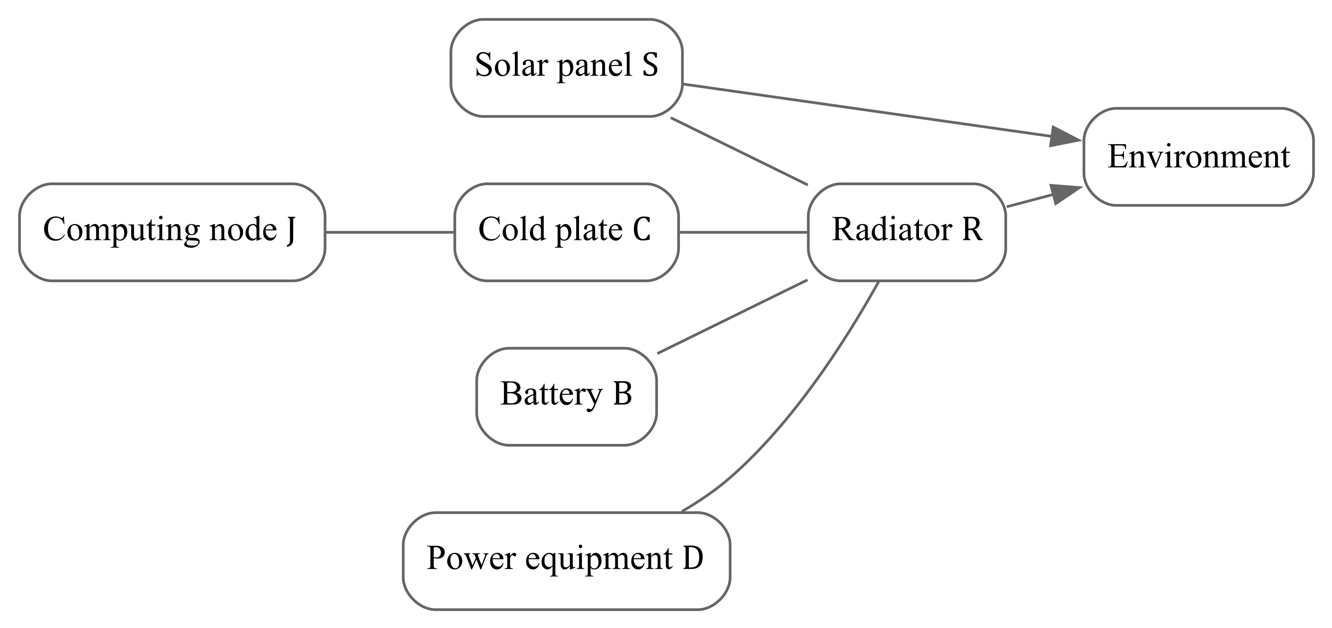
Figure 1 Heat-transfer connections between components
The solar panel, battery, and power equipment connect to the common radiator through $SR$, $BR$, and $DR$. The computing node connects through $JC$ to the cold plate, which connects through $CR$ to the radiator. Lines without arrows denote transfer paths; endpoint temperatures determine the actual flow direction. Arrows toward the environment denote emitted thermal radiation. Absorbed sunlight, Earth albedo, and infrared radiation are calculated separately from environmental inputs. Every connection requires actual conducting structure or a supported equivalent resistance.
Chapter 4 gives the component heat-balance equations, and Chapter 5 describes the functions that evaluate them. Thermal reads scene parameters, the orbital environment, and Power results, calculates heat transfer, and supplies the numerical solver with the information needed to update component temperatures. Simulation outputs are component temperatures and connection heat flows, which are also used by the 3D display.

Package decomposition
The proposed Thermal package contains the following source files, with functions listed beneath their files. Chapter 5 specifies each function.
thermal/
├── __init__.py
├── types.py
├── parameters.py
│ └── assemble_thermal_parameters
├── environment.py
│ ├── prepare_surface_environment
│ └── calculate_surface_heat
└── model.py
├── calculate_heat_flows
└── thermal_derivative
types.py defines the four data objects in Section 5.1. __init__.py exports this domain's public types and functions. parameters.py assembles model parameters, environment.py prepares irradiance and surface heat exchange, and model.py evaluates heat flows and temperature derivatives.
SimReady assets provide geometry, materials, and parameters. Scene configuration provides asset references, connections, initial temperatures, and overrides. These inputs are managed separately from source code; assemble_thermal_parameters processes them as specified in Chapter 9.
Table 3 identifies the function responsible for each calculation. Table 4 lists the inputs and outputs of each component temperature calculation. thermal_derivative combines absorbed, generated, and rejected powers to calculate how much each component heats or cools per second. The numerical solver uses these results to update temperatures.
Table 3 System models and corresponding functions
System part and responsibility | Mathematical model | Implementing functions and results
Temperature changes of all components | Coupled balances T3 | thermal_derivative calculates heating or cooling per second; the numerical solver uses this to update temperatures
Exposed surfaces of $S$ and $R$ | Absorption and emission T4 | prepare_surface_environment prepares surface inputs; calculate_surface_heat calculates absorbed and emitted powers
$SR$, $JC$, $CR$, $BR$, and $DR$ connections | Temperature-driven transfer T2 | calculate_heat_flows evaluates connection flows for the balances at both endpoints
Component materials and connection parameters | Capacitance and resistance T5 | assemble_thermal_parameters assembles parameters from assets and the scene
Table 4 lists the data needed to calculate each component temperature and the resulting output. Every component also reads its current temperature and uses the thermal capacitance, connection resistances, and applicable surface properties supplied by the scene and SimReady assets. Adjacent temperatures and connection heat flows come from the same thermal evaluation. Output temperatures are obtained after the numerical solver updates the state.
Table 4 Component model inputs and outputs
Component | Inputs | Output
Solar array $S$ | Environmental radiation, actual electrical output, radiator temperature | Array temperature $T_{S}$
Computing node $J$ | Actual electrical consumption, cold-plate temperature | Computing-node temperature $T_{J}$
Cold plate $C$ | Computing-node and radiator temperatures | Cold-plate temperature $T_{C}$
Battery $B$ | Net battery heat generation from Power, radiator temperature | Battery temperature $T_{B}$
Power equipment $D$ | Distribution and wiring heat generation from Power, radiator temperature | Equipment temperature $T_{D}$
Radiator $R$ | Heat flows from the solar array, cold plate, battery, and power equipment; environmental radiation | Radiator temperature $T_{R}$
The rows correspond to SolarArray01, Compute01, ColdPlate01, Battery01, power equipment, and Radiator01. Power equipment includes Controller01, PDU01, and assigned wiring at one shared temperature. Each material portion contributes to one component capacitance only. The computing node uses the equivalent whole-board model described in Section 4.3.

Simulation workflow
Before simulation, read components, connections, and material parameters from the scene and SimReady assets, calculate thermal capacitances and resistances, and set initial temperatures. Then repeat the calculations in Figure 2 until the simulation ends.
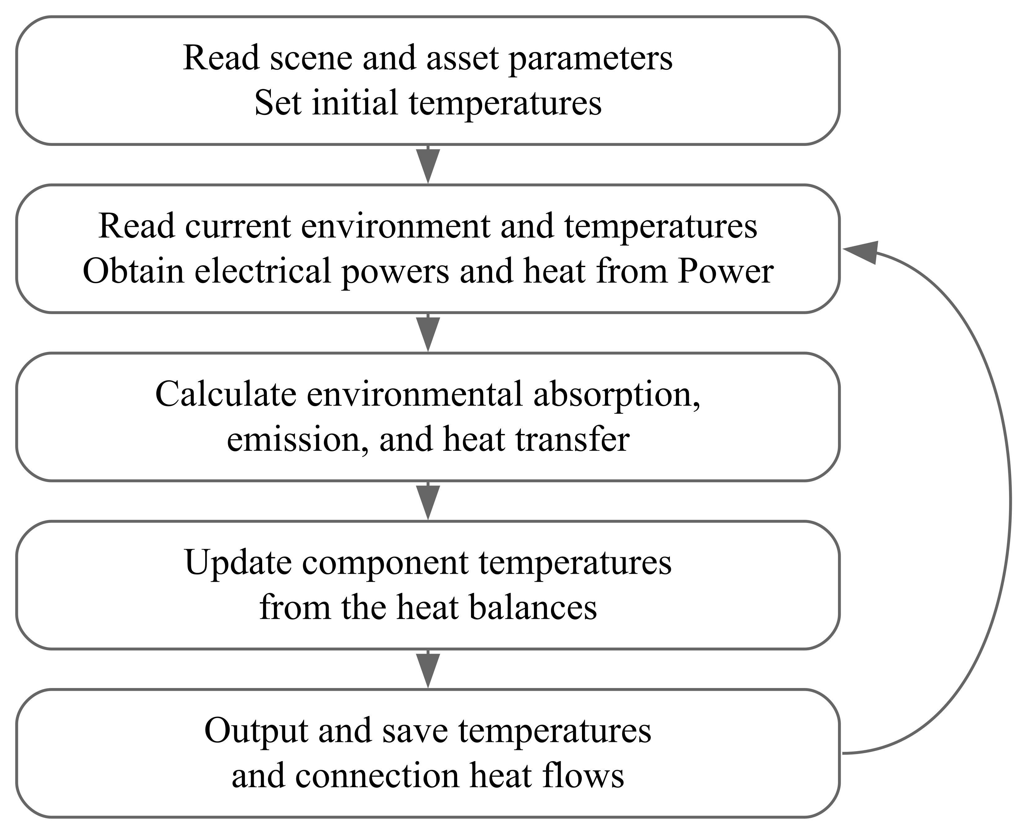
Figure 2 Thermal simulation workflow
Each calculation reads orbital position, attitude, solar irradiance, Earth-environment data, and all current component temperatures at the same instant. Power uses the current battery state and temperature to calculate actual solar electrical output, actual computing-node consumption, battery heat generation, and distribution losses for Thermal.
Thermal first calculates radiation absorbed and emitted by the solar array and radiator, then calculates heat transfer from the temperatures at both ends of each connection. Combining these results with equipment heat generation in the heat-balance equations gives how much each component heats or cools per second. The numerical solver uses these results to obtain later temperatures. This heating or cooling per second is the temperature-change rate used in Chapter 4.
Updated component temperatures and connection heat flows are saved as simulation results. Battery temperature returns to Power for subsequent battery calculations. Computing-node temperature goes to Compute to calculate its effect on performance. Other component temperatures remain in Thermal and are used in subsequent heat-transfer calculations.
The numerical solver performs the temperature update shown in the figure. thermal_derivative only calculates heating or cooling per second. Battery temperature is solved once through the Thermal equations. When this model is enabled, Orbit's power_considering_thermal stops updating the same solar-array temperature; Orbit continues to supply position, attitude, and solar-environment results. [4]

Concise Thermal Modeling Background

Overall Heat Balance
The thermal model calculates how component temperatures change with time. Each component is represented by one temperature and is called a node in the thermal network. The solar array is labeled $S$, the computing node $J$, the cold plate $C$, the battery $B$, the power equipment $D$, and the common radiator $R$. These subscripts identify components. Thus, $T_{B}$ is battery temperature and $T_{R}$ is radiator temperature; the general notation $T_{i}$ means the temperature of component $i$.
$T$ denotes temperature, while lowercase $t$ denotes time. Equations use temperature in kelvin, $K$, and time in seconds, $s$. Adding $273.15$ to a temperature in degrees Celsius gives its value in kelvin: $20 °C$ is $293.15 K$. A rise of $1 K$ is the same temperature change as a rise of $1 °C$. The notation ${\overset{˙}{T}}_{i}=dT_{i}/dt$ means how much the component temperature changes per second, in $K/s$. Positive values mean heating and negative values mean cooling.
$C_{i}$ is the thermal capacitance of component $i$, in $J/K$. It specifies the energy needed to raise that component's temperature by one degree. For example, $C_{B}=1000 J/K$ means that a net increase of $1000 J$ in stored thermal energy raises the battery temperature by one degree. Under the same net heating power, a larger capacitance gives a slower temperature change. In $C_{C}$, the first $C$ denotes thermal capacitance and the subscript $C$ identifies the cold plate. [1,2]
This report uses $P$ for electrical power, $Q$ for absorbed, generated, or emitted thermal-related power, and $q$ for heat-transfer power between components. All have units of watts, $W$. A power of $1 W$ transfers $1 J$ each second. Consequently, $C_{i}{\overset{˙}{T}}_{i}$ is the rate at which thermal energy stored in a component increases or decreases, also in $W$.
Thermal receives four powers from Power. $P_{pv}$ is the actual electrical output of the solar array. $P_{load}$ is the electrical power actually delivered to and consumed by the computing node. $Q_{B}$ is the battery's net internal heat-generation rate, and $Q_{D}$ is heat from losses in the distribution unit and its assigned wiring. This version treats all actual computing-node consumption as heat and neglects the controller's own losses. Power handles the battery's chemical energy storage during charging and supplies its separately calculated heat-generation result $Q_{B}$ to Thermal.
The environment also supplies energy to exposed surfaces. $Q_{env,i}$ is the power actually absorbed by component $i$ from direct sunlight, sunlight reflected by Earth, and Earth's infrared radiation, in $W$. The subscript $env$ means environment. The component emits thermal radiation outward at a rate $Q_{emit,i}$, where $emit$ means emission. Section 4.4 calculates these two powers. This version evaluates external exchange for the solar array and radiator; internal components exchange heat through their connecting paths. [3]
Adding the thermal-energy changes of all components gives the overall heat balance:
$$\begin{matrix}\sum_{i}{C_{i}}{\overset{˙}{T}}_{i}= & Q_{env,S}+Q_{env,R}-P_{pv}+P_{load}+Q_{B}+Q_{D} \\ & -Q_{emit,S}-Q_{emit,R}.\end{matrix}$$ | (T1)
On the left of T1, $∑_{i}$ means summing over all the components listed above. The result is the total rate of change of their stored thermal energy. The right-hand side adds environmental power absorbed by the solar array and radiator, subtracts the array's electrical output, adds heat from computing, the battery, and distribution losses, then subtracts radiation emitted by the array and radiator. A positive total means increasing stored thermal energy.
Transfer between components does not appear on the right of T1. Heat leaving the battery for the radiator reduces battery energy and increases radiator energy by the same amount, so the two terms cancel when added. T1 describes the thermal-energy balance of the complete set of components. Section 4.3 calculates each component's temperature.
Scene configuration supplies initial component temperatures. The model then calculates temperature changes from heat generation and transfer. The lumped model uses one temperature to represent each component's thermal state; different components may have different temperatures. The radiator also stores heat and changes temperature. The first version uses a lumped thermal model. Tests or finite-element analysis can supply equivalent parameters when local hot spots or complex contacts require further analysis. Sunlight and infrared heat exchange are modeled separately from ionizing-particle faults in Radiation.

Heat Transfer Between Components
Two components exchange heat through their mounting structure or another thermal connection. Indices $i$ and $j$ identify the two ends, and $T_{i}$ and $T_{j}$ are their temperatures at the same instant. $R_{ij}$ is the connection's thermal resistance in $K/W$. A larger resistance transfers less power under the same temperature difference. Thermal calculates transfer power from these two temperatures and the resistance:
$$q_{ij}=\frac{T_{i}-T_{j}}{R_{ij}}.$$ | (T2)
$q_{ij}$ is heat-transfer power in the direction from $i$ to $j$, in $W$. T2 subtracts the temperatures and divides their difference by the resistance. When $T_{i}>T_{j}$, the result is positive and heat flows from $i$ to $j$. When $T_{i}<T_{j}$, the result is negative and heat flows in the opposite direction. Equal temperatures give zero transfer through this connection. Calculations retain the sign.
The model has five connections. $SR$ connects the solar array to the radiator, $JC$ the computing node to the cold plate, $CR$ the cold plate to the radiator, $BR$ the battery to the radiator, and $DR$ the power equipment to the radiator. Each connection has its own resistance and heat flow. For example, $R_{BR}$ is battery-to-radiator resistance and $q_{BR}$ is transfer along that connection. The leading $R$ denotes resistance, while the subscript $R$ identifies the radiator.
Each heat flow is evaluated once and used in both endpoint temperature equations. The battery equation subtracts $q_{BR}$ and the radiator equation adds the same value, preserving energy consistency. Resistance comes from the connection's structure, material, contact conditions, or test results; Section 4.5 describes its calculation. Thermal resistance uses $K/W$, whereas electrical resistance in the battery model uses $Ω$. Parameter records keep them separate.

Component Temperatures
A component's temperature changes according to the energy it receives, generates, and loses. Each left-hand side below is thermal capacitance multiplied by temperature-change rate. Each right-hand side is the net energy retained per second. Dividing that side by the component's capacitance gives its temperature-change rate. Because temperature evolves with time, these are ordinary differential equations. Together, thermal resistance and capacitance form a thermal RC model, with surface radiation calculated separately from the fourth power of temperature.
$$\begin{matrix}C_{S}{\overset{˙}{T}}_{S} & =Q_{env,S}-P_{pv}-q_{SR}-Q_{emit,S}, \\ C_{J}{\overset{˙}{T}}_{J} & =P_{load}-q_{JC}, \\ C_{C}{\overset{˙}{T}}_{C} & =q_{JC}-q_{CR}, \\ C_{B}{\overset{˙}{T}}_{B} & =Q_{B}-q_{BR}, \\ C_{D}{\overset{˙}{T}}_{D} & =Q_{D}-q_{DR}, \\ C_{R}{\overset{˙}{T}}_{R} & =q_{SR}+q_{CR}+q_{BR}+q_{DR}+Q_{env,R}-Q_{emit,R}.\end{matrix}$$ | (T3)
The direction descriptions below refer to positive $q$. A negative value means that heat flows in the opposite direction; calculations retain its sign.
The first line describes the solar array. $C_{S}$ and $T_{S}$ are its thermal capacitance and temperature. $Q_{env,S}$ is absorbed external radiation; the portion of absorbed sunlight actually converted to electricity and exported is $P_{pv}$. $q_{SR}$ is heat transferred to the radiator, and $Q_{emit,S}$ is radiation emitted by the array itself. Subtracting these three outputs from absorption gives the power that changes array temperature. If the controller curtails generation, the equation uses the reduced actual $P_{pv}$ because energy not exported as electricity remains in the array's energy balance.
The second line describes the computing node. $C_{J}$ is its equivalent thermal capacitance and $T_{J}$ its model temperature. This version treats actual consumption $P_{load}$ entirely as heat. $q_{JC}$ is the power transferred to the cold plate. Their difference determines the node's heating or cooling rate. Node $J$ combines heat generation across the computing board. Using $T_{J}$ to approximate chip temperature requires calibration of capacitance and resistance against board power and measured chip temperature.
The third line describes the cold plate. $C_{C}$ is its thermal capacitance and $T_{C}$ its temperature. The plate receives $q_{JC}$ from the computing node and transfers $q_{CR}$ to the radiator. It warms when incoming heat exceeds outgoing heat and cools when outgoing heat is greater. Its temperature therefore also has to be solved.
The fourth line describes the battery. $C_{B}$ is battery thermal capacitance, $T_{B}$ is battery temperature, $Q_{B}$ is the net heat source from Power's battery heat-generation model, and $q_{BR}$ is transfer to the radiator. $Q_{B}$ includes irreversible and reversible heat and may be positive or negative; a negative value means that internal battery processes absorb heat. Thermal updates $T_{B}$ and returns it to the electrochemical model to calculate temperature effects on diffusion, reactions, and equilibrium potentials. Battery temperature is updated only once, within Thermal.
The fifth line describes power equipment. $C_{D}$ and $T_{D}$ are the combined thermal capacitance and shared temperature of the controller, distribution unit, and assigned wiring. $Q_{D}$ contains the distribution and wiring losses included in this version; $q_{DR}$ transfers heat to the radiator. Although controller losses are neglected, its assigned material still contributes to $C_{D}$.
The last line describes the radiator. $C_{R}$ is its thermal capacitance and $T_{R}$ its temperature. The flows $q_{SR}$, $q_{CR}$, $q_{BR}$, and $q_{DR}$ arrive from the solar array, cold plate, battery, and power equipment. The radiator also absorbs environmental power $Q_{env,R}$ and emits $Q_{emit,R}$. Together these powers determine radiator temperature, which in turn changes transfer along the connections in T2.
For a battery example, assume $C_{B}=1000 J/K$, $T_{B}=303 K$, $T_{R}=300 K$, $R_{BR}=0.5 K/W$, and $Q_{B}=10 W$. The battery is $3 K$ warmer than the radiator, so T2 gives $q_{BR}=3/0.5=6 W$. Each second the battery generates $10 J$, transfers out $6 J$, and retains $4 J$. Its instantaneous heating rate is therefore ${\overset{˙}{T}}_{B}=4/1000=0.004 K/s$. These numbers explain the equations and do not represent selected-device parameters.
At the start of a simulation, the scene supplies initial temperatures. Each evaluation calculates heat flows from current temperatures, uses T3 to obtain temperature-change rates, and passes them to the numerical solver to obtain later temperatures. Updated temperatures change transfer powers and surface radiation, which are recalculated. The heating rate in the preceding example therefore applies only to the stated instant.

Environmental Absorption and Surface Radiation
These equations calculate energy exchange between the exposed solar-array and radiator surfaces and the environment. External inputs include direct sunlight, sunlight reflected by Earth, and infrared radiation emitted by Earth. Irradiance is the radiation power received per square metre, in $W/{m^{2}}$. Multiplying irradiance by surface area and the absorbed fraction gives the power actually absorbed by that surface, in $W$. [3]
Index $f$ identifies an exposed surface and $i$ the component to which it belongs. One component may have several surfaces, such as the front and back of a solar array. The notation $∑_{f∈i}$ means evaluating each surface belonging to component $i$ and adding the results. This section evaluates external radiation exchange only for the solar array $S$ and radiator $R$.
$$\begin{matrix}g_{sun,f} & =Gmax(0,cosθ_{f}), \\ Q_{env,i} & =\sum_{f∈i}{A_{f}}\left[α_{f}(g_{sun,f}+g_{alb,f})+ϵ_{f}g_{IR,f}\right], \\ Q_{emit,i} & =\sum_{f∈i}{ϵ_{f}}σA_{f}T_{i}^{4}, i∈\{S,R\}.\end{matrix}$$ | (T4)
Table 5 Environmental symbols and sources
Symbol | Physical meaning, unit, and source
$$G$$ | Solar irradiance supplied by Orbit, in $W/{m^{2}}$. It already includes eclipse effects and is the same input used by Power.
$$θ_{f}$$ | Angle between the outward perpendicular direction of a surface and the direction to the Sun, in $rad$. Calculated from surface mounting, spacecraft attitude, and Sun direction.
$$g_{sun,f}$$ | Direct solar power received per square metre of surface $f$, in $W/{m^{2}}$. Calculated by the first line of T4.
$$g_{alb,f}$$ | Earth-reflected solar power received per square metre of surface $f$, in $W/{m^{2}}$. Supplied by the Earth-albedo environment input.
$$g_{IR,f}$$ | Earth infrared power received per square metre of surface $f$, in $W/{m^{2}}$. Supplied by the Earth-infrared environment input.
$$A_{f}$$ | Area of surface $f$, in $m^{2}$. From physical geometry or the asset's physical dimensions.
$$α_{f}$$ | Fraction of sunlight absorbed by the surface, also applied to Earth-reflected sunlight; between $0$ and $1$. From surface-material or coating data.
$$ϵ_{f}$$ | Infrared emissivity: emitted power divided by that of an ideal blackbody at the same temperature, between $0$ and $1$. From material or coating data; also used to approximate infrared absorptivity here.
$$σ$$ | Stefan-Boltzmann constant, $5.670374419×{10}^{-8} W/(m^{2}·K^{4})$. Used as a fixed physical constant.
The first line of T4 accounts for solar orientation. $cosθ_{f}$ is the cosine of the incidence angle, and $max$ selects the larger of the two arguments. A surface facing the Sun has $θ_{f}=0$ and receives direct irradiance $G$. Turning toward an edge-on orientation reduces reception, and a surface facing away receives zero direct sunlight. Since $G$ includes eclipse effects, no second eclipse factor is applied. Earth albedo and infrared require their own surface inputs; these two inputs still need to be added to the existing orbital-environment interface.
The second line calculates absorbed power. $α_{f}(g_{sun,f}+g_{alb,f})$ is absorbed direct and reflected solar power per square metre. $ϵ_{f}g_{IR,f}$ is absorbed Earth infrared power per square metre. Add the two, multiply by area, and sum over surfaces to obtain $Q_{env,i}$. Using emissivity to approximate infrared absorption is the gray-body assumption adopted here. Surface orientation is already included in the corresponding irradiance, so area is not projected again.
For example, consider only direct sunlight with $A_{f}=2 m^{2}$, $g_{sun,f}=1000 W/{m^{2}}$, and $α_{f}=0.8$. Absorbed power is $2×1000×0.8=1600 W$, meaning that the surface absorbs $1600 J$ of radiation energy each second. For a solar-array surface, T3 also subtracts actual electrical output and heat losses to determine the rate of change of thermal energy stored in the array.
The third line calculates outward thermal radiation $Q_{emit,i}$. Larger area, higher emissivity, or higher temperature increases the emitted power. $T_{i}^{4}$ means temperature raised to the fourth power and requires kelvin. This equation calculates emitted power; incoming radiation that is absorbed has already been calculated separately by the second line.
The front and back of the solar array have separate area and material records, as do regions with different coatings. Both sides may radiate, while electrical generation uses the actual solar-cell area. Solar electrical output must not exceed the corresponding absorbed solar power. This version neglects mutual obstruction, radiation exchange between components, and deep-space background radiation. Internal computing, cold-plate, battery, and power-equipment nodes do not directly receive the environmental radiation inputs in this section.

Thermal Capacitance and Resistance
This section determines the capacitances and resistances used above. Capacitance comes from material masses and specific heats. Resistance of a uniform solid connection comes from its length, cross-sectional area, conductivity, and contact conditions. These parameters are obtained from component and material data and remain constant within the stated temperature range in this version.
$$\begin{aligned}C_{i}=\sum_{a}{m_{i,a}}c_{p,i,a}, \\ R_{ij}=\frac{l_{ij}}{κ_{ij}A_{cond,ij}}+R_{contact,ij}.\end{aligned}$$ | (T5)
The first line of T5 calculates capacitance. Index $a$ identifies a constituent material in component $i$, and $m_{i,a}$ is the mass of that material in $kg$. Its specific heat $c_{p,i,a}$, in $J/(kg·K)$, gives the energy needed to raise one kilogram of the material by one degree. The notation $c_{p}$ follows the usual constant-pressure specific-heat convention. Multiply mass by specific heat for each material portion, then add the results using $∑_{a}$ to obtain component capacitance $C_{i}$. Each material portion belongs to one component, preventing its capacitance from being counted in both the computing board and cold plate.
For example, $1 kg$ of material with a specific heat of $1000 J/(kg·K)$ has a capacitance of $1000 J/K$. This illustrates how a physical parameter determines capacitance. An actual component uses its real material composition. The equivalent capacitance and resistance of computing node $J$ still require the calibration against board power and chip temperature described in Section 4.3.
The second line calculates connection resistance. $l_{ij}$ is conduction length along the heat-flow direction, in $m$. $κ_{ij}$ is material thermal conductivity, in $W/(m·K)$. $A_{cond,ij}$ is cross-sectional area perpendicular to heat flow, in $m^{2}$; $cond$ denotes conduction. A longer path increases resistance, while higher conductivity or a larger cross section reduces it.
$R_{contact,ij}$ is resistance at the interface between two parts, in $K/W$; $contact$ identifies that interface. Heat passes through the solid and then the contact along the same path, so their resistances add. Contact resistance depends on the contacting materials, area, mounting pressure, and related conditions. Conduction area $A_{cond,ij}$ describes an internal heat-transfer path, whereas exposed area $A_{f}$ describes the surface that absorbs and emits radiation. They are specified separately.
Mass and geometry come from component records, measurements, or SimReady assets with physical dimensions. Specific heat, conductivity, absorptivity, and emissivity come from the corresponding material or coating data. Contact resistance comes from records or tests matching the installation conditions. Scene assembly reads these parameters and applies permitted instance settings to form the current model. Assets containing only visual geometry require additional material and contact parameters.
Heat-pipe and liquid-cooling paths use equivalent total resistance from product data or tests. If that total already includes contact resistance, it is not added again. Specific devices have not yet been selected, so parameter records retain their sources and unfilled status. The numerical examples above explain the calculation only.

Detailed Functional Design
The functions in this chapter implement the connected thermal model in Figure 1. Its overall calculation entry point is thermal_derivative. It calls calculate_surface_heat for environmental absorption and emission at $S$ and $R$, and calculate_heat_flows for transfer between components. It combines those results with Power's outputs according to T3 to obtain all temperature derivatives. The coupled integrator uses this derivative set to calculate temperature changes.
Before the run, assemble_thermal_parameters converts asset materials and connections into capacitances, resistances, and surface parameters. Before each trial, prepare_surface_environment prepares synchronized surface-irradiance inputs.

Common data models
The following data objects are proposed. Construction checks array dimensions, finite values, units, and timestamps. Parameters remain read-only after startup, and trial states are separate from accepted states. run_id identifies a run; time_s is seconds from its common UTC epoch. Cross-domain ports carry instance_id, whose component assignment is checked when scene connections are established.
Table 6 Common data objects
Object | Fields and shapes | Invariants and ownership
ThermalParameters | C_J_K[6], R_K_W[5], surfaces, instance_map, provenance | Positive capacitances and resistances; path order $SR$, $JC$, $CR$, $BR$, $DR$
ThermalState | run_id, time_s, temperature_K[6] | Temperature order $S$, $J$, $C$, $B$, $D$, $R$; only Thermal owns temperatures
ThermalInputs | run_id, time_s, environment, P_pv_W, P_load_W, Q_B_W, Q_D_W | Environment and four powers share a timestamp; Q_B_W retains its sign
ThermalEvaluation | run_id, time_s, dT_dt_K_s[6], q_W[5], Q_env_W[2], Q_emit_W[2], T_B_K, T_J_K | Environment/radiation order $S$, $R$; the last two fields copy the corresponding input temperatures
C_J_K stores T5 capacitances $C_{i}$ in temperature order, in $J/K$. R_K_W stores $R_{ij}$ in path order, in $K/W$.
Each surfaces record contains surface_id, node_id, area_m2, unit normal normal_body[3], absorptivity, and emissivity. Exposed surfaces belong only to $S$ or $R$, with front and back separate. instance_map holds the assignments in Section 3.2, including the two equipment instances sharing $D$. The four external powers originate from SolarArray01, Compute01, Battery01, and PDU01 respectively. Array position alone must not connect a value to the wrong device.
All functions below return new results without modifying input states or parameters. Acceptance and storage of temperatures occur in the coupled procedure in Chapter 7. Surface-environment and heat-flow results use dictionaries with named fields, defined in the corresponding functions.

Thermal parameter assembly
assemble_thermal_parameters(components, connections, overrides)
components comes from selected assets and contains instance-to-node assignments, material masses, specific heats, and surface records. Mass is in $kg$ and specific heat in $J/(kg·K)$. connections describes $SR$, $JC$, $CR$, $BR$, and $DR$ using length, conductivity, cross-sectional area, and contact resistance, or a measured equivalent total resistance. Explicit scene overrides take precedence over the asset parameter set.
The function resolves the modified physical parameters, checks for duplicate material assignment, then sums capacitances and calculates solid-path resistances using T5. Heat-pipe or liquid-cooling equivalents use their supplied total resistance directly; an included contact resistance is not added again. The returned ThermalParameters records resolved values, units, asset revisions, and provenance. Mass, specific heat, length, conductivity, and cross-sectional area must be finite and positive, and contact resistance nonnegative. Surface area and optical properties follow T4's constraints. Missing data, duplicate surfaces, or undefined connections identify the offending record instead of producing default device values. This function does not create or update operating temperatures.

Surface environment preparation
prepare_surface_environment(orbit_input, earth_flux, parameters)
orbit_input is a synchronized record containing run_id, time_s, UTC epoch, satellite position_m[3], Earth-to-Sun sun_position_m[3], frame, quaternion_xyzw[4], and G_W_m2. Both position vectors are converted to GCRS before this call. The quaternion is an active body-to-GCRS rotation, and $G$ already includes eclipse. [4] earth_flux supplies albedo_W_m2 and infrared_W_m2 for the same surface_id values and carries the same run identifier and time. These additional surface inputs require environmental data; they cannot be inferred from Orbit's solar irradiance.
The function subtracts satellite position from the Earth-to-Sun vector and normalizes the result. It rotates each surface normal and takes its dot product with the satellite-to-Sun direction to obtain cos_incidence. Its dictionary returns run_id, time_s, surface_ids, G_W_m2, cos_incidence, albedo_W_m2, and infrared_W_m2. Surface arrays have equal lengths and follow asset surface order. Normals and quaternions must be normalized, and the position difference must be nonzero. Unsupported frames, mismatched surfaces, or missing environment records reject the calculation. This function prepares data without changing temperatures or multiplying by eclipse again.

Surface absorption and emission
calculate_surface_heat(state, environment, parameters)
state contains the current trial temperatures; environment comes from Section 5.3. For each surface the function evaluates T4: multiply $G$ by the nonnegative incidence cosine, apply area and absorptivity to direct sunlight and albedo, add infrared absorption, and evaluate emission at the owning component's absolute temperature. Summation by $S$ and $R$ returns Q_env_W[2], Q_emit_W[2], and absorbed_solar_S_W. The last quantity includes only direct sunlight absorbed by the solar panel and checks actual photovoltaic output.
The dictionary also carries run_id and time_s. Run identifiers and times must agree, temperatures must be finite and positive, and irradiances nonnegative. A temperature outside the material parameter range is reported; an unknown material-temperature function is not silently assumed. Capacitances, resistances, and optical properties remain constant within their declared applicable ranges in this version. The function does not modify state, and $S$ and $R$ use the same temperature-state array.

Component heat-transfer calculation
calculate_heat_flows(state, parameters)
The function reads endpoint temperatures and resistances in $SR$, $JC$, $CR$, $BR$, $DR$ order, evaluates T2 once for each path, and returns a dictionary containing run_id, time_s, and q_W[5]. A positive value means transfer from the first node in the path name to the second. Negative heat flows remain valid when the temperature difference reverses.
Each path is evaluated once. Its value is subsequently subtracted at the outgoing node and added at the incoming node. Missing nodes, incorrect array order, nonpositive resistance, or nonfinite inputs produce errors. The function does not update state. An unassembled connection requires a configuration change; zero resistance or clipping cannot stand in for the actual path.

Temperature derivative calculation
This function represents the entire thermal system. It returns temperature derivatives for $S$, $J$, $C$, $B$, $D$, and $R$ together, using the heat sources and transfer connections in T3.
thermal_derivative(state, inputs, parameters)
inputs is ThermalInputs. P_pv_W and P_load_W are actual electrical outputs from Power, Q_B_W is its independent battery heat result, and Q_D_W is distribution loss. After checking the run, timestamp, and component connections, the function calls calculate_surface_heat and calculate_heat_flows. It assigns these results and electrical powers to the component balances in T3 and divides by the corresponding capacitances to obtain dT_dt_K_s. It returns these results in ThermalEvaluation.
P_pv_W, P_load_W, and Q_D_W must be nonnegative; Q_B_W may have either sign. Actual solar output must not exceed the current absorbed_solar_S_W. The supplied Power evaluation must be valid and must not require a constraint event to be handled first. Thermal does not repair invalid powers or decide load restart. Returned T_B_K=temperature_K[3] and T_J_K=temperature_K[1] support recording by the original component identifiers; they are not additional integrated states.
Power coupling uses its proposed pure function solve_power_allocation(inputs, state, parameters). PowerInputs supplies the synchronized environment, requested power, and trial T_B_K; PowerState supplies lithium fractions and load-protection state. PowerResult returns the four power ports and lithium-fraction derivatives. If valid=False, report the input or numerical error without applying physical-boundary protection. If a valid result returns event_required, locate and accept the event boundary, apply the discrete protection rule, and reevaluate. An invalid result must not reach the thermal derivative. This section references Power's interface without reimplementing its battery or power control.

Public Interface Design

General contracts
All domains share one timezone-aware UTC epoch, and time_s gives elapsed seconds. Arrays follow Section 5.1. Functions reject mismatched run identifiers, times, dimensions, and nonfinite inputs. The four power ports are P_pv_W, P_load_W, Q_B_W, and Q_D_W; battery and computing-node temperatures are T_B_K and T_J_K.
Orbit's Ephemeris includes times, positions_m, velocities_m_s, and frame; AttitudeEphemeris includes times_s and quaternions_xyzw. sun_position_ephemeris returns the Earth-to-Sun vector, and sun_intensity(..., include_eclipse=True) provides $G$ including eclipse. [4] TEME requires a real frame transformation, not relabeling. These Orbit outputs are assembled at the same instant before entering Section 5.3.

Primary calling interfaces
Table 7 Primary calling interfaces
Call | Principal inputs | Return
assemble_thermal_parameters(components, connections, overrides) | Assets, connections, and scene overrides | ThermalParameters
prepare_surface_environment(orbit_input, earth_flux, parameters) | Orbit, attitude, and surface environment | Ordered environment dictionary
calculate_surface_heat(state, environment, parameters) | Temperatures, irradiances, and surface properties | Absorbed and emitted powers
calculate_heat_flows(state, parameters) | Temperatures and path resistances | Signed path heat flows
thermal_derivative(state, inputs, parameters) | Trial thermal state and synchronized Power result | ThermalEvaluation

Minimal end-to-end call
The following is design pseudocode. Calling code has already supplied the component assets, orbit records, albedo, and infrared data; no import from an invented installable thermal package is used. PowerInputs, PowerState, and solve_power_allocation belong to the Power interface described in Section 5.6. power_state holds the current trial lithium fractions and discrete state. Environment and requested power refer to that same time.
parameters = assemble_thermal_parameters(
components, connections, overrides
)
# Evaluate within one trial of the coupled ODE
state = ThermalState(run_id, time_s, trial_temperature_K)
environment = prepare_surface_environment(
orbit_input, earth_flux, parameters
)
power_inputs = PowerInputs(
run_id=run_id, instance_id=power_instance_id,
time_s=time_s, environment=power_environment,
P_request_W=P_request_W,
T_B_K=state.temperature_K[3],
)
power_result = solve_power_allocation(
power_inputs, power_state, power_parameters
)
if not power_result.valid:
# Report input or numerical errors; no derivatives
coupled_derivatives = None
elif power_result.event_required:
# Locate the boundary, accept its event, and reevaluate
coupled_derivatives = None
else:
inputs = ThermalInputs(
run_id, time_s, environment,
power_result.P_pv_W, power_result.P_load_W,
power_result.Q_B_W, power_result.Q_D_W,
)
thermal_result = thermal_derivative(
state, inputs, parameters
)
coupled_derivatives = (
power_result.dx_n_dt, power_result.dx_p_dt,
thermal_result.dT_dt_K_s,
)
# The coupled solver reads derivatives; no state update here
# Store the solver temperature only after the shared step accepts
if step_accepted and coupled_derivatives is not None:
accepted_state = ThermalState(
run_id, accepted_time_s, accepted_temperature_K
)
power_environment and orbit_input reuse the same orbit and attitude result. $G$ excludes incidence projection. coupled_derivatives shows how battery and thermal derivatives enter one integration; the numerical solver flattens them into a fixed-order vector. A rejected step discards trial results and retains the previously accepted state. Temperature ports are then delivered to Battery01 and Compute01.

End-to-End Operational Workflow
Fix asset revisions, initial values, and environmental data, then assemble parameters from scene connections. At each joint trial, read synchronized orbit and attitude, prepare the surface environment, and evaluate Power with the trial battery temperature and lithium fractions. If valid, calculate thermal derivatives and integrate them with battery derivatives. Eclipse boundaries, load switching, and battery constraints must be handled at the same physical instant.
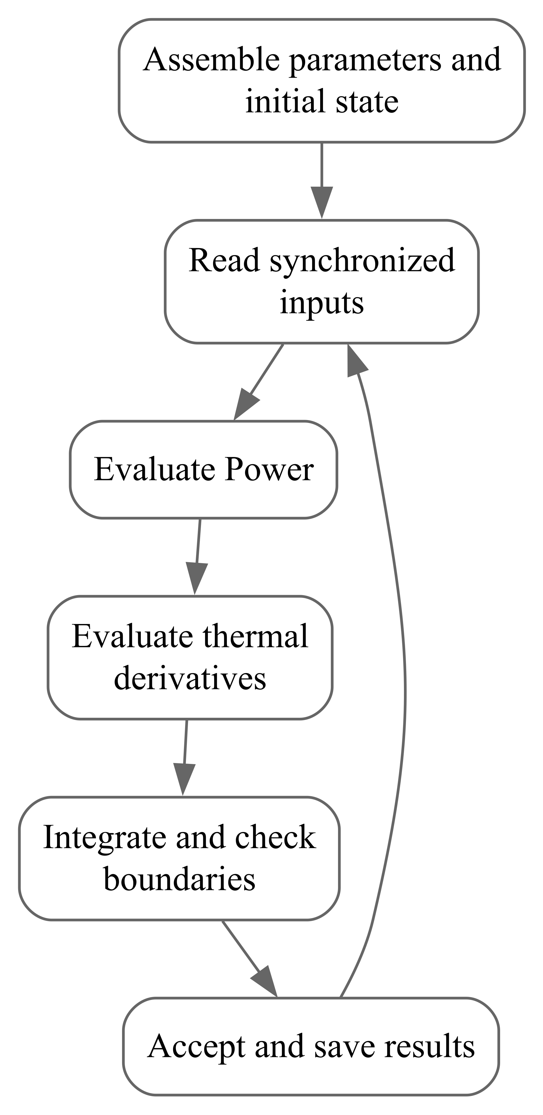
Figure 3 Thermal function calls in the coupled calculation
The diagram shows the valid-trial path. Report Power input or numerical errors and stop that evaluation. When a valid result requires a constraint event, return to its boundary, apply the declared discrete load rule, and recalculate powers and derivatives. A rejected integration step does not write temperatures. An accepted step stores temperatures, powers, heat flows, and parameter revisions. Computing reads $J$, while Power reads $B$ for the next trial. Plots and three-dimensional displays use saved results.

Numerical Design and Performance
Table 8 Numerical methods and controls
Calculation | Method | Controls and units
Temperatures and continuous battery state | One adaptive coupled ODE calculation, initially RK45 | Dimensionless relative tolerance, temperature absolute tolerance in $K$, maximum step in $s$
Disparate thermal time scales | An implicit method such as Radau may be used | Relative tolerance, absolute tolerance, and maximum step
Orbit and environment | Synchronized values; declared interpolation on continuous intervals | Input spacing in $s$ and eclipse/switching boundaries in $s$
Power current solution | Power's pure evaluator and constraint checks | Current tolerance in $A$ and power residual tolerance in $W$, configured by Power
Result output | Sample the accepted solution at required epochs | Output spacing in $s$, separate from internal integration step
Capacitance, resistance, area, and optical properties belong to the physical model. Battery variables use their own error scales. Solver tolerances and the maximum step are scene-level numerical settings that control integration error. [5]
Thermal functions evaluate a small number of paths and exposed surfaces. Coupled runtime also depends on Power root evaluations and rejected trials; record these costs separately. Discontinuous environmental inputs require interval boundaries rather than averaging across the change.

Deployment and Configuration

Runtime
The proposed implementation uses Python and NumPy for ordered numerical data and SciPy for ODE integration. Orbit transformations and solar environment continue to use Orbit's existing dependencies. [4,5] Python and dependency revisions must be checked against the selected SpaceDC environment and pinned. There is no independently installable package implementing these thermal interfaces.

Installation and interpreter configuration
Implement the modules in Section 3.2 within the existing project and run them with the project's selected interpreter. Install dependencies using the project's actual configuration files, without inferring nonexistent package names or installation commands from this report. Archive interpreter, dependency, and source revisions. Display refresh frequency does not alter physical time.

SimReady assets and scene assembly
SimReady organizes reusable geometry, materials, and simulation-related metadata and may use OpenUSD. Thermal parameters, model bindings, and ports are project extensions; standard NVIDIA assets do not automatically contain RC or battery SPM parameters. [6] Asset templates hold fixed device data. Scene instances hold placement, connections, and initial values; operating temperatures reside in separate state records.
Table 9 SimReady asset and scene records
Record | Fields | Configuration
Asset definition | asset_id, asset_version, geometry_uri | Selected device and revision, physical geometry, length units, and material assignment
Physical capability | domain, model_id, parameter_set | Select the thermal model and parameters; the model name is a controlled lookup key
Parameter evidence | ports, provenance | Temperature, heat-source, and transfer definitions with data-sheet or test sources
Scene instance | instance_id, asset_ref | Component instance and fixed asset reference
Scene configuration | parameter_overrides, initial_state, connections | Scenario changes, initial temperatures, electrical and thermal connections
Place SolarArray01, Battery01, Controller01, PDU01, Compute01, ColdPlate01, and Radiator01 under Sat01. The proposed geometry path is /World/Sat01/<instance_id>. Apply Section 3.2's temperature extents and connect $SR$, $JC$, $CR$, $BR$, and $DR$. Controller01 and PDU01 share $D$. The battery connects electrically to the controller, while its $BR$ thermal path connects to the radiator. Power and Thermal share component identifiers, and material mass is counted once.
Battery01 binds reduced-order SPM and separate heat generation in power and lumped temperature in thermal. Electrochemical parameters require appropriate source data and cannot be inferred from geometry and mass. Two instances of one asset have independent temperatures and battery states. model_id does not permit arbitrary code execution from USD.

Parameter configuration and result archive
Resolve the selected parameter set, apply scene overrides, and call assemble_thermal_parameters. Verify geometry units and transforms; a display-scaled bounding box does not directly define physical dimensions. Material, geometry, or installation changes require affected capacitances, areas, and resistances to be recalculated. Check that photovoltaic efficiency does not exceed absorptivity for the same surface and spectrum.
All initial component temperatures enter ThermalState; battery initial temperature has only that owner. Missing albedo, infrared, or installation resistance identifies the unconfigured field. Teaching cases that explicitly disable environmental terms must record the assumption. Before startup, save resolved parameters, provenance, initial state, and environmental configuration.
Archive run_id, UTC epoch, time_s, component identifiers, and state order with temperatures, the four Power ports, heat flows, and solver settings. Distinguish asset examples, measurements, and fitted values. Standard defaults cannot be recorded as measured device parameters.

Limitations and Planned Evolution
This version uses constant capacitances, resistances, and optical properties. $J$'s whole-board equivalent requires chip-temperature calibration. $D$ does not separate controller and distribution hot spots. The radiator and solar panel each use a lumped temperature, without local gradients, mutual obstruction, or radiation exchange between components.
Component subdivision depends on the required temperature outputs and the physical structure. Tests or finite elements may identify equivalent resistances for uncertain installation paths; no additional pump, pipe, or finite-element runtime model is introduced. Future solar temperature feedback or communication heat sources require coordinated changes to balances and interfaces. Accumulated particle radiation does not alter Power parameters in this version.

Requirements Traceability Matrix
Table 10 Requirements traceability matrix
ID | Requested capability | Interface | Design model | Primary output
TH-01 | Component temperature and transfer | thermal_derivative, calculate_heat_flows | T2, T3 | Temperature derivatives and path flows
TH-02 | Consistent electrical/thermal coupling | ThermalInputs, thermal_derivative | T3 and synchronized Power evaluation | Temperature response to signed heat
TH-03 | Orbital absorption and radiation | prepare_surface_environment, calculate_surface_heat | T4 | Surface environment and absorbed/emitted powers
TH-04 | Asset and parameter assembly | assemble_thermal_parameters | T5 | Capacitances, resistances, and surface parameters

Appendix A Public API Inventory
These are proposed public names, not the exports of an installed package.
Table A-1 Proposed public API inventory
Name | Kind | Contract summary
ThermalParameters | Data type | Fixed capacitances, resistances, surfaces, and component assignments
ThermalState | Data type | Run identifier, time, and ordered temperatures
ThermalInputs | Data type | Synchronized environment and four Power ports
ThermalEvaluation | Data type | Derivatives, flows, external powers, and temperature ports
assemble_thermal_parameters | Function | Asset and scene parameter assembly using T5
prepare_surface_environment | Function | Consistent frames/attitude and ordered surface inputs
calculate_surface_heat | Function | Absorption and emission from T4
calculate_heat_flows | Function | Signed heat transfer from T2
thermal_derivative | Function | Temperature derivatives from T3
Referenced Power interfaces | External types and function | PowerInputs, PowerState, PowerResult, and solve_power_allocation are defined in Power Chapter 5; Power is evaluated before thermal derivatives
Appendix B Model-Selection Guidance
Table B-1 Model-selection guidance
Question | Current baseline | Extension boundary
How do component temperatures change over an orbit? | T1–T5 with initial temperatures and actual load | Choose component divisions for the required temperature outputs
How does battery operation affect temperature? | Read Power's separate heat and return the trial battery temperature | Do not integrate another battery temperature in Power
Is an installation resistance unknown? | Use product data or tests for the actual installation | Identify an equivalent parameter with finite elements if necessary
Do local hot spots affect constraint decisions? | Use the equivalent temperature calibrated from board power and chip measurements | Subdivide components when separate local temperatures are required
Are albedo or infrared inputs missing? | Provide environment data, or explicitly label a teaching simplification | Do not treat missing inputs as a complete orbital thermal environment
Appendix C References
[1] G. Fernández-Rico et al. Quasi-autonomous thermal model reduction for steady-state problems in space systems. Applied Thermal Engineering, 2016, 105: 456–466. Section 2, Equation 1 gives the node energy balance.
[2] ECSS. ECSS-E-HB-31-03A Thermal analysis handbook. 2016. Sections 4.5.2 and 5.4 discuss node division and finite-element analysis.
[3] NASA. State-of-the-Art of Small Spacecraft Technology: Chapter 7, Thermal Control. 2026. Sections 7.1 and 7.2.1 explain environmental heat balance and surface optical properties.
[4] NTU Space Dynamics. Design Report for Orbit Dynamics Module of SDTwin. 2026-08-17. User-supplied Orbit report, Sections 3, 5, and 6.
[5] SciPy. solve_ivp. Accessed 2026-10-01. Supports the design choice of adaptive integration and error controls.
[6] NVIDIA. The SimReady Specification; Physics Best Practices; SimReady FAQ. Accessed 2026-10-01. Thermal parameters, model bindings, and ports in this report are project extensions.

