**User Manual for Wedding Planner GUI**

Page 1: **Index**

Page 2: **Display**

Page 3: **Look Up, Add**

Page 4: **Delete**

Page 5: **Undelete, Purge**

Page 6: **About, Exit**

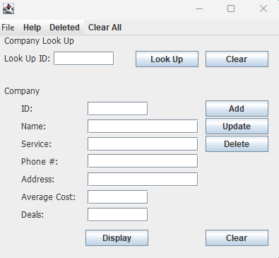

To viewall the companies in the database, click on **DISPLAY.**

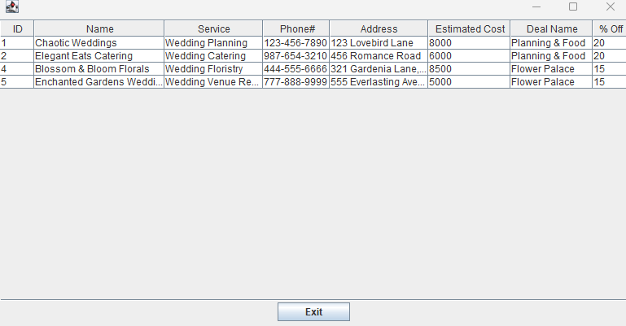

To close this window, you can click **Exit**.

To look up a company, input the companies ID number in the text box next to **LOOK UP ID:** and then click on the **Look Up** button.

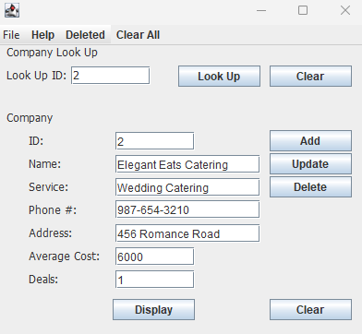

To modify a company, **Look Up** the company first then modify one or all its fields and click the **Update** button.

To add a new company input data into all the fields and click the **Add** button. Make sure the **ID** field is unique from the other IDs. Note: There are only 3 deal options 1 = 20%, 2 = 15%, and 3 = 0%.

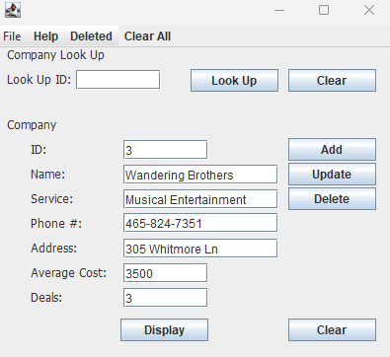

To delete a company, go to **Look Up** a company then click on the **Delete** button.

To recover or completely remove a deleted company click on the **Deleted** menu item.

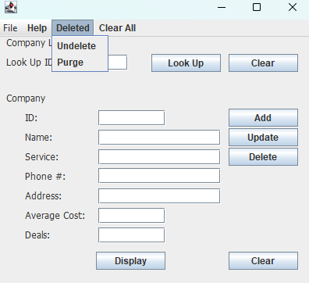

Once clicked, click on **Undelete**. Then use the drop down and select which company you want **Undelete** and click the **Undelete** button.

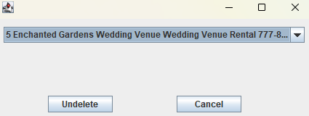

If you want to completely remove the deleted items click on **Purge** instead.

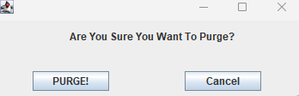

To confirm in the deletion, click the **PURGE!** button.

To learn who create this GUI and what the project is for click on the **Help** button.

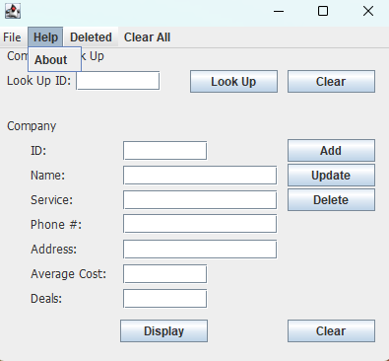

Then click **About**.

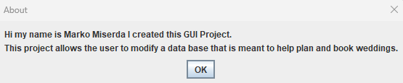

To exit this application, go to **File** and click on **Exit**.

