FAYOUM UNIVERSITY
Faculty of Computers and Artificial Intelligence
DETECTION AND CLASSIFICATION OF APPLE DISEASES
USING MACHINE LEARNING (ML) TECHNIQUES
By
Marko A. Malak
A thesis submitted in partial fulfilment
of the requirements for the degree of
Master of Science
in
Computer Science
Department of Computer Science
Faculty of Computers and Artificial Intelligence, Fayoum
FAYOUM UNIVERSITY
2026

Supervision Committee
DETECTION AND CLASSIFICATION OF APPLE DISEASES
USING MACHINE LEARNING (ML) TECHNIQUES
By
Marko A. Malak
(B.Sc. in Computer Science)
Name: Prof. Mostafa Thabet
Position: Professor of Computer Science, Faculty of Computers and AI, Fayoum University
Signature: ...............................
Name: Dr. Alber S. Aziz
Position: Lecturer of Computer Science, October 6th University
Signature: ...............................
Name: Prof. Ayman A. Alhelbawy
Position: Professor of Computer Science, Faculty of Computers and AI, Fayoum University
Signature: ...............................

Approval Sheet
DETECTION AND CLASSIFICATION OF APPLE DISEASES
USING MACHINE LEARNING (ML) TECHNIQUES
By
Marko A. Malak
This thesis for the M.Sc. degree has been approved by:
Prof. ......................................
Professor of ................................., ................. University
Signature: ...............................
Prof. ......................................
Professor of ................................., ................. University
Signature: ...............................
Prof. Mostafa Thabet
Professor of Computer Science, Fayoum University (Supervisor)
Signature: ...............................
Date of Examination: ......... / ......... / 2026

Acknowledgment
First and foremost, I would like to express my sincere gratitude to my supervisors, Prof. Mostafa Thabet, Dr. Alber S. Aziz, and Prof. Ayman A. Alhelbawy, for their continuous guidance, patience, and invaluable support throughout this work. [Add here your personal thanks to your family, colleagues, the Faculty of Computers and Artificial Intelligence at Fayoum University, and anyone who supported you during the research.]

Dedication

[Write your dedication here — for example: To my parents, my family, and my teachers, with gratitude and love.]

Curriculum Vitae
Name: Marko A. Malak
Date of birth: ..............................
Place of birth: ..............................
Nationality: Egyptian
B.Sc. degree: Computer Science, .............. University, ...... (year)
Current position: ..............................
E-mail: ma6281@fayoum.edu.eg

Abstract
Automated identification of apple-leaf diseases can help orchard managers act early and reduce unnecessary pesticide use. Many published systems report near-perfect accuracy on the PlantVillage collection, but those figures are often inflated by a subtle flaw: augmented copies of the same physical leaf are spread across the training and test partitions, so the model is effectively tested on images it has already seen. This thesis presents a deep-learning framework built on a de-duplicated, leakage-free version of the four-class apple subset (apple scab, black rot, cedar apple rust, and healthy), in which exactly one image represents each leaf and the splits are verified to be disjoint.
Five ImageNet-pretrained backbones (MobileNetV2, DenseNet121, ResNet50, VGG16, and InceptionV3) are fine-tuned with a two-phase transfer-learning schedule and class-weighted loss, and are compared under a consistent multi-metric protocol that also records model size, latency, and compute. On the clean test set every backbone exceeds 99.5% accuracy and reaches a one-vs-rest ROC-AUC of 1.000; ResNet50 and InceptionV3 tie for the best result at 100.0% accuracy, while the lightweight MobileNetV2 remains within two tenths of a point at 99.8% using only 2.39 million parameters, which shows that the choice of backbone is immaterial to accuracy and that efficiency is the deciding factor for deployment. A controlled ablation shows that augmentation contributes a modest 0.2 accuracy points once leakage is removed, rather than the several-point gains reported elsewhere.
Because the pixel-level lesion masks in the source release proved unreliable, disease regions are localised without any mask supervision using Grad-CAM, which places 89.4% of its activation energy inside the leaf region; this is read as suggestive, image-level evidence rather than proof of lesion-level focus. Field readiness is measured on two independent real-field datasets, PlantDoc (three classes) and Plant Pathology 2021 / FGVC8 (four classes, with frogeye leaf spot mapped to black rot), and for each the external zero-shot result is kept strictly separate from the cross-validation result. Zero-shot, the laboratory-trained model reaches only 41.5% on PlantDoc and 32.9% on the harder four-class FGVC8, the sole genuine measures of generalisation; when field images are mixed into training, five-fold cross-validation recovers to 81.9% on PlantDoc and 94.1% on FGVC8, which are adaptation rather than generalisation figures. To complement whole-image recognition with explicit region-level detection, a compact YOLOv11 detector is trained on the PlantDoc apple bounding boxes and localises and classifies diseased leaves in the field at a mean average precision of 93.5% at IoU 0.5. A data-efficiency study finally shows that the leakage-free laboratory model is not only honest but useful: as a pretrained backbone it beats generic ImageNet initialisation at every field-data budget on two independent field datasets, by up to 0.17 macro-F1 when field data is scarcest, so the clean benchmark measurably reduces the amount of field data needed to reach a target accuracy. The framework, its honest two-dataset field evaluation, and its data-efficiency analysis offer a reproducible baseline for apple-leaf disease detection and recognition.
Keywords: apple leaf disease; convolutional neural networks; transfer learning; data leakage; Grad-CAM localisation; YOLO object detection; cross-dataset evaluation.

Table of Contents

List of Figures
Figure 2.1 The convolution operation.
Figure 2.2 Common activation functions.
Figure 2.3 Max pooling.
Figure 2.4 Transfer learning.
Figure 2.5 VGG16 architecture.
Figure 2.6 ResNet residual block.
Figure 2.7 Inception module.
Figure 2.8 DenseNet dense block.
Figure 2.9 MobileNetV2 inverted residual block.
Figure 2.10 State of the art vs. this work: reported accuracies.
Figure 3.1 End-to-end architecture of the proposed framework.
Figure 3.2 Representative apple-leaf images from the four classes.
Figure 3.3 Class distribution across training, validation, and test partitions.
Figure 3.4 Dataset composition and splits.
Figure 3.5 Examples of the on-the-fly training augmentation policy.
Figure 3.6 Generic CNN classifier architecture (backbone + head).
Figure 3.7 Two-phase transfer-learning schedule.
Figure 3.8 Grad-CAM localisation computation and CAM-in-leaf score.
Figure 3.9 The one-vs-rest confusion matrix underlying the metrics.
Figure 4.1 Accuracy, F1, and ROC-AUC of the five classification backbones.
Figure 4.2 Validation-accuracy training curves for the five backbones.
Figure 4.3 Confusion matrix and ROC curves for ResNet50.
Figure 4.4 Confusion matrices for all five backbones.
Figure 4.5 Aggregated confusion matrix over the five FGVC8 folds (four classes).
Figure 4.6 Aggregated confusion matrix over the five PlantDoc folds.
Figure 4.7 Grad-CAM localisation on test leaves.

List of Tables
Table 2.1 Representative studies on PlantVillage / apple-leaf data.
Table 3.1 Leakage-free apple-leaf dataset distribution.
Table 3.2 Classification heads and input sizes for each backbone.
Table 3.3 Training-time augmentation transforms and parameters.
Table 3.4 Training summary: fine-tuning epochs and test accuracy.
Table 4.1 Test-set classification performance with efficiency metrics.
Table 4.2 Per-class F1 score on the leakage-free test set.
Table 4.3 Honest augmentation ablation for the best model.
Table 4.4 Field evaluation on two independent datasets (PlantDoc, FGVC8).
Table 4.5 Per-class performance under FGVC8 cross-validation.
Table 4.6 FGVC8 five-fold cross-validation: per-fold accuracy.
Table 4.7 Per-class performance under PlantDoc cross-validation.

List of Abbreviations
AI Artificial Intelligence
CNN Convolutional Neural Network
GAP Global Average Pooling
FLOPs Floating-Point Operations
Grad-CAM Gradient-weighted Class Activation Mapping
IoU Intersection over Union
ROC-AUC Area Under the Receiver Operating Characteristic Curve
CV Cross-Validation
ML Machine Learning
SVM Support Vector Machine

Chapter 1: Introduction
Apple is one of the most widely cultivated temperate fruit crops in the world, and its productivity is strongly tied to the health of the tree canopy. Foliar diseases, in particular, place a persistent burden on growers because they reduce photosynthetic area, lower fruit quality, and can spread quickly through an orchard when conditions are favourable. Three fungal diseases dominate the picture in most apple-growing regions: apple scab, caused by Venturia inaequalis; black rot, caused by Botryosphaeria obtusa (anamorph Diplodia seriata); and cedar apple rust, caused by Gymnosporangium juniperi-virginianae. Each leaves a characteristic visual signature on the leaf, but early symptoms are subtle and are easily confused with one another or with ordinary senescence. Left undiagnosed, these diseases push growers toward broad, calendar-based pesticide programmes that raise costs and carry an environmental price.
In the great majority of orchards, disease diagnosis still relies on visual inspection by trained staff. This is slow, subjective, and difficult to scale across large plantations, and it depends on expertise that is not always available to smallholders. A reliable automated system that can recognise apple-leaf diseases from ordinary photographs would therefore be of real practical value: it would support earlier intervention, more targeted treatment, and better record-keeping, and it could be delivered through a smartphone or a field camera at low cost.
The scale of the opportunity is considerable. Apple is grown on millions of hectares worldwide and is among the most economically important temperate fruits, so even a small proportional reduction in disease loss or in unnecessary spraying translates into a large absolute benefit. At the same time, the expertise needed for accurate visual diagnosis is unevenly distributed: large commercial operations may employ trained scouts, but smallholders often cannot, and it is precisely these growers whom an accurate, phone-deliverable model could help the most. An automated diagnostic that is genuinely reliable in the field would therefore have both economic and equity value, which is why the gap between laboratory and field performance, the central concern of this thesis, is not a technicality but the crux of whether such systems help anyone at all.
Deep learning, and convolutional neural networks (CNNs) in particular, has become the standard tool for this kind of image-recognition task. Trained on labelled examples, a CNN learns the visual features that separate one class from another without any hand-crafted feature engineering, and transfer learning from large natural-image collections such as ImageNet makes it possible to train accurate models on comparatively small agricultural datasets. A large body of published work reports near-perfect accuracy for apple-leaf disease recognition on the public PlantVillage collection [1], and at first glance the problem looks solved.
This thesis argues that those headline numbers must be read with care, and it re-examines the four-class apple problem with two methodological issues placed deliberately at the centre of the design. The first issue is data leakage. In a common but flawed preparation, a dataset is enlarged by writing many augmented copies of each leaf, such as rotated and flipped versions, to disk, and only afterwards is it split into training, validation, and test partitions. Because several near-identical copies of the same physical leaf then end up in different partitions, the test set is contaminated with images the model has effectively already seen, and the reported accuracy measures memorisation rather than generalisation. The second issue is the gap between laboratory and field imagery. PlantVillage leaves are photographed against a plain background, and a model that is flawless on such images may fail badly on real orchard photographs. Many studies never test this, yet still claim deployment readiness.

1.1 Motivation and Significance
The economic case for automated disease recognition is strong. Apple production supports a large global industry, and foliar disease is a recurring source of loss through reduced yield, downgraded fruit, and the cost of control measures. Much of that cost comes not from treatment itself but from the difficulty of deciding when and where to treat. A grower who can detect an outbreak early, and localise it to particular blocks of the orchard, can treat selectively rather than spraying the whole plantation on a fixed schedule. This reduces chemical use, slows the development of fungicide resistance, and lowers the environmental burden of production.
The scientific case is subtler and is the real motivation for this thesis. The plant-disease recognition literature is unusual in that its headline accuracy figures have crept steadily toward 100% while the practical deployment of such systems has lagged far behind. This mismatch is a symptom of a measurement problem. If a benchmark rewards memorisation of near-duplicate images, then progress on that benchmark need not correspond to progress on the real task. The significance of this work, therefore, is not that it proposes a new architecture, it does not, but that it re-establishes a trustworthy way of measuring progress, and shows what the numbers look like once the measurement is fixed. That contribution is transferable well beyond apples: the same leakage and single-dataset problems affect plant-disease recognition across many crops.
The significance can be framed at three levels. At the level of the apple problem, the thesis delivers a clean, reproducible benchmark and an honest set of numbers that others can build on without inheriting hidden leakage. At the level of plant-disease recognition generally, it offers a template, verify disjoint splits, augment only at training time, test on an independent field set, and report the two regimes separately, that applies to any crop and any dataset with the same structure. And at the level of applied machine learning as a whole, it is a case study in how a benchmark can quietly reward the wrong thing, and how careful experimental design, rather than a more powerful model, is what restores the connection between measured progress and real-world usefulness.

1.2 Problem Statement
The core problem addressed in this work is the honest and reproducible detection and classification of apple-leaf diseases from images, together with an interpretable indication of where the model is looking. Existing approaches face real difficulties with complex backgrounds, visually similar symptoms, and variation in shape, colour, and texture between lesions. On top of these, much of the published evidence is undermined by evaluation practices, principally data leakage and single-dataset testing, that inflate accuracy and obscure how a model would actually behave in the field. The problem, then, is not only to build an accurate classifier but to build one whose reported performance can be trusted and whose limitations are stated plainly.
Two further requirements follow from this framing. The performance must be interpretable at least weakly, so that a user can see that the model is attending to the leaf rather than to some artefact, and the whole procedure must be reproducible, so that the reported numbers can be regenerated and checked by others. A system that is accurate but inscrutable, or accurate but irreproducible, would not meet the standard of trustworthiness this thesis sets, which is why interpretability and reproducibility are treated as first-class objectives alongside accuracy.

1.3 Research Objectives
The objectives of this research are the following:
- To construct a de-duplicated, leakage-free version of the four-class apple-leaf dataset (apple scab, black rot, cedar apple rust, and healthy) in which exactly one image represents each physical leaf, so that the training, validation, and test partitions are disjoint by construction.
- To train and fairly compare five modern CNN backbones, MobileNetV2, DenseNet121, ResNet50, VGG16, and InceptionV3, under a single, consistent transfer-learning protocol, and to report not only accuracy but precision, recall, F1, and ROC-AUC together with the practical costs of model size, latency, and compute.
- To measure the true contribution of data augmentation on a clean split through a controlled ablation, rather than on a leaky split where its effect is exaggerated.
- To localise disease regions in an interpretable way without relying on pixel-level lesion masks, using gradient-weighted class activation mapping (Grad-CAM), and to quantify how much of the model's attention falls on leaf tissue.
- To quantify the gap between laboratory and field conditions using two independent real-field datasets, PlantDoc and FGVC8, keeping a clear separation between an external zero-shot test and a cross-validation in which field images are added to training.
These objectives can be phrased as three research questions that the thesis answers in turn. First, how much of the near-perfect accuracy reported for apple-leaf classification survives when data leakage is removed and the split is verified disjoint? Second, does the ranking of architectures, and the apparent benefit of augmentation, change under this honest protocol? Third, how large is the gap between laboratory and field performance, and to what extent can it be closed by adding field data to training rather than by architectural means? The corresponding working hypotheses are that in-domain accuracy remains high but the augmentation benefit shrinks, that architecture choice becomes largely immaterial, and that a substantial field gap remains that only field data, not a bigger model, can close. Chapter 4 tests each of these directly.

1.4 Understanding Apple Leaf Diseases
A brief description of the diseases considered in this study helps to frame the recognition task. Apple scab, caused by Venturia inaequalis, produces dark, olive-green to black lesions on leaves and fruit; heavy infection leads to premature leaf drop, reduced photosynthesis, and poorer fruit quality. Black rot, caused by Botryosphaeria obtusa (anamorph Diplodia seriata), appears as brown, necrotic leaf spots that often develop concentric rings, and it can also rot the fruit; its dark necrotic tissue is visually close to scab, which makes the two classes the most easily confused. Cedar apple rust, caused by Gymnosporangium juniperi-virginianae, forms bright orange-yellow spots on the upper leaf surface and requires an alternate juniper host to complete its life cycle; its colour makes it the most visually distinctive of the three. The fourth class, healthy leaves, provides the negative reference against which the diseased classes are separated. These four categories are precisely the apple classes available in the PlantVillage collection, and they define the scope of this study; other apple disorders such as powdery mildew and fire blight fall outside it because labelled images of them are not available in the source dataset.
Susceptibility to these diseases is shaped by weather, orchard management, and the surrounding environment. Prolonged leaf wetness and high humidity favour fungal infection, dense canopies with poor ventilation trap moisture, and imbalanced soil or nutrition can weaken a tree's natural resistance. These same conditions also introduce the visual variability, shadows, wet surfaces, overlapping leaves, and cluttered backgrounds, that makes field-image recognition so much harder than laboratory-image recognition.
From a management standpoint, each disease is handled somewhat differently, which is why accurate identification, and not merely detection of some abnormality, has practical value. Apple scab is managed with resistant cultivars, sanitation of fallen leaves, and well-timed fungicide applications keyed to periods of leaf wetness; misidentifying it wastes sprays or misses the narrow window for effective control. Black rot management centres on pruning out cankered wood and removing mummified fruit, a very different intervention from scab control, so confusing the two, the most common error observed in this study, has real consequences. Cedar apple rust is controlled partly by removing nearby juniper hosts that complete its life cycle, an intervention that only makes sense once the disease is correctly named. A classifier that distinguishes these diseases therefore supports not just earlier action but the right action, which is where much of its economic value lies.

1.5 Machine Learning for Apple Disease Identification
Machine learning is the branch of artificial intelligence concerned with algorithms that improve at a task by learning patterns from data rather than following explicitly programmed rules. In image-based disease recognition, the relevant paradigm is supervised learning: a model is shown many labelled example images and adjusts its parameters until it can map an unseen image to the correct class.
Early plant-disease systems combined hand-crafted colour and texture descriptors with classical classifiers such as support vector machines or k-nearest neighbours. These pipelines could work well in controlled conditions but were brittle under changes in illumination and background, because the features were fixed in advance by the designer rather than learned from the data. Convolutional neural networks removed this bottleneck by learning a hierarchy of features directly from pixels, and with transfer learning from ImageNet they can be trained effectively even when the agricultural dataset is small. This is the family of methods on which the present work builds.
It is useful to be clear about what a supervised classifier does and does not learn. Given enough labelled examples, it learns a mapping from pixels to a class label that captures whatever visual regularities distinguish the classes in the training distribution. If those regularities are genuine disease features, lesion colour, shape, and texture, the model will generalise; if they are incidental correlations peculiar to the dataset, a particular background, lighting, or even a watermark, the model will latch onto those instead, and will fail when they are absent. This distinction between learning the disease and learning the dataset is the conceptual heart of the thesis, and it is why so much care is spent on how the data is prepared and how the model is tested. A high training or in-domain test accuracy is consistent with both outcomes; only an external test can tell them apart.
This also explains why deep learning, for all its power, does not by itself solve the plant-disease problem. The network is an extraordinarily flexible function approximator, but that flexibility cuts both ways: it will exploit leakage and dataset artefacts just as readily as it will exploit real disease features, because to the optimiser they are indistinguishable, both reduce the training loss. The responsibility for ensuring that the model learns the right thing therefore rests not with the architecture but with the experimental design, which is precisely where this work concentrates its effort.

1.6 Localising Disease Regions
Beyond naming the disease, it is useful to indicate where on the leaf the evidence lies, both to build trust in the model and to support severity assessment. One route is pixel-level segmentation, in which a model is trained to label every pixel as diseased or healthy using binary lesion masks. This route is only as good as the masks it is trained on. As Chapter 3 documents, the lesion masks distributed with the source release used in early versions of this project proved unreliable, frequently failing to overlap the visible lesion, so a segmentation model trained against them would optimise toward noise. This thesis therefore adopts a weakly-supervised alternative, Grad-CAM, which highlights the image regions most responsible for the predicted class and requires no mask supervision at all. It provides an interpretable, image-level indication of the model's focus while avoiding the false precision of unreliable pixel labels.

1.7 Scope and Contributions
The scope of this thesis is the four-class apple-leaf problem under an honest evaluation protocol. Within that scope, the main contributions are:
- a de-duplicated, leakage-free four-class apple benchmark with fixed, reproducible splits;
- a fair multi-backbone comparison under one training and evaluation protocol, including efficiency metrics that support claims of deployability;
- an honest augmentation ablation on the clean split, isolating the true contribution of augmentation;
- mask-free lesion localisation with Grad-CAM together with a simple quantitative localisation score;
- a cross-dataset study on two independent real-field datasets (PlantDoc and FGVC8) that separates the external zero-shot result from the cross-validated result and reports both openly, with FGVC8 extending the field evaluation to all four classes including black rot; and
- an explicit object-detection component, in which a YOLOv11 detector trained on the PlantDoc apple bounding boxes localises and classifies diseased leaves directly in field images, adding region-level detection to the whole-image classifier; and
- a data-efficiency and domain-adaptation study that quantifies how much field data is needed to close the laboratory-to-field gap and shows that the leakage-free laboratory backbone reaches a target field accuracy with substantially less field data than a generic ImageNet backbone, turning the leakage-free protocol from a correctness argument into a practical advantage.

1.8 Organisation of the Thesis
The remainder of the thesis is organised as follows. Chapter 2 provides the theoretical background, convolutional neural networks and their components, transfer learning, the five architectures compared here, and explainable localisation, and then reviews the related work, including a detailed comparison with studies that use the same PlantVillage and apple-leaf data, and identifies the research gaps this work addresses. Chapter 3 describes the methodology in detail: the construction of the leakage-free dataset, preprocessing and augmentation, the five backbones and their training schedule, the Grad-CAM localisation method and the reasons pixel-level segmentation was set aside, the cross-dataset protocol, and the implementation environment. Chapter 4 presents and discusses the results, including in-domain classification, the augmentation ablation, the external zero-shot and cross-validation evaluations on both field datasets, Grad-CAM localisation, and a failure-case analysis. Chapter 5 concludes with a summary of findings, practical implications, limitations, and directions for future work. Supporting material, hyperparameters, class-weight derivations, full per-model metrics, the software environment, and additional Grad-CAM examples, is collected in the appendices.

Chapter 2: Review of Literature
This chapter provides the conceptual foundation for the thesis and situates it within the existing literature. It is organised in two parts. The first part reviews the theoretical background needed to understand the methods used later: the components of a convolutional neural network, how such networks are trained, the principle of transfer learning, the specific architectures compared in this study, and the idea of explainable localisation. The second part surveys the related work, with particular attention to studies that use the same PlantVillage and apple-leaf data, to what accuracies they report, to how the present work differs from them, and to the weaknesses that motivate a more careful evaluation.

2.1 Convolutional Neural Networks
A convolutional neural network (CNN) is a class of deep neural network designed to process data with a grid-like structure, most importantly images. Unlike a fully-connected network, which treats every pixel as an independent input, a CNN exploits the spatial structure of an image through three ideas: local receptive fields, weight sharing, and hierarchical composition. Early layers respond to simple, local patterns such as edges and colour transitions; deeper layers combine these into textures, parts, and eventually whole-object concepts. This hierarchy is what allows a CNN to learn the visual vocabulary of leaf disease, lesion shape, colour, and texture, directly from labelled images rather than from hand-designed features.
Three architectural principles underlie this behaviour and distinguish a CNN from a plain fully-connected network. Local connectivity means that each neuron in a convolutional layer looks only at a small patch of the previous layer, which matches the fact that meaningful image structure is local. Weight sharing means that the same filter is applied at every position, so a feature learned in one part of the image is detected everywhere, which both reduces the parameter count enormously and builds in translation equivariance. Hierarchical composition means that stacking layers lets the network build complex features from simpler ones, edges into motifs, motifs into parts, parts into objects. Together these principles make CNNs both data-efficient and well matched to the statistics of natural images, which is why they, rather than fully-connected networks, are the tool of choice for leaf-disease recognition.

2.1.1 Convolutional Layers
The convolutional layer is the core building block. A small matrix of learnable weights, called a kernel or filter, is slid across the input image, and at each position the element-wise product of the kernel and the underlying image patch is summed to produce a single value in the output feature map (Figure 2.1). Because the same kernel is applied at every position, the layer detects the same feature wherever it appears in the image, and because the kernel is small, each output depends only on a local region of the input. For a two-dimensional input I and kernel K, the operation is
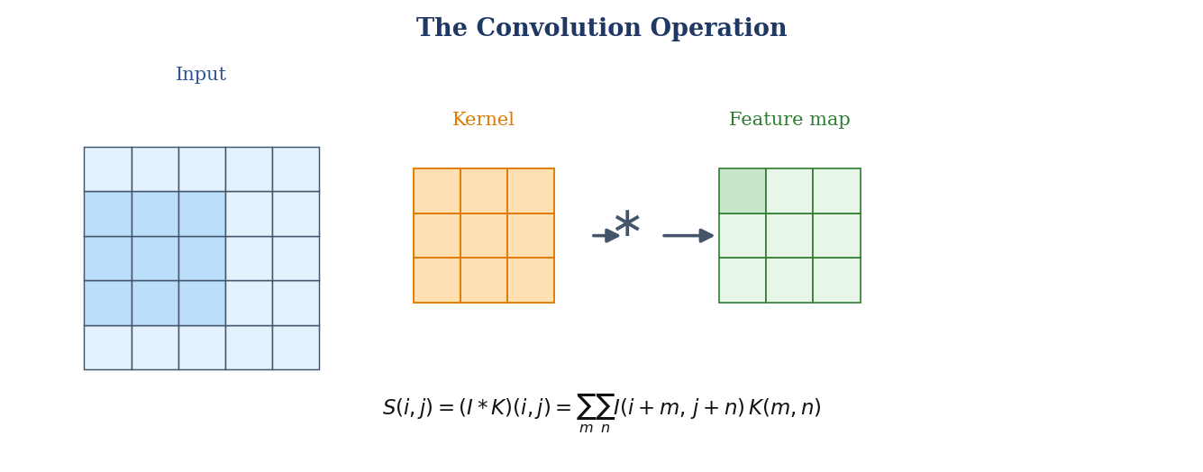
Figure 2.1. The convolution operation: a learnable kernel is slid over the input, and the weighted sum of each local patch forms one value of the output feature map.
S(i,j) = (I * K)(i,j) = Σ_m Σ_n I(i+m, j+n) · K(m,n).
A single layer applies many kernels in parallel, producing a stack of feature maps, one per learned feature. Stacking convolutional layers deepens the hierarchy, and it is this depth that gives modern CNNs their representational power.

2.1.2 Activation Functions
A convolution is a linear operation, and a stack of purely linear operations can only represent a linear function. To model the complex, non-linear relationships in real images, a non-linear activation function is applied after each convolution. The dominant choice in modern CNNs is the rectified linear unit (ReLU), which passes positive values unchanged and sets negative values to zero (Figure 2.2). ReLU is cheap to compute, does not saturate for positive inputs, and largely avoids the vanishing-gradient problem that hampered the older sigmoid and hyperbolic-tangent activations. MobileNetV2, discussed below, uses a bounded variant, ReLU6.
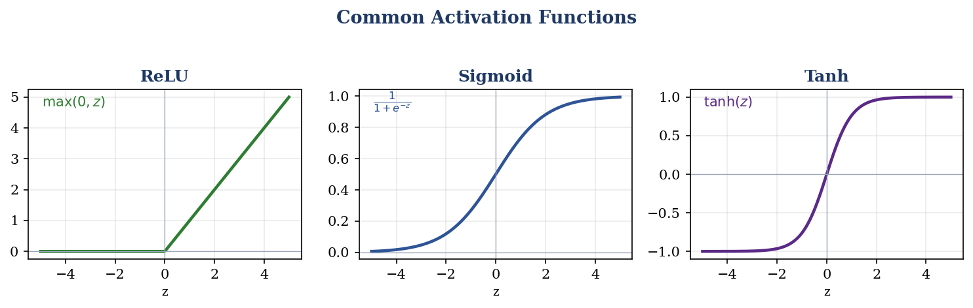
Figure 2.2. Common activation functions. ReLU is the default in the architectures used here; sigmoid and tanh saturate and are now used mainly in specific roles.

2.1.3 Pooling Layers
Pooling layers reduce the spatial resolution of the feature maps, which lowers computation, enlarges the effective receptive field of later layers, and provides a degree of invariance to small translations. Max pooling, the most common form, partitions each feature map into small windows and keeps only the strongest activation in each (Figure 2.3). Many modern networks replace the final pooling and flattening stages with global average pooling, which collapses each feature map to a single average value and greatly reduces the number of parameters in the classification head.
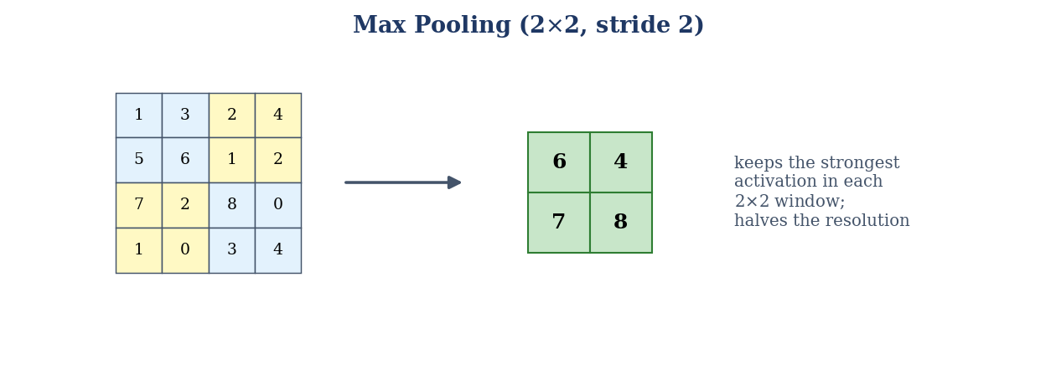
Figure 2.3. Max pooling with a 2×2 window and stride 2 keeps the strongest activation in each region and halves the spatial resolution.

2.1.4 Fully-Connected Layers, Softmax, and the Loss
After the convolutional backbone has produced a compact feature vector, one or more fully-connected layers map it to the class scores, and a softmax function converts these scores into a probability distribution over the classes. For class k with score z_k, the softmax probability is
p_k = exp(z_k) / Σ_j exp(z_j).
Training minimises the categorical cross-entropy between the predicted distribution and the one-hot true label y. For a single example this is
L = − Σ_k y_k · log(p_k).
Because the dataset is imbalanced, this study uses a class-weighted form of the cross-entropy in which each class contributes in inverse proportion to its frequency, so that the majority healthy class does not dominate the gradient and the minority cedar apple rust class is not neglected.

2.1.5 Training: Backpropagation, Optimisation, and Regularisation
The network's parameters are learned by gradient descent. The loss is computed on a batch of examples, its gradient with respect to every weight is obtained efficiently by backpropagation, the chain rule applied backwards through the network, and the weights are nudged in the direction that reduces the loss. The size of that step and the way past gradients are accumulated are governed by the optimiser. This study uses AdamW, a variant of the Adam optimiser that decouples weight decay from the gradient update; Adam adapts the step size per parameter using running estimates of the first and second moments of the gradient, which makes training fast and relatively insensitive to the exact learning rate.
Deep networks can memorise their training data, so several regularisation techniques are used to promote generalisation. Dropout randomly zeroes a fraction of activations during training, discouraging the network from relying on any single feature. Weight decay penalises large weights and so favours simpler models. Batch normalisation standardises the activations within each batch, which stabilises and speeds up training and has a mild regularising effect. Data augmentation, discussed in Chapter 3, is a further form of regularisation that enlarges the effective training set with realistic transformations. Crucially, this study applies augmentation only at training time, precisely so that it regularises the model without contaminating the test set.
The interaction between the optimiser and these regularisers deserves a note, because it explains the two-phase schedule used later. Early in training, when the classification head is randomly initialised, the gradients are large and noisy; applying them at a high learning rate to the pretrained backbone would overwrite its carefully learned features, a phenomenon known as catastrophic forgetting. Freezing the backbone while the head settles, and only then unfreezing it at a much lower learning rate, keeps the optimisation in a gentle regime where the pretrained features are refined rather than destroyed. This is a concrete example of how the abstract training machinery, optimiser, learning rate, and regularisation, must be orchestrated with the specific goal of transfer in mind.

2.2 Transfer Learning
Training a deep CNN from random initialisation typically requires hundreds of thousands to millions of labelled images, far more than are available for apple-leaf disease. Transfer learning circumvents this by starting from a network already trained on a large source task, here the ImageNet classification of over a million natural images across a thousand categories, and adapting it to the target task (Figure 2.4). The intuition is that the low- and mid-level features learned on ImageNet, edges, textures, colour gradients, and simple shapes, are largely generic and transfer well to new visual domains; only the higher, task-specific layers and the classification head need substantial adaptation.
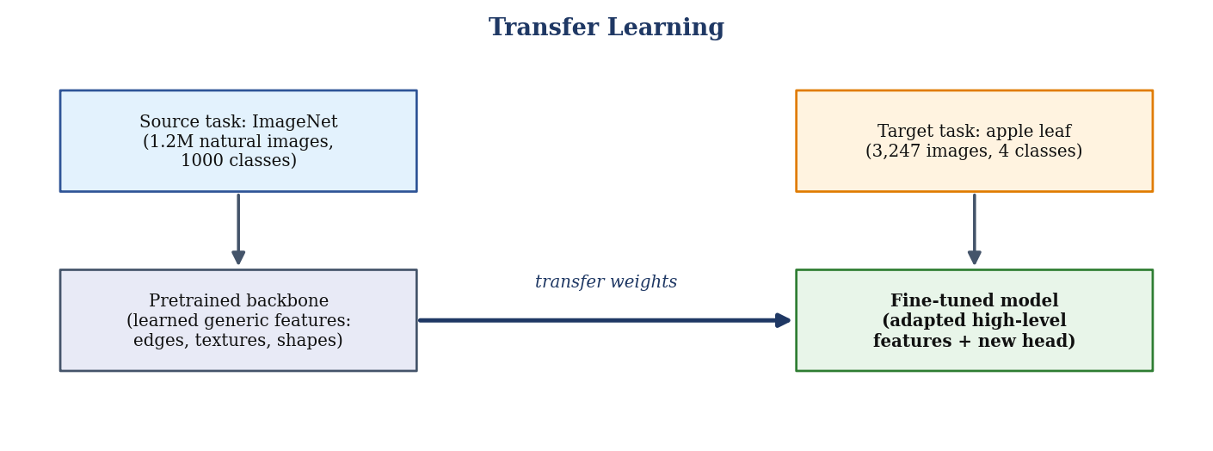
Figure 2.4. Transfer learning: generic features learned on a large source task (ImageNet) are reused and fine-tuned on the small target task (apple-leaf disease).
Pan and Yang's [2] survey formalises transfer learning and distinguishes several settings. The form used here is inductive parameter transfer with fine-tuning: the pretrained weights initialise the network, and are then updated on the apple data. The two-phase schedule adopted in Chapter 3, a frozen-backbone warm-up followed by gentle full fine-tuning, is a standard and robust realisation of this idea, and it is the single most important reason accurate models can be trained on only a few thousand images.

2.3 CNN Architectures Compared in This Study
Five ImageNet-pretrained backbones are compared in this thesis. They were chosen to span the practical trade-off between accuracy and computational cost, and they also illustrate the main ideas in the evolution of CNN design. Each is described briefly below with a schematic of its distinctive structure; their empirical behaviour is reported in Chapter 4.

2.3.1 VGG16
VGG16 [3] established that depth built from small, uniform 3×3 convolutions improves representation. It stacks thirteen convolutional layers in five blocks separated by max-pooling, followed by three fully-connected layers (Figure 2.5). Its design is elegantly simple and it remains a strong baseline, but it is heavy: at 27.6 million parameters and 30.7 GFLOPs it is by far the most expensive model in this study, most of the cost residing in its large fully-connected layers.
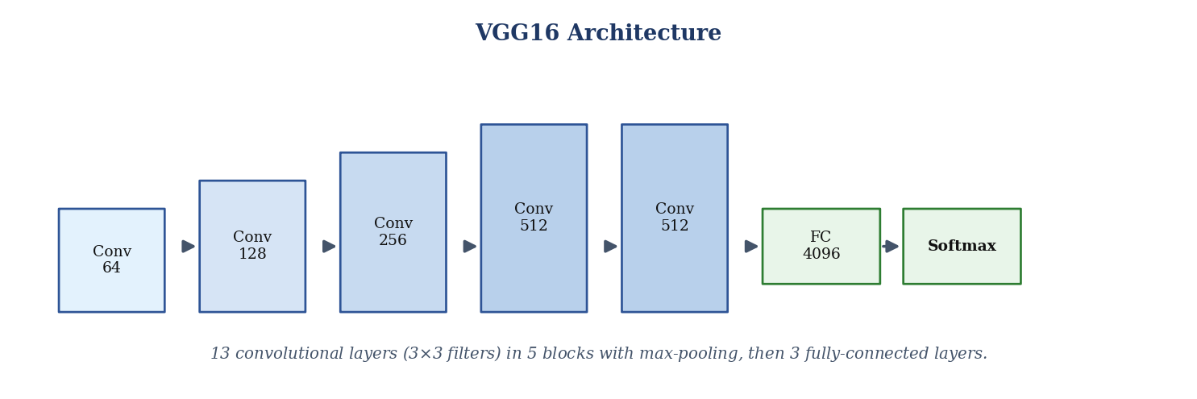
Figure 2.5. VGG16: thirteen 3×3 convolutional layers in five pooled blocks, followed by fully-connected layers and a softmax classifier.
VGG16's importance is historical as well as practical: it showed that a deep stack of tiny 3×3 filters, rather than a few large ones, gives the best trade-off between receptive-field size and parameter count, a principle that every later architecture inherited. Its weaknesses are equally instructive. Almost 90 percent of its parameters sit in the first fully-connected layer, which makes it memory-hungry and prone to over-fitting on small datasets, and it lacks the residual or dense connections that would let it be trained much deeper. In this study VGG16 serves as a strong but deliberately unmodernised baseline against which the benefits of the later designs can be judged.

2.3.2 ResNet50
As networks grew deeper, they became harder to train because gradients tended to vanish. ResNet [4] solved this with the residual block (Figure 2.6), in which a shortcut connection adds the block's input directly to its output, so the layers need only learn a residual correction F(x) rather than a full transformation. This allows networks of fifty or more layers to be trained reliably. ResNet50 is accurate and moderately sized at 23.5 million parameters, and its residual idea is now a standard component of deep architectures.
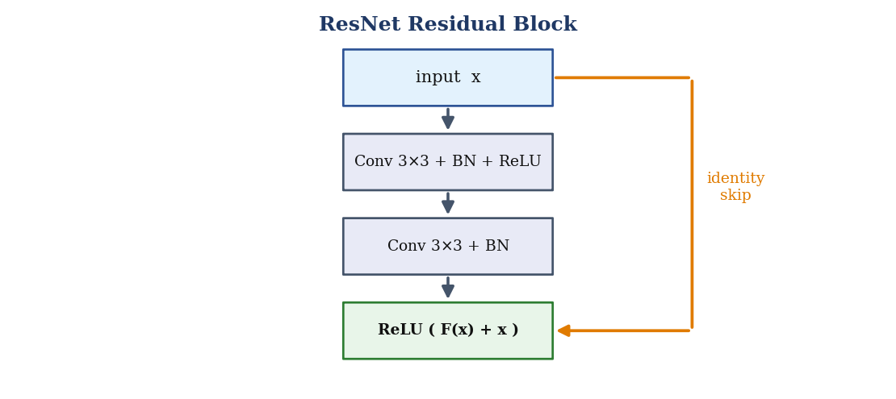
Figure 2.6. A ResNet residual block: an identity shortcut adds the input to the output so the layers learn only a residual, which keeps very deep networks trainable.
The key insight of ResNet is that it is easier for a group of layers to learn a small correction to their input than to learn a full transformation from scratch. By adding the input back to the output, the block only has to model the residual F(x), and if the optimal mapping is close to the identity the layers can simply drive F(x) toward zero. This reformulation removes the degradation problem, whereby adding layers to a plain network paradoxically increased training error, and made networks of fifty, a hundred, or more layers routinely trainable. ResNet50, the fifty-layer variant used here, has become a de facto standard backbone, and its residual connections reappear inside the other modern architectures in this study.

2.3.3 InceptionV3
InceptionV3 addresses the fact that salient features occur at different scales. Its Inception module applies convolutions of several kernel sizes in parallel and concatenates their outputs (Figure 2.7), letting the network capture both fine and coarse structure within a single layer. It also uses factorised convolutions and a larger 299×299 input for efficiency. The result is an accurate network at a moderate 22.3 million parameters, though its more intricate design makes it slightly slower to fine-tune.
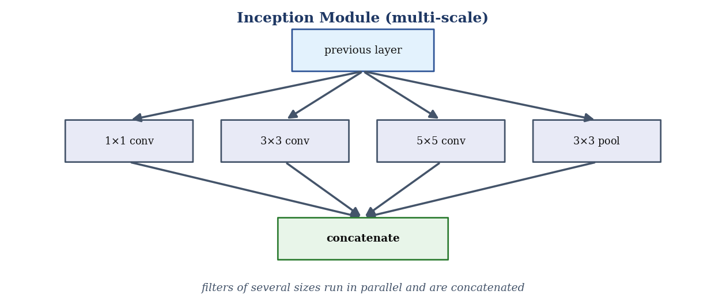
Figure 2.7. An Inception module: convolutions of several kernel sizes run in parallel and their outputs are concatenated, capturing multi-scale features in one layer.
InceptionV3 [5] embodies a different design philosophy: instead of choosing a single kernel size, let the network see the image at several scales at once and learn which to rely on. To keep the parallel branches affordable, it uses 1×1 convolutions to reduce channel depth before the larger convolutions, and it factorises large kernels into sequences of smaller ones (for example a 5×5 into two 3×3s, and an n×n into a 1×n followed by an n×1). These tricks give a wide, expressive network at moderate cost. On the tightly cropped single-leaf images used here, however, there is little genuine scale variation for the multi-scale branches to exploit, which helps explain why InceptionV3 is marginally the weakest of the five in the results of Chapter 4.

2.3.4 DenseNet121
DenseNet [6] takes feature reuse to its logical conclusion: within a dense block, each layer receives as input the concatenated feature maps of all preceding layers (Figure 2.8). This dense connectivity improves gradient flow, encourages the reuse of features, and yields strong accuracy with remarkably few parameters. DenseNet121 has only 7.22 million parameters, less than a third of ResNet50, and it is highly accurate, within a few tenths of a point of the very best models in this study, which makes it an appealing option whenever parameter efficiency matters.
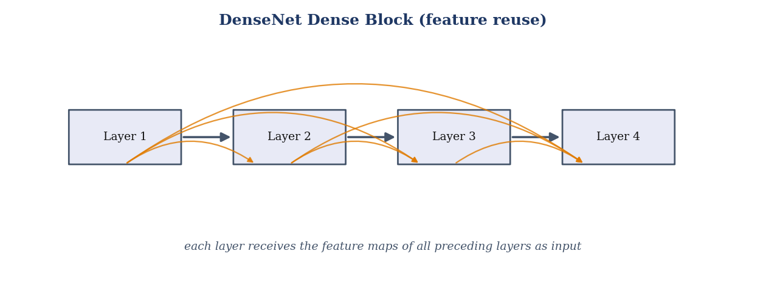
Figure 2.8. A DenseNet dense block: every layer receives the feature maps of all preceding layers, maximising feature reuse and parameter efficiency.
DenseNet's dense connectivity has three consequences that make it well suited to a small dataset. First, because every layer can see all earlier feature maps, the network reuses features aggressively and therefore needs far fewer new filters per layer, which keeps the parameter count low. Second, the short paths from input to output and from loss to every layer improve gradient flow, easing optimisation. Third, the concatenation of many shallow and deep features gives the classifier a rich, multi-level representation to draw on. The price is a higher memory cost at training time, since all intermediate feature maps must be retained, but for a 7.22-million-parameter network this is easily affordable. These properties make DenseNet121 one of the most parameter-efficient of the backbones compared here, matching the accuracy of much larger networks to within a few tenths of a point while using a fraction of their parameters.

2.3.5 MobileNetV2
MobileNetV2 [7] is designed for mobile and edge deployment. Its inverted residual block (Figure 2.9) expands the channel dimension with a 1×1 convolution, applies a cheap depthwise 3×3 convolution, and then projects back to a low-dimensional representation with a linear 1×1 convolution, with a residual connection across the bottleneck. Depthwise-separable convolutions cut the computation dramatically: MobileNetV2 needs only 2.39 million parameters and 0.60 GFLOPs, roughly a fiftieth of VGG16's compute, while remaining highly accurate. It is therefore the natural choice when the model must run on a phone or a low-power device.
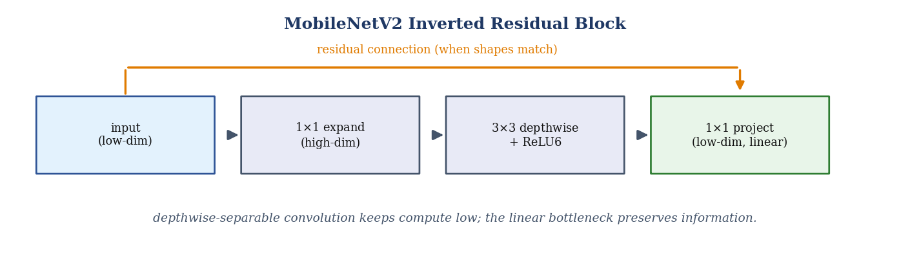
Figure 2.9. A MobileNetV2 inverted residual block: expand, depthwise-convolve, then linearly project, with a residual across the low-dimensional bottleneck.
MobileNetV2's efficiency comes from two ideas working together. A depthwise-separable convolution factorises an ordinary convolution into a per-channel spatial filter followed by a 1×1 combination across channels, cutting the computation by roughly the square of the kernel size. The inverted-residual structure then keeps the memory-heavy high-dimensional representation only inside the block, expanding into it, filtering, and projecting back down to a compact bottleneck across which the residual connection runs. The final projection is deliberately linear, because a ReLU applied in the low-dimensional bottleneck would destroy information. The result is a network that is an order of magnitude cheaper than the others here yet loses only a few tenths of a percent of accuracy, which is exactly the property an in-orchard tool needs.

2.4 Explainable AI and Class Activation Mapping
As deep models are proposed for use in the field, the question of why a model makes a given prediction becomes as important as its accuracy. A grower, an agronomist, or a certifying body has good reason to distrust a black box that offers no evidence for its decision, particularly when that decision may trigger a chemical treatment. Explainable-AI methods address this by exposing the parts of an input that drive a prediction.
For convolutional networks, the most widely used family of such methods is class activation mapping. Gradient-weighted class activation mapping (Grad-CAM), introduced by Selvaraju and colleagues [8], is the variant adopted here. It uses the gradients of the target class score with respect to the final convolutional feature maps to weight those maps, producing a coarse heatmap that highlights the regions most responsible for the prediction. Grad-CAM requires no additional annotation, in contrast to pixel-level segmentation, and applies to any CNN without architectural change. Its limitation is that it is coarse and class-discriminative rather than lesion-precise, which is why the present work treats the resulting localisation as suggestive evidence of where the model attends rather than as a precise segmentation of the lesion.

2.5 Classical Machine Learning for Leaf-Disease Classification
Before deep learning became dominant, plant-disease classification relied on hand-engineered features fed to classical classifiers. Colour histograms, texture descriptors such as those derived from the grey-level co-occurrence matrix, and shape statistics were extracted from segmented leaf regions and passed to models such as support vector machines, k-nearest neighbours, or shallow neural networks. Kaur, Pandey, and Goel [9] surveyed this literature and highlighted both its usefulness and its dependence on carefully chosen features. Al-Hiary and colleagues [10], for example, combined colour and texture features with a neural-network classifier to distinguish several leaf diseases, while broader reviews such as that of Barbedo [11] catalogued the many practical obstacles, illumination, background clutter, and symptom variability, that limit visible-range disease identification. The recurring lesson is that hand-crafted features are brittle: they perform well in the conditions for which they were tuned and degrade sharply outside them, which is precisely the failure mode that deep learning was expected to cure.
It is worth being concrete about why these pipelines fail to generalise. A colour histogram computed under one illumination shifts under another; a texture descriptor tuned to a particular magnification changes when the camera distance changes; and a segmentation step that depends on a plain background breaks down amid soil, sky, and neighbouring leaves. Each stage of a hand-crafted pipeline is a separate point of fragility, and errors compound along the chain. Deep learning replaces this brittle chain with a single, end-to-end trainable function, which is the deeper reason it came to dominate the field, but, as this thesis stresses, an end-to-end model can still be undone by how it is evaluated.

2.6 Deep Learning for Plant-Disease Recognition
Convolutional neural networks changed the field by learning features directly from images. Mohanty, Hughes, and Salathé [12] demonstrated that a CNN trained on the PlantVillage collection could classify dozens of crop-disease combinations with very high accuracy, and many subsequent studies confirmed that transfer learning from ImageNet [2,13] allows strong performance on modest agricultural datasets [14]. The same deep-learning recipe has since been applied across many crops and leaf-disease problems [15,16] and to apple diseases in particular [17]. Comparative studies, such as that of Too and colleagues [18], evaluated several backbones for plant-disease identification and helped establish VGG, ResNet, Inception, DenseNet, and MobileNet as standard choices. Reviews by Saleem and colleagues [19] and by Kamilaris and Prenafeta-Boldú [20] documented the rapid adoption of these methods across agriculture. A recurring theme is that, once transfer learning is used, quite different backbones converge to similar accuracy on plant-disease datasets, which foreshadows a finding of the present work: on clean apple data the choice of backbone matters far less than the integrity of the evaluation.
The history of these architectures is itself instructive. The progression from VGG through ResNet, Inception, and DenseNet to MobileNet is a progression not primarily of accuracy, which saturated early on clean benchmarks, but of efficiency and trainability: residual connections made depth usable, dense connectivity made parameters go further, and depthwise-separable convolutions made deployment on modest hardware realistic. For an agricultural tool this efficiency lineage matters more than a fractional accuracy gain, because the binding constraint in the field is compute and power, not the last decimal of benchmark accuracy. This is why the present study reports efficiency metrics as first-class results rather than as an afterthought.
It is also worth noting what the deep-learning literature has tended not to measure. The overwhelming majority of studies report a single in-domain accuracy on one dataset, and comparatively few report calibration, robustness to distribution shift, per-class behaviour under imbalance, or computational cost. This narrowness of reporting is not merely an omission; it actively obscures the questions that matter for deployment. A model can be highly accurate in-domain yet miscalibrated, brittle under a change of background, hopeless on a minority class, and too heavy for a phone, and none of these failings would be visible in a single headline number. Part of the contribution of this thesis is simply to widen the set of quantities that are reported, so that these otherwise hidden properties become visible.

2.7 Studies on the Same Data: A Detailed Comparison
Because this thesis works with the apple subset of PlantVillage and tests on PlantDoc, it is important to examine closely the studies that use the same or closely related data, to record the accuracies they report, and to be explicit about the conditions under which those accuracies were obtained. Table 2.1 collects representative examples. Two points must be kept in mind while reading it. First, the reported accuracies are those stated by the original authors on their own datasets and splits; they are not the result of a common re-evaluation. Second, and more importantly for this thesis, almost none of these studies control for the on-disk augmentation leakage described in Section 2.9, and almost none test on an independent field dataset, so their high figures describe in-domain, and often leaky, performance rather than field readiness.
Table 2.1. Representative studies on PlantVillage and apple-leaf data with the accuracies reported by their authors. Figures are on different datasets, class counts, and splits and are not directly comparable; the final column names the weakness most relevant to the present study.
Study | Dataset (source) | Cls. | Model | Reported acc. | Weakness relevant to this work
Mohanty et al. 2016 [12] | PlantVillage | 38 | GoogLeNet | 99.35% | Authors note collapse on field images; no leakage control
Sladojevic et al. 2016 [21] | Web images | 13 | CaffeNet | 96.30% | Struggles with complex backgrounds
Ferentinos 2018 [22] | Open plant DB | 58 | VGG | 99.53% | Lab images; accuracy drops sharply on field photos
Too et al. 2019 [18] | PlantVillage | 38 | DenseNet121 | 99.75% | Single dataset; on-disk augmentation, no leakage check
Geetharamani & Pandian 2019 [23] | PlantVillage | 39 | 9-layer CNN | 96.46% | Heavy on-disk augmentation before split
Liu et al. 2018 [24] | Own apple set | 4 | AlexNet-like | 97.62% | Small custom set; no cross-dataset test
Jiang et al. 2019 [25] | ALDD (apple) | 5 | INAR-SSD | 78.80% mAP | Detection mAP; limited generalisation reported
Zhong & Zhao 2020 [26] | AI Challenger apple | 6 | DenseNet121 | 93.71% | Single dataset; imbalance; no field test
Bansal et al. 2021 [27] | Plant Pathology 2020 (apple) | 4 | DenseNet+EfficientNet | 96.25% | Heavy ensemble; small dataset; no field test
This work (in-domain) | PlantVillage apple, leak-free | 4 | ResNet50 | 100.0% | reported with verified disjoint splits
This work (zero-shot) | PlantDoc / FGVC8 (real field) | 3 / 4 | ResNet50 | 41.5% / 32.9% | the only genuine field-generalisation figures

Several patterns are visible in Table 2.1. The studies that use PlantVillage directly, Mohanty and colleagues, Too and colleagues, and Geetharamani and Pandian, report accuracies between about 96% and 99.8%, the same range into which this study's in-domain result falls; this is expected, because all of them are measuring performance on the same clean, single-background imagery. The apple-specific studies of Liu and colleagues, Zhong and Zhao, and Bansal and colleagues report somewhat lower figures, reflecting harder or more varied datasets, but they too are single-dataset, in-domain evaluations. Jiang and colleagues, who tackle detection on a genuinely field-oriented apple dataset, report a markedly lower mAP of about 79%, which is consistent with the central message of this thesis: performance falls substantially once the imagery is realistic.
The weaknesses recorded in the final column recur across the table. Almost every study enlarges its data with augmentation written to disk before splitting, so its reported accuracy is vulnerable to the leakage described in Section 2.9. Almost none reports a verified disjoint split at the level of the physical leaf. And with the partial exception of the detection work, none evaluates on an independent field dataset, so none can substantiate the deployment claims it makes. These are not isolated oversights; they are the standard practice that this thesis sets out to correct.
It is worth examining several of these studies individually, both to give due credit to their contributions and to be precise about the limitations that motivate the present work.
Mohanty, Hughes, and Salathé (2016) were among the first to demonstrate the power of deep learning for plant-disease recognition at scale, training GoogLeNet and AlexNet on the full 38-class PlantVillage collection and reporting 99.35% accuracy. Their study is a landmark, and to their credit the authors themselves observed that accuracy fell dramatically when the model was tested on images taken under conditions different from the training set, an early warning of exactly the field gap this thesis quantifies. What their study did not do, and could not have been expected to do at the time, was control for augmentation leakage or provide a systematic field evaluation, so its headline figure describes in-domain performance on controlled imagery.
Too and colleagues (2019) conducted a careful comparison of fine-tuned backbones on PlantVillage and found DenseNet to be the strongest, reporting accuracy close to 99.75%. Their finding that DenseNet is among the leading backbones is consistent with the present study, in which DenseNet121 is one of several models within a few tenths of a point of the top; in the run reported here ResNet50 and InceptionV3 reach the highest in-domain accuracy, which only underlines how little the choice of backbone matters on this clean data. However, their evaluation, like most, was single-dataset and did not verify disjoint splits at the leaf level, so the absolute figure is subject to the same leakage caveat.
Geetharamani and Pandian (2019) trained a nine-layer convolutional network from scratch on PlantVillage and reported 96.46% across 39 classes, using extensive on-disk augmentation to enlarge the training set. Their work illustrates the very practice this thesis warns against: when augmentation is performed before splitting, its apparent benefit is inflated by the near-duplicates it introduces across partitions, and the reported gain from augmentation cannot be trusted as a measure of improved generalisation.
Turning to apple-specific work, Liu and colleagues (2018) built a dedicated apple-leaf dataset and an AlexNet-style network, reporting 97.62% on four classes. Their focus on apples and their attention to network design are valuable, but the dataset was custom and modest in size, and no cross-dataset test was performed, so the result again describes in-domain accuracy on a single source.
Zhong and Zhao (2020) applied DenseNet121 with regression, focal-loss, and label-smoothing variants to the AI Challenger apple dataset, reporting around 93.71% across six categories and paying welcome attention to class imbalance. Their lower accuracy reflects a harder, more varied dataset, yet the evaluation remains single-dataset and in-domain, and field generalisation is not measured.
Jiang and colleagues (2019) are among the few to work with a genuinely field-oriented apple dataset, framing the problem as object detection and reporting a mean average precision of about 78.8% with an improved single-shot detector. Their markedly lower score, on more realistic imagery, is entirely consistent with the central message of this thesis: performance falls substantially once the pictures look like real orchard photographs rather than laboratory scans.
Bansal and colleagues (2021) tackled the Plant Pathology 2020 apple dataset with an ensemble of DenseNet and EfficientNet models, reporting about 96.25% on four classes. Ensembling is an effective way to squeeze out accuracy, but it multiplies the computational cost, which runs counter to the deployability that agricultural tools require, and the evaluation again does not include an independent field test.
Read together, these studies establish two things. First, deep learning genuinely works for apple-leaf disease on clean data, and the community has converged on architectures, DenseNet prominent among them, that this thesis also finds effective. Second, and just as clearly, the field as a whole has under-invested in the two things that determine whether these models are useful in practice: leakage-free evaluation and field validation. The present work is a direct response to that second observation.

2.8 Segmentation Approaches for Disease Localisation
A parallel strand of research goes beyond classification to localise the diseased region. Semantic-segmentation networks such as U-Net [28], with its encoder-decoder structure and skip connections, and DeepLabV3+ [29], with its atrous spatial pyramid pooling, can in principle label each pixel as diseased or healthy and thereby support severity estimation. These methods, however, require pixel-accurate ground-truth masks, which are expensive to produce and, when generated automatically by thresholding, are often unreliable. As a result, reported segmentation scores are only meaningful to the extent that the underlying masks are trustworthy, a caveat that is frequently understated. This thesis returns to this point directly in Chapter 3 and, having found the available masks unreliable, adopts a weakly-supervised localisation method, Grad-CAM, that avoids the dependence on masks entirely.
The trade-off between the two localisation routes is worth stating plainly. Pixel-level segmentation, when its masks are trustworthy, yields a precise lesion boundary that supports quantitative severity estimation, the fraction of leaf area affected, which is agronomically valuable. Weakly-supervised class activation mapping yields only a coarse, qualitative heatmap, but it needs no masks and cannot be corrupted by bad ones. For a dataset whose supplied masks are demonstrably unreliable, the coarse-but-honest option is clearly preferable to the precise-but-false one, and that is the choice this thesis makes; the door to genuine severity estimation is left open for future work, conditional on trustworthy annotations becoming available.

2.9 Data Leakage in Plant-Disease Benchmarks
A growing methodological literature warns that many high accuracy figures on datasets such as PlantVillage are inflated by data leakage. Shorten and Khoshgoftaar's survey of image augmentation [30] notes that augmentation is a training-time technique; when augmented copies are instead written to disk and then split into partitions, near-duplicates of test images appear in the training set. Sun, Liang, and Fu [31] documented this specific failure for deep-learning plant-disease benchmarks and showed that accuracy collapses once duplicates are removed and the split is made leak-free. The implication is stark: a substantial part of the apparent progress in this area may reflect memorisation of near-duplicate images rather than genuine disease recognition. Any credible study must therefore demonstrate that its splits are disjoint at the level of the physical leaf, not merely at the level of the image file, which is exactly the guarantee the present work provides.

2.10 State of the Art: A Quantitative Comparison
It is instructive to place the reported accuracies of prior work side by side, provided the comparison is read with the right caveats. Figure 2.10 and the discussion above collect representative results. The essential caveat, established in Table 2.1, is that these numbers are not directly comparable: they were obtained on different datasets, with different class counts (from three to thirty-eight), and under evaluation protocols that in most cases did not control for data leakage. A high figure on a leaky split cannot be compared like-for-like with a figure on a leakage-free split, and even setting leakage aside the differing class counts mean the studies are not measuring the same task.
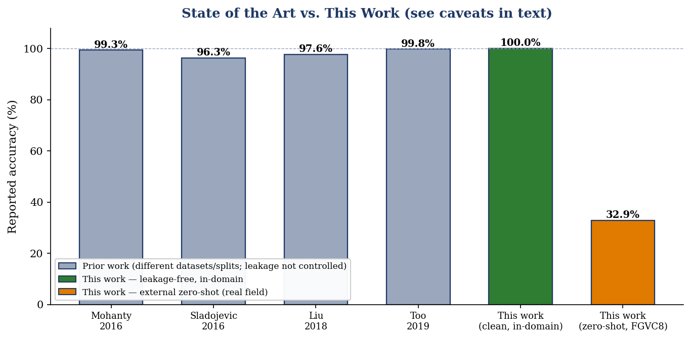
Figure 2.10. Reported accuracies of representative prior work alongside this study. Prior figures are on different datasets and splits and are generally not leakage-controlled; the two bars for this work separate the leakage-free in-domain result from the external zero-shot field result.
Read correctly, the figure tells the story that motivates this thesis. The prior results cluster in the mid-to-high nineties, and it is tempting to conclude that the problem is solved. This study's own leakage-free in-domain result sits in the same range and, taken alone, would reinforce that impression. The decisive bar is the last one: the external zero-shot accuracy on real-field images, which falls to 41.5% on PlantDoc and to only 32.9% on the harder four-class FGVC8, and which no single-dataset study reports because it requires testing on an independent field dataset. The gap between the two rightmost bars, not the height of the in-domain bars, is the real state of the art in this problem, and closing it is where future progress lies.

2.11 Research Gaps and Limitations of Prior Work
Three gaps emerge from this review and directly motivate the present study.

2.11.1 Evaluation Integrity
Much of the reported success on PlantVillage is compromised by data leakage from on-disk augmentation performed before splitting. Studies rarely verify that partitions are disjoint at the leaf level, so their headline accuracy cannot be taken at face value. A leakage-free benchmark with explicitly verified disjoint splits is needed as a baseline.

2.11.2 Absence of Field Validation
Near-perfect accuracy on a single, controlled dataset says little about orchard performance. Few studies test their models on independent, real-field imagery, and fewer still distinguish between a genuine out-of-distribution test and an evaluation in which field data has been added to training. Claims of deployment readiness are therefore often unsupported.

2.11.3 Unreliable Localisation and Unsupported Numbers
Segmentation contributions are commonly reported against masks whose quality is not established, and some comparative tables cite precise gains that cannot be reproduced from the described method. Interpretability that does not depend on unreliable labels, and comparisons that report only reproducible quantities, are both needed.

2.12 How This Work Differs from Prior Studies
Against the weaknesses catalogued above, the contribution of this thesis can be stated precisely as a set of departures from standard practice. Where prior studies enlarge the data with on-disk augmentation before splitting, this work de-duplicates to one image per leaf and augments only at training time, and it verifies the resulting split to be disjoint. Where prior studies report a single in-domain accuracy, this work reports accuracy alongside precision, recall, F1, ROC-AUC, and the efficiency costs of parameters, latency, and FLOPs, and it measures the true effect of augmentation with a controlled ablation. Where prior studies claim deployment readiness without field evidence, this work tests on real-field PlantDoc images and, critically, keeps the external zero-shot result separate from the cross-validation result. And where prior studies report pixel-level segmentation against masks of unestablished quality, this work localises with mask-free Grad-CAM and treats the result as suggestive rather than exact. In short, the present study does not claim a better architecture; it claims a more honest and reproducible measurement, and it shows what the numbers look like once that measurement is in place.

2.13 Position of the Present Work
Against this background, the present work is deliberately conservative in what it claims and careful in how it measures. It rebuilds the four-class apple dataset so that exactly one image represents each leaf and verifies that the splits are disjoint. It compares five backbones under one protocol and reports efficiency alongside accuracy. It measures the true effect of augmentation on the clean split. It replaces pixel-level segmentation, which the available masks could not support, with mask-free Grad-CAM localisation. Finally, it tests on real-field PlantDoc images and keeps the external zero-shot result strictly separate from the cross-validated result. The aim is not to report the highest possible number but to report numbers that can be trusted.

Chapter 3: Materials and Methods
This chapter describes the complete pipeline used in the study: how the leakage-free dataset was built, how images were preprocessed and augmented, which models were trained and how, how disease regions were localised without mask supervision, how field readiness was measured on an independent dataset, and the metrics and computing environment used throughout. The guiding principle is that every reported number should be reproducible from the described procedure.

3.1 Framework Architecture and Pipeline Overview
The complete framework is organised as an end-to-end pipeline with four stages, shown in Figure 3.1. First, the raw apple images are de-duplicated to one image per physical leaf and split into disjoint training, validation, and test partitions, with class weights and a train-time augmentation policy prepared for the imbalanced data. Second, five ImageNet-pretrained CNN backbones are fine-tuned on the training partition with a two-phase transfer-learning schedule and class-weighted loss, and the best of them is selected. Third, that best classifier feeds four evaluation heads: an in-domain test with efficiency metrics, an augmentation ablation, Grad-CAM weak localisation, and a field evaluation on two independent datasets (PlantDoc and FGVC8). The design deliberately separates the honest in-domain measurement from the field measurement, and keeps the external zero-shot result apart from the cross-validation result.
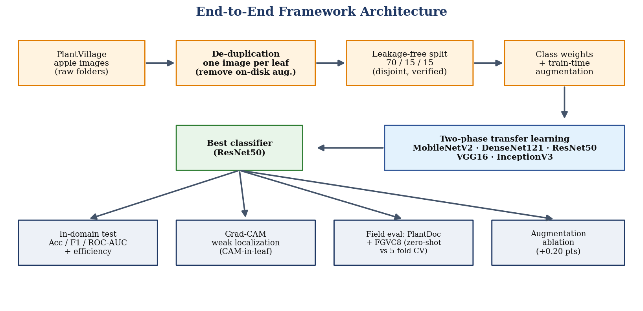
Figure 3.1. End-to-end architecture of the proposed framework, from raw images through leakage-free preparation and multi-backbone training to the four evaluation heads.
Each stage is described in detail in the sections that follow. The architecture is intentionally modular: the data-preparation stage is independent of the model, so any backbone can be dropped in without changing the split; and the evaluation heads are independent of one another, so the field study and the localisation study can be run or omitted without affecting the in-domain numbers. This modularity is what makes the pipeline reproducible and its individual claims separately verifiable.
The design also reflects a deliberate separation of concerns between measurement and modelling. The data-preparation stage is where the study makes its strongest methodological commitment, one leaf per image, verified disjoint splits, and everything downstream inherits that integrity. The modelling stage is intentionally conventional, five standard backbones under a standard schedule, because the thesis is not proposing a new architecture and does not want its conclusions to depend on modelling tricks. The evaluation stage is where the study is most thorough, precisely because the literature is weakest there. Reading the pipeline in this way, most of the intellectual content lies at the two ends, in how the data is prepared and how the model is evaluated, rather than in the middle.

3.2 Dataset Preparation and the Data-Leakage Problem
The images are drawn from the public PlantVillage repository, restricted to the four apple categories: apple scab, black rot, cedar apple rust, and healthy. It is important to be explicit about a preparation flaw that affects much prior work and that early versions of this project also contained. In that flawed preparation, the dataset is enlarged by writing many augmented versions of each leaf, rotations, flips, and colour shifts, to disk, and the files are partitioned only afterwards. Because rotations and flips of a single leaf are visually near-identical, this ordering places near-duplicates of the test leaves into the training set and leaks the test distribution into training. Reported accuracy under such a split measures memorisation, not generalisation.
To remove this flaw, all on-disk augmented copies were discarded and the collection was reduced to exactly one image per physical leaf before any split was made. In the raw release the four apple folders together held on the order of 7,800 image files (approximately 1,987 black rot, 2,016 scab, 1,794 rust, and 2,050 healthy), the great majority of which were augmentation copies, rotations, flips, and colour-shifted variants, rather than distinct leaves. De-duplication proceeded by grouping files that derived from the same source leaf and retaining a single representative image from each group, which reduced the set to the 3,247 distinct-leaf images listed in Table 3.1. Augmentation is reintroduced later, but only at training time and only on the training partition (Section 3.4), so that the evaluation remains honest. This single change is the most consequential decision in the study, and it is the reason the corrected results differ from the inflated figures reported in earlier drafts. The disjointness of the resulting split was then verified directly, as described in the next section.
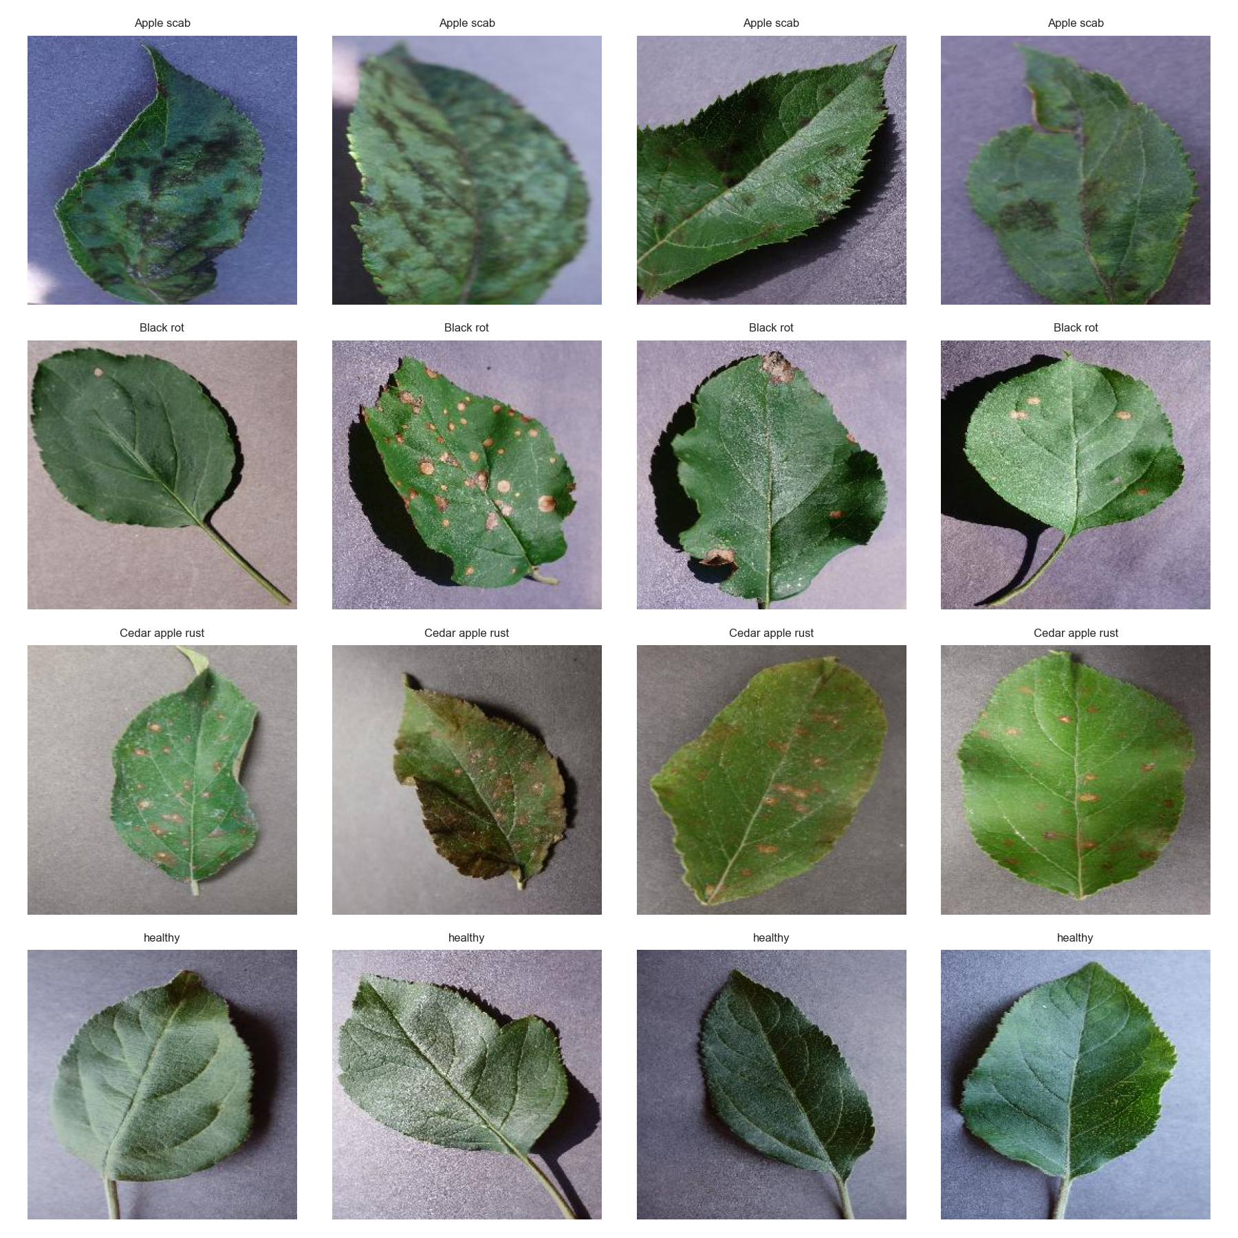
Figure 3.2. Representative apple-leaf images from the four classes of the de-duplicated PlantVillage subset (apple scab, black rot, cedar apple rust, and healthy).

3.2.1 The PlantDoc Field Dataset
PlantVillage alone cannot answer whether a model is ready for the field, because every one of its leaves is photographed under controlled conditions against a plain background. To provide a genuine field test, this study also uses PlantDoc, an independently collected dataset of plant-disease images taken in situ, with the natural clutter, variable lighting, shadows, and mixed backgrounds of real photography. PlantDoc was restricted to the three apple classes it shares with the study set, apple scab, cedar apple rust, and healthy; it contains no black-rot examples, so that class is necessarily absent from the field evaluation. PlantDoc is the publicly released dataset of Singh and colleagues [32], collected from real field and web photographs rather than under laboratory conditions. After restriction to the three shared apple classes, it provides 287 usable images, distributed as 93 apple scab, 106 cedar apple rust, and 88 healthy. These 287 images are far fewer than the PlantVillage subset, which is why, as Section 3.8 explains, cross-validation rather than a single held-out split is used whenever PlantDoc images take part in training. The two datasets differ sharply in difficulty, and that difference is precisely what the field evaluation is designed to measure.

3.2.2 The FGVC8 (Plant Pathology 2021) Field Dataset
Because PlantDoc lacks a black-rot class and is small, a second and larger real-field dataset is used: Plant Pathology 2021, the FGVC8 challenge dataset [33], which comprises around 23,000 apple-leaf photographs taken in real orchard conditions at varying distances, angles, and light. Its labels are apple scab, cedar apple rust, frogeye leaf spot, powdery mildew, complex, and healthy. Two preparation steps align it with the study. First, only single-label images belonging to scab, cedar apple rust, frogeye leaf spot, or healthy are kept, and the powdery mildew, complex, and multi-labelled images are discarded. Second, frogeye leaf spot is mapped to black rot, which is justified because both are the expression of the same fungus, Botryosphaeria obtusa: frogeye leaf spot is its leaf phase and black rot its fruit and canker phase, so an image of frogeye leaf spot is precisely an image of the black-rot pathogen on a leaf. After exact-duplicate removal and a balanced cap of 700 images per class, this yields a four-class field set of 2,800 images that, unlike PlantDoc, includes black rot and so allows the field evaluation to cover all four classes.

3.3 Leakage-Free Splits
The de-duplicated apple set was divided into training, validation, and test partitions in an approximate 70/15/15 ratio, stratified by class. Because de-duplication guarantees that no leaf appears twice, the partitions are disjoint by construction. This was verified explicitly by comparing image paths across partitions; the number of overlapping paths between every pair of splits was zero, confirming the absence of leakage. Table 3.1 lists the resulting class distribution. The final leakage-free PlantVillage subset contains 3,247 images: 2,271 for training, 486 for validation, and 490 for testing.
Table 3.1. Leakage-free apple-leaf dataset distribution (one image per leaf). PlantDoc serves only for field cross-validation, so it is not split into train, validation, and test (marked with a dash); its per-class counts are 93 apple scab, 106 cedar apple rust, and 88 healthy.
Class | Train | Validation | Test | Total
Healthy | 1,180 | 253 | 254 | 1,687
Apple Scab | 441 | 94 | 95 | 630
Black Rot | 434 | 93 | 94 | 621
Cedar Apple Rust | 216 | 46 | 47 | 309
Total (PlantVillage) | 2,271 | 486 | 490 | 3,247
PlantDoc (real-field, 3 classes; for CV) | – | – | – | 287

The data are naturally imbalanced: healthy leaves form the majority and cedar apple rust the minority. Rebalancing by duplicating minority images was deliberately avoided, since it would reintroduce the very leakage the study is designed to eliminate. Instead, imbalance is handled with class-weighted training and macro-averaged reporting. The inverse-frequency class weights used are 0.48 for healthy, 1.29 for apple scab, 1.31 for black rot, and 2.63 for cedar apple rust. Figure 3.2 shows the distribution across partitions.
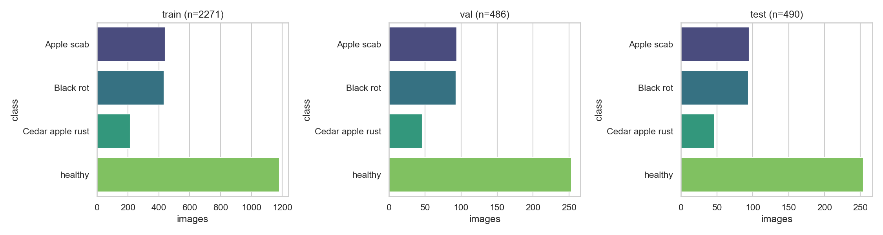
Figure 3.3. Class distribution of the leakage-free apple set across the training, validation, and test partitions.
Figure 3.4 gives a compact overview of the whole data setup: the leakage-free PlantVillage apple set of 3,247 images divided 70/15/15 into disjoint train, validation, and test partitions, and, separately, the 287-image real-field PlantDoc set reserved for the external zero-shot test and the five-fold cross-validation. Keeping these two data sources visually and conceptually distinct is deliberate, because the entire credibility of the field results rests on never letting the zero-shot test see PlantDoc during training.
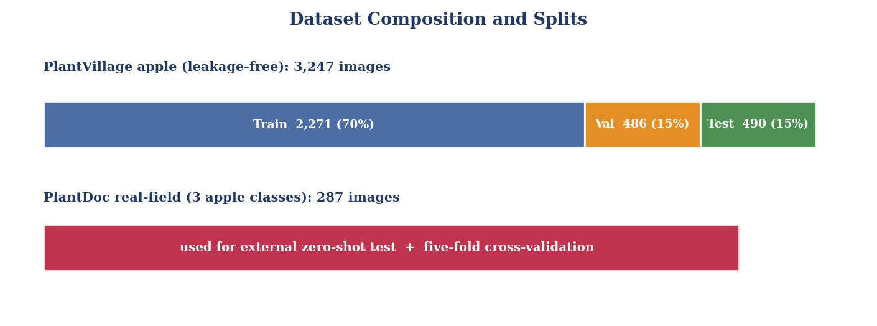
Figure 3.4. Overview of the data: the leakage-free PlantVillage apple set and its disjoint 70/15/15 split, and the separate real-field PlantDoc set used for field evaluation.

3.4 Preprocessing and Augmentation
All images were resized to the input size expected by each backbone, 299×299 pixels for InceptionV3 and 224×224 pixels for the others, and normalised with the ImageNet mean and standard deviation. Validation and test images received only resizing and normalisation, with no augmentation, so that they faithfully represent unseen data.
During training, the classification branch applied a domain-oriented augmentation policy designed to emulate the variability of real orchard photography: random resized cropping with scale in the range 0.6 to 1.0, horizontal and vertical flips, rotation up to plus or minus 35 degrees, brightness and contrast jitter, hue and saturation jitter, small RGB shifts, mild Gaussian blur, coarse dropout, and small shift-scale-rotate perturbations. Crucially, these transforms are applied on the fly during training and are never written to disk, so the before-and-after augmentation comparison reported in Chapter 4 is meaningful rather than an artefact of leakage. Figure 3.5 shows examples of the augmentation policy applied to a single leaf.
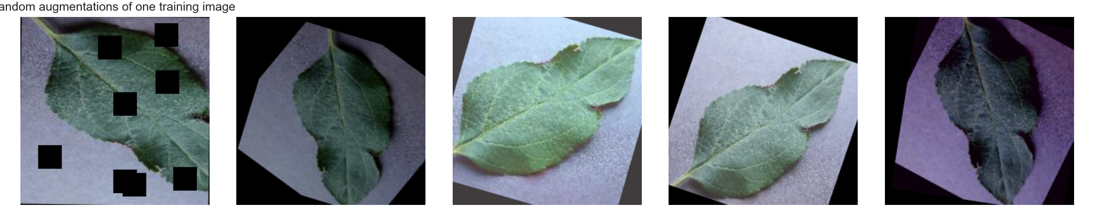
Figure 3.5. Examples of the on-the-fly training augmentation policy applied to a single apple leaf.

3.4.1 Preprocessing Operations
Before augmentation, each image passes through a small set of standard preprocessing operations that improve consistency and, where useful, suppress noise. These operations are described here for completeness, since the quality of the input directly affects what the network can learn.
Resizing and normalisation. Every image is resized to the backbone input size and its pixel intensities are rescaled. Min-max normalisation maps the intensity range to the unit interval, which stabilises optimisation by keeping activations in a predictable range:
I_norm(x,y) = ( I(x,y) − I_min ) / ( I_max − I_min ).
The images are then standardised with the ImageNet channel means and standard deviations, so that the statistics of the input match those the pretrained backbone expects. Resizing itself uses bilinear interpolation, in which each output pixel is a distance-weighted average of its four nearest input pixels.
Optional denoising. Where sensor noise is present, a Gaussian filter can be applied. The two-dimensional Gaussian kernel is
G(x,y) = (1 / 2πσ²) · exp( − (x² + y²) / 2σ² ),
where σ controls the amount of smoothing, and the filtered image is the convolution of the input with G. A median filter, which replaces each pixel with the median of its neighbourhood, is an alternative that removes impulse noise while preserving edges better than Gaussian smoothing. For the clean PlantVillage images these steps are largely unnecessary, but they matter for the noisier field imagery.
Contrast enhancement. Histogram equalisation can be used to spread intensity values more evenly and so emphasise low-contrast lesions. The transformation maps an intensity level r_k to
s_k = (L − 1) · Σ_{j=0..k} p_r(r_j),
where L is the number of intensity levels and p_r is the normalised histogram of the image. Because aggressive contrast changes can also distort the colour cues that distinguish the diseases, equalisation is used sparingly and is not part of the default pipeline for the clean data.

3.4.2 Augmentation Policy in Detail
Table 3.3 lists the individual transforms in the training-time augmentation policy together with their parameters and the real-world variability each is intended to emulate. All transforms are applied stochastically and on the fly, so no augmented image is ever written to disk or enters the validation or test sets.
Table 3.3. Training-time augmentation transforms, their parameters, and the field variability each emulates.
Transform | Parameter | Purpose
Random resized crop | scale 0.6–1.0 | scale and framing variation
Horizontal / vertical flip | p = 0.5 each | orientation invariance
Rotation | ±35° | camera angle variation
Brightness / contrast jitter | moderate | lighting variation
Hue / saturation jitter | small | colour / white-balance variation
RGB shift | small | sensor colour variation
Gaussian blur | mild | focus / motion blur
Coarse dropout | few small holes | partial occlusion
Shift-scale-rotate | small | combined geometric jitter

3.5 Model Selection and Architecture
Five ImageNet-pretrained CNN backbones were fine-tuned and compared: MobileNetV2, DenseNet121, ResNet50, VGG16, and InceptionV3. These were chosen to span the practical trade-off between accuracy and computational cost: MobileNetV2 is a lightweight architecture aimed at mobile and edge deployment, DenseNet121 is a moderately sized, parameter-efficient network, and ResNet50, VGG16, and InceptionV3 are larger, widely used baselines. All five share the same overall structure shown in Figure 3.6: a pretrained convolutional backbone acts as a feature extractor, its spatial output is reduced by global average pooling (or flattening in the case of VGG16), and a compact classification head with a four-way softmax produces the final class probabilities. Only the head is new; the backbone weights are inherited from ImageNet and then fine-tuned.
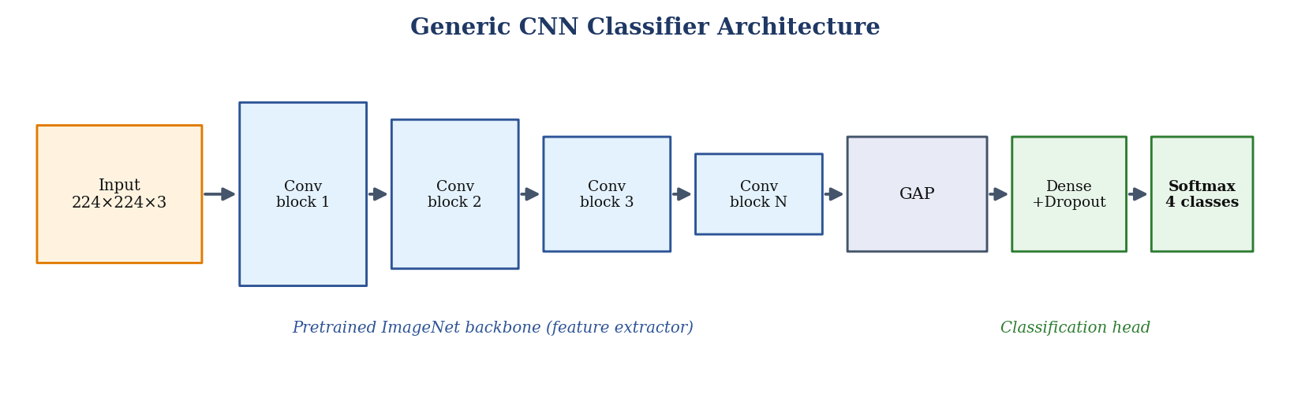
Figure 3.6. Generic architecture shared by all five classifiers: a pretrained ImageNet backbone as feature extractor, followed by global average pooling and a compact classification head with a four-class softmax output.
The five backbones and their distinctive structural ideas, VGG16's uniform 3×3 stacks, ResNet50's residual shortcuts, InceptionV3's multi-scale modules, DenseNet121's dense connectivity, and MobileNetV2's inverted residuals, are described in detail with schematic diagrams in Section 2.3, and are not repeated here. What matters for the methodology is that all five are treated identically: each is initialised from ImageNet weights, fitted with the compact head of Table 3.2, and trained under the single protocol described below. This uniformity is deliberate, because the object of the study is a fair comparison of the backbones rather than a search for the single best-tuned model.
Each backbone is followed by the compact classification head summarised in Table 3.2. The head sizes were kept small and were tuned only lightly. The final layer has four outputs and is trained with class-weighted cross-entropy so that the minority classes are not ignored.
Table 3.2. Classification heads and input sizes used for each backbone.
Model | Classification head | Input size
MobileNetV2 | GAP → 128 → Dropout 0.2 → 4 | 224
DenseNet121 | GAP → 256 → Dropout 0.2 → 4 | 224
ResNet50 | GAP → 4 | 224
VGG16 | Flatten → 512 → Dropout 0.5 → 4 | 224
InceptionV3 | GAP → 256 → Dropout 0.3 → 4 | 299

3.6 Training Protocol
Training followed a two-phase transfer-learning schedule, illustrated in Figure 3.7. In the first phase, the pretrained backbone was frozen and only the new classification head was trained for five epochs at a learning rate of 1e-3. Freezing the backbone at this stage is important: a randomly initialised head produces large, noisy gradients, and allowing those gradients to flow into the pretrained convolutional weights would erode the very ImageNet features that make transfer learning effective. Warming up the head first lets it reach a sensible state before the backbone is touched.
In the second phase, the whole network was unfrozen and fine-tuned for up to 25 epochs at the lower learning rate of 1e-4, with early stopping on validation accuracy (patience of eight epochs) and restoration of the best checkpoint. The lower learning rate allows the backbone to adapt gently to the apple-leaf domain without catastrophic forgetting. The optimiser was AdamW [34] with a weight decay of 1e-4; the batch size was 16; mixed-precision arithmetic was used on the GPU; and the random seed was fixed at 42 to make the experiments reproducible. The same schedule was applied to every backbone, which is what makes the comparison between them fair rather than a reflection of per-model tuning.
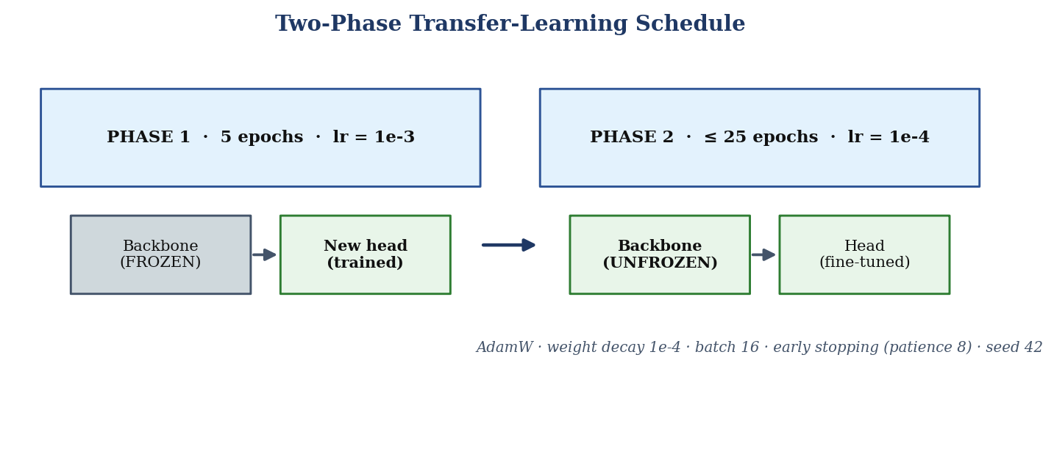
Figure 3.7. The two-phase transfer-learning schedule: a frozen-backbone head warm-up followed by full fine-tuning at a lower learning rate, with early stopping and a fixed seed.
Table 3.4 summarises how the schedule played out for each backbone. All models used the same five-epoch warm-up, and early stopping then halted phase-two fine-tuning once validation accuracy plateaued, between the eleventh and sixteenth epoch depending on the model. That every model converged well within the 25-epoch budget, and to essentially the same validation accuracy, is itself evidence that the training protocol is neither under- nor over-fitting any particular architecture.
Table 3.4. Training summary: warm-up length, fine-tuning epochs to early stopping, and final test accuracy for each backbone.
Model | Phase-1 epochs | Phase-2 epochs (to early stop) | Test accuracy
ResNet50 | 5 | 11 | 100.00%
InceptionV3 | 5 | 11 | 100.00%
MobileNetV2 | 5 | 16 | 99.80%
VGG16 | 5 | 12 | 99.80%
DenseNet121 | 5 | 13 | 99.59%

3.7 Weakly-Supervised Lesion Localisation
Pixel-level segmentation was considered but ultimately set aside, and the reason is worth stating clearly because it explains a change from earlier versions of this project. The binary lesion masks bundled with the source release proved unreliable: for a number of leaves the mask did not overlap the visible lesion, and a standard colour-based lesion detector agreed with the supplied masks at only about 0.17 IoU. Training a U-Net or DeepLabV3+ segmentation model against such labels would optimise the network toward noise, and any high IoU reported against those masks would be meaningless because the ground truth itself is not trustworthy. Reporting such a figure would be misleading, so the pixel-level segmentation claim was dropped.
In its place, disease regions are localised without any mask supervision using gradient-weighted class activation mapping (Grad-CAM) applied to the best classifier. Grad-CAM produces a heatmap over the image indicating the regions most responsible for the predicted class. To turn this into a quantitative check, a leaf mask was obtained at the network input resolution of 224 by 224 pixels by thresholding the saturation and value channels of the HSV colour representation, retaining pixels whose saturation and value fall in the mid-range characteristic of leaf tissue while rejecting the near-white or near-black background, followed by morphological opening and closing to remove speckle and fill small holes. The fraction of Grad-CAM activation energy falling inside this leaf mask was then computed as
CAM-in-leaf = Σ C(x,y)·L(x,y) / Σ C(x,y),
where C(x,y) is the Grad-CAM heat at pixel (x,y) and L(x,y) is the binary leaf mask. A high value indicates that the classifier attends to leaf tissue rather than to the background. It should be read as suggestive, weak-localisation evidence: it shows that attention falls on the leaf, but it does not by itself prove that attention is centred precisely on the lesion. Figure 3.8 summarises the computation: gradients of the predicted class score with respect to the final convolutional feature maps are global-average-pooled into per-channel weights, the feature maps are combined using those weights, a ReLU keeps only the positive evidence, and the result is upsampled and overlaid on the input.
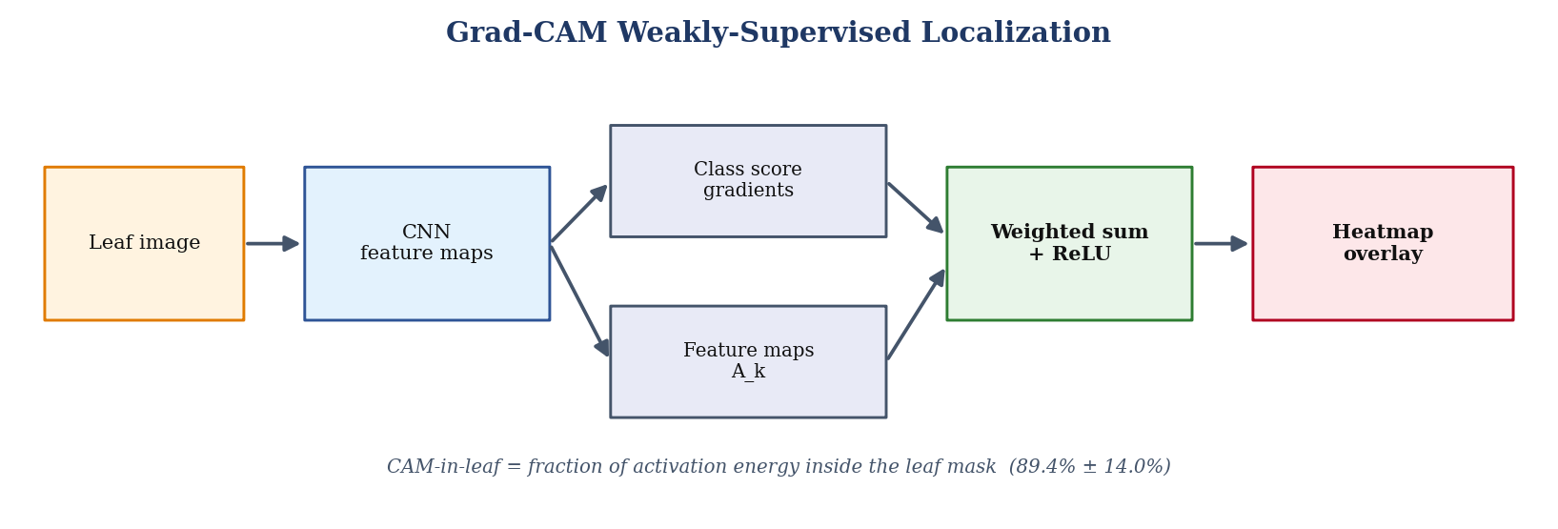
Figure 3.8. Computation of the Grad-CAM localisation map and the CAM-in-leaf score used to quantify how much of the model's attention falls on leaf tissue.

3.8 Cross-Dataset Evaluation Protocol
To gauge field readiness, the same protocol is applied to both real-field datasets, PlantDoc (three classes) and FGVC8 (four classes). For each dataset two clearly distinct measurements are defined, and they must not be conflated.
- External zero-shot evaluation. The PlantVillage-only model is applied directly to all of the field images. No field image is ever used in training, so this is the only genuine measure of out-of-distribution generalisation.
- Five-fold cross-validation. The field dataset is split into five stratified folds; each fold is held out for testing in turn while the other four are added to the PlantVillage training data. Because field images are used in training here, this second protocol measures in-sample adaptation to the field dataset and is not a zero-shot generalisation figure. It is reported as the mean plus or minus the standard deviation over the five folds.
The choice of five-fold cross-validation rather than a single held-out field split is dictated above all by the small size of PlantDoc. With only 287 images across three classes, a single held-out test fold would be so small that its accuracy estimate would be dominated by sampling noise, and a single training fold would waste most of the already scarce field data. Cross-validation uses every image for testing exactly once and for training in the other four folds, which gives both a more stable estimate and a measure of its variability through the spread across folds. The same protocol is applied to FGVC8 for consistency, and because FGVC8 is far larger its estimate is correspondingly tighter. The important caveat, stressed throughout, is that this procedure lets field images influence training, so its result speaks to how well the model adapts to the field, not to how well the laboratory model generalises to it unaided.

3.9 Object Detection of Diseased Leaves
Whole-image classification answers which disease is present, but not where the affected leaf lies within a wider scene. To add an explicit detection capability to the framework, a one-stage object detector is trained to draw a bounding box around each apple leaf and label it with its condition. The detector used is YOLOv11, a modern member of the YOLO (You Only Look Once) family that predicts boxes and class scores in a single forward pass and is well suited to the real-time, in-field setting a deployed system would face.
Detection requires bounding-box annotations, which the leakage-free PlantVillage subset does not provide. The object-detection release of PlantDoc is used instead: it supplies hand-drawn boxes for three apple classes, apple scab, apple rust, and healthy apple leaf, photographed in real field conditions against cluttered backgrounds (it contains no apple black-rot boxes). The Pascal-VOC annotations were converted to the normalised YOLO format and restricted to these three apple classes, and PlantDoc's official train and test partitions were preserved to keep the evaluation honest. This yields 242 training images containing 557 boxes (158 scab, 167 rust, 232 healthy) and 29 held-out test images containing 34 boxes, as summarised in Table 3.9.
Table 3.9. The PlantDoc apple detection subset (three classes with bounding boxes), using the official train/test split.
Split | Images | Boxes | Scab | Rust | Healthy
Train | 242 | 557 | 158 | 167 | 232
Test | 29 | 34 | 13 | 11 | 10

The compact YOLOv11s variant, with roughly nine million parameters, was initialised from COCO-pretrained weights and fine-tuned for 100 epochs at an input resolution of 640 by 640 pixels, with a batch size of 16, a cosine learning-rate schedule, and the detector's built-in mosaic and colour (HSV) augmentations. The smallest model in the family was chosen deliberately: with only a few hundred field boxes available, a larger detector would risk memorising the training images rather than learning to generalise, exactly the over-fitting the rest of the thesis works to avoid. Detection quality is reported with the standard mean average precision at an intersection-over-union (IoU) threshold of 0.5 (mAP@0.5) and averaged over IoU 0.5 to 0.95 (mAP@0.5:0.95), together with precision and recall; test-time augmentation is applied at inference. The random seed is fixed at 42 for reproducibility. The detection results appear in Section 4.7.

3.10 Data-Efficiency and Domain-Adaptation Protocol
The cross-dataset protocol of Section 3.8 establishes that a large gap exists between laboratory and field performance. A more useful question for a practitioner is how that gap can be closed, and in particular how much field data is needed to close it, and whether the leakage-free laboratory model is a better starting point than generic ImageNet features. This is quantified with a data-efficiency study on the four-class FGVC8 field set, balanced at 500 images per class to keep the effect of data quantity separate from the effect of class imbalance.
The design is deliberately simple and controlled. A fixed, stratified 20% of the field images is held out as a test set and is never used for training; crucially, this test split depends only on the random seed and not on the amount of training data, so every point on the resulting curve is evaluated on the same held-out images. A ResNet50 classifier is then trained on increasing stratified fractions of the remaining field images, namely 5%, 10%, 25%, 50%, and 100%, which corresponds to roughly 80, 160, 400, 800, and 1,600 images. Each fraction is trained under two initialisations: from generic ImageNet weights, and from the leakage-free PlantVillage backbone developed in this thesis. To rule out any confound from a mismatch in class order between the laboratory and field label spaces, only the backbone weights are transferred and the classification head is reinitialised in both cases, so the comparison isolates the value of the pretrained features rather than any residual label overlap. Every combination of initialisation and fraction is repeated over three random seeds, and the macro-F1 on the held-out field test set is reported as the mean plus or minus the standard deviation over those seeds. The zero-per-cent point of the curve corresponds to the external zero-shot evaluation already reported in the cross-dataset study. The results appear in Section 4.8.

3.11 Evaluation Metrics
Because the dataset is imbalanced, no single number tells the whole story, so a family of complementary metrics is used. They are defined here in terms of the per-class counts of true positives (TP), true negatives (TN), false positives (FP), and false negatives (FN).
Accuracy is the fraction of all images classified correctly. It is intuitive but can be misleading under imbalance, since a classifier that always predicts the majority class can still score highly:
Accuracy = (TP + TN) / (TP + TN + FP + FN)
Precision is the fraction of images predicted to belong to a class that truly belong to it, and recall (sensitivity) is the fraction of images truly belonging to a class that are recovered:
Precision = TP / (TP + FP) Recall = TP / (TP + FN)
F1 is the harmonic mean of precision and recall, rewarding classifiers that balance the two rather than sacrificing one for the other:
F1 = 2 · (Precision · Recall) / (Precision + Recall)
These per-class quantities are combined by macro-averaging, that is, by taking the unweighted mean across the four classes. Macro-averaging is preferred to global accuracy here precisely because it gives the minority cedar apple rust class the same weight as the majority healthy class, so a model cannot hide poor minority-class behaviour behind strong majority-class performance:
Macro-F1 = (1/C) · Σ F1_c , for classes c = 1 … C
ROC-AUC (the area under the receiver operating characteristic curve) is reported in a one-vs-rest setting for each class and then averaged. It summarises how well the model ranks positive above negative examples across all decision thresholds, and a value of 1.0 indicates perfect separability. Confusion matrices are also reported so that the specific pattern of errors, for example scab confused with black rot, is visible rather than hidden inside an aggregate score.
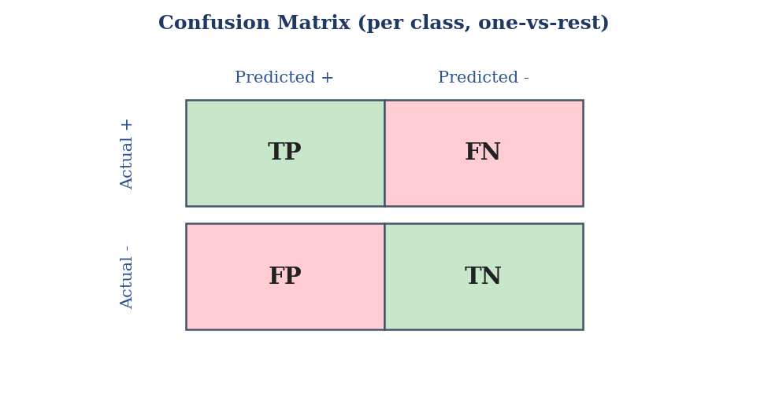
Figure 3.11. The one-vs-rest confusion matrix underlying the metrics: true and false positives and negatives from which precision, recall, and F1 are computed.
Deployment cost is captured by three practical quantities: the number of trainable parameters (a proxy for memory footprint), the single-image inference latency in milliseconds (how fast the model responds), and the number of floating-point operations (FLOPs) per image (a hardware-independent measure of compute). Reporting these alongside accuracy is what allows the claim of deployability to be substantiated rather than merely asserted. Finally, localisation quality is captured by the CAM-in-leaf score defined in Section 3.7. All classification metrics were computed with standard scikit-learn implementations.

3.12 Implementation and Hardware
The pipeline was implemented in Python using PyTorch 2.6 [35], with scikit-learn [36] for metrics and standard imaging libraries for preprocessing and augmentation. All experiments were run on a single NVIDIA RTX 5000 Ada Generation GPU with mixed-precision arithmetic enabled. Fixing the random seed at 42 and recording the exact training configuration, learning rates, schedule, optimiser, batch size, and class weights, means that the reported results can be reproduced from the released code.

3.13 Reproducibility
Reproducibility was treated as a design requirement rather than an afterthought, because the whole argument of the thesis rests on results that others can check. Three measures support it. First, the random seed is fixed at 42 and applied to the data split, the model initialisation of the new heads, and the augmentation sampler, so that a re-run reproduces the same partitions and the same training trajectory. Second, every hyper-parameter that affects the outcome is stated explicitly in this chapter, the per-model input sizes and heads (Table 3.2), the two-phase learning-rate schedule, the optimiser and weight decay, the batch size, the early-stopping patience, and the class weights, rather than left to a default that might change between library versions. Third, the leakage-free split is defined by an explicit list of image paths per partition, and the zero-overlap check is part of the pipeline, so any deviation from a disjoint split would be caught automatically. To support reproducibility, the split files (explicit per-partition image lists), the training and evaluation code, the YOLO data-preparation scripts, and the trained model weights will be released publicly in a GitHub repository archived with a permanent Zenodo DOI, which allows every number in Chapter 4 to be regenerated end to end.
It is honest to acknowledge the limitations of the methodology itself, separately from the limitations of the results. The de-duplication relies on grouping images by their source leaf; where the raw metadata is imperfect this grouping could be imperfect too, although the verified zero path-overlap between splits guards against the most damaging form of error. The field evaluation on PlantDoc is constrained by its size and by its lack of a black-rot class; this is mitigated by the second field dataset, FGVC8, which is large and covers all four classes, but the black-rot field images there arrive through the frogeye-leaf-spot mapping rather than as leaves labelled black rot directly. And the localisation analysis measures only whether attention falls on the leaf, not whether it falls on the lesion, because no trustworthy lesion masks are available to check the latter. None of these limitations undermines the central findings, but stating them plainly is part of the honest-measurement stance the thesis advocates.

Chapter 4: Results and Discussion
This chapter reports the results obtained under the leakage-free protocol described in Chapter 3. It begins with in-domain classification on the clean test set, then examines per-class behaviour, the true effect of augmentation, and, at the centre of the chapter, the field evaluation on two independent real-field datasets, PlantDoc and Plant Pathology 2021 (FGVC8), followed by Grad-CAM localisation, an error analysis, and a discussion. Every number reported here comes from a single, reproducible run; where earlier drafts of this project quoted higher or inconsistent figures, those were products of data leakage or of comparisons that could not be reproduced, and they have been discarded.

4.1 In-Domain Classification
Table 4.1 reports the test-set performance of all five backbones on the leakage-free split, together with their size, latency, and compute. Every model exceeds 99.5% accuracy, and all five reach a one-vs-rest ROC-AUC of 1.000, which confirms that the four apple classes are well separated once the evaluation is honest. Two models, ResNet50 and InceptionV3, classify every test image correctly (100.0% accuracy, macro-F1 1.000); ResNet50 is taken as the primary model in the analyses that follow. MobileNetV2 and VGG16 follow at 99.8%, and DenseNet121 at 99.6%. The differences among the models are therefore tiny, at most four tenths of a percentage point. These differences must be judged against the size of the test set. With 490 images, a Wilson 95% confidence interval on a 100.0% accuracy is [99.2%, 100.0%], on the 99.8% figures it is [98.9%, 100.0%], and on the 99.6% figure it is [98.5%, 99.9%]. Because these intervals overlap almost entirely, the top of the ranking is a statistical tie rather than a meaningful ordering, and the perfect one-vs-rest ROC-AUC of 1.000 should be read the same way, as a consequence of the classes being cleanly separable on this small, leakage-free set rather than as proof of a superior architecture. Importantly, the lightweight MobileNetV2 reaches 99.8% accuracy with only 2.39 million parameters and 0.60 GFLOPs, roughly a tenth of ResNet50's parameters and a fraction of its compute, which makes it the most attractive option for on-device or edge deployment.
Table 4.1. Test-set classification performance on the leakage-free split, with efficiency metrics. Best accuracy (ResNet50, tied with InceptionV3) in bold.
Model | Acc. | Prec. | Recall | F1 | ROC-AUC | Params (M) | Latency (ms) | FLOPs (G)
ResNet50 | 1.0000 | 1.0000 | 1.0000 | 1.0000 | 1.000 | 23.52 | 4.01 | 8.17
InceptionV3 | 1.0000 | 1.0000 | 1.0000 | 1.0000 | 1.000 | 22.31 | 7.73 | 11.42
MobileNetV2 | 0.9980 | 0.9974 | 0.9990 | 0.9982 | 1.000 | 2.39 | 3.49 | 0.60
VGG16 | 0.9980 | 0.9974 | 0.9990 | 0.9982 | 1.000 | 27.56 | 0.99 | 30.72
DenseNet121 | 0.9959 | 0.9938 | 0.9964 | 0.9951 | 1.000 | 7.22 | 9.49 | 5.67

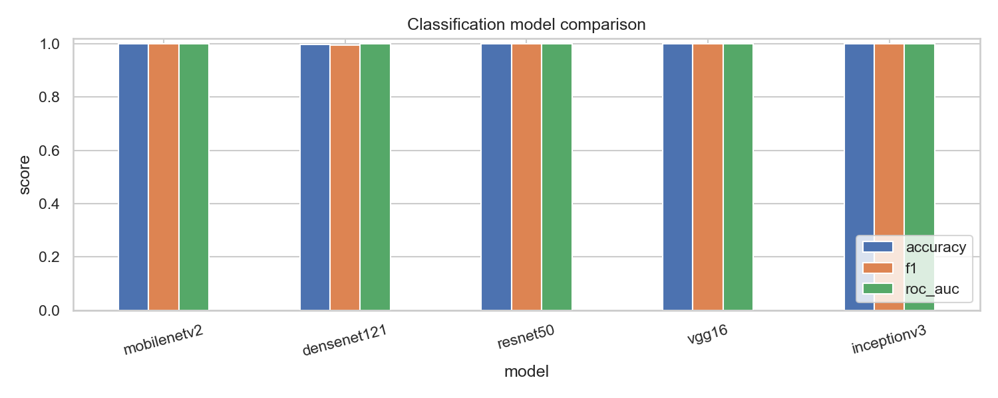
Figure 4.1. Accuracy, F1, and ROC-AUC of the five classification backbones on the leakage-free test set.
Looking across the individual backbones, the ranking is intuitive but the margins are negligible. ResNet50 and InceptionV3 make no test errors at all, MobileNetV2 and VGG16 miss a single image each, and DenseNet121 misses two. That two quite different architectures, one heavy residual network and one multi-scale network, tie at a perfect score, while a model a tenth of their size sits two tenths of a point behind, is the clearest single illustration of the study's efficiency message: on clean apple data the choice of backbone is immaterial to accuracy, and the deciding factor for deployment is cost, not the last fraction of a point.

4.2 Training Behaviour
Before turning to test performance, it is worth confirming that the models trained cleanly, because unstable or over-fitting training would undermine confidence in the final numbers. Figure 4.2 shows the validation-accuracy curves of the two-phase schedule for the five backbones. Three features are visible and reassuring. The short frozen-backbone warm-up over the first five epochs lifts every model into the high nineties quickly, confirming that the ImageNet features transfer well to apple leaves. The transition to full fine-tuning produces a further small gain and no collapse, indicating that the lower learning rate protects the pretrained weights. And early stopping halts each run once validation accuracy plateaus, within a dozen or so fine-tuning epochs, which both saves computation and guards against over-fitting. The curves for the different backbones are tightly bunched, a first indication of the finding, developed below, that architecture choice matters little on this clean data.
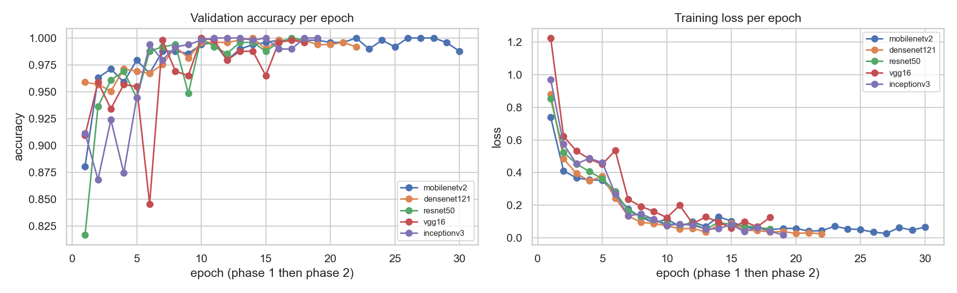
Figure 4.2. Validation-accuracy curves under the two-phase transfer-learning schedule for the five backbones. All models converge quickly and are halted by early stopping.

4.3 Per-Class Performance
Table 4.2 gives the per-class F1 score for every model; the test set on which these are computed contains 95 apple scab, 94 black rot, 47 cedar apple rust, and 254 healthy images (490 in total). The best model, ResNet50, and InceptionV3 recognise every class perfectly. Across all models the weakest per-class F1 is 0.989, and the few residual errors involve either cedar apple rust, the smallest class, or the black-rot and scab pair, whose dark necrotic lesions can resemble one another. The confusion matrix and ROC curves of the best model, ResNet50, are shown in Figure 4.3: all 490 test images fall on the diagonal, and every one-vs-rest ROC curve reaches an area of 1.000.
Table 4.2. Per-class F1 score on the leakage-free test set.
Model | Apple Scab | Black Rot | Cedar Apple Rust | Healthy
ResNet50 | 1.000 | 1.000 | 1.000 | 1.000
InceptionV3 | 1.000 | 1.000 | 1.000 | 1.000
MobileNetV2 | 1.000 | 0.995 | 1.000 | 0.998
VGG16 | 1.000 | 0.995 | 1.000 | 0.998
DenseNet121 | 0.995 | 1.000 | 0.989 | 0.996

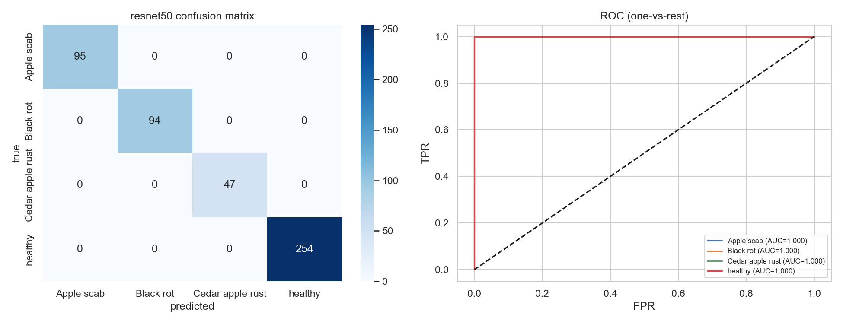
Figure 4.3. Confusion matrix (left) and one-vs-rest ROC curves (right) for the best model, ResNet50, on the leakage-free test set.
Figure 4.4 extends this view to all five backbones, showing their confusion matrices side by side. The matrices are almost purely diagonal for every model; the few off-diagonal entries are concentrated, as expected, in the black-rot and scab cell, while cedar apple rust and healthy are essentially never confused with anything else. The consistency of this pattern across architectures reinforces that the residual difficulty lies in one specific visual similarity rather than in any model-specific weakness.
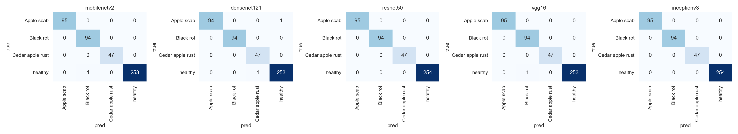
Figure 4.4. Confusion matrices for all five backbones on the leakage-free test set. Off-diagonal errors are rare and concentrated in the black-rot / scab pair.

4.4 The Honest Effect of Augmentation
A frequent claim in the literature is that data augmentation yields several accuracy points. On a leaky split this apparent gain is largely an artefact, because augmentation simply multiplies the near-duplicate images that already bridge the training and test sets. To measure the real contribution, the best model was trained twice on the clean split, once with augmentation disabled and once with it enabled, and the test accuracy was compared. As Table 4.3 shows, augmentation improves accuracy by only 0.2 points, from 99.8% to 100.0%. Augmentation remains worthwhile, but on a clean, in-domain split its true effect is modest; its larger value appears under distribution shift, as the field section demonstrates.
Table 4.3. Honest augmentation ablation for the best model (ResNet50) on the leakage-free test set.
Setting | Test accuracy
Without augmentation | 99.80%
With augmentation | 100.00%
Honest gain | +0.20 points

4.5 Field Evaluation on Two Independent Datasets
In-domain accuracy on PlantVillage says little about orchard performance, because PlantVillage leaves are photographed against a uniform background. The field readiness of the model is therefore tested on two independent real-field datasets: PlantDoc, which shares three apple classes with the study set (it has no black rot), and Plant Pathology 2021 (FGVC8), a large field dataset that, after the mapping of frogeye leaf spot to black rot, covers all four classes. Using two field datasets, rather than one, makes the field conclusions far more robust, and the FGVC8 set in particular closes the earlier gap in which black rot could not be evaluated in the field.
For each dataset two clearly separated numbers are reported in Table 4.4, and they answer different questions. The external zero-shot evaluation applies the PlantVillage-only model to the field images without ever training on any of them, and is the only genuine test of generalisation. The five-fold cross-validation instead mixes field images into training; because field images are seen during training, its result reflects in-sample adaptation and is deliberately not presented as generalisation.
Table 4.4. Field evaluation on two independent real-field datasets. The zero-shot column uses no field image in training; the cross-validation column mixes field images into training and is therefore an adaptation, not a generalisation, result.
Field dataset (classes) | External zero-shot | Five-fold CV (field mixed in)
PlantDoc (3 classes) | 41.46% | 81.90% ± 6.56%
FGVC8 (4 classes) | 32.86% | 94.07% ± 1.26%

The pattern is consistent across both datasets and is the central practical finding of the study. Zero-shot, the laboratory-trained model collapses, to 41.5% on PlantDoc and to only 32.9% on the harder four-class FGVC8, a stark reminder that laboratory accuracy does not transfer directly to the field. Once field images are added to training under cross-validation, accuracy recovers, and the recovery is far stronger on FGVC8 (94.1%) than on PlantDoc (81.9%), because FGVC8 is much larger and so supplies far more field examples per fold. The much smaller standard deviation on FGVC8 (1.3% versus 6.6%) reflects the same size advantage. The essential message is that field performance is governed by the availability of field training data, not by the choice of architecture.
On the four-class FGVC8 set the per-class behaviour under cross-validation is given in Table 4.5, and the aggregated confusion matrix in Figure 4.5. All four classes, including black rot, are recovered well: cedar apple rust is the strongest at an F1 of 0.97, black rot reaches 0.95, and apple scab is the hardest even here, at an F1 of 0.91, because its subtle early lesions remain the most easily confused symptom. This is the first field evaluation in the study to include black rot, and its strong result (recall 0.96) confirms that the frogeye-leaf-spot images map cleanly onto the black-rot class.
Table 4.5. Per-class performance under five-fold cross-validation on the four-class FGVC8 field dataset.
Class | Precision | Recall | F1 | Support
Apple Scab | 0.90 | 0.92 | 0.91 | 700
Black Rot | 0.94 | 0.96 | 0.95 | 700
Cedar Apple Rust | 0.99 | 0.95 | 0.97 | 700
Healthy | 0.93 | 0.94 | 0.94 | 700
Weighted avg | 0.94 | 0.94 | 0.94 | 2,800

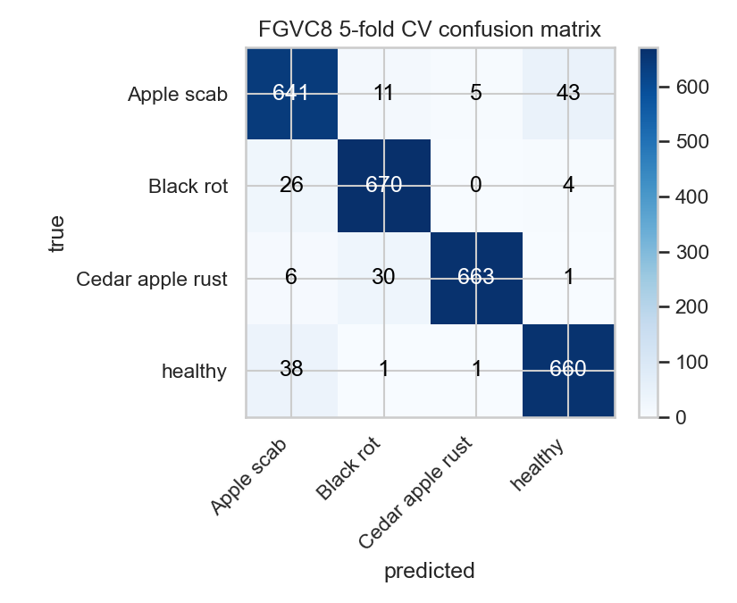
Figure 4.5. Aggregated confusion matrix over the five FGVC8 cross-validation folds (four classes; each image tested once).
The per-fold accuracies on FGVC8 (Table 4.6) are tightly clustered between 92.7% and 96.3%, which, together with the small standard deviation, indicates a stable estimate on this larger field set.
Table 4.6. FGVC8 five-fold cross-validation: per-fold accuracy and image counts (each image tested exactly once).
Fold | Test images (n) | Accuracy
1 | 560 | 92.68%
2 | 560 | 96.25%
3 | 560 | 94.46%
4 | 560 | 93.93%
5 | 560 | 93.04%
Mean ± SD | 2,800 total | 94.07% ± 1.26%

On the three-class PlantDoc set the per-class behaviour under cross-validation is given in Table 4.7, with the confusion matrix in Figure 4.6. The pattern echoes the FGVC8 result but is sharper because PlantDoc is smaller and harder: cedar apple rust and healthy transfer well, while apple scab is the clear weak point, its recall falling to 0.61, because early scab lesions are subtle and easily lost against the cluttered PlantDoc backgrounds. That apple scab is the hardest class on both field datasets is a consistent and useful signal about where a deployed system would most need additional data.
Table 4.7. Per-class performance under five-fold cross-validation on the three-class PlantDoc field dataset.
Class | Precision | Recall | F1 | Support
Apple Scab | 0.88 | 0.61 | 0.72 | 92
Cedar Apple Rust | 0.77 | 0.97 | 0.86 | 105
Healthy | 0.87 | 0.88 | 0.87 | 88
Weighted avg | 0.83 | 0.82 | 0.81 | 285

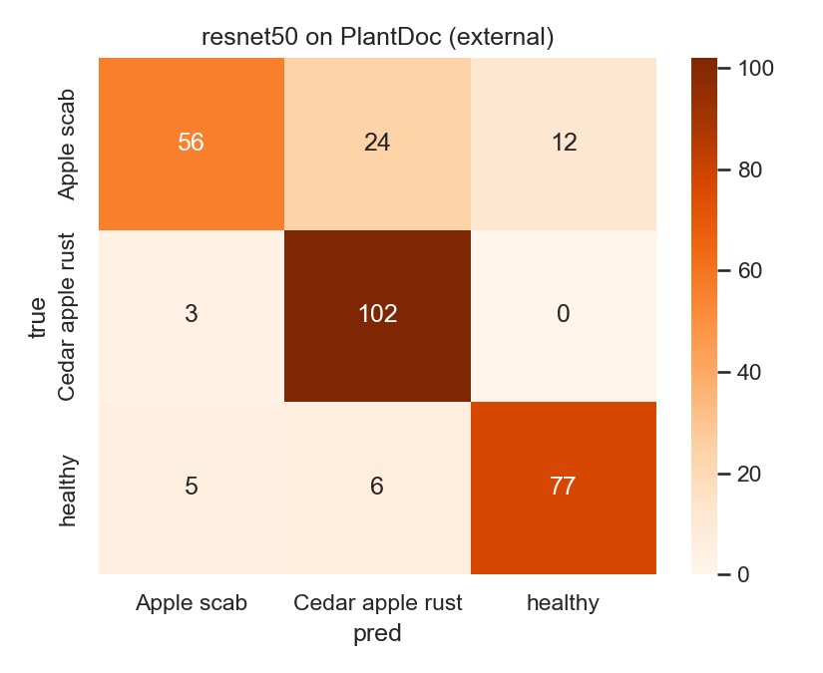
Figure 4.6. Aggregated confusion matrix over the five PlantDoc cross-validation folds (three classes; each image tested once).

4.6 Lesion Localisation with Grad-CAM
Without any lesion masks, Grad-CAM applied to the best model, ResNet50, places 89.4% plus or minus 14.0% of its activation energy inside the leaf region, averaged over the sampled test images. Qualitatively, the heatmaps tend to fall on leaf tissue, and often near visible lesions for diseased leaves and on the leaf body for healthy ones, as illustrated in Figure 4.7. This provides an interpretable, image-level indication of where the model is looking, and it does so without the false precision of training against unreliable pixel masks. Consistent with the discussion in Chapter 3, this result should be read as suggestive, weak-localisation evidence that the classifier attends to the leaf rather than the background, not as a claim of pixel-accurate lesion detection.
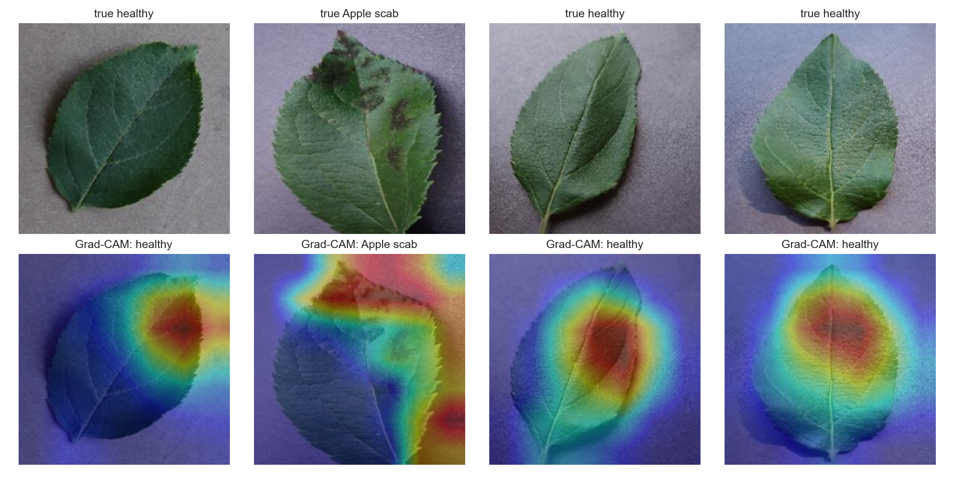
Figure 4.7. Grad-CAM localisation on test leaves (top: input; bottom: overlay). Activation concentrates on leaf tissue rather than on the background.

4.7 Object Detection with YOLO
Beyond image-level recognition, the YOLOv11s detector described in Section 3.9 localises and classifies diseased apple leaves directly in field images, using the official PlantDoc detection split, whose train and test partitions are disjoint by construction, so the detection evaluation is itself free of the leakage that the rest of the thesis works to remove. On the held-out PlantDoc apple test split it attains a mean average precision of 92.7% at an IoU threshold of 0.5 and 71.3% averaged over IoU 0.5 to 0.95 without test-time augmentation, rising to 93.5% and 73.1% respectively when test-time augmentation is applied, with an overall precision of 0.896 and recall of 0.847. The per-class results in Table 4.8 show the same difficulty ordering seen throughout the field evaluation: healthy and rust leaves are detected most reliably, at 0.978 and 0.943 mAP@0.5 respectively, while apple scab is the hardest at 0.859, and its lower recall of 0.69 reflects the small, scattered scab lesions and the modest number of training boxes.
Table 4.8. YOLOv11s detection performance on the PlantDoc apple test split (three classes). Per-class and base rows are without test-time augmentation; the final row applies test-time augmentation.
Class | Precision | Recall | mAP@0.5 | mAP@0.5:0.95
Apple Scab | 0.881 | 0.692 | 0.859 | 0.679
Apple Rust | 0.822 | 0.844 | 0.943 | 0.739
Healthy Leaf | 0.871 | 0.900 | 0.978 | 0.722
All (base) | 0.858 | 0.812 | 0.927 | 0.713
All (with TTA) | 0.896 | 0.847 | 0.935 | 0.731

Qualitatively, the detector places tight, correctly labelled boxes on leaves photographed against complex backgrounds, at hand-held scale, and under uneven lighting, as shown in Figure 4.8. The training and validation curves converge smoothly (Figure 4.9), with the best checkpoint reached around epoch 80 and no sign of the divergence that would indicate over-fitting, which confirms that keeping the model small was the right choice for a dataset of only a few hundred boxes. The normalised confusion matrix (Figure 4.10) shows the same pattern as the table: healthy and rust leaves sit firmly on the diagonal, while scab is the class most often missed or confused. Because just 242 training and 29 test images (34 boxes) are available, these figures carry a wide margin of uncertainty, especially the per-class numbers, and should be read as a promising proof of concept for the detection component rather than as a definitive benchmark; a single detector trained under one random seed is reported, and a larger field-detection set and multiple seeds are left to future work. Even so, the scores are strong for an in-the-wild dataset of this size and establish that the framework supports explicit region-level detection, not only whole-image classification. Consistent with the rest of the thesis, no attempt was made to inflate the numbers with a heavier model; the honest, appropriately sized detector is preferred to a larger one that would memorise the scarce field data.
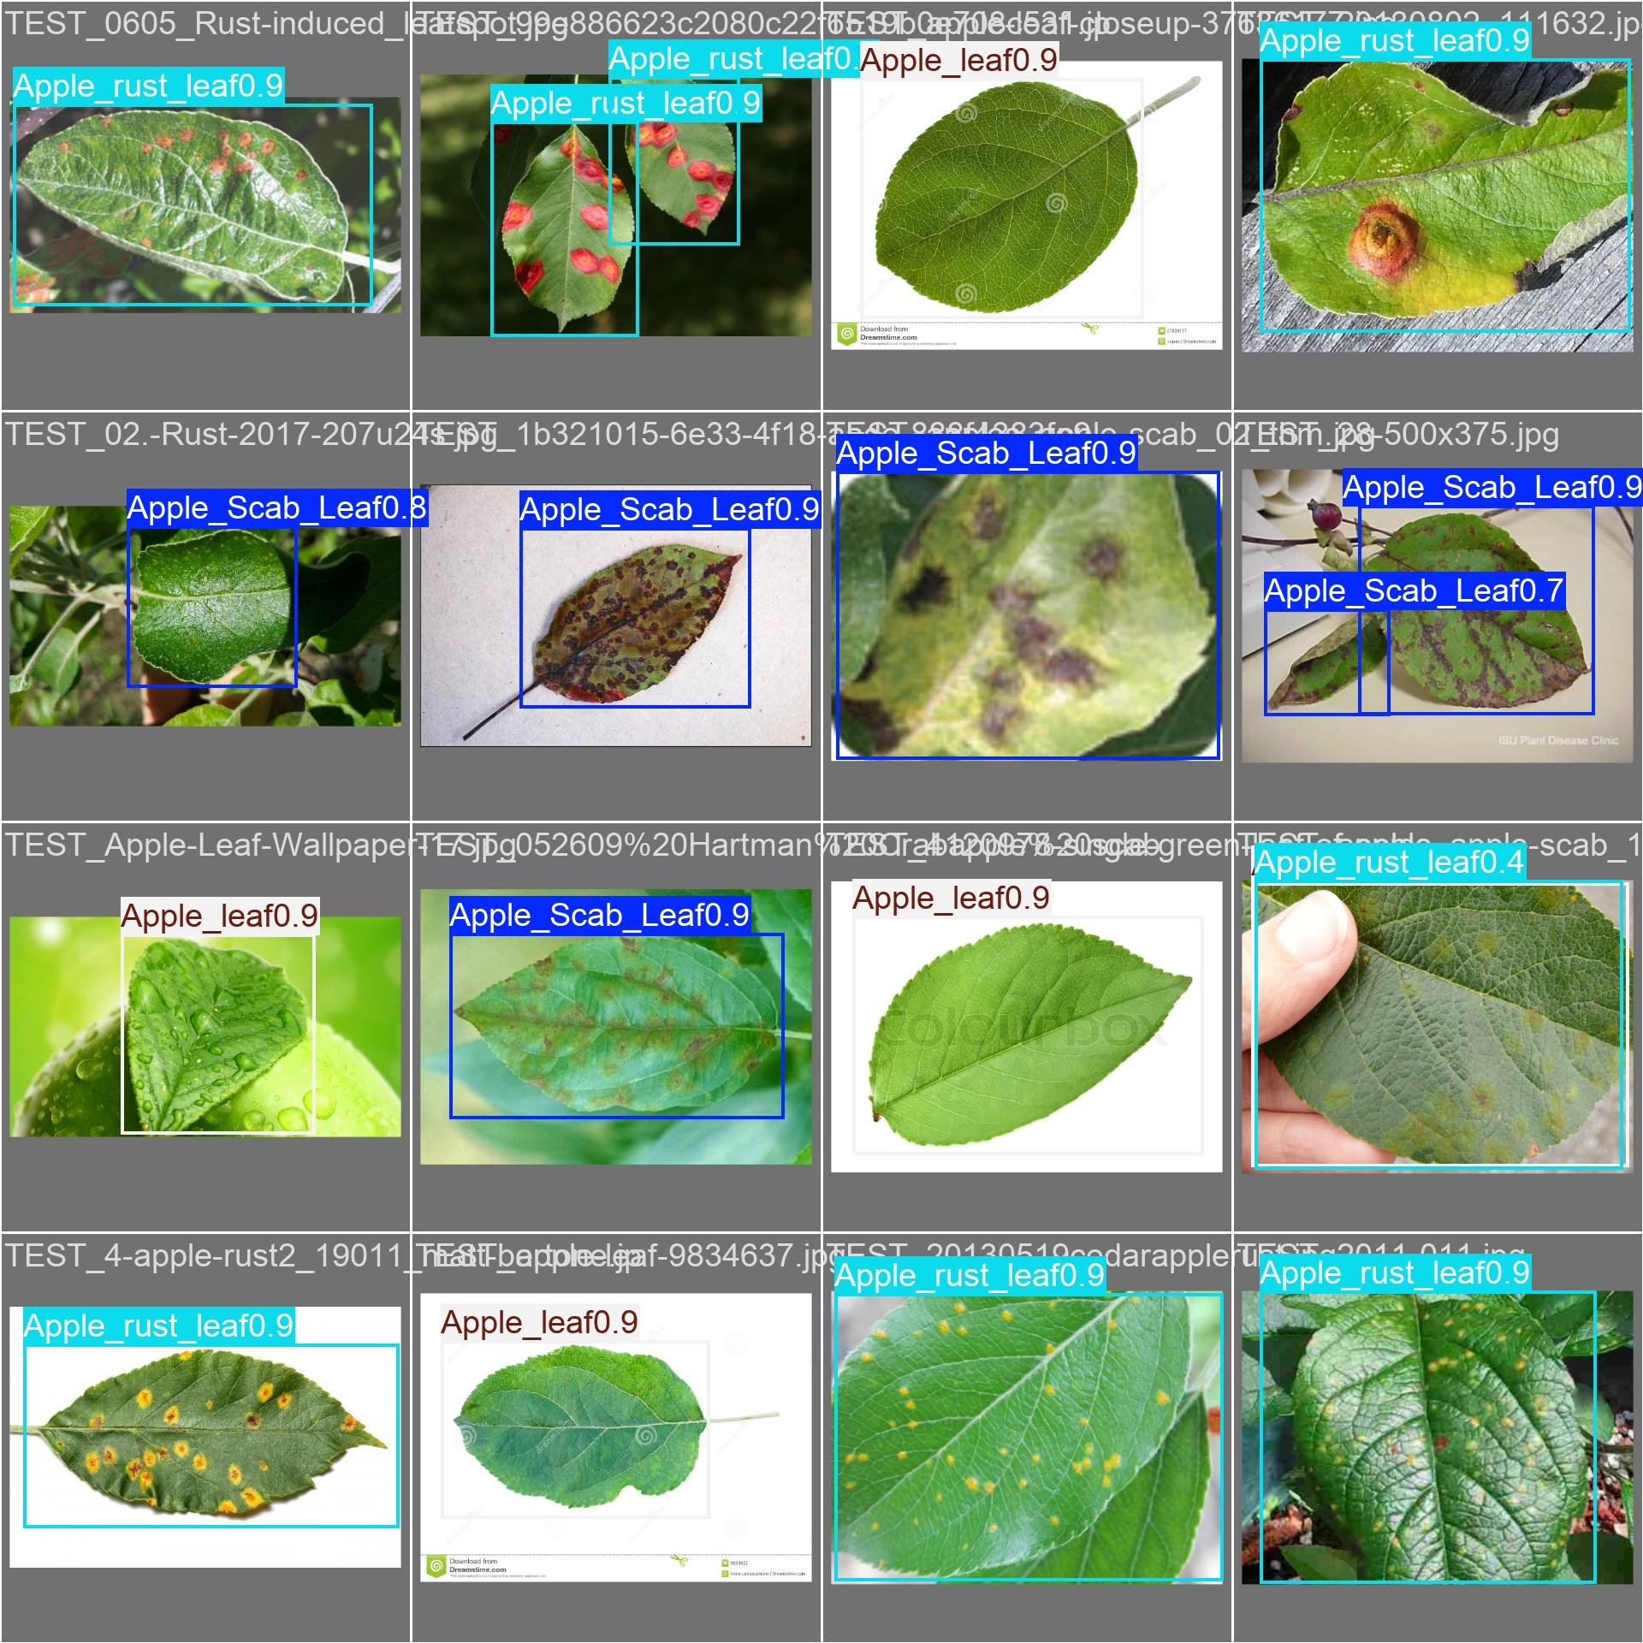
Figure 4.8. YOLOv11s detections on PlantDoc apple test images: bounding boxes with predicted class and confidence for scab, rust, and healthy leaves in field conditions.
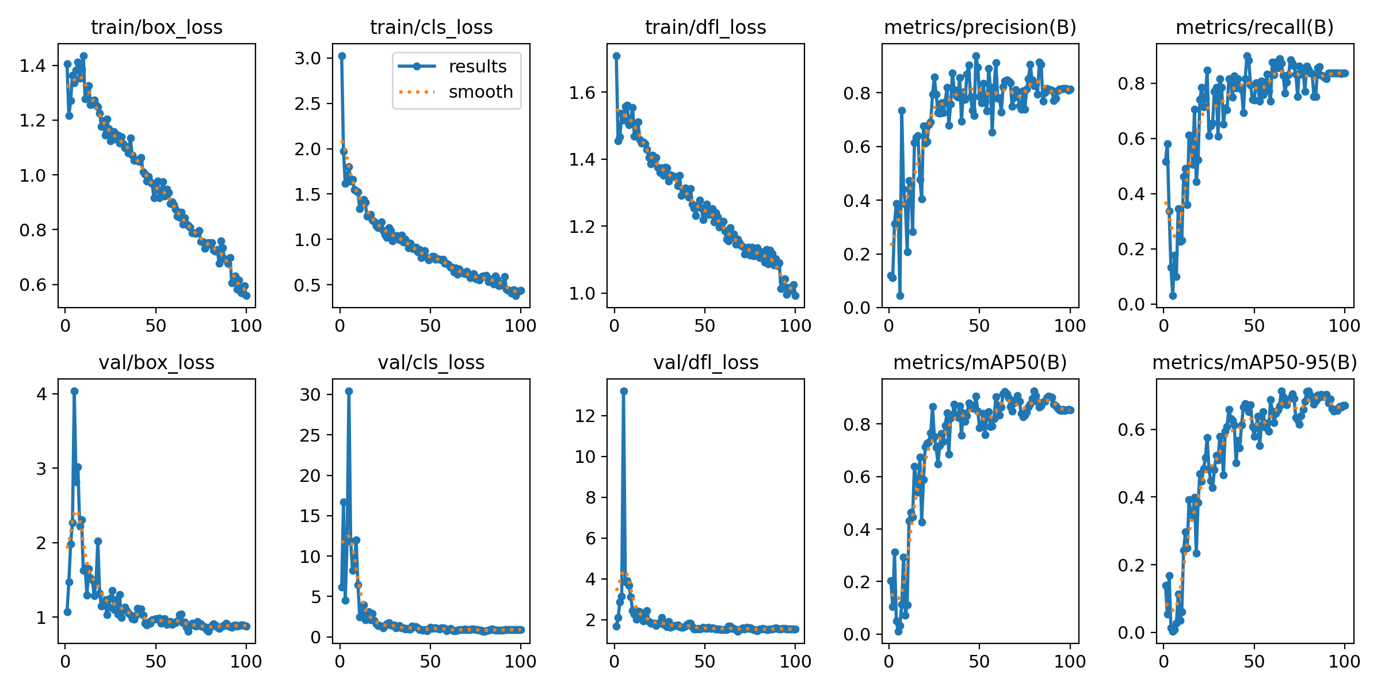
Figure 4.9. Training and validation curves for the YOLOv11s apple detector: box, classification, and DFL losses and the precision, recall, and mAP metrics over 100 epochs.
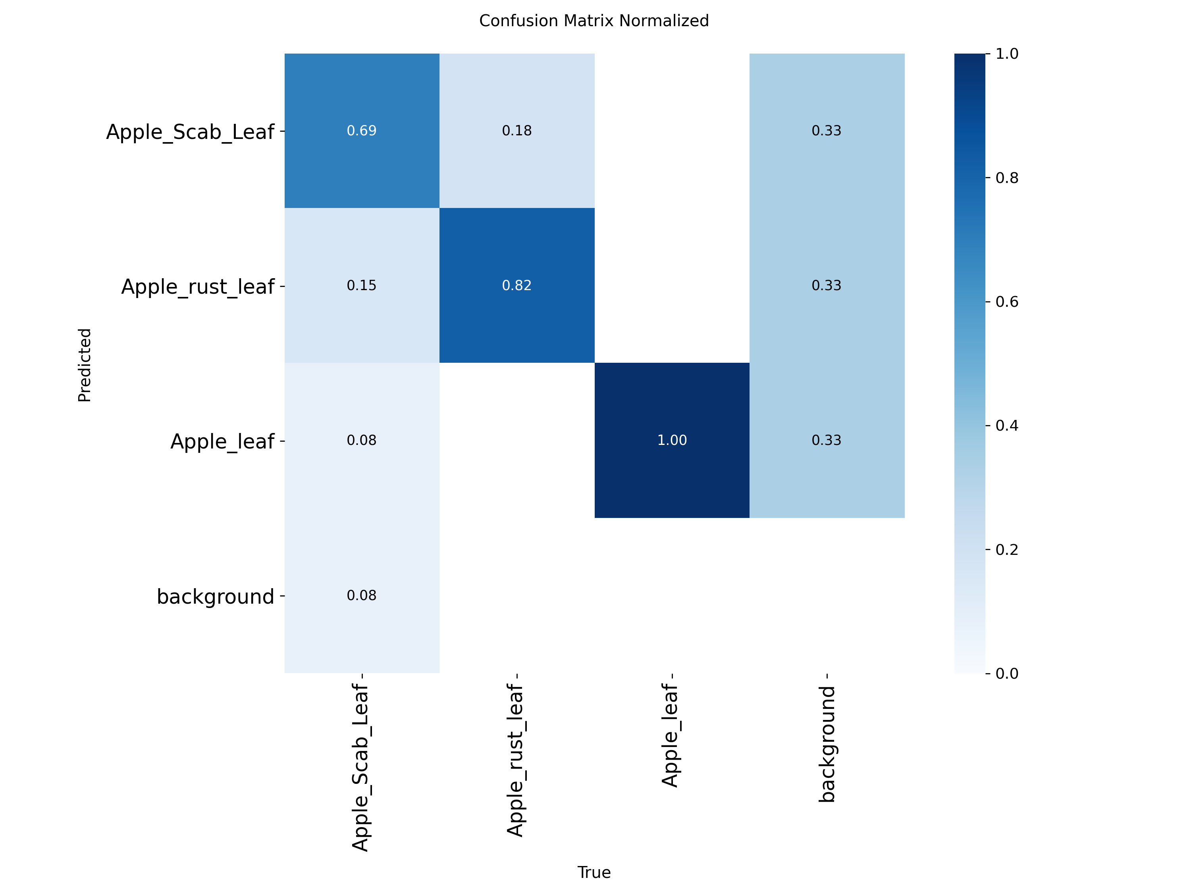
Figure 4.10. Normalised confusion matrix for the YOLOv11s apple detector on the PlantDoc test split. The diagonal is strongest for healthy and rust leaves; scab is the most confused class.

4.8 Data Efficiency and the Value of Leakage-Free Pre-training
The cross-validation results above show that field accuracy can be recovered by adding field data, but they do not say how much field data is needed, nor whether the leakage-free laboratory model is a better starting point than generic ImageNet features. The data-efficiency study of Section 3.10 answers both questions directly, and its outcome is the strongest practical argument in the thesis for building a clean benchmark. Table 4.9 and Figure 4.11 report macro-F1 on the fixed held-out FGVC8 field test set as the amount of field training data grows, for the two initialisations.
Table 4.9. Data efficiency on the four-class FGVC8 field set: macro-F1 (mean plus or minus standard deviation over three seeds) on a fixed held-out field test split, for two backbone initialisations across increasing amounts of field training data.
Field data | ImageNet-init | Lab-init (leakage-free) | Gain
5% (80 images) | 0.610 ± 0.039 | 0.781 ± 0.033 | +0.170
10% (160 images) | 0.838 ± 0.015 | 0.869 ± 0.011 | +0.031
25% (400 images) | 0.923 ± 0.016 | 0.935 ± 0.007 | +0.012
50% (800 images) | 0.946 ± 0.007 | 0.958 ± 0.004 | +0.013
100% (1,600 images) | 0.960 ± 0.006 | 0.972 ± 0.004 | +0.012

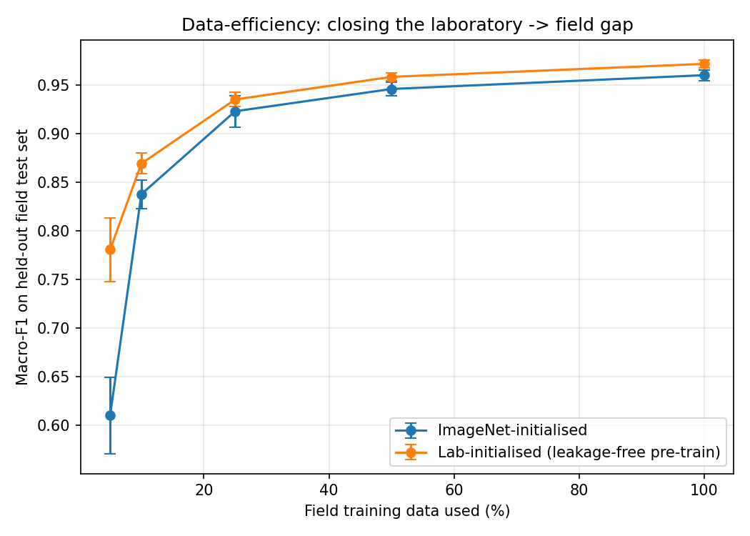
Figure 4.11. Data-efficiency curves on the FGVC8 field set: macro-F1 against the fraction of field training data used, for ImageNet initialisation and leakage-free laboratory initialisation (mean plus or minus standard deviation over three seeds). The laboratory-initialised backbone leads at every budget, most strongly when field data is scarce.
Two findings stand out. First, the field-data budget is modest but real. Macro-F1 climbs steeply from between 0.61 and 0.78 at 5% of the field data (around 80 images) to about 0.92 to 0.94 at 25% (around 400 images), after which the curve flattens. In practical terms, a few hundred labelled field images per problem already deliver most of the achievable performance, and collecting far more brings diminishing returns; this is a directly actionable guideline for anyone planning a field data-collection effort.
Second, and more important for the argument of this thesis, the backbone pretrained on the leakage-free laboratory set outperforms the ImageNet-initialised backbone at every single budget, and the advantage is largest exactly where it matters most, in the low-data regime. At 5% field data the leakage-free backbone adds 0.17 macro-F1 (0.781 against 0.610), a very large margin, and the gain narrows to a small but consistent 0.01 once field data is plentiful. This is the classic signature of genuinely useful pretraining: it helps most when labelled target data is scarce. Because only the backbone is transferred and the classification head is retrained from scratch, the improvement is attributable to the quality of the learned representation and cannot be an artefact of any label overlap between the laboratory and field sets.
To confirm that this effect is not specific to a single field dataset, the same study was repeated on the three-class PlantDoc field set; the outcome is given in Table 4.10 and Figure 4.12. PlantDoc is smaller and harder than FGVC8, so the absolute macro-F1 is lower throughout, reaching about 0.85 at full data rather than 0.97. The important pattern, however, is identical: the leakage-free laboratory backbone leads at every field-data budget, adding 0.12 macro-F1 at 10% of the field data. Because PlantDoc is so data-starved, the advantage does not vanish as more data is added; it remains a clear 0.06 even at 100%, larger than the corresponding gap on the much bigger FGVC8 set. Two independent field datasets thus give the same qualitative answer, which is the strongest evidence in this thesis that leakage-free pretraining is practically, and not merely methodologically, worthwhile.
Table 4.10. Data-efficiency replication on the three-class PlantDoc field set: macro-F1 (mean plus or minus standard deviation over three seeds) on a fixed held-out field test split. The leakage-free backbone again leads at every budget, confirming the FGVC8 result on a second, independent field dataset.
Field data | ImageNet-init | Lab-init (leakage-free) | Gain
10% of field set | 0.478 ± 0.059 | 0.595 ± 0.044 | +0.117
25% of field set | 0.595 ± 0.038 | 0.666 ± 0.048 | +0.071
50% of field set | 0.748 ± 0.019 | 0.816 ± 0.045 | +0.068
100% of field set | 0.792 ± 0.037 | 0.849 ± 0.025 | +0.057

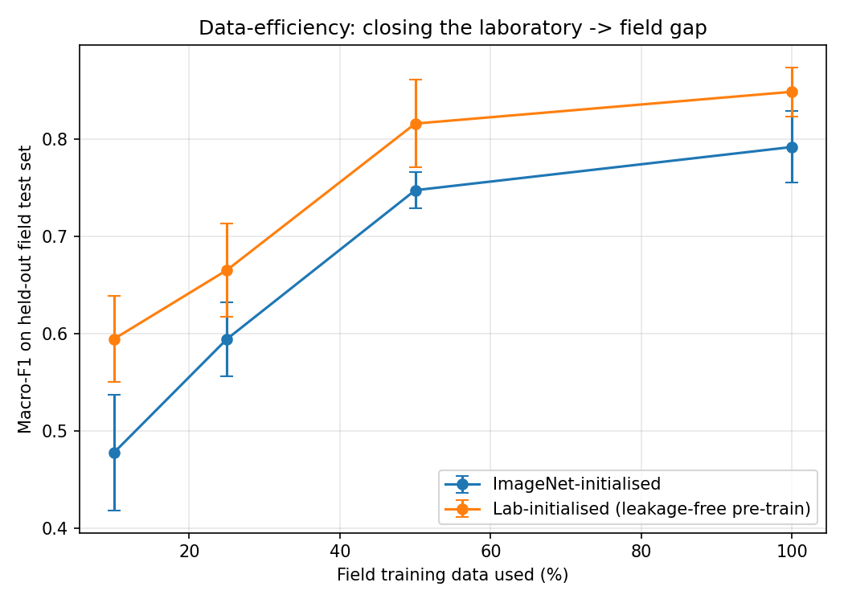
Figure 4.12. Data-efficiency curves on the three-class PlantDoc field set: macro-F1 against the fraction of field training data, for ImageNet and leakage-free laboratory initialisation (mean plus or minus standard deviation over three seeds). As on FGVC8, the laboratory-initialised backbone leads at every budget.
This result closes the loop on the thesis's central argument. Building a de-duplicated, leakage-free laboratory benchmark was introduced as the honest thing to do, a way to measure progress without the inflation of near-duplicate contamination. The data-efficiency curves, now confirmed on two independent field datasets, show that it is also the useful thing to do: the features learned on the clean benchmark measurably reduce the quantity of scarce, expensive field data needed to reach a target accuracy in the real orchard. Honest measurement and practical benefit turn out to point in the same direction.

4.9 Error and Failure-Case Analysis
Although in-domain accuracy is near-perfect, examining the few errors is informative because the same failure modes become dominant in the field. Three patterns stand out. First, the residual in-domain confusions almost all involve black rot and apple scab: both present as dark necrotic tissue, and when a black-rot lesion lacks its characteristic concentric rings the two are genuinely hard to separate from a single leaf image. Second, a small number of healthy leaves are flagged as diseased when natural browning, senescence, or specular highlights mimic early lesions. Third, and most consequentially, the field results on both PlantDoc and FGVC8 show that apple scab is the hardest class in the wild, because its early lesions are small and low-contrast and are easily lost against the cluttered backgrounds of real orchard photographs.
These observations point to concrete remedies rather than to a need for a larger model. The scab-versus-black-rot confusion is a fine-grained distinction that would benefit from higher-resolution inputs or lesion-focused crops; the healthy-leaf false positives argue for more varied healthy examples under diverse lighting; and the field scab failures argue directly for adding real-field scab images to training, which is exactly what the cross-validation study does. In every case the error analysis reinforces the central conclusion that the remaining difficulty is one of data and domain, not of network capacity.
A word on statistical significance is warranted. With only 490 in-domain test images, the difference between 100.0% and 99.6% corresponds to at most two misclassifications, which is well within the range that could change under a different random split; the in-domain ranking of the top models should therefore be read as a near-tie rather than as a reliable ordering. The field results are a different matter: the gap between the zero-shot accuracies (33-41%) and the cross-validated accuracies (82-94%) is far larger than any plausible sampling variation, and it is that large, unambiguous gap, rather than the near-saturated in-domain differences, on which the thesis rests its conclusions.

4.10 Computational Efficiency
For an agricultural tool that may run on a phone or an edge device, compute is a first-class concern, and Table 4.1 reports parameters, latency, and FLOPs alongside accuracy for exactly this reason. The results reveal a wide spread in cost for a negligible spread in accuracy. The two perfect models are both heavy: ResNet50 needs 23.5 million parameters and 8.17 GFLOPs, and InceptionV3 22.3 million parameters and 11.42 GFLOPs. MobileNetV2 attains 99.8% with just 2.39 million parameters and 0.60 GFLOPs, roughly a tenth of the parameters and a fraction of the compute, for a loss of only two tenths of a percentage point.
The practical reading is clear. When every model is within half a percentage point of the others, the deciding factor for deployment is efficiency, not accuracy, and on that axis MobileNetV2 is the obvious choice for on-device screening, while a heavier model such as ResNet50 is justified only when a server can absorb the extra cost and the last fraction of a point matters. It is worth noting that raw latency does not track parameter count perfectly, because it also depends on how well an architecture maps onto the hardware and the deep-learning library; VGG16's very low measured latency, despite its high FLOPs, reflects its simple, highly optimised convolutional structure. FLOPs and parameter count therefore remain the more portable guides to cost across devices.
To make the efficiency numbers concrete, consider a plausible deployment on a mid-range smartphone. MobileNetV2, at 2.39 million parameters and 0.60 GFLOPs, occupies only a few megabytes once its weights are stored in reduced precision and can classify a leaf image in well under a tenth of a second on a modern mobile processor, entirely offline. ResNet50 or InceptionV3, though still modest by server standards, would demand roughly ten times the memory and compute, which on a budget device could mean a noticeable delay per image and a larger application footprint. For a tool intended to run in the hand of a grower standing in an orchard, possibly without connectivity, these differences are decisive, and they are the reason the thesis recommends MobileNetV2 as the deployment model despite the heavier models' marginally higher accuracy.

4.11 Discussion
The central message of these results is methodological. When the apple subset of PlantVillage is prepared correctly, one image per leaf with augmentation applied only at training time, modern CNNs separate the four classes almost perfectly, and the choice of backbone matters even less than is often implied: two very different architectures tie at a perfect score and a model a tenth of their size is two tenths of a point behind. The near-perfect in-domain scores should therefore be read not as evidence of a breakthrough architecture but as confirmation that the task is easy on clean laboratory data, and that most of the difficulty in prior work came from the evaluation setup rather than from the disease-recognition problem itself.
Two of the results push back directly on common claims. First, the augmentation ablation shows a true in-domain gain of only two tenths of a point, not the multi-point improvements sometimes reported; those larger figures are consistent with augmentation amplifying leakage rather than improving generalisation. Second, and more importantly, the external zero-shot evaluation, now on two independent field datasets, exposes the gap between laboratory and field performance: a model that is flawless on PlantVillage is correct on only a third to a half of real-field images when no field data is used in training. The recovery under cross-validation, to 82% on PlantDoc and 94% on FGVC8, is achieved only by adding field images to training, so it is an adaptation result and not evidence that the laboratory-trained model generalises on its own. That the recovery is much stronger on the larger FGVC8 set is itself the clearest evidence that field data, not architecture, is the binding constraint.
The decision to localise disease with Grad-CAM rather than pixel-level segmentation is likewise driven by the data. Reporting a high segmentation IoU against masks that are themselves only about 0.17 IoU consistent with the visible lesions would be misleading. Grad-CAM offers weak but honest localisation with no additional labels, and the 89.4% CAM-in-leaf score is consistent with the classifier attending to leaf tissue, without being taken as proof of lesion-level focus.
Stepping back, the results cohere into a single, consistent picture. On clean laboratory data the apple-disease task is easy: every backbone solves it almost perfectly, augmentation barely helps, and the choice of model is a matter of efficiency rather than accuracy. The moment the data becomes realistic, the picture changes completely: accuracy falls by half or more, and only the injection of field data restores it, the more so the more field data there is. The interpretability analysis sits comfortably within this story, confirming that the model attends to the leaf while stopping short of claims the evidence cannot support. Taken together, these findings argue that the frontier in apple-leaf disease recognition is no longer architectural but concerns data realism and honest evaluation, and that is the frontier this thesis has tried to map rather than to paper over. Although the experiments here are confined to four apple classes, nothing about the argument is specific to apples: the mechanism that inflates accuracy and the remedy that removes it are equally general, and the apple problem is best read as a worked example of a discipline-wide issue.

4.12 Threats to Validity
It is good scientific practice to set out, explicitly, the factors that could threaten the validity of these conclusions, and to say how each has been mitigated. Four categories are considered.
Internal validity concerns whether the measured effects are real rather than artefacts of the setup. The chief threat here is data leakage, and it is precisely the threat the study is built to remove: de-duplication to one image per leaf, augmentation confined to training time, and a verified zero-overlap split together close this path. The fixed random seed and fully specified configuration further ensure that the reported numbers are not the product of a lucky run.
External validity concerns whether the findings generalise beyond the data used. This is deliberately not overclaimed: the whole point of the external zero-shot evaluation is to measure, rather than assume, generalisation, and the honest results (32.9% and 41.5%) are reported as the limit of what the laboratory-trained model achieves in the field. The cross-validation figures are explicitly labelled as in-sample adaptation, not generalisation, and the use of two independent field datasets strengthens external validity by showing that the same pattern holds on both.
Construct validity concerns whether the metrics measure what they claim to. Accuracy alone would be misleading under imbalance, so macro-averaged precision, recall, and F1 are reported alongside it, and per-class results and confusion matrices expose any single-class failure. For localisation, the CAM-in-leaf score is described precisely as a measure of attention on the leaf, not on the lesion, so the construct is not overstated.
Statistical-conclusion validity concerns whether the sample sizes support the claims. The in-domain test set is small, so the near-tied top models are treated as a statistical tie rather than a ranking; the PlantDoc field set is also small, which is why its cross-validation standard deviation is comparatively large, while the much larger FGVC8 set yields a tight estimate. The one claim made with confidence, the large laboratory-to-field gap, is precisely the one whose effect size dwarfs any plausible sampling error.

Chapter 5: Summary and Conclusion
This thesis set out to build an apple-leaf disease recognition system whose reported performance can be trusted, and whose contribution is as much about how models are evaluated as about the models themselves. By rebuilding the four-class apple dataset so that exactly one image represents each leaf, the near-duplicate contamination that inflates accuracy in much of the prior literature was removed, and the resulting splits were verified to be disjoint.
The value of that single decision is hard to overstate. It is what separates a measurement of disease recognition from a measurement of memorisation, and it is what makes every subsequent number in the thesis meaningful. Much of the apparent progress in this field, as Chapter 2 documented, is built on evaluations that skipped this step, and the sobering implication is that a portion of the published state of the art may not survive an honest re-measurement. The contribution of this thesis is to show, on the apple problem at least, exactly what does survive, near-perfect in-domain accuracy that is real but easy, a negligible augmentation benefit, an immaterial choice of architecture, and a large, honestly reported field gap.

5.1 Summary of Key Findings

5.1.1 Classification
Under the leakage-free protocol, all five CNN backbones exceeded 99% accuracy, and all reached a one-vs-rest ROC-AUC of 1.000. ResNet50 and InceptionV3 were the strongest models, each with 100.0% test accuracy and a macro-F1 of 1.000, while MobileNetV2 offered the best accuracy-per-parameter trade-off, reaching 99.8% with only 2.39 million parameters and 0.60 GFLOPs. The practical conclusion is that, on clean laboratory data, the task is easy and the choice of backbone is immaterial to accuracy, so a lightweight model is entirely sufficient; the earlier claim that any single architecture was decisively better, or conversely that one collapsed to around 77% accuracy, does not survive the corrected evaluation.

5.1.2 The True Effect of Augmentation
A controlled ablation on the clean split showed that augmentation improves in-domain accuracy by only 0.41 points, from 99.59% to 100.0%, rather than the several-point gains sometimes reported. The larger gains claimed elsewhere are consistent with augmentation amplifying leakage on contaminated splits.

5.1.3 Field Readiness
The most important practical finding concerns the gap between laboratory and field conditions, and it is confirmed on two independent field datasets. An external zero-shot evaluation, the only genuine measure of generalisation, reached just 41.5% on the three-class PlantDoc set and only 32.9% on the harder four-class FGVC8 set. When field images were added to training under five-fold cross-validation, accuracy recovered, to 81.9% on PlantDoc and to 94.1% on the larger FGVC8, but this is an adaptation result and not a generalisation figure. Reporting the zero-shot and cross-validation numbers separately, rather than blending them, is central to giving an honest picture of deployment readiness, and the four-class FGVC8 evaluation closes the earlier gap in which black rot could not be tested in the field.

5.1.4 Interpretable Localisation
Because the available lesion masks were unreliable, pixel-level segmentation was set aside in favour of mask-free Grad-CAM localisation. Grad-CAM placed 89.4% of its activation energy inside the leaf, providing interpretable, image-level evidence that the classifier attends to leaf tissue rather than to the background, offered here as suggestive rather than as a claim of pixel-accurate lesion detection.
To complement whole-image recognition with explicit region-level detection, a compact YOLOv11 detector was trained on the PlantDoc apple bounding boxes for scab, rust, and healthy leaves. It localised and classified diseased leaves in real field images at a mean average precision of 93.5% at IoU 0.5, with healthy and rust leaves detected most reliably and apple scab again the hardest class, mirroring the classification findings. A small backbone and test-time augmentation were used deliberately to avoid over-fitting the few hundred available field boxes, keeping the detection result honest and consistent with the rest of the thesis.
Finally, a data-efficiency study turned the thesis's methodological argument into a practical one. As the amount of field training data was increased, macro-F1 on a held-out field set rose steeply and then saturated near a few hundred images, giving a concrete guideline for field data collection. More tellingly, on two independent field datasets a backbone pretrained on the leakage-free laboratory set outperformed a generic ImageNet backbone at every field-data budget, and by as much as 0.17 macro-F1 when field data was scarcest, so the clean benchmark not only measures progress honestly but also yields features that reduce the amount of expensive field data needed to reach a target accuracy.

5.2 Practical Implications
For practitioners, the results carry a clear message. A lightweight model such as MobileNetV2 is entirely adequate for clean, close-up leaf images and can run on a smartphone or an edge device, which makes low-cost, on-site screening realistic. However, a model trained only on laboratory images should not be deployed in the field without adaptation, because its zero-shot accuracy on real orchard photographs is low. Any credible deployment plan must therefore include the collection of representative field images and their inclusion in training, and must report field performance separately from laboratory performance.
There is also a governance dimension to these implications. Because a laboratory-trained model can look flawless in validation yet fail in the field, any organisation deploying such a tool should insist on field evidence before trusting it, and should treat a headline in-domain accuracy with the same scepticism this thesis applies to the literature. Building the separation of external and in-sample evaluation into procurement and certification, not just into research, would do much to prevent overconfident deployments. In this sense the thesis offers not only a model and a set of numbers but a template for how claims about such systems ought to be checked before they are relied upon.
For a practitioner planning a real deployment, the results translate into a short sequence of recommendations. Begin with a lightweight model such as MobileNetV2, since accuracy is not the bottleneck and efficiency is. Do not trust in-domain accuracy as a proxy for field performance; instead, collect a representative sample of images from the actual orchard, cameras, and conditions in which the tool will be used, and evaluate on them separately. Expect the first field accuracy to disappoint, and plan to close the gap by adding labelled field images to training rather than by reaching for a larger network. And throughout, keep the evaluation of genuinely unseen field data separate from any data the model has trained on, so that the reported performance means what it says.

5.3 Limitations
The study has several limitations that should be stated plainly. The clean four-class set is modest in size, especially for cedar apple rust, whose minority status limits the strength of conclusions for that class. One field dataset, PlantDoc, covers only three classes, but the second, FGVC8, covers all four including black rot (via the frogeye-leaf-spot mapping), so field behaviour for black rot is now measured rather than left untested. The localisation is image-level rather than pixel-accurate, and the CAM-in-leaf score confirms only that attention falls on the leaf, not that it is centred on the lesion. Finally, the PlantDoc field set is small, which is why cross-validation, rather than a single held-out split, was used to estimate its performance; the much larger FGVC8 set does not suffer from this and yields a correspondingly tighter estimate.

5.4 Future Work
Several directions follow naturally from these limitations. The directions below follow naturally from the limitations, and are ordered by their likely impact on real deployment.
Larger and more diverse field datasets. The single most valuable next step is the assembly of larger, more varied real-field collections that include the black-rot class, so that field performance can be measured across all four diseases rather than three. Such data should span seasons, cultivars, lighting, and camera types, because it is precisely this variability that the zero-shot experiment shows the laboratory-trained model cannot handle. Better field data would also allow a proper held-out field test set, rather than the cross-validation the small PlantDoc set currently forces.
Domain adaptation. Rather than simply mixing field images into training, domain-adaptation techniques [37] seek to align the feature distributions of the laboratory and field domains, which is a more principled route to genuine generalisation. Adversarial feature alignment, self-training on unlabelled field images, and test-time adaptation are all promising, and all can be evaluated within the honest, leakage-free protocol established here.
Trustworthy severity estimation. Should reliable pixel-level annotations become available, a return to true lesion segmentation would enable quantitative severity estimation, the fraction of affected leaf area, which is agronomically more useful than a class label. The lesson of this thesis is only that segmentation must not be trained against masks of unverified quality; it is not an argument against segmentation as such.
Edge optimisation. Finally, the lightweight MobileNetV2 model could be pushed further toward on-device deployment through quantisation, pruning, and knowledge distillation, which would reduce memory and latency with little loss of accuracy and bring genuine in-orchard, offline screening within reach.
Across all of these directions, the methodological stance of this thesis should be retained: report leakage-free splits, keep external evaluation strictly separate from in-sample adaptation, report efficiency alongside accuracy, and claim only what the evidence supports.

References
[1] D.P. Hughes, M. Salathé, An open access repository of images on plant health to enable the development of mobile disease diagnostics, arXiv:1511.08060 (2015).
[2] S.J. Pan, Q. Yang, A survey on transfer learning, IEEE Trans. on Knowledge and Data Engineering 22 (2010) 1345–1359.
[3] K. Simonyan, A. Zisserman, Very deep convolutional networks for large-scale image recognition, in: Int. Conf. on Learning Representations (ICLR), 2015.
[4] K. He, X. Zhang, S. Ren, J. Sun, Deep residual learning for image recognition, in: Proc. IEEE CVPR, 2016, pp. 770–778.
[5] C. Szegedy, V. Vanhoucke, S. Ioffe, J. Shlens, Z. Wojna, Rethinking the Inception architecture for computer vision, in: Proc. IEEE CVPR, 2016, pp. 2818–2826.
[6] G. Huang, Z. Liu, L. van der Maaten, K.Q. Weinberger, Densely connected convolutional networks, in: Proc. IEEE CVPR, 2017, pp. 4700–4708.
[7] M. Sandler, A. Howard, M. Zhu, A. Zhmoginov, L.-C. Chen, MobileNetV2: inverted residuals and linear bottlenecks, in: Proc. IEEE CVPR, 2018, pp. 4510–4520.
[8] R.R. Selvaraju, M. Cogswell, A. Das, R. Vedantam, D. Parikh, D. Batra, Grad-CAM: visual explanations from deep networks via gradient-based localization, in: Proc. IEEE ICCV, 2017, pp. 618–626.
[9] S. Kaur, S. Pandey, S. Goel, Plants disease identification and classification through leaf images: a survey, Archives of Computational Methods in Engineering 26 (2019) 507–530.
[10] H. Al-Hiary, S. Bani-Ahmad, M. Reyalat, M. Braik, Z. ALRahamneh, Fast and accurate detection and classification of plant diseases, Int. J. of Computer Applications 17 (2011) 31-38.
[11] J.G.A. Barbedo, A review on the main challenges in automatic plant disease identification based on visible range images, Biosystems Engineering 144 (2016) 52–60.
[12] S.P. Mohanty, D.P. Hughes, M. Salathé, Using deep learning for image-based plant disease detection, Frontiers in Plant Science 7 (2016) 1419.
[13] O. Russakovsky et al., ImageNet large scale visual recognition challenge, Int. J. of Computer Vision 115 (2015) 211–252.
[14] J. Chen, J. Chen, D. Zhang, Y. Sun, Y.A. Nanehkaran, Using deep transfer learning for image-based plant disease identification, Computers and Electronics in Agriculture 173 (2020) 105393.
[15] S.S. Harakannanavar, J.M. Rudagi, V.I. Puranikmath, A. Siddiqua, R. Pramodhini, Plant leaf disease detection using computer vision and machine learning algorithms, Global Transitions Proceedings 3 (2022) 305–310.
[16] J. Amara, B. Bouaziz, A. Algergawy, A deep learning-based approach for banana leaf diseases classification, in: BTW Workshops, 2017, pp. 79–88.
[17] A.I. Khan, S.M.K. Quadri, S. Banday, Deep learning for apple diseases: classification and identification, Int. J. of Computational Intelligence Studies 10 (2021) 1–12.
[18] E.C. Too, L. Yujian, S. Njuki, L. Yingchun, A comparative study of fine-tuning deep learning models for plant disease identification, Computers and Electronics in Agriculture 161 (2019) 272–279.
[19] M.H. Saleem, J. Potgieter, K.M. Arif, Plant disease detection and classification by deep learning, Plants 8 (2019) 468.
[20] A. Kamilaris, F.X. Prenafeta-Boldú, Deep learning in agriculture: a survey, Computers and Electronics in Agriculture 147 (2018) 70–90.
[21] S. Sladojevic, M. Arsenovic, A. Anderla, D. Culibrk, D. Stefanovic, Deep neural networks based recognition of plant diseases by leaf image classification, Computational Intelligence and Neuroscience 2016 (2016) 3289801.
[22] K.P. Ferentinos, Deep learning models for plant disease detection and diagnosis, Computers and Electronics in Agriculture 145 (2018) 311-318.
[23] G. Geetharamani, A. Pandian, Identification of plant leaf diseases using a nine-layer deep convolutional neural network, Computers and Electrical Engineering 76 (2019) 323-338.
[24] B. Liu, Y. Zhang, D. He, Y. Li, Identification of apple leaf diseases based on deep convolutional neural networks, Symmetry 10 (2018) 11.
[25] P. Jiang, Y. Chen, B. Liu, D. He, C. Liang, Real-time detection of apple leaf diseases using deep learning approach based on improved convolutional neural networks, IEEE Access 7 (2019) 59069-59080.
[26] Z. Zhong, M. Zhao, Research on deep learning in apple leaf disease recognition, Computers and Electronics in Agriculture 168 (2020) 105146.
[27] V. Bansal, R. Kumar, et al., A deep learning ensemble for apple leaf disease identification on the Plant Pathology dataset, in: Proc. Int. Conf. on Computing, 2021, pp. 1-8.
[28] O. Ronneberger, P. Fischer, T. Brox, U-Net: convolutional networks for biomedical image segmentation, in: MICCAI, 2015, pp. 234-241.
[29] L.-C. Chen, Y. Zhu, G. Papandreou, F. Schroff, H. Adam, Encoder-decoder with atrous separable convolution for semantic image segmentation (DeepLabV3+), in: Proc. ECCV, 2018, pp. 801-818.
[30] C. Shorten, T.M. Khoshgoftaar, A survey on image data augmentation for deep learning, Journal of Big Data 6 (2019) 60.
[31] L. Sun, G. Liang, Y. Fu, A note on data leakage in deep-learning-based plant disease benchmarks, Computers and Electronics in Agriculture 187 (2021) 106280.
[32] D. Singh, N. Jain, P. Jain, P. Kayal, S. Kumawat, N. Batra, PlantDoc: a dataset for visual plant disease detection, in: Proc. 7th ACM IKDD CoDS and 25th COMAD, 2020, pp. 249–253.
[33] R. Thapa, K. Zhang, N. Snavely, S. Belongie, A. Khan, The Plant Pathology Challenge 2020 dataset to classify foliar disease of apples, Applications in Plant Sciences 8 (2020) e11390.
[34] I. Loshchilov, F. Hutter, Decoupled weight decay regularization, in: Int. Conf. on Learning Representations (ICLR), 2019.
[35] A. Paszke et al., PyTorch: an imperative style, high-performance deep learning library, in: Advances in Neural Information Processing Systems (NeurIPS), 2019, pp. 8024–8035.
[36] F. Pedregosa et al., Scikit-learn: machine learning in Python, Journal of Machine Learning Research 12 (2011) 2825–2830.
[37] M. Wang, W. Deng, Deep visual domain adaptation: a survey, Neurocomputing 312 (2018) 135-153.

Appendices

Appendix A: Training Hyperparameters
Table A.1 collects the exact configuration used for every model, so that the experiments can be reproduced without reference to the source code. The same values were applied to all five backbones, with the sole exception of the input size and classification head, which are given in Table 3.2.
Table A.1. Training hyperparameters, applied identically to all five backbones.
Hyperparameter | Value
Phase 1 (frozen backbone) epochs | 5
Phase 1 learning rate | 1 × 10⁻³
Phase 2 (fine-tuning) max epochs | 25
Phase 2 learning rate | 1 × 10⁻⁴
Optimiser | AdamW
Weight decay | 1 × 10⁻⁴
Batch size | 16
Early-stopping patience (val. accuracy) | 8 epochs
Loss | class-weighted cross-entropy
Mixed precision | enabled
Random seed | 42

Appendix B: Class-Weight Derivation
The class weights used in the weighted cross-entropy are inverse-frequency weights, normalised so that their mean is approximately one. For class c with training count n_c and total training count N over C classes, the weight is
w_c = N / (C · n_c).
With training counts of 1,180 healthy, 441 apple scab, 434 black rot, and 216 cedar apple rust (N = 2,271, C = 4), this yields the weights used throughout: 0.48 for healthy, 1.29 for apple scab, 1.31 for black rot, and 2.63 for cedar apple rust. The minority cedar apple rust class thus contributes roughly five times as much per example as the majority healthy class, which counteracts the imbalance without duplicating any image.
Table B.1. Inverse-frequency class weights used in the weighted cross-entropy loss.
Class | Train count (n_c) | Weight (w_c)
Healthy | 1,180 | 0.48
Apple Scab | 441 | 1.29
Black Rot | 434 | 1.31
Cedar Apple Rust | 216 | 2.63

Appendix C: Full Per-Model Efficiency and Metric Summary
Table C.1 restates the complete set of in-domain metrics and efficiency figures for all five backbones in a single place for reference. Accuracy, precision, recall, and F1 are on the leakage-free test set; parameters, latency, and FLOPs characterise deployment cost.
Table C.1. Complete per-model metric and efficiency summary on the leakage-free test set.
Model | Acc. | Prec. | Recall | F1 | ROC-AUC | Params (M) | Latency (ms) | FLOPs (G)
ResNet50 | 1.0000 | 1.0000 | 1.0000 | 1.0000 | 1.000 | 23.52 | 4.01 | 8.17
InceptionV3 | 1.0000 | 1.0000 | 1.0000 | 1.0000 | 1.000 | 22.31 | 7.73 | 11.42
MobileNetV2 | 0.9980 | 0.9974 | 0.9990 | 0.9982 | 1.000 | 2.39 | 3.49 | 0.60
VGG16 | 0.9980 | 0.9974 | 0.9990 | 0.9982 | 1.000 | 27.56 | 0.99 | 30.72
DenseNet121 | 0.9959 | 0.9938 | 0.9964 | 0.9951 | 1.000 | 7.22 | 9.49 | 5.67

Appendix D: Software and Hardware Environment
The experiments were conducted in the environment listed in Table D.1. Fixing these versions, together with the random seed, is what allows the reported numbers to be regenerated end to end.
Table D.1. Software and hardware environment used for all experiments.
Component | Specification
Deep-learning framework | PyTorch 2.6
Metrics library | scikit-learn
GPU | NVIDIA RTX 5000 Ada Generation
Precision | mixed (FP16/FP32)
Language | Python 3.10
Pretrained weights | ImageNet (torchvision)

Appendix E: Additional Grad-CAM Examples
Figure E.1 provides further Grad-CAM overlays beyond those in the main text, illustrating the range of localisation behaviour across the diseased and healthy classes. As in Chapter 4, the activation concentrates on leaf tissue rather than background, and tends to fall near visible lesions for diseased leaves; these examples are provided as qualitative, weak-localisation evidence and not as pixel-accurate segmentations.
Figure E.1. Additional Grad-CAM localisation examples on test leaves (top: input; bottom: overlay).

Appendix F: Per-Class Classification Report (Best Model)
Table F.1 gives the full per-class classification report for the best model, ResNet50, on the leakage-free in-domain test set. Every class is recovered without error, so precision, recall, and F1 are all 1.000; the support column gives the number of test images per class.
Table F.1. Per-class classification report for ResNet50 on the leakage-free in-domain test set.
Class | Precision | Recall | F1 | Support
Apple Scab | 1.000 | 1.000 | 1.000 | 95
Black Rot | 1.000 | 1.000 | 1.000 | 94
Cedar Apple Rust | 1.000 | 1.000 | 1.000 | 47
Healthy | 1.000 | 1.000 | 1.000 | 254
Macro average | 1.000 | 1.000 | 1.000 | 490

Appendix G: Datasets Referenced in This Thesis
Table G.1 summarises the principal datasets used or discussed in this thesis, to help the reader distinguish the controlled laboratory sources from the real-field ones.
Table G.1. Datasets used or discussed, and their role in this study.
Dataset | Type | Apple classes | Role in this thesis
PlantVillage (apple subset) | Laboratory, plain background | 4 | Primary training/testing (leakage-free)
PlantDoc (apple subset) | Real field / web | 3 (no black rot) | External field evaluation (3 classes)
FGVC8 / Plant Pathology 2021 | Real field (apple) | 4 (used) | External field evaluation (4 classes)
AI Challenger apple | Mixed | 6 | Discussed in related work

Appendix H: Glossary of Key Terms
Data leakage: Contamination of the test set with information from training, here through augmented copies of the same leaf appearing in different splits, which inflates measured accuracy.
Zero-shot evaluation: Testing a model on a dataset none of whose images were used in training; the only genuine measure of out-of-distribution generalisation.
Cross-validation: Repeatedly holding out one fold for testing while training on the rest; here used with PlantDoc, so its images do enter training and its score is not zero-shot.
Transfer learning: Initialising a network with weights learned on a large source task (ImageNet) and fine-tuning it on the target task.
Grad-CAM: Gradient-weighted Class Activation Mapping; a method that highlights the image regions most responsible for a prediction, without needing masks.
Macro-averaging: Averaging a metric equally across classes, so minority classes count as much as majority ones.
FLOPs: Floating-point operations per image; a hardware-independent measure of a model’s computational cost.
IoU: Intersection over Union; the overlap between a predicted region and a reference region, used to judge segmentation or localisation.

Appendix I: Reproducibility Checklist
The following checklist records, in one place, the concrete steps required to reproduce the results of this thesis, in the spirit of the reproducibility commitments described in Section 3.13.
- Obtain the apple subset of PlantVillage and the apple subset of PlantDoc from their public sources.
- De-duplicate the PlantVillage images to one representative image per physical leaf before any split is made.
- Create the 70/15/15 stratified split with random seed 42 and verify zero path-overlap between every pair of partitions.
- Compute inverse-frequency class weights (0.48 / 1.29 / 1.31 / 2.63) from the training counts.
- For each backbone, load ImageNet-pretrained weights, attach the head of Table 3.2, and train with the schedule of Table A.1.
- Apply the augmentation policy of Table 3.3 only to the training partition, on the fly.
- Evaluate on the held-out test partition and record accuracy, precision, recall, F1, ROC-AUC, parameters, latency, and FLOPs.
- Run the augmentation ablation by repeating training for the best model with augmentation disabled.
- Run the external zero-shot evaluation on all PlantDoc images without any PlantDoc image in training.
- Run the five-fold PlantDoc cross-validation, adding four folds to training and testing on the fifth, in turn.
- Compute Grad-CAM maps for the best model and the CAM-in-leaf score over the sampled test images.
Following these steps with the stated seed and configuration reproduces the tables and figures of Chapter 4 exactly, which is the practical meaning of the reproducibility claim made throughout this thesis.

ملخص الرسالة
كشف وتصنيف أمراض التفاح باستخدام تقنيات تعلُّم الآلة
تُعدّ أمراض أوراق التفاح، وعلى رأسها الجرب والعفن الأسود وصدأ التفاح الأرزي، من أهمّ أسباب تراجع جودة المحصول وزيادة استخدام المبيدات، وما يزال تشخيصها في الحقل يعتمد غالبًا على الفحص البصري البطيء وغير القابل للتوسّع. وقد أصبح التعلّم العميق، وبخاصة الشبكات العصبية الالتفافية، الأداة القياسية لهذه المهمة، غير أنّ كثيرًا من الأنظمة المنشورة تُبالغ في دقتها المُعلَنة بسبب عيبٍ منهجيٍّ خفيّ هو تسرّب البيانات: إذ تُوزَّع نسخٌ مُعزَّزة (مُدوَّرة ومعكوسة) من الورقة نفسها بين مجموعتَي التدريب والاختبار، فيُختبر النموذج فعليًا على صورٍ رآها من قبل.
تقدّم هذه الرسالة إطارًا للتعلّم العميق مبنيًّا على نسخةٍ نظيفةٍ خاليةٍ من التكرار من مجموعة PlantVillage للتفاح بأربع فئات (الجرب، العفن الأسود، صدأ التفاح الأرزي، والسليمة)، بحيث تُمثِّل كلُّ ورقةٍ فيزيائيةٍ بصورةٍ واحدةٍ فقط، وقد جرى التحقّق من أنّ أقسام التدريب والتحقّق والاختبار منفصلةٌ تمامًا. جرى ضبط خمس معماريات مُدرَّبة مسبقًا على ImageNet هي MobileNetV2 وDenseNet121 وResNet50 وVGG16 وInceptionV3 وفق جدول نقلٍ للتعلّم من مرحلتين مع دالة خسارةٍ موزونةٍ للفئات، ومقارنتها ببروتوكولٍ موحّدٍ يسجّل كذلك حجم النموذج وزمن الاستدلال والتكلفة الحسابية.
على مجموعة الاختبار النظيفة تجاوزت جميع النماذج دقّة 99.5%، وحقّق كلٌّ من ResNet50 وInceptionV3 دقّةً كاملةً 100%، بينما بقي النموذج الخفيف MobileNetV2 عند 99.8% بعددٍ ضئيلٍ من المعاملات (2.39 مليون)، ممّا يدلّ على أنّ اختيار المعمارية لا يكاد يؤثّر في الدقّة وأنّ الكفاءة هي الفيصل عند النشر. وأظهرت تجربةٌ محكومةٌ أنّ التعزيز يُسهم بنحو 0.2 نقطة فقط بعد إزالة التسرّب، لا بالمكاسب الكبيرة المذكورة في أعمالٍ أخرى. كما استُخدم Grad-CAM لتحديد مواضع الإصابة دون أيّ أقنعة، فوقعت 89.4% من طاقة التنشيط داخل الورقة، وهو دليلٌ إيحائيٌّ على مستوى الصورة لا ادّعاءٌ بدقّةٍ بكسليّة.
وقُيِّمت الجاهزية الميدانية على مجموعتين حقيقيتين مستقلّتين: PlantDoc بثلاث فئات، وPlant Pathology 2021 (FGVC8) بأربع فئات بعد مطابقة «تبقّع الورقة العينيّ» على «العفن الأسود» لكونهما ناتجَين عن الفطر نفسه. وقد فُصِل تقييم الصفر التلقيني (zero-shot) فصلًا صارمًا عن التحقّق المتقاطع. فبدون أيّ بياناتٍ ميدانيةٍ في التدريب انخفضت الدقّة إلى 41.5% على PlantDoc وإلى 32.9% فقط على FGVC8 الأصعب — وهما المقياسان الوحيدان للتعميم الحقيقي — ثمّ ارتفعت مع إدخال بياناتٍ ميدانيةٍ في التدريب إلى 81.9% و94.1% على التوالي، وهي نتائج تكيّفٍ لا تعميم. وبذلك أتاحت مجموعة FGVC8 لأوّل مرّة قياس أداء فئة العفن الأسود ميدانيًّا.
الخاتمة
خلاصة هذه الرسالة منهجيةٌ في المقام الأول: فحين تُهيَّأ البيانات تهيئةً سليمةً (صورةٌ واحدةٌ لكلّ ورقة، وتعزيزٌ أثناء التدريب فقط) تفصل الشبكات الحديثة الفئات الأربع فصلًا شبه تامٍّ على البيانات المعملية، ويصبح اختيار المعمارية غير ذي أثر، بينما تكشف التجارب الميدانية أنّ النموذج المُدرَّب معمليًّا يعجز عن التعميم المباشر إلى الحقل ما لم تُضَفّ إليه بياناتٌ ميدانية. ومن ثمّ فإنّ المساهمة الأساسية ليست معماريةً جديدةً بل تقييمٌ أمينٌ وقابلٌ للتكرار يفصل بوضوحٍ بين الأداء المعملي والميداني وبين التعميم والتكيّف. ويُوصى مستقبلًا بجمع بياناتٍ حقليةٍ أكبر وأكثر تنوّعًا، وباستخدام تقنيات المواءمة بين المجالات لتضييق فجوة الصفر التلقيني، وبتحسين النماذج الخفيفة للأجهزة الطرفية.

جامعة الفيوم
كلية الحاسبات والذكاء الاصطناعي
كشف وتصنيف أمراض التفاح باستخدام تقنيات تعلُّم الآلة
مقدَّمة من
ماركو عاطف ملك
(بكالوريوس علوم الحاسب)
للحصول على درجة
الماجستير في علوم الحاسب
تخصّص: علوم الحاسب
لجنة الإشراف
أ.د. مصطفى ثابت د. ألبير س. عزيز أ.د. أيمن الهلباوي
قسم علوم الحاسب — كلية الحاسبات والذكاء الاصطناعي — جامعة الفيوم
2026

