# NCI Fundamentals of Business Analysis

*Group Project*

Requirements Document for the re-design of the NCI website and portal

Analysis Team:

Mark Gaskin - 16111931

Patrick Moran - 16102860

Keith Redmond - 15003990

Table of Contents

1Introduction 4

1.1 Purpose of Document 4

1.2 Intended Audience 4

1.3 Assumptions 4

1.4 Out of Scope 4

1.5 Outstanding Items 5

2 Introduction & Overview to techniques being used 5

2.1 Brainstorming 5

2.2 Survey/Questionnaires 6

2.3 Observation 7

2.4 Prototype 7

3 Requirements Analysis 8

3.1 Brainstorming Analysis 8

3.2 Survey/Questionnaires Analysis 9

3.3 Observation Analysis 10

3.4 Prototype Analysis 11

4 Conclusions 8

5 Bibliography & References 8

Document History

|  |  |  |  |
| --- | --- | --- | --- |
| Ver | Name | Date | Details |
| 0.1 | Mark Gaskin | 15/10/2017 | Initial Draft |
| 0.2 | Mark Gaskin | 20/10/2017 | Include NCI Logo |
| 0.3 | Mark Gaskin/Patrick Moran | 01/11/2017 | Add Technique overview and introduction to the techniques being used |
| 0.4 | Mark Gaskin | 02/11/2017 | Updated document structure and format |
| 0.5 | Mark Gaskin | 07/11/2017 | Add Requirements Analysis table content, observation output and brainstorming. |
| 0.6 | Mark Gaskin | 07/11/2017 | observation output Updated |
| 0.7 | Mark Gaskin | 08/11/2017 | observation output Updated |
| 0.8 | Mark Gaskin | 09/11/2017 | observation clean up |
| 0.9 | Mark Gaskin | 13/11/2017 | Scrum update |
| 1.0 | Patrick Moran | 16/11/2017 | Insert Survey Analysis |
| 1.1 | Mark Gaskin | 20/11/2017 | Scrum update |
|  |  |  |  |
|  |  |  |  |
|  |  |  |  |
|  |  |  |  |
|  |  |  |  |
|  |  |  |  |
|  |  |  |  |
|  |  |  |  |
|  |  |  |  |

# Introduction

## **Purpose of Document**

The analysis team outlined above are required to complete a group project of at least 2,000 words per person, which accounts for 50% of our overall mark.

Task outline:

National College of Ireland has decided to redevelop its website and student portal and it has approached you, and asked for you to complete a Requirements Elicitation for this project.

Using at least 4 different Elicitation Techniques, you must produce a report of your findings.

This document will serve as the foundation for the solution to the website and portal redevelopment.

Your report should include (but does not have to be limited to):

* A project introduction
* An overview of the techniques that you have chosen
* A summary of the activities involved in eliciting the requirements using the chosen techniques
* A documentation of the results of your elicitation
* An analysis of the results
* Specification of the proposed solution

## **Intended Audience**

The intended audience is Glen Holmes and the analysis team.

## **Assumptions**

A minimum of 4 techniques will be used.

The submission due date is the 25th November 2017.

Minimum number of words is 6000 in total.

The team will use What’s App group for ongoing scrums and GitHub for saving documentation.

GitHub site used <https://github.com/Markog222/BA-Group-Project>

## **Out of Scope**

It was confirmed that all students were not allowed to send survey requests to lecturers or students without sign off from the ethics committee. Unfortunately, the team had completed the survey elicitation technique before this was known.

## **Outstanding Items**

N/A

2 Introduction & Overview to techniques being used

**2.1 Brainstorming**

Brainstorming is used to generate ideas for improvement opportunities.[1]

Brainstorming is a useful tool to gather information and ideas from a requirements analysis brief. It can also be used to decide on what elicitation techniques are most suitable to gather required information.

Our team has decided to use an initial brainstorming session to decide upon which techniques are best suited to gather the information needed. Brainstorming sessions will take place as the requirements analysis further develops in the form of scrums. The scrums will take place either in class or over our What’s App group. Notes of these scrums will be saved in our brainstorming analysis section.

During our first brainstorming session we have decide to further select the following techniques:

1. Survey/Questionnaires
2. Prototype
3. Observations

The three elicitation techniques listed above, and the brainstorming technique make up the four elicitation techniques required in the brief.

It should also be noted during our first brainstorming session, it was decided upon, that Mark Gaskin shall be Team lead on this requirements analysis.

**2.2 Survey/Questionnaires**

A questionnaire is a series of questions used for gathering information that is used to benefit a single individual. While more than one individual might complete the questionnaire, the responses are not aggregated for analysis.

A survey, on the other hand, is the process of gathering information for statistical analysis to benefit a group of individuals. The responses are aggregated to draw a conclusion.[2]

As outlined in the above citation a survey or questionnaire is used to gather information. In our analysis we shall be taking advantage of a survey tool (A list of which given below).

A survey tool allows us to address a wider audience in a relatively short space of time. The information gathered from such surveys allow Stakeholders to readily view the state of affairs at a given time, the mood of a society at a given time and how a workplace is performing e.g. a HR Survey.

During our initial brainstorming session, the following guidelines for a survey were agreed upon:

1. Questions should be clear and concise.
2. Questions should follow a certain sequence.
3. Questions should be in the form of Multiple Choice or a Scale.

Lists of possible hosts for our survey are listed here:

* Survey Monkey
* Type form
* Google Forms
* Client Heartbeat
* Zoho Survey
* Survey Gizmo
* Survey Plane

**2.3 Observation**

Observation or job shadowing involves looking at the actual work environment that the end user experiences every day. This technique is used when attempting to document an existing process or when a project’s goal is to improve a process. Observation is a great way to understand what the end user goes through in their job and can provide some instant requirements for how a process can be improved.[3]

As the project is on the update of a website and student portal, we shall be using this technique in two ways.

1. We will shadow a number of non-users of the website i.e. a person who has not visited the site previously. Our thoughts on this are:

* As this a college website, every year a new set of potential students will visit the website to view possible courses.
* We would be able to monitor behaviour closely and note how easy or difficult a task is to perform i.e. Where can I get Fees information? Where I can get course information? Where I can get course start date information? What requirements are needed to apply for the course?

1. We shall shadow a current student. Non -Students do not have access to the student portal. Multiple tasks will be set (to be decided upon) for the user to perform, it will be noted how easy or difficult these tasks are to perform.

**2.4** **Prototype**

A prototype in accordance to the brief of this requirements analysis i.e. A Web re-design, could consist of a wireframe, a non-functioning webpage or a rudimentary sketch.

The idea behind a prototype is to give the stakeholders a visual representation of a concept. The prototype in our case will help visualise a possible new layout. The layout change or possible layout change will be generated upon the results of the above-mentioned elicitation techniques.

3 Requirements Analysis

3.1 Brainstorming Analysis

**Scrum 1:**

**19th October 18:00 - 18:24**

**In class discussion**

**Mark, Patrick and Keith discussed the elicitation techniques that will be used.**

**Based on the discussion and on the weight of work to be done the below techniques were selected:**

* **Brainstorming**
* **Prototyping**
* **Observation**
* **Survey**

**Take Away:**

**For Saturday 21st October each person was tasked with briefly outlining what each technique would require, how it should be structured and what the outcome should provide.**

**Scrum 2:**

**22nd October 18:57 – 20:45**

**What’s App group discussion**

**The group discussed the outcome of the elicitation techniques outline completed on the 21st October. Each member set out what they believe to be the pressure points for each elicitation technique.**

**This outline is now open to be incorporated into the main process. The team also designed the structure of the main requirements document. All documents and outlines have been saved to the GitHub repository.**

**Take Away:**

**For the week coming each member was set a task of starting an observation outline and if time allowed complete one observation.**

**Scrum 3:**

**30th October 18:14 – 19:45**

**What’s App Group Discussion**

**Discussion held around starting of the observation technique. Patrick confirmed that he has completed the first non-student website observation. Keith and Mark to organise further observations.**

**Take Away:**

**Each member was request to come up with 5 questions each for the survey and to select a survey tool that best suited our needs.**

**Scrum 4:**

**6th November 14:40 – 21:30**

**What’s App Group Discussion**

**The team discussed all questions to be included on the survey monkey survey site. Several questions were mentioned with 10 of the best selected. Once the questions were confirmed the survey was formatted and the sent to class mates to complete.**

**An email was sent to NCI management requesting access to all students email’s so that a mass email can be sent with our survey. Awaiting reply.**

**Take Away:**

**Once the survey output is completed the team needs to analyse the data. Next step is to complete the observations and start reviewing possible prototype ideas.**

**Scrum 5:**

**11th November 12:00 – 12:10**

**In class Discussion**

**Based on our current output the group have defined the final elements required to be completed before submission. Next step is to complete the Requirements Analysis for Observation, Survey and provide multiple prototypes based on the output of the elicitation techniques used to date.**

**Take Away:**

**Patrick is to input the data received from the survey into the requirements documents by Thursday 16th November. Keith has been tasked with generating the prototypes and outlining the reason for the redesign, this is also due on Thursday 16th November.**

**Scrum 6:**

**18th November 12:00 – 12:10**

**In class Discussion**

**Patrick has completed the survey analysis which has been discussed between the analysts. This output has been included in the requirements documents and conclusions have been provided within the conclusion section. Keith completed the prototyping element and provided detailed information around his analysis. He has also provided several versions of the prototypes against multiple pages and function based on the outcome of the observation and surveys analysis.**

**Take Away:**

Keith is to provide a final combined prototype analysis by Tuesday 21st November which will be then added to the requirements document. The team will then commence drawing all conclusions for final submission by Friday 24th November. Reviews will continue during the final week to confirm all analyst are happy with the content.

3.2 Survey Analysis

As part of our elicitation techniques, and during our brainstorming scrums, a survey was selected to gather the consensus of the student population on their mood towards both the website and the student portal.

As mentioned above during brainstorming, the number of questions the platform on which the survey is to be conveyed i.e. Survey Monkey and the questions themselves were decided upon.

When deciding on the questions, we had to take care to elicit the most information from a limited number of questions in a short period. The time of a survey is crucial, surveys that cannot be undertaken in a matter of short minutes can be deemed long and may lead to invalid data as the user loses interest.

The questions decided upon were based upon the overall feel of the website and portal.

Question one:

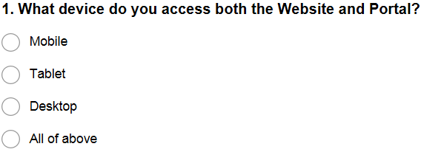

Question one gathered information on the device used by the survey participants. This would allow us to properly determine which platform is being used most regularly.

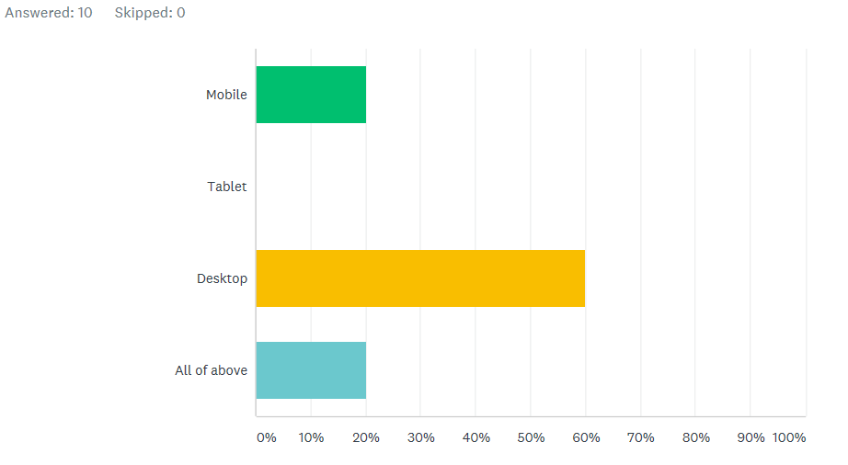

The analysis represents the clear majority use a desktop to access both the website and student portal.

Question 2:

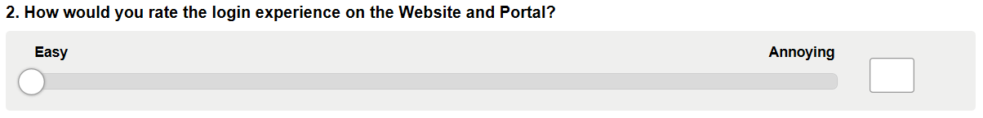

The second question is to gather information on the log on experience, through our observation technique it was noted that the log-on experience was quite long and needed user interaction a number of times to input a password.

The tolerance of the slider was set from 0 – 5 as a wider tolerance may have led to variable data with no adequate outcome.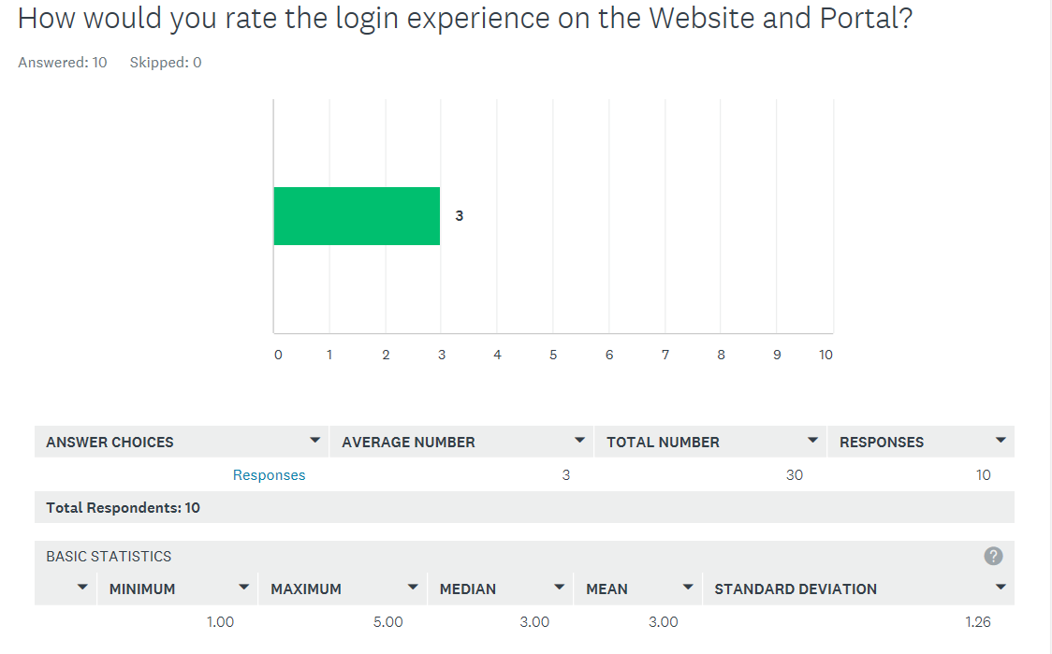

The responses to this question varied with 50% selecting a score of 1 and 2, meaning they found the log in experience easy, 50% chose a score of either 4 or 5, meaning they found the log in experience quite annoying. This gives us a median score of 3 for 10 responses.

We gather from this question that participants find the log in experience neither easy of annoying.

Question 3:

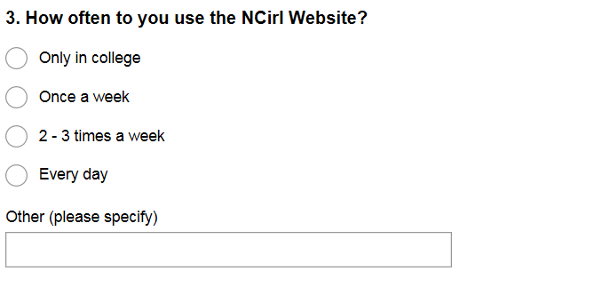

Question three gathers data on how often the site is visited.

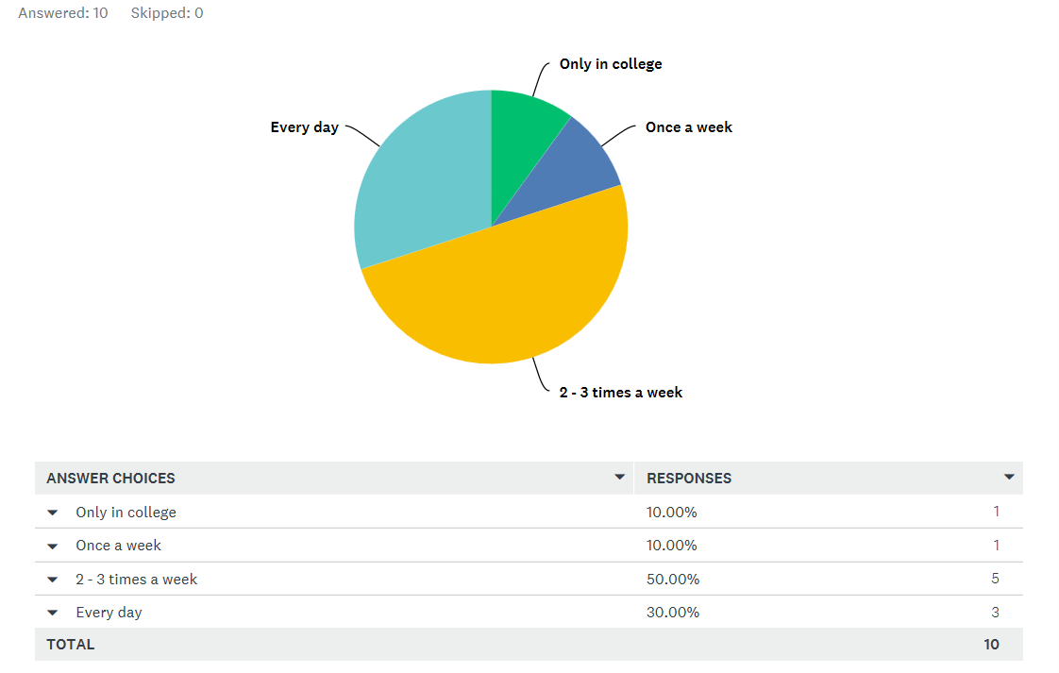

From the response, we can deduce that 80% of participants use the website at least twice a week.

Question 4.

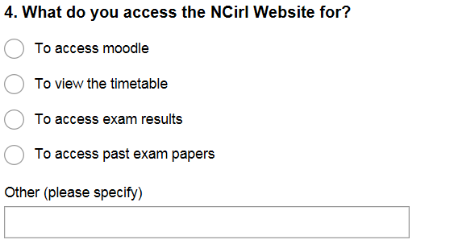

In question three we had gathered how often the participants use the website, Question 4 asks what they use it for.

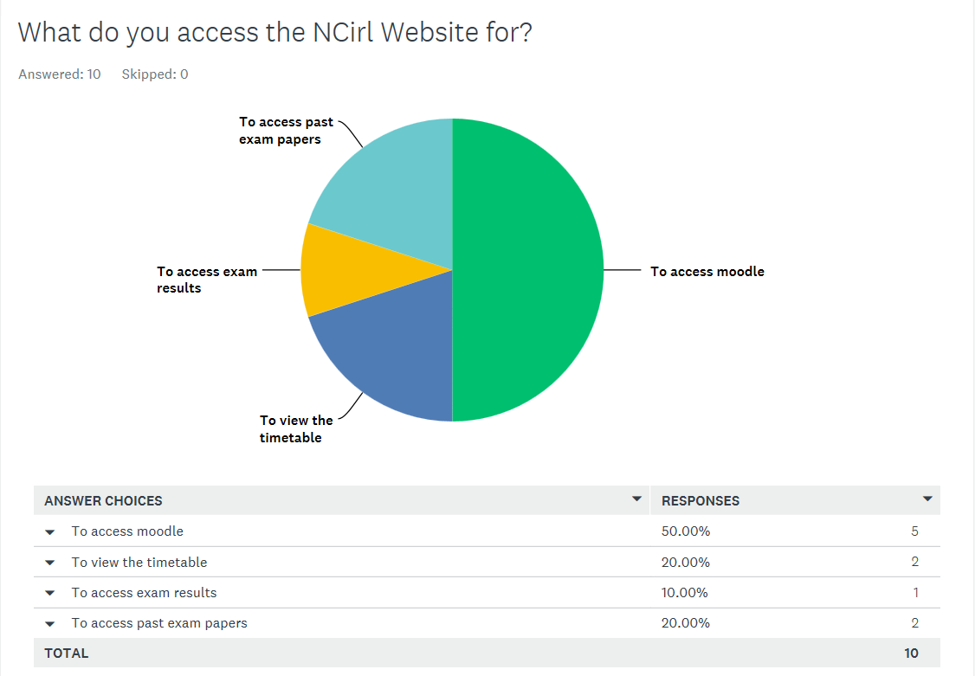

From the data we can deduce that the majority use the website just to view Moodle. The thinking behind the question is should Moodle be standalone?

Question five:

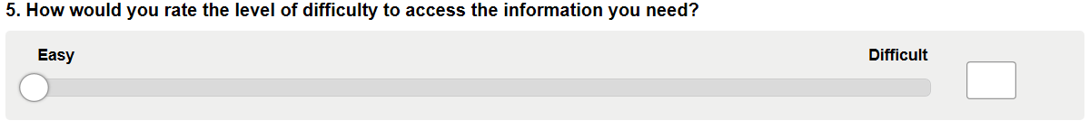

We now ask when logged in to the website how difficult information is to find.

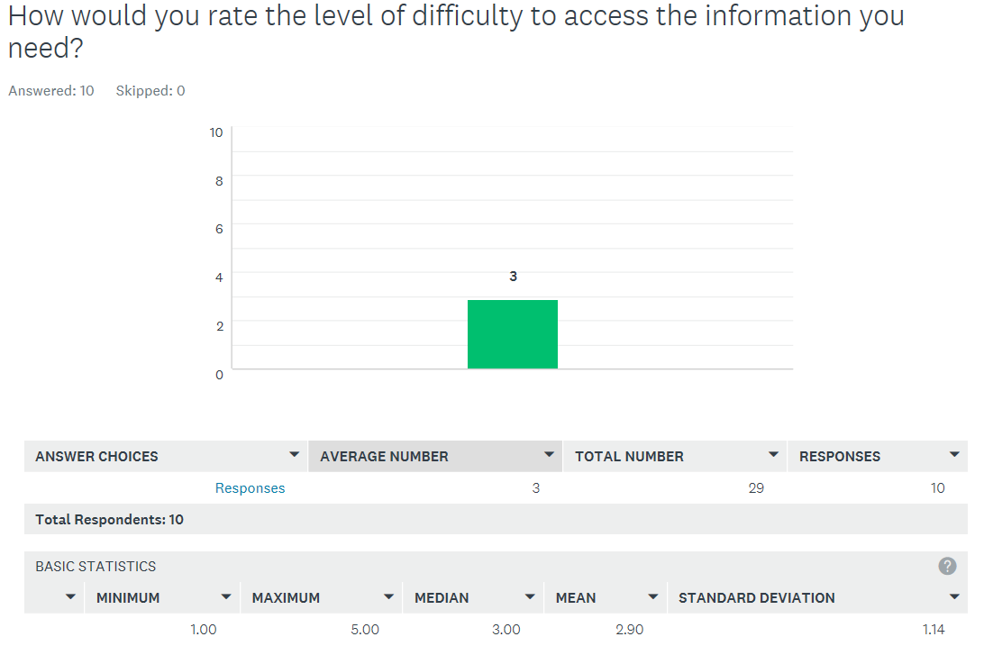

From the data 60% of the participants chose a score of three or higher, meaning they have found that finding information on the website is more difficult than easy.

Question six:

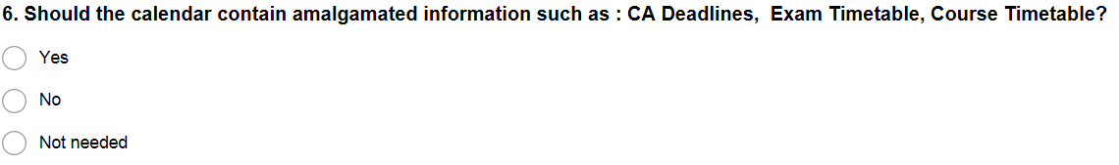

Question six is a straightforward question and was noted during our observation technique. The user noted that there was no central location for information and notes from individual lectures were on their page, CA deadlines are a manual input to the calendar etc.

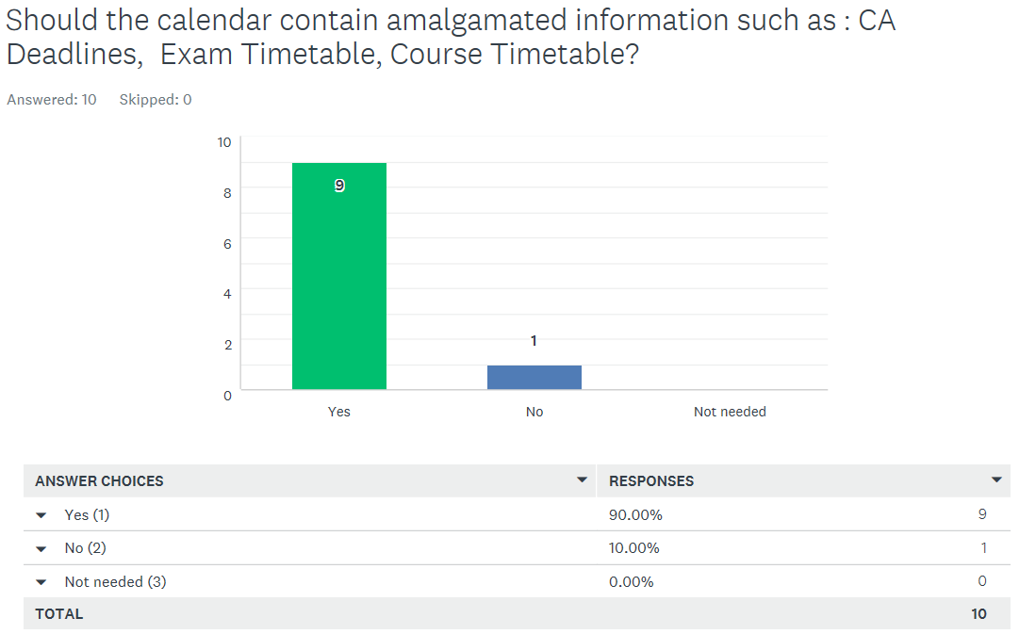

There is a clear indication that participants feel that there is a need for a centralised information centre in the form of the calendar.

Question 7:

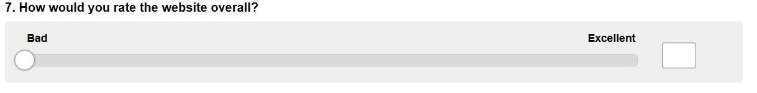

Question 7 should output the general mood of the participants towards the website, this could be an indicator of whether any updating is needed or not.

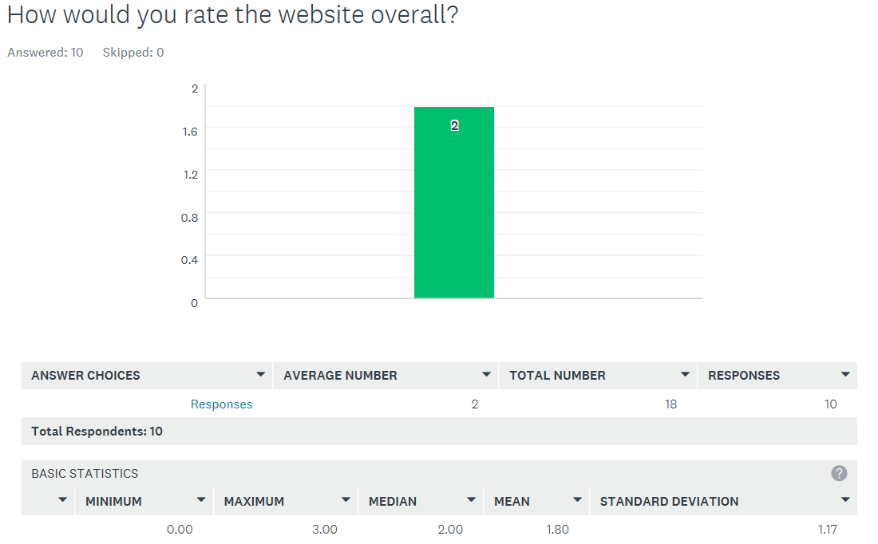

With a median of 2 from a scale of 0 – 5, 0 denoting Bad, we can deduce that the majority of participants feel that the website needs to be updated.

Question 8:

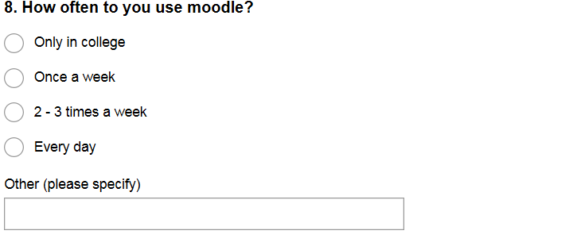

We now move on to the student portal to try and deduce the frequency of use of Moodle. The lower the score in this question the less experienced the participant is.

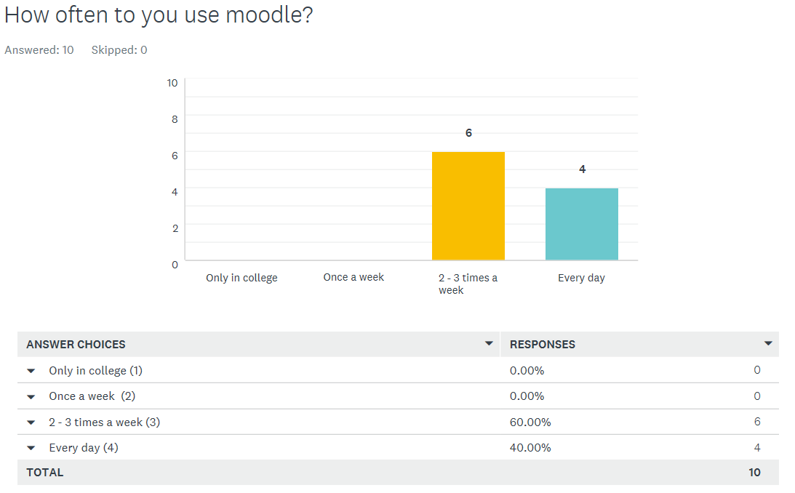

100% of participants use Moodle at least twice a week with 40% using every day. We can deduce that the participants are experienced users.

Question 9:

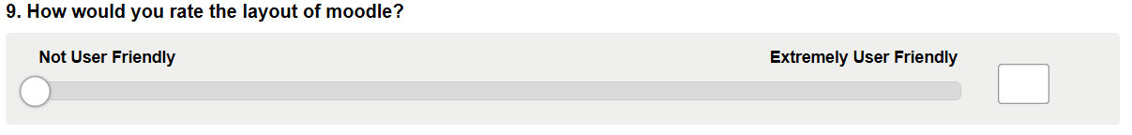

We now understand our participants are experienced users of Moodle. How do they find Moodle works for them?

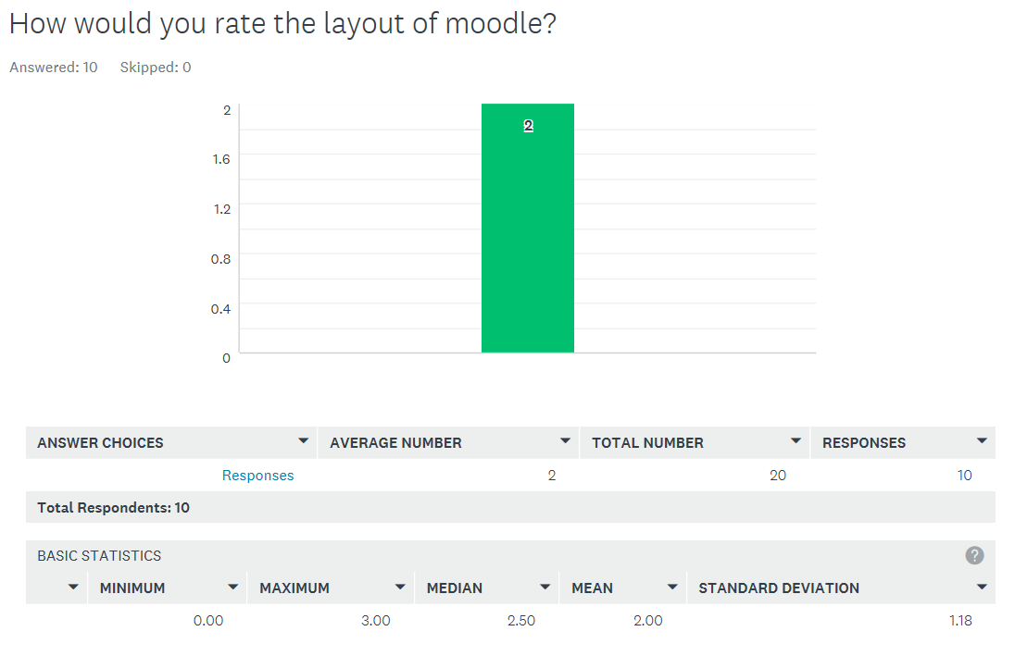

Our participants found that Moodle was not user-Friendly with 50% scoring a 2 or less, 100% a 3 or less. From this we can deduce that Moodle could do with a makeover.

Question ten:

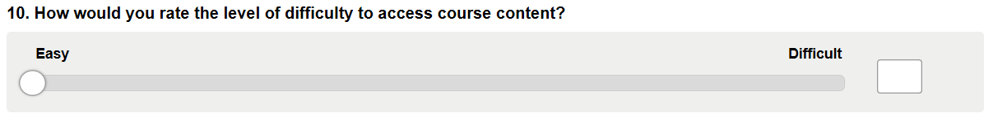

We now score the level of difficulty to access course content. Is the content where it should be?

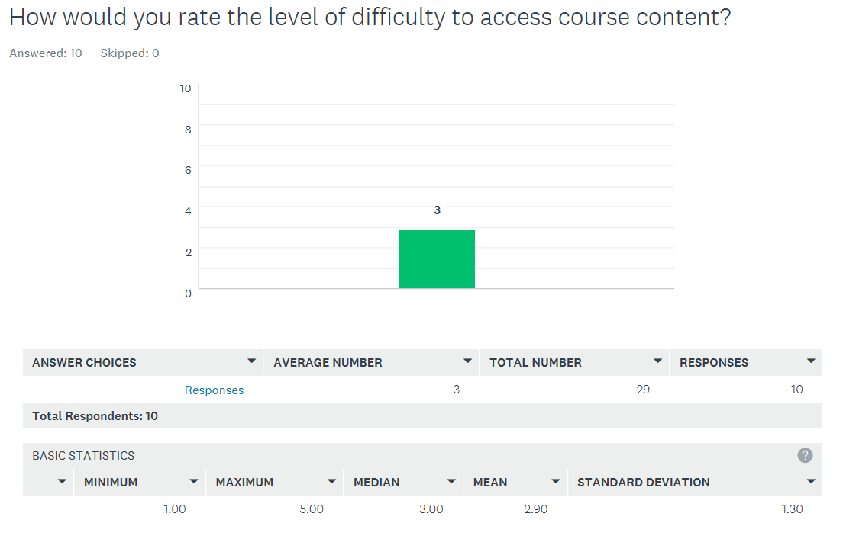

60% of our participants scored a three or higher with 40% scoring a four or five on the range of 0 – 5, meaning they found that course content was difficult to access.

Conclusion:

From our data we can conclude that the layout of the website and student portal need addressing. Additional features such as the amalgamated calendar information centre are highly recommended. A more fluid and user-friendly experience is a necessity if a redesign were to take place, as users have found that information cannot be directly accessed as they would like.

3.3 Observation Analysis

***Website***

A set number of tasks were asked to be performed by the user and observed. The goal being to determine the usability of the website for new users.

The tasks that are to be performed are:

1. Navigate to the course selector to find a pre-chosen course.
2. Find the course descriptor
3. Find the course co-ordinator
4. Find how to apply for the course
5. Find the fees for the course

The course pre-chosen was a Part-time course, a Post Graduate Diploma in Arts in Human Resource Management.

* **User 1 [Non-Student / Age Range 35 – 40]**

1. To find the course the user simply navigated to Courses, from there the user used the side navigator to navigate to Part-time courses. The user noted that it would have been preferable to have courses structured in their different discipline rather than in one page as it was relatively easy to bypass the course.
2. The course descriptor/content on the pre-chosen course leads you to another page. The user noted that it would be more helpful if each module was at the least listed and then the descriptor for the module followed through a link. To access the module descriptor, you must go through two-page loads and click two links.
3. The user was unable to find the course co-ordinator, but noted that she would more than likely contact admissions on any questions she may have about the course. The user noted that there is no direct route on the course page. It should be also noted that the user by-passed the brochure at the top of the page also. When asked the user said it was not well highlighted.
4. The user still on the course content page found it unusual that she did not have direct access to apply for the course on the page itself. The user had to navigate using the side navigator to How to apply, scroll down to part-time courses and then download an application form. The second unusual aspect was that this could not be done on-line. The user also noted that when she eventually stumbled upon the brochure and clicked the link on How to Apply, this link brought her straight back to the NCI homepage, where she needed to navigate further to the How to Apply page. This should be a direct link.
5. Although the fees are stated on the course page the Direct Debit plan could easily have been printed alongside this. The user bypassed the course a few times before the direct debit plan related to the pre-chosen course was found. The user had expected the plans to be in alphabetical order i.e. All Postgraduate courses together, all Certificates together.

In conclusion the user felt that overall the site was good but that there were too many clicks to get to the needed information. Where possible the information should be on one page and links should be direct. Several links to get one piece of information was confusing and frustrating.

* **User 2 [Non-Student / Age Range 30 – 35]**

1. To find the course the user searched for Courses and selected the required course. The user presumed this was the only way to access the course.
2. To access the module descriptor, you must go through two-page loads and click two links which the user saw as an unnecessary step when the information could be easily amalgamated into the original page.
3. The user was unable to find the course co-ordinator so gave up on the task. The observer found the source information which the user felt should be front and centre if this person needs to be contacted.
4. The user presumed that to apply for the course this section would be at the bottom of the main page, but it wasn’t which they noted as a strange concept. They commented that “Isn’t this the main point of the college to make the application process simple?”
5. The user found the course fees with ease.

In conclusion the user felt that the site was too complicated based on the area they had seen so far but that the style, look and feel could be enhanced with only some slight tweaks.

***Student Portal***

A set number of tasks were asked to be performed by the user and observed. The goal being to determine the usability of the student portal for new or current users.

The tasks that are to be performed are:

1. Navigate to Moodle from the Application and select a course.
2. Find the course grades
3. Give an overview of the module course information
4. Find and review the calendar
5. Find the course timetable

* **User 1 [Student / Age Range 30 – 35]**

1. The user navigated to Moodle from the Application page. First point made was why do they have to enter in the same password again? Why can’t this be auto-entered from the first log in?
2. They then moved into Moodle and selected a module. The grades of the course were on the left hand side and easy to find.
3. The user reviewed the setup of their current modules, form previous usage their first point was that the page is very cluttered leaving it difficult to find exactly what they want easily. They also noted that since the new version of the portal came in this year you cannot remove any modules for next semester leaving the page even more cluttered.
4. The calendar was found on the right side of the page with ease. On review, the user advised that the calendar is something they’ve never used and doesn’t seem to have any relevant information included in it.
5. The course timetable is also on the right hand side but on first review the timetable is straight away confusing. When they finally got to the course timetable the extract page only included a per week outline, i.e. week 1, week 6 but not an actual date which they advised should be included.

3.4 Prototype Analysis

4 Conclusions

5 Bibliography and References

1. Guide to the business analysis body of knowledge. (2015). Toronto: Ontario: International Institute of Business Analysis.
2. SurveyGizmo. (2017). *Are You Using a Questionnaire or Survey to Collect Data?* [online] Available at: https://www.surveygizmo.com/survey-blog/taking-the-question-out-of-questionnaires/ [Accessed 20 Oct. 2017].
3. Pious, K. (2017). *Techniques for Eliciting Quality Requirements – Observation*. [online] Captech Consulting, Inc. Available at: https://www.captechconsulting.com/blogs/techniques-for-eliciting-quality-requirements--observation [Accessed 20 Oct. 2017].

   iv Surveymonkey.com. (2017). SurveyMonkey: The World’s Most Popular Free Online Survey Tool. [online] Available at: https://www.surveymonkey.com/ [Accessed 16 Nov. 2017].