# NCI Fundamentals of Business Analysis

*Group Project*

Requirements Document for the re-design of the NCI website and portal

Analysis Group:

Mark Gaskin - 16111931

Patrick Moran - 16102860

Keith Redmond - 15003990

Table of Contents

# executive summary 4

1Introduction 5

1.1 Purpose of Document 5

1.2 Intended Audience 5

1.3 Assumptions 5

1.4 Out of Scope 5

1.5 Outstanding Items 5

2 Introduction & Overview to techniques being used 6

2.1 Brainstorming 6

2.2 Survey/Questionnaires 6

2.3 Observation 7

2.4 Prototype 7

3 Requirements Analysis 8

3.1 Brainstorming Analysis 8-10

3.2 Survey/Questionnaires Analysis 10-19

3.3 Observation Analysis 20-21

3.4 Prototype Analysis 22-28

4 Conclusions 29

5 Bibliography & References 30

Document History

|  |  |  |  |
| --- | --- | --- | --- |
| Ver | Name | Date | Details |
| 0.1 | Mark Gaskin | 15/10/2017 | Initial Draft |
| 0.2 | Mark Gaskin | 20/10/2017 | Include NCI Logo |
| 0.3 | Mark Gaskin/Patrick Moran | 01/11/2017 | Add Technique overview and introduction to the techniques being used |
| 0.4 | Mark Gaskin | 02/11/2017 | Updated document structure and format |
| 0.5 | Mark Gaskin | 07/11/2017 | Add Requirements Analysis table content, observation output and brainstorming. |
| 0.6 | Mark Gaskin | 07/11/2017 | observation output Updated |
| 0.7 | Mark Gaskin | 08/11/2017 | observation output Updated |
| 0.8 | Mark Gaskin | 09/11/2017 | observation clean up |
| 0.9 | Mark Gaskin | 13/11/2017 | Scrum update |
| 1.0 | Patrick Moran | 16/11/2017 | Insert Survey Analysis |
| 1.1 | Mark Gaskin | 20/11/2017 | Scrum update |
| 1.2 | Mark Gaskin | 20/11/2017 | Add executive summary |
| 1.3 | Keith Redmond | 22/11/2017 | Add prototyping analysis |
|  |  |  |  |
|  |  |  |  |
|  |  |  |  |
|  |  |  |  |
|  |  |  |  |
|  |  |  |  |
|  |  |  |  |

# # executive summary

This requirements document provides an analysis and evaluation of the current and prospective NCI website and the student portal. Methods of analysis include the following elicitation techniques:

* Surveys
* Observations
* Prototyping
* Brainstorming

All techniques have been broken down within the document to outline the teams understanding of the technique, the steps taken to implement these techniques and the outcome of the implementation of these techniques.

Results of the analysed data shows that several convenience changes should be implemented so that a user on the website can spend less time searching for what they need or to have one singular well laid out process to gain the information they need. In particular, searching for college course information needs to have the ability to complete registration for the course on the same page and in less than two clicks. Observation analysis shows that this process requires the user to leave the course page and research for enrolment details.

On both the Survey and the Observation it was highlighted that the student web portal needed to combine several sections so that students would have a “one stop shop” to find up-coming exam dates, CA completion dates, lecturer updates and class timetables. It has been noted that the portal calendar should be enhanced to cater for this functionality.

The report also shows a requirement for fluidity to the web portal across the board to alleviate confusion of were much used information is found. We recommend that a user surfing analysis should take place post report to determine what pages or areas are most used and design a “most visited” location within each page.

The report finds that the overall look of the website and portal is good, but the usability is poor.

# 1 Introduction

## **Purpose of Document**

The analysis team outlined above are required to complete a group project of at least 2,000 words per person, which accounts for 50% of our overall mark.

Task outline:

National College of Ireland has decided to redevelop its website and student portal and it has approached you, and asked for you to complete a Requirements Elicitation for this project.

Using at least 4 different Elicitation Techniques, you must produce a report of your findings.

This document will serve as the foundation for the solution to the website and portal redevelopment.

Your report should include (but does not have to be limited to):

* A project introduction
* An overview of the techniques that you have chosen
* A summary of the activities involved in eliciting the requirements using the chosen techniques
* A documentation of the results of your elicitation
* An analysis of the results
* Specification of the proposed solution

## **Intended Audience**

The intended audience is Glen Holmes and the analysis team.

## **Assumptions**

A minimum of 4 techniques will be used.

The submission due date is the 24th November 2017.

Minimum number of words is 6,000 in total.

The team will use What’s App group for ongoing scrums and GitHub for saving documentation.

GitHub site used <https://github.com/Markog222/BA-Group-Project>

## **Out of Scope**

It was confirmed that all students were not allowed to send survey requests to lecturers or students without sign off from the ethics committee. Unfortunately, the team had completed the survey elicitation technique before this was known but at the time only sent the survey within the class.

## **Outstanding Items**

N/A

2 Introduction & Overview to techniques being used

**2.1 Brainstorming**

Brainstorming is used to generate ideas for improvement opportunities.[1]

Brainstorming is a useful tool to gather information and ideas from a requirements analysis brief. It can also be used to decide on what elicitation techniques are most suitable to gather required information.

Our team has decided to use an initial brainstorming session to decide upon which techniques are best suited to gather the information needed. Brainstorming sessions will take place as the requirements analysis further develops in the form of scrums. The scrums will take place either in class or over our What’s App group. Notes of these scrums will be saved in our brainstorming analysis section.

During our first brainstorming session we have decide to further select the following techniques:

1. Survey/Questionnaires
2. Prototype
3. Observations

The three elicitation techniques listed above, and the brainstorming technique make up the four elicitation techniques required in the brief.

It should also be noted during our first brainstorming session, it was decided upon, that Mark Gaskin shall be Team lead on this requirements analysis.

**2.2 Survey/Questionnaires**

A questionnaire is a series of questions used for gathering information that is used to benefit a single individual. While more than one individual might complete the questionnaire, the responses are not aggregated for analysis.

A survey, on the other hand, is the process of gathering information for statistical analysis to benefit a group of individuals. The responses are aggregated to draw a conclusion.[2]

As outlined in the above citation a survey or questionnaire is used to gather information. In our analysis we shall be taking advantage of a survey tool (A list of which given below).

A survey tool allows us to address a wider audience in a relatively short space of time. The information gathered from such surveys allow Stakeholders to readily view the state of affairs at a given time, the mood of a society at a given time and how a workplace is performing e.g. a HR Survey.

During our initial brainstorming session, the following guidelines for a survey were agreed upon:

1. Questions should be clear and concise.
2. Questions should follow a certain sequence.
3. Questions should be in the form of Multiple Choice or a Scale.

Lists of possible hosts for our survey are listed here:

* Survey Monkey
* Type form
* Google Forms
* Client Heartbeat
* Zoho Survey
* Survey Gizmo
* Survey Plane

**2.3 Observation**

Observation or job shadowing involves looking at the actual work environment that the end user experiences every day. This technique is used when attempting to document an existing process or when a project’s goal is to improve a process. Observation is a great way to understand what the end user goes through in their job and can provide some instant requirements for how a process can be improved.[3]

As the project is on the update of a website and student portal, we shall be using this technique in two ways.

1. We will shadow a number of non-users of the website i.e. a person who has not visited the site previously. Our thoughts on this are:

* As this a college website, every year a new set of potential students will visit the website to view possible courses.
* We would be able to monitor behaviour closely and note how easy or difficult a task is to perform i.e. Where can I get Fees information? Where I can get course information? Where I can get course start date information? What requirements are needed to apply for the course?

1. We shall shadow a current student. Non -Students do not have access to the student portal. Multiple tasks will be set (to be decided upon) for the user to perform, it will be noted how easy or difficult these tasks are to perform.

**2.4** **Prototype**

A prototype in accordance to the brief of this requirements analysis i.e. A Web re-design, could consist of a wireframe, a non-functioning webpage or a rudimentary sketch.

The idea behind a prototype is to give the stakeholders a visual representation of a concept. The prototype in our case will help visualise a possible new layout. The layout change or possible layout change will be generated upon the results of the above-mentioned elicitation techniques.

3 Requirements Analysis

3.1 Brainstorming Analysis

**Scrum 1:**

**19th October 18:00 - 18:24**

**In class discussion**

**Mark, Patrick and Keith discussed the elicitation techniques that will be used.**

**Based on the discussion and on the weight of work to be done the below techniques were selected:**

* **Brainstorming**
* **Prototyping**
* **Observation**
* **Survey**

**Take Away:**

**For Saturday 21st October each person was tasked with briefly outlining what each technique would require, how it should be structured and what the outcome should provide.**

**Scrum 2:**

**22nd October 18:57 – 20:45**

**What’s App group discussion**

**The group discussed the outcome of the elicitation techniques outline completed on the 21st October. Each member set out what they believe to be the pressure points for each elicitation technique.**

**This outline is now open to be incorporated into the main process. The team also designed the structure of the main requirements document. All documents and outlines have been saved to the GitHub repository.**

**Take Away:**

**For the week coming each member was set a task of starting an observation outline and if time allowed complete one observation.**

**Scrum 3:**

**30th October 18:14 – 19:45**

**What’s App Group Discussion**

**Discussion held around starting of the observation technique. Patrick confirmed that he has completed the first non-student website observation. Keith and Mark to organise further observations.**

**Take Away:**

**Each member was request to come up with 5 questions each for the survey and to select a survey tool that best suited our needs.**

**Scrum 4:**

**6th November 14:40 – 21:30**

**What’s App Group Discussion**

**The team discussed all questions to be included on the survey monkey survey site. Several questions were mentioned with 10 of the best selected. Once the questions were confirmed the survey was formatted and the sent to class mates to complete.**

**An email was sent to NCI management requesting access to all students email’s so that a mass email can be sent with our survey. Awaiting reply.**

**Take Away:**

**Once the survey output is completed the team needs to analyse the data. Next step is to complete the observations and start reviewing possible prototype ideas.**

**Scrum 5:**

**11th November 12:00 – 12:10**

**In class Discussion**

**Based on our current output the group have defined the final elements required to be completed before submission. Next step is to complete the Requirements Analysis for Observation, Survey and provide multiple prototypes based on the output of the elicitation techniques used to date.**

**Take Away:**

**Patrick is to input the data received from the survey into the requirements documents by Thursday 16th November. Keith has been tasked with generating the prototypes and outlining the reason for the redesign, this is also due on Thursday 16th November.**

**Scrum 6:**

**18th November 12:00 – 12:10**

**In class Discussion**

**Patrick has completed the survey analysis which has been discussed between the analysts. This output has been included in the requirements documents and conclusions have been provided within the conclusion section. Keith completed the prototyping element and provided detailed information around his analysis. He has also provided several versions of the prototypes against multiple pages and function based on the outcome of the observation and surveys analysis.**

**Take Away:**

Keith is to provide a final combined prototype analysis by Tuesday 21st November which will be then added to the requirements document. The team will then commence drawing all conclusions for final submission by Friday 24th November. Reviews will continue during the final week to confirm all analyst are happy with the content.

3.2 Survey Analysis

As part of our elicitation techniques, and during our brainstorming scrums, a survey was selected to gather the consensus of the student population on their mood towards both the website and the student portal.

As mentioned above during brainstorming, the number of questions the platform on which the survey is to be conveyed i.e. Survey Monkey and the questions themselves were decided upon.

When deciding on the questions, we had to take care to elicit the most information from a limited number of questions in a short period. The time of a survey is crucial, surveys that cannot be undertaken in a matter of short minutes can be deemed long and may lead to invalid data as the user loses interest.

The questions decided upon were based upon the overall feel of the website and portal.

Question one:

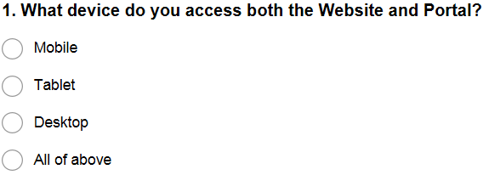

Question one gathered information on the device used by the survey participants. This would allow us to properly determine which platform is being used most regularly.

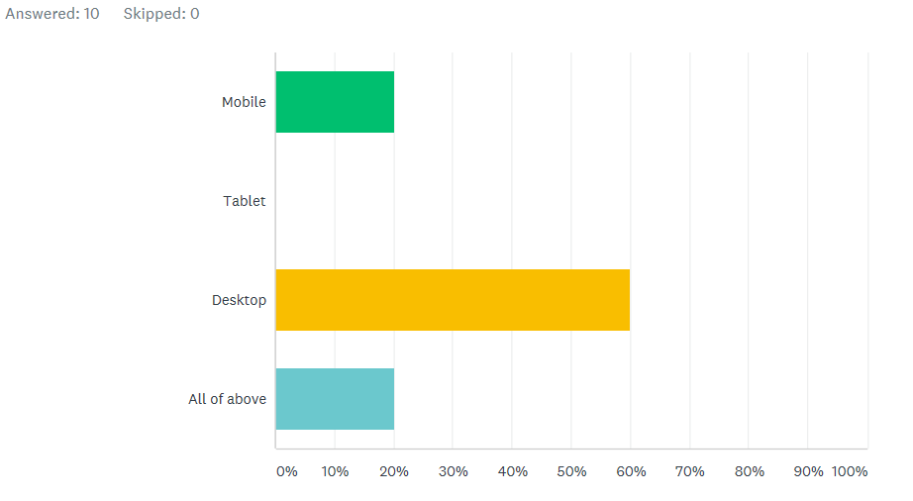

The analysis represents the clear majority use a desktop to access both the website and student portal.

Question 2:

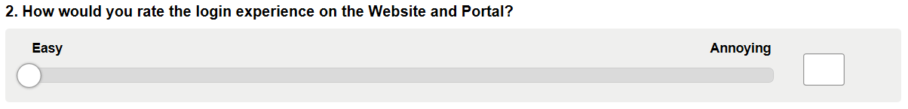

The second question is to gather information on the log on experience, through our observation technique it was noted that the log-on experience was quite long and needed user interaction a number of times to input a password.

The tolerance of the slider was set from 0 – 5 as a wider tolerance may have led to variable data with no adequate outcome.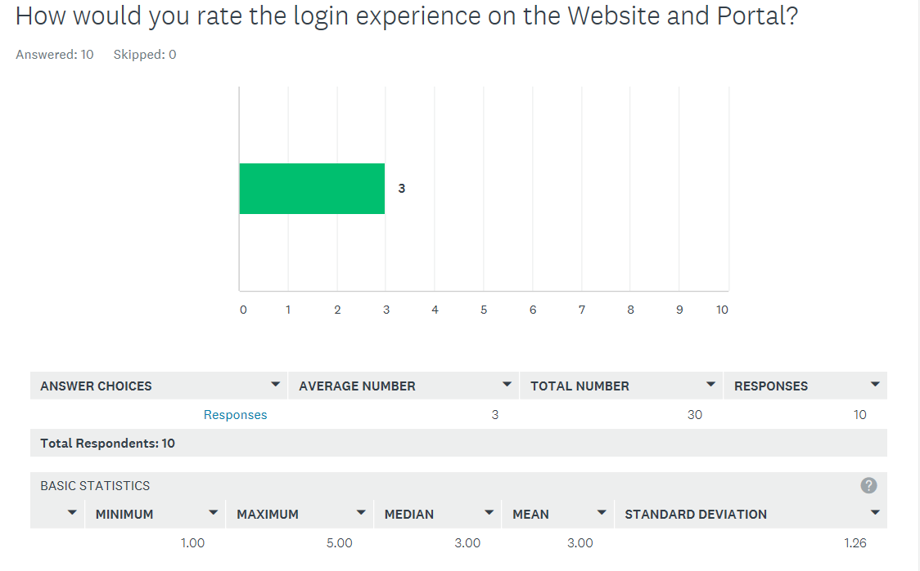

The responses to this question varied with 50% selecting a score of 1 and 2, meaning they found the log in experience easy, 50% chose a score of either 4 or 5, meaning they found the log in experience quite annoying. This gives us a median score of 3 for 10 responses.

We gather from this question that participants find the log in experience neither easy of annoying.

Question 3:

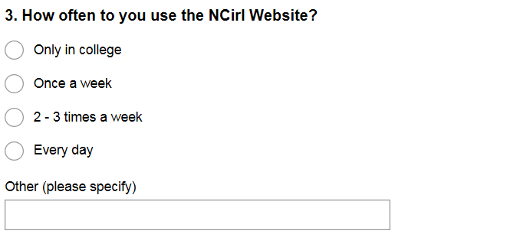

Question three gathers data on how often the site is visited.

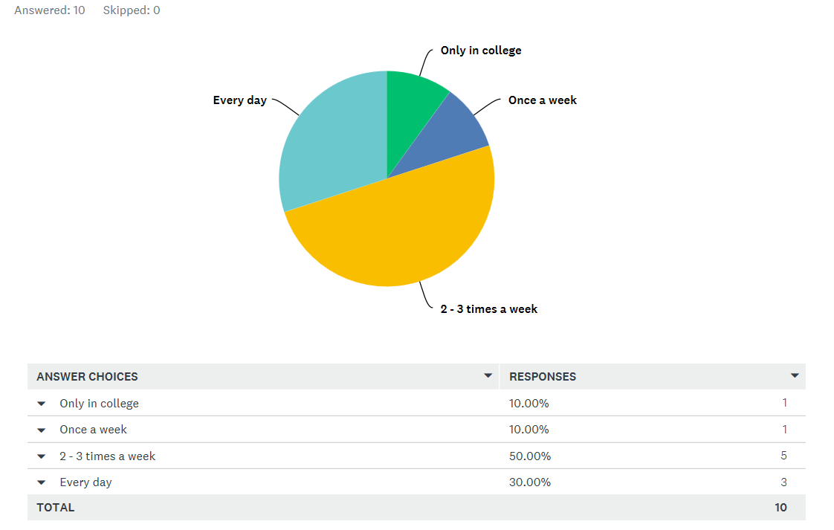

From the response, we can deduce that 80% of participants use the website at least twice a week.

Question 4:

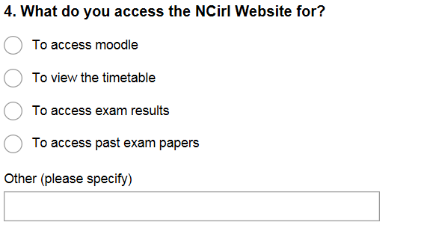

In question three we had gathered how often the participants use the website, Question 4 asks what they use it for.

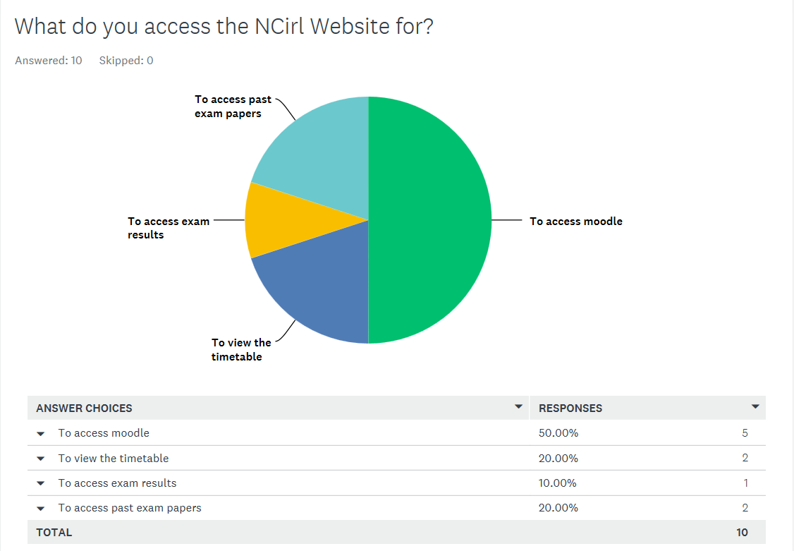

From the data we can deduce that the majority use the website just to view Moodle. The thinking behind the question is should Moodle be standalone?

Question five:

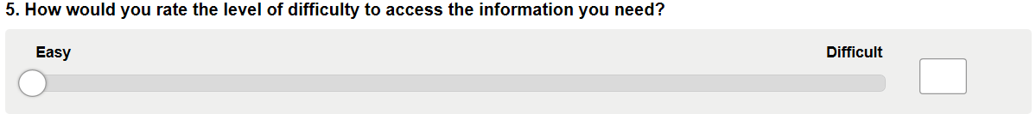

We now ask when logged in to the website how difficult information is to find.

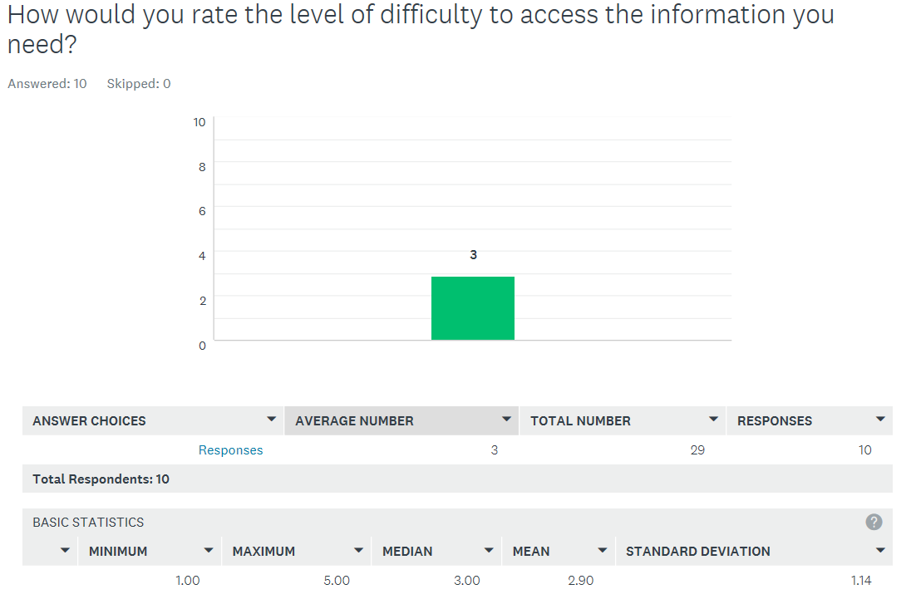

From the data 60% of the participants chose a score of three or higher, meaning they have found that finding information on the website is more difficult than easy.

Question six:

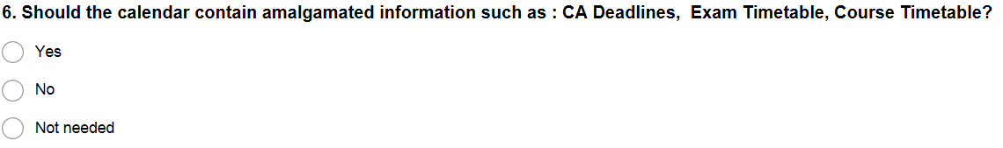

Question six is a straightforward question and was noted during our observation technique. The user noted that there was no central location for information and notes from individual lectures were on their page, CA deadlines are a manual input to the calendar etc.

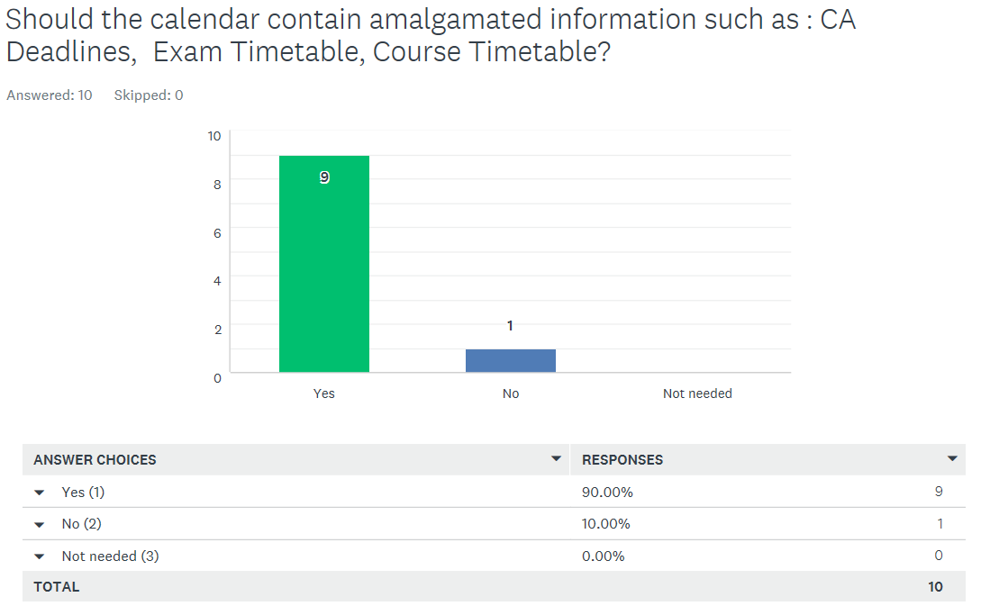

There is a clear indication that participants feel that there is a need for a centralised information centre in the form of the calendar.

Question 7:

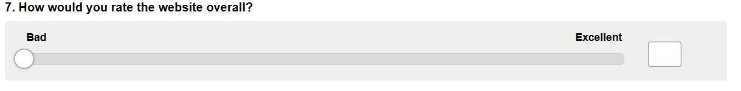

Question 7 should output the general mood of the participants towards the website, this could be an indicator of whether any updating is needed or not.

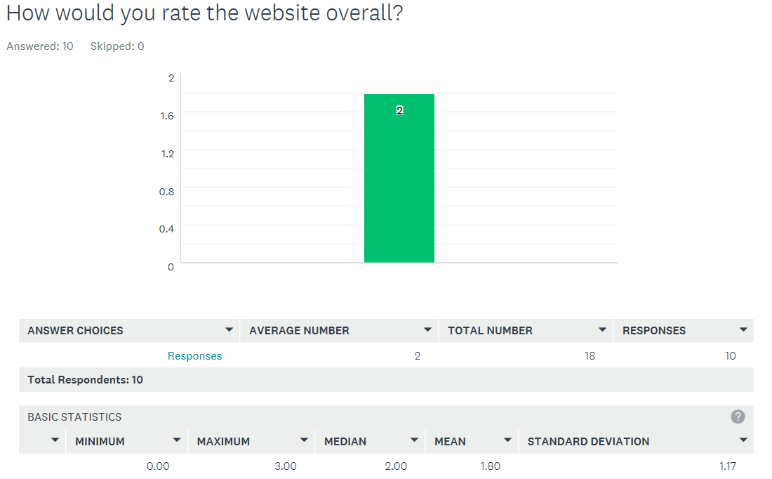

With a median of 2 from a scale of 0 – 5, 0 denoting Bad, we can deduce that the majority of participants feel that the website needs to be updated.

Question 8:

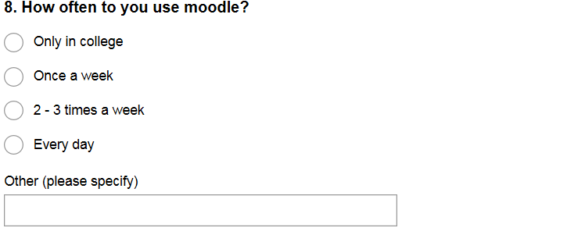

We now move on to the student portal to try and deduce the frequency of use of Moodle. The lower the score in this question the less experienced the participant is.

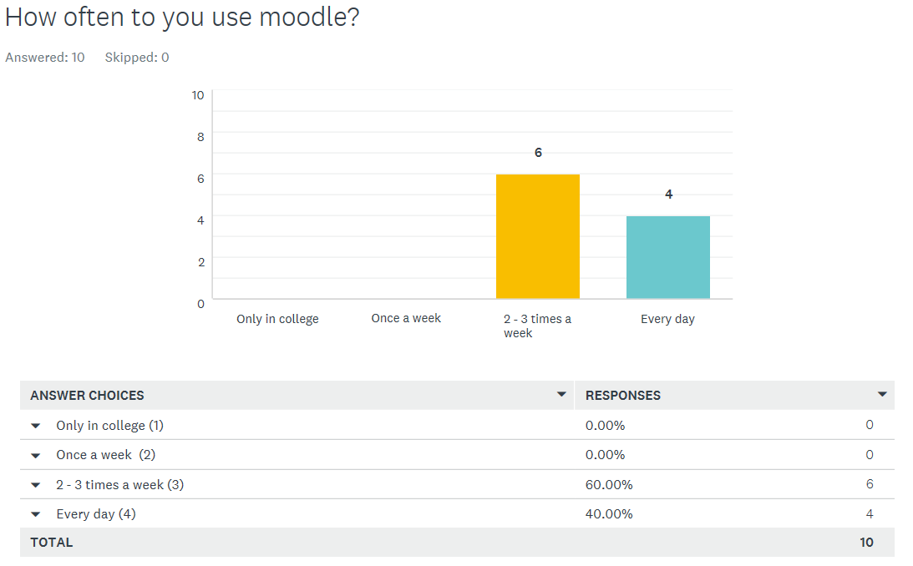

100% of participants use Moodle at least twice a week with 40% using every day. We can deduce that the participants are experienced users.

Question 9:

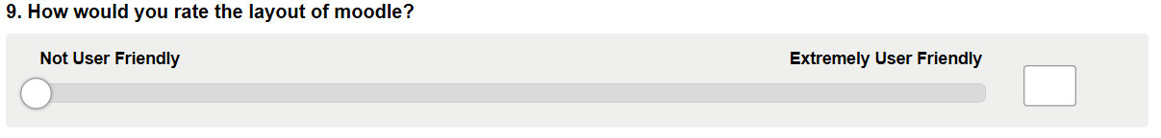

We now understand our participants are experienced users of Moodle. How do they find Moodle works for them?

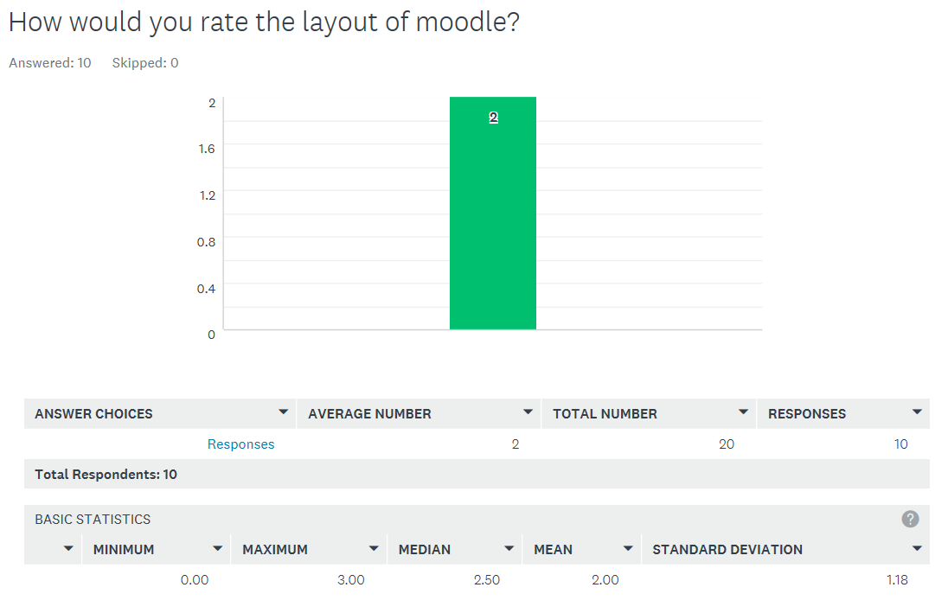

Our participants found that Moodle was not user-Friendly with 50% scoring a 2 or less, 100% a 3 or less. From this we can deduce that Moodle could do with a makeover.

Question ten:

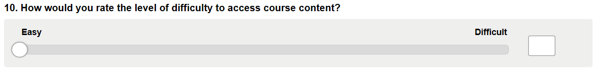

We now score the level of difficulty to access course content. Is the content where it should be?

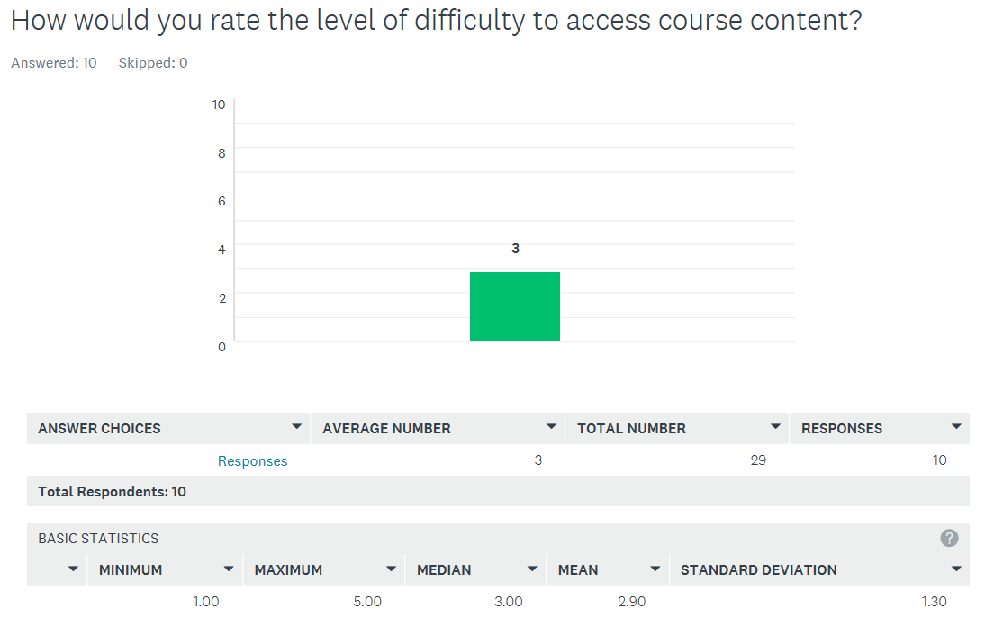

60% of our participants scored a three or higher with 40% scoring a four or five on the range of 0 – 5, meaning they found that course content was difficult to access.

3.3 Observation Analysis

***Website***

A set number of tasks were asked to be performed by the user and observed. The goal was to determine the usability of the website for new users.

The tasks that are to be performed are:

1. Navigate to the course selector to find a pre-chosen course.
2. Find the course descriptor
3. Find the course co-ordinator
4. Find how to apply for the course
5. Find the fees for the course

The course pre-chosen was a Part-time course, a Post Graduate Diploma in Arts in Human Resource Management.

* **User 1 [Non-Student / Age Range 35 – 40]**

1. To find the course the user simply navigated to Courses, from there the user used the side navigator to navigate to Part-time courses. The user noted that it would have been preferable to have courses structured in their different discipline rather than in one page as it was relatively easy to bypass the course.
2. The course descriptor/content on the pre-chosen course leads you to another page. The user noted that it would be more helpful if each module was at the least listed and then the descriptor for the module followed through a link. To access the module descriptor, you must go through two-page loads and click two links.
3. The user was unable to find the course co-ordinator, but noted that she would more than likely contact admissions on any questions she may have about the course. The user noted that there is no direct route on the course page. It should be also noted that the user by-passed the brochure at the top of the page also. When asked the user said it was not well highlighted.
4. The user still on the course content page found it unusual that she did not have direct access to apply for the course on the page itself. The user had to navigate using the side navigator to How to apply, scroll down to part-time courses and then download an application form. The second unusual aspect was that this could not be done on-line. The user also noted that when she eventually stumbled upon the brochure and clicked the link on How to Apply, this link brought her straight back to the NCI homepage, where she needed to navigate further to the How to Apply page. This should be a direct link.
5. Although the fees are stated on the course page the Direct Debit plan could easily have been printed alongside this. The user bypassed the course a few times before the direct debit plan related to the pre-chosen course was found. The user had expected the plans to be in alphabetical order i.e. All Postgraduate courses together, all Certificates together.

In conclusion the user felt that overall the site was good but that there were too many clicks to get to the needed information. Where possible the information should be on one page and links should be direct. Several links to get one piece of information was confusing and frustrating.

* **User 2 [Non-Student / Age Range 30 – 35]**

1. To find the course the user searched for Courses and selected the required course. The user presumed this was the only way to access the course.
2. To access the module descriptor, you must go through two-page loads and click two links which the user saw as an unnecessary step when the information could be easily amalgamated into the original page.
3. The user was unable to find the course co-ordinator so gave up on the task. The observer found the source information which the user felt should be front and centre if this person needs to be contacted.
4. The user presumed that to apply for the course this section would be at the bottom of the main page, but it wasn’t which they noted as a strange concept. They commented that “Isn’t this the main point of the college to make the application process simple?”
5. The user found the course fees with ease.

In conclusion the user felt that the site was too complicated based on the area they had seen so far but that the style, look and feel could be enhanced with only some slight tweaks.

***Student Portal***

A set number of tasks were asked to be performed by the user and observed. The goal was to determine the usability of the student portal for new or current students.

The tasks that are to be performed are:

1. Navigate to Moodle from the Application and select a course.
2. Find the course grades
3. Give an overview of the module course information
4. Find and review the calendar
5. Find the course timetable

* **User 1 [Student / Age Range 30 – 35]**

1. The user navigated to Moodle from the Application page. First point made was why do they have to enter in the same password again? Why can’t this be auto-entered from the first log in?
2. They then moved into Moodle and selected a module. The grades of the course were on the left hand side and easy to find.
3. The user reviewed the setup of their current modules, form previous usage their first point was that the page is very cluttered leaving it difficult to find exactly what they want easily. They also noted that since the new version of the portal came in this year you cannot remove any modules for next semester leaving the page even more cluttered.
4. The calendar was found on the right side of the page with ease. On review, the user advised that the calendar is something they’ve never used and doesn’t seem to have any relevant information included in it.
5. The course timetable is also on the right hand side but on first review the timetable is straight away confusing. When they finally got to the course timetable the extract page only included a per week outline, i.e. week 1, week 6 but not an actual date which they advised should be included.

3.4 Prototype Analysis

Through the results of the Survey & Observation elicitations we have formulated several prototypes to help visually show the breakdown of the flaws or amendments in the NCI website/Portal and what we propose to do to overcome them. The prototypes were developed using tools such as white boards, Word and a wireframe software called Pencil (https://pencil.evolus.vn/).

From the Survey, it was clear that the majority of the individuals who access the NCI website did so through a PC and largely were disappointed with the use of Moodle and had difficulty accessing information at hand.

Secondly through our Observation of user’s navigating the web page it was clear that certain features were hard to find as the information was scattered randomly across the webpage and was difficult to complete a task within one location without having to leave to seek other details. The user also found they had to make several clicks before they reach their destination. Overall the NCI webpage appears to be unorganised and difficult to use from a general user’s perspective.

**Prototype V0.1 - Hierarchy**

Prototype version 0.1 is our first attempt to address the redesign of the website, through this method as seen below we attempted to develop a consensus of the Hierarchy so that we could make the lay out more efficient meaning reducing click navigation. We based this around the available courses and the information relevant to them as it was the main point of interest for users in the Observation tests. Secondly, we also wanted to enhance the student portal by including more features. We also attempted to develop the information we should include at the various stages through the webpage.

* Home Page – Doesn’t need to be adjusted too much from the original design but ideally, from what we have researched, we believe it should be less cluttered so that the main points of interest that we are focusing our efforts on can be viewed with ease.
* Course Index – From here we will be implementing a slightly different file structure as we noticed during our Observation Elicitation that people would prefer if the courses fell under certain discipline types.
* Course Level Selection – When a discipline types has been selected, Business or finance for example, a full time and part time option should be available followed by qualification level.
* Course Selection - Once the user has filtered through the various categories they should be given course titles that fit the criteria of your selections.
* Course Summary – At this point the user would like a summary of the selected course and additional options for greater detail to be gained on the course.
* Course Schedule – Should include a calendar and relevant dates through the semesters.
* Course Modules – In depth explanation on the modules that will be taught.
* Course Fee – Here there should be a break down on payment methods via debt card, cash or cheque and if it’s incremental or lump sum.
* Student Portal – With the results of the survey it was clear that the overall opinion of Moodle/Student Portal was poor. We addressed this in the same manner as the Course Index and that was to determine the most relevant topics and list them clearly in the Student Portal.
* Moodle
* Mail
* Calendar
* One Drive

Through this Hierarchy we would include secondary features such as contact options, support options etc. Academic Support, Financial Support, Disabilities support.

**Prototype V0.2**

At this stage, we were interested in coming up with a web page template and so we played around with some designs on a white board which you can see an example of below. This allowed us to gage the proportion of the web page in the sense of what material needs to be listed and what we can leave out so that the webpage does not appear bloated. We also gained the chance to ask ourselves what fashion can we display the topics etc. through drop down bars, scowling and various containers on the page. Overall, we found the NCI web page looked well but mainly needed reduced information which allowed us to consider salvaging some of the design layout of the current NCI website.

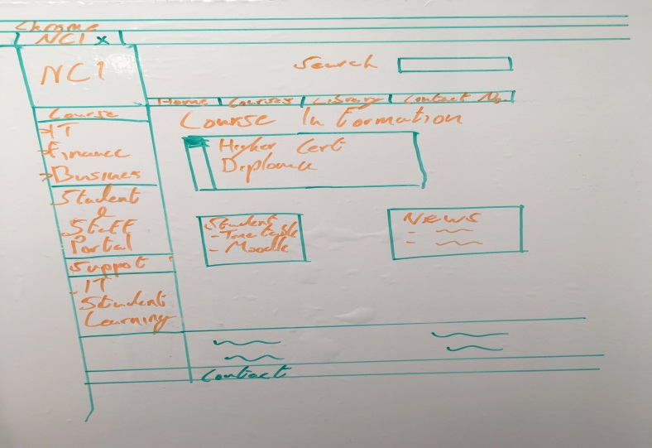

**Prototype V0.3**

This prototype is the final piece which is a combination of prototype V01 & V02 but with added elements. The Pencil application was particle helpful as it allowed us to implement and trial various additional elements because it was visual dynamic to manipulate. At this stage, we had a greater understanding on what we aimed to do in a wireframe prototype which allowed us to achieve greater detail and clarify on what our developed web page would look like. As you can see below I have attached a PDF with several wire frame examples which shows our hierarchy idea in play and with what we learned from the users through the Survey and observations. We attempted to map out the various stages a user would go through when querying what courses are available and what they may need to know. In the example below you will see that much of the information they may seek can be obtained with 3 clicks or more and we have provided a written guide as you lead yourself through the wire frame pages.

*Home Page* - As you can see the home page is of a similar design to the existing NCI home page because we felt that we only needed to remove some unnecessary content. This allows for the content we found users to be most frustrated with to be more visible.

On this page, our aim is to better highlight the headings for the Courses and Student Portal specifically but we are also recommending some feature changes that we believe are also required.

Secrevit fontes liquidum locoque pronaque?   
Illas semine campoque declivia oppida

Secrevit fontes liquidum locoque pronaque?   
Illas semine campoque declivia oppida

Secrevit fontes liquidum locoque pronaque?   
Illas semine campoque declivia oppida

Secrevit fontes liquidum locoque pronaque?   
Illas semine campoque declivia oppida

*Course Type Selection* - This wireframe is just an example on how we imagined some additional content to appear on the home page via drop down menus. Again, this is an example of how we are address the hierarchy structure as we are trying to bring together relatable topics that can be found in a structure that is linear so that they are ether appearing all in one area or is immediately linked via a previous relatable page.



Call Us At 1807676465

Exams Office

Fees Department

IT Department

Library

Business

Finance

Management

Information Technology

Human Resource

CIPD

Social Science

Secrevit fontes liquidum locoque pronaque?   
Illas semine campoque declivia

Secrevit fontes liquidum locoque pronaque?   
Illas semine campoque declivia

Secrevit fontes liquidum locoque pronaque?   
Illas semine campoque declivia

Secrevit fontes liquidum locoque pronaque?   
Illas semine campoque declivia

*Course Index* - This page is linked from the home page through selecting the Course option or the additional options in the drop-down menu which circumvent this page and lead directly to the discipline type selected. The purpose of this page is to show the user what type of disciplines are taught in our college with some brief details based on the disciplines listed. What’s also is listed is some links to information about how to apply to any course, about how fees are handled, available grants/schemes and lastly information on learning Support etc. support class’s and support for students with difficulties. Essentially, we would want information such as that easily accessible to the public so that it would help assist new students evaluating the college and the course’s they may be interested in.



How to Apply

Fees & Grants

Learning Support

Business

Finance

Management

Information Technology Human Resource Management

CIPD

Social Science

Secrevit fontes liquidum locoque pronaque?

Secrevit fontes liquidum locoque pronaque?   
Illas semine campoque declivia oppida

Secrevit fontes liquidum locoque pronaque?

Secrevit fontes liquidum locoque pronaque?

*Course Level Selection* – Once you have selected your discipline you will then be asked if you wish to do a full-time course or a part time course which once selected will generate all the course levels that are available.



*Course Selection* – Now that the course level has been selected courses should generate that fit the criteria of the previous selections.



*Course Summary* – The purpose of this page is to provide a brief description on the selected course and other necessary information you must know. This page also provides the option to select links to more detail information about the schedule, duration for the course, what modules are taught and some information about them and the overall cost of the course. There are also more obvious support options if the user has any queries about the course or possible difficulties.



*Course Schedule* – This is one of the sub topic within a selected course and helps new and current students determine when they’re mid-term breaks take place, when the course its self-starts & finishes and lastly roughly when exams take place



*Course Modules* – Provides more in-depth details on the individual modules of the selected course throughout all the different years of the course.



*Course Fee* – Elaborates on course fee and the various payment methods. Also provides links to information on how to go about requesting grants and if they are eligible.



*Student Portal* – This wire frame is linked directly from the home page and it is the main hub for all current students to visit. This page I would consider to be essential to they’re progress in their course, what I mean by this is that is clearly shows the option to visit their Moodle page, notifies them of Mail & Calendar updates which could be of significant important and so should be easily seen. This page also provides additional information specifically based around support for the students whether its financial, learning and learning difficulties. As mentioned before the Moodle/student portal is seen to be of poor standard when it comes to being easily navigated and information located.



4 Conclusions

Survey Conclusion:

From our data we can conclude that the layout of the website and student portal need addressing. Additional features such as the amalgamated calendar information centre are highly recommended. A more fluid and user-friendly experience is a necessity if a redesign were to take place, as users have found that information cannot be directly accessed as they would like.

Prototype Conclusion:

To conclude our perspective on our prototype assessment which was developed through the combined research of the Observation and Survey elicitation we feel that the aim of redeveloping the website should be to declutter and reorganise the links/information associated with them. To make the page clearer and links/information for the average new users and current students more should be more relevant to suit their needs. Through our prototype development and designs we hope our efforts to portray this embody those values we seek to establish in a fully developed website.

5 Bibliography and References

1. Guide to the business analysis body of knowledge. (2015). Toronto: Ontario: International Institute of Business Analysis.
2. SurveyGizmo. (2017). *Are You Using a Questionnaire or Survey to Collect Data?* [online] Available at: https://www.surveygizmo.com/survey-blog/taking-the-question-out-of-questionnaires/ [Accessed 20 Oct. 2017].
3. Pious, K. (2017). *Techniques for Eliciting Quality Requirements – Observation*. [online] Captech Consulting, Inc. Available at: https://www.captechconsulting.com/blogs/techniques-for-eliciting-quality-requirements--observation [Accessed 20 Oct. 2017].

   iv Surveymonkey.com. (2017). SurveyMonkey: The World’s Most Popular Free Online Survey Tool. [online] Available at: https://www.surveymonkey.com/ [Accessed 16 Nov. 2017].

   v Pencil.evolus.vn. (2017). Home - Pencil Project. [online] Available at: https://pencil.evolus.vn/ [Accessed 22 Nov. 2017].