Survey

As part of our elicitation techniques, and during our brainstorming scrums, a survey was selected to gather the general consensus of the student population on their mood towards both the website and the student portal.

As mentioned above, during brainstorming, the number of questions, the platform on which the survey is to be conveyed i.e. Survey Monkey and the questions themselves were decided upon.

When deciding on the questions, we had to take care in order to elicit the most information from a limited number of questions in a very short period of time. The time of a survey is crucial, surveys that cannot be undertaken in a matter of short minutes can be deemed long and may lead to invalid data as the user loses interest.

The questions decided upon were based upon the overall feel of the website and portal.

Question one:

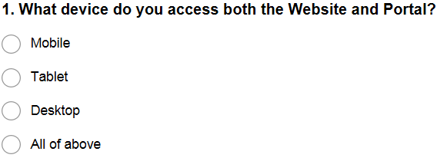

Question one gathered information on the device used by the survey participants. This would allow us to properly determine which platform is being used most regularly.

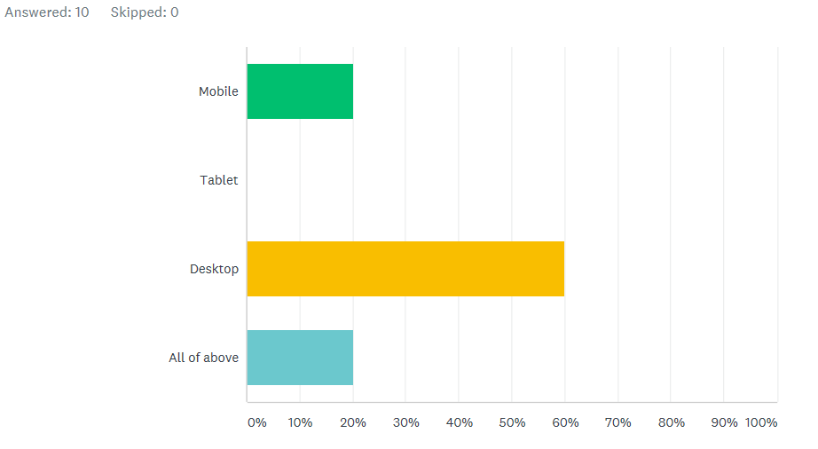

The analysis represents the vast majority use a desktop to access both the website and student portal.

Question 2:

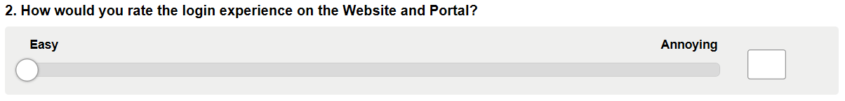

The second question is to gather information on the log on experience, through our observation technique it was noted that the log-on experience was quite long and needed user interaction a number of times to input a password.

The tolerance of the slider was set from 0 – 5 as a wider tolerance may have led to variable data with no adequate outcome.

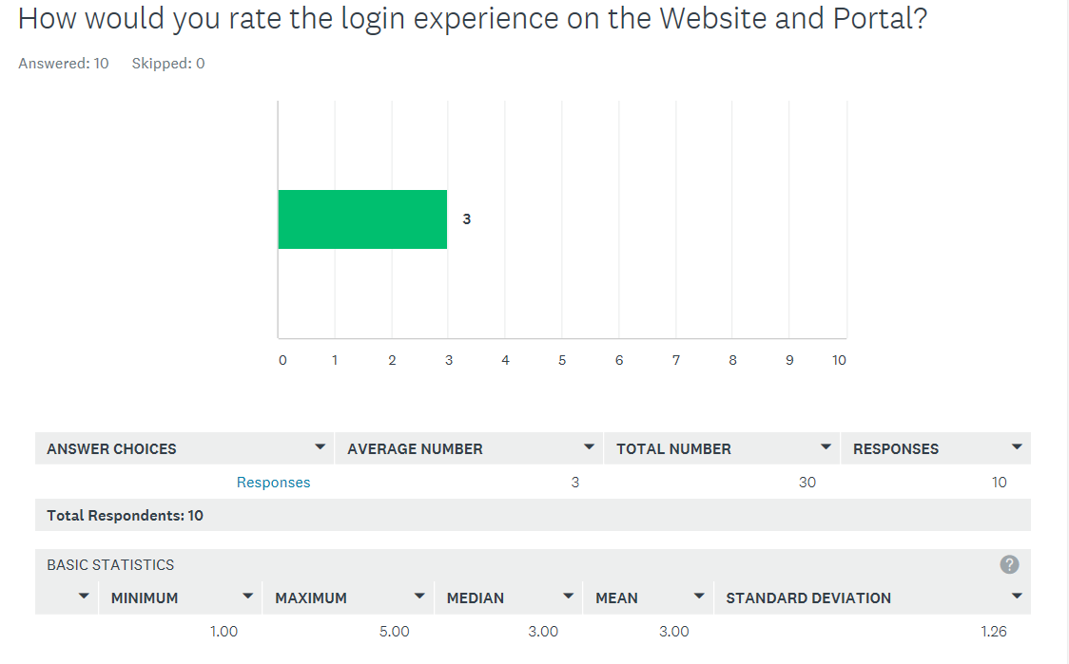

The responses to this question varied with 50% selecting a score of 1 and 2, meaning they found the log in experience easy, 50% chose a score of either 4 or 5, meaning they found the log in experience quite annoying. This gives us a median score of 3 for 10 responses.

We gather from this question that participants find the log in experience neither easy of annoying.

Question 3:

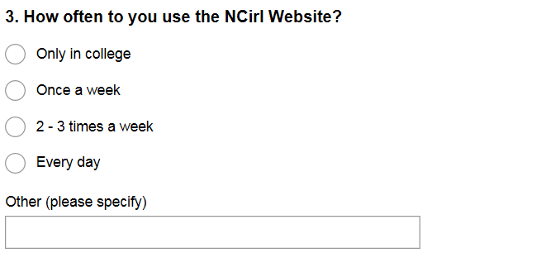

Question three gathers data on how often the site is visited.

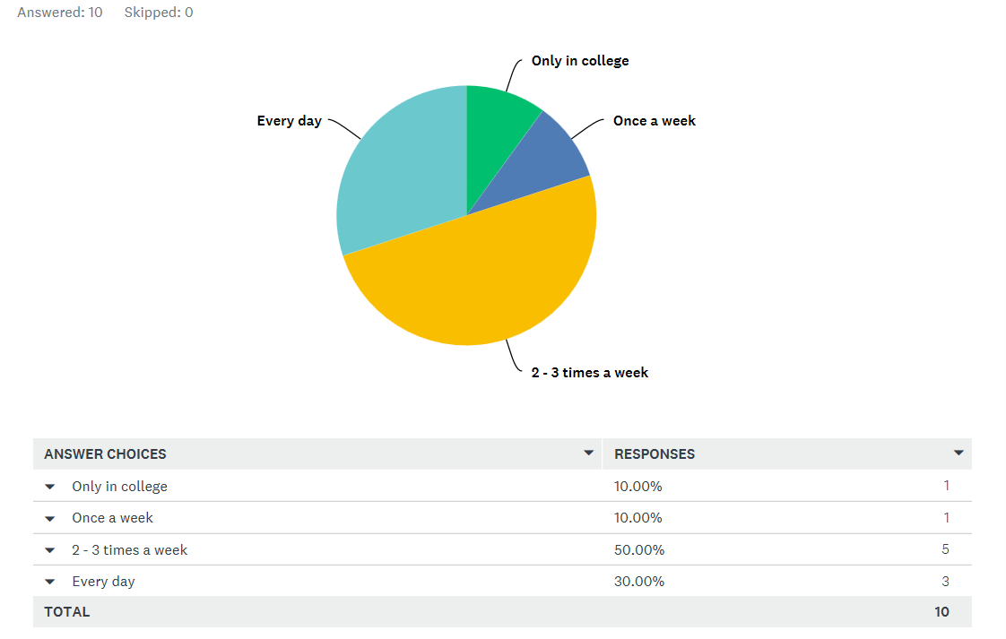

From the response, we can deduce that 80% of participants use the website at least twice a week.

Question 4.

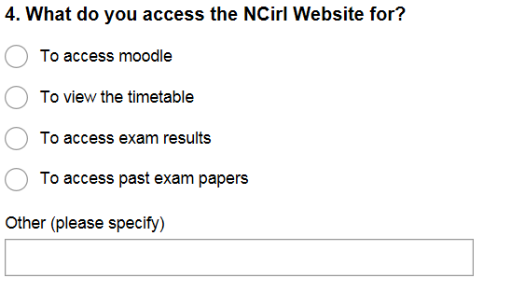

In question three we had gathered how often the participants use the website, Question 4 asks what they use it for.

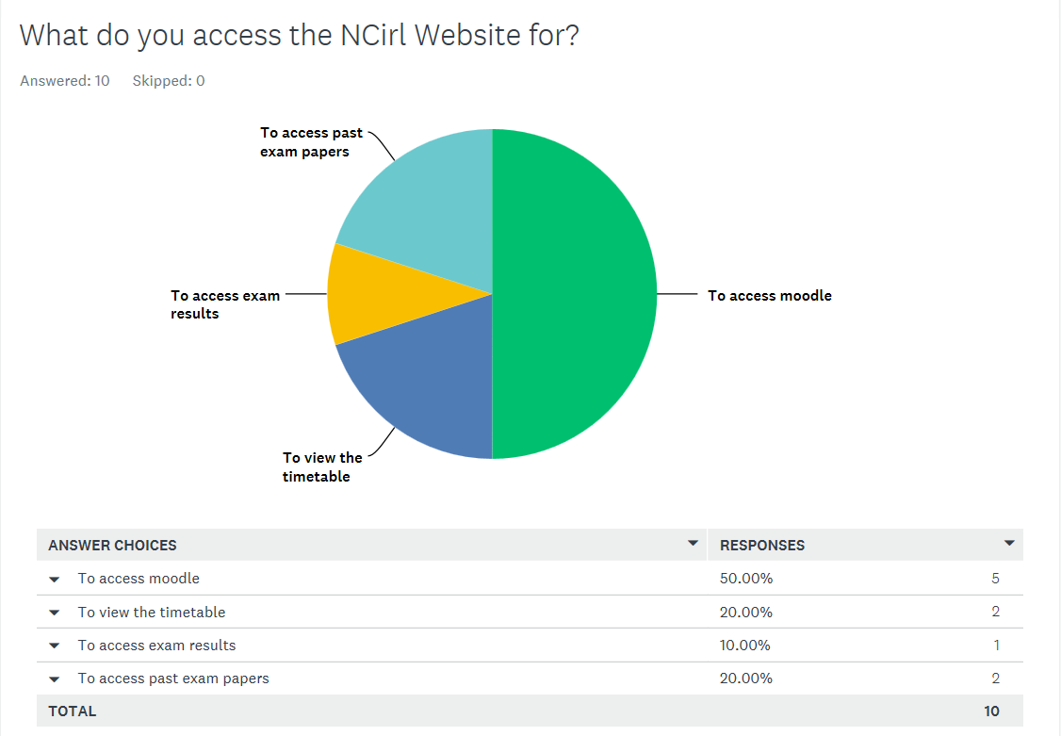

From the data we can deduce that the majority use the website just to view moodle. The thinking behind the question is should moodle be standalone?

Question five:

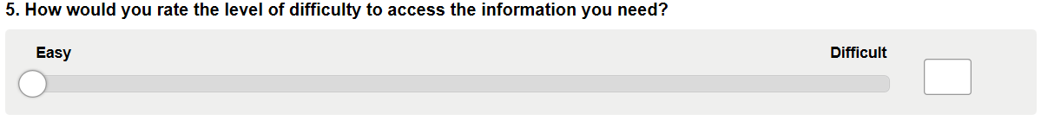

We now ask when logged in to the website how difficult information is to find.

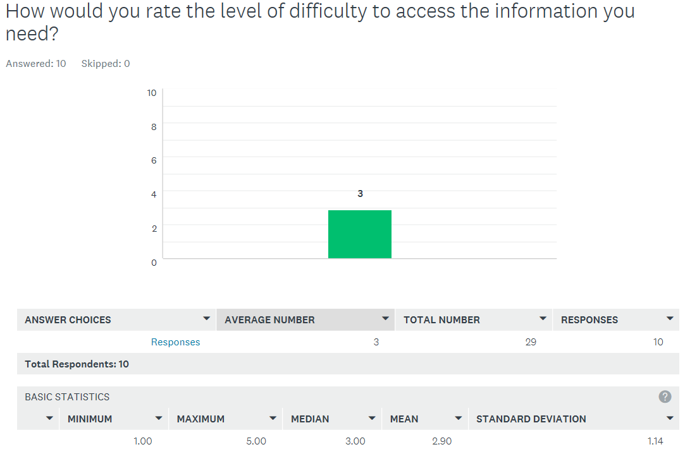

From the data 60% of the participants chose a score of three or higher, meaning they have found that finding information on the website is more difficult than easy.

Question six:

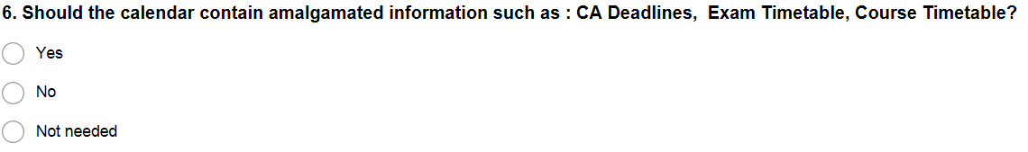

Question six is a straightforward question and was noted during our observation technique. The user noted that there was no central location for information and notes from individual lectures were on their page, CA deadlines are a manual input to the calendar etc.

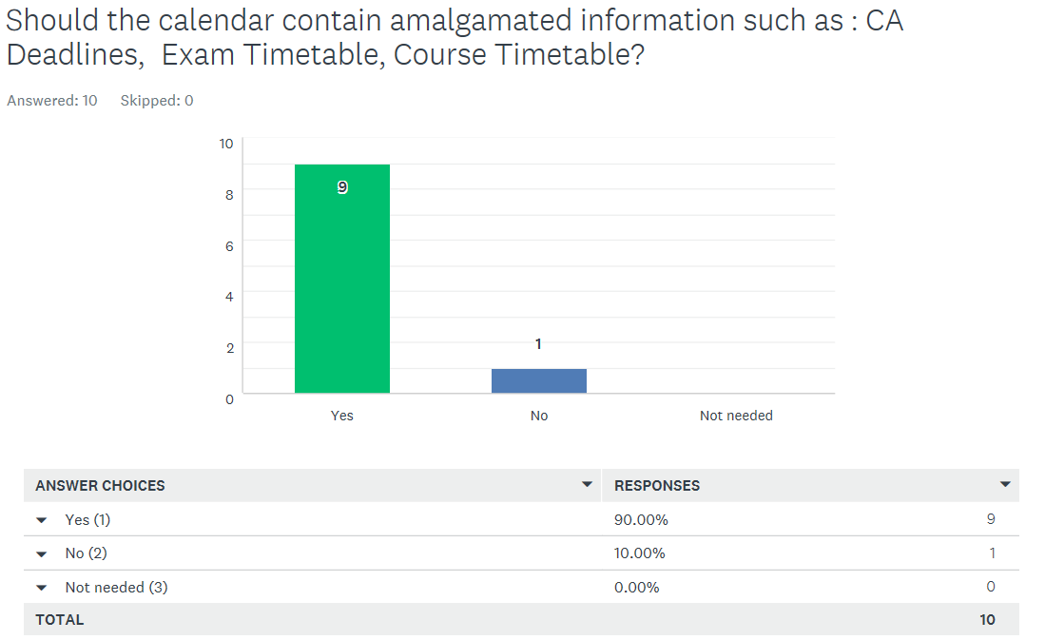

There is a clear indication that participants feel that there is a need for a centralised information centre in the form of the calendar.

Question 7:

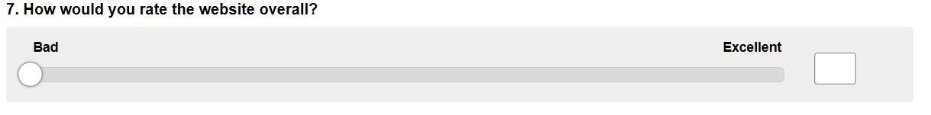

Question 7 should output the general mood of the participants towards the website, this could be an indicator of wether any updating is needed or not.

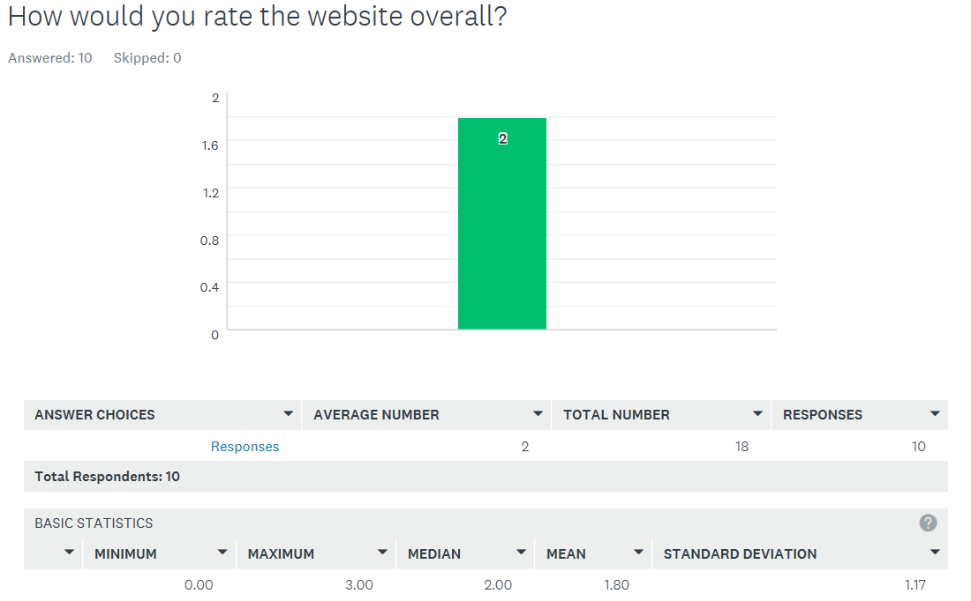

With a median of 2 from a scale of 0 – 5, 0 denoting Bad, We can deduce that the majority of participants feel that the website needs to be updated.

Question 8:

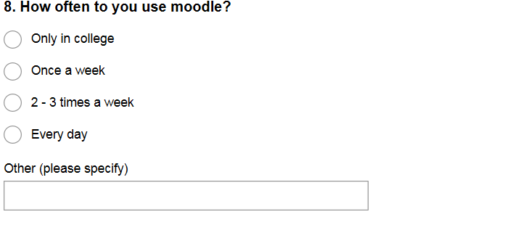

We now move on to the student portal to try and deduce the frequency of use of moodle. The lower the score in this question the less experienced the participant is.

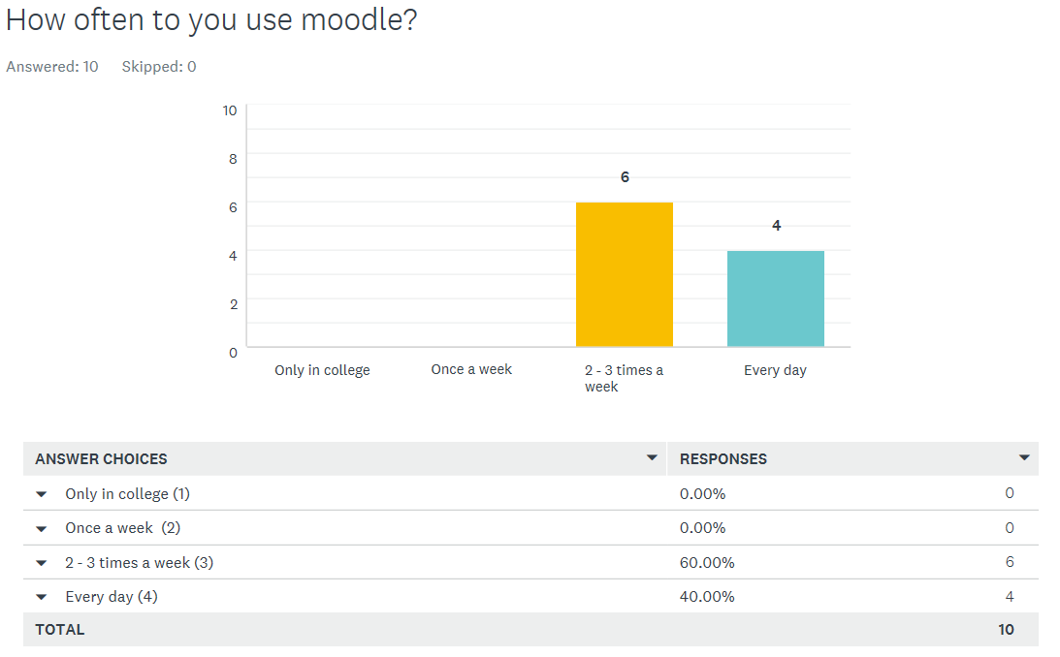

100% of participants use moodle at least twice a week with 40% using every day. We can deduce that the participants are experienced users.

Question 9:

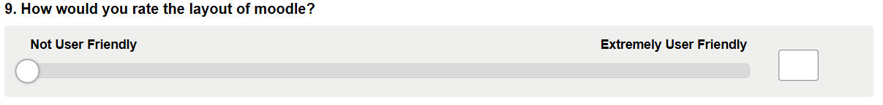

We now understand our participants are experienced users of Moodle. How do they find Moodle works for them?

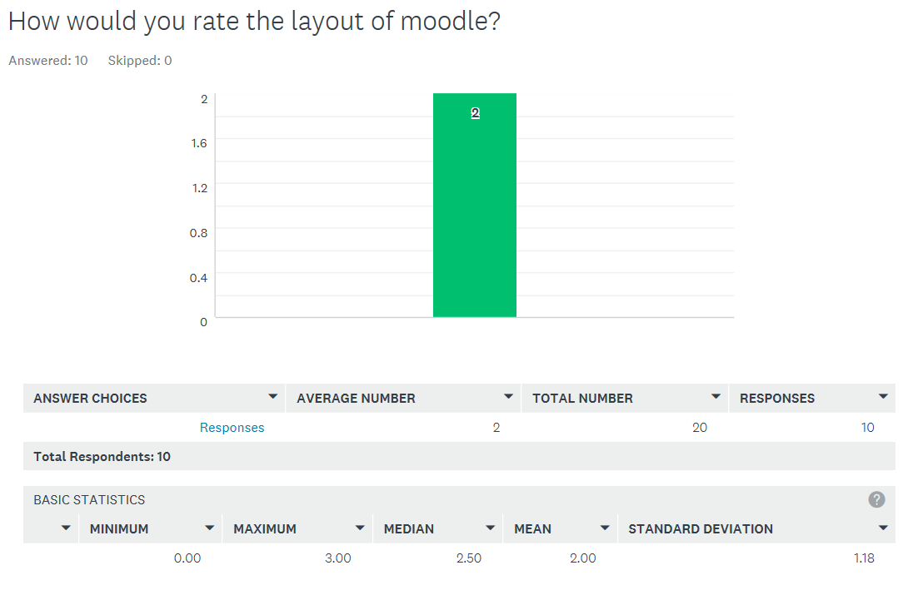

Our participants found that Moodle was not user-Friendly with 50% scoring a 2 or less, 100% a 3 or less. From this we can deduce that moodle could do with a makeover.

Question ten:

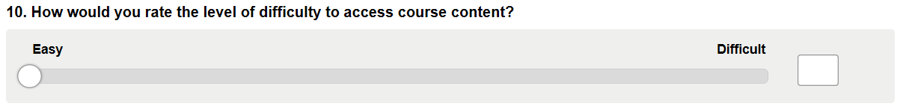

We now score the level of difficulty to access course content. Is the content where it should be?

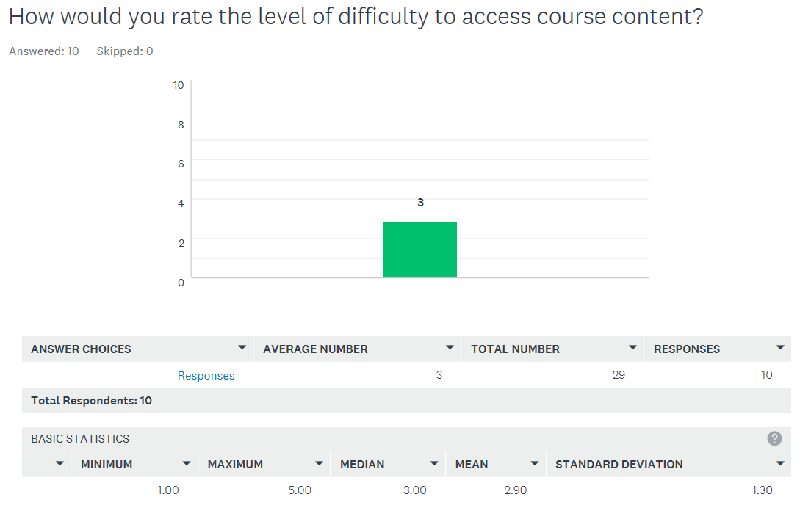

60% of our participants scored a three or higher with 40% scoring a four or five on the range of 0 – 5, meaning they found that course content was difficult to access.

Conclusion:

From our data we can conclude that the layout of the website and student portal need addressing. Additional features such as the amalgamated calendar information centre are highly recommended. A more fluid and user friendly experience is a necessity if a redesign were to take place, as users have found that information cannot be directly accessed as they would like.