420-511-VA WEB SERVICES
WINTER 2026
TEAM PROJECT PROPOSAL
Adaptive Recipe & Fitness Service
A REST Web API for Intelligent Recipe Management and Workout Planning
VANIER COLLEGE
Teacher: Sleiman Rabah
February 2026

Executive Summary
The Adaptive Recipe & Fitness Service is a REST-based web API that revolutionizes how users interact with recipes and fitness routines. Unlike traditional recipe services that simply display instructions, our service provides intelligent features including ingredient-based recipe search, automatic ingredient substitutions, measurement conversions, cost estimation, recipe scaling, and dietary restriction management.
The service addresses real-world problems: food waste from unused ingredients, inability to follow recipes due to missing ingredients, confusion over measurement units, and difficulty adapting recipes to dietary needs. By integrating with external APIs for nutritional data, pricing information, and workout demonstrations, the service creates a comprehensive cooking and fitness system.

Table of Contents
- Data Model Design
- Resources Overview
- Detailed Resource Specifications
- Resource Relationships via URIs
- HTTP Response Codes Mapping
- Composite Resources

1. Data Model Design

1.1 Database Overview
The database consists of 10 normalized (3NF) tables organized into two main domains: Recipe Management (7 tables) and Fitness Management (3 tables). The schema supports complex relationships, maintains data integrity through foreign keys, and enables efficient querying through strategic indexing.

1.2 Entity-Relationship Diagram
See attached ER diagram (schema_with_relationships.png) showing all 10 tables with their fields, primary keys (PK), foreign keys (FK), and relationship connections. The diagram illustrates one-to-many relationships and junction tables for many-to-many associations.
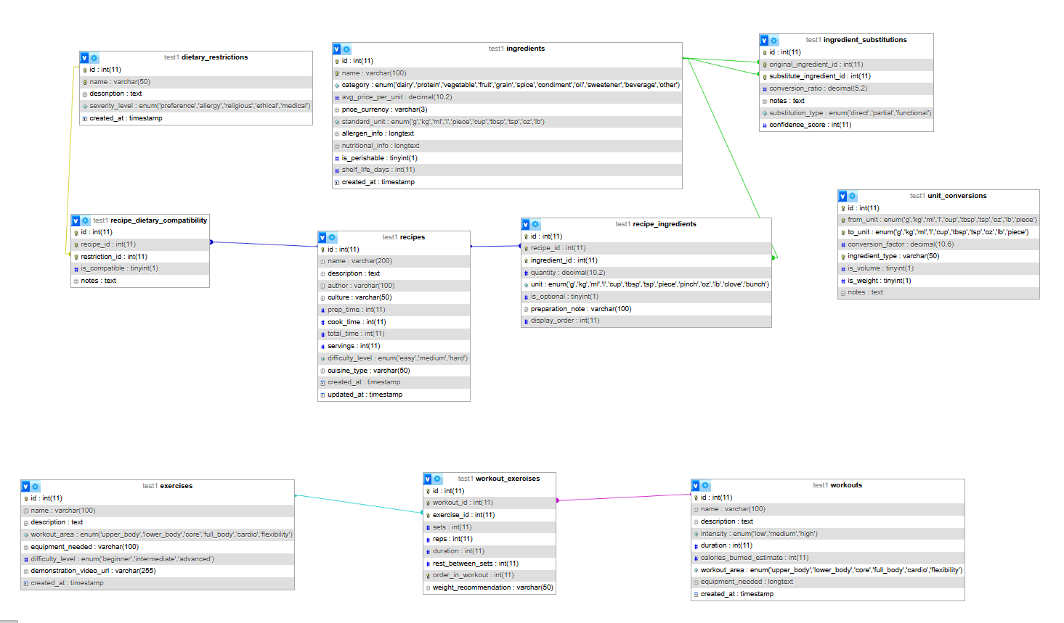

Table 1: Recipes
Field | Type | Description
id | INT PK | Unique identifier
name | VARCHAR(200) | Recipe name
description | TEXT | Cooking instructions
author | VARCHAR(100) | Recipe creator
culture | VARCHAR(50) | Cultural origin
prep_time | INT | Prep time (minutes)
cook_time | INT | Cook time (minutes)
servings | INT | Default portions
difficulty_level | ENUM | easy, medium, hard
cuisine_type | VARCHAR(50) | Italian, Mexican, Chinese, etc.
Relationships:
- One-to-Many → Recipe_Ingredients
- One-to-Many → Recipe_Dietary_Compatibility

Table 2: Ingredients
Fields: id (PK), name, category, avg_price_per_unit, price_currency, standard_unit, allergen_info (JSON), nutritional_info (JSON), is_perishable, shelf_life_days
Purpose: Master catalog with pricing and nutritional data for ingredient-based search and cost estimation.

Table 3: Recipe_Ingredients (Junction)
Fields: id (PK), recipe_id (FK), ingredient_id (FK), quantity, unit, is_optional, preparation_note, display_order
Purpose: Links recipes to specific ingredient quantities. Enables recipe scaling and ingredient substitution.

Table 4: Ingredient_Substitutions
Fields: id (PK), original_ingredient_id (FK), substitute_ingredient_id (FK), conversion_ratio, notes, substitution_type, confidence_score
Purpose: Smart substitution engine. Example: 1 cup sour cream = 1 cup Greek yogurt (ratio: 1.0, confidence: 8/10).

Table 5: Unit_Conversions
Fields: id (PK), from_unit, to_unit, conversion_factor, ingredient_type, is_volume, is_weight, notes
Purpose: Handles metric/imperial conversions. Supports ingredient-specific conversions (1 cup flour ≠ 1 cup water in grams).

Table 6: Dietary_Restrictions
Fields: id (PK), name, description, severity_level (preference/allergy/religious/ethical/medical)
Purpose: Master list including vegetarian, vegan, gluten-free, halal, kosher, nut-free, etc.

Table 7: Recipe_Dietary_Compatibility
Fields: id (PK), recipe_id (FK), restriction_id (FK), is_compatible, notes
Purpose: Maps recipes to dietary compatibility with modification suggestions. Example: &#x201C;Can be made vegan by using plant milk.&#x201D;

Table 8: Workouts
Fields: id (PK), name, description, intensity, duration, calories_burned_estimate, workout_area, equipment_needed (JSON)
Purpose: Predefined workout routines categorized by intensity and body area.

Table 9: Exercises
Fields: id (PK), name, description, workout_area, equipment_needed, difficulty_level, demonstration_video_url
Purpose: Individual exercise library with video demonstrations.

Table 10: Workout_Exercises (Junction)
Fields: id (PK), workout_id (FK), exercise_id (FK), sets, reps, duration, rest_between_sets, order_in_workout, weight_recommendation
Purpose: Links workouts to exercises with specific parameters (sets, reps, rest periods).

2. Resources Overview
The API exposes 20+ RESTful endpoints organized into collection and singleton resources. Each resource supports appropriate HTTP methods (GET, POST, PUT, PATCH, DELETE) with comprehensive filtering, sorting, and pagination.

2.1 Collection Resources
- /api/recipes - All recipes
- /api/ingredients - All ingredients
- /api/dietary-restrictions - All dietary restrictions
- /api/workouts - All workout routines
- /api/exercises - All exercises

2.2 Singleton Resources
- /api/recipes/{id} - Specific recipe
- /api/ingredients/{id} - Specific ingredient
- /api/workouts/{id} - Specific workout
- /api/exercises/{id} - Specific exercise

2.3 Nested/Relationship Resources
- /api/recipes/{id}/ingredients - Ingredients for a recipe
- /api/recipes/{id}/substitutions - Available substitutions
- /api/ingredients/{id}/substitutes - Substitute options
- /api/workouts/{id}/exercises - Exercises in workout
- /api/recipes/{id}/dietary-compatibility - Diet compatibility

2.4 Computational/Action Resources
- /api/recipes/{id}/scale?factor=2.0 - Scale recipe portions
- /api/recipes/{id}/cost - Calculate recipe cost
- /api/convert?from=cup&to=ml&quantity=2 - Unit conversion
- /api/workouts/{id}/calories?weight=70 - Calorie calculation

3. Detailed Resource Specifications

3.1 Recipes Talia
Collection URI: /api/recipes
Singleton URI: /api/recipes/{recipe_id}
Method | Operation | Description
GET | List all recipes | Returns paginated list with optional filters
POST | Create recipe | Adds a new recipe to the collection
GET | Retrieve recipe | /api/recipes/{id} — full details
PUT | Replace recipe | /api/recipes/{id} — full update
DELETE | Remove recipe | /api/recipes/{id} — delete from system

Filtering Parameters:
- cuisine_type - Filter by cuisine (italian, mexican, chinese, etc.)
- difficulty_level - Filter by difficulty (easy, medium, hard)
- max_time - Maximum total cooking time in minutes
- dietary - Filter by dietary restriction ID
Sorting Parameters:
- sort_by - name, total_time, difficulty_level, created_at
- order - asc (ascending) or desc (descending)
Pagination Parameters:
- page - Page number (default: 1)
- limit - Items per page (default: 20, max: 100)

3.2 Ingredients Mariam
Collection URI: /api/ingredients
Singleton URI: /api/ ingredients /{ingredients _id}
Method | Operation | Description
GET | List all ingredients | /api/ingredients
POST | Create ingredient | /api/ingredients
GET | Retrieve ingredient | /api/ingredients/{id}
PUT | Replace ingredient | /api/ingredients/{id}
DELETE | Remove ingredient | /api/ingredients/{id}

Filtering Parameters:
- name – filter by ingredient name
- category
- is_perishible
- avg_price_per_unit (?max_price)
- allergen
Sorting Parameters:
- sort_by - name, avg_price_per_unit. category
- order - asc (ascending) or desc (descending)
Pagination Parameters:
- page - Page number (default: 1)
- limit - Items per page (default: 20, max: 100)

3.3 Exercises Said
Collection URI: /api/exercises
Singleton URI: /api/exercises /{id }
Method | Operation | Description
GET | List all exercises | /api/exercises
POST | Create exercise | /api/exercises
GET | Retrieve exercise | /api/exercises/{id}
PUT | Replace exercise | /api/exercises/{id}
DELETE | Delete exercise | /api/exercises/{id}

Filtering Parameters:
- name – filter by ingredient name
- workout_area
- difficulty_level
- equipment_needed (?equipment)
Sorting Parameters:
- sort_by - name, difficulty_level, workout_area
- order - asc (ascending) or desc (descending)
Pagination Parameters:
- page - Page number (default: 1)
- limit - Items per page (default: 20, max: 100)

Representations: JSON (default), XML

3.5 Workouts Collection & Singleton
URIs: /api/workouts, /api/workouts/{id}
Operations: GET, POST, PUT, PATCH, DELETE
Filtering: intensity, workout_area, max_duration
Sorting: name, intensity, duration, calories_burned_estimate

3.6 Exercises Collection & Singleton
URIs: /api/exercises, /api/exercises/{id}
Operations: GET, POST, PUT, PATCH, DELETE
Filtering: workout_area, difficulty_level, equipment_needed
Sorting: name, difficulty_level, workout_area

3.7 Dietary Restrictions
URIs: /api/dietary-restrictions, /api/dietary-restrictions/{id}
Operations: GET, POST, PUT, DELETE
Filtering: severity_level (preference/allergy/religious/ethical/medical)

3.8 Computational/Action Resources
These resources perform calculations and transformations based on the underlying data. Each team member contributes at least one computational functionality.

Computational Function 1: Recipe Scaling
URI: /api/recipes/{id}/scale?factor={scale_factor}
Method: GET
Description: Scales recipe ingredients by specified factor (0.5x, 2x, 3x, etc.).
Example: GET /api/recipes/5/scale?factor=2.0

Computational Function 2: Cost Estimation
URI: /api/recipes/{id}/cost
Method: GET
Description: Calculates total cost based on ingredient quantities and average prices.
Returns: { total_cost: 15.47, currency: 'USD', cost_per_serving: 3.87 }

Computational Function 3: Unit Conversion
URI: /api/convert?from={unit}&to={unit}&quantity={amount}&ingredient={name}
Method: GET
Description: Converts between metric and imperial units with ingredient-specific density adjustments.
Example: GET /api/convert?from=cup&to=g&quantity=2&ingredient=flour

Computational Function 4: Calorie Calculation
URI: /api/workouts/{id}/calories?weight={kg}
Method: GET
Description: Estimates calories burned during workout based on user weight and exercise intensity.
Returns: { calories_burned: 450, duration_minutes: 45, intensity: 'high' }

Computational Function 5: Ingredient Substitution Finder
URI: /api/ingredients/{id}/substitutes
Method: GET
Description: Finds alternative ingredients with conversion ratios and confidence scores.
Filtering: min_confidence (1-10), substitution_type (direct/partial/functional)

Computational Function 6: Nutritional Analysis
URI: /api/recipes/{id}/nutrition
Method: GET
Description: Aggregates nutritional information from all recipe ingredients. Returns calories, protein, carbs, fat per serving.

4. Resource Relationships via URIs
The API expresses relationships between resources through hierarchical URIs. This design follows RESTful principles where resource relationships are navigable through the URL structure.

4.1 Recipe-Ingredient Relationships
- /api/recipes/{id}/ingredients - All ingredients in a recipe
- /api/recipes/{id}/ingredients/{ingredient_id} - Specific ingredient details
- /api/recipes/{id}/substitutions - Available ingredient substitutions

4.2 Dietary Compatibility Relationships
- /api/recipes/{id}/dietary-compatibility - All diet compatibilities
- /api/dietary-restrictions/{id}/recipes - Recipes meeting restriction
- /api/recipes?dietary={id} - Filter recipes by dietary need

4.3 Workout-Exercise Relationships
- /api/workouts/{id}/exercises - Exercises in workout routine
- /api/exercises/{id}/workouts - Workouts using this exercise
- /api/workouts/{workout_id}/exercises/{exercise_id} - Exercise details in context

4.4 Ingredient Substitution Relationships
- /api/ingredients/{id}/substitutes - Alternative ingredients
- /api/ingredients/{original_id}/substitute-for/{substitute_id} - Specific substitution details

5. HTTP Response Codes Mapping
The API uses standard HTTP status codes to communicate operation results. This section maps status codes to specific operations and conditions.
Code | Status | When Used
200 | OK | Successful GET, PUT, PATCH requests
201 | Created | Successful POST - new resource created. Location header points to new resource.
204 | No Content | Successful DELETE - resource removed, no content returned
400 | Bad Request | Invalid request format
401 | Unauthorized | Missing or invalid authentication credentials
403 | Forbidden | Authenticated but lacks permission to access resource
404 | Not Found | Resource does not exist. Example: GET /api/recipes/99999
409 | Conflict | Duplicate resource. Example: POST ingredient with existing name
500 | Internal Server Error | Unexpected server error. Database connection failed, unhandled exception.
Error Response Format:
{ "error": { "code": 422, "message": "Validation failed", "details": [ { "field": "prep_time", "issue": "must be positive integer" } ] } }

6. Composite Resources

6.1 Enhanced Recipe with Nutrition
URI: /api/recipes/{id}/enhanced
Local Data: Recipe details, ingredients, cooking instructions from database
External API: Nutritionix API (https://www.nutritionix.com/business/api)
Enhancement: Adds detailed nutritional breakdown (calories, macros, vitamins) per ingredient and serving
Response includes: - Local recipe data (name, instructions, servings) - External nutritional data (total calories, protein, carbs, fat, fiber) - Per-serving calculations - Vitamin and mineral content

6.2 Recipe with Real-Time Pricing
URI: /api/recipes/{id}/market-price
Local Data: Recipe ingredients and stored average prices
External API: Open Food Facts API (https://world.openfoodfacts.org/data)
Enhancement: Fetches current market prices for ingredients by region
Response includes: - Ingredient list with quantities - Local average prices (database) - Current market prices (API) - Price comparison and savings potential - Regional price variations

6.3 Workout with Video Demonstrations
URI: /api/workouts/{id}/with-videos
Local Data: Workout routine, exercise list, sets/reps from database
External API: YouTube Data API (https://developers.google.com/youtube/v3)
Enhancement: Embeds exercise demonstration videos and user ratings
Response includes: - Workout details (name, duration, intensity) - Exercise list with local parameters (sets, reps, rest) - YouTube video links for each exercise - Video metadata (views, ratings, duration) - Alternative video suggestions

Appendix

A. Data Sources
- Recipe Database: USDA FoodData Central, Open Recipe Database
- Nutritional Data: Nutritionix API, Open Food Facts
- Pricing Data: Open Food Facts, Local grocery APIs
- Exercise Videos: YouTube Data API, ExerciseDB API

B. External APIs Used Maybe
- Nutritionix API - Nutritional data enrichment
- Open Food Facts API - Ingredient pricing and product data
- YouTube Data API - Exercise demonstration videos

