Online Store Database

Done By:
- Mo’men Osama Galal Awad
ID: 2401247521

- Marwan Ehab Adel Mostafa
ID: 2401248195

- Marwan Ahmed Elsayed El-Mahdy
ID: 2401248710

- Youssef Ahmed Mohamed Abdallah
ID: 2401241251

- Ziad Gamal Najeeb Desoky
ID: 23012071
Report Summary

About Our Project. (Done)

Analysis Stage. (Done)

DB Design & Mapping. (Done)

DB implementation (SQL). (Done)

Graphical User Interface (GUI). (Done)

- About Our Project
The Online Store Database Project aims to design and implement a structured, efficient, and scalable database system that supports the main operations of an e-commerce platform. As online shopping continues to grow, having a reliable backend that can store, manage, and retrieve data quickly becomes essential for ensuring a smooth user experience.
This documentation provides a detailed overview of the database design, including the system requirements, Entity-Relationship Diagram (ERD), schema description, relationships between tables, and the logic behind each component. The goal is to build a database that supports core functionalities such as user management, product catalog handling, order processing, payment tracking, and inventory control.
By following a clear, normalized design, this project ensures data consistency, minimizes redundancy, and enables future scalability. Whether for academic purposes or real-world applications, this database serves as a robust foundation for any online store system.

- Analysis Stage
Tables:
- Product:
This table has all of product attributes
Attributes:
- ID Datatype: INT Primary Key
- Name Datatype: Varchar
- Quantity Datatype: Integer
- Price Datatype: Numeric
- Status Datatype: ENUM
- Category_ID Datatype: INT
- Vendor_ID Datatype: INT
- Warehouse_ID Datatype: INT
Samples:
INSERT INTO Products (ID, Price, Name, Quantity, Category_ID, Status)
VALUES (1, 299.99, 'Laptop', 50, 1, 'Available');

INSERT INTO Products (ID, Price, Name, Quantity, Category_ID, Status)
VALUES (2, 49.99, 'Chair', 100, 2, 'Available');

- Order:
This Table contains Most details of each order
Attributes:
- ID Datatype: INT Primary Key
- Amount Datatype: INT
- Date Datatype: DATE
- Status Datatype: ENUM
- Customer_ID Datatype: INT
- Delivery_ID Datatype: INT
Samples:
INSERT INTO Orders (ID, Amount, Order_Date, Delivery_Date, Status, Customer_ID, Delivery_ID)
VALUES (1, 349.98, '2023-10-01', '2023-10-05', 'Delivered', 1, 1);
INSERT INTO Orders (ID, Amount, Order_Date, Delivery_Date, Status, Customer_ID, Delivery_ID)
VALUES (2, 49.99, '2023-10-02', '2023-10-06', 'Pending', 2, 2);
- Order_Details:
This table links each product with its order
Attributes:
- Order_ ID Datatype: INT Primary Key
- Product_ID Datatype: INT
- Price Datatype: NUMERIC
Samples:
INSERT INTO Order_Details (Order_ID, Product_ID, Quantity, Price)
VALUES (1, 1, 1, 299.99);

INSERT INTO Order_Details (Order_ID, Product_ID, Quantity, Price)
VALUES (1, 2, 1, 49.99);

- Customer:
This table contains All details of each customer.
Attributes:
- ID Datatype: INT Primary Key
- First_Name Datatype: VARCHAR
- Last_name Datatype: VARCHAR
- Gender Datatype: ENUM
- Email Datatype: VARCHAR
- Phone Datatype: INTEGER
- Address Datatype: VARCAHR
- City Datatype: VARCHAR
- Birth_Date Datatype: DATE
- Registration_Date Datatype: DATE
- Status Datatype: ENUM

Samples:
INSERT INTO Customers (ID, First_Name, Last_Name, Gender, Status, Email, Phone, Address, Birth_Date, Registration_Date)
VALUES (1, 'John', 'Doe', 'M', 'Active', 'john@example.com', '123-456-7890', '123 Main St', '1990-01-01', '2023-01-01');
INSERT INTO Customers (ID, First_Name, Last_Name, Gender, Status, Email, Phone, Address, Birth_Date, Registration_Date)
VALUES (2, 'Jane', 'Smith', 'F', 'Inactive', 'jane@example.com', '987-654-3210', '456 Elm St', '1985-05-15', '2022-06-10');

- Employee:
This table contains all employees’ details
Attributes:
- ID Datatype: INT Primary Key
- First_Name Datatype: VARCHAR
- Last_name Datatype: VARCHAR
- Gender Datatype: ENUM
- Email Datatype: VARCHAR
- Phone Datatype: NUMERIC
- Address Datatype: VARCHAR
- City Datatype: VARCHAR
- Birth_Date Datatype: DATE
- Hire_Date Datatype: DATE
- Salary Datatype: INTEGER
- Status Datatype: ENUM
- Super_ID Datatype: INTEGER
- Dep_ID Datatype: INTEGER
Samples:
INSERT INTO Employees (ID, Status, Salary, First_Name, Last_Name, Email, Gender, Attribute, Super_ID, Phone, Dep_ID, Address, Birth_Date, Hire_Date)
VALUES (1, 'Active', 50000.00, 'Mike', 'Brown', 'mike@company.com', 'Male', 'Manager', NULL, '111-222-3333', 1, '100 Office Blvd', '1980-03-20', '2015-07-01');

INSERT INTO Employees (ID, Status, Salary, First_Name, Last_Name, Email, Gender, Attribute, Super_ID, Phone, Dep_ID, Address, Birth_Date, Hire_Date)
VALUES (2, 'Active', 40000.00, 'Sara', 'Davis', 'sara@company.com', 'Female', 'Clerk', 1, '444-555-6666', 2, '200 Office Ave', '1992-11-12', '2018-09-15');

- Department:
This table contains department’s’ details
Attributes:
- ID Datatype: INT Primary Key
- Dep_Name Datatype: VARCHAR
- Mgr_ID Datatype: INTEGER
Samples:
- INSERT INTO Departments (ID, Dep_Name, Mgr_ID)
VALUES (1, 'Sales', NULL);
- INSERT INTO Departments (ID, Dep_Name, Mgr_ID)
VALUES (2, 'HR', NULL);
- Category:
This table contains all details of categories
Attributes:
- ID Datatype: INT Primary Key
- Name Datatype: VARCHAR
- Description Datatype: VARCHAR
Samples:
- INSERT INTO Categories (ID, Description, Name)
VALUES (1, 'Electronic gadgets', 'Electronics');
- INSERT INTO Categories (ID, Description, Name)
VALUES (2, 'Home and garden items', 'Home Goods');
- Vendor:
This table contains vendor’s details
Attributes:
- ID Datatype: INT Primary Key
- Name Datatype: VARCHAR
- Contact_Name Datatype: VARCHAR
- Email Datatype: VARCHAR
- Address Datatype: VARCHAR
- City Datatype: VARCHAR
- Phone Datatype: INTEGER
Samples:
- INSERT INTO Vendor (ID, First_Name, Last_Name, Email, Address, Phone)
VALUES (1, 'Alice', 'Johnson', 'alice@vendor.com', '789 Vendor Rd', '555-111-2222');
- INSERT INTO Vendor (ID, First_Name, Last_Name, Email, Address, Phone)
VALUES (2, 'Bob', 'Williams', 'bob@vendor.com', '321 Supplier Ln', '555-333-4444');

- Warehouse:
This table contains all warehouses and its details
Attributes:
- ID Datatype: INT Primary Key
- Name Datatype: VARCHAR
- Location Datatype VARCHAR,
- Capacity Datatype: INTEGER
Samples:
1. INSERT INTO Warehouse (ID, Name, Location, Capacity)
VALUES (1, 101, 'New York', 5000);
- INSERT INTO Warehouse (ID, Name, Location, Capacity)
VALUES (2, 102, 'Los Angeles', 3000);

Relations:
- Product:
- Product -> Category: (Mandatory) - M:1
- Each category must have at least one product
- Each product must be in one and only one category.
- Category (FK)*(Includes)⟶Product/s

- Product -> Vendor: (Mandatory) - M:M
- Each vendor must sell at least one product
- Each product must come from at least one vendor.
- Vendor/s⟶(Sells)⟶Product/s

- Product -> Warehouse: (Mandatory) - M:M
  - Each warehouse must contain number of products, and the product can be in at least one warehouse.
  - Warehouse/s⟶(Contains)⟶Product/s

- Orders
- Order -> Customer: (M:1)
  - Each Customer do one order at least but one order has one customer.

- Order -> Employee: (M:1)
- Each order has only one delivery, But We may have one
delivery has many orders.

3. Order Details: (Mandatory) - (M:1)
1. Order_Details -> Order:
a. each order must have at least one Order_Detail.
b. Order⟶(Has)⟶Order_Detail/s
2. Order_Details -> Product: (Mandatory) - (M:1)
a. each product must have at least one Order_Detail.
b. Product⟶(Has)⟶Order_Detail/s

3.Order_Detail -> Order & Order_Detail * Product:
(Mandatory) - (M:M)
- Each order must have at least one product and each product must have at least one order.
- Order/s⟶(Has)⟶Product/s
4. Employee
1.Employee -> Department: (Mandatory) - (M:1)
a. each employee must be in one and only one department b. Each department has at least one employee.
c. Department⟶(Has)⟶Employee
2. Employee -> Supervisor: (Optional: Mandatory) - (M:1)
a. Each employee has at most one supervisor (zero or one)
b. Each supervisor must have at least one employee.
c. Employee⟶(Supervise)⟶Employee (Self Referencing)
5.Department
- Department -> Employee: (Mandatory) - (1:1)
- Each department must have one and only one manager
- Every manager mange one and only one department.
- Employee⟶(Manage)⟶Department

6. Vendor
1. Vendor -> Category: (M:M)
a. Each Vendor May work with one category at least
b. Each category Can depends one Vendor or more
- Vendor -> Product: (M:M)
- Each vendor can sell at least one product
- Each product can be sold by at least one vendor.

7.Warehouse
1. Warehouse -> Category: (M:M)
a. Each warehouse can contain at least one category
b. Each category can be contained in at least one warehouse.

- Warehouse -> Product: (M:M)
a. each warehouse can contain at least one product
b. each product can be contained by at least one warehouse.

C. Database Design and Mapping
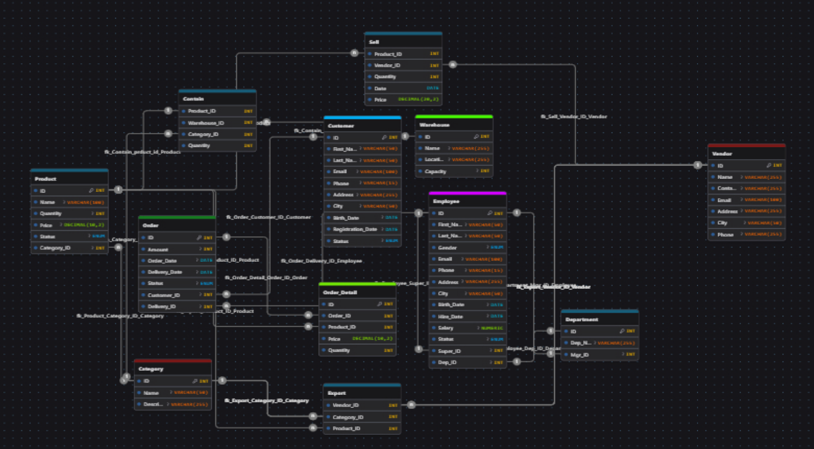
1. Complex form

2.Simple form
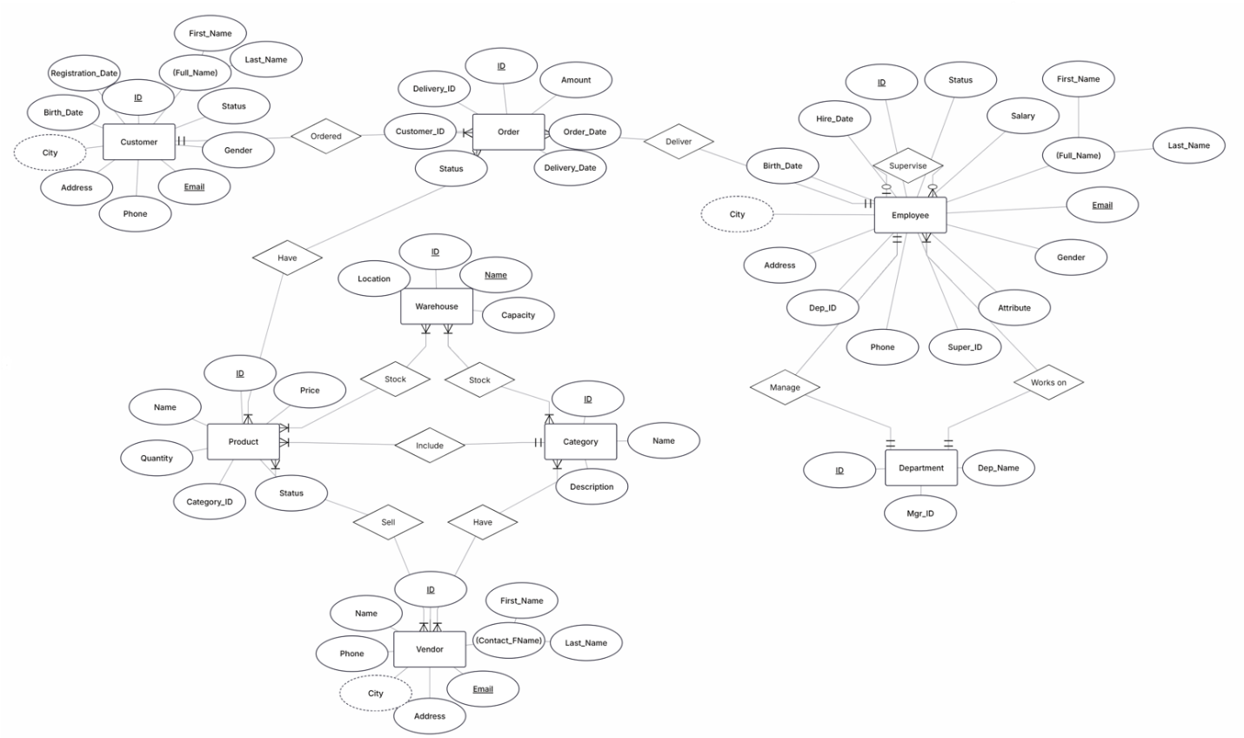

D. Database Implementation
1. Tables creation:
…
2.Quireis implementation:
a. Find the top 3 categories by total revenue
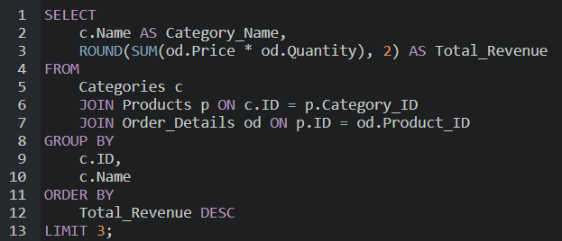
Output:

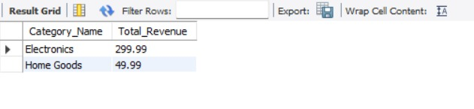

b. List vendors who supply products stored in 2 different warehouses
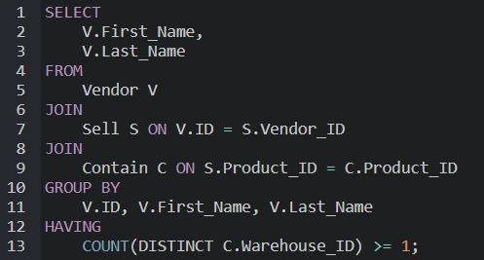

Output:

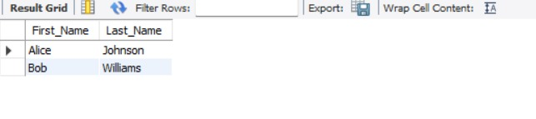

c. Show customers who ordered products from at least 2 different categories
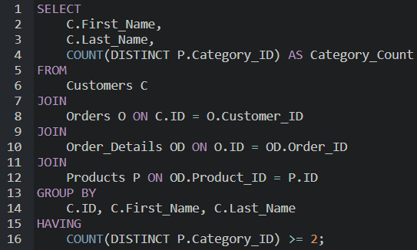

Output:

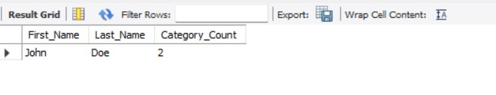

d. Calculate the average delivery time per employee
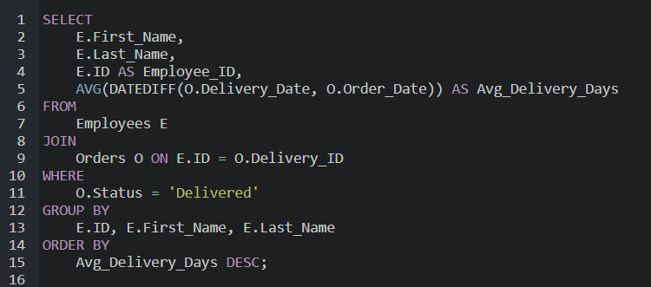

fourth query

Output:
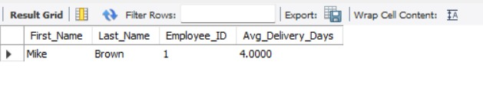

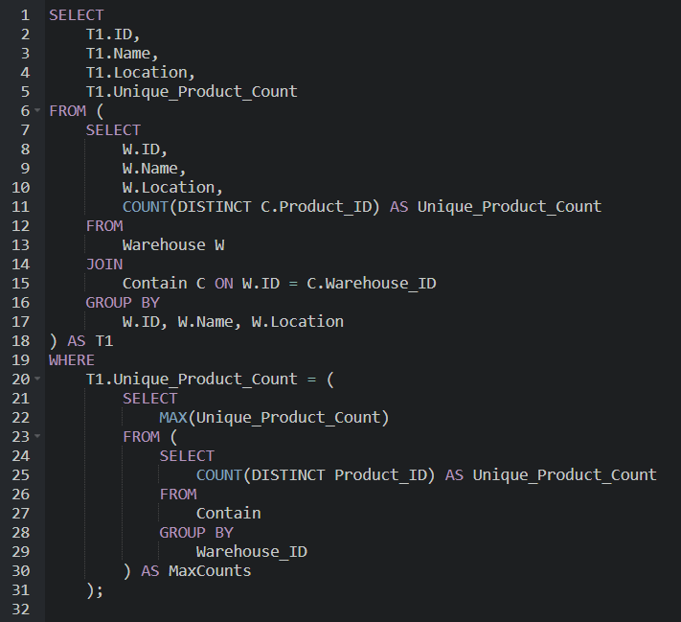
e. Find the warehouse that stores the highest number of unique products

Output:
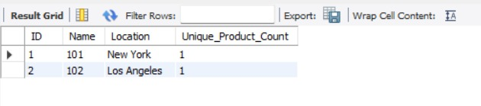
f. Display the basic personal information (name and email) of all customers currently registered in the system
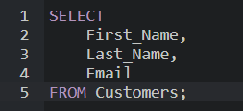

Output:
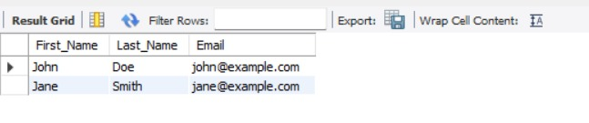

g. Find customers who spent more than the average spending of all customers
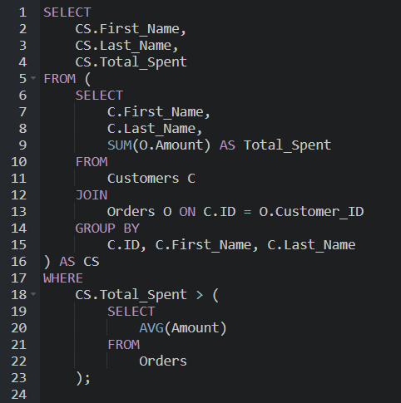

Output:

