LANSANGAN, GIAN DARRYLL T.

LINGAD, DAREN D.

BSTM 1B

BORGMA

**I.TITLE OF THE BUSINESS**

**II. INTRODUCTION**

We are excited to present a business proposal for a coffee and snack shop located at the Bamboo Hub in Bamboo Echo Park, Lubao Pampanga. Our shop will offer a limited but high-quality selection of food and beverages, including nachos, bread, cake, and coffee. Our target market will be cyclists and tourists who visit the park. Our shop will be open from 6am to 4pm daily, providing a convenient location for park visitors to grab a quick bite or a refreshing drink during their visit. Our selection of food and beverages will be carefully curated to cater to the needs of our customers, providing a delicious and satisfying experience. We will offer both indoor and outdoor seating, providing a comfortable and relaxing environment for our guests to enjoy their snacks and beverages. Our location at the Bamboo Hub, a popular stop for cyclists and tourists, will provide us with a steady stream of customers who are in need of refreshment during their visit to the park. We believe that our coffee and snack shop will be a welcome addition to Bamboo Echo Park, providing a convenient and enjoyable experience for park visitors. We look forward to the opportunity to discuss this proposal further and to answer any questions you may have. The Lubao Bamboo Hub is an eco-tourism destination located by the riverbank of Sta. Catalina in Lubao, Pampanga. The bamboo hub serves as both a protective shield against threats of soil erosion and a tourist destination. Managed by the Lubao Municipal Government, the Lubao Bamboo Hub and Eco-Park attracts around 600 visitors every weekend. With its bending bamboo culms forming a canopy, resembling an enchanting forest overhead, the Lubao Bamboo Hub is a relaxing tourist destination for people who want to relax and take a stroll.

SWOT ANALYSIS STRENGTHS -Although the coffee shop is a quick turned around small business. But its target market and customers require high-quality service like a clean place, washed cups, good sitting arrangements, nice seats, and clean waiters and staff. It’s because all of these little things give the impression of a healthy environment. WEAKNESSES -When you open your coffee shop in a certain market, it’s not something that people can’t copy and create the same product. Competitors can easily enter the market and you’ll have no option but to share the profit with them. OPPORTUNITIES -Build are brand awareness with local promotions. Build stronger customer relationships THREATS -Consumer becoming more price sensitive. Weak bargaining power abused by suppliers

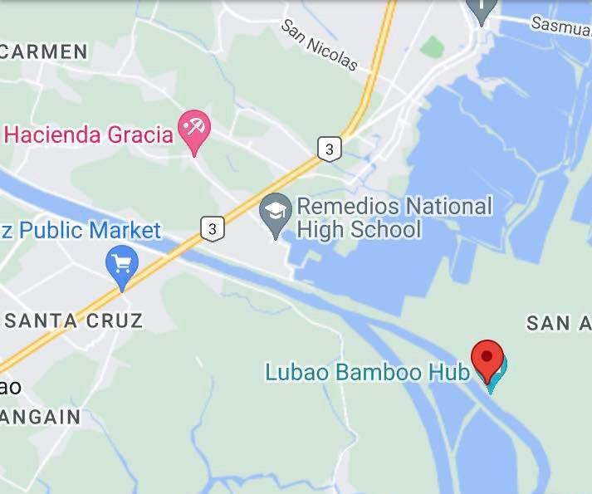

**III. ORGANIZATIONJAL CHART**

MANAGER- a person who controls the activities, business dealings, and other aspects of the career

CASHIER- a person handling payments and receipts in a store, bank, or other business.

SERVICE CREW-The Service Crew is responsible for presenting menus to patrons. He /She takes orders and answers questions on meal items. He /She makes recommendations and serves food/beverages to customers.

BARISTA- a person whose job involves preparing and serving different types of coffee.

IV. MISSION & VISSION

Mission Our goal is to serve our community by producing distinction coffee flavoured in a calm environment. We strive to create a welcoming space for coffee enthusiasts to escape the hustle and bustle of your day.

Vision We work tirelessly to provide the best coffee while giving each and every one of our customers the impression that they are entering their home when they enter one of our coffee shops because we want to be the most adored and respected coffee shop.

V. GOALS & OBJECTIVES

Goals- We aim to serve the best quality and most interesting varieties of coffees, teas, espresso drinks and accompaniments at all times to everyone.

Objectives- To provide a friendly, comfortable atmosphere where the customer can receive quality food, service and beautiful scenery at a reasonable price.