OOSD CA Project

Media Equipment Management System

# Description

The **Media Equipment Management System** is designed to streamline the process of managing media equipment in an educational setting. Its primary objectives and features include:

* **Purpose & Scope:**  
  The system facilitates the reservation, check-out, and return of media equipment (e.g., cameras, projectors, microphones) used by lecturers and students. It addresses practical needs such as preventing double-booking and ensuring the equipment is well-maintained and available when needed.
* **User Groups:**
  + **Lecturers and Students:** Can search for equipment, reserve it for specific time slots, check it out when needed, and return it after use.
  + **Media Equipment Staff:** Oversee reservation processes, handle equipment check-out and return, and manage equipment maintenance or repairs.
  + **Administrators:** Responsible for managing the overall equipment inventory, defining user access levels.
* **Key Functionalities:**
  + **Equipment Discoverability:** Allows users to filter and search for equipment by type and availability.
  + **Reservation Management:** Supports the process of booking equipment for particular time slots with in-built checks to avoid conflicts (double-booking).
  + **Check-Out and Return Processes:** Ensures that equipment is properly checked out when reserved and returned, updating its availability status appropriately.
  + **Maintenance Tracking:** Monitors the condition of equipment.

# System Requirements

The project’s requirements are outlined in both functional and non-functional aspects:

## Functional Requirements

1. **Equipment Discoverability:**
   * Users must be able to search and filter the inventory based on equipment type (cameras, projectors, microphones, etc.)
2. **Reservation, Check-Out, and Return Functionality:**
   * **Reservation:**
     + Users (lecturers and students) should be able to reserve equipment for specific time slots.
     + The system must prevent double-booking by ensuring an item is reserved by only one user for a given time slot.
   * **Check-Out:**
     + Upon arriving at the media centre, the system must allow users to easily check out reserved equipment, confirming the reservation.
   * **Return:**
     + The system should update the equipment's status to “available” once returned.
     + It must capture details regarding the condition of the equipment upon return.
3. **Access Control:**
   * **Lecturers and Students:**
     + Searching and Reservation of available equipment. Viewing previous reservations.
   * **Media Equipment Staff:**
     + Approval and denial of reservations, managing check-outs/returns and updating equipment “state”. Detailed reporting on equipment usage and condition.
   * **Administrators:**
     + Full access to inventory control, user access settings, approval or denial of reservation requests and detailed reporting on equipment usage and condition.

## Non-Functional Requirements

1. **User Experience & Usability:**
   * The system should be intuitive and easy to navigate for all user roles.
   * Users must have clear and accurate views of equipment availability and their personal reservation history.
2. **Reliability and Accuracy:**
   * Ensure that the inventory, reservation data, and maintenance logs are accurate and updated in real time.
   * The system must reliably prevent double-booking and ensure the integrity of the check-out/return process.
3. **Security and Access Control:**
   * Implement robust access control mechanisms to ensure each user group only has access to the features and data relevant to their role.
4. **Maintainability and Extensibility:**
   * The system should be designed for ease of updates, such as incorporating new types of media equipment.

# Database Tables

**Figure 1. Users Table Structure**

**Figure 2. Users Table Data**

**Figure 3. Student Table Structure**

**Figure 4. Student Table Data**

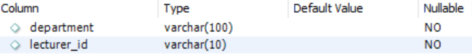

**Figure 5. Lecturers Table Structure**

**Figure 6. Lecturers Table Data**

**Figure 7. Equipment Table Structure**

**Figure 8. Equipment Table Data**

**Figure 9. Reservations Table Structure**

**Figure 10. Reservations Table Data**

**Figure 11. Check-in/Check-out Table Structure**

**Figure 12. Check-in/Check-out Table Data**

## A diagram of a computer AI-generated content may be incorrect.ER Diagram

**Figure 13. Database ER Diagram**

# Interesting Code Snippets

**Figure 14. Code for generating a Pie Chart for Equipment Checked out vs Available**

**Figure 15. Code for generating Bar Chart of Pending and Approved Reservations**

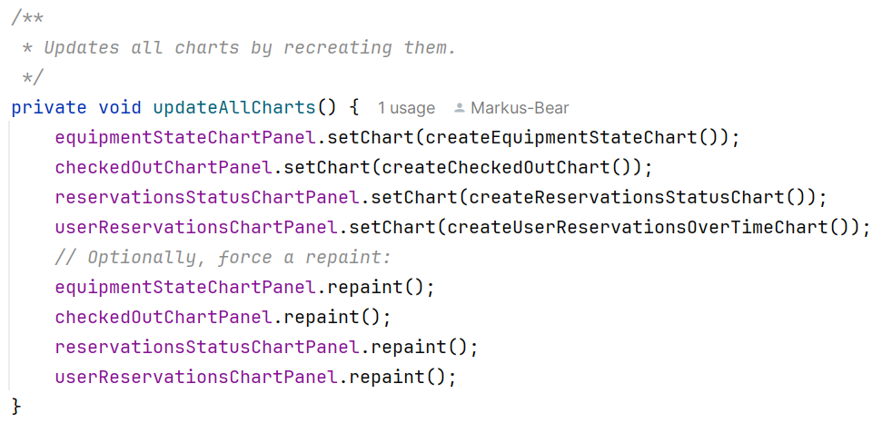

**Figure 16. Code for refreshing the Charts on the Admin + Media Staff Home Page**

# A white sheet with black text AI-generated content may be incorrect.Unit Tests