TrailTrack
Real-Time Trail Conditions and Community Walks for Ireland
Final Year Project Specification
Mark Mukiiza
C00166672
BSc (Hons) Software Development, Level 8
South East Technological University, Carlow
October 2026

1. Introduction

1.1 Problem Statement
Trail conditions in Ireland, such as mud, flooding, storm damage, and seasonal closures, change frequently, but no platform offers real-time, Irish-specific condition reporting, so hikers plan around static, often outdated information or discover conditions only once on the trail. A second, related gap is that community-organised group walks, a well established part of Irish hillwalking culture, are currently coordinated informally across club websites, Facebook groups, and WhatsApp threads, with no single place to discover or join one. Both problems are made worse by the patchy mobile signal typical of upland and forested trail areas, which most existing tools are not designed around.

1.2 Motivation
This gap is one I have run into personally. I hike regularly at Dysart Woods in County Laois, a roughly 6km route with meaningful elevation change, and have researched other local trails including Glenbarrow, the Slieve Bloom Mountains, and Monicknew Woodlands. Signal coverage across these routes is inconsistent, and there is no reliable, up-to-date way to check trail status before setting out. This is a problem I would genuinely use a solution for.

1.3 Aims and Objectives
The overall aim of this project is to design and build a mobile application that allows hikers to report and view real-time trail conditions across Irish trails, and to organise or join community group walks. The specific objectives are to:
- Integrate an authoritative source of Irish trail geometry (the Sport Ireland National Trails Register) as the base dataset.
- Build a reporting system that lets hikers submit and view real-time trail conditions, validated by a lightweight moderation layer.
- Enable local walkers and trail-maintaining organisations to organise and discover community group walks, and to contribute verified, authoritative updates on the trails they maintain.
- Support offline use so condition reports can be queued and submitted without an active connection.
- Deliver a working, testable product incrementally across four iterations, with critical evaluation of performance, usability, and architectural trade-offs.

2. Background and Related Work
The two leading general-purpose hiking platforms are AllTrails and Komoot. Both offer offline maps, GPS navigation and some crowd-sourced condition feedback, and list thousands of trails across Ireland. Table 1 compares them with TrailTrack.
 | AllTrails | Komoot | TrailTrack
Condition reports | Paid tiers only | Limited | Free
Report format | Free-text reviews | Free-text comments | Quick tap-based categories
Trail data | Crowd-built | Crowd-built | Sport Ireland register
Offline use | Paid tiers | 1 free region | Queued reports
Group walks | No | No | Yes
Pros | Huge trail library; GPS navigation | Strong route planning; turn-by-turn navigation | Free; authoritative data; built for Irish trails
Cons | Conditions paywalled; free-text only | Thin condition feedback; offline mostly paid | Smaller coverage; no navigation; small user base at launch
Table 1: Comparison with the two leading general-purpose hiking platforms
Sport Ireland's National Trails Register is the authoritative open dataset of over 920 waymarked Irish trails (CC BY 4.0), but it records only where trails are, not their current condition. TrailTrack adds a free condition-reporting layer and a community layer on top of it, a combination existing platforms do not offer.

3. Technologies
This project aims to explore and use the technologies listed below. They were chosen to build a map-based mobile app on top of a geospatial database, using only free and openly licensed data.
Component | Technology
Mobile client | Flutter (Android first; one codebase allows a later iOS port)
Local/offline storage | SQLite (via a local ORM), queued sync on reconnect
Backend API | Spring Boot (Java 21, Gradle)
Database | PostgreSQL + PostGIS (geospatial queries)
Base map / tiles | OpenStreetMap tiles via flutter_map (no cost, no API key)
Trail geometry source | Sport Ireland National Trails Register (data.gov.ie, CC BY 4.0)
Version control / Documentation | GitHub / Doxygen
Table 2: Technologies used in the project

4. System Architecture
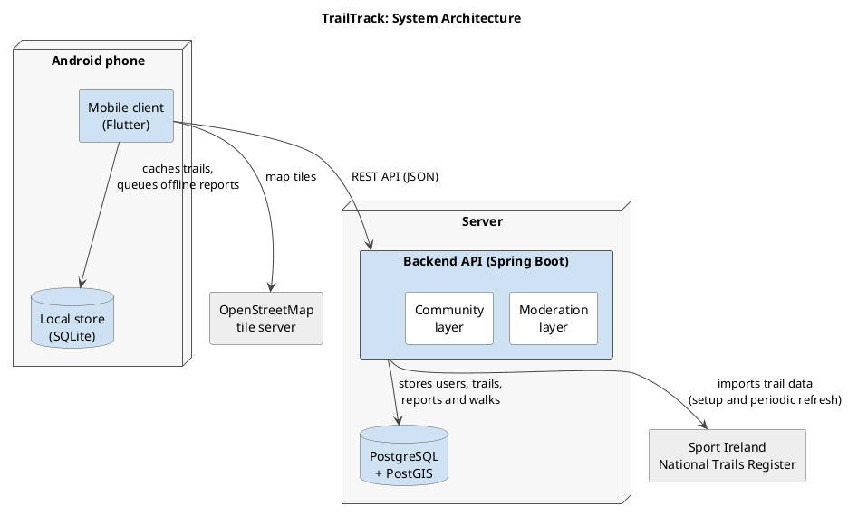
Figure 1: System architecture
The system is composed of six main components, shown in Figure 1:
- Mobile client (Flutter): map, trail overlays, registration, reporting and community walks.
- Local store (SQLite): cached trails and queued offline reports.
- Backend API (Spring Boot): REST endpoints for the app, and the sync target for offline reports.
- Database (PostgreSQL + PostGIS): users, trails, reports and walks, with geospatial indexing.
- Moderation layer: rules that validate reports, e.g. flagging a condition when several independent reports agree.
- Community layer: walk events and RSVPs (online only), and extra trust for verified trail-maintainer accounts.
Trail geometry is imported from the Sport Ireland National Trails Register at setup time and refreshed periodically, rather than queried live on every request, both for performance and to avoid a hard runtime dependency on a third-party service during demonstrations.

5. Functional Requirements

5.1 Mandatory
- App running on Android.
- User registration and storage of account details.
- Import and display of trail geometry from the Sport Ireland National Trails Register.
- Ability to submit a trail condition report against a specific trail.
- Ability to search/filter trails by location, distance, or difficulty.
- Ability to create, browse and RSVP to community group walks tied to a specific trail and date.

5.2 Discretionary
- Moderation rules: automatic flagging of reports based on corroboration from multiple users.
- Optional hazard location on a report, pinned on the trail map.
- Ability to rate and favourite trails.
- Web UI providing read-only access to trail conditions.
- Verified trail-maintainer accounts (e.g. Coillte, the County Council, local walking clubs) whose reports carry elevated trust in the moderation layer, with the ability to mark a reported issue as acknowledged or resolved.
- Offline mode: reports queued locally while offline and synced automatically on reconnect.

5.3 Exceptional
- Full offline-first architecture with conflict resolution on sync (not just queuing).
- Advanced search incorporating elevation, terrain type, or recent condition trend.
- Portability of the client across multiple platforms.
- Supplement the Sport Ireland register with community-mapped trails from OpenStreetMap, labelled by source and checked for duplicates against registered trails.
- Verified clubs and admins can record trails by GPS for routes not in the register, confirming public access or landowner permission before publishing; shown as club routes.

6. Non-Functional Requirements
- Offline resilience: core viewing and reporting features must degrade gracefully with no connection, not fail outright.
- Licence compliance: Sport Ireland (CC BY 4.0) and OpenStreetMap (ODbL) attribution must be displayed within the application.
- Data privacy: condition reports are not linked to a user's location history. An optional hazard location is opt-in, snapped to the trail, and never shown with the reporter's identity. Walk-event attendee lists are visible only to other attendees and the organiser.
- Usability: report submission should be completable in a small number of steps, usable one-handed outdoors.

7. Deliverables
The project is delivered in four iterations of approximately six weeks each. Table 3 sets out the features each iteration aims to deliver.
Iteration | Weeks | Release | Planned features
1 | 1-6 | v0.1 | Sport Ireland trail import (County Laois); registration and login; map display on OpenStreetMap; condition reports (online only); search by name and distance.
2 | 7-12 | v0.2 | Live condition overlays and hazard pins on the map; search and filter by location, distance and difficulty; community walks (create, browse, RSVP); data model refined from Iteration 1 feedback.
3 | 13-18 | v0.3 | Offline report queuing and sync; moderation rules for crowd-submitted reports; verified trail-maintainer accounts.
4 | 19-24 | v1.0 | Testing and polish; Exceptional tier features if ahead of schedule.
Table 3: Planned delivery for each iteration

