**Flame**

By Markus Damm

What‘s Flame?

* 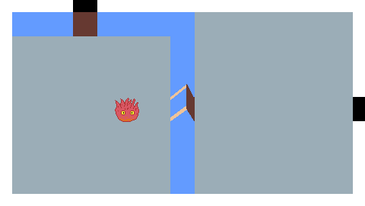Singleplayer
* 2D-Action
* Pixel-Art
* Created with FUDGE

What‘s Flame not?

1 Early scribble of a possible room with portals and a raised bridge

* NO Dungeon Crawler
* NO Roguelike
* NO finished product

Ein Bild, das Text, Screenshot, Multimedia-Software, Software enthält.
Inspiration: The Binding of Isaac

2 Image from www.youtube.com

Movement- and attack-keys are the same as in The Binding of Isaac. The player has to fight enemies and can aquire Power-Ups.

Plans existed to add additional abilities, a burnout-mechanic and create a dungeon with different rooms, which had to be canceled.

Core Idea

Fight waves of enemies, collect Power-Ups to grow stronger, survive!

You are a fiery friend fighting to keep your flame lit. Shoot fireballs on fiendish attackers while avoiding them and their projectiles in an open arena. But be aware: your adversaries hide in the shadows and are only revealed once you let your flickering light shine on them.

Enemies

 Octo: They try to catch you.

 Goriya: Be aware of their projectile. Don’t let them surround you!

(additional sprites are taken from www.spriters-resource.com, Legend of Zelda: A Link to the Past.)

Features

VUI: shows your health and the remaining enemies from this wave.

Light: you are in a very dark area, but your fire provides you with enough light to see the near area around you.