Birdcatcher Cats ($BIRDPAW) Whitepaper
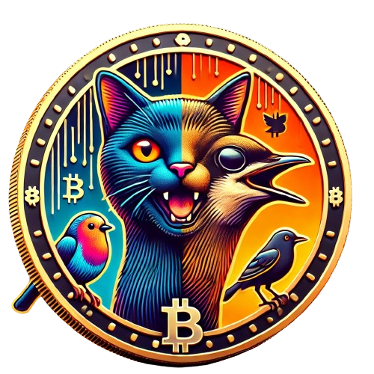

Introduction
In the whimsical world of Birdcatcher Cats, where agility meets strategy, and feline finesse is celebrated, a new meme coin emerges to capture the imagination of crypto enthusiasts and cat lovers alike. Birdcatcher Cats (BIRDPAW) is more than just a token; it's a playful exploration of the timeless cat-and-bird dynamic, reimagined in the context of the decentralized financial ecosystem.

The Philosophy of Birdcatcher Cats
Birdcatcher Cats embodies the spirit of our feline friends: curious, agile, and always on the hunt. Just as cats pursue their feathered prey with a mix of patience and pounce, our token aims to offer both steady growth and exciting opportunities for profit. Here's how the essence of a cat's hunt translates into the philosophy of Birdcatcher Cats:
- Curiosity and Exploration: Cats are natural explorers, always seeking new adventures. In the same vein, Birdcatcher Cats encourages users to explore the possibilities of decentralized finance, discovering new ways to grow their assets.
- Patience and Precision: The successful cat knows when to wait and when to strike. Birdcatcher Cats values strategic investment and timing, rewarding those who are patient and precise in their approach.
- Agility and Adaptability: In a world that changes as swiftly as the crypto market, agility is key. Our token and platform are designed to adapt to market trends, ensuring resilience and opportunity for our holders.

Tokenomics
At the heart of Birdcatcher Cats is a well-structured tokenomics model that ensures stability, growth, and rewarding participation. Here are the key parameters:
- Total Supply: 1,000,000,000 BIRDPAW
- Distribution:
  - 50% allocated for initial distribution among early adopters and stakeholders.
  - 35% reserved for development, marketing, and future initiatives.
  - 15% dedicated to rewards, incentivizing active participation and long-term commitment.
- Network: Ethereum (ERC-20)

The Fun and Profit Equation
Birdcatcher Cats is not just about the serious business of crypto trading; it's also about having fun along the way. Our community thrives on humor, creativity, and the shared joy of watching cats do what they do best—catch birds! With Birdcatcher Cats, you can:
- Catch the Bird, Get the Bag!: Just like a cat seizing its prey, with Birdcatcher Cats, your financial targets are within reach.
- Catnapping Profits!: Earn while you snooze. Our token rewards system is designed to grow your assets even when you're taking a catnap.
- Feather Your Nest with $BIRDPAW: Build your crypto empire with one of the most fun and engaging tokens in the market.

