Task 1.

|  |  |  |  |  |
| --- | --- | --- | --- | --- |
| Stream | mCp | Inlet T | Final T | 1.Law |
| H1 | 50 | 200 | 70 | 6500 |
| H2 | 10 | 300 | 60 | 2400 |
| C1 | 70 | 90 | 180 | -6300 |
| C2 | 15 | 40 | 220 | -2700 |
|  |  |  |  | -100 |
| CW |  | 30 | 40 | 0 |
| HPS |  | 240 | 240 | -100 |

The first law limits says that the minimum heating required is 100kW.

Task 2.

|  |  |  |  |
| --- | --- | --- | --- |
|  | delta T = 0 | delta T = 10 | delta T = 20 |
| CW | 570 | 1125 | 1750 |
| LPS | 670 | 1225 | 1850 |
| Diff | -100 | -100 | -100 |

These are the energy targets for the streams.

The pitch points are found using guess and check.

T_diff = 0

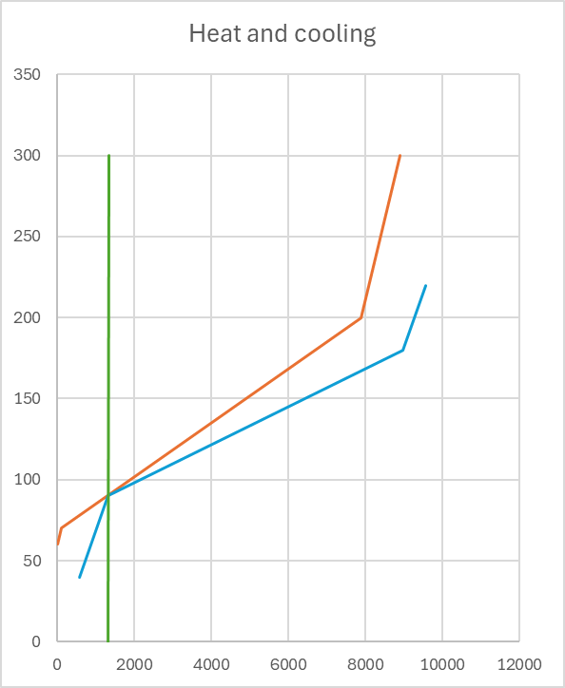

T_diff = 10

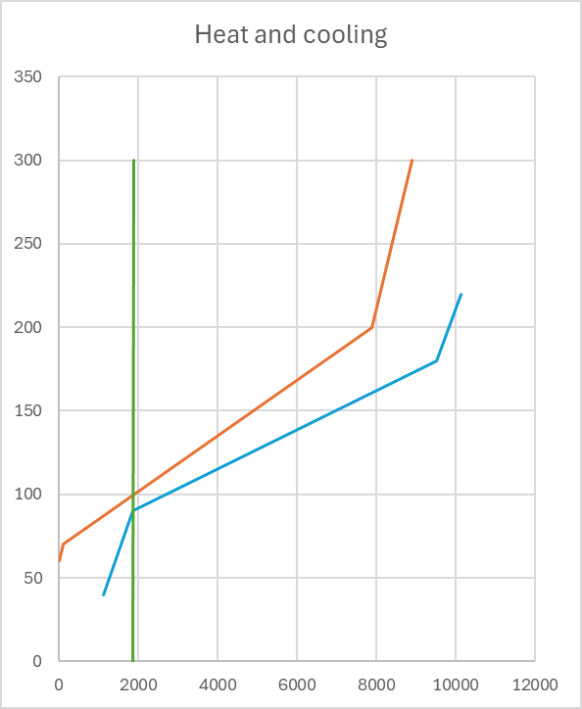

T_diff = 20

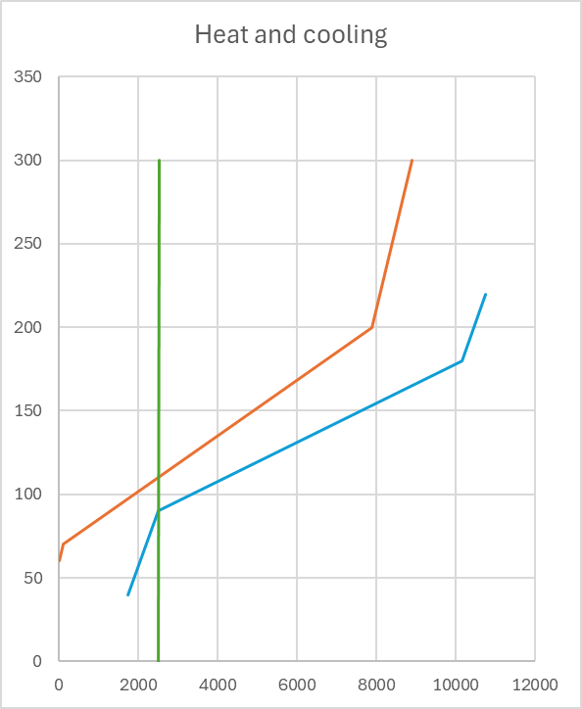

Task 3.

The Pinch is around around 1458,3 Duty

|  |  |  |  |  |
| --- | --- | --- | --- | --- |
|  |  | delta T = 0 | delta T = 10 | delta T = 20 |
| CW |  | 1100 | 1700 | 2300 |
| LPS |  | 1175 | 1775 | 2375 |
| Diff |  | -75 | -75 | -75 |

T_diff = 0

T_diff = 10

T_diff = 20