**[ristiinlatauksista, CFAn oletuksista]**

Many items typically have typically high cross-loadings on several factors (REFs), and when the factor loadings are interpreted as measurement relations, this means that the individual question items function as measurements of the (mal-)functioning of several cognitive processes at the same time. In natural sciences it would be preposterous to assert that a single reading of a measurement instrument provides information on several *measuranda*: when taking the reading of my thermometer, I do not expect it to contain information on what time it is. The analogous idea in factor analysis is known as the requirement of simple structure, i.e., roughly, that each item should load only on a single factor (REF). In addition, confirmatory factor analyses of the DBQ have found that the postulated factor structures do not suffice to explain the correlations among the items. Rather, it has been necessary to correlate the measurement errors of several items to obtain satisfactory model fit (Mattsson 2015, Australia ainakin). For instance, the covariation among the two items related to speeding is not entirely explained by them both being violations (”deliberate deviations from those practices believed necessary to maintain the safe operation of a potentially hazardous system”, Reason et al. 1990). The basic assumption of confirmatory factor analysis (CFA) measurement models is that of conditional independence among the observed variables when the correct measurement model has been specified. In other words, given a specific level of the latent variable, no correlation among the observed variables measuring it should remain.

Another lively discussion has concerned the number and nature of the properties that the DBQ measures. One view is that the only factor solution that generalizes to all the different versions of the instrument is the two-factor solution of *errors* and *violations*. On the other hand, investigations on the commonly used 27- or 28-item version of the instrument have found that a four-factor model of *slips* / *errors*, *lapses*, *ordinary violations* and *aggressive violations* is needed to adequately fit the data. Still others have argued for a three-factor model (REF). Recently, a bi-factor model involving one general traffic behavior factor together with the four factors mentioned above has bee proposed as the best-fitting model. In addition, a hierarchical model of four first-order factors and two second-order factors has been proposed (REF). Others have discussed whether it matters (Mattsson) or not (de Winter) if factor analysis or principal components analysis is used as an analysis method. In spite of the different things being measured in different studies, it is commonly thought that the measurement instruments reflect the (mal-)functioning of different psychological phenomena. This is illustrated by the following quote: “As each type of behaviour has a distinct psychological underpinning … different interventions are required to reduce their frequency and also associated crash risk” (REF Australia). When it comes to the measurement properties of the 27-item DBQ, rigorous tests of the measurement equivalence of the DBQ have indicated its lack of measurement equivalence across genders and age groups in Finland and the presence of (partial) strong measurement equivalence across genders and two age groups in Australia (and the lack of measurement equivalence when applying the same model to the youngest and oldest age group). The Australian study also found a total lack of measurement equivalence when comparing professional vs. non-professional drivers, while an earlier study comparing Finnish and Irish data found there to be a lack of measurement equivalence of violations and the presence of partial strong measurement equivalence of XXX. The results concerning the measurement equivalence of the instrument imply, for instance, that error proneness or aggresiveness sum scores could be meaningfully used as outcomes, covariates or moderators in a study comparing Australian male and female drivers (perhaps as long as they are not very old or young), and that they should not be so used when comparing Finnish drivers, because it appears that the phenomena themselves are structured differently in different age groups or genders in Finland.

**[mikä liikennekäyttäytymisiä aiheuttaa?]**

The numerous cross-loadings in EFA studies of the DBQ and the failure of the conditional independence assumption in Mattsson et al. (2015) and Australia (REF) are compatible with hypothesizing that there may be direct causal associations among the behaviors, thoughts and emotions that the individual DBQ items are related to. For instance, feeling angry at another road user might lead one to race away from the traffic lights or to disregarding the speed limit [tsekkaa ristiinlataukset]. In addition, the correlated error terms hint at the covariation between pairs of items not being completely explained by the factor structure. For instance, the results of Australia [and me?] are compatible with the idea of there being a factor related to speeding: perhaps there are stable individual differences in how much people enjoy speeding. Further, one may question from a purely theoretical point of view whether the factor structures obtained in DBQ studies are realistic representations of psychological differences between people (ref Mattsson response as well). For instance, violations are defined as ”deliberate deviations from those practices believed necessary to maintain the safe operation of a potentially hazardous system” (ref Reason et al. 1990). Thinking of violations as a latent variable leads one to hypothesize that the propensity to act in this manner is the only thing that has an influence on the individual differences in the behaviors that load on this factor. This, on the other hand, is an overly simplistic view from the psychological point of view: surely other things drive the way that people choose to behave than their propensity to violate rules and practices? For instance, there may well be stable individual differences in how much people enjoy speeding, how much they are annoyed by their progress being impeded (see also refs Parker & Mesken), how much they view traffic as a competition etc. [tähän voi vielä lisätä jotain].

The recently developed network analysis offers an interesting method to investigate the potential causal relationships among DBQ variables. Entä alifaktorit? Ainakin niistä voi luoda hypoteeseja.

In addition, network analysis in itself allows comparing the centrality of different behaviors, which is a question that does not arise in factor models of traffic behavior.

Plausible candidates for latent variables / emergent aggregates: enjoying speed; being annoyed by impeded progress. Verkostomallien avulla voi selittää onnettomuuksia sellaisilla muuttujilla, jotka olisivat faktorimalleissa kehnoja tai jotka pudotettaisiin pois, mutta ovat kuitenkin tärkeitä selittäjiä, esim. humalassa ajaminen.

Expression of commitment to latent variable perspective: different psychological processes underlie different traffic behaviors.

Component: causally autonomous, not exchangeable with other components. Two items that assess precisely the same component will be highly correlated (correlated errors).

Relations among components: oneway causal (plan ahead 🡪 able to meet obligations); feedback loops (sleepless worried 🡪 tired 🡪 worried about sleeplessness); semantical (logical): Liking a clean house, liking a clean desk.

Extraversion 🡪 make friends, feel good in company, like parties

Certain components cluster together and the personality dimensions emerge from these clusters.

Humans as dynamical systems:

Behavior feeds back to the system of other behaviors, cognitions, emotions, schemas, scripts etc. When a behavior was successful (i.e. goal was reached) it is reinforced in the future. Behavior patterns are stable: no small disturbance will change the way that a person is likely to behave. People seek out environments which are suitable for their behavioral repertoires: perhaps, for instance, the drivers who are likely to speed have acquired and use cars which make it enjoyable to speed. Further, people who like to compete may actively seek out situations in which they get to race from the traffic lights.

Kun ihmiset saavat perusteltua toimintansa itselleen tietyllä tavalla, tai kun he vain tottuvat toimimaan tietyllä tavalla, saavutetaan käyttäytymistilojen tasapaino.

Tietyt virhetyypit / käyttäytymiskomponentit vaihtelevat yhdessä: Reasonin ajatus absent-minded henkilöistä (“error proneness is not specific to any one cognitive domain, but operates more or less uniformly across all types of mental function”). Toiset komponentit voivat olla hyvinkin riippumattomia toisistaan: rikkomusten tekeminen ja hölmöt virheet todennäköisesti eivät korreloi keskenään.

Tasapainotilat kehittyvät ihmisen kasvaessa: jos lapsi tykkää vauhdista polkupyörällä tai suksilla, hän tykkää vauhdista aikuisenakin todennäköisesti. Tämä voi johtaa hyvän auton hankintaan täysi-ikäisenä ja kovaa ajamiseen sekä nopeusrajoitusten rikkomiseen, mikä tekee todennäköisemmäksi myös muut toiminnot, joita on kivaa tehdä hyvällä autolla, esim. liikennevaloista kiihdyttelyn.

Näkemys on hyvin paljon erilainen kuin latenttien muuttujien olettamiseen perustuva ajatus: nyt ei ajatella, että olisi esimerkiksi violoivia henkilöitä, vaan vauhdista pitäviä henkilöitä tai etenemisestä pitäviä henkilöitä ja kun näitä toimintoja kuvaavista muuttujista lasketaan summa, saadaan perinteistä latenttia muuttujaa vastaava olento.

Ne tilanteet, joissa mallia ei ole vielä säädetty lisäämällä ristiinlatauksia, korreloivia virhetermejä tai toisen asteen faktoreita, ovat kiinnostavia liikennekäyttäytymisen verkostoanalyysin kannalta: ne kertovat potentiaalisista kausaaliyhteyksistä komponenttien välillä. Piirteet muodostuvat, kun biologiset, psykologiset ja sosiaaliset voimat kytkevät tietyt toiminnot ja ajatukset yhteen: esim. jos henkilö ei ole kovin kiinnostunut autoilusta, hän saattaa tehdä herkemmin hassuja tarkkaavaisuusvirheitä – hänen tarkkaavaisuutensahan on jossain muualla kuin ajotehtävässä.

Keskeisten tottumusten muuttaminen lienee vaikeaa: ne aktivoituvat uudelleen muiden toimintojen vaikutuksesta.

Speeding: impatience, enjoyment, being late, self-entitelement, not focused, thrill-seeking, road rage

In short, it appears safe to say that it is not clear how many latent properties are measured by the DBQ, whether the measured properties should be thought of as being in a hierarchical relationship with one another (Lajunen) or not or whether a general factor of driving behavior should be postulated (Rowe), and whether the instruments measures identical or highly similar properties across different groups of respondents.

**[Verkostoanalyysin motivointi (entä verkosto*mallien*?) liikennetutkimuksessa]**

**[Mittaaminen psykologiassa, latentit muuttujat]** When a psychologist talks about measurement, she is likely referring to a latent variable model such as an Item Response Theory (IRT) model or a factor model. This is the case also in traffic psychology, with the Driver Behavior Questionnaire (DBQ) being one of the more commonly used measurement instruments (see, for instance de Winter & Dodou, af Wåhlberg meta-analyysit jne). The basic idea of factor analysis is to infer the existence of in principle unobservable latent variables from the co-variation patterns of the observed variables (with variance unique to each observed variable partialed out). In this formalism, the latent variables are seen as *causing* the observed variables to vary together, with the observed variables assumed conditionally independent of each other given the value of the latent variable. This characteristic of the latent variable models is known as *the assumption of local independence*. Importantly for the present interests, any pairwise associations between observed variables that remain after conditioning on the latent variables are seen primarily as troublesome shortcomings of the measurement model and breaches of a central assumption rather than as a phenomenon of interest in themselves. Models such as these are referred to as *reflective measurement models*, because the observed behaviors, thoughts and emotions are seen as passive reflections of the underlying latent variable.

**[Vaihtoehto latenteille muuttujille: parittaisten yhteysien analyysi]** In this contribution I propose an alternative for the latent variable models of traffic psychological measurement. In particular, I will focus on the pairwise associations between the observed variables that remain after conditioning on all other observed variables as a phenomenon of central interest, rather than as an unwanted nuisance[1]. In this context, the conditional dependence relationships are of more interest than the unconditional (or marginal) ones, because the latter may well be spurious, i.e. due to both associated variables having a common cause. Also, the unconditional dependencies fail to take into account the possibility that an intervening variable exists on the causal path from one variable to another. The conditional dependencies that remain after controlling all other variables in the network can then be interpreted as A) potential causal connections in either direction, B) reflections of the effect of a latent variable or C) as common method variance related to similarly worded questions (REF!)

**[Kausaalinen voima verkostomalleissa]** Recently, such conditional association relationships have been investigated using network analysis methods, which on their part are based on concepts from mathematical graph theory (Network psychometrics, state of the aRt + muut refs). In particular, symptoms of psychiatric disorders and data from personality questionnaires have been analyzed in this manner. In network models, causal power is attributed to the individual nodes in the network (corresponding to individual symptoms, behaviors, or thoughts etc.) rather than to in principle unobservable latent variables.

**[Kausaalinen voima verkostomalleissa liikennetutkimuksessa]** When analyzing psychiatric disorders, the network perspective produces results that conform with how practitioners think of the phenomena in their daily work. For instance, it is natural for psychologists to consider how individual symptoms may lead to each other. This can be contrasted with the latent variable perspective, according to which only the latent variables possess causal power. In the field of psychiatry, this corresponds to, say, stating that depression causes anxiety, disallowing talk about individual depression symptoms (e.g. lack of sleep) causing individual anxiety symptoms (e.g. fatigue). This is relevant for traffic psychology research as well, since in traffic psychology it might be more enlightening to investigate the relationships of individual behaviors and thoughts to accident proneness rather than to attribute causal power to broadly defined latent variables such as “proneness to violate rules” or “proneness to memory lapses” as is commonly done when analyzing data collected using the DBQ. For instance, it might be of interest to know whether the tendency to tailgate other drivers in a bout of aggression is related to accident-proneness when controlling for other traffic behaviors such as tendency for speeding or the frequency of committing different types of errors in controlling the vehicle.

**[Ehdollinen riippumattomuus; mediaation kanssa flirttailu (meneekö liian pitkälle???)]** A further benefit of the network perspective is that it allows the investigation of *conditional independence* *relationships*, i.e. finding pairs of variables that may be marginally associated but which are rendered independent when accounting for the other variables in the network. Investigating such relationships may be of practical importance, as it may allow uncovering mediated relationships between forms of behavior, or behavior and accidents. For instance, a question that could be asked is: “What is the shortest path in the network from aggressively tailgating other drivers to being involved in an accident? Is the relationship direct, or mediated by other variables?” Uncovering such relationships may lead to a better understanding of the ways in which people behave in traffic, and provoke formulating hypotheses to be tested using experimental methods. Practical applications might involve different network models built for different accident types, and asking questions such as: “Does frequent tailgating result in more rear-end collisions?” From the practical point of view it is important to bear in mind that the conditional independence relationships are postulated at the population level. In actual samples, however, sampling variation is likely to produce conditional dependencies that might be close but not exactly zero. For this reason, and to avoid overfitting the network models to the data at hand, the-so called lasso (L1) penalty is applied in the calculation of the inverse covariance matrix (see Methods section for details).

**[Mereologia-filosofiasta lyhyesti]** Further, the work on network analyses of personality data is also directly relevant for the present concerns, since the analysis methods and research designs commonly used in personality psychology are exactly identical to those used in traffic psychology. Correlational designs based on using questionnaires and factor analyses as the main analysis method are commonly used in both fields. According to the network perspective, phenomena related to personality could similarly be seen as an interacting system of ways of behaving, thinking and feeling rather than reflections of broad latent personality variables such as extroversion or agreeableness. Perhaps it is so that people who often go to parties are more likely to gain new friends, and again be invited to new parties, as Cramer et al. (2012) put it, rather than both behaviors being caused by the underlying, in principle unobservable property of extroversion. Cramer et al. (2012) also use the metaphor of a flock of birds to describe the relationships of personality characteristics: the individual components of the flock move (or vary) together without the need of postulating a latent variable to underlie them. Also, the idea of *mereology* has been suggested as a relevant theoretical framework for thinking about the network phenomena, albeit so far in a rather vague manner (ref Borsboom joku).

The idea of network models of self-report data is compatible with the theoretical idea of humans as dynamical systems (REF Borsboom, Cramer). These ideas have been developed in the area of psychopathology and personality research and their central idea is that stable patterns of behavior emerge from the interaction of the component parts of personality / psychopathology, rather than being caused by an underlying latent property such as a syndrome or a personality trait. The central tenets of the idea of humans as dynamical systems also seem compatible with general theories of traffic behavior, such as the zero-risk theory of Summala, or the XX theory of Fuller.

. Recently, five principles have been suggested as the theoretical basis of the network models of psychopathology (REF Borsboom). It may be illustrative to consider applying them in the context of modeling driver behavior (to the extent that they are applicable). The first principle is called “complexity”, and, applied to driver behavior, it can be phrased: “Clusters of driver behavior emerge from the interaction between different components in a network of driver behavior”. This principle states that insofar there are stable groups of driver behaviors such as aggressive driving, they emerge from the interaction

1. Driver Behavior Questionnaire as a viable basis for networks: The second principle is about whether driver behaviors
2. The question of whether driver behaviors are described at the correct level of granularity in questionnaires determines whether it is useful to model
3. the DBQ is naturally an important question to consider when thinking of whether self-report data can be used as a basis of constructing network models of traffic behavior. For instance, Mattsson (2012) has argued that the DBQ items do not map cleanly on cognitive processes, even though behaviors related to the (mal-)functioning of a certain cognitive / emotional / motivational process might be natural candidates as the “atomic components” of a driver behavior network.
4. Direct causal connections between components: as specified above, this seems plausible as a representation of at least some relationships of the behaviors encoded in to the DBQ items.
5. Driver behavior follows network structure: Certain symptoms are more tightly connected than others. Observable types of driver behavior arise from the interactions of groups of behaviors. This idea is perhaps the most difficult one to accommodate in a network model of driver behavior. The types of traffic behavior would perhaps correspond with the latent variable structure of the DBQ, or to types of behaviors specified in traffic psychological theories (such as?)
6. Hysteresis: “Mental disorders arise due to the presence of hysteresis in strongly connected symptom networks, which implies that symptoms continue to activate each other, even after the triggering cause of the disorder has disappeared”. In the context of traffic behavior, this principle might apply to driving styles, realized as interconnected ways of thinking, behaving and feeling. The driving style may be picked up from one’s parents or peers, and one may hold onto the driving style even when the parents or peers have stopped influencing one’s driving choices. Tai voi soveltaa aggression heräämiseen liikenteessä: ei tarvita välttämättä kuin pieni tönäisy (joillakin yksilöillä), ja he pysyvät kauan aggressiivisessa tilassa.

------------------------------------------------------------------------------------------------

DISKUSSIOON POHDINTAA SIITÄ, MITÄ MALLIIN VAIKUTTAVAT STRESSORIT VOISIVAT OLLA. Esim. aggression herääminen jonkin pienen ärsytyksen seurauksena joissain autoilijoissa tai se, miten onnettomuus tai läheltä piti –tilanne voi vaikuttaa (tai olla vaikuttamatta) käyttäytymisverkostoon (Rajalin & Summala). Se, että näin vakavat tapahtumatkaan eivät välttämättä vaikuta verkostoon, kertoo siitä kuin syvässä tottumukset istuvat.

However, unlike psychopathology networks, a network model of traffic behavior is not the result of a sudden external shock; rather, it is a description of the stable state of the behavior, thoughts and emotions of the individual in question. For instance, Summala (REF) emphasizes the way that human traffic behavior is to a large extent a habitual activity. It has been proposed that habits may function as the attractor states of networks of behaviors, cognitions and emotions (REF). It is of course conceivable that external events function as random shocks that affect the interconnections of the network, even though not in the same way as in the case of psychopathology. A shock that might alter the state of the traffic behavior network might be an accident or a near miss (tyyppi ja Summala, effect of accidents on behavior). After such an external event, the activation status of the nodes of the network might change (i.e. an individual might exceed speed limits more rarely) and the connections between the nodes might change (i.e. speeding might activate nodes related to attention-related errors less, because the individual started to pay more attention to the driving task after the incident).

------------------------------------------------------------------------------------------------

## The measurement properties of the DBQ

The DBQ was originally conceived of as an instrument to operationalize the constructs of Reason’s (1990) theory in traffic research in order to understand human error as a factor contributing to traffic accidents. The original questionnaire instrument consisted of 50 question items aimed to measure five constructs. The initial failure of the items to capture variation in the constructs that it was meant to capture lead to the modification of the construct structure[2]: after the initial analysis resulted in three principal components, subsequent studies continued from there in an attempt to replicate this structure. After this, constructs and items purportedly measuring them have been added and removed, leading to quite a wide variety of instruments dubbed the DBQ that differ in the number of constructs (1-7) and items (10-112). In what follows, we mainly concentrate on the 27-item version[3] of the DBQ, since it has been used quite widely and confirmatory analyses (CFA / ESEM) have been performed on it in addition to exploratory analyses (PCA / EFA).

The confirmatory studies have assessed the factorial structure and the measurement equivalence of the instrument. Comparisons of the two-,three-, and four-factor solutions have indicated that four factors are needed to sufficiently explain the covariation of the DBQ items in different countries (Finland and Ireland: Mattsson et al., 2015; Romania: Sarbescu, 2013 and China: Zhang et al., 2013). Analyses comparing subgroups of respondents formed on the basis of age and sex have similarly favored the four-factor solution (Mattsson, 2012). Similarly, in a Danish sample based on using CFA and the original 50-item version of the DBQ, the four- and three-factor solutions fit the whole sample and different subgroups based on ages and genders roughly equally well (Martinussen et al., 2013)[4].

However, the *number* of factors is naturally not the whole truth about what an instrument measures: the minimum requirement for an instrument to measure conceptually similar constructs is for the items to load on the same factors. This is sometimes the case: for instance, the studies of Mattsson et al. (2015) and Sarbescu (2013) showed that the original four-factor solution (REF) fits data from Ireland and Romania adequately (even though some cross-loadings needed to be estimated in the study of Mattsson et al. (2015)). Still, Mattsson et al. (2015) found that only two of the four factors were similar enough to be comparable across the Finnish and Irish data, and the four-factor solution of Zhang et al. (2013) was completely different from those of the other studies. Similarly, different factor structures needed to be estimated for the different age and gender groups in the Finnish data examined in Mattsson (2012): for instance, in the oldest age group, traffic behaviors usually included in the rule violations DBQ subscale actually loaded more strongly on the factor of inadvertent slips of attention. Similarly, the youngest respondents may have considered overtaking from the inside and pushing in at the last minute as aggressive behaviors, since the related items loaded most strongly on the aggressive violations factor.

EFA results? Xie & Parker(2002) eri 4-fakt ratkaisu. Mesken et al. (2002) uncovered a qualitatively different four-factor structure for the same 28-item instrument: they named their four-factor structure lapses, errors, interpersonal violations and speeding violations. The factor of interpersonal violations, on its part, resembled the first factor (Aggression) in the youngest age group in Mattsson (2012). Using PCA as an analysis method, Eugenia Gras et al. (2004) found a four-component solution of errors, violations, interpersonal violations and lapses, with different items loading on the components than was expected[5].

To summarize, previous research has shown that four factors are needed to obtain adequate fit to data, but also that the four factors cannot be considered measurements of the same underlying phenomena across studies. Actually, it has been suggested that to obtain results that generalize across studies, two-factor solutions should be used (de Winter & Dodou, 2010, de Winter, 2014; and for discussion, Mattsson, 2014). In this sense, the researchers face a dilemma: the two-factor does not fit the data adequately, while the four-factor structure does not generalize. On the other hand, Mattsson (2012) has called for redesigning the DBQ based on recent work in psychology and cognitive science. Based on this review of the discrepant results obtained using the present versions of the instrument, that idea seems still relevant.

**One important property of the latent variable model is that it directs one’s attention toward thinking of what the items that load on a factor have in common. This may sometimes lead to excessively dichotomous thinking (that what the items have in common is the only relevant cause-effect relationship)**: In this context it may be of interest to note that Mesken et al. (2002) suggested that different motivational pathways may lead to speeding (wanting to be in destination on time, feeling the positive feelings related to speed), even though they considered speeding-related behavior a latent variable of its own. This conceptualization is congruent with how cause-effect –relationships are thought to function in reflective measurement models. Still, adopting the factor analysis model forces the authors to formulate their explanations of the findings in an unnecessarily dichotomous manner: the anger items (showing hostility in whatever means; sounding horn; tailgating in anger) are not about anger after all, but together with the other items loading on the same factor, indicate the presence of a motive to harm other drivers (either physically or psychologically) and the lack of respect for others. While this may very well be so, having to discard the immediately obvious explanation (the drivers committed these acts because they were feeling anger) in order to find a common denominator for behaviors loading on a single factor is one example of throwing the baby out with the bathwater. In this article, I would like to suggest that the network model provides a more plausible model of the relationships among driving behaviors on the one hand, and between background motives and driving behavior on the other. Analogical reasoning applies to how the “speeding violations” factor of Mesken et al. (2002) cuts across the “fast driving” and “maintaining progress” factors of Lawton et al. (1997): A network model could more easily accommodate both explanations simultaneously.

When considering the assumed causal power of the DBQ latent variables, or the lack thereof, a fascinating recent study by Zhao et al. (2012) is relevant. They investigated the kinds of independently and objectively measured traffic behaviors that the DBQ scale mean scores, or dichotomized scale scores, correlate with. The authors calculated the three mean scores of violations, errors and lapses based on the 24-item version of the DBQ and found that drivers with high violation scores 1) drove on average 4 kph faster than drivers with low violation scores, 2) made more sudden changes in driving speed, 3) had a larger standard deviation of steering wheel angle and 4) made more lane changes. The authors then interpreted a high violation score as indicating that the driver has an aggressive driving style. Lapse scores were correlated with more steering wheel reversal, which is thought to reflect the amount of attention devoted to the driving task. Interestingly, the authors found that the mean score of errors (the items largely overlap with those labeled “slips” in the present study) correlated with nothing they could measure about real world driving performance.

Zhao et al. (2012) clearly attributed causal power to the latent variables in their study. The causal chains suggested by the authors could perhaps be described as aggressiveness 🡪 speeding; aggressiveness 🡪 sudden speed adjustments; aggressiveness 🡪 lane changes & overtaking; with each of these increasing the risk of accidents[6] [diskussiossa: tähän liittyviä kysmyksiä olisi helppo keksiä kyselyyn: ohitatko vai ohitetaanko sinut useammin?]. Still, it is equally possible that only a subset of the items included in calculating the scale scores would have correlated with the independently observed traffic behaviors. It is at least logically possible that the speeding-related items correlated strongly with actual speeding, with the other items having zero correlations with it. If this is the case, the speeding-related items would have served as the signal in the correlation of the violation score and actual speeding, with the other violation items serving mostly as noise. Be that as it may, it would be fascinating to re-analyze the data from the Zhao et al. (2012) study using network analysis methods.

Further, from the practical point of view it seems that basing the analysis on using scale mean scores as Zhao et al. (2012) did, leads to formulating causal hypotheses that are excessively simple from the point of view of understanding actual driver behavior. This critique applies naturally to DBQ research and is in no particular way targeted specifically at the carefully conducted study by Zhao et al. (2012). For instance, when researching the effectiveness of interventions to change the speeding habits of drivers, the variables thought to play a causal role have included the drivers’ beliefs and values concerning speeding, the perceived acceptability of speeding, drivers’ self-efficacy to drive at a certain speed, the anticipated affect related to speeding etc. (Fylan et al., 2006). The hallmark of science is the careful manipulation of an independent variable and observing its effects on a dependent variable. The intervention studies can be seen as attempts to manipulate the drivers’ speeding behavior, and, if the above-mentioned list of factors playing a causal role is even a crude approximation of the multitude of factors actually playing a role in the choice of a certain behavior, it is clear that the causal relationships are likely to be complex. Looking at things from this perspective makes it clear that interpreting the DBQ violations as reflecting proneness to violate rules, or an aggressive driving style, is too coarse a description to be of much use in understanding the causal mechanisms of drivers’ choices to behave in a certain manner. In this contribution I wish to suggest that network analysis might offer a more natural analysis method for investigating the complex associations between beliefs, thoughts and emotions underlying observed behaviors of different kinds.

Finally, even though Zhao et al. (2012) interpreted violations scores as indicating the aggressiveness of drivers, different interpretations have been given in earlier studies. Violations were originally defined as “Deliberate deviations from those practices deemed necessary to maintain the safe operation of a potentially hazardous system” (Reason et al., 1990). It is of interest to note that this definition has always been used in an apparently normative sense, as the behaviors classified as violations are practices deemed necessary to maintain the safe operation of the system *by the authors of the relevant studies*, not the respondents themselves. Thus, when used as a predictor of observed behavior, the violation score needs to be defined in a way that is relevant for the subjects themselves: if the violations are thought to have causal power to influence actual driving behaviors, the causal mechanism cannot possibly involve the idea of behaviors that the authors of a study consider (morally) reprehensible. Of course it might be that everyone agrees on which behaviors are in this manner necessary for safety, but this suggestion seems unlikely. In this sense, the approach taken by Zhao et al. (2012) has its merits: even though their approach of finding the meaning of the latent variables is purely data-driven, at least it is not moralistic.

Some other interpretations for the psychological phenomenon reflected by the violation scores have been drivers’ feeling of invulnerability, lack of concern for safety and willful disregard of potential hazards, such as the sight of a another vehicle (Parker 1995). It is curious that all these interpretations were offered within a single study. It would seem more principled to define an explanatory concept in a certain way and then stick with that definition for the duration of the study in which the concept is used, or preferably for even a longer time.

Furthermore, Parker, Reason et al. (1995) found a relationship between the violation scores and self-reported accidents, and attributed this to faulty attitudes and motivations of drivers. Roughly, they saw the associations as *faulty attitudes 🡪 violations 🡪 accidents*, and thought that the best way of influencing the causal chain would be to attempt changing the attitudes. They used safety campaigns related to seat belt use as an example and suggested that similar campaigns might be fruitful related to the other types of violations. Even though they don't mention this explicitly, the reference to seat belt use campaigns makes the reader think that they consider similar campaigns, related to individual driving behaviors classified as violations, as the correct way forward in promoting traffic safety. However, because of this, it would seem more in keeping with the authors’ ideas to examine the associations between certain background characteristics and individual driving behaviors, or those between safety campaigns and their effects on individual driving behaviors rather than examining associations between those characteristics and mean violation scores that comprise several different kinds of driving behaviors. In this sense, the network approach to analyzing data from self-report studies would seem a more natural choice when thinking of the proposed cause-effect-relationships related to changing how people behave in traffic. Further, when considering the causal antecedents of different types of violations in the context of the theory of planned behavior, Parker et al. (1998) found that “the basic theory of planned behavior constructs were not significantly predictive of ‘ordinary’ violations, although affective attitudes were”. In this context I’d like to suggest the possibility that different ‘ordinary’ violations might be differentially affected by the constructs postulated in the theory of planned behavior (perceived behavioral control, perceived norms etc.) similarly to the causal chains postulated based on the intervention studies by Fylan et al. (2006).

### Simulation

The current simulation investigated only the effect of distributional form on the values of different correlation coefficients. First, continuous variables were created using the two-stage procedure of Mair, Satorra & Bentler (2012). Three variables following the exponential distribution with rate parameters of 0.5, 2 and 3, respectively, were joined together using the Gumbel copula. The covariance among the first and second variable was specified as 0.5, that among the first and the third as 0.2 and that among the second and the third as 0.09. All variables had a standard deviation of one, so the covariances can also be interpreted as correlations. These correlation values were chosen to be of a similar magnitude to the polychoric correlations actually calculated among the DBQ variables in the present data set. The variables thus produced were then cut into five categories to produce ordinal variables whose underlying continuous non-normally distributed counterparts had the population correlations mentioned above.

The simulation was based on running 1000 repetitions of the following procedure. First, the continuous random variables were formed using the procedure described above. Pearson and Spearman correlations were calculated for the continuous variables. Then the ordinal versions of these variables were created, and different correlation coefficients were calculated among the ordinal variables. The correlation coefficients included 1) the Pearson correlation, 2) the empirical polychoric correlation (Ekström REF), 3) the “ordinary” polychoric correlation and 4) the Spearman correlation. The average deviations from the two correlation coefficients calculated for the continuous variables were then calculated. The idea was to choose the correlation coefficient with the least average deviation from the correlation calculated for the continuous variables. The results of the simulation are shown in Table X.

In table X, the first three rows (rp12 to rp23) show the average Pearson correlations over the 1000 simulation runs. rp refers to Pearson correlations calculated based on the simulated continuous data and rs to Spearman correlations . The values that are subtracted from these are the values of different correlation coefficients, calculated after categorizing the continuous variables into five categories. The empirical polychoric correlation is abbreviated as "epc" and the adjusted version (adjusted coefficient from Ekström REF) as epcadj. rp_cat and rs_cat are the Pearson and Spearman correlations calculated based on the categorized variables, respectively. polycor refers to ordinary polychoric correlations.



Figure X shows scatterplots from one of the simulation runs, with linear regression lines together with second and third degree polynomials fitted to the data. Although some deviations from linearity are present, no radical deviations from monotonicity are apparent.

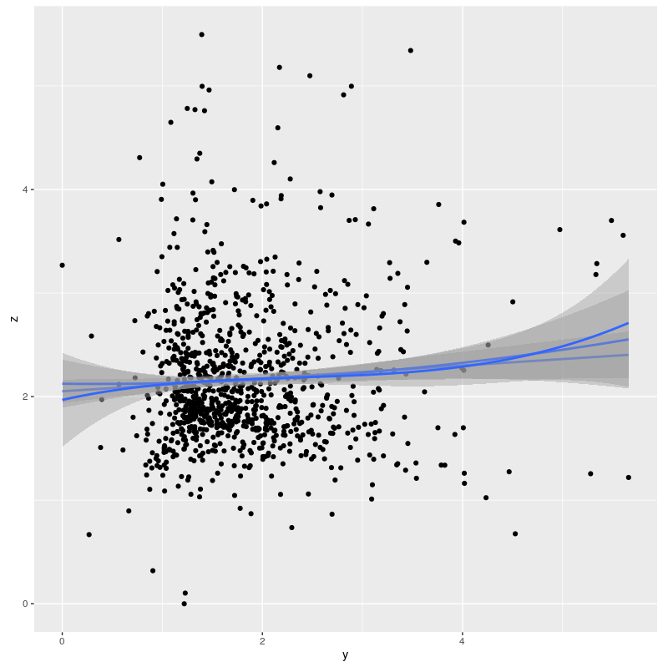 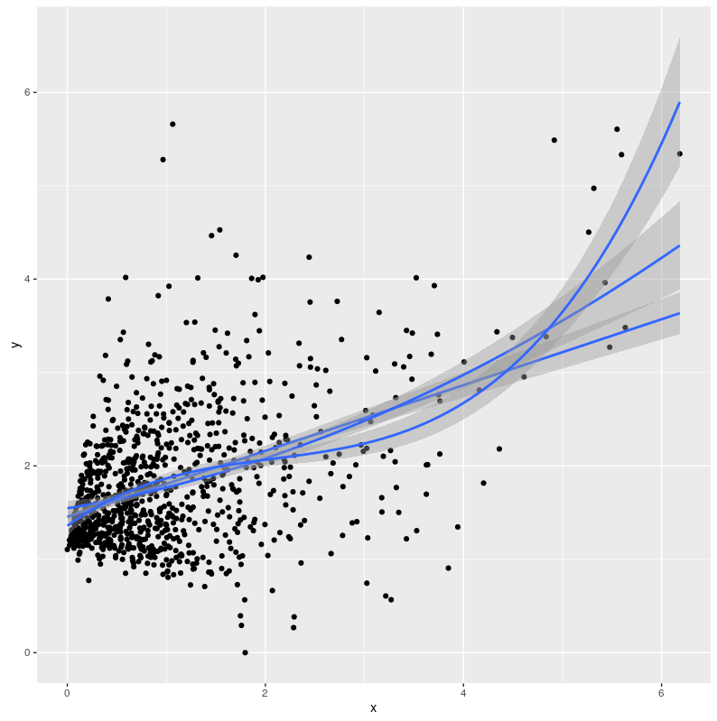 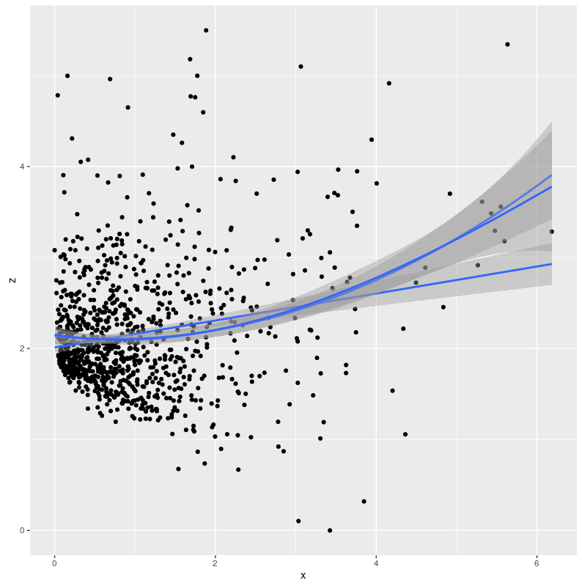

Figure X. Scatterplottei

1. These pairwise conditional dependency relationships are known as partial correlations when the variables are continuous and the associations linear. Further, with this type of data the unconditional dependencies are most commonly operationalized as zero-order correlations.
2. Instead of the items used to measure the construct, which would have been the other logical choice
3. or the 28-item version, if the item related to driving under the influence is included.
4. A methodological note is in order: fitting the measurement models separately to subsamples of respondents does not yet show that the same things are being measured across the subsamples. To do this, measurement equivalence analyses need to be carried out (REF). This point has been made before in the DBQ context by Mattsson (2012), Mattsson et al. (2015) and Oviedo-Trespalacios & Scott-Parker (2017). Measurement equivalence analyses allow comparing the equality of factor loadings, intercept terms and error terms.
5. The numbers of items on the components were 12, 9, 3 and 3; one item presumed to load on lapses was discarded, and it’s also noteworthy that the expected component structure would have consisted of 6, 6, 8 and 8 items on the respective factors
6. Previous DBQ research has suggested that it is not speeding in itself, but an incorrect speed choice for the circumstances which increases the probability of an accident (Parker et al., 1995). This is probably a necessary qualification for the results of Zhao et al. (2012), as well.