Assignment 1 – UML
Provide class examples of the following relationships.
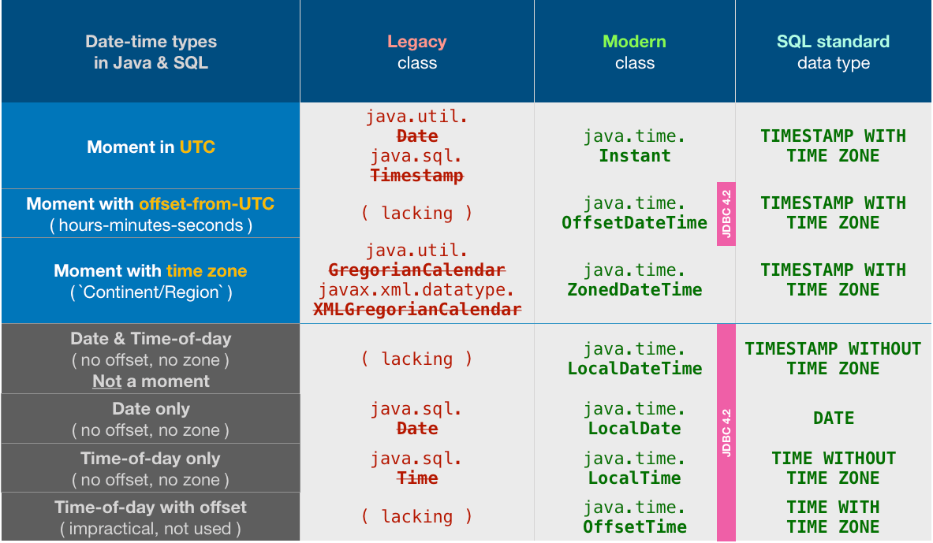
I have included a short explanation of assumptions made for each example to justify the design. Also, I may have mixed knowledge of this course with some previous knowledge (e.g. I don’t think we’ve learned about getters and setters or Java specific datatypes like LocalDate/Period yet) – I hope that is not an issue. As proof that I did my research and it was not AI created ideas, I add screenshots (see Figure 1 & Figure 2) with sources and self-made pseudo-code examples for selected methods/functions (see Figure 5).
Figure 1: Research result on what datatype to use for date representation (https://stackoverflow.com/questions/28730136/should-i-use-java-util-date-or-switch-to-java-time-localdate).
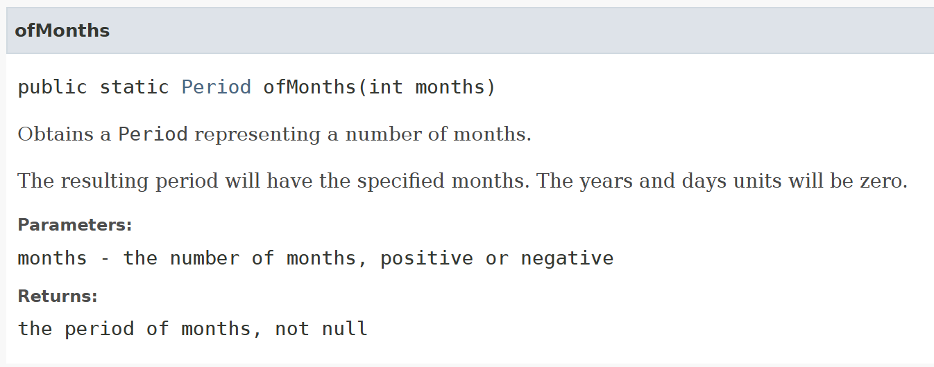
Figure 2: Research result on what datatype to use for date interval representation & calculation (https://docs.oracle.com/javase/8/docs/api/java/time/Period.html).

One-to-One relationship
I have decided to design the relationship between Patient and MedicalRecord. I suppose that if handled strictly/more modern, a new Patient instantiation usually happens before their first MedicalRecord. So, if we include that thought it could also be a One-to-Zero or One relationship. But in this scenario, the stakeholders are old-school and first take in all the information on paper and then create the Patient and MedicalRecord simultaneously. Therefore, one Person has one MedicalRecord. Furthermore, it is a composition, because if a Patient is removed from the system, their MedicalRecord is also deleted.
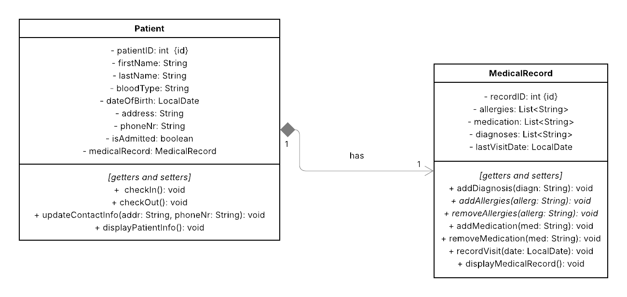
I suppose the attributes should be self-explanatory for both classes. For Patient, the checkIn and -Out methods update the isAdmitted status. I wouldn’t update this over a setter, because they are meaningful domain-actions – not simple updates. The others should be self-explanatory. For MedicalRecord, Allergies and Medication can be removed as those can change over time. The existence of the method recordVisit is justified in the same way as checkIn and -Out.
Figure 3: UML class-diagram for the chosen One-To-One relationship.

Aggregation relationship
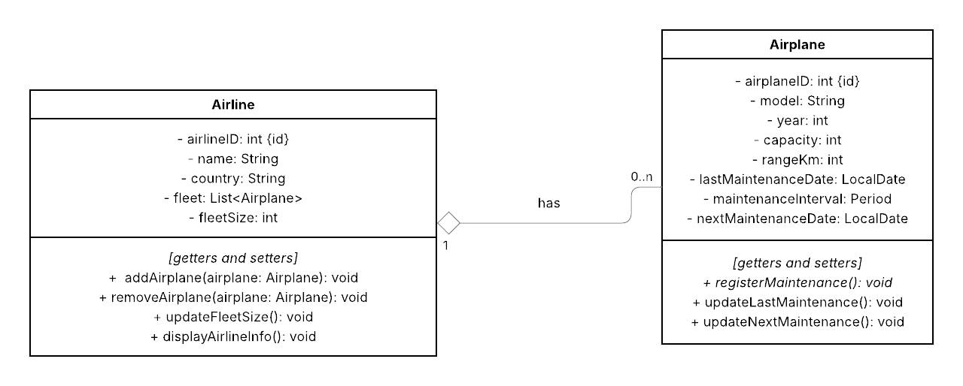
I have chosen an aggregation relationship between Airline and Airplane. In the chosen scenario, an Airline can have no or many instances of Airplane. I consider it an aggregation because the Airplane can still exist, even if the Airline does not (e.g. in some sort of hangar/storage or as part of a different Airline instance).
Figure 4: UML class-diagram for the chosen aggregation relationship.
The existence of the methods can be justified in the same way as in exercise 1. For proof that I designed this myself (again, because I think I used parts we didn’t cover in class yet) I add my example pseudo code for the methods of Airplane in Figure 5 below.
Figure 5: Pseudo code for the methods of class Airplane.

Composition relationship
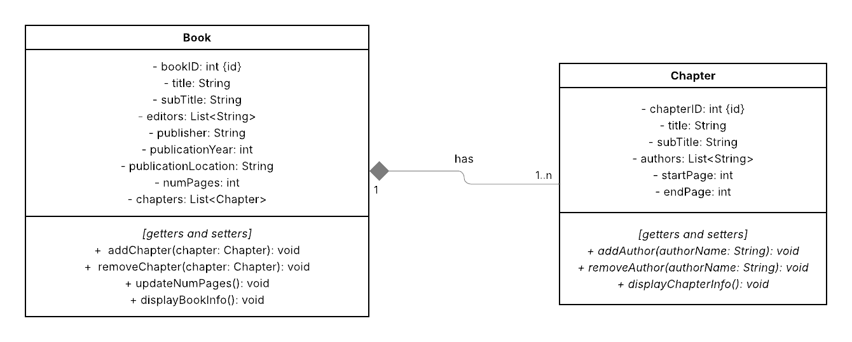
Here I have chosen the relationship between Book and Chapter. It is a composition, because if a Book is deleted, so are its Chapter instances. It is a One-To-Many with minimum 1 relationship, because our stakeholders don’t have instances of Book without any Chapter.
Figure 6: UML class-diagram for the chosen composition relationship.
It would be better to also have Author as a class, but for this exercise it should do as it is now. No further explanation here, because it would be redundant.

