select FirstName, MiddleName, LastName, FullName, Description
from dbo.Artist left join dbo.Artwork
on dbo.Artist.Id = dbo.Artwork.ArtistId
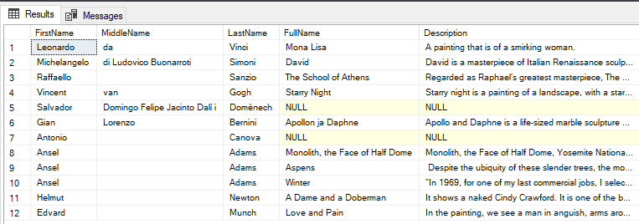
select FullName, Description, Form
from dbo.Artwork inner join dbo.ArtworkType
on dbo.Artwork.ArtworkTypeId = dbo.ArtworkType.Id
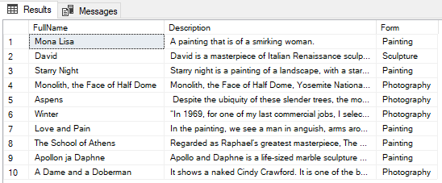
select FirstName, MiddleName, LastName, FullName, Description
from dbo.Person right outer join dbo.Artwork
on dbo.Person.Id = dbo.Artwork.PersonId
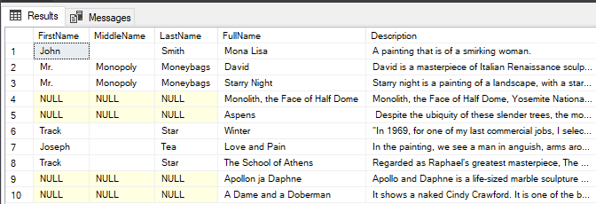

Create Procedure spSearchArtists
@FirstName nvarchar(100) = NULL,
@LastName nvarchar(100) = NULL
As
Begin
Select * from dbo.Artist where
(FirstName = @FirstName OR @FirstName IS NULL) AND
(LastName = @LastName OR @LastName IS NULL)
End
Go

execute spSearchArtists
