Good morning,

In this document I condensed all the information regarding the project that might be important for your work in the next weeks. First of all there is the project schedule, including all the tasks we have to complete, listed with its duration and the date, we need to have finished them. Afterwards there is a Gantt-hart, showing you the dependencies, we have to consider in the execution of the project. I´ve colored the critical parts in red. We have to take care not to get delays in these tasks, because they have an impact on the duration of the whole project. With these two charts you should be able to track the progress of the project.

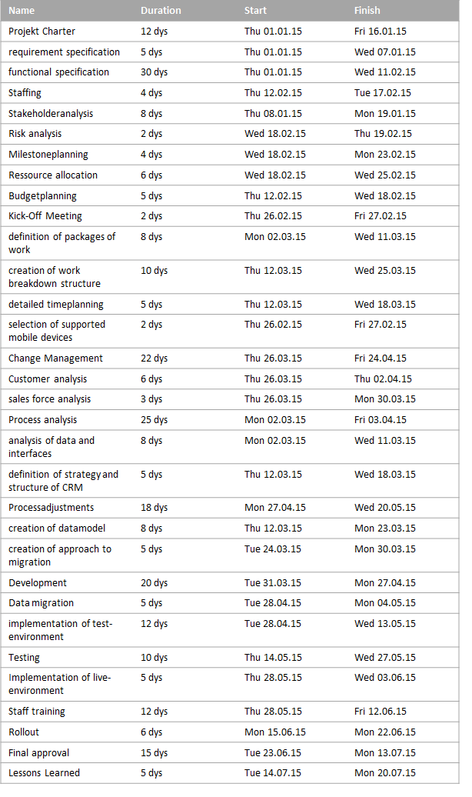

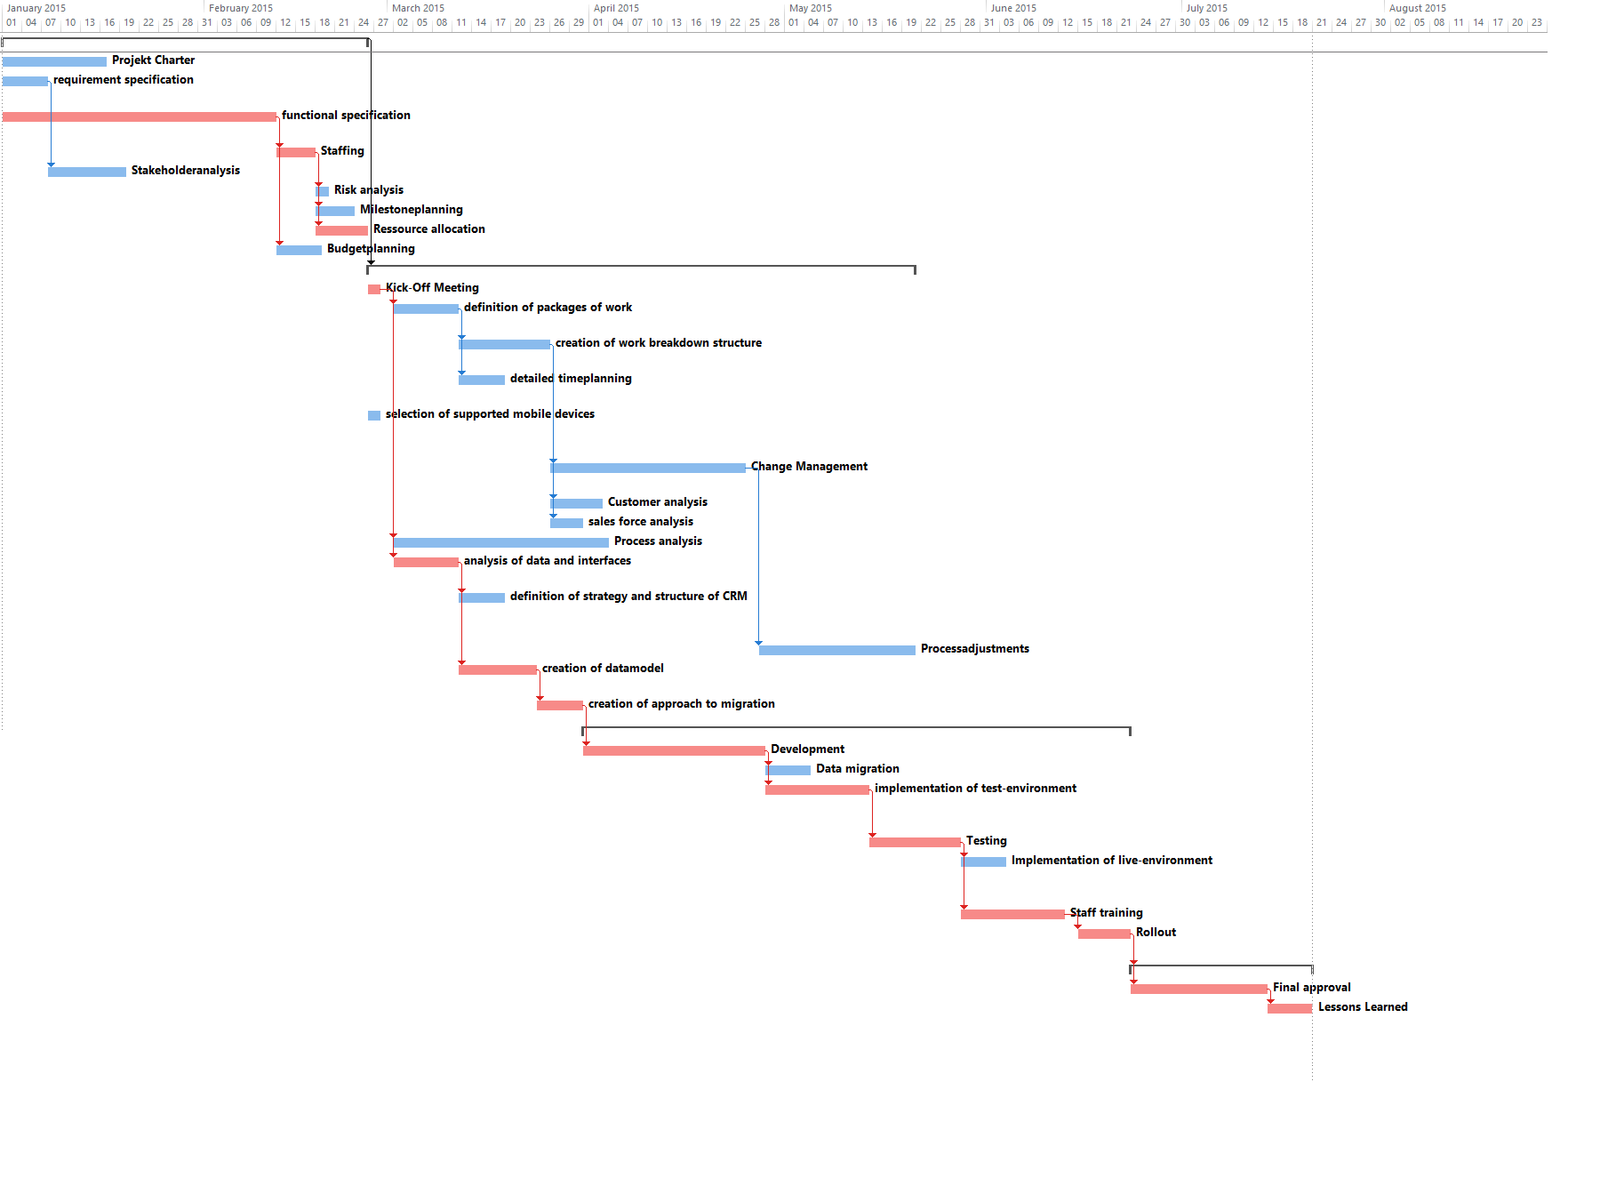

Next is an overview of the costs of the phases of our project. It´s derived from the duration of the tasks and I´ve summarized the costs of all the consultants, IT-specialists, your working time and the time I spend on the project.

The time all the participants will spend on the project is visualized in the next graphic. This represents the estimated time I calculated for all the tasks, combined with the employees working on the tasks. As you can see, you won´t get to enjoy the beautiful state of Texas too much over the time of the project.

Corresponding to the working time, I estimated the cost each employee will cause. This might be a good basis for decisions in case we get into problems regarding time or cost of the project.

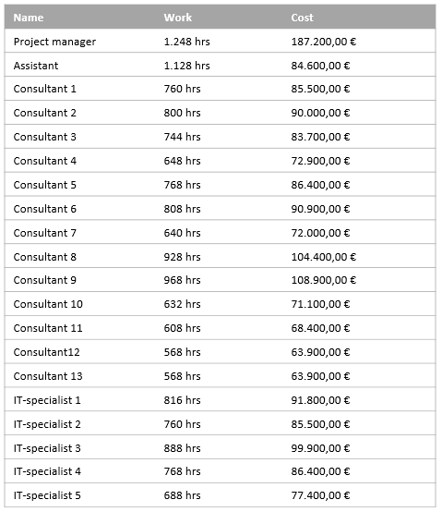

To conclude I´ve got a list of all the tasks, combined with the working time that I estimate is needed to complete it and the cost that would result from that time.

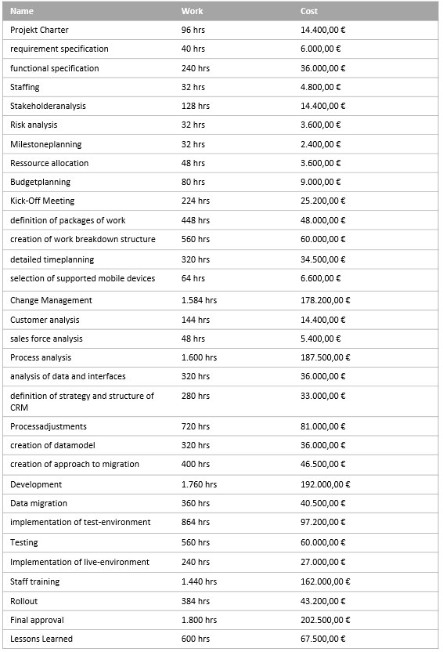

I hope, I provided all the information you need and my project chart is a helpful basis for your further decisions in this project.