|  |  |
| --- | --- |
| Project motivation | |
| Aim of the project | Implementation of the CRM-solution brillianCRM into the company’s technical architecture of Concrete Machinery. The successful end of the project is defined by the handover of the product. |
| Expected Benefit | The system aims to raise the efficiency of the involved business processes and optimize the sales department. Furthermore the customer’s loyalty should be improved to gain a long-term advantage in competition. The reaction time towards customer’s requests is also improved by the system. |
| Assumptions | * IT resources at customer’s site are sufficient * Specification sheet is provided at a given time * In case of problems support is always available by Silicon Bombay |
| Constraints | * Limited budget provided by project sponsor * Dependency on data input by sales department * Adherence to data security |

|  |  |
| --- | --- |
| Stakeholders and organisation | |
| Stakeholders | * Project sponsor * customers of sales department * governmental organizations * Competitive companies * Future users of the CRM-solution * IT support Silicon Bombay |
| Project manager | Player |
| Responsibility of project manager | The project manager owns the authority to decide about the time scheduling during the project phase as well as about the budget’s apportionment. He is responsible for the staffing and constitutes the interface between Concrete Machinery and brillian CRM |
| Project sponsor | Concrete Machinery Sales Department |

|  |  |
| --- | --- |
| Project approval requirement | brillianCRM is responsible for the handover of the final CRM-solution towards the customer Concrete Machinery. The steering committee will decide about the final approval of the process success. |

|  |  |
| --- | --- |
| Scope of the project | |
| Deliverables | * Analyses of the current state * To-be analyses of the new sales processes to achieve the priorly described benefits * Implementation of an on premise CRM-solution * Migration of current sales data into the new system * User training |

|  |  |
| --- | --- |
| Time of the project | |
| Start | January 1st |
| Finish | September 30st |
| Period | 9 months |

|  |  |
| --- | --- |
| Costs | The project is scheduled with a budget of 25 million USD |

|  |  |
| --- | --- |
| Risk management | |
| Major risk items | * Functions are necessary but out of scope * Additional requirements of data protection by the government * IT department of Concrete Machinery is not ready for the implementation |

|  |  |
| --- | --- |
| Communication | |
| Means of communication | The primary way of communication between Concrete Machinery and brillianCRM are e-mails and phone calls. The steering committee will congress once every three month. |

Milestones

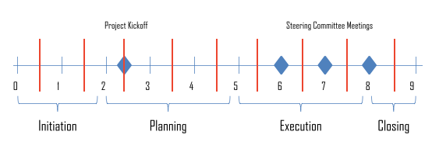

Project Charter Approval

B. R. Stylus

(Signature of Project Sponsor Concrete Machinery)

(Signature of Project Manager brillianCRM)