|  |  |  |  |  |  |  |
| --- | --- | --- | --- | --- | --- | --- |
| Case | Test 1 Score | Test 2 Score | Test 3 Score | Total Score | Average | Prediction |
| 1 | 60 | 50 | 83 | 193 | 64 | No errors and results will show |
| 2 | 105 | 85 | 1 | 86 | 43 | Application will run and will ask the user to input another score |
| 3 | 85 | 95 | 96.5 | N/A | N/A | Application will break because of runtime error |

Part 2 – M07:

Both of the Set breakpoint and debug window screenshots in one

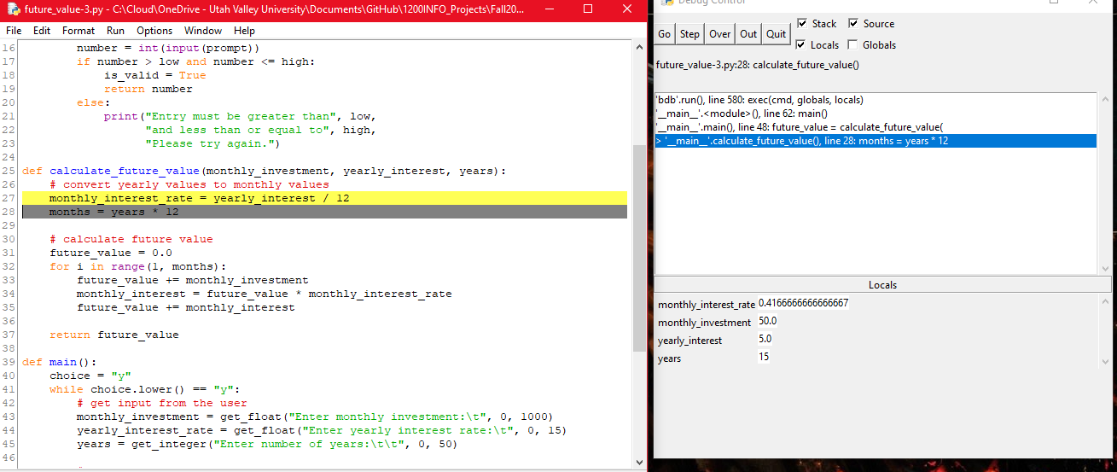

Final result screenshot with correct result

