Part 1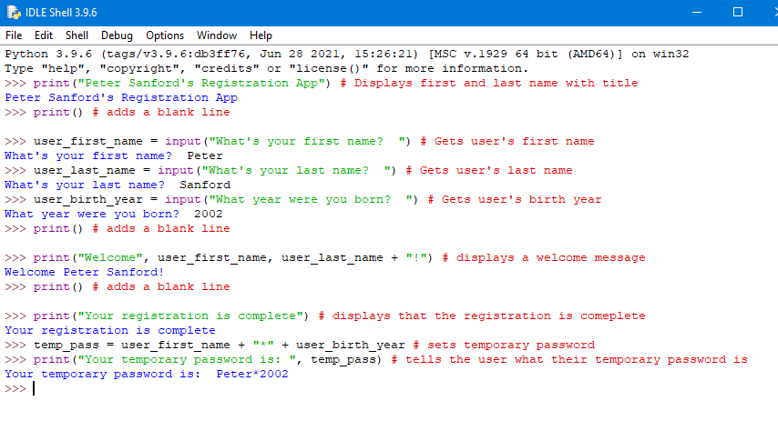

Part 2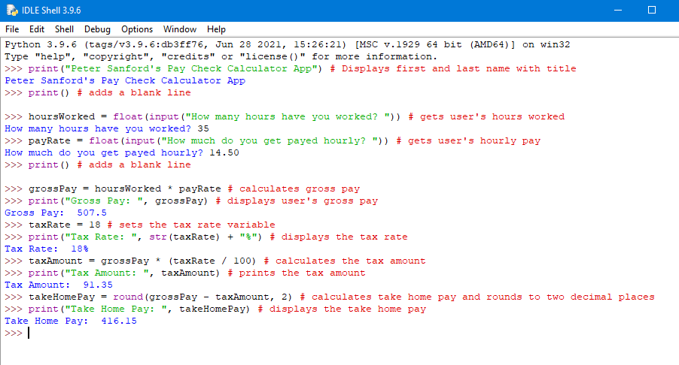

Part 3

