

Final Report: Geo 419

Modulare Programmierung in der Fernerkundung: Dateninterpretation mit Python

Students
Konstantin Schellenberg
RobinKohrs

Lecturer
John Truckenbrodt

1. Introduction

Two different multi-spectral optical satellite constellations deliver open data source for earth observation.
However, this extensively huge and growing database is merely comparable without significant pre-processing and
alignment. New products from NASA promise an ease of efforts of comparability. The Harmonised Landsat Sentinel product (HLS) provides coregistered pixels and atmospherically corrected, thus fully harmonised scenes. By matching the individual swaths of the satellite constellations to the UTM tiles access is facilitated.

The development of reproducible code embraces the relatively new programming paradigm of open science. Historically, languages such as Fortran, S, C or IDL have been used for implementing spatial or statistical problem but their design hindered that larger groups of scientists were able to use them, or were proprietary (IDL). R and Pyhton, yet, fill the demand of the community for flexible and easy-to-use programming. Here, literate programming in Jupyter Notebooks or Rmarkdown documents makes it easy to make code understandable and accessible.
Python consits of core libraries and custom extentions. In the spatial domain `gdal` and `proj` written in C play an integral role in loading, warping and calculating upon spatial data, vector and raster formats respectively. However, their inherited C-API, which has been implemented in the `osgeo` package, is neither pythonic nor straightng forward. Hence, some wrappers and utilities have been written in order to make this API usable by still accessing the fast C core. Rasterio [] or pyroSAR [] are worth mentioning in this respect. On top of that, download API, are friendly utilities to query and load larger amounts of data. The increasing demand and supply on hypertemporal and larger dimensional spectral remote sensing data make their use inevitable since manual selection of the scenes and areas become unfeasiable.
The relatively new NASA‘s HLS product currently cannot requests neither via the <https://asf.alaska.edu/>, not the Earth Explorer, nor Google Earth Engine. In order to spead the use of the harmonised product, Benjamin Mack <https://github.com/benmack/nasa_hls.git> developed a python downloader which comprises the following functions:

- Querying and download the HLS product
- Viewing metadata
- Cloud cover filtering
- Converstion of GeoTiffs

In order to make the program be more flexible, the goal of this extension is to
1. Download tiles by setting spatial (user defined verctor geometry) and temporal inqueries to the HLS server,
2. Mosaic the HDF4 formatted product per band and acquisition date.

As part of the module report will want to add the following post procession tasks:
3. Calculate spectral indexes from the downloaded products.
4. Plot the results inline with `ipyleafet` and `folium` on a Open Street Map WMS service.

Tasks 1 and 2 are meant to work in accordance with the `nasa_hls` package and aims to lead to a pull request to the repository; 3 and 4 shall give an overview of to use the new utilities and the HLS product.

https://hls.gsfc.nasa.gov/wp-content/uploads/2019/01/HLS.v1.4.UserGuide_draft_ver3.1.pdf

2. The Product
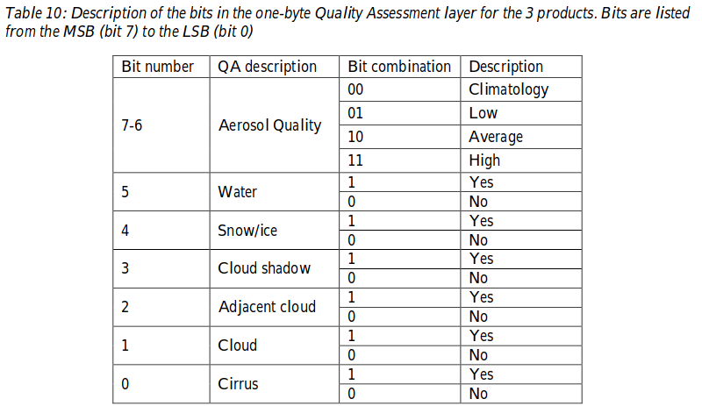
The Sentinel-2 mission has two identical satellites in orbit, the S2-A and -B, launched in 2015 and 2017. With repeat cycles of 12 days each and 6 days combined and with higher spectral resolution in the red edge band, the Sentinels mark a new chapter in the European optical earth observation. In contrast, the Landsat mission date back much further to the 1970s providing a consistant multi-spectral observation time series of over 40 years. The latest satellite, the Landsat 8 Operational Land Imager (OLI), in combination with another thermal sensor fly on orbits repeating ever 16 days. The launch took place in 2013.

3. Our Approach

As mentioned above, and what turned out to be a little trickier than expected, the main goal was to expend the existing capabilities of the nasa_hls-package bfall by an option to download only tiles that fall within a user-specified Region of Interest (futher called ROI). Python has many ways to deal with vector data. One of the most common ones might be the library GeoPandas. Based on the widely used data analysis library „pandas“ it is extends its features by the possibility to integrate geospatial data. It depends heavily on shapely and fiona and uses matplotlib and descarted for plotting. It‘s two main datastructures (classes) are the GeoSeries and the GeoDataFrame. All this is said, as much of our workflow used instances of these classes in some way. But first things first. How does the download of the HLS-Scenes actually work.

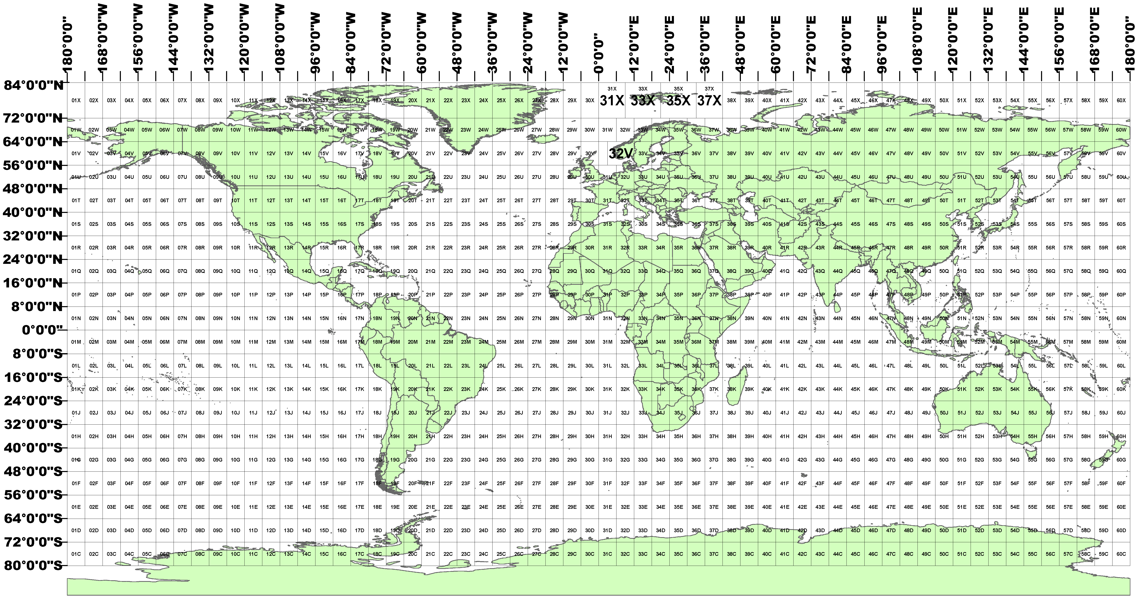Figure 1: NASA HLS Tiles
3.1 The Download based on a Vector.

The NASA HLS Tiling system is closely related to the UTM (Universal Transverse Mercator) – naming convention. Meaning that each tile has a five digit identifier. The first three digits are the actual UTM tiles, the last two one are a unique identifier. Without further elaborating the tiling system, one can view all the tiles in Figure 1 and the currently available test sites for download in Figure 2. This is not meant as a ressource for finding possible tiles. For this one might acccess: https://hls.gsfc.nasa.gov/products-description/tiling-system/

In order to download NASA HLS with the already existing nasa_hls programm, the user needed to know a priori the names of the tiles he wanted to query. This can be a little cumbersome. That‘s where the main functionality of our plays a role. As we didn‘t see any other chance in the beginnen stages of the project we decided to dowload the .kml-file which hold all the tiles shown in Figure 2. This decision was made by us, knowing, that this is not ideal. The shape is ~100 MB in size and definitly nothing someone wants to have somewhere on the disk, Nevertheless this enabled us to a simple spatial subsetting (comparison).

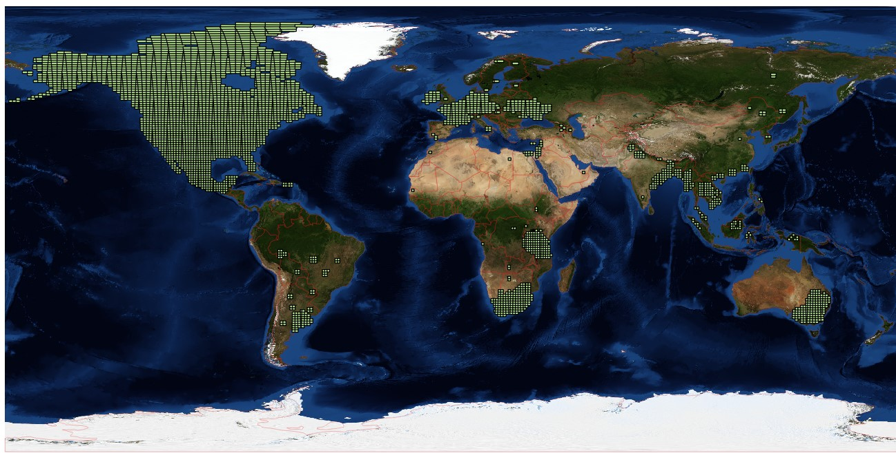Figure 2: NASA HLS Test Sites

Geopandas doesn‘t come automatically with the driver for kml-files enabled. After setting this option we could simply „compare“ the users shape and the .kml-file and obtain the tile-ids which are then fed into the download function from the nasa_hls python module download_hls_dataset.py. The HLS files are quite big and it‘s not in the user‘s interest to download any file without even seeing the amout of data prior to the actual download. As in many other GIS we created a function, and this is actually the first function a user of our programm wants to call, that returns a list of GeoDataFrames. This list can be printed and evaluated by the user. More or less as a side-product we created the option to restrict this output to a certain time. This can be a single date, an entire year or a subset of a year. Further details on the function can be found in the docstring.

In summmary summary this first function has only one non-optional arguments. This is the path to the user-shape. Moreover one can specify a product. Being either [„S30“] or [„L30“]. The former referring to Sentinel-products, the latter to Landsat-products. Until this point it seems to be possbile to also use the two in parallel by passing [„S30“, „L30“] as parameter. This, however, will cause the programm to fail when downloading the scenes and creating this tiffs. More on this later. In case no product is passed as parameter, the deafult is set to [„L30“]. As last argument the user can, as outlined above, pass some time information. If no time information is provided at all, it will be created a list of all scenes of 2018.

Within this function we made use of pythons build in datatype: dictionaries. Dictioanries are helpful in the way that they are srtructured in key:value-pairs. In our case the hashable keys are integers representing the unique dates within the timespan the user specified in the function-call. The vakues are list containing Geopandas GeoDataframes. This is necessary for the nect step.

Once the user is sattisfied with the output of the funtion (meaning that he has all the Scenes in the python-list that he has in mind), he can call the download_tiles-function. It might be helpful do save the output of make_tiles_dataset in a variable. By doing so, one can simple use this variable as input-parameter for the download_tiles-funtion. This function simply calls the already existing download_batch- function. As said above, the user has a list of list at this point with each list containg the DataFrames for each single date. The download_batch-funtion is then called iteratively for each list in the list.

Finally the HLS-files are downloaded to a user-specified path.

3.2 The Creation of the final GeoTIFFS

Once the HDF Scenes are downloaded, the user can decide individuallly what to do with these files. All the files come in the Hierachical Data Format (hdf). They can also be accessed directly over this link: https://hls.gsfc.nasa.gov/data/v1.4/. As we‘ll discuss in more depth later, the hdf-fileformat was new ground for us and presented some unexpected behaviour.

In case the user only wants to convert one of the entire hdf-files to a GeoTIFF, the nasa_hls package offers the possibility to do so via the convert_hdf2tiffs-function. This function uses the gdal_translate-call via the subprocess library instead of using gdal directly in python with the osgeo library.
If, on the other side, the user decides to convert all the hdf-files he downloaded into tiffs that are cropped and masked on the extend of the initially provided shapefile he has the option to use the make_mosaic-function. At first this function creates a virtuall mosaic (a vrt-file) for each day for each band. These mosaics of bands are then mosaiced again and finally create a virtual mosaic for each day. During the execution of this function gdal gets called via the osgeo library, as well as over the command line. This non-homogeneity is one of the points that still needs to be revised.
In the end the output will be on GeoTiff for each day. Holding either 11 band plus a quality assasment (QA) band in the Sentinel Case. Or 10 bands plus a QA in the case of Landsat products.

- what geomtric resolution do we acutally download??
- would there be the chance to download a different one?

The overwall (epxtected) workflow can be seen in Figure 3.

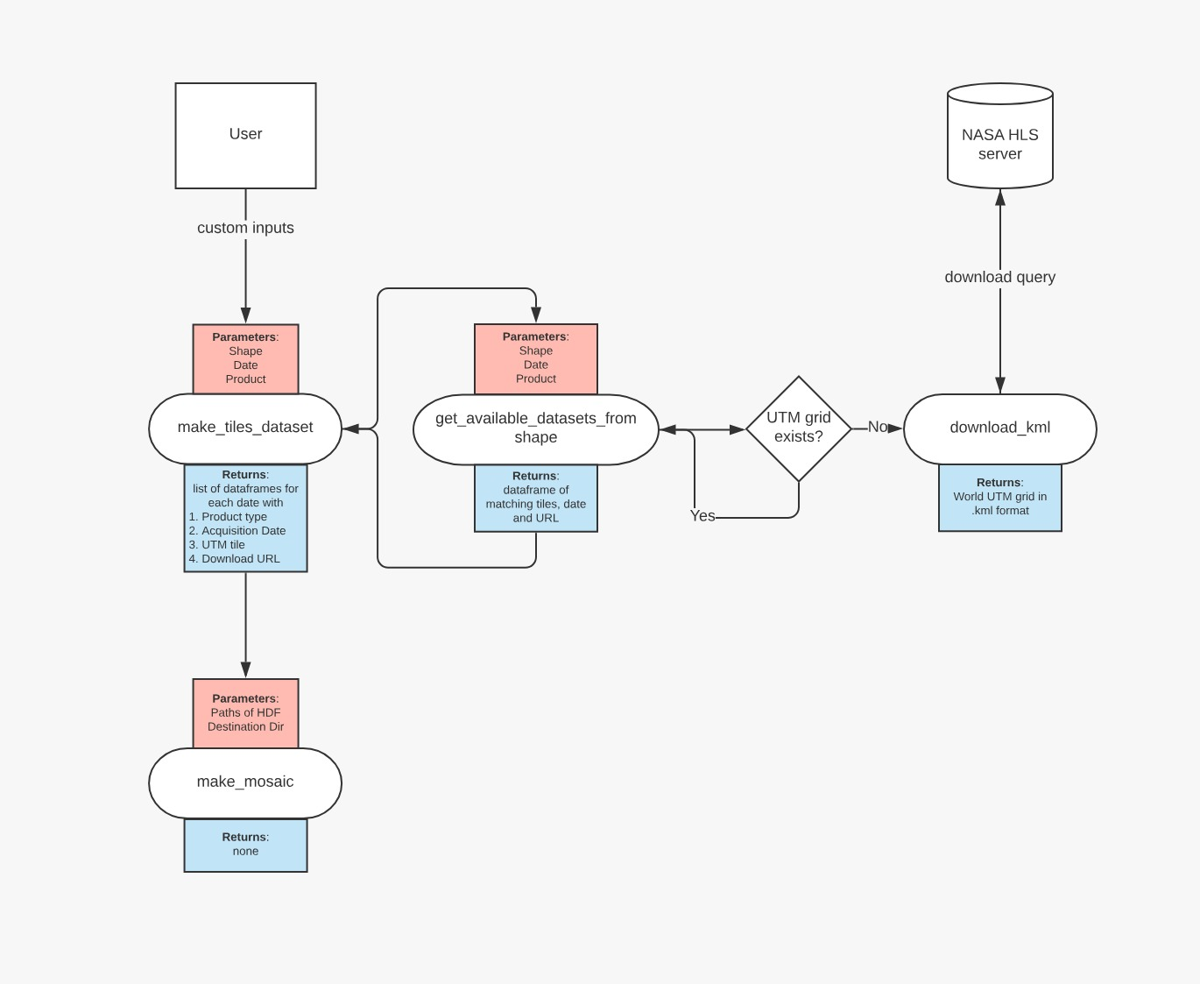Figure 3: Workflow
3.3 The Output

- maybe better to implement in the notebook?

4. Challenges
Although we started working on this small project in Novembem 2019 and never really stopped looking into the code, it still feels like there is a lot missing. This is mainly due to all the smaller and bigger issues that had to be addressed along the way. The next chapter will give light to some of the more emblematic ones, as they might appear again in future research.

4.1 Git(-hub)
Today a world without some version ontrol seems nearly as impossible as a world without the classic social networks. Git, and especially the combination of git and github, seem to dominate this market at the moment. As simple as the idea of versioning, creating branches and merging one into another might seem, it costed and still costs us lots of time and nerves.

I think one of the major problems we faced during the project was a simple and clean routine, where everyone knew what he was „allowed“ to do and what not. Basically some „best practice“ that each one would follow. This could have prevented us from several merge conflicts, that seem kind of unnecessary in a team of two. Just to give one concrete example. When working remotely on two different branches that are both some kind of development branch of the master branch, we were insecure on what is the best way of integrating a single function of one development branch into the master and ame sure at the same time that the other development brach integrates this modification as well. Does it always needs to be via pull request or can it just simply be some kind of merege. What exactly is a rebase and so on… In the end it always worked in some way or another. Yet it seems as quite some experience is needed to really establish a clean and stable workflow.

4.2 Gdal

Implemented in many GI-applications today, the geospatial data abstraction library (gdal) is the de facto standard for reading, writing and, to some extend, modifying raster and vector data. First released in 2000, it supports an incredible amount of drivers (for all the raster drivers have a look here: https://gdal.org/drivers/raster/index.html). And just to name some of the programms using gdal: ArcGIS, QGIS, GoogleEarth or GRASS GIS are all depending on the library.

In our case we decided to use gdal for more than one reason. One of them is the dataformat in which the HLS-porducts are available. Once downloaded there is no „let‘s drag and drop the file in QGIS and get an idea of what we are dealing with“. As gdal has capabilites of reading this file format (our data come in HDF release 4, or short: HDF4) it seemed to be the way to go. Moreover gdal offers the virtual format. This format makes it possible to create a gdal „virtual“ mosaic from many other gdal datasets. This brings huge advantages in terms of disk and memory usage, as well as time reduction for processing. VRTs are basically just text (or better: xml-markup) files that contain all the information needed to modify the underlying original data and are stored as a .vrt file.

Gdal offers so many command line utilities for rasters (found here: https://gdal.org/programs/gdalbuildvrt.html) that it might seem scary for new users of it. There are other sites that list all the gdal-commands in a way that‘s even less appealing for the „normal“ user. Nevertheless it returns all these issues with the time that‘s saved at runtime. For our purposes we only needed some basic gdal utilities. By reading the documentation and commiting to the „trial and error“-approach we managed to use gdal for our needs. One of the main challanges was the HDF-File format. It behaves completely different to other formates we were used to. One hdf-file, that is one downloaded HLS products, doesn‘t contain multiple bands like a multiband-GeoTiff. It‘s composed of subdatasets. Until we got to the point of understanding how to work with these subdatasets some hours and days passed by. While we considered the command line usage of gdal almost comfortable (in terms of setting the options), the API via the osgeo-package in python is a little trickier. That‘s why we finally used both. The easier tasks are running gdal via osgeo while the cropping and mosaicing are calling gdal from the command line.
Another, until today unsolved problem, is the crs. When downloaded the HLS products (the .hdf-file) the crs is the one for the utm-zone that overlaps with the HLS tile. During the tests of our product, we used a testing region from South Africa. Thus, the referece system should contain a „S“ after the two first digits. Something like „34S“. After processing the .hdf product with our functions and importing the final GeoTiff into QGIS, the crs though was wrong, as there was a N, indicating North, in the crs.

4.3 Other technical/python challenges

For both of us it was a new experiece to really try to develop something small on our own. Instead of just dealing with the implementation of the „geospatial“ problem, we invested many and many hours in order to get to the point where we actually could start thinking about how to write python-code, that would solve this problem. This was mainly due to python-specific challenges. One thing that stood out was, again, the absence of a clear and conscious workflow. Starting with the simple import statements within a python-package (relative or aboslute) to the directories where python looks for packages or the use of certain packages. All this seems to be solved by now, but simply requested vast amouts of time.

5. Conclusion

