Progress report: Design Week 3

name: Joost Hintzen

student ID: 10434143

name: Marco Heuvelman

student ID: 10176306

name: Mark van den Hoven

student ID: 10533133

name: Sammy Heutz

student ID: 10445765

name: Shan Shan Huang

student ID: 10768793

**Outline of our narrative**

**“Guns don’t kill people; people kill people”**

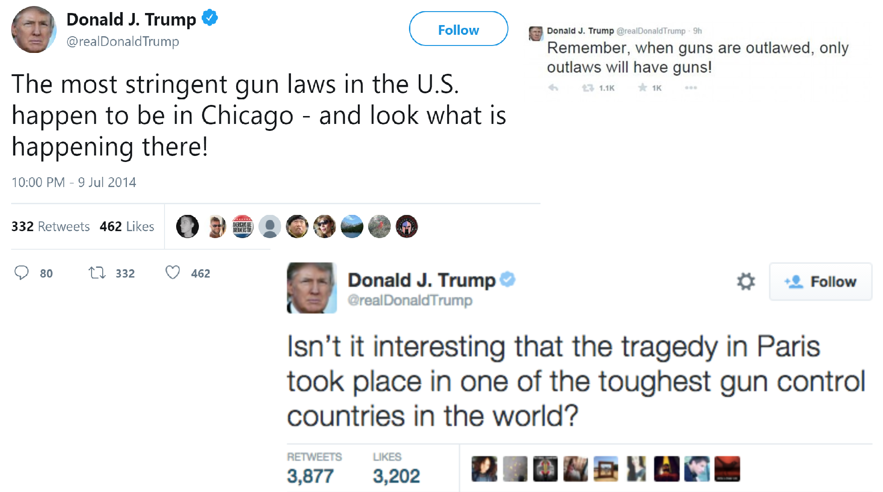

Everyone has heard about the “Guns don’t kill people; people kill people” argument in the gun control debate. How many mass shootings have occured in the last few years in the US? Is there any relation between mass shootings and how strict gun laws are in that state?

To examine this, we have looked into data that provided us with information about mass shootings within the United States. Firstly, when looking at the number of mass shootings in the time period from 1966-2017, it becomes apparent that the number of mass shootings have increased over the years. Notably, there seems to be a steady increase in shootings since 2004, which is when the assault weapons ban was lifted (see Visualization 1). This suggest that there is indeed a relationship between the strictness of gun laws and mass shootings.  
  
In order to further explore this relationship, we then decided to visualize the number of shootings per state (visualization 2). It seems as if California is the “US capital of mass shootings”. To examine whether state’s gun laws influence the amount of mass shootings, we then looked into the Brady Score per state, which is a score given to each state which provides an indication of how strict or loose it’s gun laws are. We then visually correlated these scores to the number of mass shootings per state (visualization 4). It seems as if there is a positive relationship between brady score and amount of shootings, which suggests that states with stricter gun laws have more shootings. This is an unexpected findings, which could be interpreted in a number of ways. For instance, it could be that states which have more mass shootings decide to have stricter gun laws to try and counteract this effect.

However! We forgot one important element! Of course, every state has a different population size. It might very well be that the number of mass shootings is related to a state’s population size, i.e. that states with bigger populations also have a higher amount of shootings. To look into this, we created a relative amount of shootings per 100.000 people (visualization 3). This graph shows that the amount of shootings per state changes when population size is taken into account. Now, the states are much closer together, and California is among the states with the least shootings. Michigan is now an extreme outlier.

**The last part with the second scatterplot and our conclusion has to be added next week (we are still making it).**

**Visualizations**  
  
1: Shows the increase in Mass Shootings from 1966-2017. Here, our narrative will focus on the fact that after 2004, there seems to be an increase in shootings, which is when the assault weapons ban was lifted.

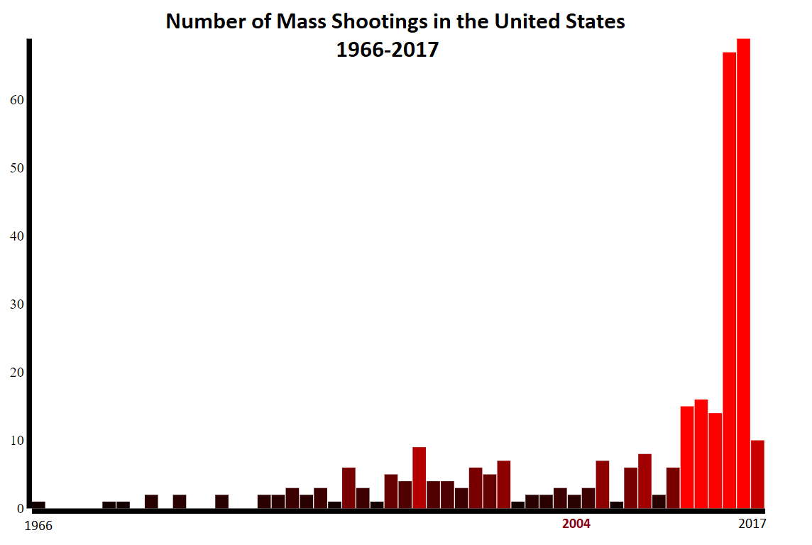

2. Shows the number of shootings per state from 1966-2017, to illustrate how some states have more shootings than others.

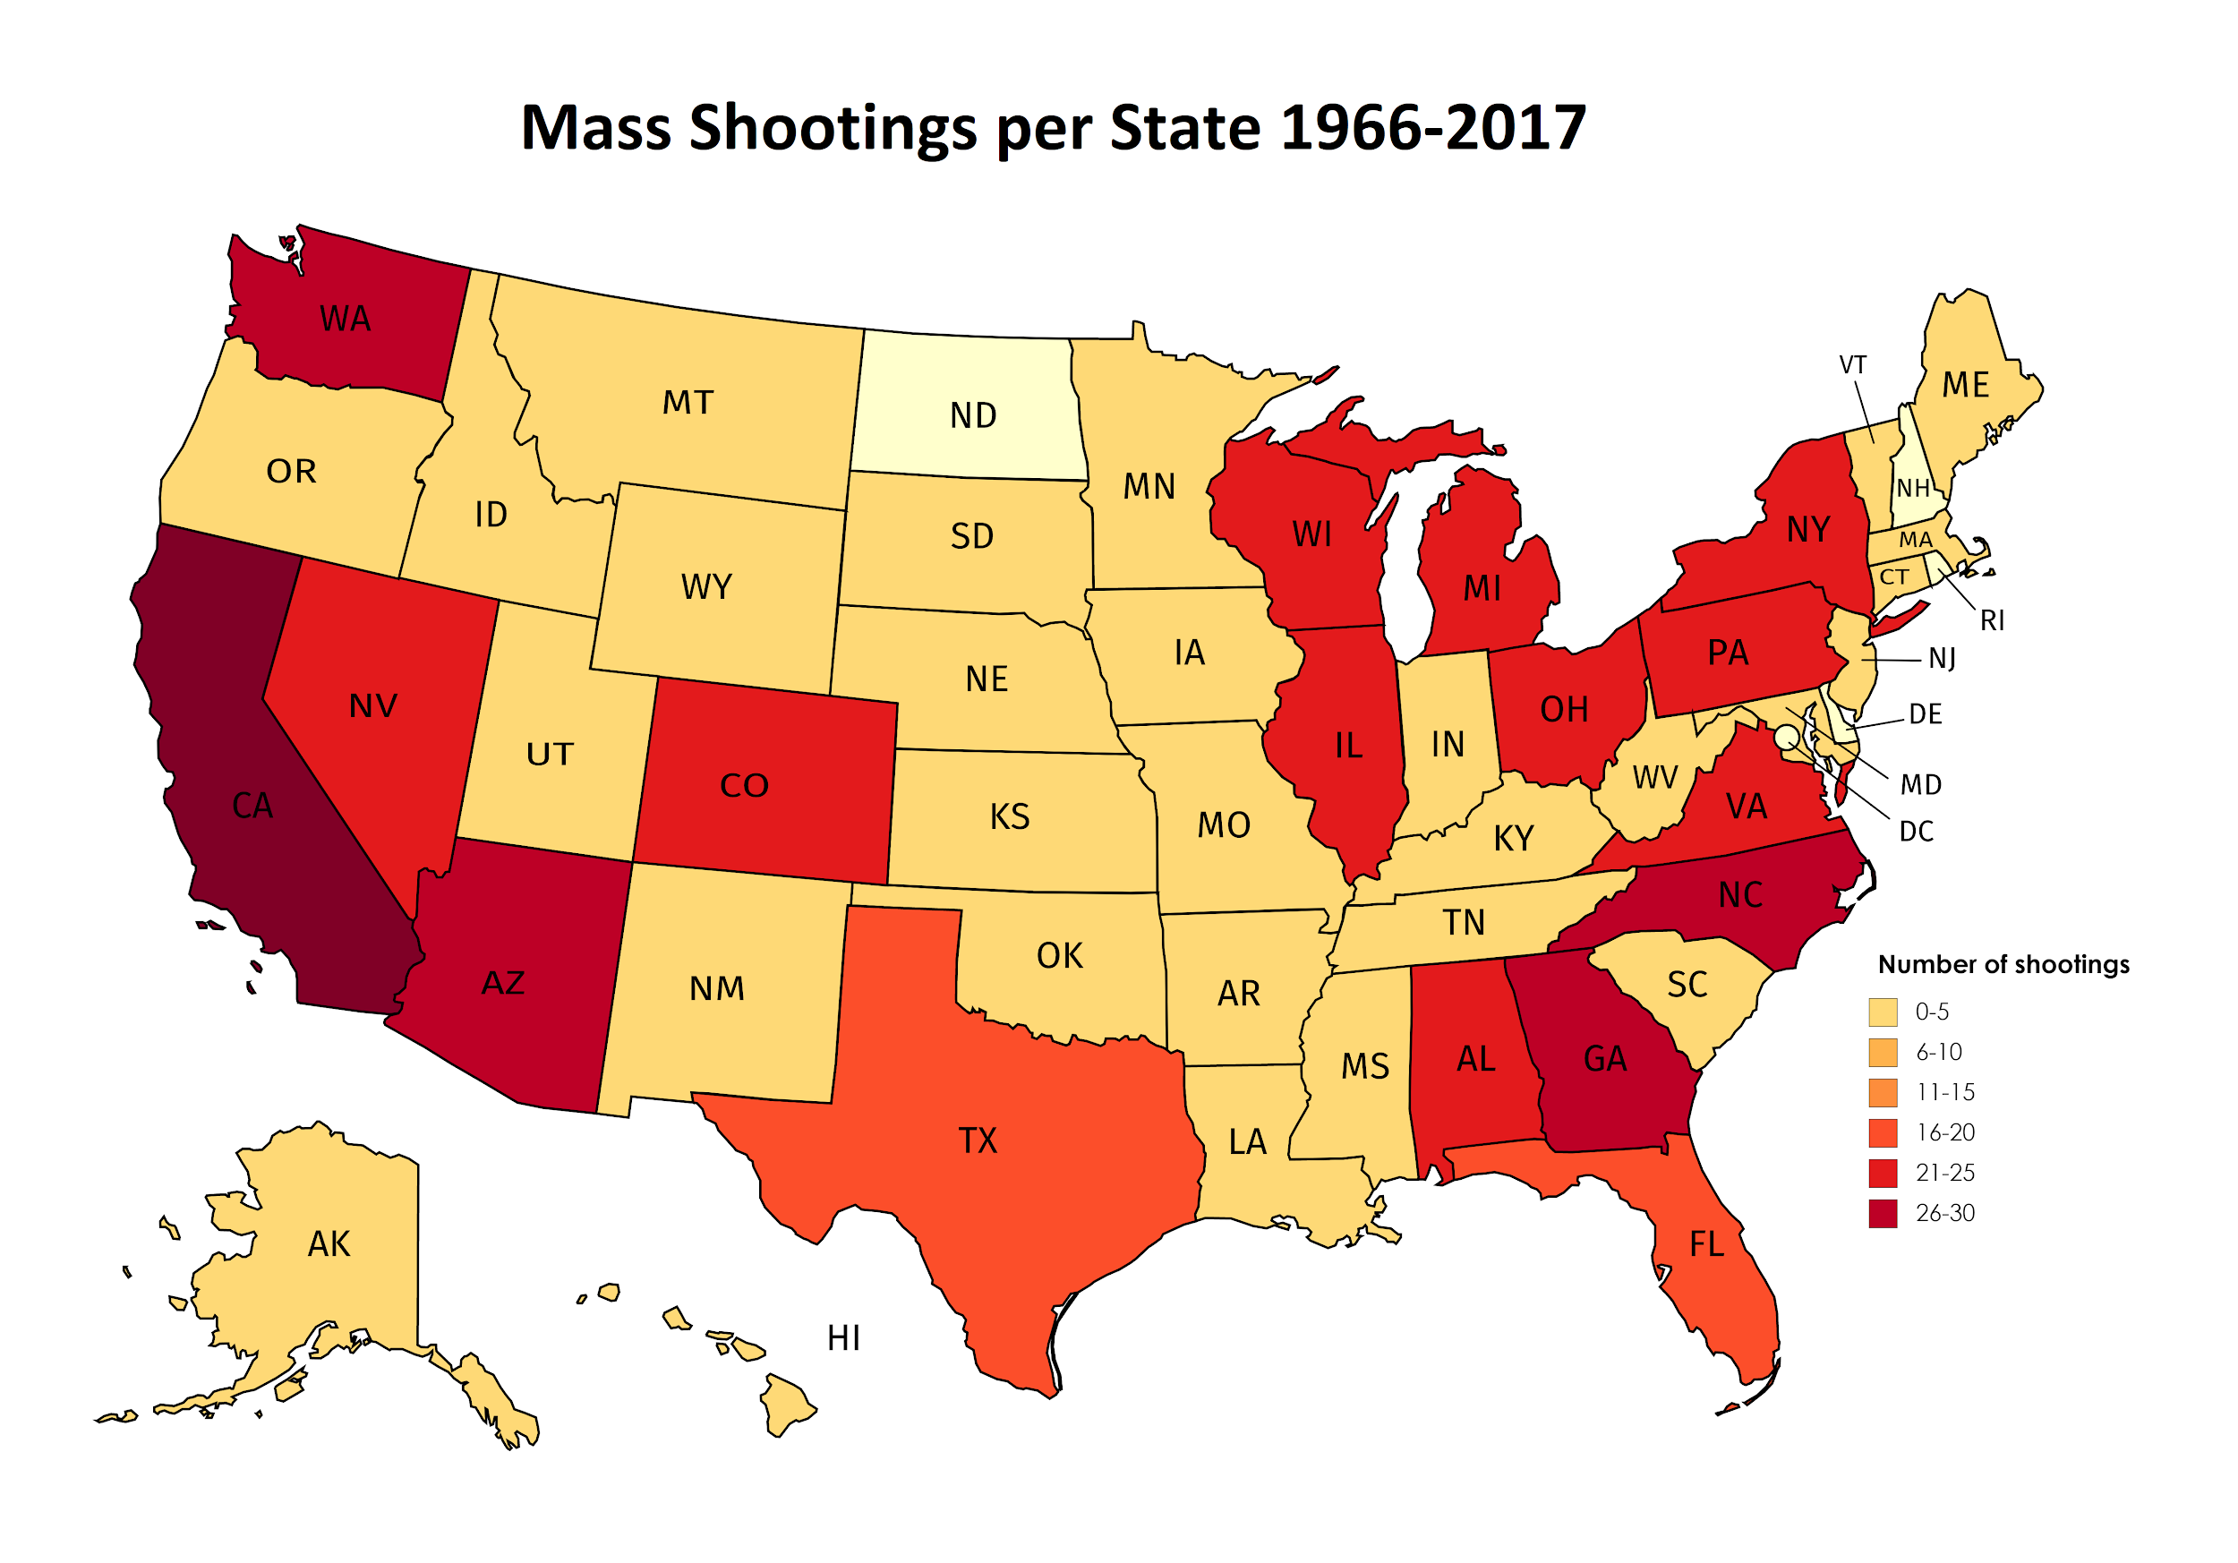

3. Illustrate the number of shootings per state from 1966-2017, but normalized for the population per state, to illustrate how population size influences the number of shootings. It shows how most states actually have a similar amount of mass shootings when looking at the population, except for Michigan.

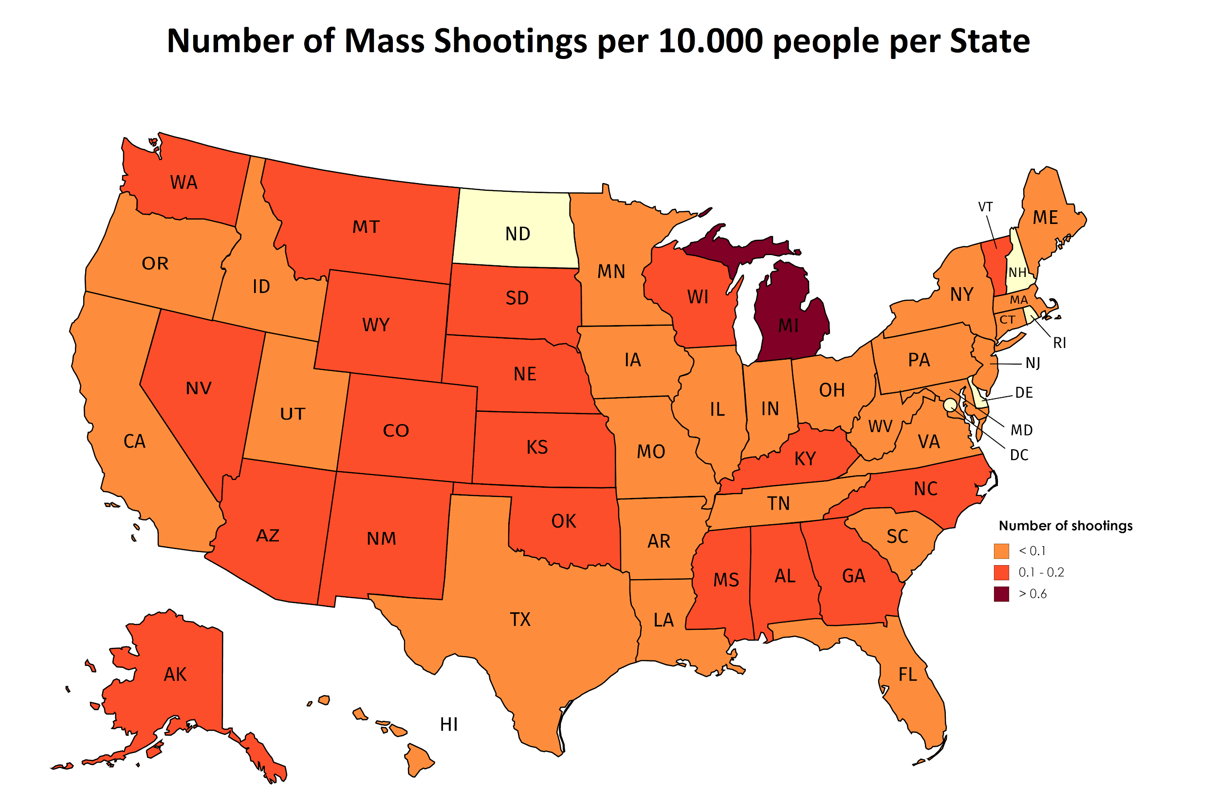

4. Scatter

Illustrate the number of victims in mass shootings per state from 1966-2017, and a brady state score that tells us how strict gun laws are per state. There seems to be a positive correlation: the stricter the gun laws, the more victims.

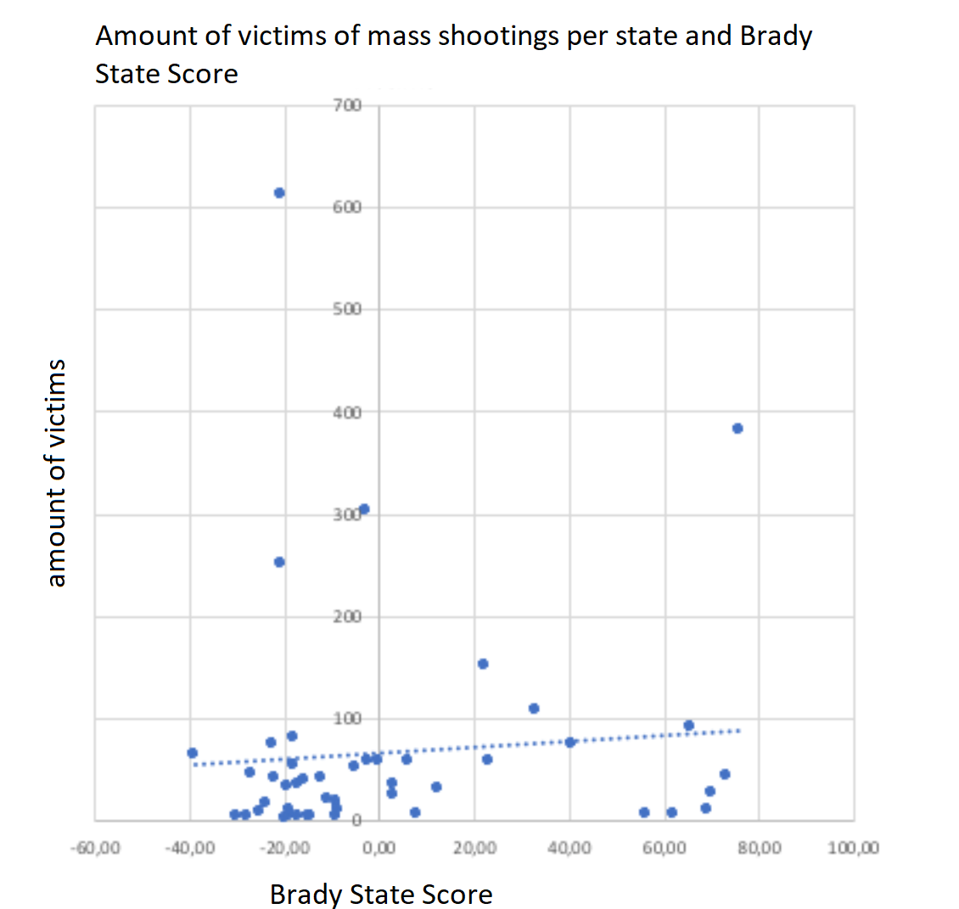

5. Scatterplot with population size → not ready yet.

**Datasets:**

“US Mass shootings”

<https://www.kaggle.com/zusmani/us-mass-shootings-last-50-years>

“Brady campaign score per state” (high score = loose gun laws, low score = strict gunlaws)

(<http://www.crimadvisor.com/data/Brady-State-Scorecard-2014.pdf>)