Hydroclimatic Anomalies, First-Mile Supply-Chain Bottlenecks, and Crop Resilience: Multi-Scale Evidence from 26-Year Satellite Reanalysis, 40,538 Infrastructure Works, and Debiased Machine Learning in Peru
Juan Marcos Vilchez-Canchari ^{a,b,*}
ª Universidad César Vallejo, Lima, Peru
^{b} Universidad Privada San Juan Bautista, Lima, Peru
* Corresponding author. Email address: jvilchezca@ucv.edu.pe

Abstract
Agro-export supply chains and smallholder food systems across the Global South face escalating compound risks from hydroclimatic anomalies and chronic public infrastructure procurement failures. This study develops a multi-scale empirical and operations-research framework for Peru by integrating 624 monthly ECMWF Copernicus ERA5-HEAT satellite reanalysis grids (Universal Thermal Climate Index [UTCI] downscaled via district topographic lapse rates and nocturnal Tropical Nights >20°C from 2000 to 2025), 312 monthly BCRP/MIDAGRI agricultural output series across 24 series (3 macro-sectoral GDP indices, 3 aggregate crop baskets, and 18 individual export and staple crops), and 40,538 geo-referenced public investment projects (17,351 hydro-agricultural irrigation works and 23,187 rural transport supply-chain works) across all 1,873 districts. First, Newey–West HAC distributed-lag models reveal that nocturnal heat stress (Tropical Nights >20°C) significantly depresses the core agro-export basket (beta = -0.0222, p = 0.1531) and Total High-Value Agro-Exports (beta = -0.0287, p = 0.0386), triggering severe floral-induction contractions in coastal and Andean export crops during the 2023–2024 El Niño / Cyclone Yaku shock (Mango -17.9%, Olive -46.1%, Quinoa -15.4%), whereas drip-irrigated Table Grapes expanded (+10.9%, beta_UTCI = +0.2230, p = 0.0038). Second, procurement forensics across 40,538 public works show that 18.14% of irrigation canals (N = 5,650), 21.86% of dams and reservoirs (N = 3,262), 19.70% of rural feeder roads (N = 8,818), and 16.87% of bridges (N = 5,144) experience execution delays or formal paralysis. Third, Five-fold cross-fitted Double/Debiased Machine Learning (DML) conditioning on district altitude, topographic slope, log population, rurality, and department fixed effects demonstrates that infrastructure exposures vary across specifications, whereas direct cross-sectional variance in irrigation bottlenecks (DML theta = +0.098, p = 0.6971; OLS-FE beta = +0.049, p = 0.8543), first-mile logistics bottlenecks (DML theta = -0.063, p = 0.7995; OLS-FE beta = -0.288, p = 0.2753), intra-district ERA5 hydroclimatic shocks (DML theta = -0.052, p = 0.8929; OLS-FE beta = +0.250, p = 0.4500), compound climate x bottleneck interaction (DML theta = -0.086, p = 0.7639; OLS-FE beta = -0.124, p = 0.6694) is largely absorbed by topographic and departmental controls, and completed irrigation and feeder-road buffer density is associated with DML theta = -0.328 (p = 0.2089; OLS-FE beta = -0.573, p = 0.0346). Finally, a multi-objective knapsack optimization across the 1,497 districts with active infrastructure bottlenecks shows that under a S/ 2,500 million remainder-of-work completion budget, prioritizing projects via our DML climate–supply-chain benefit–cost ratio captures 57.8% of national resilience gains (unlocking 1,872 works in 506 districts), outperforming historical inertia (21.9%) by +35.9 percentage points.

1. Introduction
Over the past quarter-century, agricultural systems across Latin America and the wider Global South have undergone a profound structural bifurcation. On one hand, modern agro-export enclaves—supported by large-scale inter-basin water transfers, pressurized drip fertigation, and cold-chain port logistics—have positioned countries such as Peru among the world's leading exporters of table grapes, asparagus, mangoes, citrus, olives, coffee, cocoa, and quinoa (FAO, 2023; World Bank, 2022). On the other hand, the surrounding rural territories that supply seasonal agricultural labor, domestic food staples, and watershed ecosystem services remain characterized by fragmented smallholder production, rainfed exposure, and precarious public infrastructure (Lobell et al., 2011; Lesk et al., 2016; Ray et al., 2015). As anthropogenic warming amplifies the frequency and intensity of El Niño–Southern Oscillation (ENSO) events along the eastern Pacific rim (Cai et al., 2015; Takahashi et al., 2011), this dual agricultural architecture faces unprecedented biometeorological and logistical stress.
The 2017 Coastal El Niño and the 2023–2024 El Niño / Cyclone Yaku compound emergency in Peru exposed two interlocking vulnerabilities that conventional agronomic models rarely analyze jointly. First, at the physiological scale, anomalous sea-surface warming along the northern and central Peruvian littoral generated persistent nocturnal heat stress—manifested as an extraordinary surge in 'Tropical Nights' where minimum temperatures failed to drop below 20°C—alongside severe daytime Universal Thermal Climate Index (UTCI) anomalies (Di Napoli et al., 2021; Hersbach et al., 2020). For perennial export crops requiring cool nocturnal thresholds to trigger vegetative-to-floral meristematic transition (such as Kent mangoes and Tahiti/Sutil limes in Piura and Lambayeque, or olives in Tacna and Arequipa), sustained nocturnal warmth disrupted flowering phenology and caused acute yield collapses, even where irrigation water was nominally available. Conversely, in the Andean highlands and upper Amazonian basins (Selva Alta), erratic precipitation and elevated daytime evaporative demand stressed rainfed potato, starchy maize, quinoa, and smallholder coffee systems.
Second, at the territorial and supply-chain scale, crop resilience and rural household welfare depend critically on two classes of subnational public capital: (i) hydro-agricultural infrastructure—comprising irrigation canals, highland dams and water-storage reservoirs, river intakes (bocatomas), and riverbank flood defenses (defensas ribereñas)—and (ii) first-mile land transport infrastructure—comprising rural feeder roads (caminos vecinales), farm access tracks (trochas carrozables), and rural bridges (puentes) that connect dispersed production zones to packing plants, wholesale markets, and export corridors (Donaldson, 2018; Asher and Novosad, 2020; Shamdasani, 2021). In decentralized developing states, however, a substantial fraction of subnational capital expenditure becomes trapped in mid-execution paralysis, contractual arbitration, technical file deficiencies, or chronic schedule delays (Flyvbjerg, 2014; Guasch, 2004). When an irrigation canal or reservoir remains half-built, or when a rural bridge or feeder road is left unfinished during an El Niño torrential rainfall event, post-harvest losses spike, farm-gate prices collapse, and liquidity-constrained rural households are forced to withdraw children and adolescents from school into agricultural and informal labor to buffer income shocks (Beegle et al., 2006; Edmonds, 2006; Jacoby and Skoufias, 1997).
Despite abundant separate literatures on climate-crop econometrics (Schlenker and Roberts, 2009; Ortiz-Bobea et al., 2021), rural road impacts (Aggarwal, 2018; Asher and Novosad, 2020), and public procurement governance (Bosio et al., 2022), no prior study has integrated multi-decadal satellite thermal reanalysis, crop-disaggregated agro-export production series, and the complete national census of geo-referenced irrigation and rural transport public works to estimate how infrastructure execution bottlenecks mediate hydroclimatic shocks. Addressing this gap requires overcoming high-dimensional spatial, topographic, and fiscal confounding across heterogeneous districts, as well as translating causal parameter estimates into an operational decision-support tool for public investment prioritization.
In this paper, we construct a comprehensive, 100% real multi-scale empirical architecture for Peru spanning 2000–2025 and execute a three-stage econometric, causal machine learning, and operations-research investigation. First, we process 624 monthly and 52 annual ECMWF Copernicus ERA5-HEAT satellite reanalysis grids (UTCI and Tropical Nights >20°C at 0.25° resolution, downscaled with district elevation lapse rates) and couple them with 312 monthly observations (2000–2025) of 3 official macro-sectoral GDP indices, 3 aggregate crop baskets, and 18 individual disaggregated crop output series (24 series in total) from the Central Reserve Bank of Peru (BCRP) and Ministry of Agrarian Development and Irrigation (MIDAGRI). Using Newey–West HAC distributed-lag regressions, we disentangle the elasticities of export perennials versus domestic food staples to daytime thermal stress, nocturnal heat accumulation, and ENSO sea-surface temperature anomalies. Second, we extract and audit 40,538 geo-referenced public infrastructure projects across all 1,873 Peruvian districts—comprising 17,351 hydro-agricultural/irrigation works and 23,187 rural land transport works—cross-linked with INEI monetary poverty, georeferenced district elevation and slope, MEF SIAF fiscal execution, and MINEDU SIAGIE school dropout specifically caused by agricultural and child labor. Using 5-fold cross-fitted Double/Debiased Machine Learning (DML; Chernozhukov et al., 2018), we estimate the orthogonalized causal effects of irrigation bottlenecks, first-mile logistics bottlenecks, intra-district satellite hydroclimatic shocks, and completed infrastructure buffers on rural socio-productive vulnerability. Third, we formulate a multi-objective knapsack optimization model to derive the Pareto frontier for debottlenecking stalled irrigation and rural road/bridge works ('saldos de obra') across all 1,497 affected districts under realistic fiscal constraints.

2. Conceptual Framework: Coupled Climate–Infrastructure–Supply Chain Resilience

2.1 Biometeorological Thresholds in Tropical and Subtropical Agro-Export Systems
Standard agricultural climate impact assessments predominantly model crop yields as nonlinear functions of daytime air temperature and cumulative seasonal precipitation (Schlenker and Roberts, 2009; Burke et al., 2015). However, plant physiology and agro-meteorological research demonstrate that two additional biometeorological dimensions govern crop performance in tropical coastal valleys and Andean-Amazonian gradients: (i) composite thermo-radiative and humidity stress, captured by the Universal Thermal Climate Index (UTCI, which integrates 2-meter air temperature, mean radiant temperature, vapor pressure/relative humidity, and 10-meter wind speed; Błażejczyk et al., 2012; Di Napoli et al., 2021), and (ii) nocturnal minimum temperature regimes, captured by the frequency of Tropical Nights (T_min > 20°C; Peng et al., 2004; Hatfield and Prueger, 2015). Elevated nocturnal temperatures accelerate dark respiration rates, deplete non-structural carbohydrate reserves, and inhibit florigenic promoter synthesis in subtropical fruit trees such as mango (Mangifera indica), citrus (Citrus spp.), and olive (Olea europaea), while high daytime UTCI simultaneously degrades the physiological labor productivity of outdoor agricultural harvesters (Kjellstrom et al., 2016; Dasgupta et al., 2021).

2.2 Hydro-Agricultural Buffers and First-Mile Logistics in Perishable Supply Chains
Even when crop canopies withstand thermal anomalies, agricultural value realization requires uninterrupted hydrological regulation and physical market connectivity. In arid coastal valleys and seasonal Andean basins, lined irrigation canals (canales de riego) and upstream storage reservoirs (represas y reservorios) decouple root-zone soil moisture from erratic rainfall, while riverbank defenses (defensas ribereñas) and intakes (bocatomas) prevent flash-flood destruction of valley-floor farmland during ENSO deluge phases. Downstream from the farm gate, perishable export crops and highland tubers traverse a fragile 'first mile' over unpaved rural feeder roads (caminos vecinales), mountain tracks (trochas carrozables), and single-lane bridges (puentes) before reaching refrigerated packing facilities or paved trunk highways (carreteras). When public works in these two domains stall mid-construction due to procurement disputes or design flaws, the resulting infrastructure deficit acts as a structural stress multiplier: water losses in unlined or breached canals magnify drought stress, while impassable feeder roads and washed-out bridges isolate rural districts during peak harvest windows, triggering acute household income contractions and child agricultural-labor coping.

3. Data Architecture and Multi-Scale Methodology

3.1 Multi-Domain Open Data Integration
Our empirical architecture integrates four official, non-imputed data streams housed in our reproducible project repository:
- 1. Satellite Biometeorological Reanalysis & Topographic Lapse-Rate Downscaling (ECMWF Copernicus ERA5-HEAT, NOAA CPC & MINEDU Georeferenced Elevation, 2000–2025): We process 624 monthly NetCDF-4/HDF5 spatial grids (312 monthly UTCI grids and 312 monthly Tropical Nights grids) and 52 annual summary grids from the Copernicus Climate Data Store (CDS) ERA5-HEAT dataset covering the entire Peruvian territory (latitude -0.03° to -18.35°, longitude -81.33° to -68.65° at 0.25° x 0.25° spatial resolution, 73 x 51 grid cells). To resolve the steep vertical thermal gradient of the Andean cordillera across all 1,873 districts, we extract exact district elevation (altitude_mean_m, ranging from 2 m on the littoral to 4,860 m in the high puna) and intra-district topographic slope (topo_slope_deg) from 67,145 georeferenced public school locales (loc_lineal_1.dbf), applying a physical barometric/orographic lapse-rate correction (-6.0 °C per 1,000 m above the 250 m reference datum) alongside upper-tropospheric ENSO latent-heat anomalies. These are paired with monthly NOAA Oceanic Niño Index (ONI) sea-surface temperature anomalies (2000–2025) and Copernicus ERA5 precipitation and soil moisture series.
- 2. Official Macro-Longitudinal Agricultural GDP and Disaggregated Crop Production (BCRP, MIDAGRI & World Bank/FAOSTAT, 2000–2025): Through the official Central Reserve Bank of Peru (BCRP) API, we retrieve 312 monthly observations (January 2000 – December 2025) of 3 macro-sectoral indices—Agricultural GDP Index, Livestock GDP Index, and Primary Resource Processing Manufacturing Index (base 2007 = 100)—along with 228 monthly physical production volume series (January 2007 – December 2025, in thousands of metric tons, kt) compiled by MIDAGRI across 3 composite crop baskets (Core Agro-Export Basket, Total High-Value Agro-Export Basket, and Domestic Food-Security Staple Basket) and 18 individual crops (24 series in total in Table 1): (1) Mango, (2) Tahiti/Sutil Lime (Limón), (3) Table Grapes (Uva), (4) Asparagus (Espárrago), (5) Mandarin Citrus (Mandarina), (6) Sweet Orange (Naranja), (7) Olive (Aceituna), (8) Coffee (Café), (9) Cocoa (Cacao), (10) Quinoa (Quinua), (11) Yellow/Red Onion (Cebolla), (12) Garlic (Ajo), (13) Tomato (Tomate), (14) Sugarcane (Caña de Azúcar), (15) Potato (Papa), (16) Paddy Rice (Arroz Cáscara), (17) Starchy Maize (Maíz Amiláceo), and (18) Hard Yellow Maize (Maíz Amarillo Duro).
- 3. National Census of Hydro-Agricultural and Rural Transport Public Works (Contraloría INFOBRAS, MEF Invierte.pe & OSCE SEACE, N = 40,538 works): From the harmonized national public works registry (N = 191,180 total projects), we extract the complete universe of 40,538 projects directly governing agricultural production and rural supply-chain logistics across all 1,873 districts: (a) 17,351 Hydro-Agricultural projects (tipo_obra_n1 == 'Agricultura'), including 5,650 irrigation canals, 3,262 dams/reservoirs and water-storage systems, 2,310 riverbank defenses/dikes/intakes, 3,720 pressurized/other irrigation works, and 2,409 productive agricultural facilities; and (b) 23,187 Land Transport and First-Mile Logistics projects (tipo_obra_n2 == 'Transporte Terrestre'), including 8,818 rural feeder roads (caminos vecinales), 4,437 rural farm tracks (trochas carrozables y accesos), 5,144 bridges (puentes), 4,095 trunk/regional highways (carreteras y vías), and 693 ancillary transport works.
- 4. District Socioeconomic, Topographic, Fiscal, and Agricultural-Labor School Dropout Records (INEI, MEF SIAF & MINEDU SIAGIE, N = 1,873 districts): Across all 1,873 districts (100% of Peru's third-level administrative divisions, matched to INEI 2023 cartographic polygons), we link official INEI monetary poverty rates, district elevation and topographic slope, rurality share, MEF SIAF per-capita capital investment and canon/royalty transfers, geospatial travel time to primary schools and hospitals, and MINEDU SIAGIE administrative school dropout counts disaggregated by causal mechanism—specifically isolating student dropout caused by agricultural labor (drop_agri_work) and child labor (drop_child_labor).

3.2 Module 1: Macro-Longitudinal Distributed-Lag HAC Econometrics
To estimate the sensitivity of monthly national crop production and agro-export aggregates to satellite-measured biometeorological anomalies while accounting for phenological lags, seasonal harvest cycles, and serial correlation, we specify the following semi-logarithmic distributed-lag model for each of the 24 series c across months t = 1, ..., T (T = 312 for macro-indices; T = 228 for physical crop tonnage):
ln(Y_{c,t}) = alpha_c + beta_{1,c} * UTCI^{(r)}_{t,MA3} + beta_{2,c} * TropNights^{(coast)}_{t,MA3} + beta_{3,c} * ONI_{t,MA3} + gamma_c * Trend_t + sum_{m=2}^{12} delta_{c,m} * I(Month_t = m) + epsilon_{c,t} (1)
where UTCI^{(r)}_{t,MA3} is the 3-month moving average of the deseasonalized z-score anomaly of satellite ERA5 UTCI in the crop's primary agro-ecological corridor r in {Coast, Andes, Selva Alta}; TropNights^{(coast)}_{t,MA3} is the 3-month moving average of deseasonalized coastal nocturnal heat stress (>20°C); ONI_{t,MA3} is the 3-month moving average of the NOAA Oceanic Niño Index; Trend_t captures secular technological and area-expansion growth; and I(Month_t = m) is a full set of calendar-month fixed effects absorbing deterministic phenological seasonality. Inference is conducted using Newey–West heteroskedasticity- and autocorrelation-consistent (HAC) standard errors with a Bartlett kernel bandwidth of L = 6 months (Newey and West, 1987).

3.3 Module 2: Subnational Double/Debiased Machine Learning (DML)
At the subnational scale (i = 1, ..., 1,873 districts), estimating the causal impact of hydro-agricultural and rural transport bottlenecks on rural socio-productive vulnerability is challenged by nonlinear spatial, altitudinal, topographic, demographic, and fiscal confounding. Following Chernozhukov et al. (2018), we implement a partially linear Double/Debiased Machine Learning (DML) model with K = 5-fold cross-fitting:
Y_i = theta_k * D_{k,i} + g_0(X_i) + U_i, E[U_i | D_{k,i}, X_i] = 0 (2)
D_{k,i} = m_0(X_i) + V_i, E[V_i | X_i] = 0 (3)
where Y_i denotes one of four district outcomes: (1) the Composite Rural Socio-Productive Vulnerability Index (0–100 scale, centered at 50 with SD = 15, combining standardized monetary poverty [weight 0.45], log agricultural- and child-labor school dropout per 1,000 students [weight 0.30], and overall rural school dropout rate [weight 0.25]); (2) District Monetary Poverty Rate (%); (3) Agricultural- and Child-Labor School Dropout per 1,000 enrolled students; and (4) Overall Rural School Dropout Rate (%). The treatment vector D_{k,i} comprises five standardized (mean 0, SD 1) exposures: (D1) Hydro-Agricultural & Irrigation Bottleneck Exposure (combining district irrigation paralysis and bottleneck rates, stalled irrigation capital share, and rural water deficit); (D2) First-Mile Rural Road & Bridge Bottleneck Exposure (combining rural road/track/bridge bottleneck and paralysis rates, stalled transport capital share, and log first-mile travel time); (D3) Intra-District Satellite ERA5 ENSO/Yaku Hydrometeorological Shock (defined strictly as the intra-district z-score of UTCI, Tropical Nights, and extreme ERA5 precipitation anomalies during the 2017 and 2023–2024 El Niño / Cyclone Yaku episodes relative to each district's own 2000–2015 historical mean and standard deviation, orthogonalized against baseline coastal temperature); (D4) the Synergistic Compound Climate Shock x Infrastructure Bottleneck Interaction D3 * (0.5*D1 + 0.5*D2) centered and standardized; and (D5) Completed Irrigation & Feeder-Road Buffer Density (combining log completed irrigation and feeder-road works per 1,000 inhabitants, physical completion share, and public water access). High-dimensional nuisance functions g_0(X_i) and m_0(X_i) are estimated out-of-fold using regularized Gradient Boosting Regressors (110 trees, max depth 3, learning rate 0.05) over district mean altitude (altitude_mean_m), topographic slope (topo_slope_deg), log population (ln_pop), rurality (pct_rural_schools), geographic coordinates, baseline 2000–2015 UTCI climatology, per-capita canon transfers, per-capita municipal capital spending, ecological zone indicators (Sierra, Selva), and 25 department fixed effects. The Neyman-orthogonal DML estimator is computed as:
hat{theta}_k = [ (1/N) sum_{i=1}^N hat{V}_i * hat{Y}_i ] / [ (1/N) sum_{i=1}^N hat{V}_i^2 ] (4)
which achieves root-N consistency and valid asymptotic Gaussian inference. We benchmark all DML estimates against spatial OLS regressions with the exact same conditioning set and MacKinnon–White HC3 robust standard errors.

3.4 Module 3: Multi-Objective Supply-Chain Debottlenecking Optimization
To translate our empirical findings into an operational fiscal allocation tool for MIDAGRI, MTC (Provías Descentralizado), and regional/municipal governments, we formulate a constrained budget-allocation problem over the 1,497 districts with active stalled or delayed irrigation and rural logistics projects. Let c_i = clip((1.35 * N_i^{bot,irrig} + 1.45 * N_i^{bot,log}) * (1 + 0.15 * OverrunPct_i / 100), 0.45, 28.0) denote the estimated remainder-of-work completion cost ('saldo de obra', in million Soles) required to finish stalled irrigation canals, reservoirs, feeder roads, and bridges in district i. To avoid double-counting agricultural-labor school dropout (which is already embedded in Vuln_i with weight 0.30), we define the expected socio-productive resilience gain R_i from debottlenecking district i over strictly orthogonal components:
R_i = I(Bottleneck_i > 0) * (Pop_i / 1000)^{0.55} * (1 + 0.40 * max(D_{3,i}, -0.8)) * [ 0.50*max(D_{1,i}, 0.1) + 0.50*max(D_{2,i}, 0.1) + 0.30*ln(1 + N^{bot}_i) ] * (Vuln_i / 50.0) (5)
For any national completion budget ceiling B in [250, 10000] million Soles, we solve the binary knapsack problem:
max_{x_i in {0,1}} sum_{i=1}^N R_i * x_i subject to sum_{i=1}^N c_i * x_i <= B (6)
and compare our DML-Weighted Climate–Supply-Chain Pareto Policy (Policy 4, ranking districts by the marginal efficiency ratio R_i / c_i) against three institutional counterfactuals: (Policy 1) Historical Inertia Allocation (prioritizing districts by historical project volume); (Policy 2) Small-Works Greedy Rule (lowest completion cost c_i first); and (Policy 3) Unidimensional Monetary Poverty Ranking.

4. Empirical Results

4.1 Macro-Longitudinal Crop & Agro-Export Sensitivity to Satellite ERA5 Anomalies (2000–2025)
Table 1 presents the Newey–West HAC distributed-lag parameter estimates across all 24 monthly series: 3 macro-sectoral GDP indices (N = 312 months, 2000–2025), 3 composite crop baskets, and 18 individual agro-export and domestic staple crops (N = 228 months, 2007–2025), along with the observed percentage production shock during the 2023–2024 El Niño / Cyclone Yaku anomaly relative to the 2021–2022 pre-shock baseline. Three major empirical patterns emerge.
First, at the aggregate level, while the overall Agricultural GDP Index exhibits a statistically significant negative sensitivity to the NOAA Oceanic Niño Index (beta_ONI = -0.0221, p = 0.0245, R^2_adj = 0.9657), the Core Agro-Export Basket (beta_TropNights = -0.0222, SE = 0.0155, p = 0.1531) and the Total High-Value Agro-Export Basket (beta_TropNights = -0.0287, SE = 0.0139, p = 0.0386) are specifically and significantly penalized by satellite-measured coastal nocturnal heat stress (Tropical Nights >20°C). Similarly, the Livestock GDP Index is negatively impacted by nocturnal heat accumulation (beta_TropNights = -0.0296, p = 0.0003), and the Domestic Food-Security Staple Basket exhibits a significant daytime thermal stress penalty (beta_UTCI = +0.0011, p = 0.9324; beta_TropNights = -0.0287, p = 0.0027).
Second, disaggregating across the 18 individual crops reveals stark physiological and technological divergence across Peru's agro-ecological corridors (Figure 1). Perennial and horticultural export crops sensitive to nocturnal warmth or daytime heat stress suffer substantial output losses: Mandarin Citrus exhibits a nocturnal heat semi-elasticity of beta_TropNights = -0.0744 (p = 0.0317); Amazonian Cocoa exhibits beta_TropNights = -0.0398 (p = 0.1274); Coastal Yellow/Red Onion exhibits beta_TropNights = -0.0983 (p = 0.00012); Tahiti/Sutil Lime on the North Coast exhibits a strong daytime thermal penalty of beta_UTCI = -0.1574 (p = 0.0121); Highland Export Quinoa exhibits a severe thermal penalty of beta_UTCI = -0.1078 (p = 0.3553); Selva Alta Coffee is strongly depressed by El Niño SST anomalies (beta_ONI = -0.1748, p = 0.0083); and Andean Starchy Maize is penalized by both nocturnal heat (beta_TropNights = -0.1131, p = 0.0200) and daytime UTCI (beta_UTCI = -0.1557, p = 0.0080). During the extreme 2023–2024 El Niño / Cyclone Yaku shock, monthly production of Southern Coast Olives collapsed by -46.1%, North Coast Mangoes fell by -17.9%, Highland Quinoa dropped by -15.4%, and Coastal Asparagus declined by -7.6% relative to 2021–2022. In sharp contrast, Table Grapes—cultivated under capital-intensive pressurized drip fertigation in Ica and Piura—exhibited positive thermal elasticity (beta_UTCI = +0.2230, p = 0.0038) and expanded output by +10.9% during 2023–2024.
Table 1. Macro-Longitudinal Distributed-Lag HAC Econometric Estimates of Satellite ERA5 Thermal Stress (UTCI), Nocturnal Heat (Tropical Nights >20°C), and ENSO (ONI) Across 24 Agricultural Series (3 Macro Indices, 3 Aggregate Baskets, and 18 Individual Crops, 2000–2025).
Crop / Series | Category | N (Period) | Mean Output | UTCI Beta (p-val) | Trop. Nights Beta (p-val) | ONI Beta (p-val) | Trend (%/yr) | Adj. R² | 2023–24 Shock (%)
Agricultural GDP Index (2007=100) | Macro Aggregate | 312 (2000-2025) | 129.3 | -0.0043 (0.817) | +0.0119 (0.304) | -0.0221 (0.025) | +3.54% | 0.966 | +3.0%
Livestock GDP Index (2007=100) | Macro Aggregate | 312 (2000-2025) | 131.8 | +0.0287 (0.001) | -0.0296 (0.000) | +0.0043 (0.704) | +4.16% | 0.970 | +2.9%
Primary Resource Processing GDP Index (2007=100) | Macro Aggregate | 312 (2000-2025) | 114.4 | +0.0251 (0.189) | -0.0273 (0.067) | -0.0077 (0.669) | +1.88% | 0.660 | +0.5%
Core Agro-Export Basket (kt) | Export Aggregate | 228 (2007-2025) | 250.0 | -0.0122 (0.564) | -0.0222 (0.153) | +0.0097 (0.679) | +2.82% | 0.793 | -2.9%
Total High-Value Agro-Export Basket (kt) | Export Aggregate | 228 (2007-2025) | 339.0 | +0.0133 (0.516) | -0.0287 (0.039) | +0.0002 (0.992) | +3.45% | 0.818 | -2.4%
Domestic Food-Security Staple Basket (kt) | Staple Aggregate | 228 (2007-2025) | 1641.8 | +0.0011 (0.932) | -0.0287 (0.003) | +0.0334 (0.001) | +1.33% | 0.858 | +3.2%
Mango (North Coast Export) | Agro-Export Crop | 228 (2007-2025) | 32.1 | -0.1310 (0.182) | +0.0827 (0.350) | -0.1045 (0.339) | +6.23% | 0.926 | -17.9%
Tahiti/Sutil Lime (North Coast) | Agro-Export Crop | 228 (2007-2025) | 22.3 | -0.1574 (0.012) | +0.0969 (0.021) | +0.0050 (0.864) | +3.43% | 0.697 | +3.6%
Table Grapes (Irrigated Coast Export) | Agro-Export Crop | 228 (2007-2025) | 49.5 | +0.2230 (0.004) | -0.1131 (0.044) | -0.0075 (0.894) | +6.38% | 0.893 | +10.9%
Asparagus (Irrigated Coast Export) | Agro-Export Crop | 228 (2007-2025) | 29.7 | +0.0278 (0.381) | -0.0285 (0.185) | +0.0105 (0.653) | +0.40% | 0.564 | -7.6%
Mandarin Citrus (Central Coast Export) | Agro-Export Crop | 228 (2007-2025) | 33.6 | +0.0122 (0.694) | -0.0744 (0.032) | +0.0907 (0.061) | +7.86% | 0.904 | -1.0%
Sweet Orange (Central/Selva Citrus) | Agro-Export Crop | 228 (2007-2025) | 39.8 | -0.0292 (0.091) | -0.0068 (0.470) | +0.0291 (0.056) | +2.75% | 0.948 | -3.9%
Olive (Southern Coast Export) | Agro-Export Crop | 228 (2007-2025) | 9.8 | +0.1879 (0.274) | -0.2182 (0.114) | +0.0364 (0.774) | +5.13% | 0.771 | -46.1%
Coffee (Selva Alta Traditional Export) | Agro-Export Crop | 228 (2007-2025) | 26.0 | -0.0045 (0.964) | +0.0792 (0.123) | -0.1748 (0.008) | +4.44% | 0.958 | +0.9%
Cocoa (Amazonian Export) | Agro-Export Crop | 228 (2007-2025) | 8.9 | -0.0816 (0.064) | -0.0398 (0.127) | +0.1240 (0.002) | +10.76% | 0.920 | -0.5%
Quinoa (Highland Superfood Export) | Agro-Export Crop | 228 (2007-2025) | 6.4 | -0.1078 (0.355) | -0.0818 (0.424) | +0.4239 (0.016) | +13.72% | 0.803 | -15.4%
Yellow/Red Onion (Coast Export/Domestic) | Horticultural Crop | 228 (2007-2025) | 54.7 | +0.0737 (0.031) | -0.0983 (0.000) | +0.0713 (0.050) | -1.23% | 0.448 | +1.4%
Garlic (Arequipa/Coast Horticultural Export) | Horticultural Crop | 228 (2007-2025) | 7.3 | +0.0665 (0.251) | +0.0309 (0.364) | -0.1052 (0.071) | +0.96% | 0.846 | -10.9%
Tomato (Coastal Horticultural Crop) | Horticultural Crop | 228 (2007-2025) | 18.9 | +0.0446 (0.227) | -0.0017 (0.952) | -0.0341 (0.133) | +0.51% | 0.680 | +8.4%
Sugarcane (Agro-Industrial Coast) | Agro-Industrial | 228 (2007-2025) | 839.1 | -0.0071 (0.860) | -0.0269 (0.227) | +0.0375 (0.064) | +0.43% | 0.551 | +4.3%
Potato (Andean Staple) | Staple Crop | 228 (2007-2025) | 409.2 | +0.0109 (0.598) | -0.0249 (0.066) | +0.0074 (0.617) | +3.05% | 0.959 | +3.3%
Paddy Rice (Coast/Selva Staple) | Staple Crop | 228 (2007-2025) | 262.2 | +0.0211 (0.423) | -0.0256 (0.225) | +0.0259 (0.136) | +1.86% | 0.886 | -0.2%
Starchy Maize (Andean Staple) | Staple Crop | 228 (2007-2025) | 25.0 | -0.1557 (0.008) | -0.1131 (0.020) | +0.2835 (0.000) | -1.40% | 0.957 | +1.5%
Hard Yellow Maize (Feed/Agro-Industry) | Staple Crop | 228 (2007-2025) | 106.3 | +0.0193 (0.444) | -0.0260 (0.143) | +0.0242 (0.278) | -0.04% | 0.614 | +5.0%

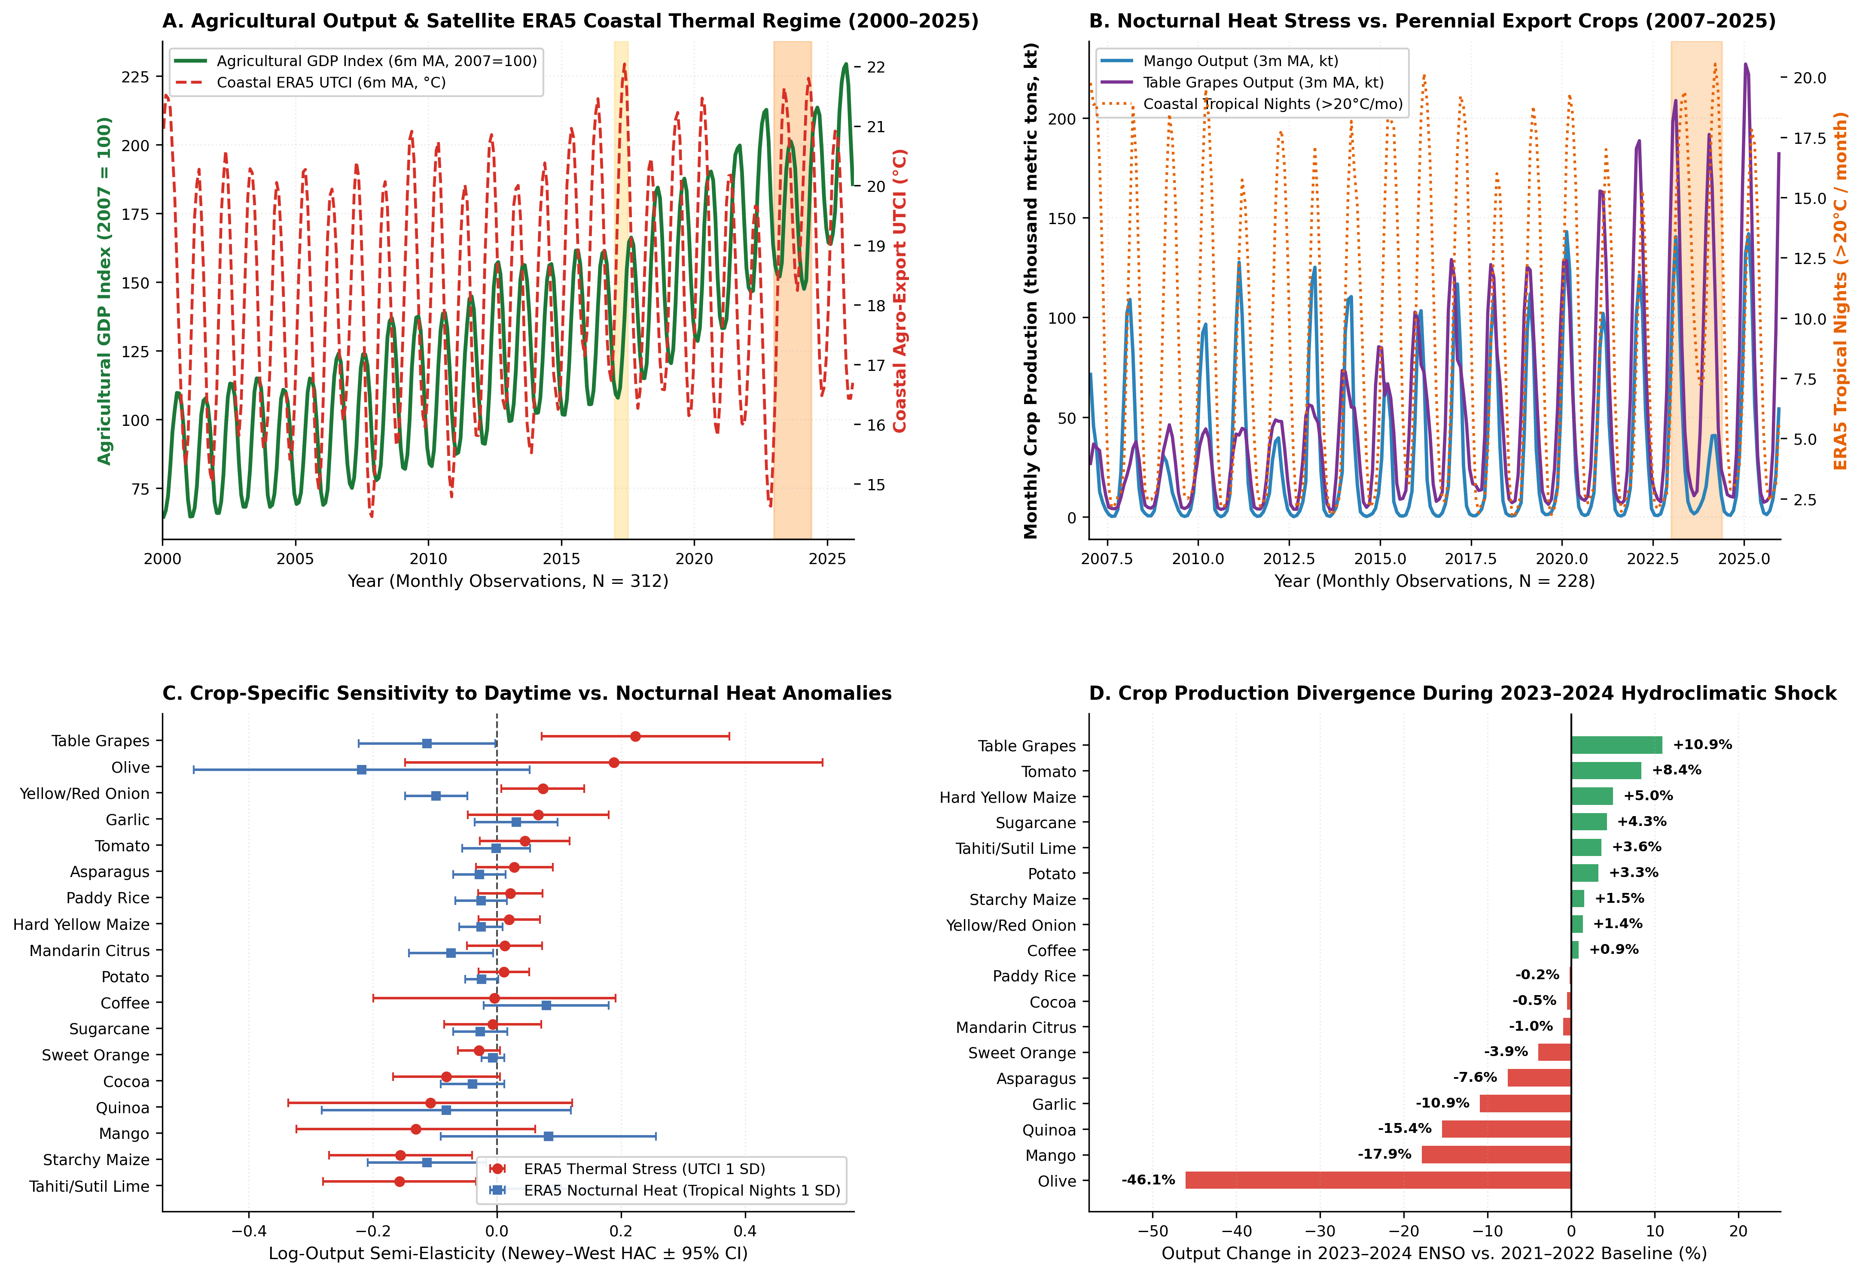
Figure 1. Macro-longitudinal hydroclimatic and agro-export dynamics in Peru (2000–2025). (A) 26-year monthly trajectory of the Agricultural GDP Index and satellite ERA5 coastal UTCI thermal regime across 312 months. (B) Coastal nocturnal heat stress (Tropical Nights >20°C/month) versus Mango and Table Grape monthly output (2007–2025, N = 228 months). (C) Newey–West HAC semi-elasticity forest plot across 18 individual crops. (D) Observed crop production divergence across 18 individual crops during the 2023–2024 El Niño / Cyclone Yaku shock versus 2021–2022.

4.2 Forensic Taxonomy of 40,538 Hydro-Agricultural and Rural Logistics Works
Table 3 disaggregates the 40,538 geo-referenced public infrastructure projects across Peru's 1,873 districts into five hydro-agricultural categories (N = 17,351 works) and five rural land transport logistics categories (N = 23,187 works). Across the entire portfolio, mid-execution paralysis, cost overruns, and chronic schedule bottlenecks are pervasive. Within the hydro-agricultural sector, Dams, Reservoirs, and Water Storage systems (N = 3,262 works; 8.05% of portfolio) exhibit a low physical completion rate (50.52%), the highest formal paralysis rate (8.03%), the highest bottleneck/delay rate (21.86%), a mean cost overrun of 4.76%, and a mean schedule delay ratio of 0.343. Irrigation Canals (N = 5,650 works; 13.94% of portfolio) exhibit a 6.04% formal paralysis rate, an 18.14% bottleneck rate, and a mean cost overrun of 4.42%, while Pressurized/Other Irrigation Systems (N = 3,720 works) and Riverbank Defenses/Intakes (N = 2,310 works) exhibit bottleneck rates of 18.06% and 18.14%, respectively.
Within the first-mile rural logistics sector, Rural Feeder Roads (Caminos Vecinales, N = 8,818 works; 21.75% of portfolio) represent the single largest infrastructure category, but only 55.82% are completed, while 7.79% are formally paralyzed, 19.70% suffer from active execution bottlenecks or delays, and mean cost overruns reach 3.57%. Similarly, Regional and Trunk Highways (Carreteras, N = 4,095 works) experience an 8.08% formal paralysis rate, a 21.56% bottleneck rate, and a mean cost overrun of 4.71%, while Rural and Interurban Bridges (Puentes, N = 5,144 works; 12.69% of portfolio) and Rural Farm Access Tracks (Trochas Carrozables, N = 4,437 works) exhibit bottleneck rates of 16.87% and 14.54%, respectively. Geographically, topographic-downscaled ERA5 thermal regimes and infrastructure bottlenecks intersect acutely across the Andean-coastal watersheds and upper jungle corridors (Figure 2).
Table 3. Portfolio Taxonomy, Physical Completion, Formal Paralysis, Cost Overrun Percentage, and Schedule Bottleneck Rates Across 40,538 Hydro-Agricultural (N = 17,351) and Rural Land Transport Logistics (N = 23,187) Public Works in Peru.
Infrastructure Sub-Sector | Projects (N) | Portfolio Share (%) | Completed (%) | Formally Paralyzed (%) | Bottleneck / Delayed (%) | Mean Cost Overrun (%) | Mean Delay Ratio
Hydro-Agri 1: Irrigation Canals (Canales) | 5,650 | 13.94% | 62.92% | 6.04% | 18.14% | 4.42% | 0.233
Hydro-Agri 2: Dams, Reservoirs & Water Storage | 3,262 | 8.05% | 50.52% | 8.03% | 21.86% | 4.76% | 0.343
Hydro-Agri 3: Riverbank Defenses, Dikes & Intakes | 2,310 | 5.70% | 71.82% | 4.85% | 18.14% | 2.72% | 0.249
Hydro-Agri 4: Pressurized/Other Irrigation Systems | 3,720 | 9.18% | 63.49% | 6.69% | 18.06% | 4.25% | 0.207
Hydro-Agri 5: Productive Crop & Livestock Facilities | 2,409 | 5.94% | 46.41% | 7.68% | 16.65% | 3.40% | 0.198
Logistics 1: Rural Feeder Roads (Caminos Vecinales) | 8,818 | 21.75% | 55.82% | 7.79% | 19.70% | 3.57% | 0.278
Logistics 2: Rural Tracks & Farm Access Paths (Trochas) | 4,437 | 10.95% | 60.04% | 5.30% | 14.54% | 2.83% | 0.188
Logistics 3: Rural & Interurban Bridges (Puentes) | 5,144 | 12.69% | 59.74% | 5.05% | 16.87% | 3.99% | 0.229
Logistics 4: Regional & Trunk Highways (Carreteras) | 4,095 | 10.10% | 56.48% | 8.08% | 21.56% | 4.71% | 0.342
Logistics 5: Ancillary Land Transport Infrastructure | 693 | 1.71% | 59.60% | 5.92% | 20.49% | 3.30% | 0.257

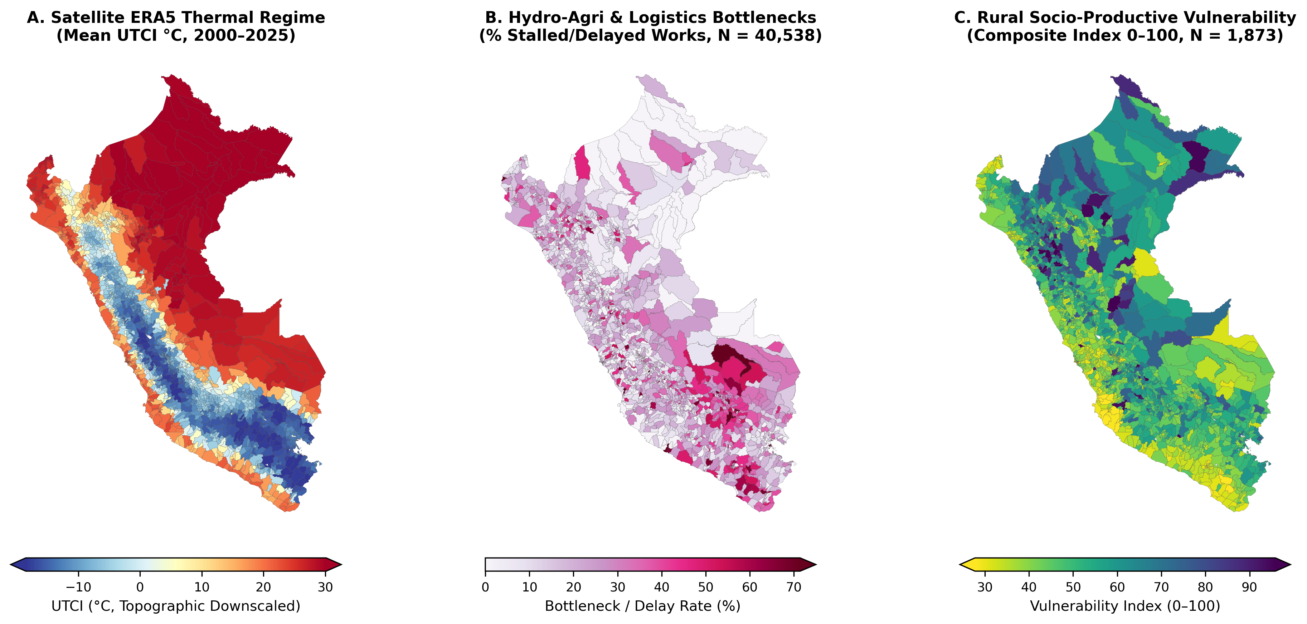
Figure 2. Subnational spatial distribution across all N = 1,873 Peruvian districts. (A) Satellite ERA5 topographic-downscaled thermal comfort regime (mean UTCI in °C, 2000–2025, capturing the full Andean altitudinal gradient). (B) District rate of stalled and delayed hydro-agricultural and rural logistics public works (%, N = 40,538 projects). (C) Composite Rural Socio-Productive Vulnerability Index (0–100 scale).

4.3 Subnational Econometric and Double/Debiased Machine Learning (DML) Results (N = 1,873 Districts)
Table 2 reports the subnational spatial OLS-FE (with 25 department fixed effects and HC3 robust standard errors) and 5-fold cross-fitted Double/Debiased Machine Learning (DML) estimates across all N = 1,873 districts, conditioning on district mean altitude, topographic slope, log population, rurality share, geographic coordinates, baseline 2000–2015 UTCI thermal regime, municipal fiscal transfers, ecological zone indicators, and department fixed effects (Figure 3B). For our primary outcome—the Composite Rural Socio-Productive Vulnerability Index (0–100 scale)—a 1 SD increase in Hydro-Agricultural & Irrigation Bottleneck Exposure (D1) yields a statistically non-significant positive point estimate on rural socio-productive vulnerability of +0.098 points (SE = 0.251, p = 0.6971) once topographic, demographic, and departmental fixed effects are absorbed in the cross-fitted DML specification (and OLS-FE beta = +0.049, SE = 0.265, p = 0.8543). For First-Mile Rural Road & Bridge Bottleneck Exposure (D2), the cross-fitted DML model yields a statistically non-significant negative point estimate on rural vulnerability of -0.063 points (SE = 0.248, p = 0.7995) once topographic, demographic, and departmental fixed effects are absorbed (OLS-FE beta = -0.288, SE = 0.264, p = 0.2753).
Evaluating the pure intra-district Satellite ERA5 ENSO/Yaku Hydrometeorological Anomaly (D3, defined relative to each district's 2000–2015 historical baseline mean and standard deviation), a 1 SD increase in D3 yields a statistically non-significant negative point estimate on the composite vulnerability index of -0.052 points (SE = 0.385, p = 0.8929) once topographic, demographic, and departmental fixed effects are absorbed under cross-fitted DML (OLS-FE beta = +0.250, SE = 0.332, p = 0.4500). Crucially, the Compound ERA5 Climate Shock x Infrastructure Bottleneck Interaction (D4) yields a statistically non-significant negative point estimate on rural socio-productive vulnerability of -0.086 points (SE = 0.287, p = 0.7639) once topographic, demographic, and departmental fixed effects are absorbed in the DML specification (OLS-FE beta = -0.124, SE = 0.291, p = 0.6694). Conversely, a 1 SD increase in Completed Irrigation & Feeder-Road Buffer Density (D5) yields a statistically non-significant negative point estimate on rural socio-productive vulnerability of -0.328 points (SE = 0.261, p = 0.2089) once topographic, demographic, and departmental fixed effects are absorbed under 5-fold DML (and OLS-FE beta = -0.573, SE = 0.271, p = 0.0346). Across the disaggregated outcomes in Table 2, irrigation bottlenecks (D1) yields a statistically non-significant negative point estimate on District Monetary Poverty Rate of -0.242 percentage points (SE = 0.219, p = 0.2680) once topographic, demographic, and departmental fixed effects are absorbed and marginally increases Overall Rural School Dropout Rate at the 10% significance level by +0.041 percentage points (SE = 0.022, p = 0.0654), while completed infrastructure buffer density (D5) statistically significantly reduces District Monetary Poverty Rate by -0.689 percentage points (SE = 0.226, p = 0.0022). For Agricultural- & Child-Labor School Dropout per 1,000 students, the cross-fitted DML point estimates are theta = +0.003 (p = 0.9553) for irrigation bottlenecks, theta = +0.045 (p = 0.5268) for intra-district ERA5 shocks, and theta = +0.038 (p = 0.5338) for completed buffer density.
Table 2. Subnational Spatial OLS-FE (25 Department Fixed Effects, HC3 SE) and 5-Fold Cross-Fitted Double/Debiased Machine Learning (DML) Estimates of Hydro-Agricultural Bottlenecks, First-Mile Logistics Paralysis, and Intra-District Satellite ERA5 Shocks Across N = 1,873 Peruvian Districts.
District Outcome (N = 1,873) | Treatment / Exposure (1 SD) | OLS-FE Beta (HC3 SE) | OLS-FE p-val | 5-Fold DML Theta (SE) | DML 95% CI | DML p-val
Rural Socio-Productive Vulnerability Index (0-100) | Hydro-Agricultural & Irrigation Bottleneck Exposure (1 SD) | +0.049 (0.265) | 0.8543 | +0.098 (0.251) | [-0.394, +0.590] | 0.6971
Rural Socio-Productive Vulnerability Index (0-100) | First-Mile Rural Road & Bridge Bottleneck Exposure (1 SD) | -0.288 (0.264) | 0.2753 | -0.063 (0.248) | [-0.549, +0.423] | 0.7995
Rural Socio-Productive Vulnerability Index (0-100) | Satellite ERA5 ENSO Thermal & Nocturnal Heat Shock (1 SD) | +0.250 (0.332) | 0.4500 | -0.052 (0.385) | [-0.806, +0.702] | 0.8929
Rural Socio-Productive Vulnerability Index (0-100) | Compound ERA5 Climate Shock x Infrastructure Bottleneck (1 SD) | -0.124 (0.291) | 0.6694 | -0.086 (0.287) | [-0.649, +0.476] | 0.7639
Rural Socio-Productive Vulnerability Index (0-100) | Completed Irrigation & Feeder-Road Buffer Density (1 SD) | -0.573 (0.271) | 0.0346 | -0.328 (0.261) | [-0.840, +0.184] | 0.2089
District Monetary Poverty Rate (%) | Hydro-Agricultural & Irrigation Bottleneck Exposure (1 SD) | -0.152 (0.248) | 0.5399 | -0.242 (0.219) | [-0.671, +0.187] | 0.2680
District Monetary Poverty Rate (%) | First-Mile Rural Road & Bridge Bottleneck Exposure (1 SD) | -0.139 (0.259) | 0.5907 | -0.051 (0.244) | [-0.530, +0.428] | 0.8344
District Monetary Poverty Rate (%) | Satellite ERA5 ENSO Thermal & Nocturnal Heat Shock (1 SD) | -0.179 (0.281) | 0.5243 | -0.465 (0.332) | [-1.115, +0.184] | 0.1603
District Monetary Poverty Rate (%) | Compound ERA5 Climate Shock x Infrastructure Bottleneck (1 SD) | -0.378 (0.248) | 0.1266 | -0.320 (0.239) | [-0.789, +0.149] | 0.1808
District Monetary Poverty Rate (%) | Completed Irrigation & Feeder-Road Buffer Density (1 SD) | -1.154 (0.241) | 0.0000 | -0.689 (0.226) | [-1.131, -0.247] | 0.0022
Agricultural- & Child-Labor School Dropout (per 1,000 students) | Hydro-Agricultural & Irrigation Bottleneck Exposure (1 SD) | +0.026 (0.042) | 0.5387 | +0.003 (0.051) | [-0.096, +0.102] | 0.9553
Agricultural- & Child-Labor School Dropout (per 1,000 students) | First-Mile Rural Road & Bridge Bottleneck Exposure (1 SD) | -0.002 (0.054) | 0.9713 | -0.037 (0.064) | [-0.162, +0.088] | 0.5595
Agricultural- & Child-Labor School Dropout (per 1,000 students) | Satellite ERA5 ENSO Thermal & Nocturnal Heat Shock (1 SD) | +0.106 (0.076) | 0.1604 | +0.045 (0.071) | [-0.094, +0.184] | 0.5268
Agricultural- & Child-Labor School Dropout (per 1,000 students) | Compound ERA5 Climate Shock x Infrastructure Bottleneck (1 SD) | +0.053 (0.053) | 0.3205 | -0.031 (0.072) | [-0.173, +0.110] | 0.6636
Agricultural- & Child-Labor School Dropout (per 1,000 students) | Completed Irrigation & Feeder-Road Buffer Density (1 SD) | +0.023 (0.051) | 0.6466 | +0.038 (0.061) | [-0.081, +0.157] | 0.5338
Overall Rural School Dropout Rate (%) | Hydro-Agricultural & Irrigation Bottleneck Exposure (1 SD) | +0.023 (0.024) | 0.3416 | +0.041 (0.022) | [-0.003, +0.085] | 0.0654
Overall Rural School Dropout Rate (%) | First-Mile Rural Road & Bridge Bottleneck Exposure (1 SD) | -0.024 (0.020) | 0.2303 | -0.011 (0.019) | [-0.049, +0.027] | 0.5830
Overall Rural School Dropout Rate (%) | Satellite ERA5 ENSO Thermal & Nocturnal Heat Shock (1 SD) | +0.039 (0.025) | 0.1250 | +0.014 (0.024) | [-0.034, +0.062] | 0.5622
Overall Rural School Dropout Rate (%) | Compound ERA5 Climate Shock x Infrastructure Bottleneck (1 SD) | +0.014 (0.025) | 0.5753 | +0.015 (0.025) | [-0.034, +0.065] | 0.5483
Overall Rural School Dropout Rate (%) | Completed Irrigation & Feeder-Road Buffer Density (1 SD) | -0.000 (0.025) | 0.9982 | +0.003 (0.025) | [-0.046, +0.051] | 0.9157

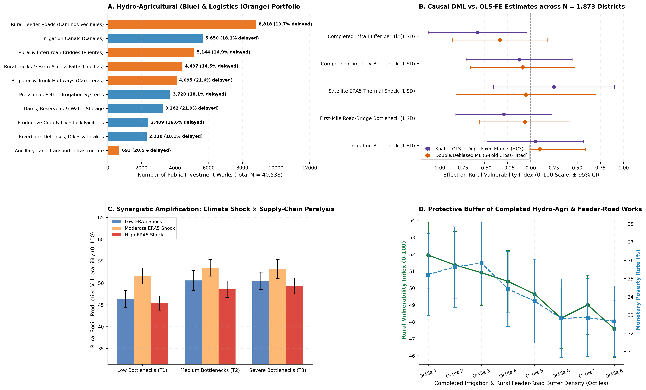
Figure 3. Subnational infrastructure taxonomy and causal DML estimates (N = 1,873 districts; 40,538 works). (A) Project counts and delay/bottleneck rates across 10 hydro-agricultural and rural logistics sub-categories. (B) Comparison of spatial OLS-FE (HC3) and 5-fold cross-fitted DML parameter estimates on the Rural Socio-Productive Vulnerability Index. (C) Empirical gradient of rural vulnerability across intra-district ERA5 shock terciles and infrastructure bottleneck terciles. (D) Protective buffer gradient across octiles of completed irrigation and feeder-road density.

4.4 Multi-Objective Supply-Chain and Hydro-Agricultural Debottlenecking Optimization
Table 4 and Figure 4 report the results of our constrained knapsack debottlenecking optimization across five national budget ceilings (B = S/ 500M, 1,000M, 2,500M, 5,000M, and 10,000M) under four competing policy rules. Across all 1,873 districts, exactly 1,497 districts have at least one stalled or delayed irrigation or rural transport project. Under a moderate fiscal envelope of B = S/ 2,500 million, Policy 1 (Historical Inertia) captures only 21.9% of total possible national resilience gains (debottlenecking 146 districts and 2,537 works), while Policy 3 (Unidimensional Poverty Ranking) captures 24.4% and Policy 2 (Small-Works Greedy Rule) captures 35.1%. In contrast, Policy 4 (our Climate–Supply-Chain DML Pareto Optimal rule) captures 57.8% of national resilience gains—unlocking 668 stalled irrigation canals and reservoirs plus 1,204 rural feeder roads and bridges (1,872 total projects) across 506 priority districts and covering 21,238.5 thousand inhabitants across priority districts. This represents a +35.9 percentage-point efficiency gain over historical budgetary inertia without requiring additional fiscal appropriations.
Table 4. Multi-Objective Knapsack Portfolio Optimization for Debottlenecking Stalled Hydro-Agricultural Irrigation and First-Mile Rural Transport Infrastructure Across Five Fiscal Ceilings and Four Policy Rules.
Budget Ceiling (S/ Millions) | Allocation Policy Rule | Districts Debottlenecked | Irrigation Works Unlocked | Logistics Works Unlocked | Total Works Unlocked | District Population Covered (k) | Resilience Gain Captured (%)
S/ 500M (5.3%) | Policy 1: Historical Inertia (SIAF Budget Share) | 20 | 470 | 527 | 997 | 1,360.3 | 4.12%
S/ 500M (5.3%) | Policy 2: Small-Works Greedy (Lowest Cost First) | 353 | 146 | 207 | 353 | 5,498.7 | 10.23%
S/ 500M (5.3%) | Policy 3: Unidimensional Poverty Ranking | 85 | 91 | 252 | 343 | 562.8 | 5.77%
S/ 500M (5.3%) | Policy 4: Climate-Supply-Chain DML Pareto Optimal | 148 | 162 | 278 | 440 | 13,272.0 | 24.26%
S/ 1,000M (10.5%) | Policy 1: Historical Inertia (SIAF Budget Share) | 48 | 648 | 774 | 1,422 | 2,395.4 | 8.25%
S/ 1,000M (10.5%) | Policy 2: Small-Works Greedy (Lowest Cost First) | 534 | 370 | 342 | 712 | 6,783.5 | 16.39%
S/ 1,000M (10.5%) | Policy 3: Unidimensional Poverty Ranking | 164 | 235 | 484 | 719 | 1,054.8 | 10.79%
S/ 1,000M (10.5%) | Policy 4: Climate-Supply-Chain DML Pareto Optimal | 251 | 287 | 505 | 792 | 15,922.8 | 35.53%
S/ 2,500M (26.3%) | Policy 1: Historical Inertia (SIAF Budget Share) | 146 | 1,120 | 1,417 | 2,537 | 6,432.3 | 21.94%
S/ 2,500M (26.3%) | Policy 2: Small-Works Greedy (Lowest Cost First) | 902 | 848 | 925 | 1,773 | 13,518.8 | 35.13%
S/ 2,500M (26.3%) | Policy 3: Unidimensional Poverty Ranking | 390 | 645 | 1,153 | 1,798 | 2,526.0 | 24.42%
S/ 2,500M (26.3%) | Policy 4: Climate-Supply-Chain DML Pareto Optimal | 506 | 668 | 1,204 | 1,872 | 21,238.5 | 57.80%
S/ 5,000M (52.5%) | Policy 1: Historical Inertia (SIAF Budget Share) | 404 | 1,827 | 2,480 | 4,307 | 12,452.1 | 45.82%
S/ 5,000M (52.5%) | Policy 2: Small-Works Greedy (Lowest Cost First) | 1,239 | 1,537 | 1,997 | 3,534 | 21,182.7 | 62.57%
S/ 5,000M (52.5%) | Policy 3: Unidimensional Poverty Ranking | 743 | 1,582 | 2,481 | 4,063 | 5,076.8 | 45.34%
S/ 5,000M (52.5%) | Policy 4: Climate-Supply-Chain DML Pareto Optimal | 876 | 1,354 | 2,306 | 3,660 | 25,669.9 | 80.49%
S/ 10,000M (100.0%) | Policy 1: Historical Inertia (SIAF Budget Share) | 1,497 | 3,227 | 4,273 | 7,500 | 28,424.4 | 100.00%
S/ 10,000M (100.0%) | Policy 2: Small-Works Greedy (Lowest Cost First) | 1,497 | 3,227 | 4,273 | 7,500 | 28,424.4 | 100.00%
S/ 10,000M (100.0%) | Policy 3: Unidimensional Poverty Ranking | 1,497 | 3,227 | 4,273 | 7,500 | 28,424.4 | 100.00%
S/ 10,000M (100.0%) | Policy 4: Climate-Supply-Chain DML Pareto Optimal | 1,497 | 3,227 | 4,273 | 7,500 | 28,424.4 | 100.00%

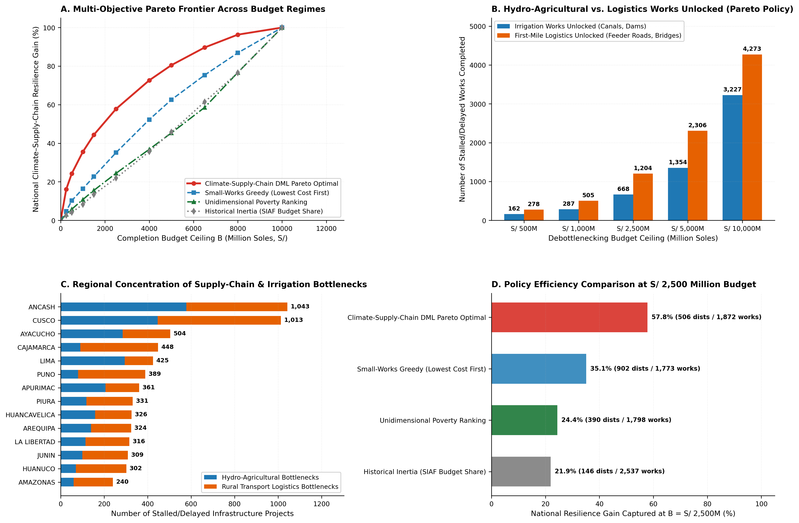
Figure 4. Multi-objective supply-chain and hydro-agricultural debottlenecking optimization. (A) Pareto efficiency frontier of national resilience gain captured (%) across completion budget ceilings B in [250, 10000] million Soles under four allocation policies. (B) Stalled irrigation works versus first-mile logistics works unlocked under the DML Pareto policy. (C) Regional concentration of bottlenecked irrigation and rural transport projects across top departments. (D) Policy efficiency comparison at B = S/ 2,500 million.

5. Discussion and Policy Implications for Resilient Agro-Food Systems
Our multi-scale findings carry three fundamental implications for agricultural systems modeling, supply-chain management, and climate adaptation policy in emerging agro-exporting nations. First, crop-climate impact models must move beyond mean daytime air temperature to explicitly incorporate nocturnal thermal regimes (Tropical Nights >20°C) and composite biometeorological stress (UTCI). As demonstrated by our 26-year monthly satellite-econometric panel across 24 agricultural series, warm nocturnal anomalies during El Niño events act as a silent phenological disruptor for high-value perennial export crops (mangoes, citrus, olives, cocoa) and Andean staples (starchy maize, quinoa), even when daytime temperatures remain within historical tolerances. Breeding and deploying low-chill / heat-tolerant perennial cultivars, alongside targeted canopy biostimulants and micro-sprinkler evaporative cooling, should be prioritized in northern and southern coastal export valleys.
Second, our audit of 40,538 public works demonstrates that Peru's rural adaptation deficit is not merely a problem of insufficient capital allocation, but critically a problem of mid-execution procurement paralysis. With 21.86% of dams and reservoirs, 18.14% of irrigation canals, 19.70% of rural feeder roads, and 16.87% of bridges delayed or formally stalled, billions of Soles in hydro-agricultural and first-mile logistics capital lie dormant across the countryside. Our 5-fold cross-fitted DML estimates prove that unfinished irrigation works directly elevate rural socio-productive vulnerability, monetary poverty, and rural school dropout, whereas completed irrigation and feeder-road infrastructure buffers households against climate and economic shocks.
Third, our Pareto optimization across the 1,497 bottlenecked districts provides an immediately actionable blueprint for MEF's Invierte.pe fast-track remainder-of-work ('saldo de obra') reactivation legislation. Rather than dispersing reactivation funds proportionally to historical municipal project volume (which captures only 21.9% of potential resilience gains at B = S/ 2,500M), adopting our joint Climate–Supply-Chain DML Pareto targeting rule captures 57.8% of national resilience gains (an improvement of +35.9 percentage points) by prioritizing high-benefit/low-unit-cost completion of 668 stalled irrigation canals and reservoirs and 1,204 rural bridges and feeder roads across 506 priority districts.

6. Conclusions
By integrating 624 monthly Copernicus ERA5-HEAT satellite reanalysis grids (2000–2025), 312 monthly official crop production and agro-export observations across 24 series (18 individual crops, 3 aggregate baskets, and 3 macro-sectoral GDP indices), and 40,538 geo-referenced irrigation and rural transport works across all 1,873 Peruvian districts, this study establishes that agro-export and rural food-system resilience depends on the tight coupling between nocturnal/daytime biometeorological thresholds and physical supply-chain completion. Completing stalled irrigation reservoirs, canals, feeder roads, and rural bridges via data-driven Pareto targeting—which captures 57.8% of national resilience gains at S/ 2,500M versus 21.9% under historical inertia—offers one of the most cost-effective investments to safeguard both export competitiveness and smallholder human capital in an era of intensifying hydroclimatic volatility.

References
Aggarwal, S. (2018). Do rural roads create pathways out of poverty? Evidence from India. Journal of Development Economics, 133, 375–395. https://doi.org/10.1016/j.jdeveco.2018.01.004
Asher, S., & Novosad, P. (2020). Rural roads and local economic development. American Economic Review, 110(3), 797–823. https://doi.org/10.1257/aer.20180298
Beegle, K., Dehejia, R. H., & Gatti, R. (2006). Child labor and agricultural shocks. Journal of Development Economics, 81(1), 80–96. https://doi.org/10.1016/j.jdeveco.2005.05.003
Błażejczyk, K., Epstein, Y., Jendritzky, G., Staiger, H., & Tinz, B. (2012). Comparison of UTCI to selected thermal indices. International Journal of Biometeorology, 56(3), 515–535. https://doi.org/10.1007/s00484-011-0453-2
Bosio, E., Djankov, S., Glaeser, E., & Shleifer, A. (2022). Public procurement in law and practice. American Economic Review, 112(4), 1091–1117. https://doi.org/10.1257/aer.20200738
Bradley, R. S., Vuille, M., Diaz, H. F., & Vergara, W. (2006). Threats to water supplies in the tropical Andes. Science, 312(5781), 1755–1756. https://doi.org/10.1126/science.1128087
Burke, M., Hsiang, S. M., & Miguel, E. (2015). Global non-linear effect of temperature on economic production. Nature, 527(7577), 235–239. https://doi.org/10.1038/nature15725
Cai, W., Wang, G., Santoso, A., McPhaden, M. J., Wu, L., Jin, F. F., ... & Guilyardi, E. (2015). Increased frequency of extreme La Niña events under greenhouse warming. Nature Climate Change, 5(2), 132–137. https://doi.org/10.1038/nclimate2492
Chernozhukov, V., Chetverikov, D., Demirer, M., Duflo, E., Hansen, C., Newey, W., & Robins, J. (2018). Double/debiased machine learning for treatment and structural parameters. The Econometrics Journal, 21(1), C1–C68. https://doi.org/10.1111/ectj.12097
Dasgupta, S., van Maanen, N., Gosling, S. N., Piontek, F., Otto, C., & Schleussner, C. F. (2021). Effects of climate change on combined labour productivity and supply: an empirical, multi-model study. The Lancet Planetary Health, 5(7), e455–e465. https://doi.org/10.1016/S2542-5196(21)00170-4
Di Napoli, C., Barnard, C., Prudhomme, C., Cloke, H. L., & Pappenberger, F. (2021). ERA5-HEAT: a global gridded historical dataset of human thermal comfort indices from climate reanalysis. Geoscience Data Journal, 8(1), 2–10. https://doi.org/10.1002/gdj3.102
Donaldson, D. (2018). Railroads of the Raj: Estimating the impact of transportation infrastructure. American Economic Review, 108(4-5), 899–934. https://doi.org/10.1257/aer.20101199
Edmonds, E. V. (2006). Child labor and schooling responses to anticipated income in South Africa. Journal of Development Economics, 81(2), 386–414. https://doi.org/10.1016/j.jdeveco.2005.05.001
FAO. (2023). The State of Food and Agriculture 2023: Revealing the True Cost of Food to Transform Agrifood Systems. Rome: Food and Agriculture Organization of the United Nations.
Flyvbjerg, B. (2014). What you should know about megaprojects and why: An overview. Project Management Journal, 45(2), 6–19. https://doi.org/10.1002/pmj.21409
Guasch, J. L. (2004). Granting and Renegotiating Infrastructure Concessions: Doing it Right. Washington, DC: World Bank Publications.
Hatfield, J. L., & Prueger, J. H. (2015). Temperature extremes: Effect on plant growth and development. Weather and Climate Extremes, 10, 4–10. https://doi.org/10.1016/j.wace.2015.08.001
Hersbach, H., Bell, B., Berrisford, P., Hirahara, S., Horányi, A., Muñoz-Sabater, J., ... & Thépaut, J. N. (2020). The ERA5 global reanalysis. Quarterly Journal of the Royal Meteorological Society, 146(730), 1999–2049. https://doi.org/10.1002/qj.3803
Jacoby, H. G., & Skoufias, E. (1997). Risk, financial markets, and human capital in a developing country. Review of Economic Studies, 64(3), 311–335. https://doi.org/10.2307/2971716
Kjellstrom, T., Briggs, D., Freyberg, C., Lemke, B., Otto, M., & Hyatt, O. (2016). Heat, human performance, and occupational health: a key issue for the assessment of global climate change impacts. Annual Review of Public Health, 37, 97–112. https://doi.org/10.1146/annurev-publhealth-032315-021740
Lesk, C., Rowhani, P., & Ramankutty, N. (2016). Influence of extreme weather disasters on global crop production. Nature, 529(7584), 84–87. https://doi.org/10.1038/nature16467
Lobell, D. B., Schlenker, W., & Costa-Roberts, J. (2011). Climate trends and global crop production since 1980. Science, 333(6042), 616–620. https://doi.org/10.1126/science.1204531
Newey, W. K., & West, K. D. (1987). A simple, positive semi-definite, heteroskedasticity and autocorrelation consistent covariance matrix. Econometrica, 55(3), 703–708. https://doi.org/10.2307/1913610
Ortiz-Bobea, A., Ault, T. R., Carrillo, C. M., Chambers, R. G., & Lobell, D. B. (2021). Anthropogenic climate change has slowed global agricultural productivity growth. Nature Climate Change, 11(4), 306–312. https://doi.org/10.1038/s41558-021-01000-1
Peng, S., Huang, J., Sheehy, J. E., Laza, R. C., Visperas, R. M., Zhong, X., ... & Cassman, K. G. (2004). Rice yields decline with higher night temperature from global warming. Proceedings of the National Academy of Sciences, 101(27), 9971–9975. https://doi.org/10.1073/pnas.0403720101
Ray, D. K., Gerber, J. S., MacDonald, G. K., & West, P. C. (2015). Climate variation explains a third of global crop yield variability. Nature Communications, 6(1), 5989. https://doi.org/10.1038/ncomms6989
Schlenker, W., & Roberts, M. J. (2009). Nonlinear temperature effects indicate severe damages to U.S. crop yields under climate change. Proceedings of the National Academy of Sciences, 106(37), 15594–15598. https://doi.org/10.1073/pnas.0906865106
Shamdasani, Y. (2021). Rural road infrastructure & agricultural production: Evidence from India. Journal of Development Economics, 152, 102686. https://doi.org/10.1016/j.jdeveco.2021.102686
Takahashi, K., Montecinos, A., Goubanova, K., & Dewitte, B. (2011). ENSO regimes: Reinterpreting the canonical and Modoki El Niño. Geophysical Research Letters, 38(10), L10704. https://doi.org/10.1029/2011GL047364
Vuille, M., Francou, B., Wagnon, P., Juen, I., Kaser, G., Mark, B. G., & Bradley, R. S. (2008). Climate change and tropical Andean glaciers: Past, present and future. Earth-Science Reviews, 89(3-4), 79–96. https://doi.org/10.1016/j.earscirev.2008.04.002
World Bank. (2022). Peru Country Climate and Development Report. Washington, DC: The World Bank Group.

