November 14, 2014

To: CSS 422, Fall 2014

From: Nick Abel, EA Decoder

Julio Perez, I/O, Op Code

Subject: Team Progress Report 3

Reporting Period: (11/10 - 11/14)

**Work Done**

1. Followed the scheduled entries for this week in the schedule.
2. Created subroutines to analyze bytes after opcode is parsed and decoded.
3. Created the intake of 10 opcodes.

**OpCode/Effective Address Machine Code Tables**

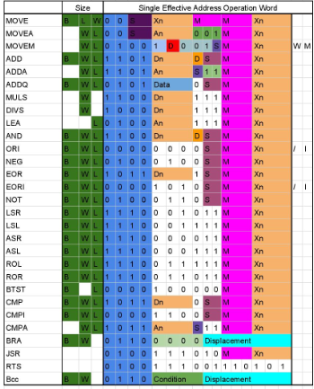

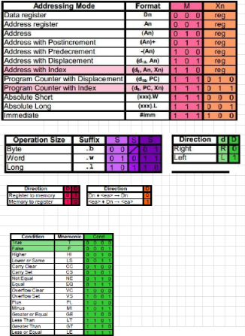

**Problems**

There were no issues to report.

**Next Week**

|  |  |
| --- | --- |
| **Priority** | **Task** |
| 1 | Continue decoding opcodes as the schedule dictates. |
| 2 | Displaying output correctly for full lines of machine code that is decoded. |
| 3 | Work on Bad or not interpreted commands. |
|  |  |

**Self Evaluation:**

As of this week Team Effective is on track to complete the project on time. If we can keep to this schedule we should be successful in completing the project by the deadline. Currently we have no problems creating obstacles for the team, so the forecast for this project and Team Effective looks good. We are adding more meeting times according to workload.