

Republic of the Philippines
North Eastern Mindanao State University

Gamification and Interactive Simulation in Digital Logic Education: A platform for Enhancing Conceptual Understanding and Engagement

A Research Paper Presented by:
Cabero, John Mark T.

April 6, 2026

Overview
Digital logic education has, for the better part of the last decade, leaned heavily on software simulation to close a persistent gap: most students never get near actual hardware. Tools like Logisim and Digital Works changed something real. Instead of physical breadboards, expensive ICs, and labs that closed at five o’clock, students could open a laptop and drag gates onto a virtual canvas. The barrier dropped. Practice that once required supervised lab time became something a student could do at midnight, alone, on a personal computer with no equipment beyond the machine itself.
Yet the gap did not close as fully as it appeared. Current simulation tools still leave students staring at static connections—wires and gates that sit inert on screen while the underlying behavior, propagation delay, race conditions, signal timing, remains entirely invisible. Feedback, when it arrives, comes through a teacher’s gradebook days or weeks after the fact. By then, whatever mistake a student made has already been rehearsed enough times to feel correct. Teachers carry the weight of this: manually tracing each submitted circuit, a process that limits how many practice exercises they can realistically assign. And underneath all of it, perhaps the most stubborn problem of all—these tools feel like obligation. Students complete the minimum. Curiosity rarely enters the picture. Many reach the end of a digital logic course with a passing grade and a genuinely fragile understanding of how circuits actually behave.
This study proposes a different approach. LogicPlay is a gamified learning platform built specifically for mobile-first use, where students drag and drop logic gates directly onto their phone screen and watch colored signal animations trace the flow of electricity through each connection in real time. Not a delayed report, immediate visual feedback, the kind that maps abstract behavior onto something the eye can follow. An integrated machine learning grader evaluates submitted circuits instantly, cutting the feedback loop from days to seconds. Points, levels, badges, and time-limited challenges layer on top of the core simulation, not as decoration but as deliberate motivational scaffolding. The whole system ships as a Progressive Web Application, meaning it runs on any device, caches locally, and continues working even when the network drops. The goal is not merely a better simulator. It is a platform where understanding digital logic and actually wanting to practice it might, for once, be the same thing.
General Objective
To develop a gamified platform with interactive simulation and automated feedback that improves conceptual understanding and engagement in digital logic education.
Specific Objectives
- To design a drag-and-drop circuit builder with real-time signal flow animation that helps students visualize abstract gate operations.
- To implement a machine learning-based auto-grading system that provides instant feedback on student circuit submissions.
- To integrate gamification elements including points, level, badges, and challenges that increases student motivation to practice.
- To evaluate the platform’s effectiveness in improving test scores and self- reported engagement compared to traditional simulation tools.

Project Timeline
Figure 1: Gantt Chart for LogicPlay
Figure 1 shows the project timeline from February to May, divided into four months with weekly tasks. February fucoses on planning, documentation, and building the backend core. In March the work moves to frontend development, circuit simulation, and starting the machine learning auto-grading system. April is for adding gamification features, completing the PWA offline support, and beginning testing ans polishing. May is reserved for final testing, preparing the presentation, making revisions based on feedback, and submitting the completed project. This schedule ensures each part of the system is built step by step, with enough time for testing and improvements before the deadline.
The Gantt chart was updated to reflect a change that happened during the project. A new activity called Documentation Update was added, scheduled in the last week of March (W9). This update covers the additional contents written for Part III of the research documentation, specifically the sections from 6.0 System Design up to but not including the References. These sections include the development approach, system architecture, use case diagram, data flow diagram, entity relationship diagram, user interface design, test cases, and system requirements. The documentation work for these parts was done alongside the backend and frontend development phase, which is why it falls in that same period. Adding this activity to the chart makes the timeline more accurate and shows that documentation is not just done at the start but is also updated as the system design becomes clearer and more complete.

Statement of the Problem
Several interconnected problems appear to be driving the persistent underperformance of students in digital logic courses, and this study is structured around addressing them in combination rather than in isolation. The most immediate is a visualization deficit. Students work with simulation tools that render circuits as static diagrams, lines connecting boxes, with no indication of how signals actually propagate through gate networks over time. Concepts like propagation delay and glitch behavior remain stubbornly abstract when the tool cannot show them moving. What students see is a snapshot; what they need to understand is a process. The second problem compounds the first: feedback reaches students too late to be corrective. When a teacher manually grades submitted circuits, often days after the fact, the student has already rehearsed whatever error they made enough times to internalize it. Wrong mental models calcify quickly. Hardware access makes these worse, physical components are expensive, lab time is finite, and the opportunity to simply try things and fail cheaply is rarely available outside of supervised sessions. Meanwhile, the manual grading burden on teachers limits how many exercises they can assign, which means students get less practice precisely when practice matters most. Underlying all of this is an engagement problem that tends to go underacknowledged. Current tools offer no intrinsic motivation to explore beyond the assigned minimum. Students complete what is required. The platform proposed here attempts to address the whole picture: real-time visualization, automated feedback, reduced hardware dependency, and engagement mechanisms that make continued practice feel worthwhile rather than obligatory.

6.0 System Design
The design of LogicPlay follows a clear separation between what users see and touch versus what runs behind the scenes. This split matters because circuit simulation needs to feel instant—no one wants to wait for a server to respond while dragging a gate across the screen. The frontend handles the heavy visual work. The backend manages data, users, and grading. They talk to each other only when necessary.

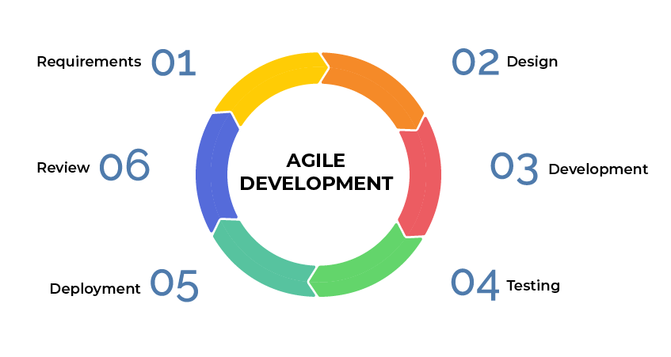
6.1 Development Approach
Figure 2 shows the Agile Development Approach.
LogicPlay follows the Agile development methodology, specifically Scrum. The choice was deliberate, not because Agile is trendy, but because building a circuit simulator with gamification elements involves too many unknowns to plan everything upfront.

6.2 System Architecture.
LogicPlay runs as a decoupled client-server web application with Progressive Web App (PWA) capabilities. Decoupled simply means the frontend and backend can live apart—different servers, different update schedules, different teams could even work on them. This matters for a classroom tool because teachers might use it on school computers while students access it from phones at home. The same backend serves both.
The frontend uses React with Vite as the build tool. Tailwind CSS handles styling with indigo and emerald colors—calm but not boring. The circuit canvas runs on p5.js, a library built for animation and interactivity. Every gate drag, every wire connection, every signal pulse happens right there in the browser. No round trips to a server for basic interaction.
The backend runs FastAPI, a Python framework built for speed and async operations. It exposes a REST API that speaks JSON. When a student submits a circuit, the frontend packages the circuit data as JSON and sends it via HTTP POST. FastAPI validates the data, checks authentication, stores the submission, and runs the auto-grader. The response comes back with a score, possible badges, and level updates. The frontend then updates what the student sees.
Authentication uses JSON Web Tokens (JWT) with passlib for password hashing. No plaintext passwords anywhere. The token system lets the server trust that a request came from who it claims to be without checking the database every single time.
The database is SQLite for development and MVP. SQLAlchemy acts as the ORM—it translates Python objects into SQL queries and back. This keeps the code clean even when the database changes later.
A service worker built with Workbox enables offline caching. Students who lose internet connection can still open the app and work on circuits. Submissions queue up and send when connection returns. The future goal includes full offline circuit play, but the current implementation caches static assets and basic functionality.
System Communication Pattern
The typical flow looks like this:
- A student builds a circuit by dragging gates onto the canvas and connecting wires. The canvas runs entirely client-side—every click responds instantly.
- When ready to submit, the student hits a button. The frontend packages the circuit as JSON.
- The browser sends a POST request to the backend at an endpoint like /api/submissions.
- FastAPI receives the request, checks the JWT to know which student submitted, and validates the circuit data structure.
- The backend evaluates the circuit. This could be rule-based checking (does the truth table match?) or eventually a machine learning model that understands correct circuit patterns.
- The backend saves the submission to the database and computes a score.
- The response returns to the frontend with the score, any earned points, and badge unlocks.
- React updates the UI—shows a "Mission Complete" message, increments the level bar, plays a badge animation.
- All of this happens in seconds. The student gets feedback immediately, not next week.
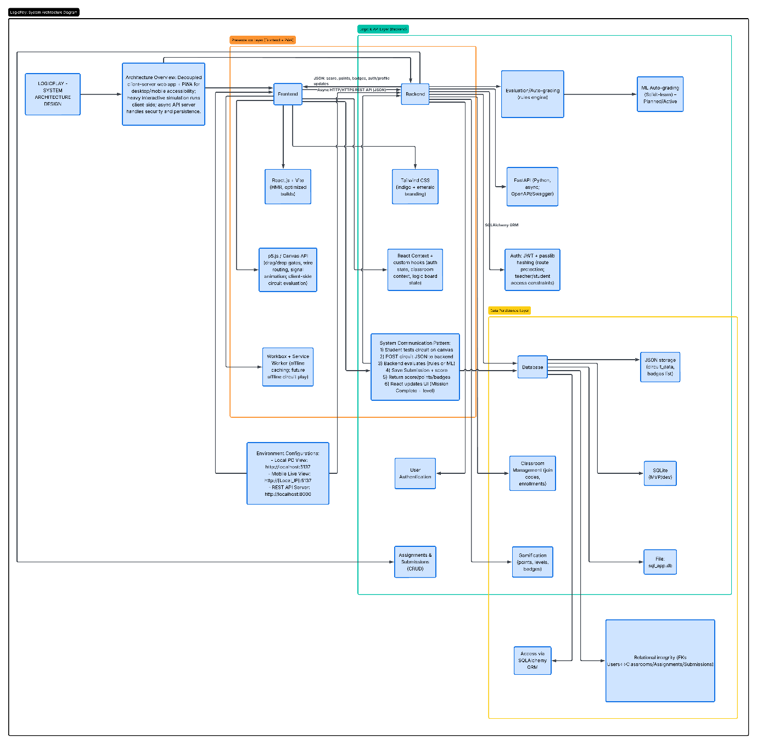
Figure 3 shows the System Architecture Design
Figure 3 illustrates the complete architecture. The frontend block contains the React components, the p5.js canvas, Tailwind styling, and the Workbox service worker. Arrows show data flowing to and from the backend via HTTPS. The backend block shows FastAPI handling requests, SQLAlchemy managing database operations, and JWT handling authentication. The database block lists the main tables. The diagram makes clear what runs where—the browser handles the interactive parts, the server handles persistence and security.
6.3 Use Case Diagram
The use case diagram defines who can do what inside LogicPlay. Two primary actors exist: the Student and the Teacher. Each has different needs and different permissions.
Student Actions
A student enters the system by logging in or registering. Once inside, they can join a classroom using a join code—no manual approval needed, just a six-character code the teacher shares. This keeps enrollment simple.
The core student activity is designing logic circuits. The drag-and-drop interface lets them place AND, OR, NOT, NAND, NOR, XOR, and XNOR gates. They connect gates by clicking and dragging wires. The simulation shows signal flow in real time with animated pulses. This visual feedback is the whole point—students see electricity move, not just static lines on a diagram.
Students submit assignments when ready. The system auto-grades instantly and returns a score. No waiting for the teacher to find time.
A mission report card shows performance across all assignments. Students see which missions they completed, what scores they got, and where they need improvement.
Badges and levels provide the gamification layer. Completing assignments earns points. Points unlock levels. Specific achievements—like building a circuit with no errors on the first try or finishing three assignments in a week—earn badges. These appear as small icons in the student's profile. The effect is psychological but real: students want to collect them all.
Teacher Actions
Teachers create classrooms. Each classroom gets a unique join code that students use to enroll. The teacher can see who joined and when.
Creating assignments is the teacher's main work. They set a title, description, due date, and point reward. They can also specify target gates—for example, "build a circuit using only NAND gates that behaves like an XOR gate." This forces students to think differently.
Grading student circuits happens partly automatically. The system provides an auto-score based on correctness, but teachers can override it, add feedback, and assign a manual score. Some things machines miss—elegance, creativity, following instructions that aren't purely logical. The teacher catches those.
The grading interface shows each student's circuit visually, not just as JSON data. Teachers see the gates, the connections, the same view the student had. This makes grading faster and more accurate.
Generating progress analytics gives teachers the big picture. Which students are struggling? Which assignments were too hard? Where do most students make the same mistake? The analytics dashboard answers these questions with charts and tables. Teachers can export data for their own records.
System Boundaries
The use case diagram includes the system boundary labeled "Core Platform & Management Dashboard." Everything inside this boundary is LogicPlay's responsibility. Authentication, classroom management, assignment handling, submission processing, grading, gamification—all inside. Things outside the boundary include external authentication providers (not used yet), payment systems (not applicable), and external learning management systems (future integration possible).
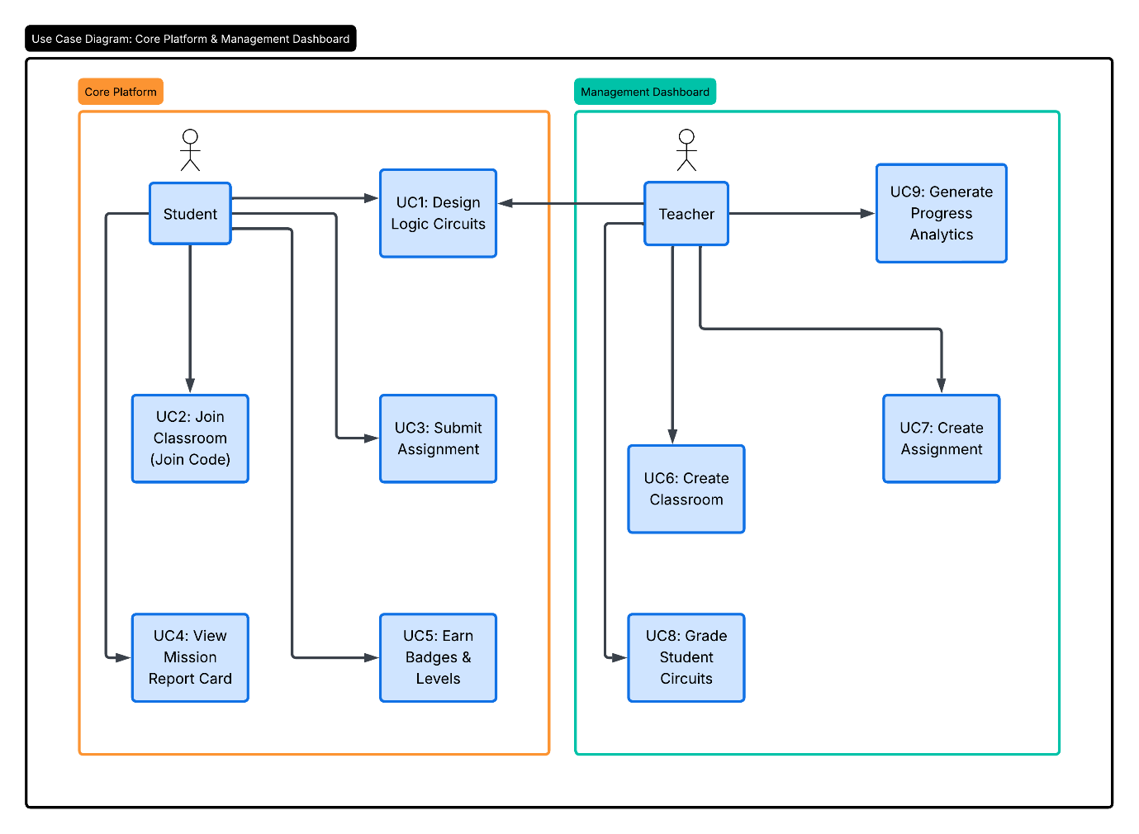
Figure 4: Use Case Diagram of LogicPlay
Figure 4 shows all use cases and their relationships. The student actor connects to six use cases: Login/Register, Design Logic Circuits, Join Classroom, Submit Assignment, View Mission Report Card, and Earn Badges & Levels. The teacher actor connects to four: Create Classroom, Create Assignment, Grade Student Circuits, and Generate Progress Analytics. The diagram uses standard UML notation, stick figures for actors, ellipses for use cases, solid lines for associations. No extends or includes relationships appear because the use cases are relatively independent.

6.4 Data Flow Diagram
Data flow diagrams trace how information moves through the system. Two levels are presented: Level 0 (context diagram) shows the system as a single process with external entities. Level 1 breaks that single process into smaller processes and shows data stores.
Level 0: Context Diagram
At the highest level, LogicPlay interacts with two external entities: Student and Teacher. Data flows in both directions.
From Student to System:
- Login and registration information
- Join code for enrollment
- Circuit submissions
- Assignment answers
- From System to Student:
- Authentication tokens
- Mission reports showing performance
- Feedback on submissions
- Points and badge notifications
From Teacher to System:
- Login information
- Classroom and assignment data
- Graded scores and feedback
- From System to Teacher:
- Authentication tokens
- Student submissions for gradin
- Progress analytics and reports
The context diagram treats the entire system as a black box. We don't care what happens inside, only what enters and leaves. This helps identify all external dependencies before designing internal details.
Level 1: Logical DFD
The Level 1 diagram opens the black box. Six processes handle the work:
Process P1 (User Authentication): Handles login, registration, and token validation. It checks credentials against user records and issues JWTs for valid sessions. All other processes depend on P1 to know who is making requests.
Process P2 (Classroom Management): Creates classrooms, generates join codes, handles enrollments, and manages classroom rosters. When a student submits a join code, P2 validates it and creates an enrollment link between student and classroom.
Process P3 (Circuit Design & Simulation): This runs primarily on the frontend but the diagram shows it as a process because data still flows. The student interacts with the canvas; circuit data is stored temporarily in browser state and sent to the backend only on submission.
Process P4 (Assignment & Submission Management): Teachers create assignments through P4. Students submit work to P4. The process stores submissions, tracks due dates, handles late submissions, and maintains submission status (pending, graded, returned).
Process P5 (Evaluation & Grading): The auto-grader lives here. P5 receives circuit JSON, evaluates correctness against expected behavior, and returns a score. For teacher grading, P5 provides the interface to review submissions and add manual scores and feedback.
Process P6 (Gamification & Progression): Tracks points, levels, and badges. When a submission gets graded, P6 checks if new thresholds were crossed, did the student just reach 100 points? Level up. Did they complete a difficult challenge? Award a badge. P6 also sends notifications to keep students informed of their progress.
Data Stores
Seven data stores support these processes:
- D1 (User Records): Stores usernames, password hashes, roles (student/teacher), points, levels, and earned badges. The users table in the ERD maps directly to this store.
- D2 (Classroom Data): Stores classroom names, join codes, creation dates, and teacher ownership information.
- D3 (Enrollments): Links students to classrooms. A single student can be in multiple classrooms; a single classroom contains many students
- D4 (Assignments): Stores assignment details, title, description, due date, point reward, target gate specifications.
- D5 (Submissions): Stores circuit JSON, auto-scores, teacher scores, teacher feedback, submission timestamps, and late status.
- D6 (Badge Definitions): Stores badge names, descriptions, and the requirements to earn them (e.g., "score 100% on three assignments" or "complete five circuits in one week").
- D7 (Challenge Data): Stores optional challenge missions separate from regular assignments. Challenges are self-directed; students attempt them for extra points and badges.
Data Flow Examples
Student submits assignment:
- Student → P4 (circuit data) → D5 (store submission) → P5 (evaluate) → D1 (update points) → P6 (check badges) → D5 (update score) → Student (return feedback)
- Teacher creates classroom:
- Teacher → P2 (classroom details) → D2 (store classroom) → P2 (generate join code) → Teacher (return join code)
- Student joins classroom:
- Student → P2 (join code) → D2 (validate code) → D3 (create enrollment) → Student (confirmation)
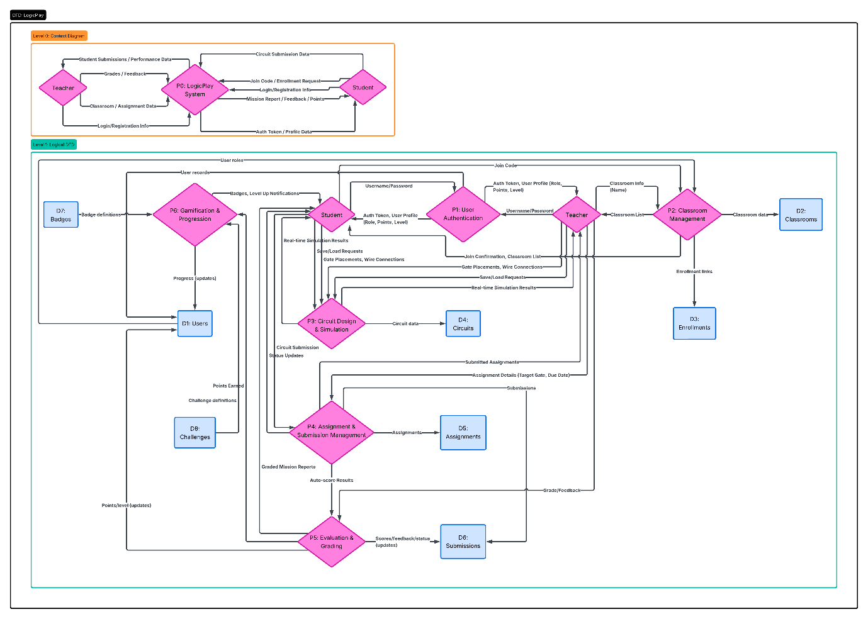
Figure 5: Data Flow Diagram Level 1 of LogicPlay
Figure 5 presents the complete Level 0 and Level 1 DFD. The diagram uses open-ended rectangles (parallel lines) for data stores, rounded rectangles for processes, and arrows for data flows. External entities (Student and Teacher) appear at the edges. The six processes are arranged logically: authentication on the left, classroom and assignment management in the middle, evaluation and gamification on the right. Data stores sit between processes that use them. The diagram shows, for example, that P4 (Assignment & Submission Management) reads from D2 (Classroom Data) and D4 (Assignments), writes to D5 (Submissions), and also reads from D5 when retrieving existing submissions. The complexity is manageable, a sign of good decomposition.
6.5 Entity Relationship Diagram
The physical ERD defines exactly how data lives in the database. Each table, each column, each foreign key appears here. This is the blueprint SQLAlchemy follows to create the actual database.
Users Table
The users table is the heart of the system. Every person who uses LogicPlay, may it be student or teacher, it has one row here.
- user_id (PK, integer): Auto-incrementing primary key. Never exposed to users.
- username (unique, text): The login name. Students pick their own; teachers probably use email addresses.
- password_hash (text): Not the actual password. A bcrypt or similar hash. Even if the database leaks, passwords remain safe.
- role (enum: student/teacher): Determines permissions. A teacher can create classrooms; a student cannot.
- points (integer): Running total of earned points. Starts at zero.
- level (integer): Derived from points. More points means higher level. The exact formula is configurable.
- created_at (timestamp): When the account was created. Useful for analytics.
Classrooms Table
Classrooms group students under a teacher's supervision.
- classroom_id (PK, integer): Unique identifier.
- teacher_id (FK → users.user_id): Which teacher owns this classroom. A teacher can have many classrooms.
- name (text): Display name like "CS3A - Digital Logic Spring 2026"
- join_code (text, unique): Six-character code students type to enroll. Generated randomly when the classroom is created.
- created_at (timestamp): Creation date.
Enrollments Table
- This is a junction table. It connects students to classrooms. Many-to-many relationships need a third table.
- enrollment_id (PK, integer): Surrogate key.
- student_id (FK → users.user_id): The student joining.
- classroom_id (FK → classrooms.classroom_id): The classroom being joined.
- enrolled_at (timestamp): When enrollment happened. Useful for tracking dropouts.
Assignments Table
Teachers create assignments inside classrooms.
- assignment_id (PK, integer): Unique identifier.
- teacher_id (FK → users.user_id): Who created this. Denormalized slightly for quick access.
- classroom_id (FK → classrooms.classroom_id): Which classroom this belongs to.
- title (text): Short name like "NAND to XOR Challenge"
- description (text): Longer explanation, possibly with hints.
- target_gate (text, nullable): If specified, restricts which gates students can use. "NAND only" is a common constraint.
- due_date (timestamp, nullable): When submissions stop being on time.
- accept_late (boolean): Can students submit after the due date? Sometimes yes, with penalty.
- points_reward (integer): Base points for completion. Bonus points possible for excellence.
- created_at (timestamp): Creation date.
Submissions Table
Every time a student submits an assignment, one row appears here.
- submission_id (PK, integer): Unique identifier.
- assignment_id (FK → assignments.assignment_id): Which assignment these answers.
- student_id (FK → users.user_id): Who submitted.
- circuit_data (JSON or text): The complete circuit description. Gates, wires, positions, everything needed to reconstruct the visual.
- auto_score (integer, nullable): Score from the automatic grader. 0 to 100 scale.
- teacher_score (integer, nullable): Score from the teacher. Overrides auto_score if present.
- teacher_feedback (text, nullable): Comments from the teacher.
- submitted_at (timestamp): When the submission arrived.
- is_late (boolean): True if submitted after due_date.
- status (enum: pending/graded): Pending means the teacher hasn't reviewed it yet. Graded means done.
Badges Table
- Badges are achievements. This table defines what badges exist.
- badge_id (PK, integer): Unique identifier.
- name (text, unique): "Logic Master" or "Perfect Submission"
- description (text): "Earned by scoring 100% on five assignments"
- requirement_type (text): What kind of achievement triggers this. Options: "score_threshold", "streak", "challenge_complete"
- requirement_value (integer): The number that matters. For score_threshold, maybe 100. For streak, maybe 3.
User Badges Table (implied but not shown in the diagram
Students earn badges. A separate table would link users to badges with an earned_at timestamp. The provided ERD shows badges linked directly in the users table via a "badges" column, but that's denormalized. The proper normalized design uses a junction table. The implementation will use the junction table approach.
Circuits Table (for saved drafts)
- Students might save circuits without submitting. The circuits table handles this.
- circuit_id (PK, integer): Unique identifier.
- user_id (FK → users.user_id): Who owns this draft.
- circuit_data (JSON): The saved circuit.
- score (integer, nullable): If auto-graded, store the score.
- feedback (text, nullable): Auto-grader feedback.
- created_at (timestamp): When the draft was created.
Challenges Table
- Challenges are optional missions separate from regular assignments.
- challenge_id (PK, integer): Unique identifier.
- title (text): "The XOR Challenge"
- description (text): "Build an XOR gate using only AND, OR, and NOT gates"
- target_gate (text, nullable): The gate students must produce.
- gate_count (integer, nullable): Limit on how many gates can be used.
- points_reward (integer): Points for completion.
Relationships Summary
- A User can own many Classrooms (one-to-many via teacher_id)
- A User can be enrolled in many Classrooms (many-to-many via Enrollments)
- A Classroom has many Assignments (one-to-many)
- An Assignment has many Submissions (one-to-many)
- A User has many Submissions (one-to-many)
- A User can earn many Badges (many-to-many, implied)
- A User can save many Circuits (one-to-many)
Indexing Strategy
- Performance matters even for a small system. Indexes go on:
- username in users table (for login lookups)
- join_code in classrooms table (students join by code)
- classroom_id in assignments table (show assignments for a classroom)
- assignment_id in submissions table (show submissions for an assignment)
- student_id in submissions table (show all submissions by one student)
- submitted_at in submissions table (sorting by date)
- SQLite handles these indexes efficiently. The database stays small enough that indexes aren't strictly necessary, but they're good practice.
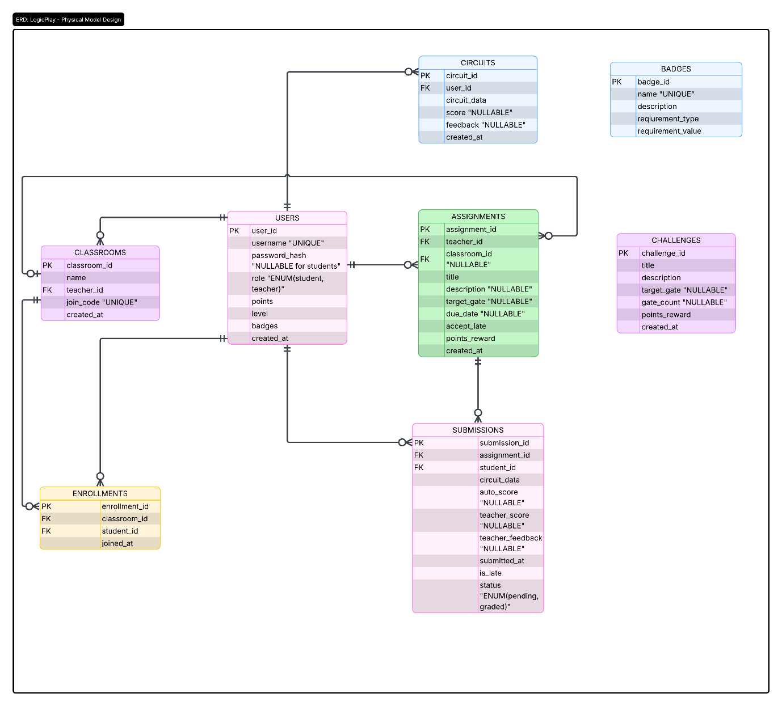
Figure 6: Entity Relationship Diagram of LogicPlay
Figure 6 shows the complete physical ERD. Tables appear as boxes with column lists. Primary keys have "(PK)" after them. Foreign keys have "(FK)" and an arrow pointing to the referenced table. The diagram uses crow's foot notation. lines with three-pronged ends for "many" relationships, single lines for "one." For example, the line from Users to Classrooms has a crow's foot near Classrooms and a single line near Users, meaning one user can own many classrooms but each classroom belongs to exactly one user. The Enrollments table sits between Users and Classrooms with crow's feet on both sides, so many students can enroll in many classrooms. The diagram is readable at a glance but contains all details needed for implementation.
6.6 User Interface Design
The interface balances two realities: students use phones, teachers use laptops. What works on a 24-inch monitor breaks on a 6-inch screen. So LogicPlay adapts, not through a separate mobile app, but through responsive design that reflows the same interface and experience.
Design Philosophy
Three principles guide the interface. First, show the circuit canvas first. Everything else like components, controls, challenges that can slide, collapse, or hide. The canvas is the work. Second, empty states must explain themselves. A blank screen with no guidance frustrates. A blank screen that says "Drag gates here to start building" teaches. Third, gamification elements (XP, levels, badges) appear everywhere but never block the main task. Progress is motivation, not distraction.
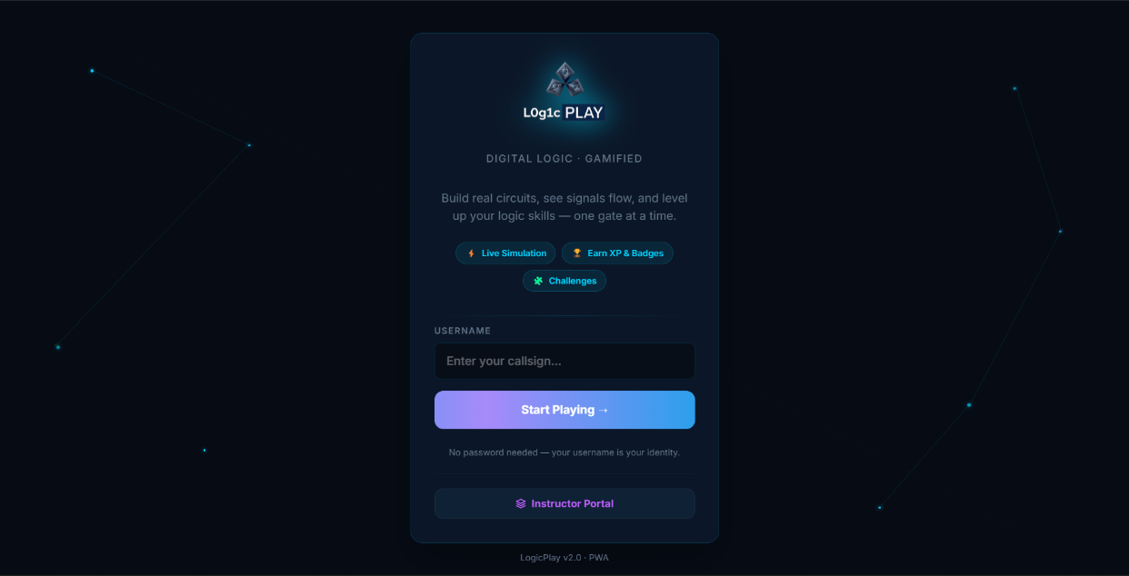
6.6.1 Landing Page
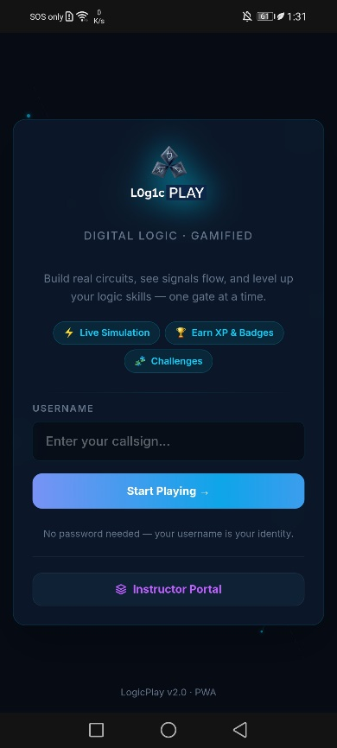
Figure 7: LogicPlay’s Landing Page (Deskto/PC view)

Figure 8: LogicPlay’s Landing Page (Mobile view)
The entry point is direct. "LogicPlay" appears with a stylized '1' replacing the 'i', a small nod to binary. The tagline reads "Digital Logic · Gamified." Below that, a short pitch: "Build real circuits, see signals flow, and level up your logic skills, one gate at a time."
Three feature badges sit beneath: "Live Simulation," "Earn XP & Badges," and "Challenges." These aren't decoration. They telegraph the core value before the user commits to anything.
The main action is a single field: "USERNAME" with placeholder "Enter your callsign..." No password for students. The design decision is intentional, young users forget credentials. Removing that friction means more practice, fewer help desk tickets. A button labeled "Start Playing →" submits.
Below the button, a note clarifies: "No password needed, your username is your identity." At the bottom, "Instructor Portal" links to teacher login. Small text reads "LogicPlay v2.0 · PWA”, the user knows this works offline.
6.6.2 Teacher Portal - Sign In and Registration
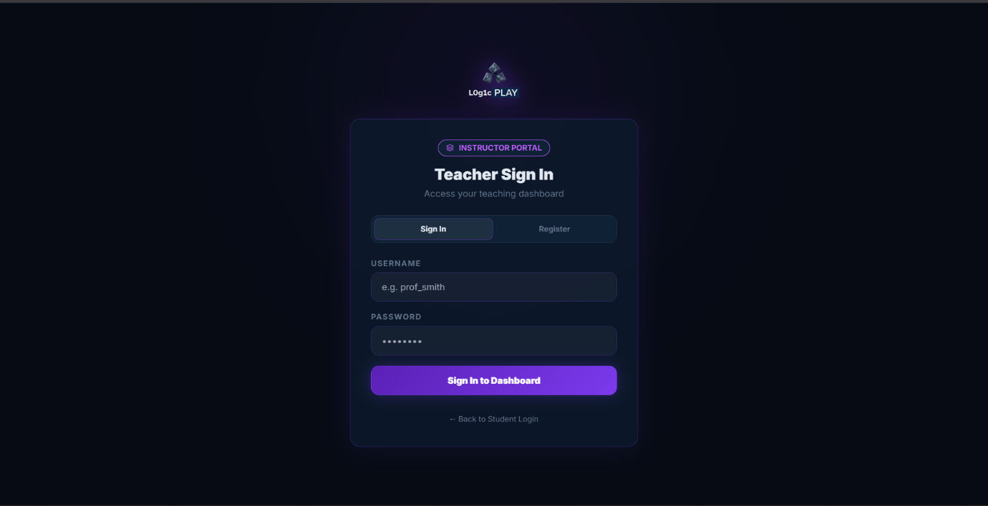
Figure 9: LogicPlay’s Teacher Login Form(Desktop/PC view)
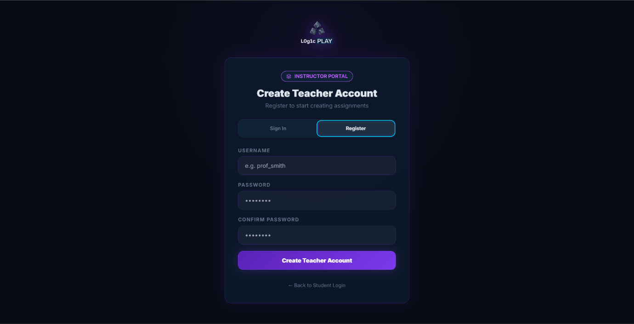
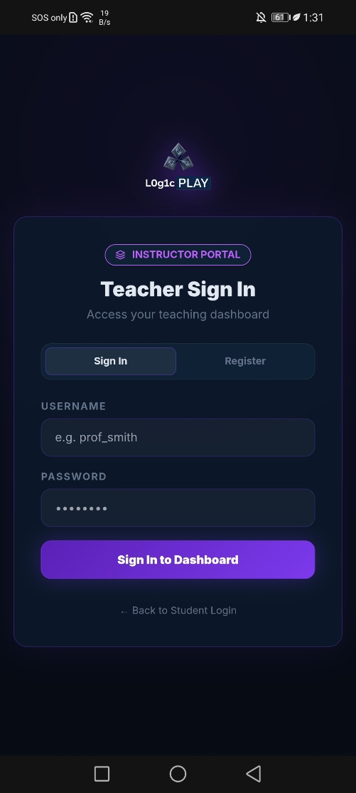
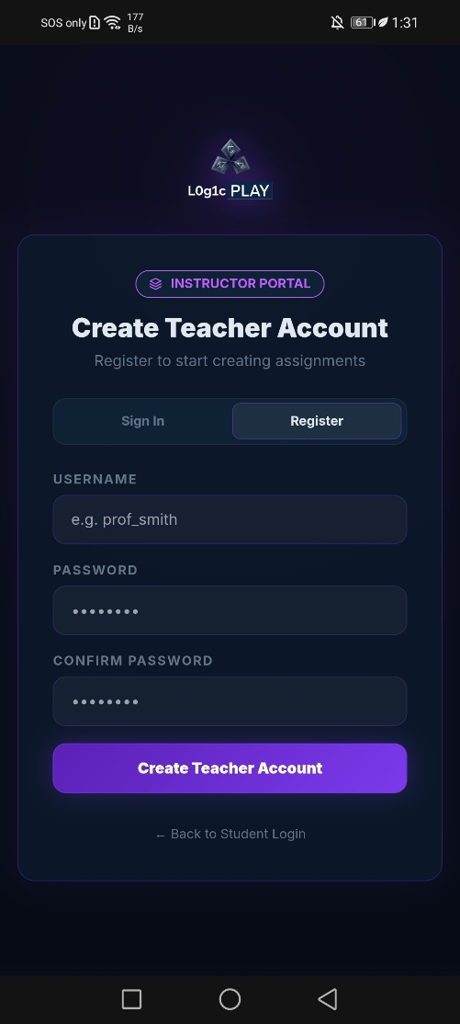
Figure 10: LogicPlay’s Teacher Registration Form (Deskto/PC view)

Figure 11: LogicPlay’s Teacher – Login and Registration Form (Mobile view)
Teachers get separate authentication. The sign-in screen asks for username and password—teachers need security that students don't. A "Sign In to Dashboard" button submits. Below that, a "Register" link for new accounts.
The registration screen collects username, password, and confirmation. A "Create Teacher Account" button completes the process. Both screens include a "Back to Student Login" link, useful for teachers testing the student experience.
The visual treatment matches the student side but uses slightly more formal language. "e.g. prof_smith" as a placeholder suggests naming conventions. No gamification here. Teachers are here to work.
6.6.3 Student Profile Screen (Mobile View)
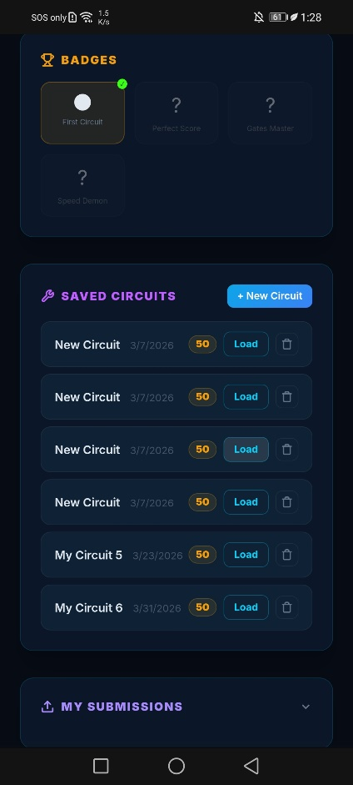
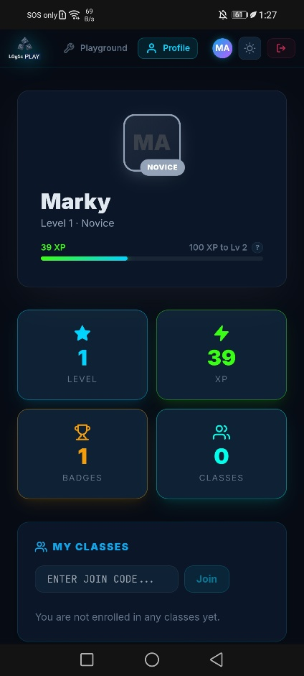
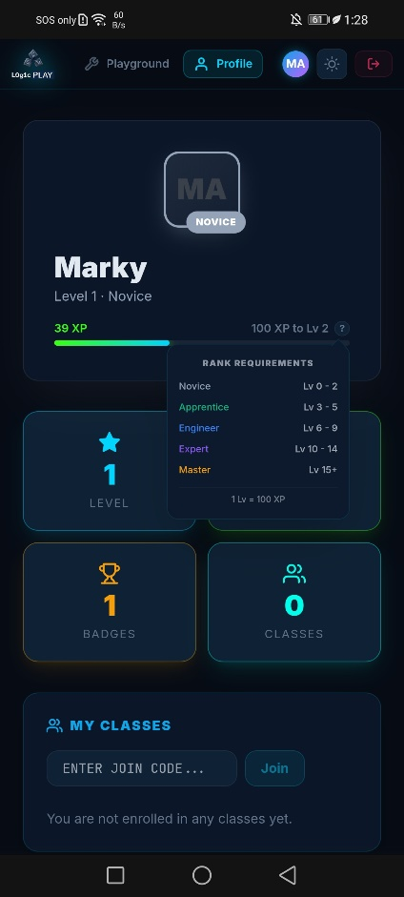
After login, mobile users see a profile screen that serves as dashboard. The layout stacks vertically, no sidebars on small screens.
Figure 12: LogicPlay’s Student Profile (Mobile View)
The header shows an avatar placeholder ("MA" for Marky) and level information. "Lv 1" appears with "NOVICE" as a subtitle. An XP bar shows "39 XP" and "100 TO LEVEL 2", the student knows exactly how close they are.
Four metric cards appear in a grid: LEVEL (shows 1), XP (shows 39), BADGES (shows 1), CLASSES (shows 0). Each card is tappable, likely navigating to detailed views.
Below the cards, rank requirements are explained. A collapsible or visible section shows:
- Novice: Lv 0 - 2
- Apprentice: Lv 3 - 5
- Engineer: Lv 6 - 9
- Expert: Lv 10 - 14
- Master: Lv 15+
A note clarifies: "1 Lv = 100 XP." This transparency matters. Students can calculate exactly what they need.
The MY CLASSES section shows a text field with placeholder "ENTER JOIN CODE..." and a "Join" button. Below that, helpful empty state: "You are not enrolled in any classes yet."
Badges appear as a section with icons. The screenshot shows four badge placeholders: First Circuit, Perfect Score, Gates Master, Speed Demon. Tapping a badge likely shows description and earn date.
Navigation sits at the bottom (visible in other screenshots): Playground and Profile tabs. The active tab highlights.
6.6.4 Playground - Circuit Builder (Mobile View)
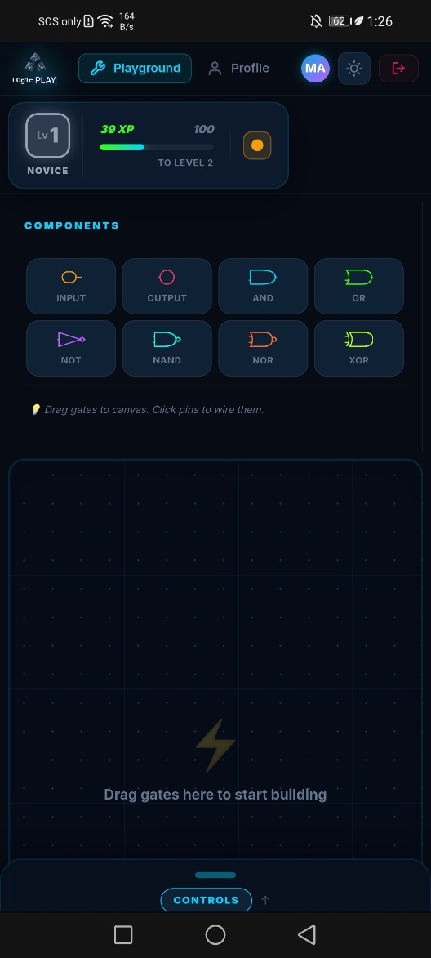
The playground is where students spend most of their time. On mobile, the interface prioritizes the canvas but makes controls accessible through tabs and drawers.
Figure 13: LogicPlay’s Main Dashboard – Playground (Mobile View)

Top Bar
The top shows "Logic PLAY" logo, student name (Marky), level badge "NOVICE," and XP indicator "39 XP" with "100 TO LEVEL 2." A menu icon (three lines) likely opens navigation or settings.

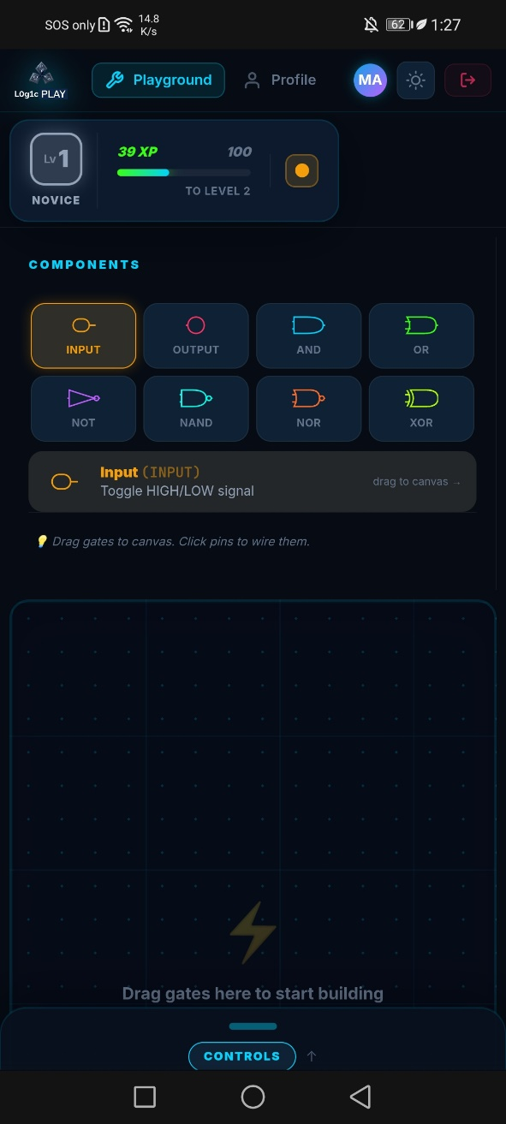
Component Library
Figure 14: LogicPlay’s Main Dashboard – Playground (Mobile View)
Below the top bar, a horizontal or vertical list of components appears. The screenshot shows:
- INPUT
- OUTPUT
- AND
- OR
- NOT
- NAND
- NOR
- XOR
Tapping INPUT reveals a tooltip or modal: "Toggle HIGH/LOW signal" with a hint "drag to canvas →". This teaches the component's purpose before the student even places it.

Canvas Area
Figure 15: LogicPlay’s Main Dashboard – Playground (Mobile View)

The canvas dominates the middle of the screen. When empty, it shows a prompt: "Drag gates to canvas. Click pins to wire them." Below that, a larger placeholder: "Drag gates here to start building." The double instruction reinforces the action, first drag a gate, then click pins to connect.

Controls Tabs
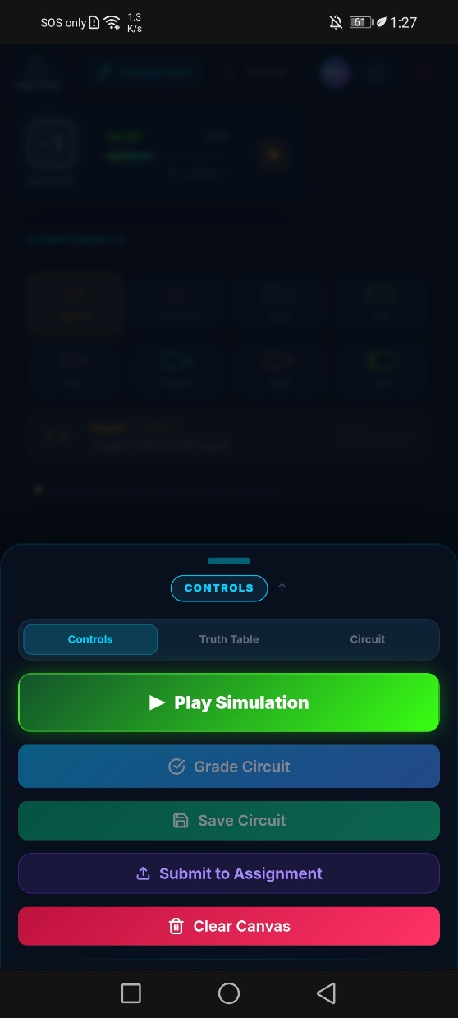
Below the canvas, three tabs: CONTROLS, TRUTH TABLE, CIRCUIT. This tabbed design saves space on mobile.
Figure 16: LogicPlay’s Playground Simulation Controls (Mobile View)

The CONTROLS tab shows action buttons:
- Play Simulation
- Grade Circuit
- Save Circuit
- Submit to Assignment
- Clear Canvas
These are stacked vertically, easy to tap with a thumb.
The TRUTH TABLE tab shows the circuit's truth table. When no INPUT gates exist, a helpful message appears: "Add INPUT gates to see the truth table." The system doesn't show an empty table and that’s what explains how to populate it.
The CIRCUIT tab shows metadata: GATES count, INPUTS count, WIRES count, OUTPUTS count. This gives students diagnostic information. Too many gates? The assignment might restrict them. Missing wires? The count reveals incomplete connections.
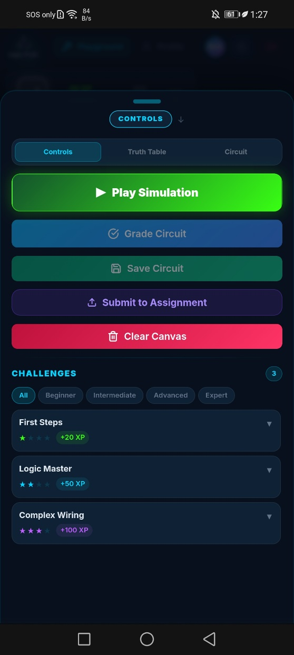
Challenges Section
Figure 17: LogicPlay’s Playground Simulation Controls (Mobile View)

Below the tabs, a challenges area appears. Filter chips run horizontally: All, Beginner, Intermediate, Advanced, Expert. Each challenge card shows:
- Title (e.g., "First Steps")
- Difficulty stars (★ ★ ★ ★ ★)
- XP reward (+20 XP)
The screenshot shows three challenges: First Steps (+20 XP), Logic Master (+50 XP), Complex Wiring (+100 XP). Tapping a challenge likely opens details or starts a guided mission.
6.6.5 Playground - Desktop View
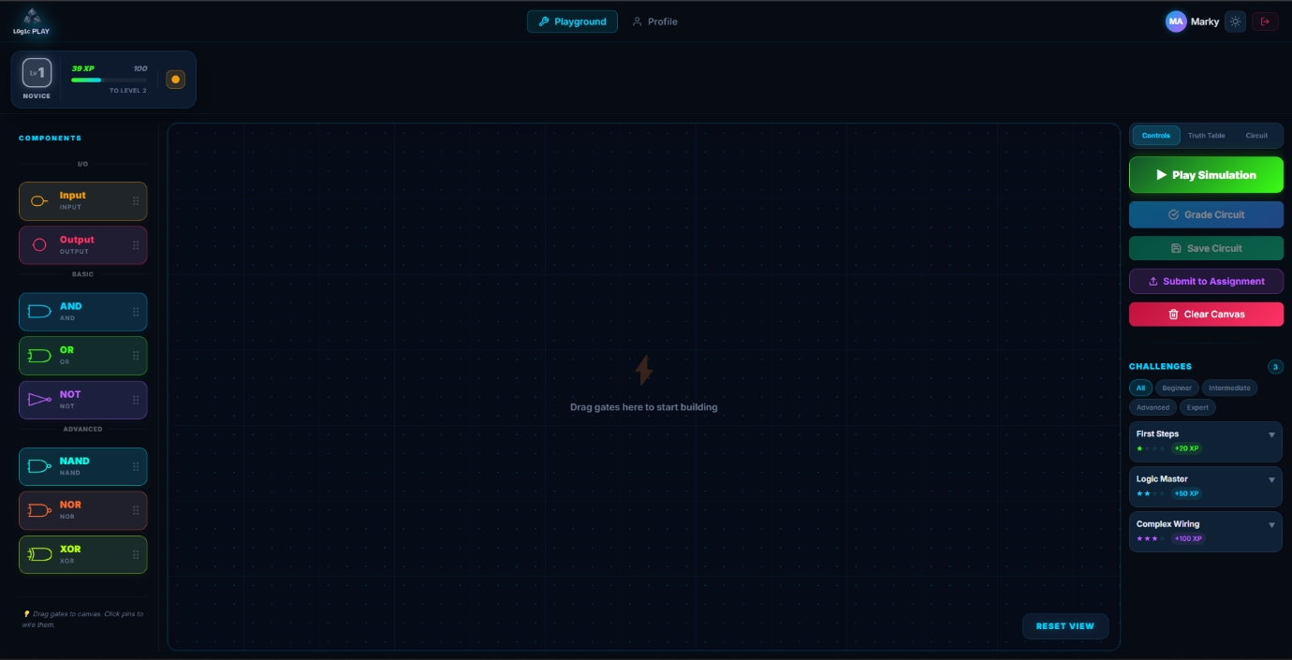
Figure 18: LogicPlay’s Main Dashboard - Playground (Desktop/PC View)
Desktop view uses a three-column layout. Component library on the left (vertical scroll), canvas in the middle, controls and challenges on the right. The tabbed interface disappears, everything visible at once. This matches expectation: desktop users have screen real estate, so use it.
The component library shows categories (Input, Output, Basic, Advanced) with gate icons. The canvas is larger, supporting complex circuits. The right panel shows action buttons, truth table, circuit info, and challenges stacked vertically.
6.6.6 Saved Circuits and Submissions Screen
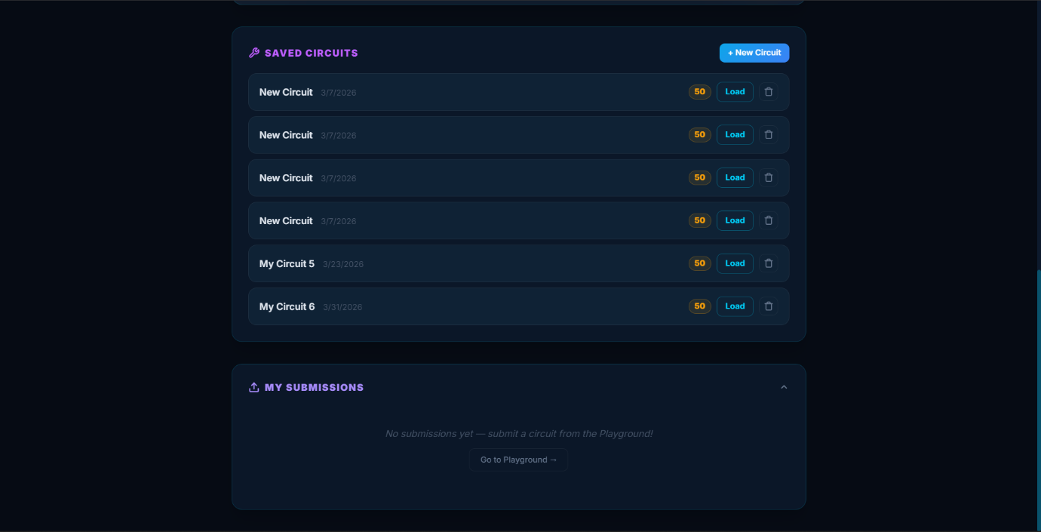
Figure 19: LogicPlay’s Profile Tab Dashboard – Saved Circuit (Desktop/PC View)
This screen (accessed from profile or a dedicated tab) shows two lists.
Saved Circuits
Each saved circuit entry shows:
- Circuit name (e.g., "My Circuit6")
- Date saved (e.g., "3/31/2026")
- Score (e.g., "50" — likely percentage or points)
- A "Load" button
A "+ New Circuit" button at the top creates a blank circuit. The screenshot shows six saved circuits, students can return to work in progress.
My Submissions
Below saved circuits, submissions appear. When empty, a message says "No submissions yet, submit a circuit from the Playground!" A "Go to Playground" link directs the student to the circuit builder. Empty states here are instructional, not dead ends.
6.6.7 Badges Collection Screen
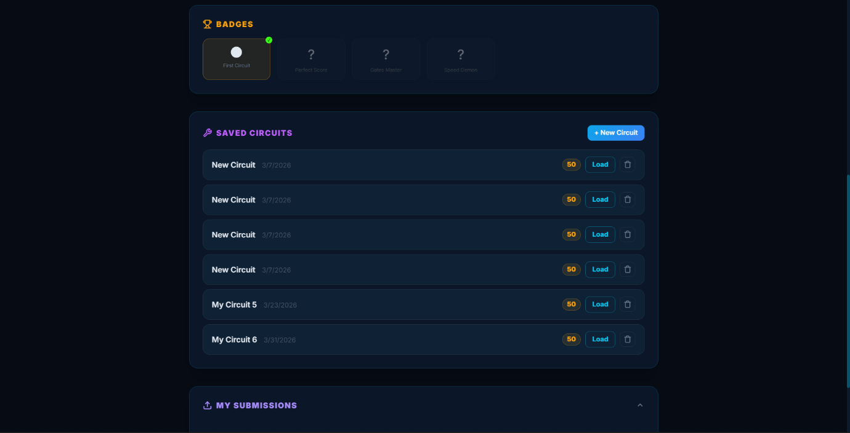
Figure 20: LogicPlay’s Profile Tab Dashboard – Badges (Desktop/PC View)
A dedicated badges screen shows earned and unearned badges. The screenshot shows four badges in a grid: First Circuit, Perfect Score, Gates Master, Speed Demon. Each badge appears as a card with an icon and name. Tapping likely shows description, earn date, and requirement for unearned badges.
6.6.8 Teacher Dashboard - Overview (Desktop)
The teacher dashboard assumes desktop use, managing classes on a phone is possible but perhaps can be painful. The interface uses a left sidebar for navigation and main content area for data.
Header Stats
Three cards show key metrics:
- CLASSES (0)
- TASKS (0)
- STUDENTS (12 – test players/students)
These numbers update in real time. The student count (12) persists even with no classes, from a test data.
Tab Navigation
Tabs across the top: My Class, Assignments, Submissions, Analytic. Each shows relevant content.
My Class Tab
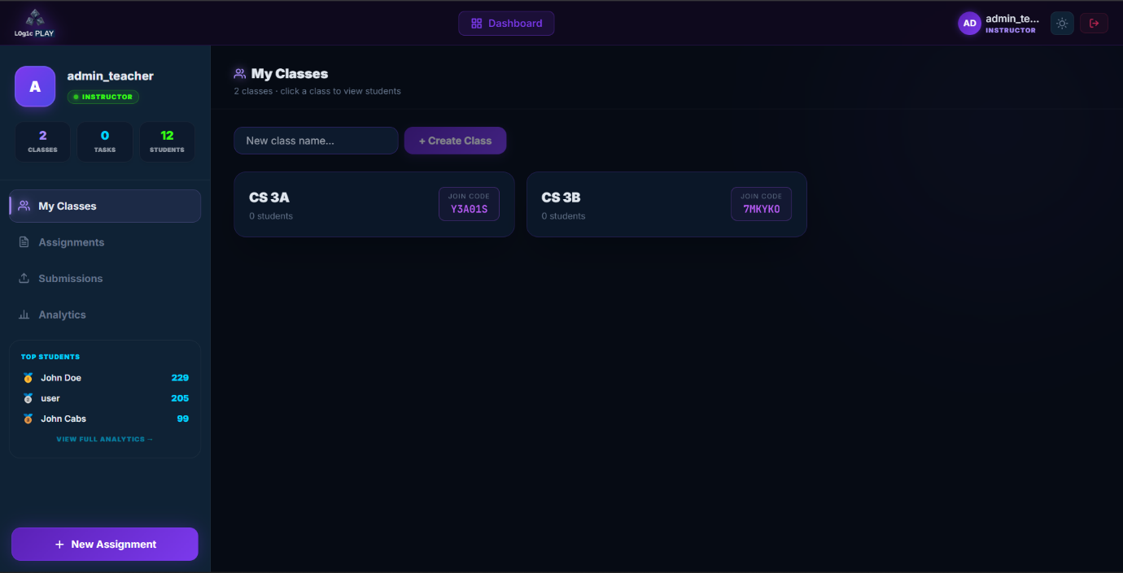
Figure 21: LogicPlay’s Teacher Dashboard – My Classes Tab (Desktop/PC View)
Shows a list of classes. When empty: "0 classes · click a class to view students" with a "Create Class" button. A text field "New class name..." appears for quick creation. Empty state message: "You haven't created any classes yet."
Assignments Tab
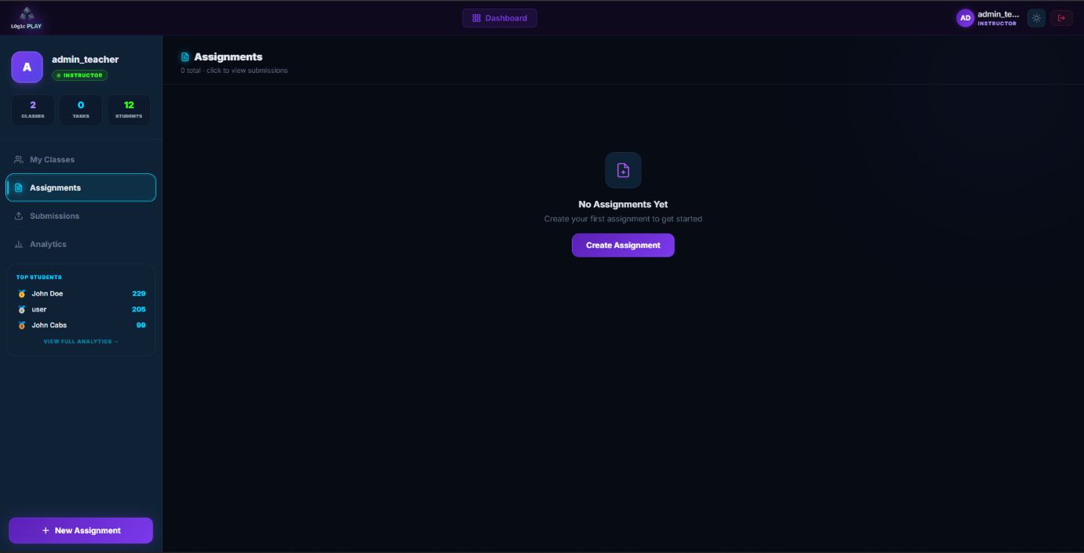
Figure 22: LogicPlay’s Teacher Dashboard - Assignments Tab (Desktop/PC View)
Shows assignments for the selected class. When empty: "0 total · click to view submissions" with a "Create Assignment" button. A card states "No Assignments Yet Create your first assignment to get started."
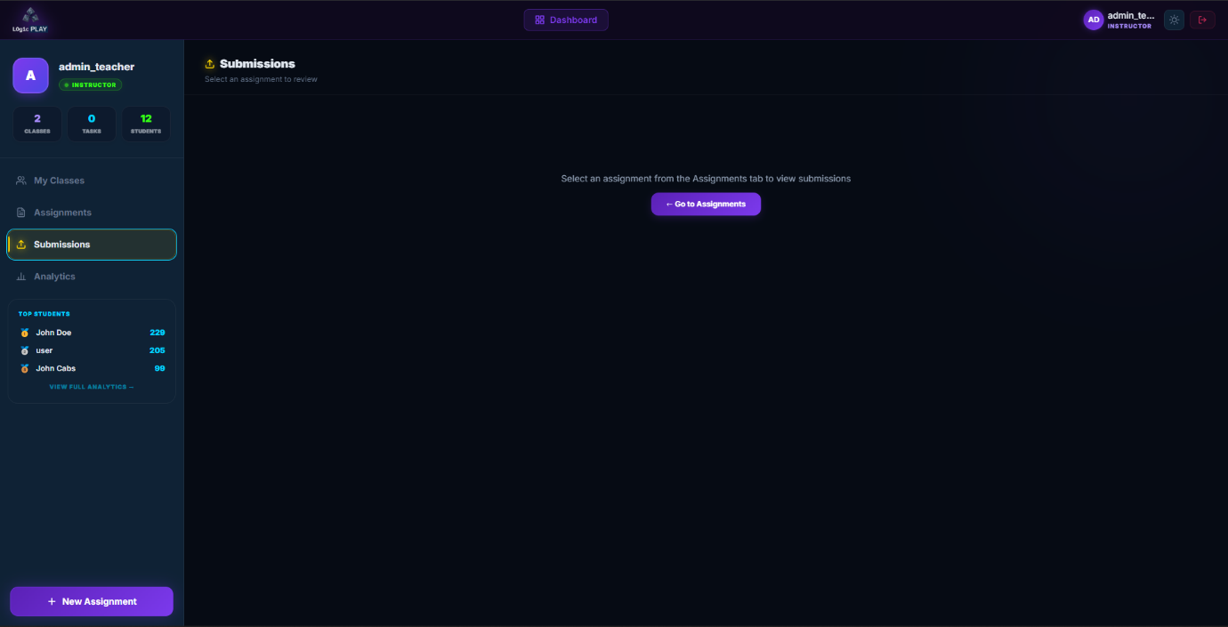
Submissions Tab
Figure 23: LogicPlay’s Teacher Dashboard – Submission Tab (Desktop/PC View)

Shows submissions for a selected assignment. When no assignment selected: "Select an assignment to review" with a card: "Select an assignment from the Assignments tab to view submissions" and a "Go to Assignments" button. The interface guides teachers through the workflow rather than dumping them into an empty table.
Analytic Tab
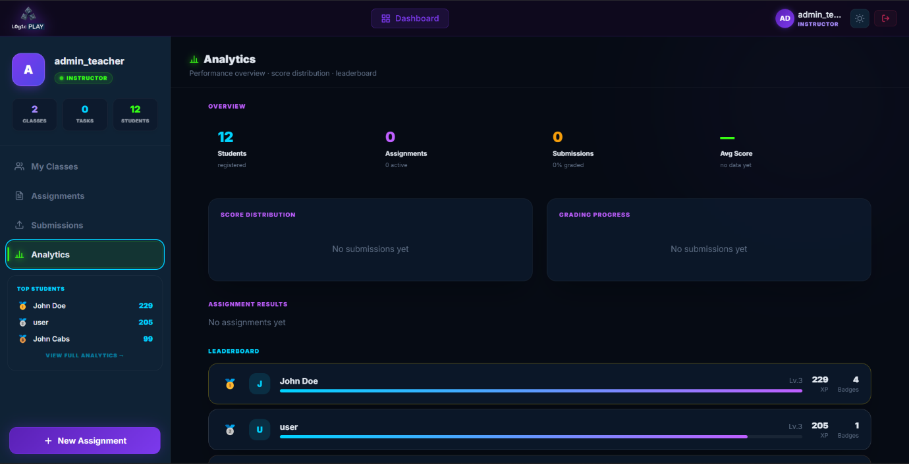
Figure 24: LogicPlay’s Teacher Dashboard – Analytics Tab (Desktop/PC View)
Shows performance data in cards and charts:
Overview metrics:
- Students registered (12)
- Assignments (0 active)
- Submissions (0% graded)
- Avg Score (no data yet)
Score Distribution: Bar chart placeholder "No submissions yet"
Below that, will be the leaderboard and assignment results.
6.6.9 Create Assignment Form
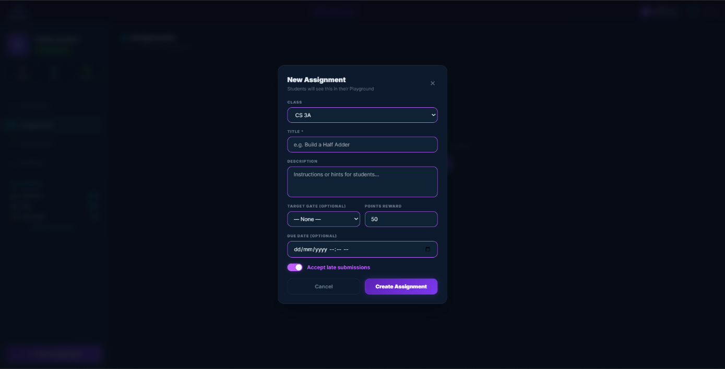
Figure 25: LogicPlay’s Teacher Dashboard – Create New Assignment Modal (Desktop/PC View)
The form collects:
- CLASS (dropdown will display "No classes available (Create one first)" when empty)
- TITLE * (required, placeholder "e.g. Build a Half Adder")
- DESCRIPTION (textarea "Instructions or hints for students...")
- TARGET GATE (OPTIONAL) dropdown with "None" as default
- POINTS REWARD (number input, default 50)
- DUE DATE (OPTIONAL) date picker, with filtering cannot create an assignment of past dates.
- Accept late submissions (checkbox)
Cancel and Create Assignment buttons at the bottom. The asterisk on TITLE indicates required field.
6.6.10 Empty States Throughout
The system handles empty states carefully. Every empty list explains why it's empty and what to do next:
- No classes (student): "You are not enrolled in any classes yet" + join code field
- No classes (teacher): "You haven't created any classes yet" + create button
- No assignments: "No Assignments Yet Create your first assignment to get started" + button
- No submissions for assignment: "Select an assignment from the Assignments tab to view submissions" + button
- No INPUT gates in truth table: "Add INPUT gates to see the truth table"
- No challenges in category: "No challenges in this category"
This pattern prevents the "now what?" feeling. Users always know the next action.
6.6.11 Responsive Behavior
The interface detects screen size and adjusts:
Mobile (below 768px):
- Single column layout
- Bottom navigation (Playground, Profile)
- Tabbed controls (CONTROLS, TRUTH TABLE, CIRCUIT)
- Collapsible component library (drawer or modal)
- Larger touch targets (minimum 44px)
- Challenges as horizontal scroll
Desktop (above 768px):
- Three-column layout (components | canvas | controls)
- Persistent sidebars
- All tabs visible simultaneously
- Smaller touch targets (mouse-optimized)
- Challenges as vertical list
Tablet (768px to 1024px):
- Hybrid approach, two columns (components+canvas | controls)
- Some collapsing but less than mobile
6.6.12 Visual Design Details
The color scheme uses indigo as primary (#4F46E5) and emerald as secondary (#10B981). Buttons use solid indigo for primary actions (Start Playing, Create Assignment), outline indigo for secondary (Cancel, Back to Student Login).
Typography uses system sans-serif (SF Pro on iOS, Roboto on Android, Inter on desktop). This ensures fast rendering, no custom font loading delays.
Cards have subtle shadows (box-shadow: 0 1px 3px rgba(0,0,0,0.1)). Active states have elevation changes to simulate pressing.

The XP bar uses a gradient fill (emerald to indigo) with rounded corners. Level badges use colored backgrounds matching rank: Novice (gray), Apprentice (green), Engineer (blue), Expert (purple), Master (gold).
6.6.13 Accessibility Considerations
Touch targets on mobile are minimum 44x44px per Apple's guidelines. Buttons have sufficient contrast (WCAG AA minimum). The canvas supports keyboard navigation on desktop, arrow keys move selected gates, delete key removes them.
Screen reader announcements occur when circuits are graded ("Score received: 85 percent") and when levels change ("Congratulations, you reached Level 2"). The PWA supports reduced motion preference, animations disable for users who need that.
6.6.14 Offline Behavior
The service worker caches the interface. Students opening the app without internet see the last loaded version. Saved circuits store in IndexedDB locally. Submissions queue and send when connection returns. The UI shows a small indicator when offline and then a cloud with a slash, but doesn't block the main workflow. Circuit building works fine without internet. Only submission and saving to server require connectivity.

6.6.15 Test Cases
Functional testing ensures each feature works as intended. Test cases document inputs, expected outputs, and actual results.
Table 1: User Authentication Test Cases
Test Case | Input | Expected Output | Result | Interpretation
TC-AUTH-01:  No credentials | Empty username, empty password | Error message: "Username and password required"
TC-AUTH-02: Correct credentials | Valid username, valid password | Redirect to dashboard, JWT stored
TC-AUTH-03: Correct username, wrong password | Valid username, invalid password | Error message: "Invalid credentials"
TC-AUTH-04:  Wrong username, correct password | Invalid username, valid password | Error message: "Invalid credentials"
TC-AUTH-05:  Both wrong | Invalid username, invalid password | Error message: "Invalid credentials"
TC-AUTH-06:  SQL injection attempt | admin' -- as username | Treated as literal string, no SQL injection
TC-AUTH-07: Registration new user | New username, valid password, role student | Account created, redirect to login
TC-AUTH-08: Duplicate registration | Existing username, any password | Error message: "Username already exists"
TC-AUTH-09:  Access protected route without token | Direct GET to /api/submissions | 401 Unauthorized response
TC-AUTH-10: Expired token | Valid but old JWT | 401 Unauthorized, prompt to login again

Table 2: Circuit Submission Test Cases
Test Case | Input | Expected Output | Result | Interpretation
TC-CIRC-01:  Valid simple circuit | AND gate with both inputs high | Score 100, correct truth table match
TC-CIRC-02:  Invalid circuit | OR gate with wrong truth table | Score 0, feedback "Output incorrect for input (0,1)"
TC-CIRC-03: Incomplete circuit | Gate with unconnected output | Error message, submission rejected
TC-CIRC-04:  Too many gates | Circuit exceeding gate limit | Warning but submission allowed, score penalty
TC-CIRC-05:  Late submission | Submit after due_date with accept_late=true | Marked is_late=true, no penalty
TC-CIRC-06: Late submission not allowed | Submit after due_date with accept_late=false | Rejected, error message
TC-CIRC-07: Empty circuit | No gates placed | Error: "Cannot submit empty circuit"
TC-CIRC-08: Malformed JSON | Hand-crafted request with wrong structure | 400 Bad Request, validation error

Table 3: Classroom Management Test Case
Test Case | Input | Expected Output | Result | Interpretation
TC-CLASS-01: Teacher creates classroom | Valid classroom name | Classroom created, join_code generated
TC-CLASS-02: Duplicate classroom name | Same teacher, same name | Allowed (no unique constraint on name)
TC-CLASS-03: Student joins with valid code | Correct join_code | Enrollment created, student added to roster
TC-CLASS-04: Student joins with invalid code | Wrong join_code | Error: "Invalid join code"
TC-CLASS-05: Student joins already enrolled | Valid code but already enrolled | Error: "Already enrolled in this classroom"
TC-CLASS-06: Teacher views roster | Classroom ID | List of enrolled students with join dates
TC-CLASS-07: Student leaves classroom | Classroom ID | Enrollment removed, submissions preserved

Table 4: Gamification Test Cases
Test Case | Input | Expected Output | Result | Interpretation
TC-GAME-01:  Points accumulation | Submission scored 85 | 85 points added to user.points
TC-GAME-02:  Level up threshold | Points cross 100 threshold | Level increases, notification sent
TC-GAME-03:  Badge earned | Complete requirements for "Perfect Score" | Badge awarded, appears in profile
TC-GAME-04: Multiple badges at once | Submission triggers two badges | Both awarded, two notifications
TC-GAME-05:  Badge already earned | Trigger same badge again | No duplicate badge, no notification

Each test case will be executed with 10 attempts. A test passes if all 10 attempts produce the expected output. The acceptable rate is 100% for critical functions such as (authentication, submission saving) and 90% for non-critical functions like (animations, notifications).

6.7 System Requirements
The system must run on modest hardware. Students use school-provided laptops and personal phones—neither is top-of-the-line.
6.7.1 Software Requirements
Table 5: Software Requirements
Software | Version | Description
Operating System (Server) | Ubuntu 20.04+ or Windows Server 2019+ | The backend runs on Linux during development; Windows support possible but not tested
Operating System (Client) | Any modern OS | Windows 10+, macOS 11+, ChromeOS, iOS 15+, Android 11+
Web Browser (Desktop) | Chrome 90+, Firefox 88+, Edge 90+ | Safari 14+ works but p5.js performance may vary
Web Browser (Mobile) | Chrome for Android, Safari for iOS | PWA installation supported on both platforms
Python | 3.9+ | Backend runtime
Node.js | 18+ | For building the frontend (development only; users don't need this)
SQLite | 3.35+ | Embedded database, no separate installation needed
FastAPI | 0.100+ | Python web framework
React | 18+ | Frontend library (compiled to static files)
p5.js | 1.7+ | Canvas simulation library

6.7.2 Hardware Requirements
Table 6: Hardware Requirements
Hardware | Minimum | Recommended | Description
Server CPU | 2 cores, 2 GHz | 4 cores, 2.5 GHz | Handles API requests and auto-grading
Server RAM | 4 GB | 8 GB | SQLite is lightweight; RAM matters for concurrent users
Server Storage | 20 GB SSD | 50 GB SSD | Database and user uploads (circuit JSON is small)
Client CPU (Desktop) | 2 cores, 1.5 GHz | 4 cores, 2.0 GHz | p5.js simulation uses CPU for animation
Client RAM (Desktop) | 4 GB | 8 GB | Browser memory for canvas and React
Client Storage (Desktop) | 100 MB free | 500 MB free | PWA caches assets locally
Client CPU (Mobile) | Any modern phone CPU | Mid-range or better | Older phones may struggle with complex circuits
Client RAM (Mobile) | 2 GB | 4 GB | iOS and Android both work within these limits
Network | 1 Mbps | 5 Mbps | Submission requires upload; simulation works offline
Screen Resolution | 800x600 | 1280x720 or higher | Canvas needs enough space for gates

The server requirements assume about up to 50 concurrent users. And for larger deployments, upgrading to PostgreSQL and adding more RAM would be necessary for the system to stay efficient.

References

Del Carmen, J., & Bulaclac, J. (2026). Perceived usefulness of logic circuit design in enhancing technical proficiency among BSIT students in Nueva Ecija University of Science and Technology- Peñaranda Off-Campus. https://www.researchgate.net/publication/400788723_Perceived_Usefulness_of_Logic_Circuit_Design_in_Enhancing_Technical_Proficiency_Among_BSIT_Students_in_Nueva_Ecija_University_of_Science_and_Technology-_Penaranda_Off-Campus

Antipolo, J. J., & Lopez, M. L. (2021). Simulation application: Improving the procedural knowledge of electronics technology students in electric circuits. American Journal of Educational Research. https://www.researchgate.net/publication/350784074_Simulation_Application_Improving_the_Procedural_Knowledge_of_Electronics_Technology_Students_in_Electric_Circuits

Thomas, A. J., & Kumar, S. R. (2024). A study on progressive web apps: Revolutionizing user experiences and redefining web applications. ShodhKosh: Journal of Visual and Performing Arts. https://www.granthaalayahpublication.org/Arts-Journal/ShodhKosh/article/view/5977

Ali, D. F., Ahmad, A. R., Wahab, N. A., Kamaruzaman, N., & Omar, M. (2024). Enhancing visualization skills in engineering education using virtual and augmented reality environment. International Journal of Academic Research in Progressive Education and Development. https://ijarped.com/index.php/journal/article/view/3163

Paiva, J. C., Leal, J. P., & Figueira, Á. (2022). Automated assessment in computer science education: A state-of-the-art review. ACM Transactions on Computing Education, 22(3), Article 34, 1-40. https://repositorio.inesctec.pt/server/api/core/bitstreams/49605368-51db-4de7-97fa-de7922b28790/content

Dhobale, K., Ekhande, S., Gadhave, P., & Parate, R. (2024). Mobile application for computer engineering department to improve students skillsets. INTERANTIONAL JOURNAL OF SCIENTIFIC RESEARCH IN ENGINEERING AND MANAGEMENT, 08(11), 1-7. https://www.researchgate.net/publication/385761631_Mobile_Application_for_Computer_Engineering_Department_to_Improve_Students_Skillsets

Gamarra, M., Dominguez, A., Velazquez, J., & Páez, H. (2022). A gamification strategy in engineering education—A case study on motivation and engagement. Computer Applications in Engineering Education. https://www.researchgate.net/publication/355570022_A_gamification_strategy_in_engineering_education-A_case_study_on_motivation_and_engagement

