

**Spotify Internationalization Analysis**

**Arb Maksuti**

1. **Introduction**

Spotify is the world’s largest music stream service provider. Based in Stockholm, Sweden, the company was founded by Daniel Ek and Martin Lorentzon in 2006, as an alternative way to legally stream music, leveraging on the increasing internet speed and capacities which characterized the 2000s.

The service was launched for consumers in 2008, and since then has grown to encompass more than 60 million songs from artists world-wide. Due to its innovative playlist generation and suggestion algorithms, Spotify was able to cement itself as the de facto leader of the online music streaming industry in a relatively short time, all while successfully cornering other industry incumbent music and podcast streaming services, like Pandora and Deezer. As the market of digital media streaming services has grown Spotify has successfully tackled with both SoundCloud and Tidal, arguably winning the music streaming race (Issarice.com, 2019).

These wins have, on a large part, been a result of Spotify’s internationalization efforts, which have diffused legal music streaming in countries and population segments which were fully dependent on illegally obtained music and other forms of digital media. In many aspects Spotify revamped the market for music, by catering directly to the digital consumer, and in many cases allowing artists to have more control on their work.

Spotify started providing its services for the first time in February 2009, with an initial launch in the United Kingdom, which quickly generated clout for the new application, which was still testing and providing free memberships. Its next big step was launching in the United States in 2011 which allowed Spotify to obtain with more recognition, and as a result more users. It had become evident that there was huge demand for a streaming-based music application that resonated with users (BBC, 2018).

Its growing operations were met with growing demands and peculiarities related to the specific business model the company followed. To meet these challenges, Spotify understood that its international operations would have to rely on effective localization of services and tailored music suggestions, based on region and the musical preferences of similar individuals within the region. This localization approach allowed the company to grow from a small team in Sweden into a large international business with 54 offices spread across 25 countries.

These strategic moves to expand globally and tackle with US giants in the sector came at no small cost, pushing the profitability window for Spotify quite a few years; with the company becoming profitable in February of 2019, a decade after its launch. Nonetheless the result of taking these risks head-on was a successful catalytic process which pushed users to re-envision music ownership, teaching them to seek access to music through subscription fees, versus the traditional physical or digital static ownership. Spotify’s model effectively merged local radio dynamics, a one-point access to digital goods and a more effective take on digital ownership – all of which require state of the art international coordination, strategizing and efficient organization from the company. This specific combination allows Spotify to both capitalize on the global aspects of its business, and get the most out of the localization of their platform, creating a highly interconnected and customized experience for its users. Spotify has been able to generate a very strong positive response in both areas of its international strategy approach (Jones, 2018).

1. **Internationalization strategy (I/R framework)**

Spotify strategy relies on multiple levels of internationalization to optimize not only its reach to customers, but also to optimize its fiscal and operational activities.

Spotify’s tiered ownership heavily relies on international financial dynamics, to appropriately manage monetary inflows and outflows, as well as investments. Essentially, Spotify Technology S.A., located in Luxembourg acts as a holding company for Spotify’s other companies by controlling 100% of the Swedish entity Spotify A.B. which acts as a seat of management, planning and development of all related companies.

On the other hand, Spotify A.B. is the owner of all other Spotify entities distributed in 57 offices located on 25 countries. Out of these companies, the UK based Spotify Ltd., and the US based Spotify USA Inc., act as more central operational and managerial centers for the company in terms of broader strategy, especially because they also act as steppingstones for Spotify to partake in stock market operations. The other international Spotify entities work on providing localized content, music, and offers to the international reach of the application, tailoring services and allowing for the local market (Brown, 2019).

This approach has allowed Spotify to jump ahead of its competitors, who weren’t able to set out such a diverse and targeted business operation in their beginnings, inadvertently giving Spotify the required market space to grow financially and operationally in many regions. In this case Spotify was able to leverage local music and musicians to increase the propensity of the local populations to jump on the music-streaming bandwagon – due to the sheer promise of accessibility of frequently overlooked local artists along with more famous world-wide artist to the target audience. This tactic, while more expensive, in addition to being harder to control and manage in the beginning, set out a success path for Spotify which in time morphed the company into the industry standard in every country for music publishing.

In addition to strategic aspects, Spotify tends to be an outlier in the way it manages its own employees, focusing on increasing personal employee accountability and leveraging talent and interests.

To do so, Spotify bases its workflows entirely on the Agile methodology which is a standard approach used by innovative and development based companies. This approach allows Spotify to balance the act between its software developers and its business efficiently – while allowing employees to have the freedom to innovate and through an egalitarian system, exert their impact onto the operations and the company at large. This approach in essence is a balancing act to push employees to both be accountable of their work and very conscientious, but also to feel free to optimize and innovate within the Spotify environment (Brown, 2019).

It’s evident that this more technologically tailored management method has worked for Spotify, which now boasts a few thousand people working worldwide for the company, who cohesively and incrementally have improved the company in many aspects.

Spotify’s so-called Squads and Tribes model, achieves high levels of freedom, accountability, and alignment, by ditching management paradigms, and allowing for a flexible and dynamic leadership role within the Squad, which can change based on the problem at hand, rather than using fixed positions that provide specific roles. Along with its Agile approach to development and project management, Spotify has leveraged it’s company culture to imbue its human resources with the same benefits and flexibility inherent from the Agile method. In Spotify’s case, flexibility and plasticity have been major characteristics that have set Spotify apart from its competitors.

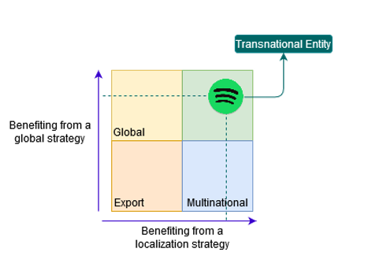As a Transnational company, Spotify has created its very own a structural model, merging characteristics of the Flatarchy model when it pertains to intra-team management, and of the matrix management model when it pertains to the business at large. Due to its complexity and focus on the value of information diffusion within the entity, Spotify has been categorized as an having N-form organizational structure, which is heavily based on the principle of shared integrational systems of knowledge diffusion throughout the company and its operations. Spotify’s unique N-form uses the Squads and Tribes as a way to cluster and match skills and knowledge within the company – with the clear goal of producing higher value in a shorter and more efficient time-span.

The inherent flexibility of the workforce as managed by Spotify allows for very high adaptability to market changes, ease of approaching new markets and market segments, allowing for reactionary as well as long term strategic goals to be easily implemented in a short timeframe. Spotify further strengthens this system by grouping people of certain skills within “Guilds”, or groups related to certain services, skills and knowledge, which based on their common ground can be grouped and they used or deployed to work on new, or highly specific projects and challenges in a fast and accurate manner – whereas specialized individuals from within the company can be identified and assigned to projects based on their skills.

These capacities and the method of work, along with company’s focus on spreading knowledge and capitalizing on human capital in a large pool operating synchronously in many countries, makes Spotify a legit Transnational Entity based on the Integration/Responsiveness Framework. Its managerial methods and reliance on technology facilitate operational processes have created a tight knit, highly self-regulated innovation organism.

|  |  |
| --- | --- |
| Spotify’s Table of Characteristics | |
| Transnational Entity | |
| Role of Subsidiary | Localized and differentiated contribution. Production of global level and local level utility for the main entity. Enhancement of Global Competitiveness |
| Network Model | Integrated network |
| Vertical Product Flows | Bidirectional |
| Inter-subsidiary Product Flows | High |
| Centralisation of Decisions | Medium level centralization of decision with one main management office and two high level subsidiaries with decision making power (US, UK). Other subsidiaries have local decision making power. |
| Management Transfers, Visits, Joint Working Teams | High – With a complex and highly focused on efficiency management system, the entity has high levels of egalitarianism, specialization and collaboration. |
| Centres of Excellence | High - Very focused on knowledge and know-how diffusion within the company |
| Product Modification | High – Localized versions of Spotify target a multitude of markets in a customized fashion. |
| Local Production | Medium – Most of the technology is produced by its centers of excellence and its software development teams, while localization happens based on local offices. |
| Dependency | Interdependence – The company relies on each of its offices to deliver its high quality service |

1. **Motives for internationalization**

Spotify identified very early on its objective, both in terms of financial and operational strategy. It understood that to really make a profit in a very new and highly competitive industry, it had to rely on two large pool of resources, a large number of artists and songs it’d be licensed to stream through a royalty model, as well as a large pool of listeners. This model can only come to fruition in its true potential when it taps the global markets.

With this goal in mind, Spotify used its ambitions to drive its’ strategy in terms of internationalization, pursuing immediately an international approach, by registering in the UK, and then in the US in a relatively short time span, while heavily relying on investment and running on a loss. While very risky, this strategy created a network of users and recognition which would set out to be a very profitable path, yielding 130 million premium users as of the and a total of 299 million active users for first Quarter of 2020. Non-premium users still do generate revenue through in-app advertising, making use of the freemium pricing model to provide further incentive for them to turn premium (Statista, 2020).

Thus Spotify can be categorized as a company that relies on Market-seeking as the main optimization mechanism within its strategic approach. In the same time Spotify has displayed a keen interest in following markets with a high level of resources and financial benefits, including creating a seat in Luxembourg, and establishing a US entity that allows them to get listed in the NYSE (New York Stock Exchange) – allowing the entity to have access to a much larger pool of investment and establishing it as a global market leader.

Thus four main categories of driving the decision for internationalization can be identified for Spotify:

1. Market seeking objectives – which focus on chasing a wider market, thus making use of the economies of scale and leveraging on a wide array of both content producers and consumers;
2. Investment or Asset seeking objectives – related directly to their need to pull in investment, and leverage the benefits of going public;
3. Institutional and legal optimization objectives – that relate to Spotify’s financial structure, and ensuring to benefit from different tax legislations;
4. Competition based objectives – which focus on putting Spotify on a plane leveled field with its competitors, both in financial and operational terms.

In terms of aligning with their goals and motivations, Spotify has moved very fast in its 12 years of market operation, and has successfully established an efficient interconnected system of entities which effectively tactically and strategically prime it to leverage on both market dynamics, and asset availability, in a wide range of markets simultaneously, transforming this management hardship into a tangible strong point (Michael Mankins, 2017).

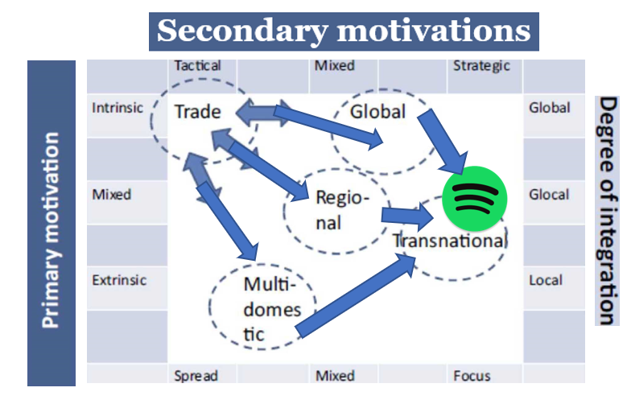These characteristics would put the company on a Stage 3 development in terms of aligning their motivations and goals, with their operational dynamics. In the case of Spotify all three avenues of Globalization, Regional and Multidomestic were followed in the same time tailoring for multiple regions, and countries, while adapting economies of scale with the purpose of establishing a large base of cashflows consumers, which can then be converted and retained, either as premium users or as freemium ad-based users which make use of Spotify’s very large repertoire of music, podcasts and digital media.

These moves in many ways were conditioned by the first movers in the industry like iTunes, which during the genesis of Spotify used different strategies in providing music services, focusing mainly on the sale of tracks and albums, and much less on the music as a service, royalty based method used by Spotify. Hence, the immediate internationalization strategy the company followed was a necessity in the light of the external factors, competition and the scale needed for the service to be successful.

In terms of customized content, Spotify has mostly followed a country-by-country approach, but in some cases larger regions have been aggregated together in the initial offering of the service, as both a market gauge and as a price savvy way to enter new high-risk markets, including the recent expansion of Spotify to eastern European countries, and Russia.

Nonetheless, Spotify, governing more than 50% of the total music streaming market, will inevitably keep expanding to increase its reach and probably approach developing markets, with more targeted low-cost offers of service, as a strategy to wean off the dependence of lower income countries from pirated music (Statista, 2020).

1. **IHRM Activities**

As described in Spotify’s approach to optimization and IR Framework, the company has been one of the first movers in terms of embracing a flatter organizational design, focused on knowledge generation, specialization of the workforce capacities and integration of capabilities across the company. Spotify’s method focuses on a specialization approach where teams are named ‘squads’, and are pushed to act like independent startups where each squad completes and oversees different tasks within an operational flat management structure.

This management philosophy allows the company to create a participative environment where managerial levels act as a consultative filter, an approach that allows for a fast flow of ideas and provides opportunities for employees and team members to partake actively into the decision-making processes, in essence capitalizing not just on the skills of the people they hire but on their ideas as well (Suarez, 2019).

Not only has Spotify achieved a financial competitive advantage, but this method of operation has allowed for very agile and swift changes to products to follow trends and demands, responding to the feedback of consumers in a very time-effective and tangible manner.

The Tribes and Squads model demands for individual who can actively be accountable and self-regulating in their jobs, making it an imperative to both hire high performing individuals and providing the type of corporate culture that fosters their talents and capacity for time and resource management. This approach leverages on the feeling of inclusion and responsibility generated from the increased challenge, risk and personal accountability for results. By treating squads as lean-startups individuals within them, feel compelled to contribute – effectively creating a very growth-driven atmosphere in the job (Hardy, 2016).

Further down the management line, the Squads are organized in a matrix fashion, interconnected in a *tribe*. These tribes, comprised of several lightly linked squads, are grouped through a horizontal structure called *Chapter*. These groups focus on providing support on specific skills and competencies, and act as tools for educating and assisting employees in many aspects of their work – while also providing tools for further learning and employee development. Finally, Guilds are the last tier of group, where individual members may join regardless of their teams, but rather join based on interest or skill. This allows Spotify to identify specific talent in a timely manner and allows people to contribute with their skills in a wide array of projects with the company.

In its core Spotify uses a Polycentric staffing model, with certain Geocentric features which act as moderating forces to any issues which would arise from the traditional polycentric model. Specifically, Spotify localizes office staff based on the country and in some cases region, hiring more than 90 different nationalities in their offices across the world. Usually this method of management may increase friction and distance between managers operating in different regions and may create a disconnect between global and local goals. Spotify has been able to completely avoid this problem by its generalized approach to its pool of employees and its focus on specialty groups, and squads, which flatten the organizational inefficiencies, and allow for a free flow of ideas within employees of offices globally (Manocchio, 2019).

In addition to focusing on the free flow and exchange of ideas, Spotify has also tried to balance out the inequalities in its workforce, even though this process has been relatively slow, as shown 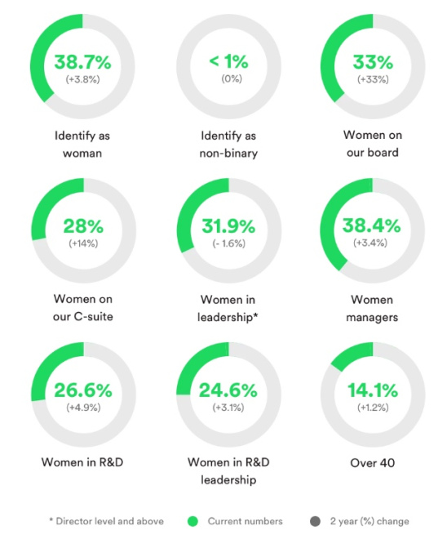by data publish by Spotify in terms of the composition of their employees. With 38.7% of the total number of employees identifying as women; 33% of the board of directors being women, and less than 1% identifying as non-binary. The data also shows that in a multiethnic environment like the US branch of the company, 50% of Spotify employees identify as white, 14.5% as Asian, and the remaining identify either as black, mixed or Hispanic. This information has prompted Spotify to focus on increasing the diversity and inclusion in their company, by empowering individuals coming from minorities, and trying to eliminate gender bias from their management and operations (Watson, 2020).

Due to its methods of organizing employees and management, Spotify has gained notoriety as having a very satisfying workplace where employees are engaged socially and inclusively. Data from Glassdoor how that 89% of employees approve of the CEO, and 75% of employees would suggest other people to work there – truly impressive numbers that showcase Spotify’s success in hiring and maintaining great employees that generate value for the company. These achievements are also a result of the community building efforts focused on inducing a social and healthy work environment (Glassdoor, 2019).

Spotify provides a flexible schedule for national holidays, so that it can appease the different background of their employees; which along with social events, music events for employees and a culture that emphasize individuality and autonomy, positively impact employee satisfaction in the workplace (Donnelly, 2018).

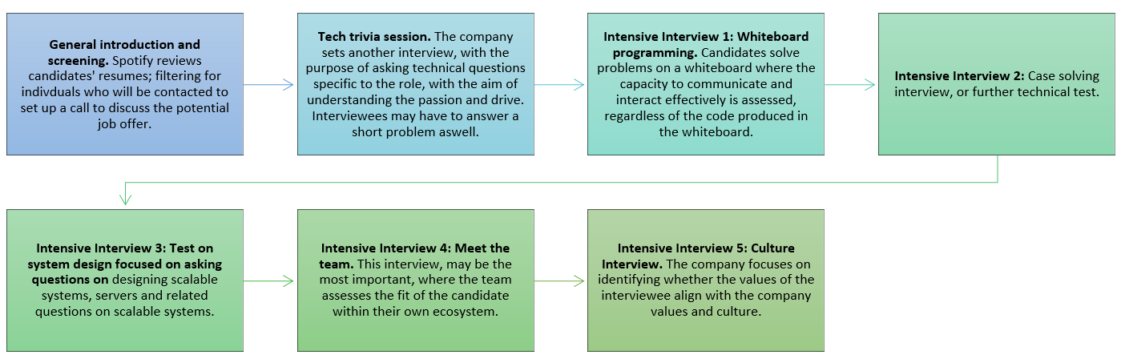To achieve this high degree of self0gvernment, alignment and cohesion in a transnational entity like Spotify, hiring highly capable people who are a cultural fit for the company is pivotal; thus Spotify focuses on hiring individuals who not only show excellent technical aptitude but also show that they share the same values with the company. Thus, a Spotify follows a specific hiring process which tests not only professional abilities but also the team and cultural fit of future employees (Academy Nobl, 2016).

This process is described in the chart above, consists of multiple steps, where first the candidate is analyzed whether they’re technical enough for Spotify’s goals and the role they’re applying for; secondly they’re assessed for their fit within the team; thirdly they’re assessed for what they bring to the team in terms of knowledge, experience or talent; and finally any specific reasons why this individual would not be a fit are scrutinized.

Candidates successfully completing this rigorous process, are considered to be a potential valuable asset for the company and that they would be able to both handle their role, and excel in growing professionally within the company.

1. **International organization structures**

Spotify has invested a lot of effort and time to adapt the Agile management methodology onto their scaled business, which relied on both size and specialization. Following and organic management philosophy allowed Spotify to develop its in-house model of aligning resources, capacities with needs in real time, allowing them to leverage the talent of every single individual in their network based on their skill among other filtering dynamics. These wide spans of control, focused on the egalitarian exchange of ideas rely on a low formalization of communication and control, and the decentralized decision-making with the intent of maximizing the potential of any situation that may arise in any endeavor.

These teams act as cross-functional units that defy traditional hierarchy, but rather work on a problem by problem basis, regrouping and transforming to match capacities with the relevant work at hand. This approach contributes to further Spotify’s Innovation strategy, which is also its secret sauce and its earlies competitive edge, focusing on Artificial Intelligence in targeting music suggestions for customers and for the generation of new playlists (Hardy, 2016).

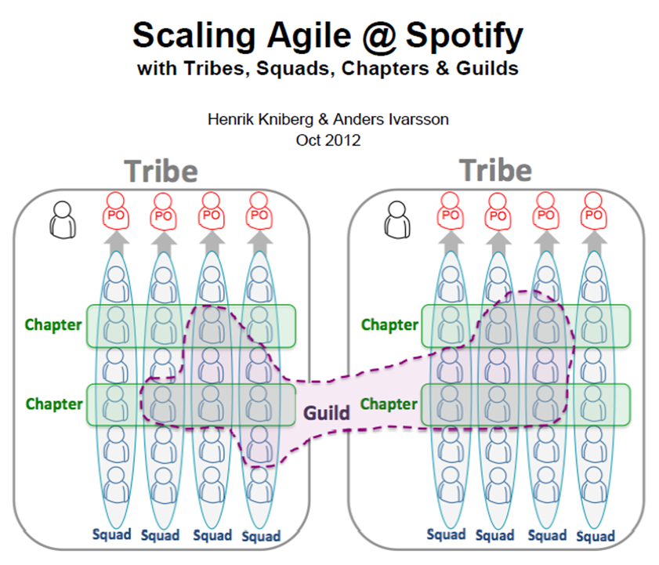As discussed previously, the structuration of Spotify’s employee management follows a structure derived from the Agile framework where employees work in Squads, which in turn comprise tribes, where certain individuals work on specific Chapters.

Furthermore, employees can choose to become part of the additional structure called a Guild, where people who capitalize on the free flow of information to share skills, passions or interests that create a setting that allows to not only share experiences and ideas, but also provide for quick and easy way to locate talent within the network when the need arises in any part or project the company is engaged in.

The architecture of the organization in Spotify allows for a certain fluidity and organic reorganization of teams, focusing on delivering quick, high quality results, and allowing for scalability on a global level. Spotify’s strategy is fit for continuous growth, reinforcing scalability both from a technological and from an organizational perspective – with the main goal being the provision of a high quality service in a timely and seamless fashion to the end consumer. Whereas, it manages to keep internal bureaucracy to minimal levels to encourage the free flow of ideas and encourages the speedy production of new features or continuous optimization (Sellgren, 2019).

1. **Sustainability and business ethics**

Spotify is a company that places special emphasis on CRS and ethical conduct, and in general strives to be a morally and socially upstanding entity. This commitment can also be observed in their choice of having a Director of Social Impact dedicated to this pursuit; a position which officializes the organization and coordination of the company’s accountability and ethics. Its endeavors in CSR have two main areas of concentration the first being environmental in nature and the second being social in nature focusing on empowering artists and leveraging their passion onto a career (McPherson, 2017).

Spotify’s approach engages a broad array of stakeholders, including artists, business partners and investors, fans, and employees. The company also engages local communities which benefit from the increased utility generated by the active involvement of artists who can target their talent onto a profitable and dynamic platform. Their commitment to achieving a zero-carbon footprint, also benefits a wide range of stakeholders indirectly, as the company sets example by moving to data centers operating with zero carbon emissions. Spotify has been a completely carbon neutral company since 2019, with the completion of a two-year transition which was accompanied by the closure of six of their seven data centers, transitioning to carbon neutral Google Cloud Platform servers, effectively reducing its footprint by 1500 tons a year (Colipano, 2019).

Spotify’s corporate greening process still has its weak points which relate to the high level of energy usage associated with digital processing, which in essence is a problem that cannot be prevented for technology companies. Nonetheless, Spotify has a great track record of environmental corporate social responsibility engagements and commitments.

Spotify’s Triple Bottom-line Matrix

Inapplicable - Positive - Negative -

|  |  |  |
| --- | --- | --- |
| Economic | Environmental | Social |
| CheckmarkSales, profits, ROI | EthernetPollutants emitted | CheckmarkHealth and safety record |
| CloseTaxes paid | CheckmarkCarbon footprint | CheckmarkCommunity impacts |
| CheckmarkMonetary flows | EthernetRecycling and reuse | CheckmarkHuman rights, privacy |
| CheckmarkJobs created | CloseWater and energy use | CheckmarkProduct responsibility |
| CheckmarkSupplier relations | CheckmarkProduct impacts | CheckmarkEmployee relations |

*Economic factors*

* Sales, profits, ROI – Spotify has been profitable since 2019, and has ensured continuous growth and expansion to its investors and other stakeholders.
* Monetary flows – Spotify has been generating a considerable stream of monetary inflows due to its services and operations, even before being profitable.
* Jobs created – Spotify employs more than 3000 people globally, and strives to be a highly culturally diverse company, creating jobs that are realistically and equitably distributed.
* Supplier relations – Spotify does not rely on suppliers, or third parties to provide its services, but nonetheless it relies on Googles Cloud Platform data processing units, thus the company maintains good ties with Google, a relationship which was cemented with their migration to carbon-neutral Google data centers.
* Taxes paid – Spotify, like many other large technology companies, uses its international capacities to limit the amount of taxes they pay locally. The company has leveraged setting its global ultimate parent company in Luxemburg to further downsize the amount of taxes they pay, due to its beneficial taxing laws. In the same time, a number of tax avoidance methods have raised suspicion in some countries where the company operates including its Australian entity.

*Environmental*

* Pollutants emitted – the company does not produce any pollutants in any facet of their activities.
* Carbon footprint – Spotify has achieved a completely carbon-neutral operation since 2019
* Recycling and reuse – Spotify does not produce any recyclable waste, nor does it publicly engage in recycling efforts.
* Water and energy use – the company incurs a very high energy toll, consuming massive amounts of electricity to maintain, cool and manage its datacenters and software development operations. While this is an inevitable part of technology companies, these processes use massive amounts of energy and of water to both keep the severs running and maintain their cooling systems.
* Product impacts –Spotify has also been pivotal in the sharp decline of music piracy, by creating a new paradigm for legal and readily accessible music; and has established new methods for consuming entertainment and manage large Agile teams in a scalable and efficient manner.

*Social*

* Health and safety record – Spotify has a great health record, providing good health plans for its employees, generating no pollutants that may affect the communities where Spotify has physical locations, and having no health related incidents since its inception as a company.
* Community impacts - Spotify has allowed new artists to have a platform that they can publish their work and monetize it easily, creating new possibilities for independent artists. This move has empowered local artists worldwide, and as decreased the control large media corporations have on the careers of some artists, especially the ones with no direct access to producers and local artists. This has created new avenues for communities to capitalize on the passion and talent of their members.
* Human rights, privacy – Spotify supports human rights activism. In terms of privacy, Spotify has a pretty standard approach where pseudonymized user data is shared with Spotify entities, and other third parties doing the processing for Spotify. This data is also fed onto the algorithm to generate suggestions and playlists based on user preferences.
* Product responsibility – Spotify legally protects its product and provides protection for the content generated by its users, serving as content arbitrage platform connecting and engaging consumers with content creators.
* Employee relations – Spotify keeps impeccable employee relations, which is also demonstrated by its high rating on Glassdoor, and its commitment in empowering employees with an egalitarian and fostering system, which relies on employee autonomy and self-accountability.

# Bibliography

Academy Nobl, 2016. *How Spotify Recruits Talent.* Santa Monica, California, US: https://academy.nobl.io/how-spotify-recruits-talent/?fbclid=IwAR1SrD0sFbkKJPY7cxXEmSPN16BeNnumdSoSljRaN2s0jSrx8v0n9QFOFXI.

BBC, 2018. *How Spotify came to be worth billions.* BBC, https://www.bbc.com/news/newsbeat-43240886 ed. London, UK: BBC, https://www.bbc.com/news/newsbeat-43240886.

Brown, C., 2019. *Spotify’s Organizational Structure for Flexible Growth & Expansion.* US: https://www.rancord.org/spotify-organizational-structure-design-structural-characteristics?fbclid=IwAR1SrD0sFbkKJPY7cxXEmSPN16BeNnumdSoSljRaN2s0jSrx8v0n9QFOFXI#:~:text=Spotify's%20N%2DForm%20Organizational%20Structure,streaming%20enterprise%20and%20its%20.

Colipano, A., 2019. *Does Spotify Take Part in Corporate Social Responsibility?.* Oregon, US: https://twntynineteen.wordpress.com/2019/10/30/does-spotify-take-part-in-csr/?fbclid=IwAR2MxVAdgkcn7rv-fMCPixTFZpWv8-SxqX0TyhPq49_bsY9UibwZIot-skQ.

Donnelly, G., 2018. *Spotify’s June 2018 Diversity Report Shows Some Slow Progress.* New York City, US: https://fortune.com/2018/07/11/spotifys-june-2018-diversity-report-shows-some-slow-progress/?fbclid=IwAR3YFhUjW42wmLQakd-zgUkDQhZrcyRF8w3EMcQWjrdzcvSaoX_4b-PUeCk.

Glassdoor, 2019. *Bewertungen für Spotify.* Hamburg, Germany: https://www.glassdoor.de/Bewertungen/Spotify-Bewertungen-E408251.htm?fbclid=IwAR0V4axPq1nTougRqurC1Z8o5k0_j_N8LUkVcXlnhvNrFnO85hP8GH_AOus&countryRedirect=true.

Hardy, A.-C., 2016. *Agile Team Organisation: Squads, Chapters, Tribes and Guilds.* San Francisco, US: Medium, https://medium.com/@achardypm/agile-team-organisation-squads-chapters-tribes-and-guilds-80932ace0fdc?fbclid=IwAR0V4axPq1nTougRqurC1Z8o5k0_j_N8LUkVcXlnhvNrFnO85hP8GH_AOus.

Issarice.com, 2019. *Spotify's Business Timeline.* US: Timelines, https://timelines.issarice.com/wiki/Timeline_of_Spotify.

Jones, D., 2018. *Spotify Is A Great Growth Prospect.* New York, US: https://seekingalpha.com/article/4161056-spotify-is-great-growth-prospect?fbclid=IwAR3ctXB-GLwbtq5VbKVwjLtcVlzPOqNmN-ZUDm42o8ZY71N9WwhUFnfmVus.

Manocchio, P., 2019. *Human Resources in the 2018 Business Studies HSC exam.* Wollongong, Australia: University of Wollongong, https://documents.uow.edu.au/content/groups/public/@web/@bus/documents/doc/uow216435.pdf?fbclid=IwAR0shBlpyqzLALq7quRMP8gh5Mz12MAmJguz2wx9hqNryhWV2_6-_tXX3Dk.

McPherson, S., 2017. *How Spotify Uses Music To Drive Social Change.* New Jersey, US: Forbes Magazine, https://www.forbes.com/sites/susanmcpherson/2017/06/20/how-spotify-uses-music-to-drive-social-change/?fbclid=IwAR1WTv_Iuc9j6XCLSS1c8roNv9grPMCnfhQ3bMtueC8g-GyXPfYFpwSZ9JM#e69ae5bf55a4.

Michael Mankins, E. G., 2017. *How Spotify Balances Employee Autonomy and Accountability.* Massachussets, US: Harvard Business Review, https://hbr.org/2017/02/how-spotify-balances-employee-autonomy-and-accountability?fbclid=IwAR31_YI9FQEku88XD-lCuLhX3IQ9OWBKmWpS_Ri6xN1b43HWGfnqWF0orjo.

Sellgren, J., 2019. *No Talent Acquisition team is an island.* Stockholm, Sweden: https://hrblog.spotify.com/category/talent-acquisition/?fbclid=IwAR02bC0k4beUOj-4CcAWMNs9Xl7TrbZBbZW30XEGxqw9eLAoG5Libaienpw.

Statista, 2020. *Spotify Aggregate Statistics.* US: Statista.

Suarez, P., 2019. *How Spotify Keeps its Culture Social and Fresh.* Chicago, US: Fivetonine, https://fivetonine.co/blog/spotify-culture-social-fresh?fbclid=IwAR0CcJg9yK_e6EcfQngIN7xFMtadh1vFOq-elM2i9tuPxmYxO2OG02Kaf14.

Watson, A., 2020. *Distribution of female Spotify employees worldwide as of July 2018, by category.* Hamburg, Germany: https://www.statista.com/statistics/916027/spotify-employee-gender-department-global/?fbclid=IwAR3Awr8pd53ZrWZbZFxzZt4ut5FeKR9Mn_WEKlAuvfR6CFAshIfY7zjPHTk.