**Course Name (CMPS-481)**

**Spring 2021**

**T 6:50-10:00 pm**

**Project #: MIDTERM**

**Title: POS SYSTEM**

**Due Date: 13 Apr 2021**

**Grade:**

**e-mail: marlene.zeledon@laverne.edu Submitted by: Marlene Boyce**

**major: Computer Science Concentration: Internet Programming**

|  |  |  |  |  |  |  |  |
| --- | --- | --- | --- | --- | --- | --- | --- |
| **Y**  **I=**    **N** | **Description – 10%**  **Incomplete** | **Y**  **I**    **N** | **Design – 15%**  **UML and flowchart; pseudocode - if asked** | **Y**  **I**    **N** | **Code – 50%**  highlight and comments piece of the code which you had to **add** or **modify (worth 10 %)** | **Y**  **I**    **N** | **Test – 25%**  **Test plan**  **(4 test cases – include boundary testing) with screenshot results** |

|  |  |  |  |  |  |  |  |
| --- | --- | --- | --- | --- | --- | --- | --- |
| **Y**  **I=**    **N** | **Description –10%**  **Incomplete** | **Y**  **I**    **N** | **Design – 15%**  **UML and flowchart; pseudocode - if asked** | **Y**  **I**    **N** | **Code – 50%**  highlight and comments piece of the code which you had to **add** or **modify (worth 10 %)** | **Y**  **I**    **N** | **Test – 25%**  **Test plan (4 test cases – include boundary testing) with screenshot results** |

**Submitted to**

**Prof. Juan Rodriguez**

**University of La Verne, La Verne**

**Class Diagram:**

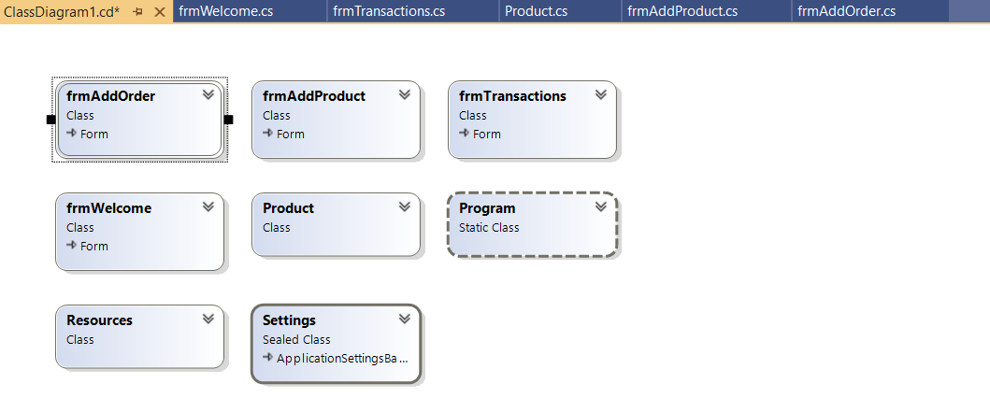

**OUTPUT [ SCREEN SHOTS]:**

**“Welcome Form”**

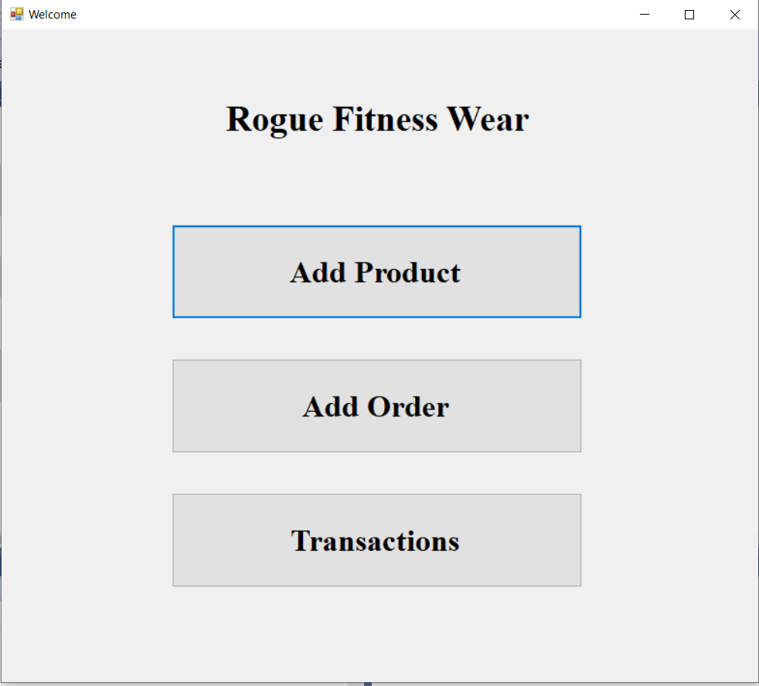

**After clicking “Add Product”**

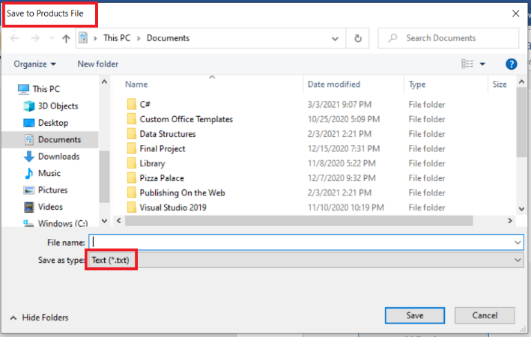

**“Add Product Form”**

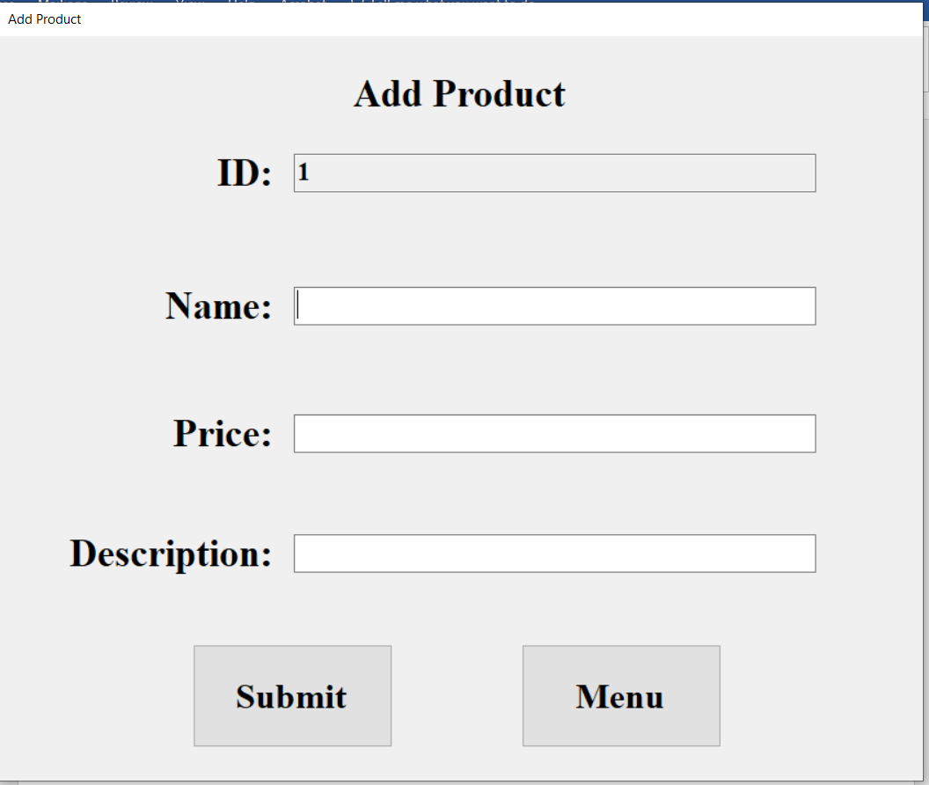

**Click “Submit”**

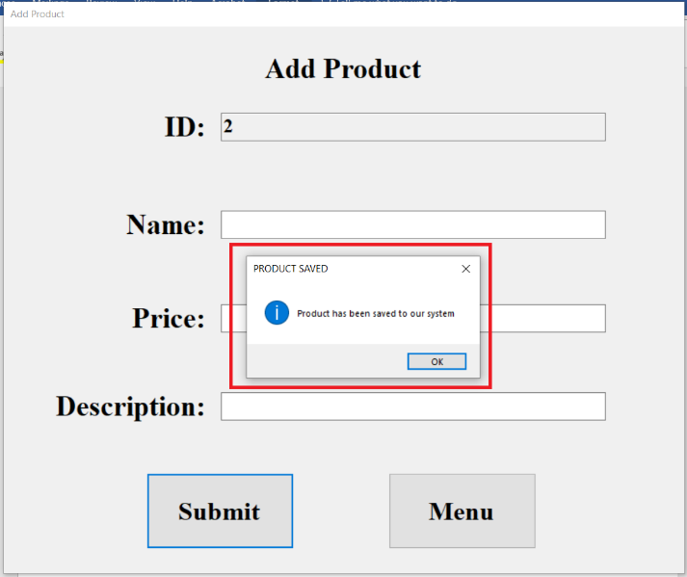

**Click “Add Order”**

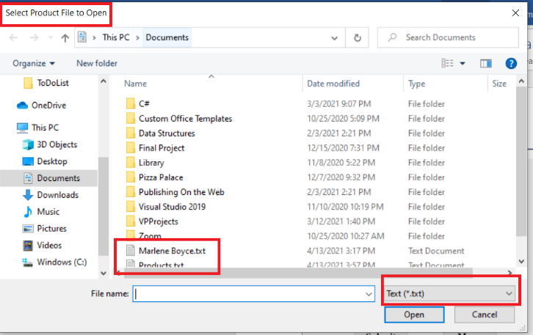

**Once file is selected:**

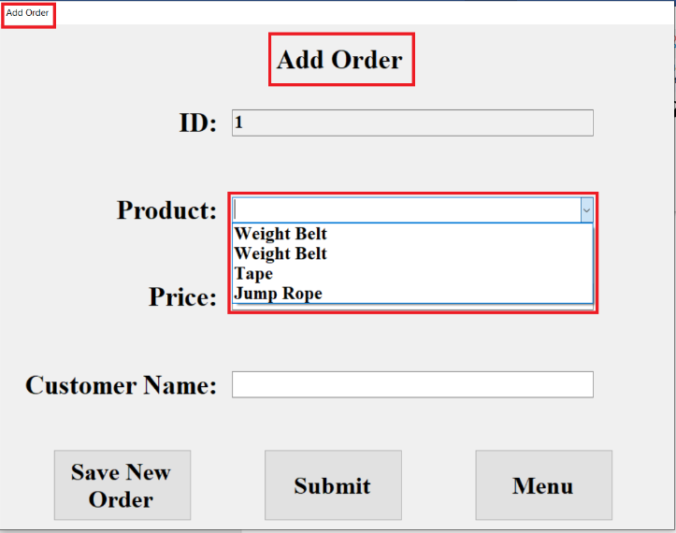

**Enter details!**

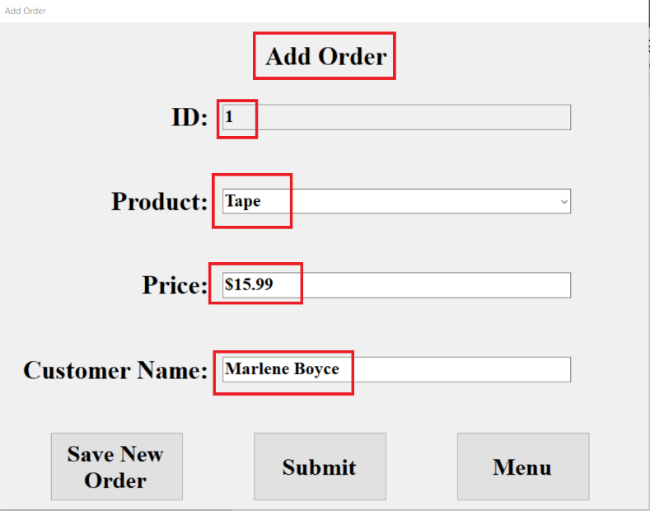

**Order Saved**

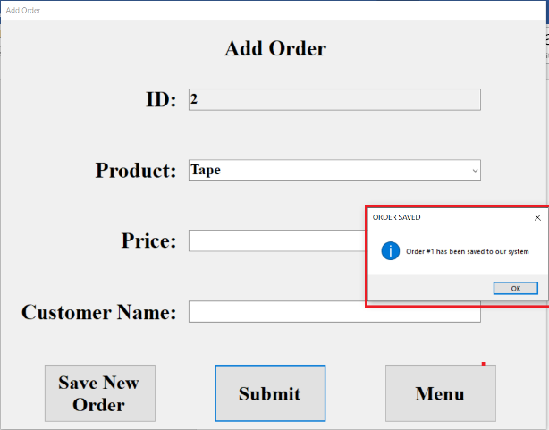

**Transactions:**

