COSC 603 APG

Software Testing and Maintenance

Spring 2016

**Project #1 – Reengineering Legacy Systems**

Name: Marlene Encinas

**Task 3 – Using Eclipse and Git/GitHub Desktop for Configuration Management**

Completed Code Academy Course Learn Git. See Screen.

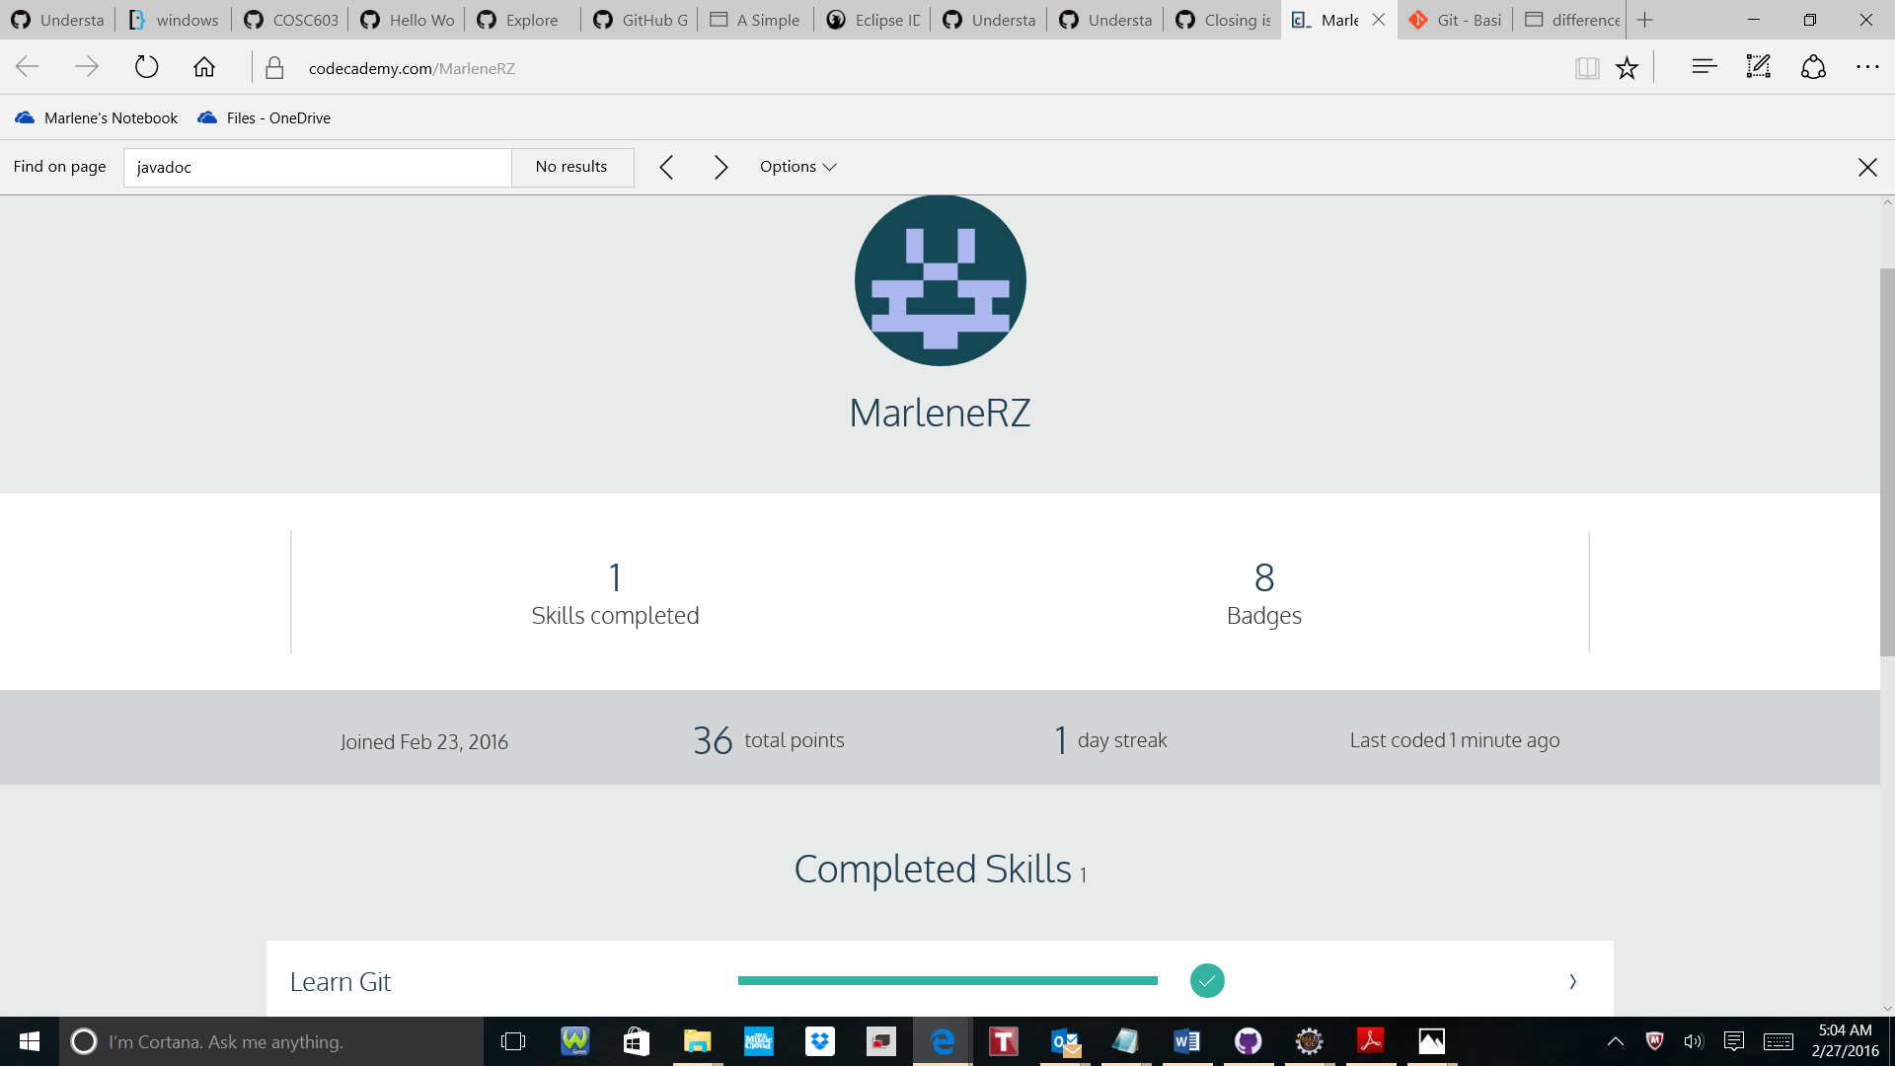

Code Academy was easy to sign up and start the course Learn Git right away.

I had issues with the connection. It disconnected easily by itself or if I took too much time on a topic, it got disconnected as well, but I could progress in the lessons.

I got stuck to move from a branch to a master, but after searching I found out I needed to commit first.

It is still unclear to me why I have to fetch before merging to origin/master. I think I will discover it while I progress in the class.

Overall, I really like that Code Academy is very practical and easy to use. I learned a topic and right away I was able to practice it which helped me fix better my knowledge. Although I am more Windows oriented, it was fine to use the command lines. I feel more familiar with GitHub and its functions.

Thanks for this suggestion!