MIND BrainAge~EpiAge Project
ENIGMA QC Appendix
All scripts and steps provided in this section relate to materials provided by the ENIGMA consortium (https://enigma.ini.usc.edu/, https://github.com/ENIGMA-git) and the specific versions of instructions used by the ENIGMA-Antisocial Behavior working group (hence the naming of some of the files).
The following instructions assume that FreeSurfer processing has been completed, and the visual QC outputs have been generated in Section 2 of the main document (ENIGMA-Extraction of (sub)cortical ROIs & QC webpages). Outputs should be saved under /brain_epi/mri/output/enigma_outputs.
- Check that your csv files with the ROIs are saved under /brain_epi/mri/output/enigma_outputs/measures
    - CorticalMeasuresENIGMA_SurfAvg.csv
    - CorticalMeasuresENIGMA_ThickAvg.csv
    - LandRvolumes.csv
- All required scripts are available in the scripts folder: /brain_epi/mri/scripts/QC/enigma
  - ENIGMA_CortexROI_plots.R
  - enigma_plots.R
  - outlier_LandRvolumes.R
  - outliers.R
  - viewing_subjects_freeview.txt
As part of the ENIGMA QC process, we will do the following:
- Run simple R scripts to identify subjects with outlying ROIs
- Run simple R scripts to create histograms for each cortical and subcortical ROI
- Visual quality checking (cortical & subcortical)
- Adjust output files (.csv) based on QC
- Re-run the histogram steps

Outlier detection cortical
This step requires that you have R installed and that you have the script outliers.R from the provided scripts folder.
Change directories to the location of your CorticalMeasuresENIGMA_ThickAvg.csv and CorticalMeasuresENIGMA_SurfAvg.csv.
cd /brain_epi/mri/output/enigma_outputs/measures
Copy the outliers.R script into the same directory.
cp /brain_epi/mri/scripts/QC/enigma/outliers.R /brain_epi/mri/output/enigma_outputs/measures
Then run:
R --no-save --slave < outliers.R > outliers_cortical.log
This will generate a log file that will tell you which subjects are outliers (2.68*SD) and for which structures they are outliers for. Make sure you look at these subjects closely as you proceed with the quality check protocol to make sure they are segmented properly.
NB: Just because a subject is an outlier for a particular region does not necessarily mean they should be excluded from the analysis. If a subject is segmented properly in FreeSurfer (which you will visually verify at later steps in this protocol) then please do keep them in the analysis.

Outlier detection subcortical
Now we will run a semi-automated script to detect outliers in the subcortical regions. This step requires that you have R installed and the outlier detection script ‘outlier_LandRvolumes.R’
Make sure that you are still in the ‘measures’ folder where the LandRvolumes.csv file is stored.
Copy the outlier_LandRvolumes.R script into the same directory.
cp /brain_epi/mri/scripts/QC/enigma/outlier_LandRvolumes.R /brain_epi/mri/output/enigma_outputs/measures
Then run:
R --no-save --slave < outlier_LandRvolumes.R > outliers_subcortical.log
This will generate a log file that will tell you which subjects are outliers (2.68*SD) and for which structures they are outliers for. Make sure you look at these subjects closely as you proceed with the visual quality check protocol to make sure they are segmented properly.
NB: As above, just because a subject is an outlier for a particular region does not necessarily mean they should be excluded from the analysis. If a subject is segmented properly in FreeSurfer (which you will visually verify at later steps in this protocol) then please do keep them in the analysis.

Creating histograms & summary stats – cortical
In the next step, we generate histogram plots of our data. You can find the script ENIGMA_CortexROI_plots.R needed for this step in the provided scripts folder (/brain_epi/mri/scripts/QC/enigma).
Create a folder in your enigma_qc folder for figures and navigate into the folder.
mkdir /brain_epi/mri/output/enigma_outputs/figures_cortical
cd /brain_epi/mri/output/enigma_outputs/figures_cortical
Copy the LandRvolumes.csv file to this folder.
cp /brain_epi/mri/output/enigma_outputs/measures/Cortical* /brain_epi/mri/output/enigma_outputs/figures_cortical
Copy the R script ENIGMA_CortexROI_plots.R into the same folder
cp /brain_epi/mri/scripts/QC/enigma/ENIGMA_CortexROI_plots.R /brain_epi/mri/output/enigma_outputs/figures_cortical
Then, run the script from within the folder:
R --no-save --slave < ENIGMA_CortexROI_plots.R
This will create a summary stats file with summary measures of your sample but also histograms for all cortical ROIs. These are useful to check for distribution issues beyond the identified outliers.

Creating histograms & summary stats – subcortical
In the next step, we generate histogram plots of our data. You can find the script enigma_plots.R needed for this step in the provided scripts folder.
Create a folder in your enigma_qc folder for figures and navigate into the folder.
mkdir /brain_epi/mri/output/enigma_outputs/figures_subcortical
cd /brain_epi/mri/output/enigma_outputs/figures_subcortical
Copy the LandRvolumes.csv file to this folder.
cp /brain_epi/mri/output/enigma_outputs/measures/LandRvolumes.csv /brain_epi/mri/output/enigma_outputs/figures_subcortical
Copy the R script enigma_plots.R into the same folder
cp /brain_epi/mri/scripts/QC/enigma/enigma_plots.R /brain_epi/mri/output/enigma_outputs/figures_subcortical
Then, run the script from within the folder:
R --no-save --slave < enigma_plots.R
As above, this will create a summary stats file with summary measures of your sample but also histograms for all subcortical ROIs. These are useful to check for distribution issues beyond the identified outliers.
Optional step: Move all ENIGMA QC materials into the QC folder to have all QC materials in place. The following instructions will assume that you have not done this and the QC outputs remain in /brain_epi/mri/output/enigma_outputs/.
mv /brain_epi/mri/output/enigma_outputs /brain_epi/mri/QC/

Perform the visual QC
You can now perform the QC using the webpages, information from the outlier detection. and generated histograms. Notably, QC images and webpages were created during Section 2: ENIGMA-Extraction of (sub)cortical ROIs & QC webpages, only if Steps 3-5 were set to TRUE.
In your /brain_epi/mri/output/enigma_outputs/qc folder you should see the following subfolders:
- cortical_internal
- cortical_external
- subcortical

Cortical
Open the internal and external webpages (i.e., ENIGMA_External_QC.html in the cortical_external folder & ENIGMA_Cortical_QC.html in the cortical_internal folder) using a browser of choice.
Some examples of what the external view should look like:
These are examples of successful reconstructions:
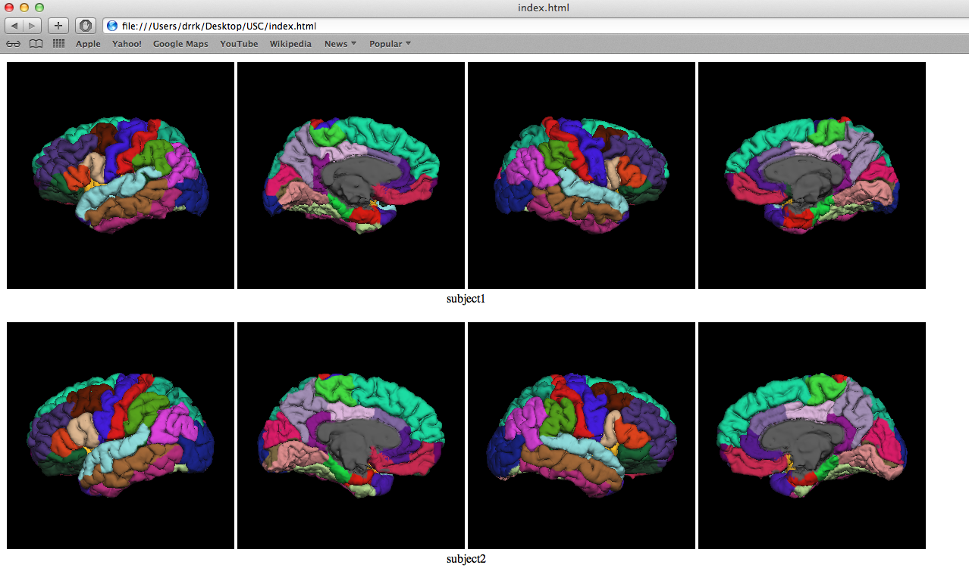
Here is an example of a poor labeling (this would lead to full exclusion of the subject):
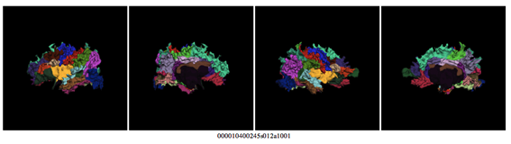
Perform the QC using the following linked guidance documents:
- Cortical_QC_2.0_ENIGMA_ASB.pdf: Please review this document carefully before starting as it includes the key issues to look out for.
- Cortical_QC_Oneview_ENIGMA_ASB This file provides a color coded reference of each FreeSurfer ROI that you can use as your reference.
Record your ratings in ‘template_Cortical_QC_ENIGMA_dataset.xlsx’ provided in brain_epi/mri/scripts/ENIGMA-FreeSurfer-protocol/)
The general idea is to scroll through the webpages and check for poorly segmented regions and to then record any regional fails in Cortical_QC_Template_ENIGMA_ASB.xlsx by adding “L”, “R” or “L/R” into the respective cell (without the quotation marks).
Consistent with the PDF guide, please focus on:
- General QC issues (page 9-13 pdf guide)
- Internal QC view (page 14-18 pdf guide)
- External QC – lateral view (page 19-25 pdf guide)
- External QC – mid saggital view (page 26-31 pdf guide)
Important guidance
- Additional QC examples can be found here.
- A training video on how to perform the cortical QC can be found here with example participants and outputs located here.

If you are unsure whether a region should be failed, you can further inspect a subject in FreeView (a programme including in the FreeSurfer suite) where you can navigate through individual slices. Code to do this has been provided by ENIGMA and can be found in the folder that you downloaded from their Github page: /brain_epi/mri/scripts/ENIGMA-FreeSurfer-protocol/view_FS_3d_QC.sh and we have also provided some useful code snippets in our scripts folder (/brain_epi/mri/scripts/QC/enigma/viewing_subjects_freeview.txt)
Adjust output files (.csv) based on QC
If the QC reveals bad segmentations, please do the following:
- Open the data files CorticalMeasuresENIGMA_ThickAvg.csv and CorticalMeasuresENIGMA_SurfAvg.csv in Excel
- Save them as CorticalMeasuresENIGMA_ThickAvg_beforeQC.csv and CorticalMeasuresENIGMA_SurfAvg_beforeQC.csv; make sure to keep these copies of your original CSV files!
- Mark poorly segmented cortical regions with "NA" (without the quotes) in the CorticalMeasuresENIGMA_ThickAvg.csv and CorticalMeasuresENIGMA_SurfAvg.csv files; make sure that you insert NAs in BOTH CSV FILES!
- If the whole subject is poorly segmented mark all of the entries in a subject's row with "NA".
- If you have many failed regions and would like to (partly) automate this process, we also have a spreadsheet available that can help with aligning decisions made in Cortical_QC_Template_ENIGMA_ASB.xlsx with your csv files. Please contact Marlene Staginnus (ms2290@bath.ac.uk).
- Please copy the new, QC’ed files (i.e., CorticalMeasuresENIGMA_ThickAvg.csv & CorticalMeasuresENIGMA_SurfAvg.csv) into /brain_epi/mri/extracted_features/ (i.e., overriding the previous file), so that these can be used for the subsequent analyses.
NB: Make sure to save the files back in CSV format (i.e., the files with NAs). Please open and inspect the csv files to verify that none of the values have converted to a scientific notation; e.g., 1.51708e+06. To avoid this rounding off, you can change the formatting of all metrics to “general” (or ‘number’) instead of “scientific” in excel before you convert the spreadsheet to csv/saving it as csv.
NB2: If you have identified poor segmentations beyond individual regions or major issues (see general QC issues in the QC guide), look at the (status-)log-file in the subject’s FreeSurfer output folder (under scripts), to see whether a specific error has been reported. If possible, try to solve that error and re-run “recon-all” on the subjects showing poor segmentations and regenerate the QC outputs.

Subcortical
While the cortical webpages show all regions simultaneously, separate webpages are available for the subcortical regions in the subcortical folder (e.g. ‘ENIGMA_Amyg_volume_QC.html’).
Use the information provided by the outlier detection, the histogram plots, webpages, and the examples in this guideline document to create an overview of poor segmentations.
An example spreadsheet to record your decisions has been provided by ENIGMA and can be found under brain_epi/mri/QC/template_Subcortical_QC_ENIGMA-ASB.xlsx (or /brain_epi/mri/scripts/ENIGMA-FreeSurfer-protocol/template_Subcortical_QC_ENIGMA_dataset.xlsx for an alternative version). For subcortical regions particularly, inspecting outliers and potential poor segmentations in FreeView (see code snippets in /brain_epi/mri/scripts/enigma/viewing_subjects_freeview.txt) is especially recommended.
Adjust output files (.csv) based on QC
Exclude poor segmentations by doing the following:
- open LandRvolumes.csv in Excel
- save the file as LandRvolumes_beforeQC.csv – make sure to keep this copy of your original CSV file!
- mark poorly segmented volumes with “NA” (without the quotes) in the LandRvolumes.csv file
- you may have to exclude all volumes for some of the subjects, in that case please mark all volumes in the row as “NA” (without the quotes)
- If you have many failed regions and would like to (partly) automate this process, we also have a spreadsheet available that can help with aligning decisions made in template_Subcortical_QC_ENIGMA-ASB.xlsx with your csv files. Please contact Marlene Staginnus (ms2290@bath.ac.uk).
- Please copy the new, QC’ed file (LandRvolumes.csv) into /brain_epi/mri/extracted_features/ (i.e., overriding the previous file) so that this can be used for the subsequent analyses.
NB: Please make sure to save the file with NAs (i.e., LandRvolumes.csv) in CSV format. Please open and inspect the CSV file to verify that none of the values have converted to a scientific notation; eg 1.51708e+06. To avoid this rounding off, you can change the formatting of all metrics to “general” instead of “scientific” in excel before you convert the spreadsheet to csv.
NB2: If you have identified poor segmentations beyond individual regions or major issues (e.g., see general QC issues in the QC guide), look at the (status-)log-file in the subject’s FreeSurfer output folder (under scripts), to see whether a specific error has been reported. If possible, try to solve that error and re-run “recon-all” on the subjects showing poor segmentations and regenerate the QC outputs.

Re-generate histograms and summary stats
After performing the visual QC, it can be useful to regenerate the histograms based on the QC’ed files; these can then be inspected for remaining issues / a last sanity check. Please see above for how to do this (cortical & subcortical).
Please return to the main document (4.mri_preprocessing_MIND) for information on cut-offs to fail an entire participant.

