MIND BrainAge~EpiAge Project
MRIQC Appendix
The following instructions assume that the raw data for all participants is available under /brain_epi/mri/raw.

Transform your raw T1-weighted scans into BIDS format
To run MRIQC, your raw data (i.e., .nii or .nii.gz files) must be in BIDS format. There are multiple tools that can help you transform your data into BIDS format (e.g., bidsify). We have also provided a Python script that can help with this process (see /brain_epi/mri/scripts/QC/MRIQC/organize_bids.py).
- This file takes an input folder with the .nii files (path must be defined in line 7)
- And outputs a directory (raw_BIDS) that conforms to BIDS (path must be defined in line 10)
- It also creates a dataset_description.json file that is required by MRIQC – you can make changes to the information provided in this file, if you like (starting line 16)
- In line 31, you must define the common prefix of your subject names and the common suffix (you can also delete one of the two conditions entirely). Please note that in order to be BIDS compliant & work with MRIQC subject names need to start with “sub-”.
- Depending on the structure of your participant names, you might also have to change line 33 (so that the subject name is correctly extracted from the file name).
- The script takes around 15 minutes per 100 participants
If python is installed, you can run this file from the terminal after making the outlined changes.
python /brain_epi/mri/scripts/QC/MRIQC/organize_bids.py
The output should look something like this:
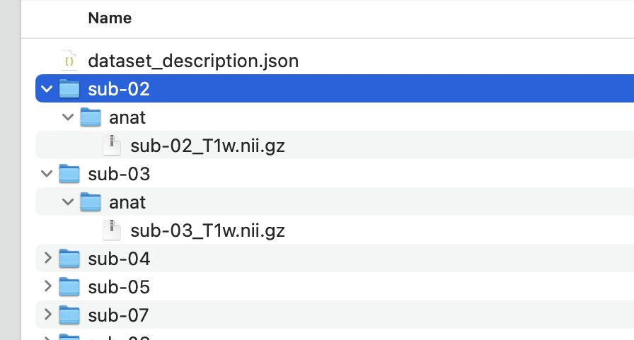
Please feel free to adjust this as much as possible. The provided script is a simple workaround to create a MRIQC compliant folder for those that are usually not working with BIDS, but it does not make your data fully BIDS compliant. You are welcome to use full BIDS formatting.

Generating MRIQC reports
Once your raw data is in BIDS format, MRIQC can be run.
Option 1: Below we provide the instructions for running MRIQC with Docker.
Option 2: Alternatively. Code for use on a high performance computer cluster using apptainer is provided in this preprint (see section on ‘execute MRIQC’).
Option 3: On our HCP system apptainer was not available and we therefore forced Docker to emulate the amd64 architecture of our HCP system for use with singularity. The container file for this approach can be downloaded here. Brief instructions for execution are provided below (Option 3).
Option 1: Docker (tested on Mac M3)
- Create the folder for the MRIQC output
docker pull nipreps/mriqc:24.0.2
- Ensure that your Docker application is open & then run the following in your terminal:
docker pull nipreps/mriqc: 24.0.2
- Generate the individual-level MRIQC reports by executing the following code in your terminal. You need to provide that path to your raw_BIDS folder and to where you want the outputs to be stored. Note that processing can be sped up by increasing the number of CPU cores used (using the --n_procs flag) or by submitting multiple batches (if working with a HPC).
docker run -it --rm \
-v /brain_epi/mri/raw_BIDS:/data:ro \
-v /brain_epi/mri/QC/MRIQC_output:/out \
nipreps/mriqc:24.0.2 /data /out participant --n_procs 2 --no-sub
This script will generate the individual-level MRIQC reports for all subjects in the MRIQC_output folder (feel free to adjust the output structure if you are following BIDS). On a Mac Pro (M3), this process took around 5 minutes per subject (and around 8 hours for 100 participants), using 2 CPUs.
- --no-sub: MRIQC by default attempts to upload anonymized quality metrics to a publicly accessible web server (mriqc.nimh.nih.gov); in the above code, this is disabled with the --no-sub flag.
- If only some participants should be included, these can be specified specific with the flag --participant-label sub-01 sub-02 sub-03
- If you run into memory issues, you can increase the resources allocated to Docker in the Docker settings (see screenshot below) or via shell command (see bottom of this page). We previously ran into issues that could not be fully resolved by increasing resources. Instead, running it in batches of 5-20 participants worked.
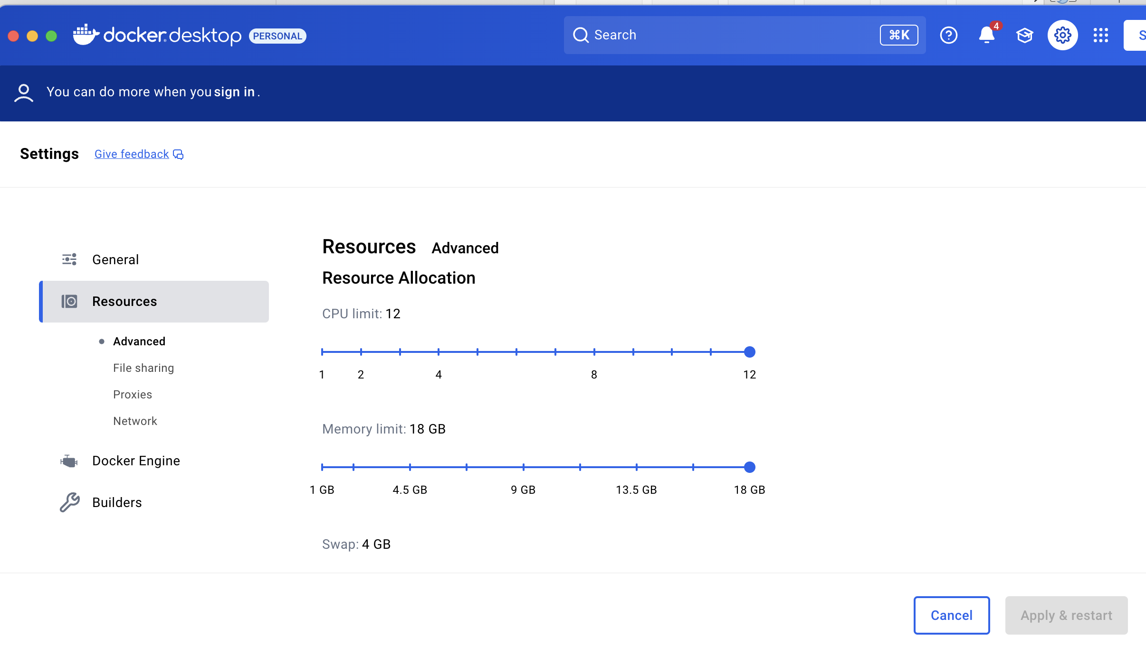
- After the individual reports have been generated (see examples in /brain_epi/mri/sanity_checks/MRIQC), the group-level report can be generated (please do this by time point).
docker run -it --rm \
-v /brain_epi/mri/raw_BIDS:/data:ro \
-v /brain_epi/mri/QC/MRIQC_output:/out \
nipreps/mriqc:24.0.2 /data /out group --n_procs 2 --no-sub
This creates a .tsv file ending in group_T1w.tsv that includes the image quality metrics (e.g., signal to noise ratio, contrast to noise ratio) per participant. It also creates an overview .html page that illustrates the distribution of all IQMs (see /brain_epi/mri/sanity_checks/MRIQC).
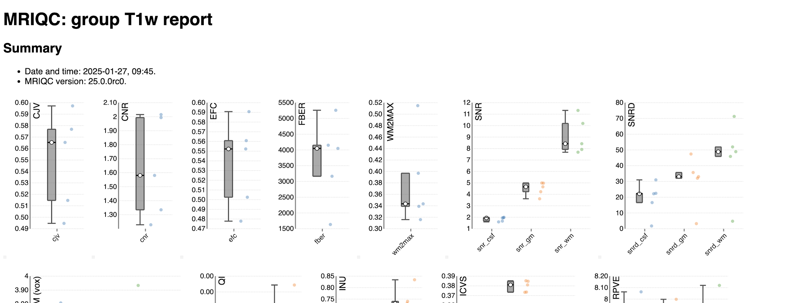

Option 3: MRIQC using singularity container (for Linux HPC without apptainer)
Please note that any code provided in this section will require adaptation to align with your local HCP system.
- Save this .sif file in the folder on your HPC. The following script assumes that it is saved under /brain_epi/. If not, please take extra care when adjusting paths in the following instructions.
- Load singularity
module load Singularity/4.2.0-GCC-12.3.0 #update with your version (check it using module avail Singularity)
- Create MRIQC_output folder that will hold the individual and group-level QC output
mkdir -p /campaign/path/to/brain_epi/MRI/MRIQC_output
- Get individual-level output
singularity run --cleanenv \
-B mri/raw_BIDS:/data:ro \
-B mri/QC/MRIQC_output:/out \
mriqc_24.0.2.sif \ #assumes .sif file is located in /brain_epi/
/data /out participant --n_procs 3 --no-sub
- Get group-level output
singularity run --cleanenv \
-B mri/raw_BIDS:/data:ro \
-B mri/QC/MRIQC_output:/out \
mriqc_24.0.2.sif \
/data /out group --n_procs 3 --no-sub

Working with MRIQC outputs
A detailed overview of the recommended workflow is provided here.
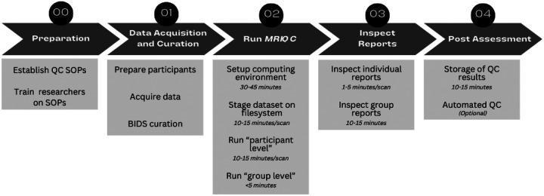
After generation of the individual and group reports, this includes:
- Inspection of individual participant reports
  - This step can be useful to spot movement, distortions, misalignment etc.
- Inspection of the group report
  - Useful for investigating the range and clustering of image quality metrics (IQMs), as well as to identify participants that are outliers in some IQM distribution. Individual reports can be viewed by clicking on data points, so that researchers can see how the visual reports are impacted by high, low, and average IQM values.
We appreciate that following the entire workflow may be too time intensive. We would therefore recommend the prioritisation of the following steps:
- Generation of the individual & group level reports so that the latter can be shared with the consortium (the group-level report should be generated by time-point).
- Inspection of the visual group level report to identify gross outliers/issues across the provided metrics. In the .html report it is possible to click on individual data points, which will open the individual reports for examination.
- Inspection of the IQMs across the sample. An overview of the provided Image Quality Metrics (IQMs) can be found here.
- We have provided a script that identifies participants that are quantitative outliers based on 1.5*the interquartile range (based on Q1 and Q3) to help with the identification of problematic subjects: /brain_epi/mri/scripts/QC/MRIQC/outliers_MRIQC.R. If a scan is an outlier across multiple metrics, please manually inspect their individual reports and discard if the underlying data is of poor quality. This approach is consistent with a recent brain age study by Dörfel et al. (2023).
  - Table 1 below shows which metrics are considered in the outlier script and in which direction values are considered to be outlying.
  - If your group report file is not named group_T1w.tsv, please open the script outliers_MRIQC.R in your preferred editor before running it, make the following edit and then save: In line 15 replace the .tsv file name with the file name of your MRIQC group report (e.g., ALSPAC_group_T1w.tsv)
  - Navigate into the folder where the MRIQC group report is stored and run the script from the terminal:
cd /brain_epi/mri/QC/MRIQC_output/
Rscript /brain_epi/mri/scripts/QC/MRIQC/outliers_MRIQC.R
- If you remove participants based on the MRIQC reports (or other QC approaches), please regenerate the group-level report and name it with the suffix _afterexclusions)
Table 1
MRIQC IQM | which direction is considered in the outlier script
cjv | high
cnr | low
efc | high
fber | low
fwhm_avg | high
fwhm_x | high
fwhm_y | high
fwhm_z | high
icvs_csf | not included in script
icvs_gm | not included in script
icvs_wm | not included in script
inu_med | not included in script
inu_range | not included in script
qi_1 | high
qi_2 | high
rpve_csf | high
rpve_gm | high
rpve_wm | high
size_x | not included in script
size_y | not included in script
size_z | not included in script
snr_csf | low
snr_gm | low
snr_total | low
snr_wm | low
snrd_csf | low
snrd_gm | low
snrd_total | low
snrd_wm | low
spacing_x | not included in script
spacing_y | not included in script
spacing_z | not included in script
summary_bg_k | both
summary_bg_mad | both
summary_bg_mean | both
summary_bg_median | both
summary_bg_n | both
summary_bg_p05 | both
summary_bg_p95 | both
summary_bg_stdv | both
summary_csf_k | both
summary_csf_mad | both
summary_csf_mean | both
summary_csf_median | both
summary_csf_n | both
summary_csf_p05 | both
summary_csf_p95 | both
summary_csf_stdv | both
summary_gm_k | both
summary_gm_mad | both
summary_gm_mean | both
summary_gm_median | both
summary_gm_n | both
summary_gm_p05 | both
summary_gm_p95 | both
summary_gm_stdv | both
summary_wm_k | both
summary_wm_mad | both
summary_wm_mean | both
summary_wm_median | both
summary_wm_n | both
summary_wm_p05 | both
summary_wm_p95 | both
summary_wm_stdv | both
tpm_overlap_csf | low
tpm_overlap_gm | low
tpm_overlap_wm | low
wm2max | not included in script

Some metrics were removed from the outliers script as outlying observations on these may not be informative. These could be checked individually:
- inu_*: summary statistics (max, min and median) of the INU field (bias field) as extracted by the N4ITK algorithm [Tustison2010]. Values closer to 1.0 are better, values further from zero indicate greater RF field inhomogeneity.
- wm2max (white-matter to maximum intensity ratio); values should be around the interval [0.6, 0.8]
- volume_fraction (icvs_*): the ICV fractions of CSF, GM and WM. They should move within a normative range.

