# COMP – Assigment 1

I define the reddest spot as max value in the range of lower and upper red.

    lower_red = np.array([0, 0, 100])

    upper_red = np.array([50, 50, 255])

Processing Time:

The processing time for the brightest spot is 0.03 seconds.

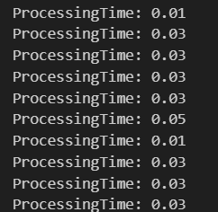

If we add the code for the reddest spot the processing time is slightly higher.

ProcessingTime with reddest spot:

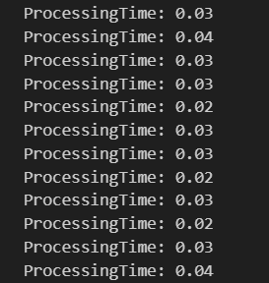

With both the reddest spot and the max brightness the processing time is even higher, approximately between 0.17 – 0.30 seconds.

ProcessingTime with reddest spot and max brightness:

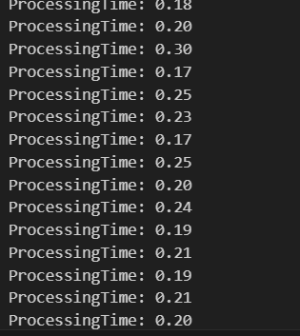

If the image is not displayed the processing time appears to be higher, even though that is not what one would expect. Might be due to other processes running in the background.

If the image is not displayed (with brightness and reddest point):

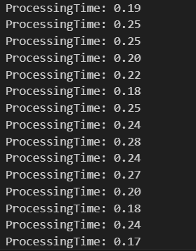

The for-loop implementation needs way more processing time than the built-in function. The for-loop needs between 0.19 – 0.45 seconds while the build-in function only needs around 0.02 seconds.

For-Loop:

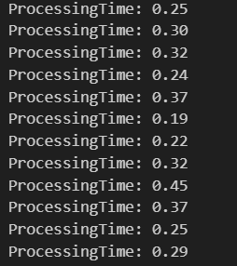

Built-in function:

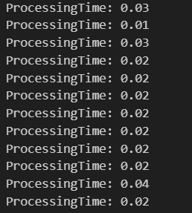

Moving the hand in front of the camera the latency is maybe half a second. When capturing from the mobile phone the latency is way higher, maybe 2 seconds or more.

GitHub: <https://github.com/Marlenexyz/COMP>