# COMP - Assignment 4

Fps with nano Modell:

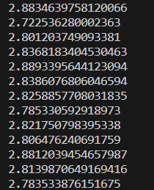

Number of parameters:

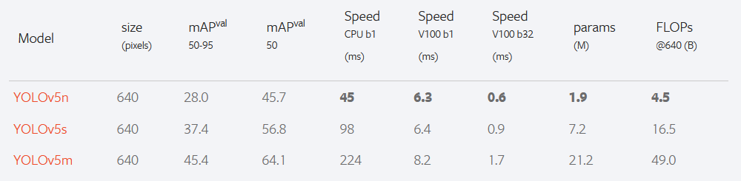

Precision:

Recall: