**Part 1:**

Compare response time and CPU load:

1. **Sysfs from shell script**

Response Time: Ø 4.28 ms

CPU Load: 23.8 %

Results change if CPU fully loaded: Ø 1,97 ms

Top:

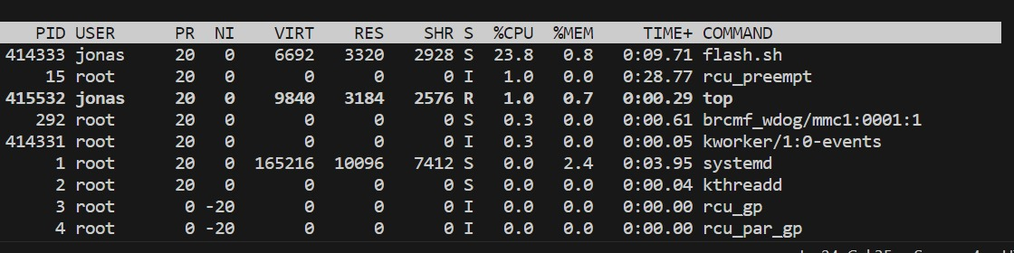

Top with load: Ein Bild, das Text, Screenshot, Schrift, Zahl enthält.

Oscilloscope picture:

Ein Bild, das Screenshot, Menschliches Gesicht, Person, Quadrat enthält.

1. **Sysfs from C++ application polling pin status using a timed read()**

Response Time: Ø 213.9 µs

CPU Load: 76.8 %

Results change if CPU fully loaded: Ø 205.3 µs

Top:

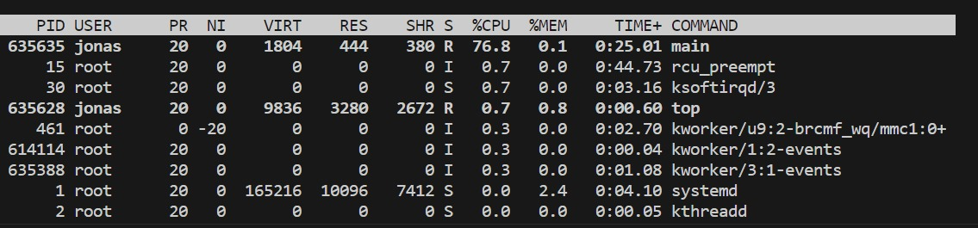

Top with load:

Ein Bild, das Text, Screenshot, Schrift, Zahl enthält.

Oscilloscope picture:

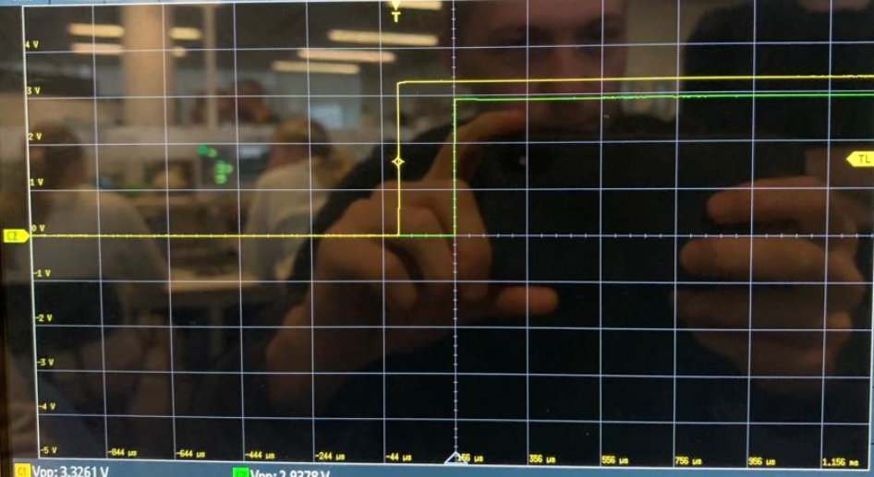

1. **Sysfs from C++ application using poll() function provided by kernel**

Response Time: Ø 397.1 µs

CPU Load: 0.3 %

Results change if CPU fully loaded: Ø 262.7 µs

Top:

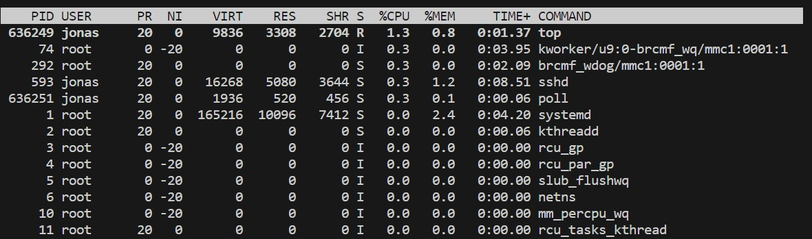

Top with Load:

Ein Bild, das Text, Screenshot, Schrift, Zahl enthält.

Oscilloscope picture:

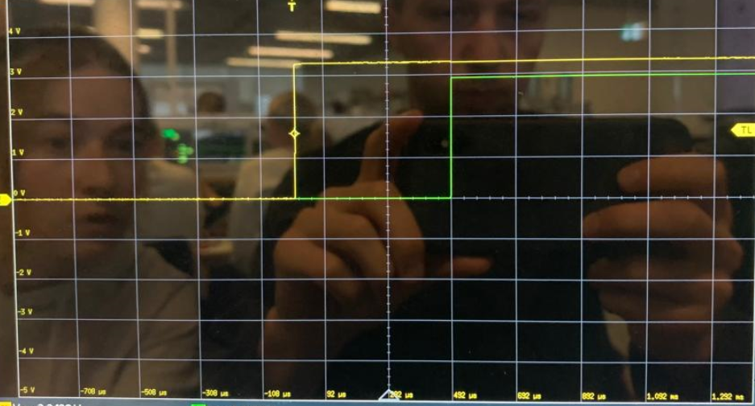

1. **Kernel modul using interrupts**

Response Time: Ø 18.91 µs

CPU Load: 0%

Results change if CPU fully loaded: Ø 11.03 µs

Top:

Ein Bild, das Text, Screenshot, Karte Menü enthält.

Top with load:

Ein Bild, das Text, Screenshot, Software, Zahl enthält.

Oscilloscope picture:Ein Bild, das Screenshot, Text, Multimedia-Software, Software enthält.

* **Which mechanism would suffice for counting encoder pulses?**  
  The encoder period is 664.45 µs, so every mechanism except from the *Sysfs from shell script* is valid for the counting.

**Part 2:**

**Speed print:**

ref. rps: 1.000000, act. rps: 0.952381, duty: 0.026125  
ref. rps: 1.000000, act. rps: 0.952381, duty: 0.026125  
ref. rps: 1.000000, act. rps: 1.428571, duty: -0.235129  
ref. rps: 1.000000, act. rps: 0.952381, duty: 0.026125  
ref. rps: 1.000000, act. rps: 0.952381, duty: 0.026125  
ref. rps: 1.000000, act. rps: 0.952381, duty: 0.026125  
ref. rps: 1.000000, act. rps: 0.952381, duty: 0.026125  
ref. rps: 1.000000, act. rps: 0.952381, duty: 0.026125  
ref. rps: 1.000000, act. rps: 0.952381, duty: 0.026125  
ref. rps: 1.000000, act. rps: 1.428571, duty: -0.235129  
ref. rps: 1.000000, act. rps: 0.952381, duty: 0.026125  
ref. rps: 1.000000, act. rps: 0.952381, duty: 0.026125  
ref. rps: 1.000000, act. rps: 0.952381, duty: 0.026125  
ref. rps: 1.000000, act. rps: 0.952381, duty: 0.026125  
ref. rps: 1.000000, act. rps: 0.952381, duty: 0.026125  
ref. rps: 1.000000, act. rps: 0.952381, duty: 0.026125  
ref. rps: 1.000000, act. rps: 1.428571, duty: -0.235129  
ref. rps: 1.000000, act. rps: 0.952381, duty: 0.026125  
ref. rps: 1.000000, act. rps: 0.952381, duty: 0.026125  
ref. rps: 1.000000, act. rps: 0.952381, duty: 0.026125  
ref. rps: 1.000000, act. rps: 0.952381, duty: 0.026125

**Control rate:**

**Duty Cycle:**

In the diagram above the jitter (peaks downwards) are visible when using the usleep() function for timing of the control rate.

Ein Bild, das Text, Screenshot, Schrift, Zahl enthält.

The results weren`t affected in our case. In the table it is visible that the injected busy task takes up 99.3% CPU load. However, the controller worked fine.

Injecting the busy task before starting the main task to control the motor would result in the motor not spinning at all.

GitHub: <https://github.com/Marlenexyz/EMBE-Group>

YouTube: <https://www.youtube.com/watch?v=buABB3gQtAQ>