1. What are the main phases in the database design? What is done on each development phase?

Answer: the main phases are the conceptual design, the logical design and the physical design. Conceptual data modeling:

* Develops preliminary conceptual data model
* Compares preliminary conceptual data model with enterprise data model
* Develops detailed conceptual data model

Logical database design:

* Transforms conceptual data model into relations
* Normalization

Physical database design:

* Specifies the organization of physical records, the choice of fire organizations, and the use of indexes

1. What is the entity – relationship (ER) data model?

Answer: Entity – relationship data model is a high – level data model that defines data elements and their relationship for a specified software system.

S_id

PHONE_NUMBER

STUDENT

Number of rooms

NAME

CODE

DORMITORY

COURSE

LOCATION

COURSE_ID

NAME

NAME

ID

LOCATION

NAME

TEACHER

UNIVERSITY

CODE

FACULTY

COURSE_ID

CLASSROOM

MANAGER_ID

OFFICE OF THE REGISTAR

1. One – to – one relationship
2. 1

ID

has

Student

1. One – to – many relationship
2. M

assigned

order

customer

1. Many – to – one relationship

M 1

study

College

Student

1. Many – to – many relationship

M M

assigned

Project

Student

1. 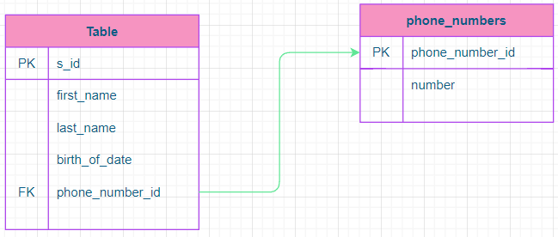a)

b)

Number of rooms

NAME

CODE

DORMITORY

COURSE

LOCATION

COURSE_ID

NAME

has

Lives in

NAME

ID

Works in

LOCATION

NAME

TEACHER

UNIVERSITY

CODE

COURSE_ID

has

FACULTY

CLASSROOM

MANAGER_ID

OFFICE OF THE REGISTAR

1. 