1. Every conversion into BCNF may not be dependency preserving

Consider the following schema; a b c and c->b Clearly the above schema is in 3NF, because ab->c is a superkey dependency and ,from c->b we can see that b-c=b, which is a subset of the primary key (such dependency is also allowed in 3NF). But, the above schema is not in BCNF because c->b is neither super-key nor trivial dependency. So we decompose above schema , keeping it lossless. Only possible lossless decomposition is: ac and cb. (because,their intersection c is primary key for the 2nd table). But clearly the dependency ab->c is lost.

1. 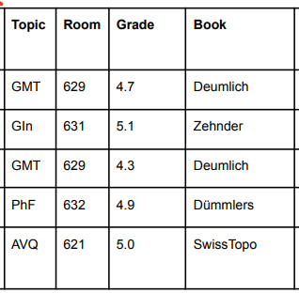
2. 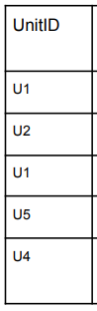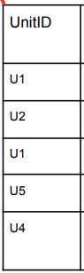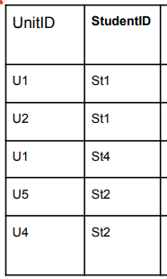
3. 