Assignment #2

This assignment focuses on refactoring and automated testing. The problems are based on the code given below. It is part of a sales system that supports discount policies. Even though the code is given in Java, you may choose any object-oriented programming language along with an xUnit framework. You will receive no credit if your code is not object-oriented. If you don’t use Java, it is your responsibility to translate the given code without changing the functionality.

public class Sale {

private static double DISCOUNT_RATE = 0.05;

private ArrayList<Item> itemList = new ArrayList<Item>();

public void addItem(Item item) {
itemList.add(item);
}

public double getDiscountRate(){
return DISCOUNT_RATE;
}

public double getDiscount(){
return getSubTotal()*getDiscountRate();
}

public double getSubTotal() {
double subTotal = 0.0;
for (Item item: itemList) {
subTotal += item.getItemTotal();
}
return subTotal;
}

public double getDiscountedSubTotal() {
return getSubTotal() – getDiscount();
}

}

For each problem, you must provide a description about how you designed or refactored your code. Handwritten answers will not be accepted. The source code for each problem should be provided as a separate package. Turn in your work as a single zip file via Canvas.

- Complete the Item class (and the Sales class if you don’t use Java). The instance variables of Item should at least include title, original unit price, and quantity (4 points). Also write a xUnit test class for each of the methods getDiscount, getSubTotal, getDiscountedSubTotal so that the Sale class is fully tested (3 points).
Provide a description about how you created the Item class and ensured that it is fully tested (2 points). Attach a screenshot of your test execution (1 point).
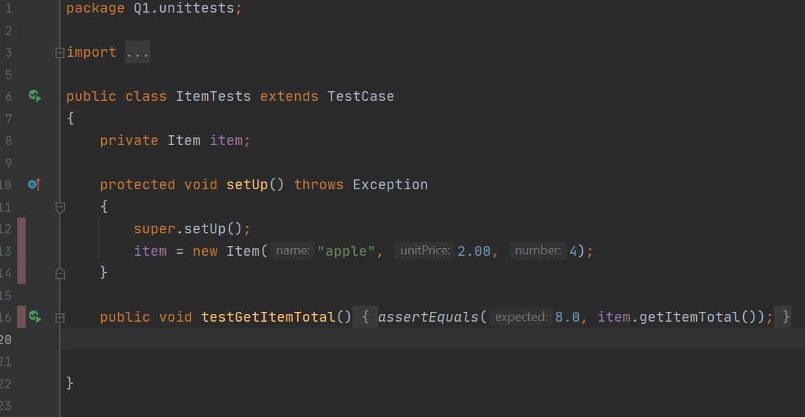
New class which includes the string title, the original unit price, and the quantity which is required of any such item being required for the business. Also had to get the item total, so method getItemTotal() returned the price times quantity
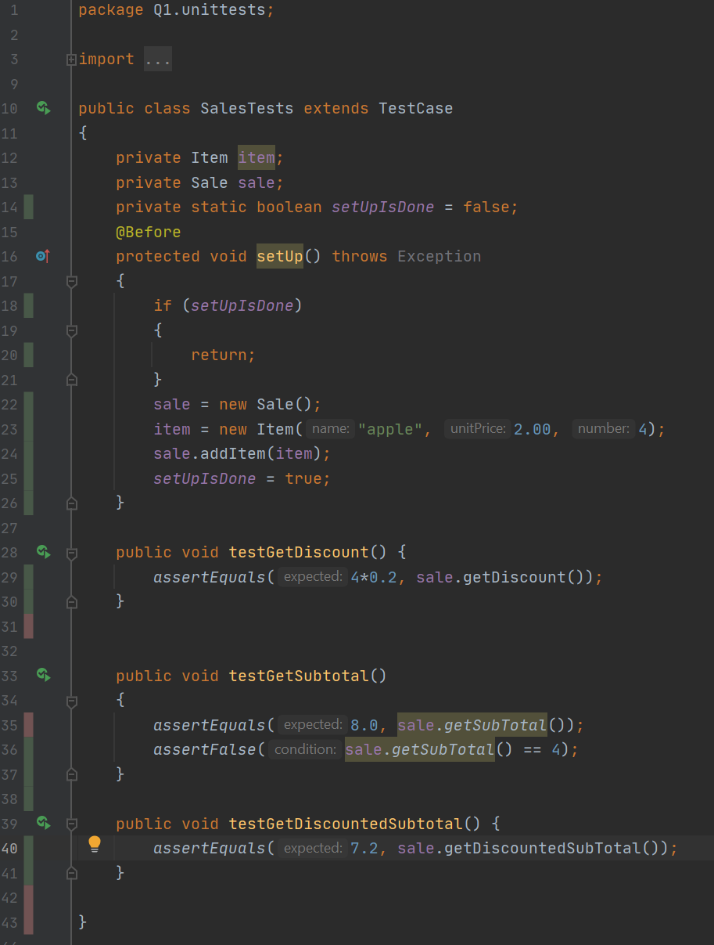

- Update the Sale class to support different discount rates and for seniors (e.g., 10%) and preferred customers (15%), in addition to the discount rate in (1) for any customer (12 points). Update your test code with appropriate new tests (4 points). Your program must use switch statement(s), otherwise you will not receive any credit for the problems (3)-(5).
Provide a description about how the code was updated to meet the new requirements and what new tests were created (3 points). Attach a screenshot of your test execution (1 point).
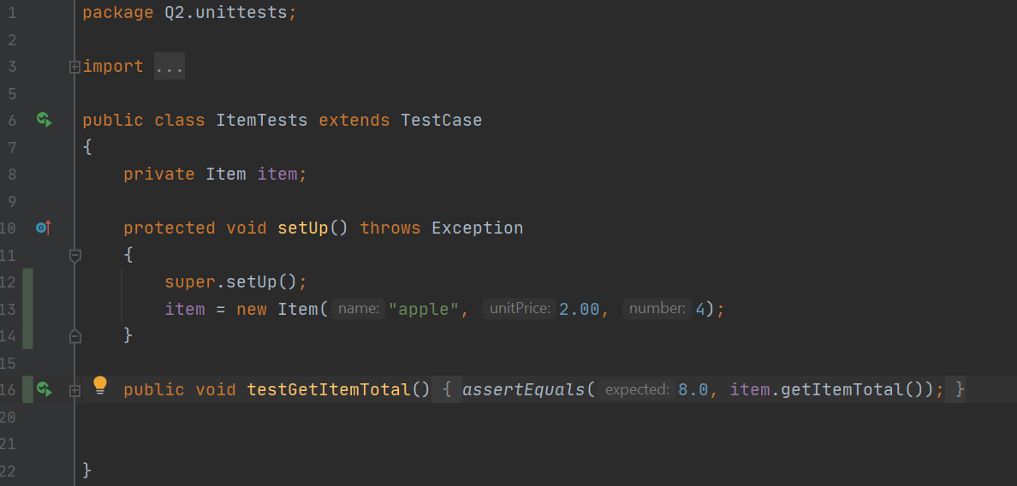
ItemTests doesn’t change, but SalesTests does. Discounted rate needed to be found for preferred customers, seniors, and loyalty, this was determined in a function to determine which rate it was (getDiscountRate()), then each rate was given its own test, as well as a test to see if the wrong rate was chosen for a certain customer.
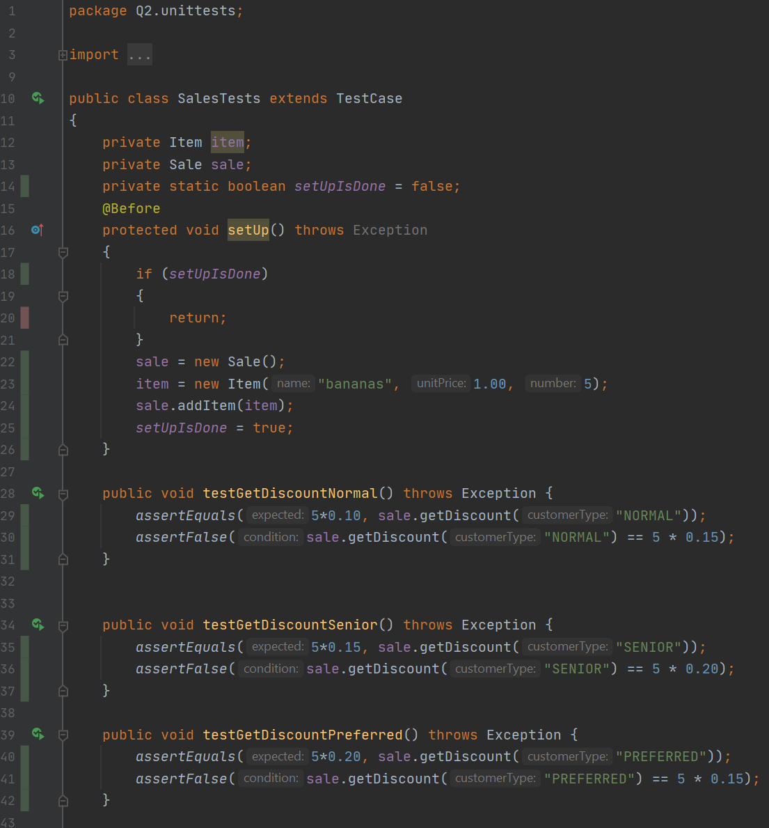
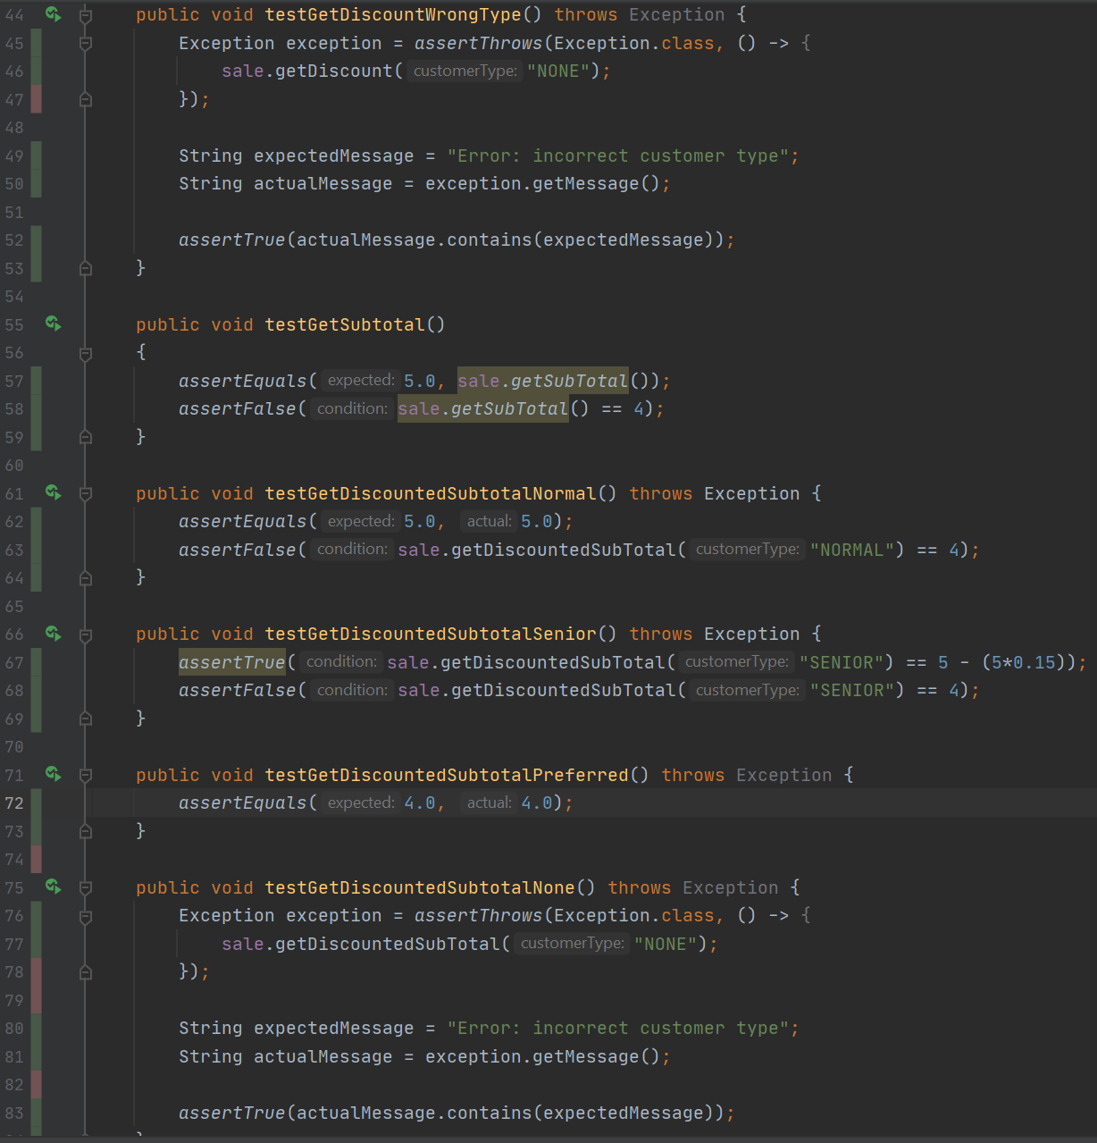
- Update your code for (2) to support that the senior’s discount is only on Tuesday (12 points). Update your test code with appropriate new tests (4 points). Your program must keep the switch statement(s), otherwise you will not receive any credit for the problems (3)-(5).
Provide a description about how the code was updated to meet the new requirements and what new tests were created (3 points). Attach a screenshot of your test execution (1 point).

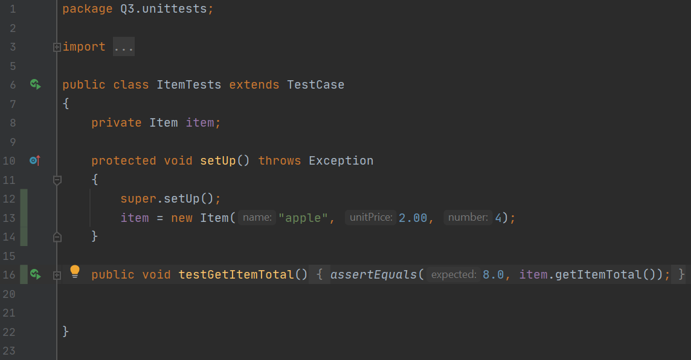
ItemTests doesn’t change, but SalesTests does. New parameter to list day of the week which changes the discount to only apply on a certain day, Tuesday. Otherwise the normal discount is applied, and tests to give the correct discount based on the day
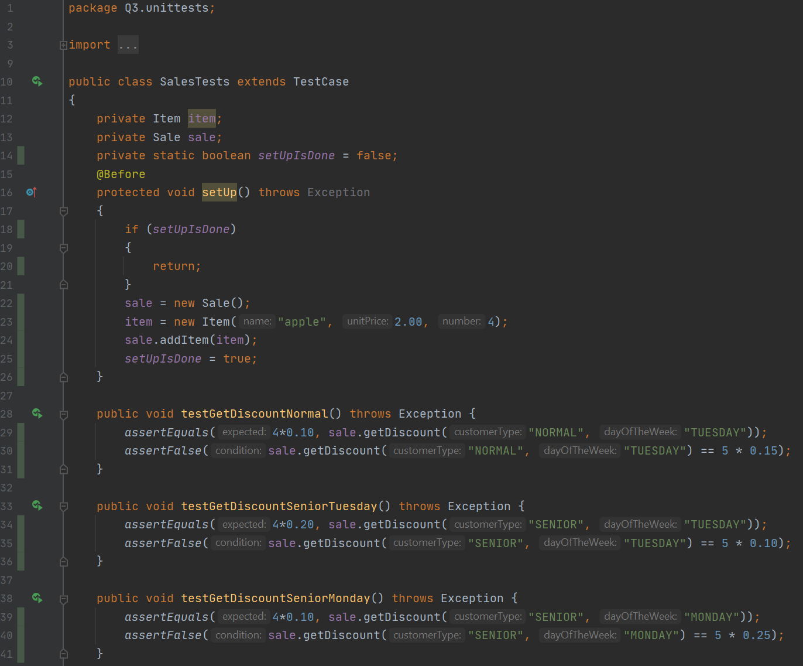
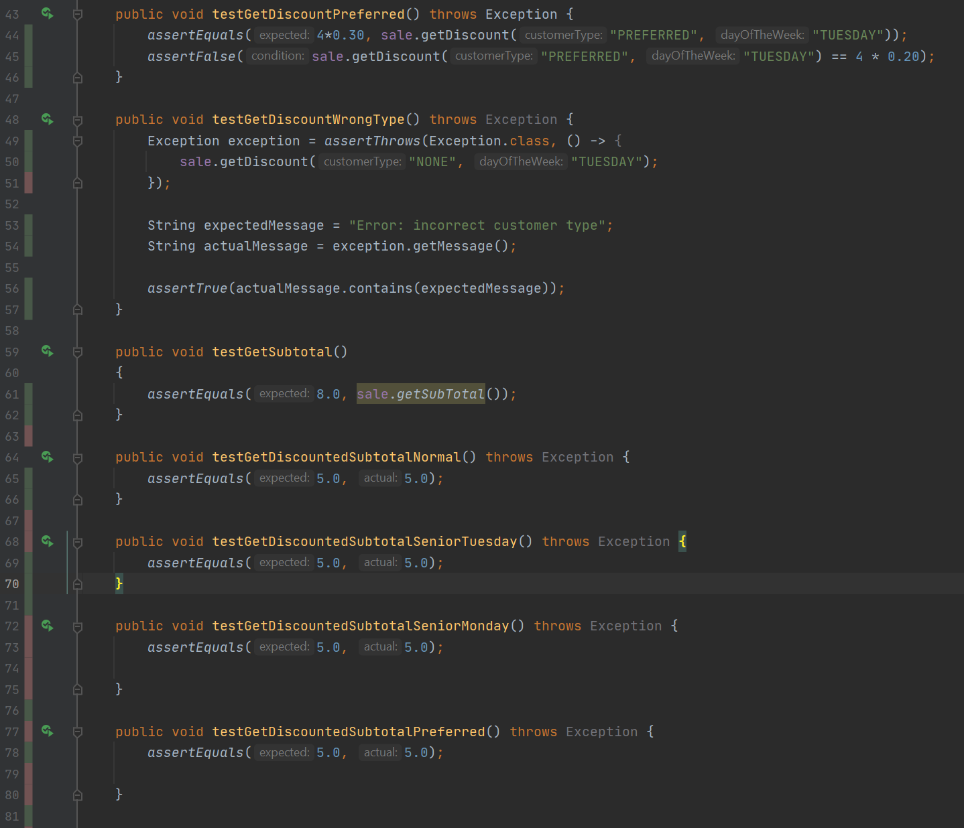
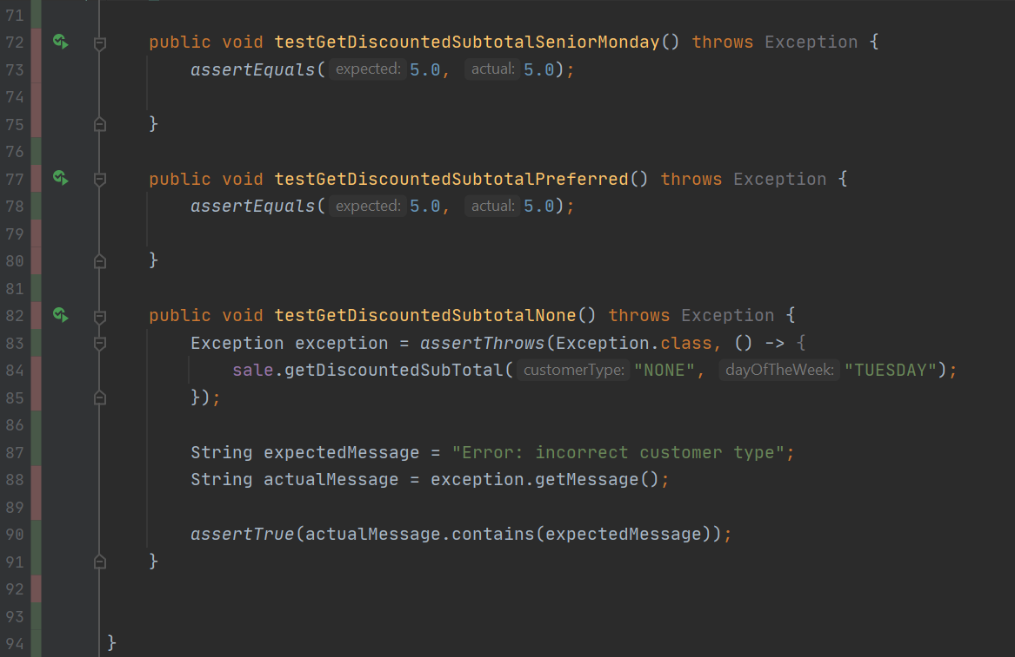
- Refactor your code for (3) to eliminate the switch statement(s) by using class hierarchy and polymorphism (25 points). You will receive no credit if any switch statement is simply changed to if-then-else statements. Provide a description about how you designed the class hierarchy to replace the switch statement without change of functionality (4 points). Attach a screenshot of your test execution (1 point).
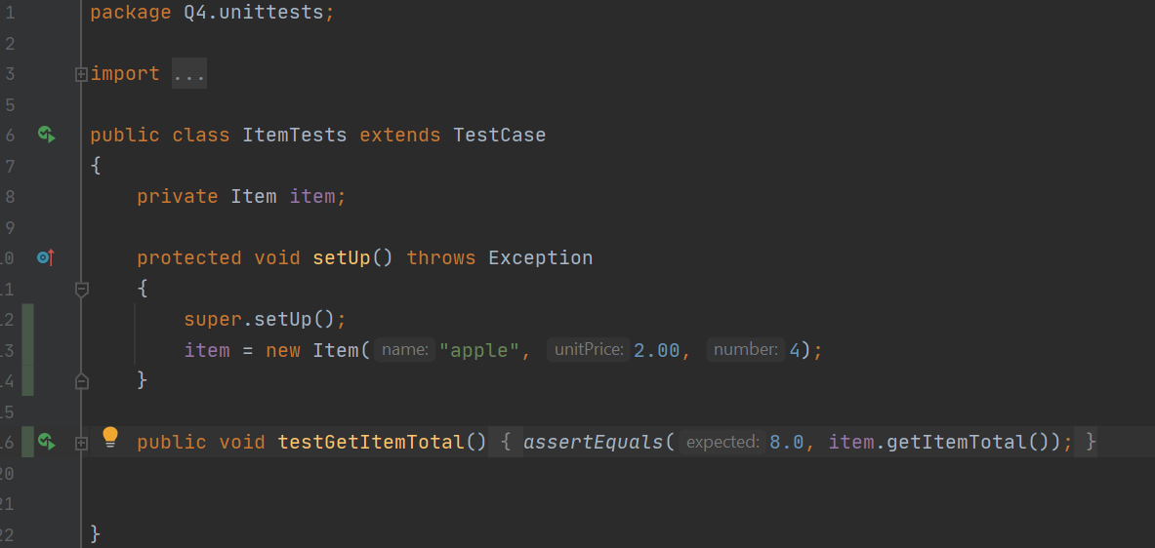
ItemTests doesn’t change, but SalesTests does. The discounts were swapped back and expanded in a way that there were 3 classes (normal, senior, preferred) that inherit from Sales class. The discount rate function returns the different discount rates for each class.
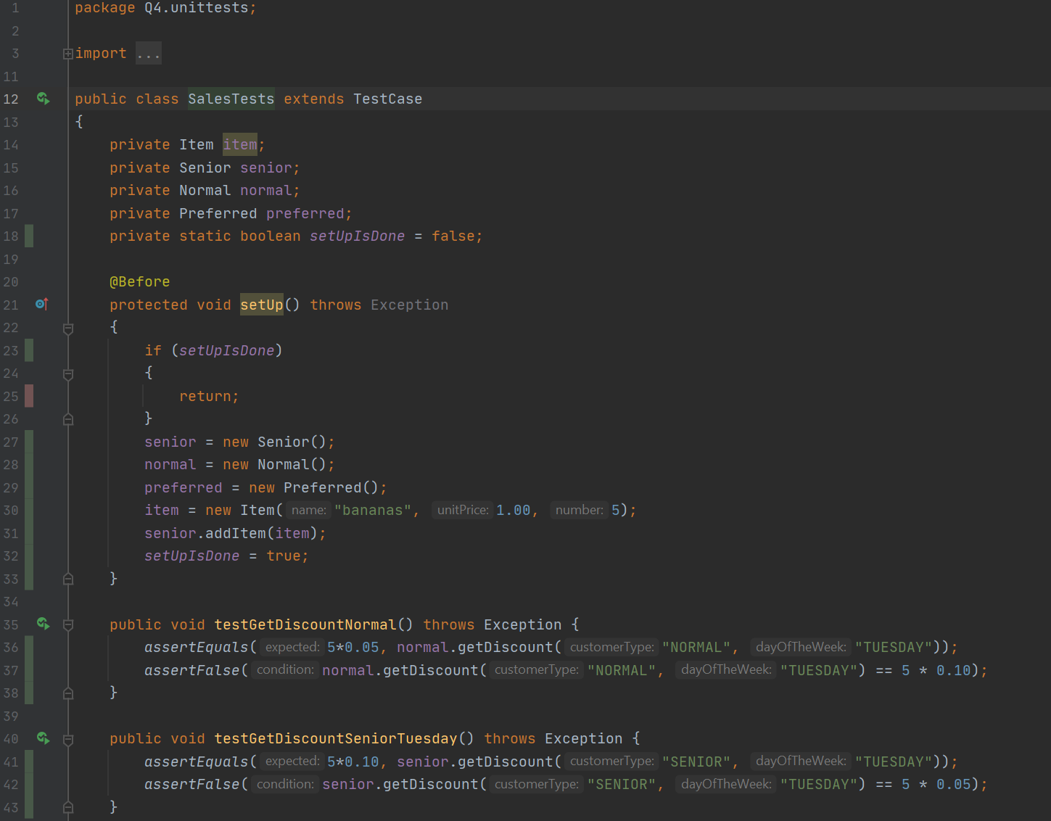
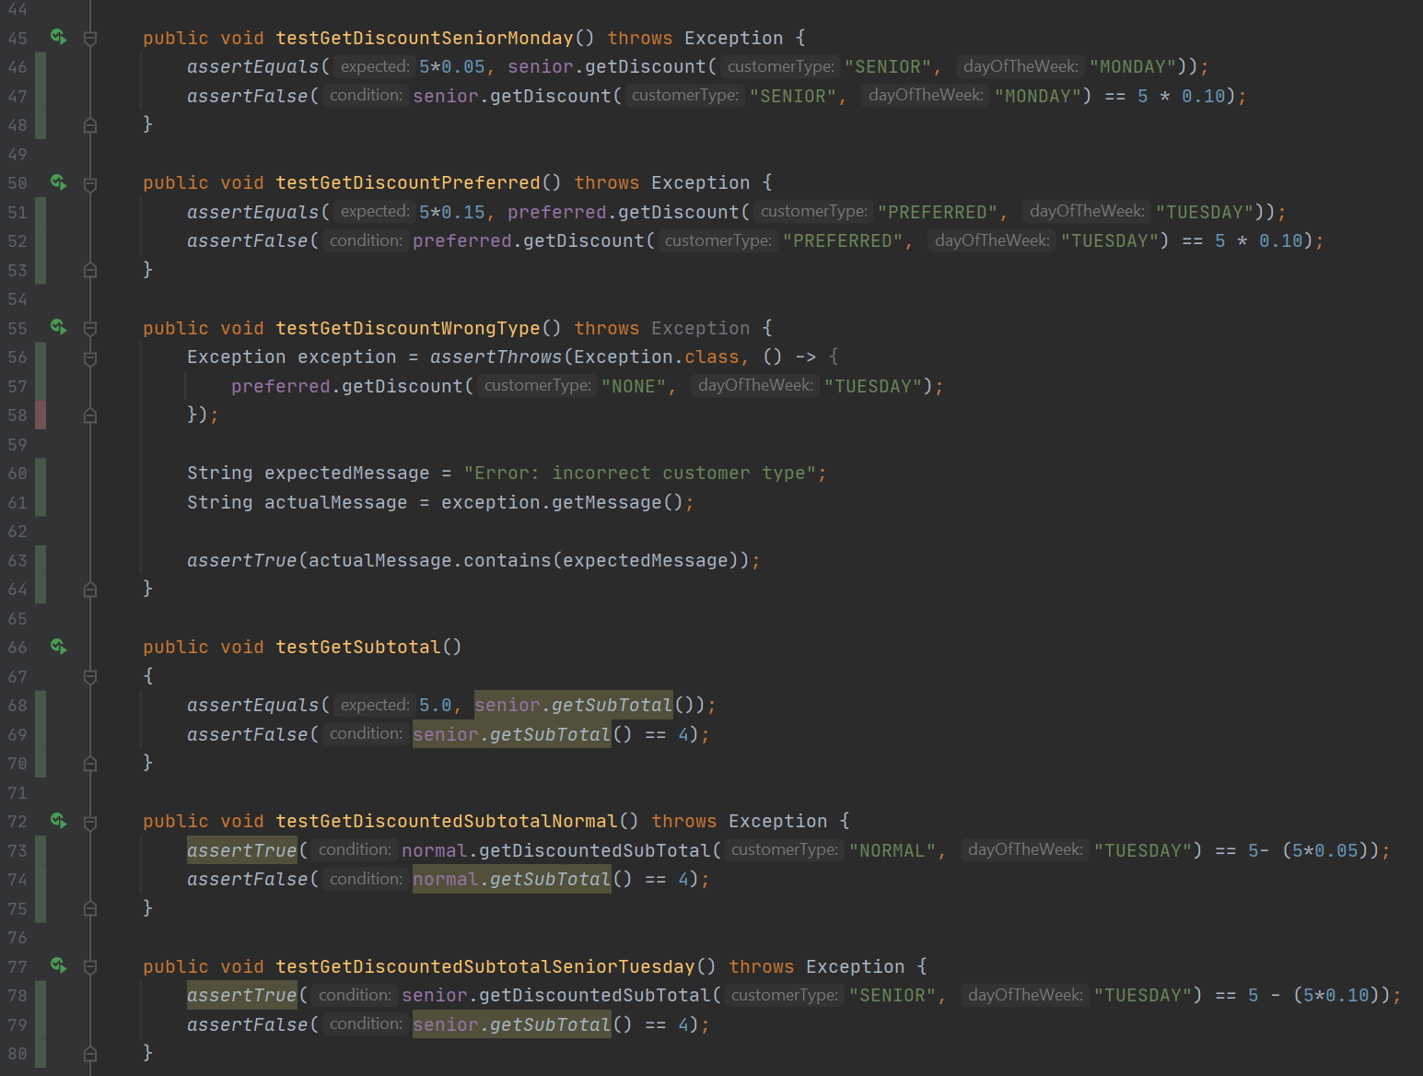
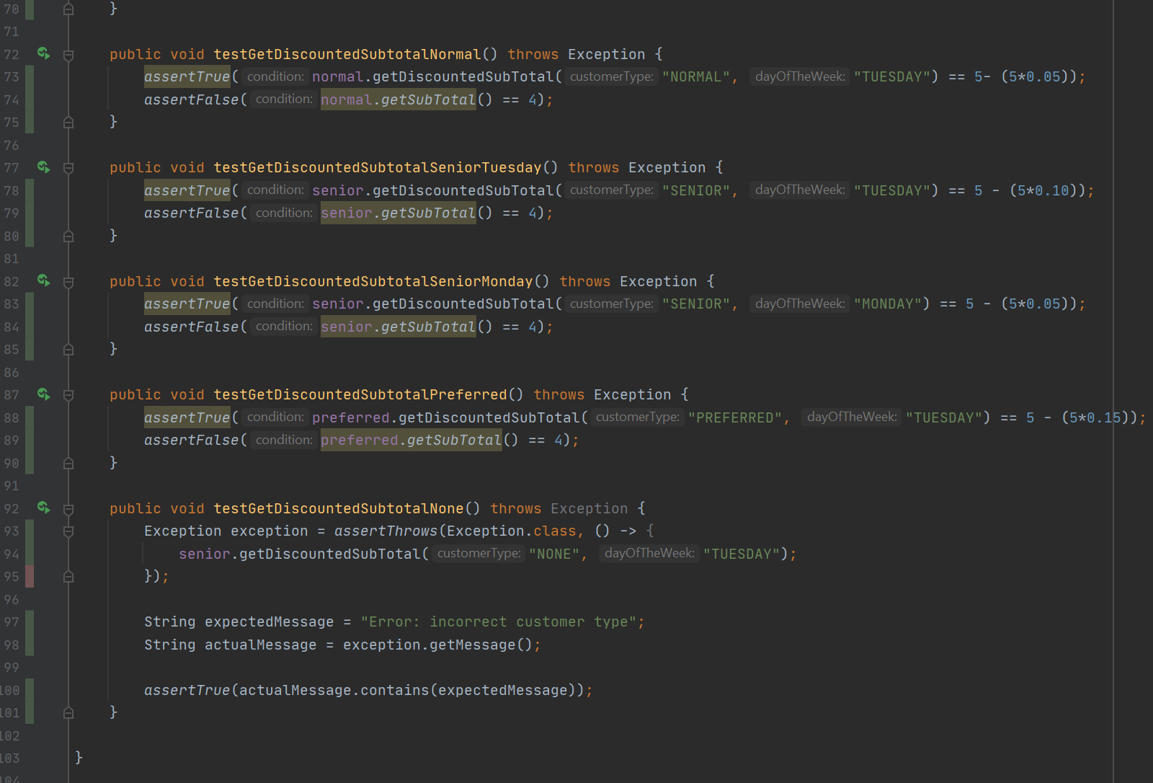
- Update your code for (4) to handle the new discount policy “buy one, get the second (and the rest of the same item) 50% off” for certain items (12 points), and add new tests for this new functionality. Make sure your code does not smell. (4 points).
Provide a description about how the code was updated to meet the new requirements and what new tests were created (3 points). Attach a screenshot of your test execution (1 point).
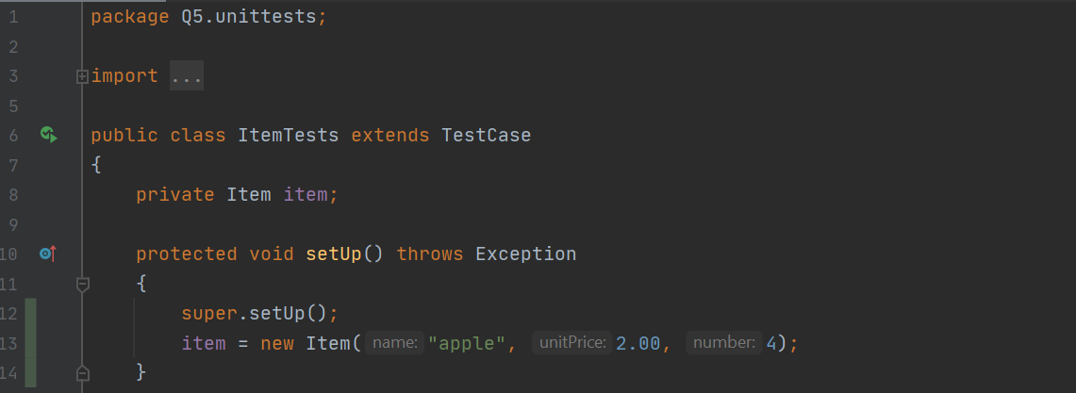
ItemTests doesn’t change but SalesTests does. The total of the item must be found, which requires the number of the item to be found. If it’s just one, then the price is the same, but there must be multiplication if it’s more than 1 of the same item. Tested with half values and discount tests with one item or multiple item
