**CN5006 PORTFOLIO:**

**Week 1 code:**

**Self-evaluation:**

I have improved my java script language skills and will work more to improve them. This was a great refresher after the summer holiday.

**Exercise:**

This program was created to function as a calculator that is capable of four kinds of operations.

# **Week 2 lab tasks:**

1) Repeat the same process to search Education for Master and .Find the avg,min,max age and avg min max Salary of the people group by Marital status.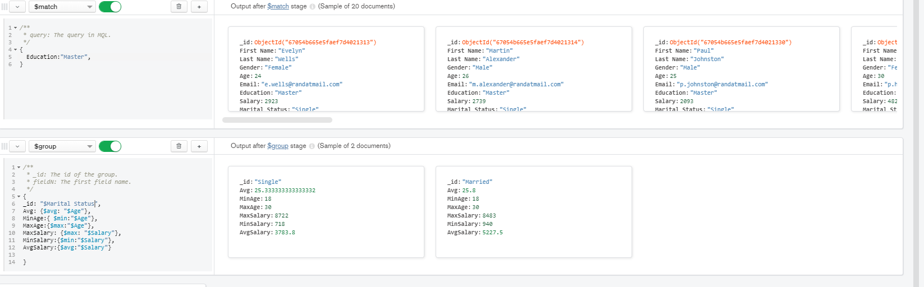

2) 2. find min,max average salary of each age group of female 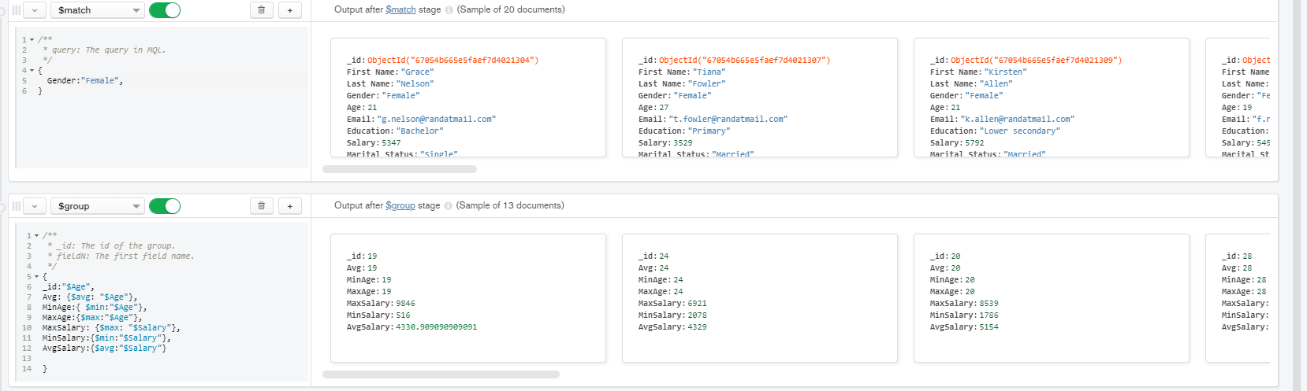

3) find min,max average salary of each age group of male 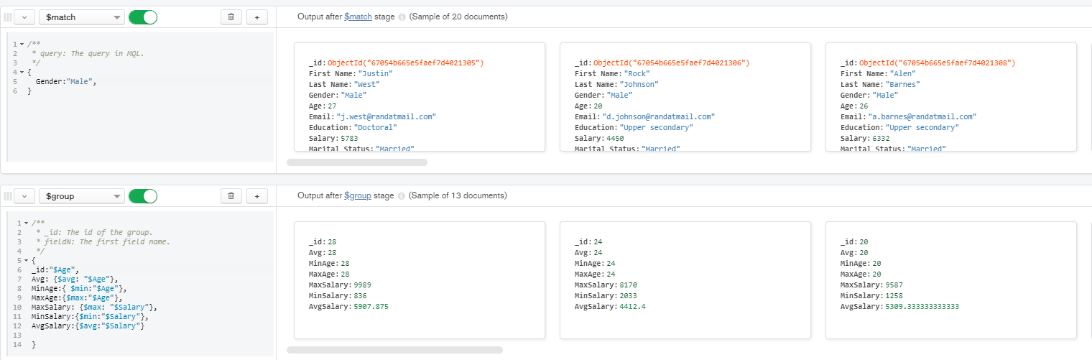4) Count married and unmarried females and males.

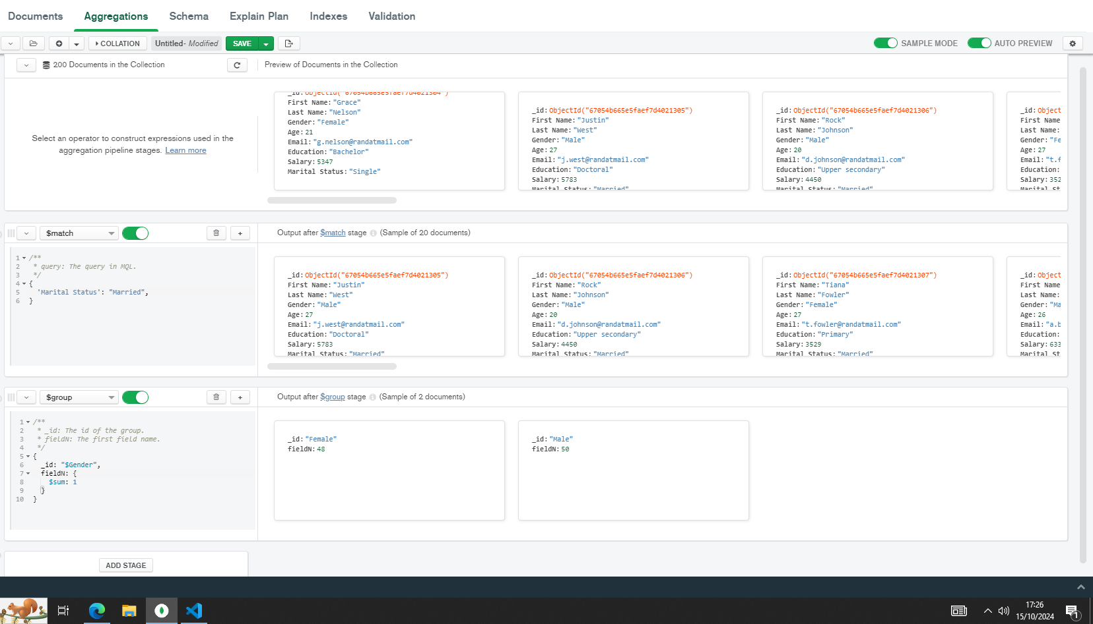

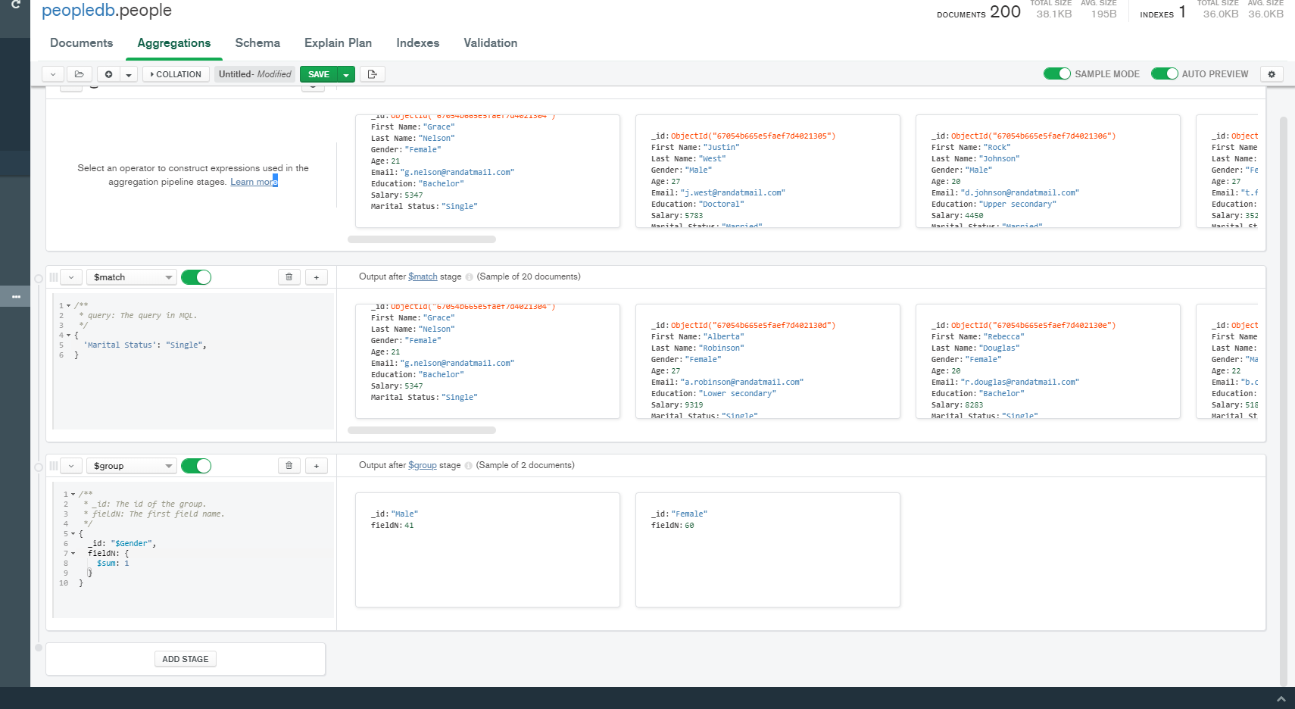

**Report:**

The work that been done with this code has been used to separate the data that has been given from a spread sheet then sorted into different categories depending on the need.

**WEEK 3:**

Submit the code for the completed Exercises i.e.: i) Index.js ii) Person.js iii) Employeeinfo.js iv) Exercise 4.js

**Report:**

The coding that I’ve done during this lesson displays the information of the device that is being used. It also displays the information of the student information that has been given. I learned how to link different methods together.

**WEEK 4:**

Localhost:5000/GetStudents

Localhost:5000/ GetStudentid/3

Localhost:5000/ GetStudentid/4

Localhost:5000/ studentinfo

**Report:**

This week I learnt how to implement data that has been provided and display it in a format that separates the data into different categories. The data has also been displayed in different formats.