Wastewater, Rate of change of positive tests

`Marlin derived from work by Brian Yandell

The code was derived from work by the DSI. This analysis looks at the rate of change of the positive rate of COVID-19 in Madison Wisconsin and matches this with the wastewater data. While offering promising results Difficulties arise when trying to convert it to a measure of positive COVID-19 rates. This and bad fundamentals leads to the conclusion that this is a bad model for Covid-19 positive rates.  
The Original R code file can be found in the [pandemic github repository](https://github.com/UW-Madison-DataScience/pandemic/blob/master/wastewater.Rmd).  
The Code for this R File can be found in the [Covid Waste Water Exploration](https://github.com/MarlinRLee/Covid-Waste-Water-Exploration/blob/main/general%20model%20finding.Rmd)

## [1] "Time shifted 5 Days"

## [1] "Model is log(N1/(Pct_BCoV*PMMoV))"

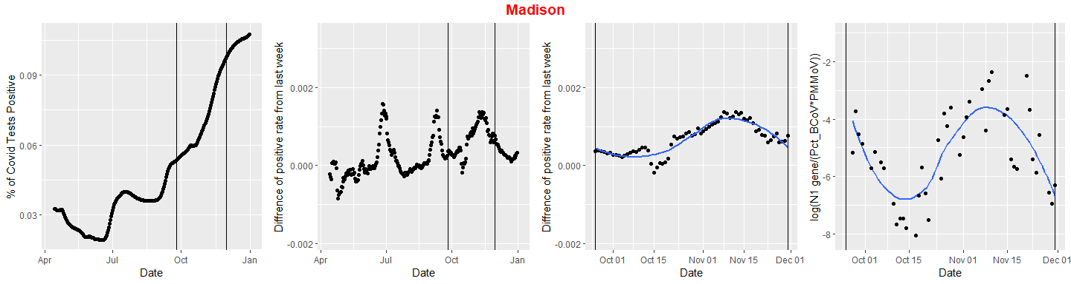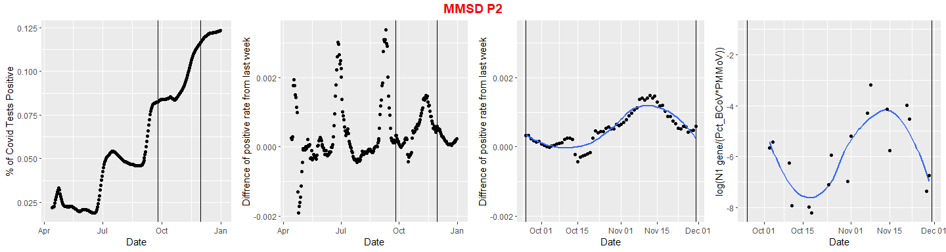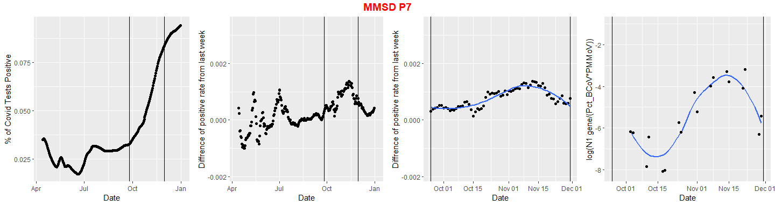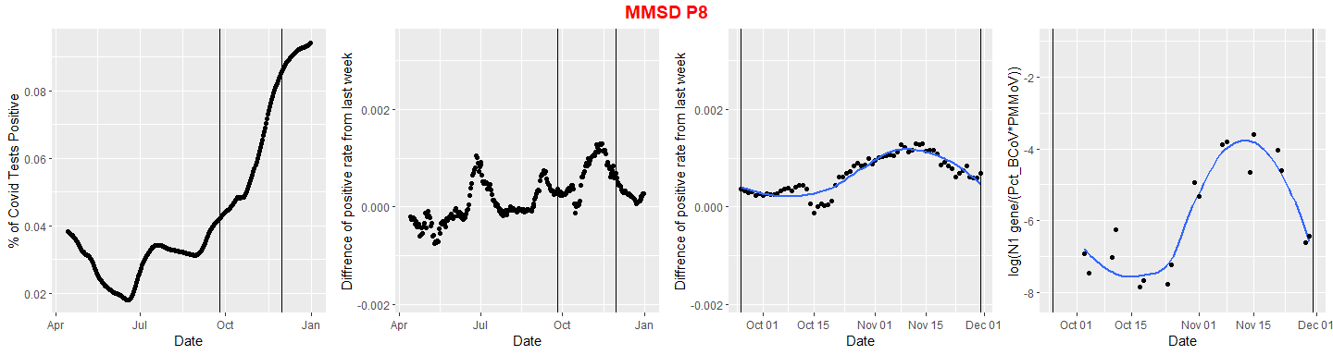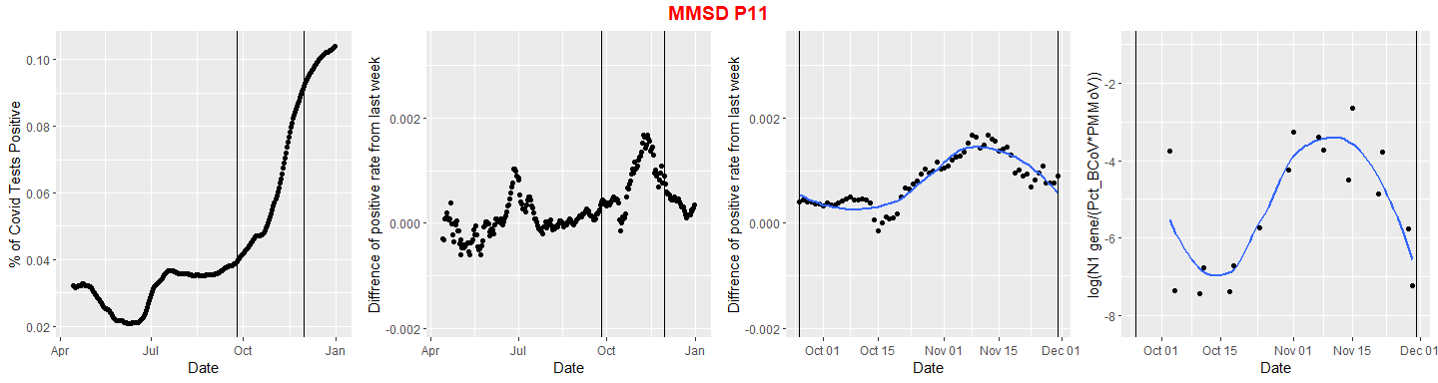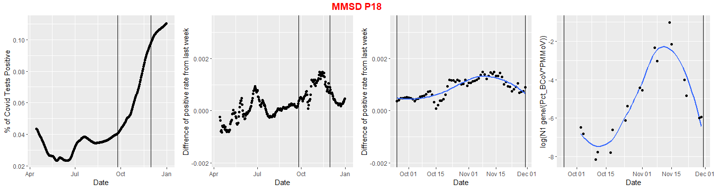

Chronic Overprediction for The Madison Sample is likely due to the more frequent sample collection leading to less change per sample.

##   
## Call:  
## lm(formula = der ~ Model, data = modelData)  
##   
## Coefficients:  
## (Intercept) Model   
## 0.00440 0.00042

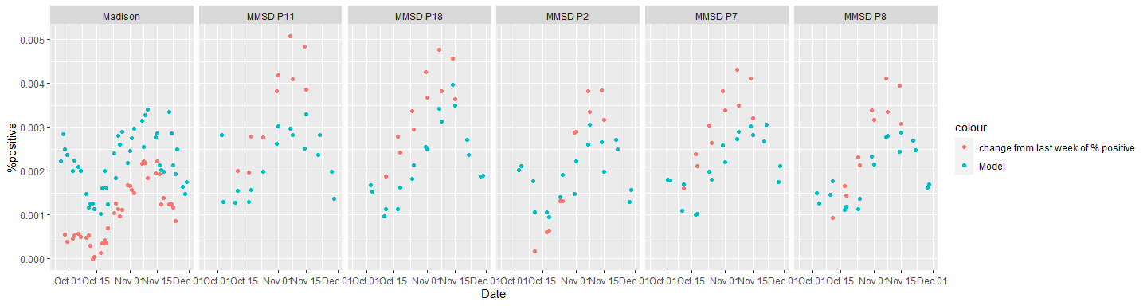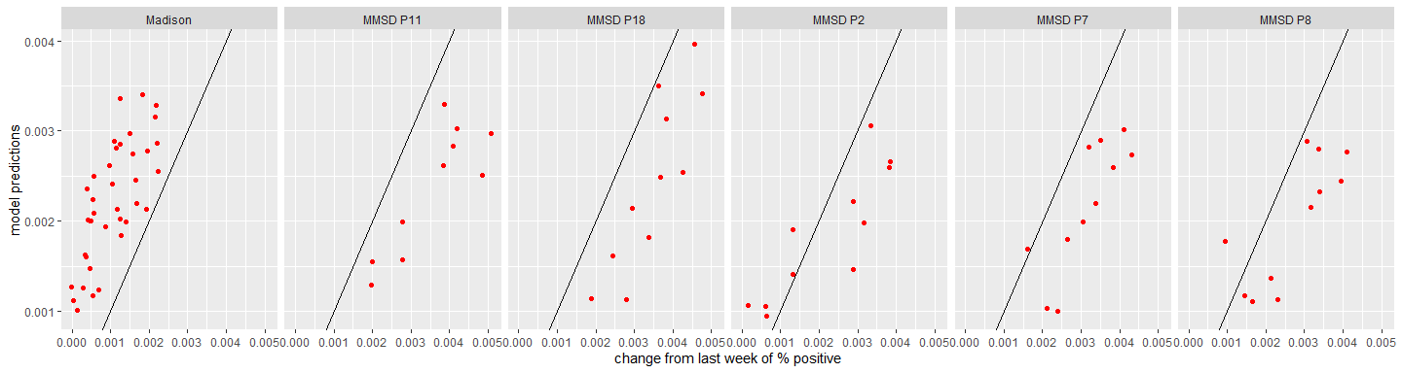

R^2 for the model

## # A tibble: 6 x 2  
## Site R20  
## <chr> <dbl>  
## 1 Madison 0.990  
## 2 MMSD P11 0.984  
## 3 MMSD P18 0.990  
## 4 MMSD P2 0.985  
## 5 MMSD P7 0.989  
## 6 MMSD P8 0.989

Convert model of change of % positive tests into model of % positive test by summing previous values.

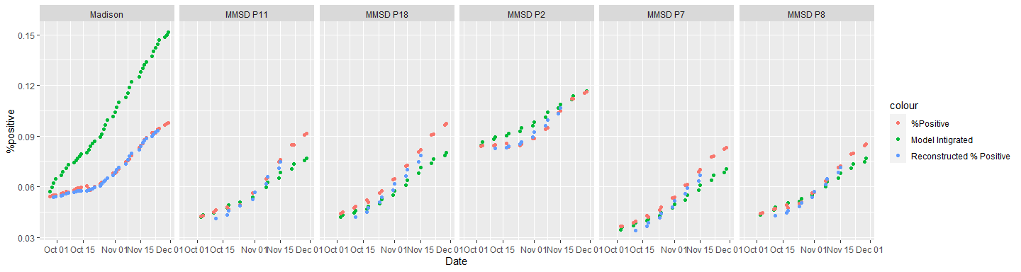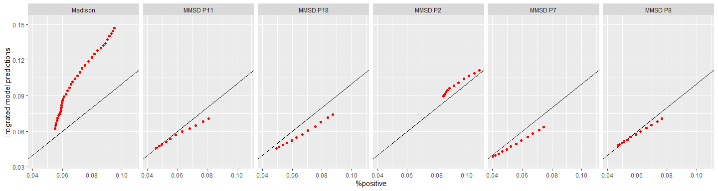

R^2 for the integrated model. Terrible prediction for Madison is due to the chronic overprediction resulting from its more frequent sampling. Other sampling locations have otherwise unexplained inaccuracies

## # A tibble: 6 x 2  
## Site R20  
## <chr> <dbl>  
## 1 Madison -5.73   
## 2 MMSD P11 0.800  
## 3 MMSD P18 0.472  
## 4 MMSD P2 0.445  
## 5 MMSD P7 0.632  
## 6 MMSD P8 0.910