Wastewater, Model Work

`Marlin derived from work by Brian Yandell

The code was derived from work by the DSI. This analysis seeks to model % of tests positive using wastewater Data. This model has logical reasons to be predictive but only finds moderate success when broken down by collection site. Particularly it consistently underpredicts the % positive rate in the P2 district.  
The Original R code file can be found in the [pandemic github repository](https://github.com/UW-Madison-DataScience/pandemic/blob/master/wastewater.Rmd).  
The Code for this R File can be found in the [Marlin Lee waste Water Work](https://github.com/MarlinRLee/Covid-Waste-Water-Exploration/blob/main/general%20model%20finding.Rmd)

## [1] "Time shifted 5 Days"

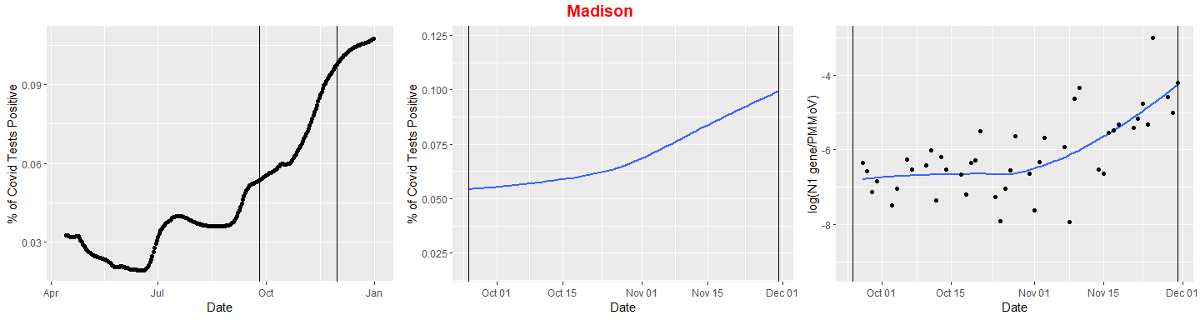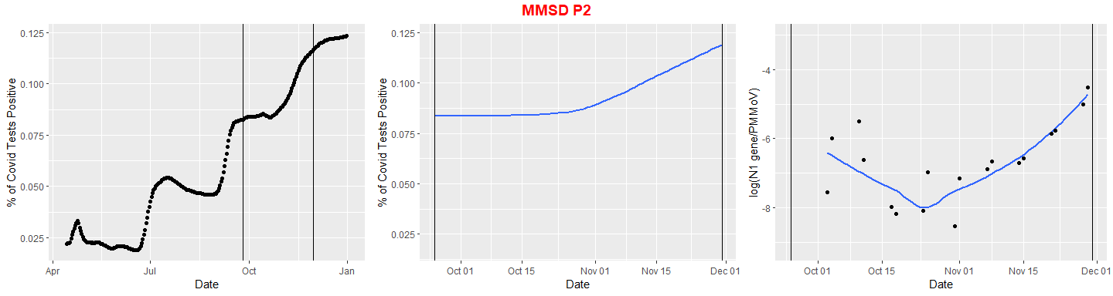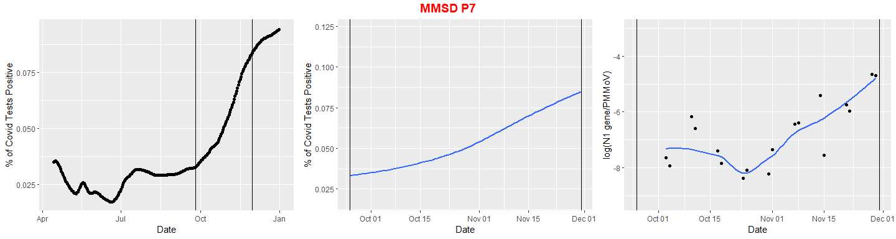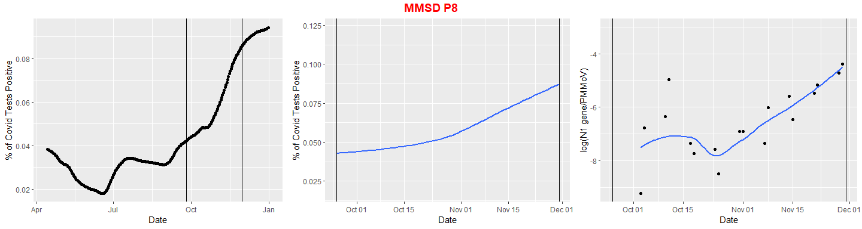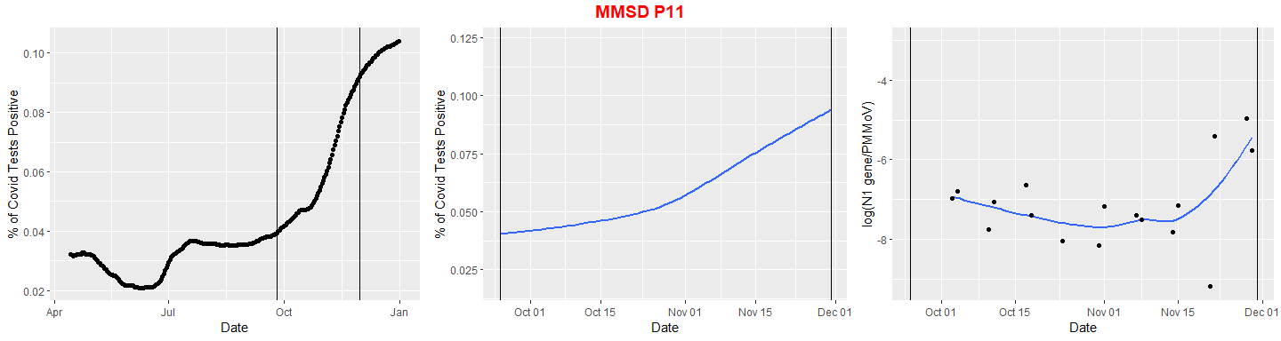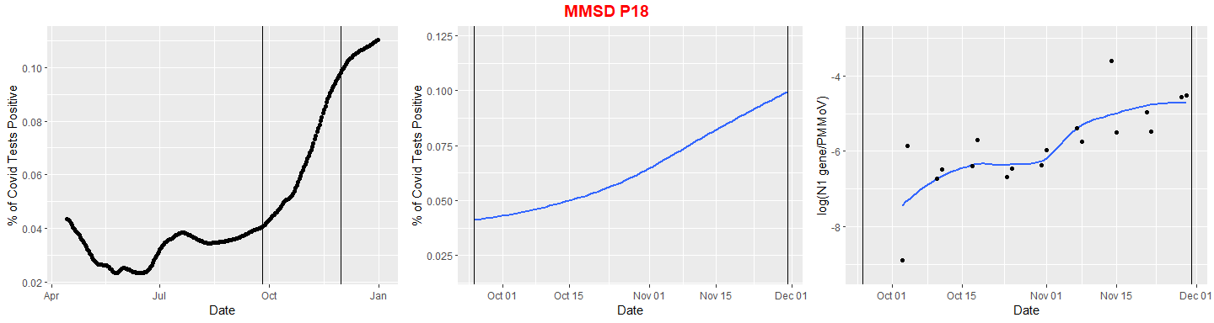

##   
## Call:  
## lm(formula = roll ~ Model, data = AdjustedData)  
##   
## Coefficients:  
## (Intercept) Model   
## 0.121401 0.008305

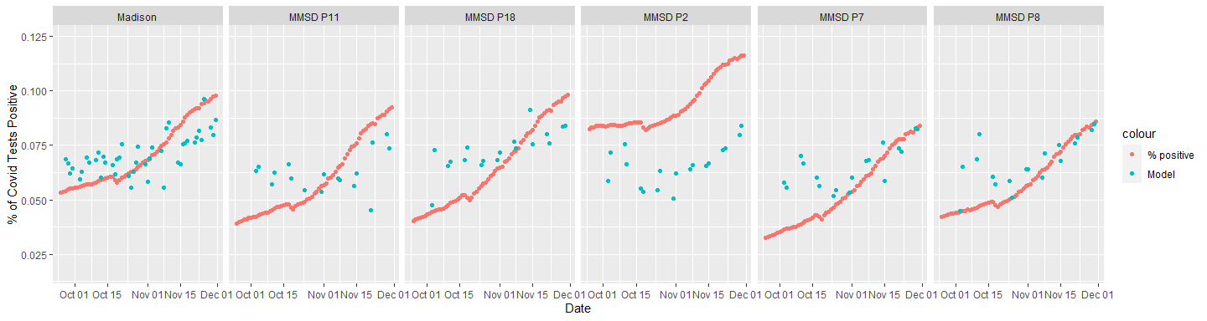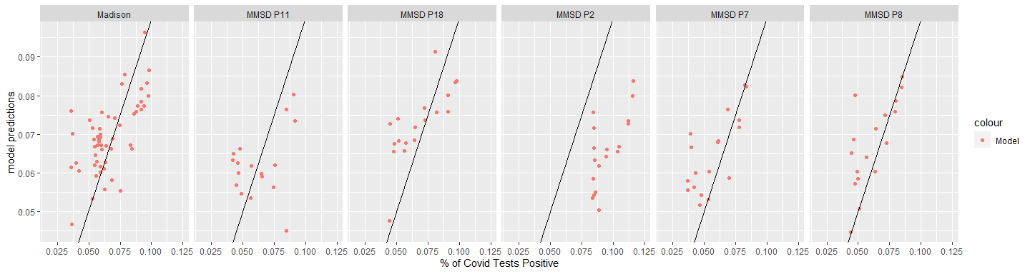

R^2 for the model

## # A tibble: 6 x 2  
## Site R2  
## <chr> <dbl>  
## 1 Madison 0.647  
## 2 MMSD P11 0.513  
## 3 MMSD P18 0.703  
## 4 MMSD P2 0.189  
## 5 MMSD P7 0.604  
## 6 MMSD P8 0.694