Wastewater, Total_Flow

`Marlin derived from work by Brian Yandell

The code was derrived from work by the DSI.  
The Original R code file can be found in the [pandemic github repository](https://github.com/UW-Madison-DataScience/pandemic/blob/master/wastewater.Rmd).

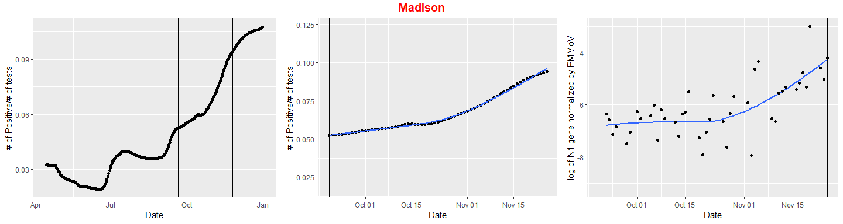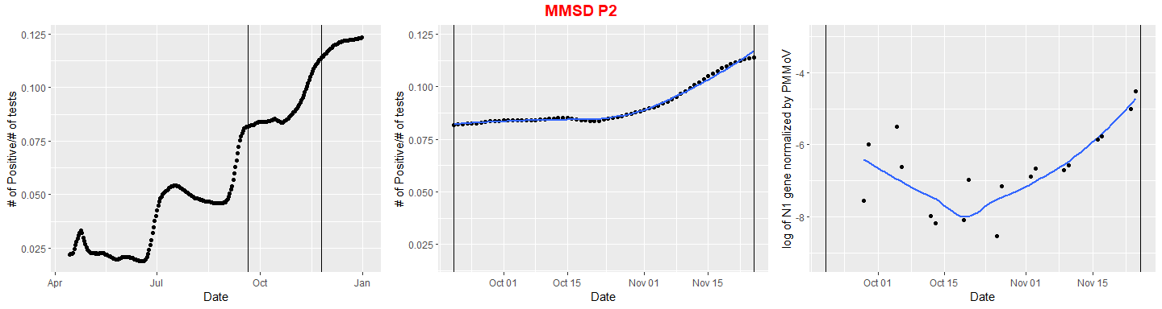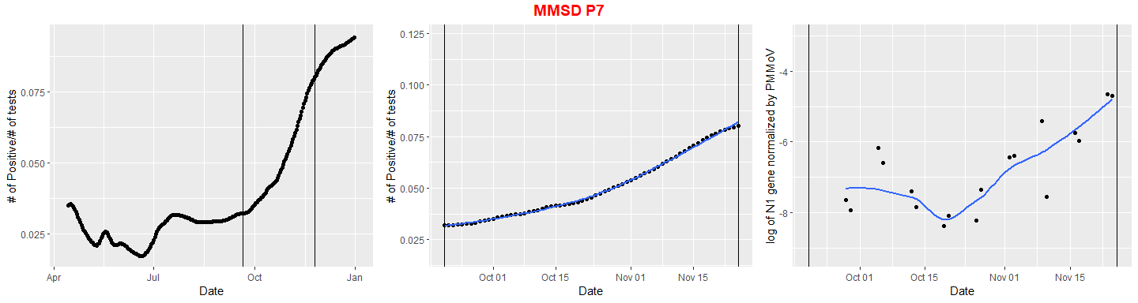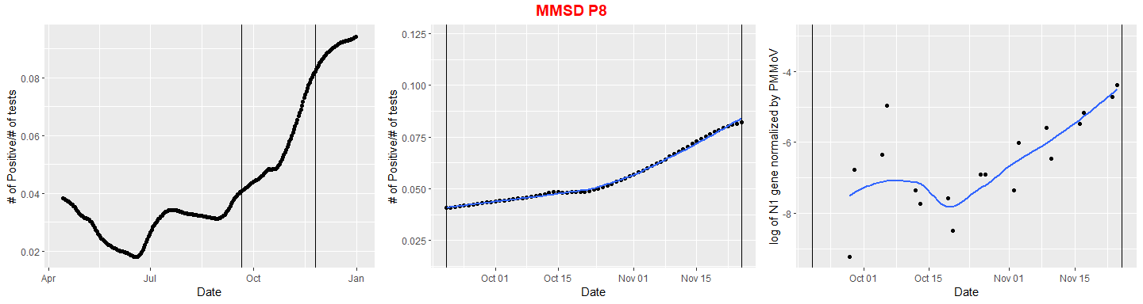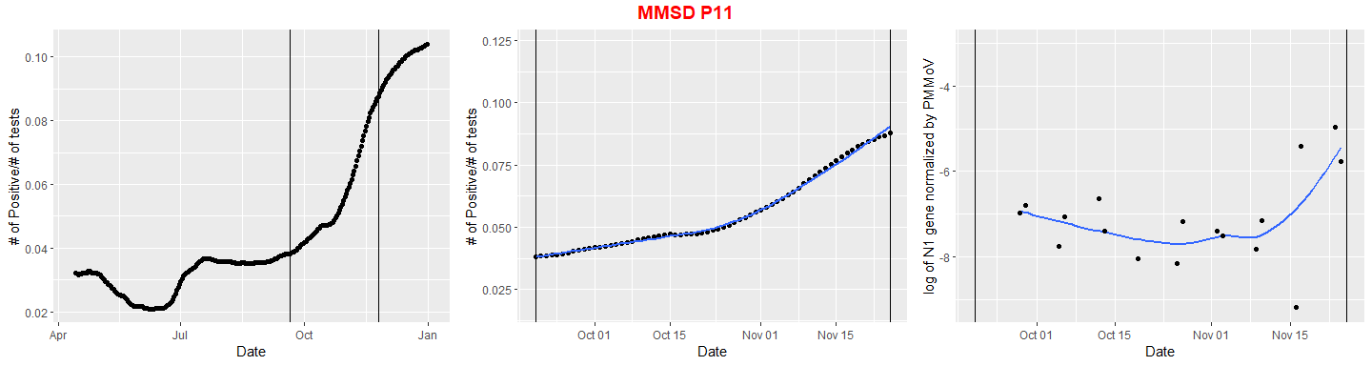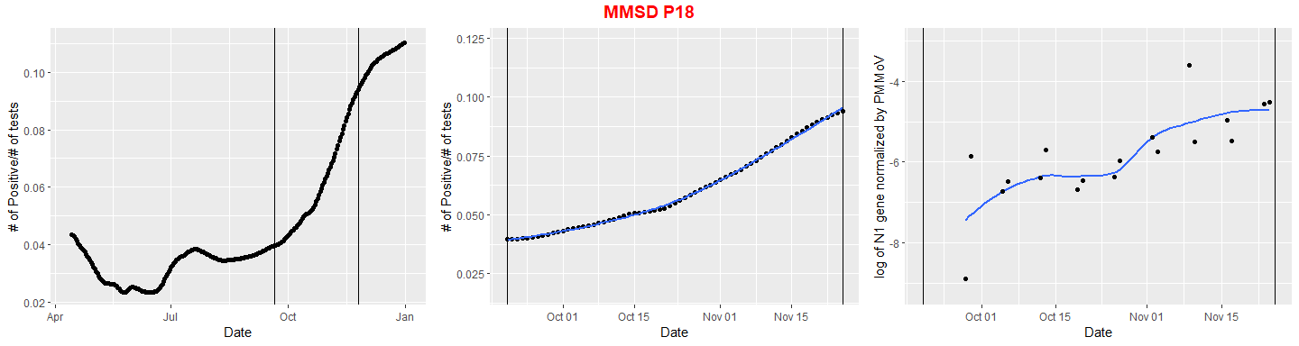

##   
## Call:  
## lm(formula = roll ~ Model, data = AdjustedData)  
##   
## Coefficients:  
## (Intercept) Model   
## 0.114935 0.007838

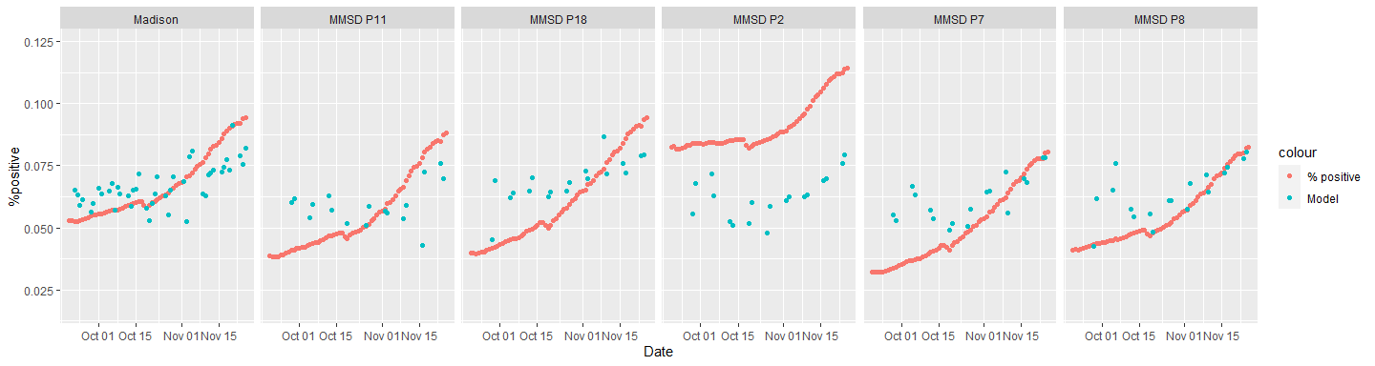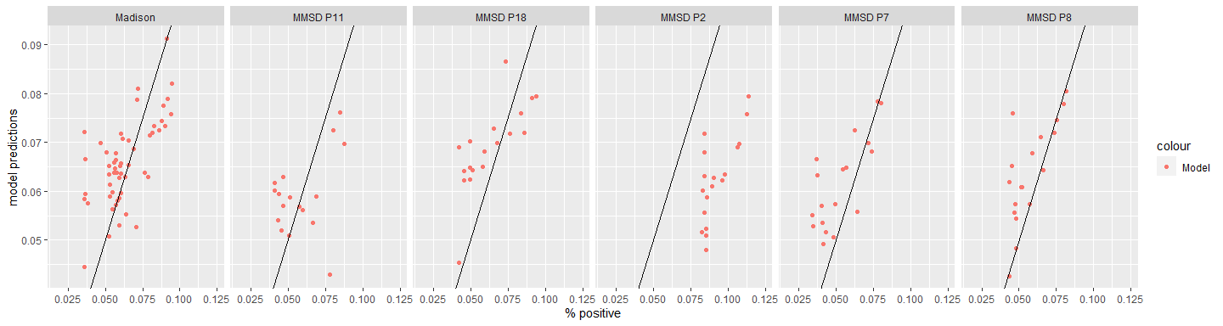

R^2 for the model

## # A tibble: 6 x 2  
## Site R2  
## <chr> <dbl>  
## 1 Madison 0.963  
## 2 MMSD P11 0.942  
## 3 MMSD P18 0.958  
## 4 MMSD P2 0.891  
## 5 MMSD P7 0.938  
## 6 MMSD P8 0.965