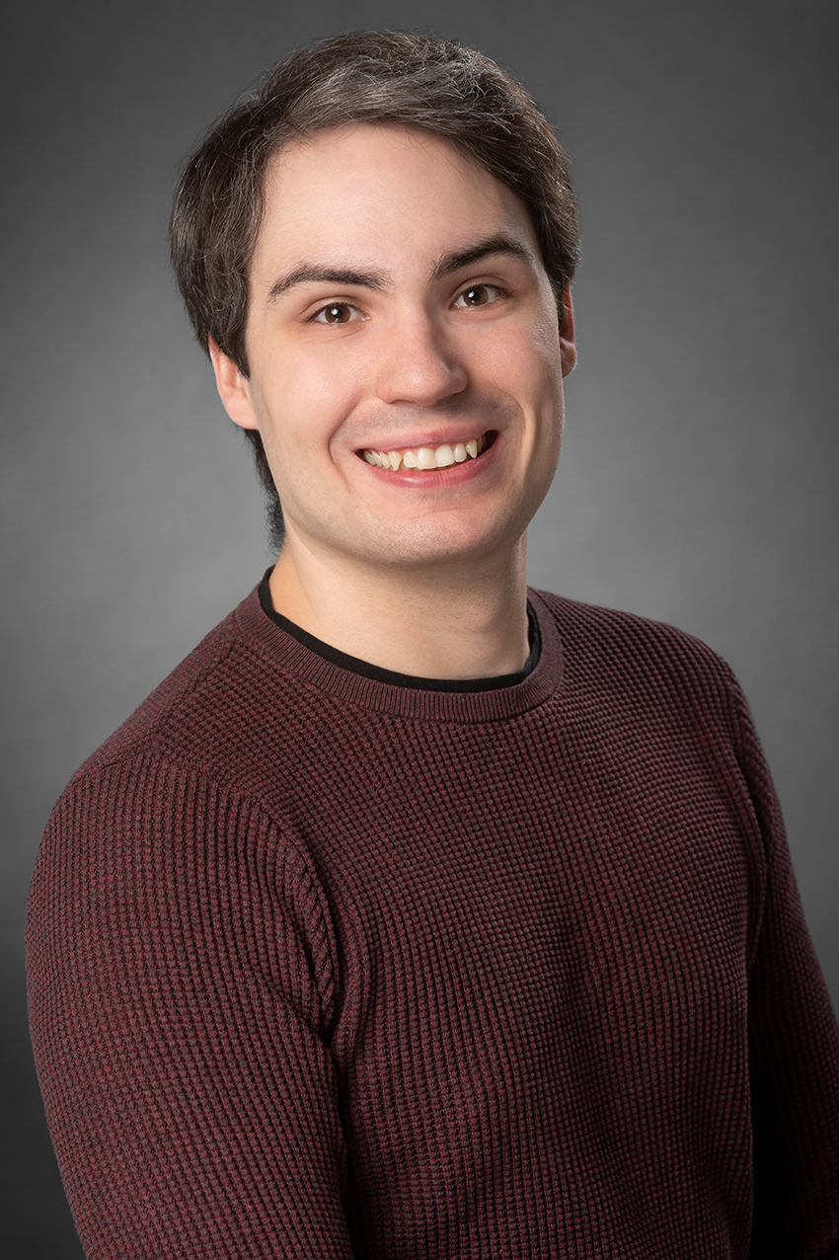
Curriculum Vitae
Personal Data
Name | Marlin Benedikt Schäfer
Birth | 28. December 1995
Address | Callinstraße 38  D-30167 Hannover
E-Mail | marlin.schaefer@aei.mpg.de
Website | marlin-schaefer.me

Experience
Postdoctoral researcher, Albert-Einstein-Institut Hannover, Hannover – 12/2022 – present
Machine learning application to gravitational-wave searches.
Doctoral researcher, Albert-Einstein-Institut Hannover, Hannover – 11/2019 – 12/2022
Research on the topic „Machine learning applications for neutron star research“. For publications and talks see below.
Assistant researcher, Albert-Einstein-Institut Hannover, Hannover – 04/2019 – 09/2019
Support of the working group in administrative tasks and creation of a group-wiki.
Tutor, Institut für theoretische Physik, Hannover – 10/2016 – 03/2019
Teaching and explaining basic concepts of physics for students of the initial 5 bachelor semesters in physics. I received only positive feedback on my work from students and professor.
Tutor, uniKIK, Hannover – August and September of the years 2016, 2017, 2018
Refreshing the memory on school mathematics for students aiming for a degree with a large share in mathematics as well as introducing concepts of higher mathematics for the first time. I received only positive feedback on my work.
Paperboy, Zeitungs-Vertriebs-GmbH Bothfeld, Hannover – 01/2011 – 09/2011
Weekly distribution of 340 newspapers.
Education
Doctorate theoretical physics. Leibniz-Universität Hannover – 11/2019 – 12/2022
Thesis title: “Machine Learning Applications in Search Algorithms for Gravitational Waves from Compact Binary Mergers”
Master of Science Physik, Leibniz-Universität Hannover – 09/2017 – 09/2019
Bachelor of Science Physik mit Auszeichnung, Leibniz-Universität Hannover – 10/2014 – 05/2018
Allgemeine Hochschulreife (Abitur), Kaiser-Wilhelm- und Ratsgymnasium, Hannover – 08/2006 – 07/2014
Publications
MLGWSC-1: The first Machine Learning Gravitational-Wave Search Mock Data Challenge
Authors: Marlin B. Schäfer, Ondřej Zelenka, Alexander H. Nitz, He Wang, Shichao Wu, Zong-Kuan Guo, Zhoujian Cao, Zhixiang Ren, Paraskevi Nousi, Nikolaos Stergioulas, Panagiotis Iosif, Alexandra E. Koloniari, Anastasios Tefas, Nikolaos Passalis, Francesco Salemi, Gabriele Vedovato, Sergey Klimenko, Tanmaya Mishra, Bernd Brügmann, Elena Cuoco, E.A. Huerta, Chris Messenger, Frank Ohme
https://arxiv.org/abs/2209.11146 (pre-print), 09/2022
4-OGC: Catalog of gravitational waves from compact-binary mergers
Authors: Alexander H. Nitz, Sumit Kumar, Yi-Fan Wang, Shilpa Kastha, Shichao Wu, Marlin Schäfer, Rahul Dhurkunde, Collin D. Capano
https://arxiv.org/abs/2112.06878 (pre-print), 12/2021
From One to Many: A Deep Learning Coincident Gravitational-Wave Search
Authors: Marlin B. Schäfer, Alexander H. Nitz
https://doi.org/10.1103/PhysRevD.105.043003, 08/2021
Training Strategies for Deep Learning Gravitational-Wave Searches
Authors: Marlin B. Schäfer, Ondřej Zelenka, Alexander H. Nitz, Frank Ohme, Bernd Brügmann
https://doi.org/10.1103/PhysRevD.105.043002, 06/2021
3-OGC: Catalog of gravitational waves from compact-binary mergers
Authors: Alexander H. Nitz, Collin D. Capano, Sumit Kumar, Yi-Fan Wang, Shilpa Kastha, Marlin Schäfer, Rahul Dhurkunde, Miriam Cabero
https://doi.org/10.3847/1538-4357/ac1c03, 05/2021
Gravitational-wave Merger Forecasting: Scenarios for the Early Detection and Localization of Compact-binary Mergers with Ground-based Observatories
Authors: Alexander H. Nitz, Marlin Schäfer, Tito Dal Canton
https://doi.org/10.3847/2041-8213/abbc10, 10/2020
Detection of gravitational-wave signals from binary neutron star mergers using machine learning
Authors: Marlin B. Schäfer, Frank Ohme, Alexander H. Nitz
https://doi.org/10.1103/PhysRevD.102.063015, 06/2020
Analysis of Gravitational-Wave Signals from Binary Neutron Star Mergers Using Machine Learning
Authors: Marlin B. Schäfer
https://doi.org/10.15488/7467 (Masterarbeit), 09/2019
Talks
16.12.2022 – PhD thesis defense
Mandatory talk to obtain the doctorate degree.
16.09.2021 – PyCBC workshop
Registered talk on the application of PyCBC to my research.
31.08.2021 – Spring meeting of the German physical society
Registered talk on the publication from 08/2021.
29.07.2021 – GW-Mull
Registered talk at a conference on the applications of machine learning to gravitational-wave data analysis. My talk was on the publication from 06/2021.
30.06.2021 – LVK-meeting
Invited talk as non-member from the machine learning working group of the LIGO/Virgo/Kagra collaboration. The talk was on the publication from 06/2021.
30.04.2021 – PhD workshop
A talk aiming to explain the scientific research questions in our working group to other PhD students from our institute. The workshop was also partially organized by me.
23.06.2020 – Seminar Cardiff
Invited talk at a working group in Cardiff, Wales on the publication from 06/2020.
22.06.2020 – Seminar Jena
Invited talk at a seminar in Jena, Germany on the publication from 06/2020.
18.06.2020 – Seminar Ramat Gan
Invited talk at a working group in Ramat-Gan, Israel on the publication from 06/2020.
04.03.2020 – PCCP workshop
Registered talk at a workshop on deep learning applications to astronomy in Paris, France. The talk was about the contents of my master thesis.
21.03.2019 – Spring meeting of the German physical society
Registered talk in Munich, Germany on the current state of my master thesis research.
Prizes and stipends
12/2018 – Niedersachsenstipendium
A stipend awarded by the state of Lower Saxony for students within the standard period of study and exceptional grades.
11/2016 – Niedersachsenstipendium
A stipend awarded by the state of Lower Saxony for students within the standard period of study and exceptional grades.
07/2014 – Abiturpreis der DPG
Prize from the German physical society for students with exceptional achievements during physics lessons.
Additional qualifications
PhD representative
The PhD students at the Albert-Einstein-Institut elect representatives among themselves yearly. These representatives handle communication with the institute leadership, organize social meetings, and are the first point of contact if conflict arises. In January 2020 a colleague of mine and myself were elected unanimously. Since then we have organized monthly social meetings and focused on improving the relationship with out sister institute in Potsdam.
Organization of a PhD Workshop
Together with three other PhD representatives we have introduced a new collaborative project between the two locations of the Albert-Einstein-Institut in Potsdam and Hannover. In this project students from the different research groups are supposed to explain their main research questions to PhDs from different backgrounds within our institutes. Through these meetings we managed to improve the communication between the two locations drastically. One of these workshops could take place in person, such that we had to organize a one and a half day program, catering, and transport. The feedback was consistently positive and we hope to be able to organize a second in-person meeting in the near future.
Voluntary trainer for badminton
In my free time I teach a group of about 10 kids for a local sports club weekly how to play badminton. Sometimes I also train the youth and adults. I’ve been doing this volunteer work since September 2019.
Hobbyproject PyTrest
In my free time I’ve been writing on a Python package called PyTrest. Its main purpose is to allow for easy analysis of stock trading strategies and the ability to do paper trading. The source code is available at the following link: https://github.com/MarlinSchaefer/PyTrest.
Project planning workshop
I successfully attended a workshop on the basics of project planning at the Planck Academy.
Basics of business administration workshop
I successfully attended a workshop on the basics of business administration offered by the Graduierten Akademie of the Leibniz Universität Hannover.

