

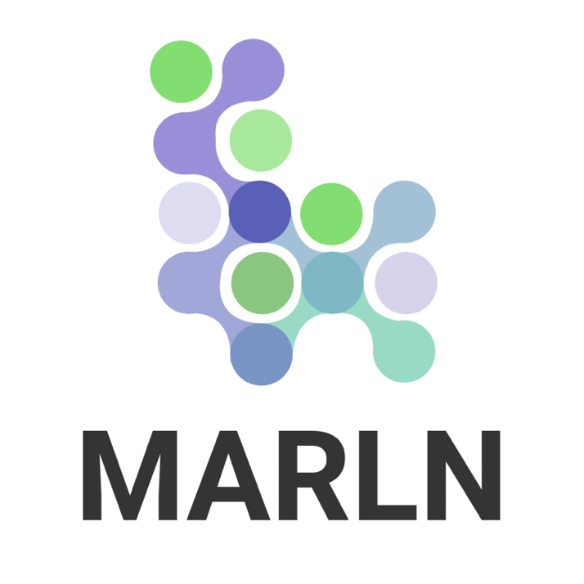
Technical & Commercial Proposal

Confidentiality

A1 Silicon Valley Institute, MARLN CORP is submitting this proposal to Dalilna for Training and Consultancy Company with the explicit understanding that the contents will not be divulged to any third party without prior written consent from MARLN CORP.

Table of Contents

1. Executive Summary 4
1.1 A1 Silicon Valley Training Institute Value Proposition 4
1.2 Values Alignment – Corporate Social Responsibiltiy 5
2. Why Choose A1 Silicon Valley Training Institute? 6
2.1 Training Delivery Modes 7
3. Understanding Your Need 10
4. Pre-Training Requirements 13
5. Company Overview 14
5.1 Our Expertise 14
5.2 Marln Corp Consulting: Your Partner in Business Growth 16
5.3 Gen AI and ML Consulting Services 18
5.4 Data Engineering and Analytics 18
6. Commercial Proposal 19
7. Terms and Conditions 21

Executive Summary

A1 Silicon Valley Training Institute (A1 SV), a company of MARLN Corporation extends its gratitude to Dalilna for Training and Consultancy Company hereafter referred to as “DTC” for the opportunity to present this proposal to support your organization’s objectives by delivering comprehensive, end-to-end technical and digital training solutions. We aim to provide programs that not only meet DTC’s current needs but also equip your team with the skills required to address future business challenges and opportunities. We leverage our expertise in technical and business training to deliver impactful training modules that align with your strategic goals and drive measurable business results.

The requested series of trainings:

- Product Development – 3 days
- Generative AI Explorer – 3 days
- Ethical AI – 2 days
- Big Data Tools – 5 days
- Scrum Mastering – 5 days

As part of DTC’s plan to establish a partnership with a supplier capable of delivering impactful technical and digital training programs to a governmental entity in Saudi Arabia, A1 Silicon Valley is proud to propose a solution designed to exceed your expectations.

1.1 A1 Silicon Valley Training Institute - Value Proposition

- Technical Expertise: Leveraging our extensive experience in technical and digital transformation training, projects and consulting, we offer modules covering critical areas such as generative AI, cybersecurity, cloud infrastructure, and digital innovation.

- Customized Learning Journeys: Programs are designed to cater to varied learning needs, from foundational knowledge to advanced skills in leadership, technology, and business optimization.

- Global Best Practices: Incorporating insights and methodologies derived from our work with industry-leading clients globally, tailored to local and governmental contexts in Saudi Arabia.

- Measurable Outcomes: Ensuring every training program drives clear, quantifiable results by tracking employee performance improvement and skill application post-training.

This proposal includes:

- Pre-Training plan
- Detailed pricing
- Our experience and expertise

1.2 Values Alignment – Corporate Social Responsibiltiy

We are pleased to share with you that aside from Global Leadership and Excellence in Training, Consulting and Product Innovation Services, we take immense pride in what we do towards the cause of Primary Education in fulfilling our Corporate Social Responsibility.

Through the untiring efforts of the below mentioned organizational vehicles, MARLN CORP is a significant contributor to the goal of Universal Primary Education,
on in rural Kenya, Tanzania, India, Pakistan and Bangladesh.

- Aims at making a tangible impact on identified social issues in active partnership with the Government and other related sections of the society.
- Mission to develop world class human resources in the field of education.
- Works with government to improve access, content and delivery of education.

MARLN’s community initiative to improve the Quality of Education.

Works with Teachers, Principals, Parents, Educationists, NGOs and other education bodies to bring about this change through advocacy, consensus building, financial support for pilot programs and teacher training.

THE MARLN CORP PROMISE
With the highest regard for human values, we are committed to serving our customers with integrity, delivering innovative and cost-effective solutions, and applying innovative approaches every single day.

Why Choose A1 Silicon Valley Training Institute?

- Customized Training Programs
We customize each module to align with your organizational goals, ensuring the content is relevant and impactful.

- World-Class Trainers

- A network of certified trainers and industry experts with hands-on experience in their fields.

- Trainers who bring real-world insights to the classroom, bridging the gap between theory and application.

- Innovative Training Methods

- Interactive Learning: Hands-on workshops, real-world simulations, and role-playing exercises.

- Flexible Delivery Modes: In-person, online, or hybrid formats to suit your needs.

- State-of-the-Art Tools: Leveraging the latest learning technologies such as virtual labs, AI-powered platforms, and gamified training modules.

- Alignment with Business Goals

- Our training programs are designed to directly impact your organization’s bottom line.

- We align our content with your strategic objectives, whether it’s driving innovation, improving operational efficiency, or fostering leadership.

- Focus on Measurable Outcomes

- Customized training programs with clearly defined KPIs and OKRs to measure success.

Post-training evaluations to ensure knowledge retention and application

- Cutting-Edge Tools and Techniques
A1 Silicon Valley leverages the latest tools, technologies, and best practices to deliver engaging and effective training.

- Global Perspective with Local Relevance
While we bring global expertise, we tailor our programs to address Saudi Arabia’s unique challenges and opportunities, aligning with Vision 2030.

- Proven Results
Our training programs have consistently delivered measurable outcomes, including improved productivity, enhanced employee engagement, and successful implementation of learned concepts.

2.1 Training Delivery Modes
To ensure flexibility and accessibility, training programs can be delivered through a variety of modes. Each delivery method is tailored to suit the unique needs of the organization and participants:
1. In-Person Training
- Description: Classroom-style training conducted on-site or at an external venue.
- Advantages:
  - Facilitates face-to-face interaction and hands-on learning.
  - Encourages collaboration and immediate feedback.
  - Best for workshops, practical exercises, and team-building activities.
- Ideal For:
  - Leadership and team-oriented training.
  - Hands-on technical sessions.
2. Virtual/Online Training
- Description: Training delivered via virtual platforms like Zoom, Microsoft Teams, or Google Meet.
- Advantages:
  - Accessible from anywhere, reducing travel costs and time.
  - Flexible scheduling to accommodate different time zones.
  - Recordable sessions for future reference.
- Ideal For:
  - Distributed or remote teams.
  - Technical skill-building and knowledge-sharing sessions.
3. Hybrid Training
- Description: Combines in-person and virtual training formats.
- Advantages:
  - Balances the benefits of face-to-face interaction and remote accessibility.
  - Allows participation from both on-site and remote employees.
- Ideal For:
  - Organizations with mixed-location teams.
  - Scenarios where practical sessions are supplemented with online theory.
4. Self-Paced E-Learning
- Description: Training modules accessed through an LMS (Learning Management System) at the participant’s convenience.
- Advantages:
  - Flexible learning schedule for participants.
  - Scalable for large teams.
  - Interactive elements such as quizzes, videos, and gamified content enhance engagement.
- Ideal For:
  - Long-term upskilling initiatives.
  - Technical certifications and knowledge retention.
5. On-the-Job Training (OJT)
- Description: Practical training conducted in the workplace as employees perform their regular tasks.
- Advantages:
  - Immediate application of skills to real-world scenarios.
  - Encourages active learning and skill reinforcement.
- Ideal For:
  - Process-oriented industries.
  - Role-specific skill development.
6. Blended Learning
- Description: A mix of self-paced e-learning modules, virtual sessions, and in-person workshops.
- Advantages:
  - Combines the flexibility of online learning with the interactive nature of face-to-face sessions.
  - Offers a personalized learning journey.
- Ideal For:
  - Comprehensive training programs requiring multi-level engagement.
  - Leadership and cross-functional training.
7. Boot Camps
- Description: Intensive, short-duration training focused on specific topics or skills.
- Advantages:
  - Fast-tracks learning for critical or time-sensitive skills.
  - Highly engaging and immersive format.
- Ideal For:
  - Rapid skill-building needs.
  - New technology adoption or change management.

Understanding Your Need

Creating a corporate training plan involves a strategic approach to align the training objectives with your organizational goals. Here's a comprehensive framework on how we develop a corporate training plan and the prerequisites:
Step 1: Identify Training Needs
- Conduct a Training Needs Analysis (TNA):
  - Assess organizational goals and identify skill gaps within teams or departments.
  - Our SMEs will Interview employees, managers, and stakeholders to understand their training requirements.
  - Use surveys, performance evaluations, and assessments to collect data.
- Align Training Goals with Business Objectives:
  - Ensure the training program supports strategic goals such as productivity improvement, digital transformation, or compliance.
Step 2: Define Learning Objectives
- Clearly define the outcomes expected from the training.
- Use the SMART framework:
  - Specific: Clearly state what skills or knowledge participants will gain.
  - Measurable: Identify metrics to evaluate success (e.g., improved productivity, certifications earned).
  - Achievable: Ensure the objectives are realistic.
  - Relevant: Align with organizational priorities.
  - Time-bound: Set a timeline for achieving goals.
Step 3: Design the Training Program
- Determine the Training Format:
  - In Person Training and immersive workshop
  - Incorporate a mix of lectures, interactive sessions, case studies, and hands-on projects.
- Select Content Areas:
  - Customize content to the specific needs of teams, departments, or industries.
- Set the Schedule:
As we comprehend DTC is seeking classroom training, and the duration of days as mentioned above, we will follow the training delivery mode and duration as requested by DTC.
  - Avoid scheduling conflicts with major organizational events or busy periods.
- Choose Training Methods:
  - Use e-learning platforms, coaching, mentoring, or external experts.
  - Incorporate interactive tools such as virtual labs, gamification, and simulations
Step 4: Identify Trainers and Resources
- Trainers:
  - Use internal subject matter experts (SMEs) or external professional trainers.
  - Ensure trainers are well-versed in both the content and delivery methods.
- Materials and Tools:
  - Prepare or procure training materials such as manuals, slides, and videos.
  - Choose our in house platforms like LMS (Learning Management Systems) for online training videos (Nexus Hive)
- Venue and Equipment:
  - Partner with DTC to secure training rooms, computers, projectors, and other necessary tools. The Project Manager from A1Silicon Valley will be the single point of contact (SPOC) for any queries.

Step 5: Establish Evaluation and Feedback Mechanisms
- Define how you will measure the training's effectiveness:
  - Pre- and post-training assessments to evaluate knowledge gain.
  - Surveys and feedback forms for participants and trainers.
  - KPIs (Key Performance Indicators) like employee retention rates, productivity improvement, or reduced skill gaps. Please note that this will change depending upon the specific KPIs as determined by DTC and the governmental entity.
Step 6: Develop a Rollout Plan
- Communicate the training plan to DTC appointed stakeholders, including employees, managers, and trainers.
- Set clear expectations, including who will attend, how, and when.
Step 7: Monitor and Optimize the Training Program
- Continuously track progress during the training.
- Collect participant feedback and make adjustments to the content, methods, or schedule as needed.
- Provide post-training support through refresher sessions, mentoring, or additional resources.
- The delivery of the training will be in English.

Pre-Training Requirements
- Organizational Readiness:
  - Secure leadership buy-in and budget approvals for the training program.
  - Communicate the purpose and benefits of the training to employees to ensure engagement.
  - A1 Silicon Valley will appoint a Project Manager to coordinate training logistics.
- Training Needs Assessment:
  - Conduct skills gap analysis and map training needs to business objectives.
- Content and Resource Preparation:
  - Develop training materials and ensure trainers are adequately briefed.
  - Test all technology tools (e.g., LMS, AV equipment) before the training begins.
- Participant Selection:
  - Identify participants who will benefit most from the training.
  - Group employees by skill levels or roles to provide targeted learning experiences.
  - Pre training self-preparation material will be dispersed to the participants through email.
  - Class Roster and bio of the participants should be shared with A1 Silicon Valley team when we sign the training contract.
- Environment Setup:
  - Prepare physical training environments to ensure a smooth experience.
- Measurement Planning:
  - Define how success will be measured (e.g., productivity metrics, certification completion, participant satisfaction).

Company Overview

A1 Silicon Valley Institute is a part of MARLN Corporation. A1Silicon Valley is a leader in providing tailored training solutions that empower teams to achieve measurable outcomes. Our programs are designed to align with your strategic objectives and deliver maximum value."

At A1 Silicon Valley, we bring unparalleled expertise in delivering cutting-edge technical and business training solutions to organizations across the globe. With a proven track record of transforming workforces for companies, startups, and government agencies, we empower teams to achieve measurable outcomes and stay ahead in a rapidly evolving world.

Our Expertise

- Global Reach with Local Relevance
- Worldwide Experience: We have successfully delivered training programs across North America, Europe, and Asia, tailoring our approach to meet the unique cultural, technological, and business needs of diverse regions.
- Customized Solutions: Each program is adapted to align with local business challenges and global industry standards.

Comprehensive Training Portfolio
We specialize in both technical training and business skill development, ensuring organizations achieve a balanced growth of technical proficiency and strategic acumen.

- Technical Training Expertise:
- Cloud Computing: AWS, Azure, GCP
- Artificial Intelligence & Machine Learning
- Generative AI: LLMs, Image & Text Generation
- Big Data Analytics: Hadoop, Spark, Snowflake
- Cybersecurity and Data Privacy Compliance
- DevOps, Agile, and Scrum Methodologies

- Business Training Expertise:
- Leadership Development and Executive Coaching
- Digital Transformation Strategies
- Product Development and Innovation
- Data-Driven Decision Making
- Change Management and Organizational Agility
- Operations Management including supply chain, Logistics, Inventory
- Business Process Management
- Project Management
- ITSM Training – Service Delivery

- Industry-Specific Focus
Our training programs are designed to address the unique needs of various industries, including:

- Technology & IT: Upskilling teams on the latest tech advancements.
- Finance & Banking: AI-driven analytics and compliance training.
- Healthcare: Digital health solutions and compliance with global standards.
- Public Sector: E-government initiatives, AI ethics, and data management.
- Manufacturing: Automation, Industry 4.0, and predictive maintenance.

Our Commitment

At A1 Silicon Valley, we don’t just provide training; we create a lasting impact by equipping your teams with the skills, tools, and confidence to succeed in a competitive world. Our commitment to excellence, innovation, and measurable results makes us your trusted partner in workforce development.

Marln Corp Consulting: Your Partner in Business Growth

Welcome to MARLN Corporation, a dynamic 100% women-owned IT consulting company based in the vibrant San Francisco Bay Area. With a commitment to empowering businesses through innovative technology solutions, MARLN Corporation blends industry expertise with a diverse perspective. Founded by a team of experienced professionals, we specialize in delivering tailored IT services that drive efficiency, foster growth, and enhance operational excellence. Our mission is to bridge the gap between technology and business, providing clients with strategic insights and solutions that meet their unique challenges. At MARLN Corporation, we believe in the power of collaboration and inclusivity, and we are dedicated to helping organizations thrive in today’s fast-paced digital landscape. Join us as we redefine the future of IT consulting, one solution at a time.

MARLN Corp was founded in 2016 in the State of California and is based in Cupertino (San Francisco Bay Area), California. We have partner offices in India, Singapore, Canada and Germany.

Our Approach
We believe in a collaborative approach to consulting, working closely with our clients to develop solutions that meet their specific needs and goals.

The name "MARLN" embodies a powerful narrative centered around the qualities that reflect the company’s commitment to empowering women in technology and fostering a diverse, inclusive environment.

- M stands for Mentorship, highlighting MARLN’s dedication to supporting and guiding women in their professional journeys. The company prioritizes mentorship programs that empower female talent, ensuring they have the resources and encouragement needed to thrive in the tech industry.

- A represents Advocacy, as MARLN actively champions the advancement of women in technology. By advocating for equitable opportunities and representation, MARLN seeks to break down barriers and create a more inclusive workforce.

- R signifies Resilience, reflecting the strength and determination of women navigating the challenges of the tech landscape. MARLN is committed to fostering an environment where resilience is celebrated, inspiring women to overcome obstacles and achieve their goals.

- L stands for Leadership, emphasizing the importance of female leadership within the organization and the tech sector as a whole. MARLN cultivates a culture that not only promotes women into leadership roles but also empowers them to lead with confidence and vision.

- N embodies Nurturing, representing MARLN’s commitment to creating a supportive community for women in tech. By nurturing talent and encouraging collaboration, MARLN fosters an environment where women can flourish and drive innovation.

- Together, these qualities encapsulate the spirit of MARLN Corporation, guiding its mission to empower women through innovative IT consulting solutions while advocating for a more equitable and inclusive future in technology.

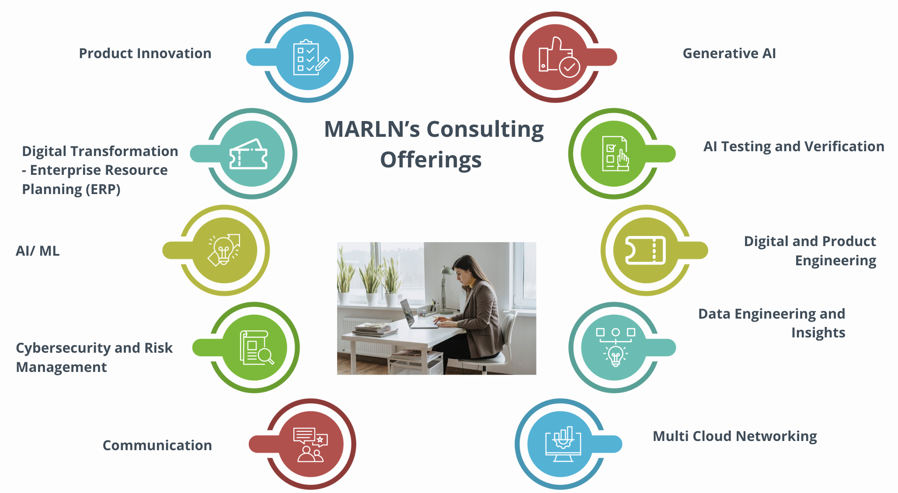

Gen AI and ML Consulting Services

Crafting cutting-edge generative AI models requires high-quality data solutions. These encompass a spectrum of strategies, from curating diverse golden datasets to refining data through fine-tuning and optimizing for human preferences.

- Custom AI Development
- Data Assessment and Preparation
- AI Model Deployment and Integration
- Red Teaming
- Prompt Engineering
- Model Tuning
- RAG Optimization
- Guard Rails and Policy
- AI Training and Education

Data Engineering and Analytics

Transform your business models and enhance your digital economy with cutting-edge data engineering software built on cloud technologies. Our next-generation data analytics capabilities are enriched with deep domain expertise, a comprehensive understanding of technology, and advanced data visualization tools.
We empower you to unlock the potential of advanced data analytics, delivering actionable insights through data science, artificial intelligence (AI), machine learning (ML), and intuitive data visualization, enabling you to see and understand your data like never before.

- Collect and Prepare Data
- Data Exploration and Governance
- Data Analysis and Modeling
- AI/Machine Learning Enhanced Decision Making and Planning
- Monitoring and Evaluation

Commercial Proposal

We are confident that our training solutions will empower your team with the tools and insights needed to succeed in today’s dynamic business environment. This proposal provides the pricing and the commercial terms to support your decision-making process.

We look forward to the opportunity to partner with your organization and contribute to your success through our world-class training programs.

Please find the attachments for the detailed breakdown of the training modules.

Pricing Table: 18 day training program

Training | Duration | Per Participant | 35 participants*price
Product Development | 3*7 hrs | $15000 | $525,000
Generative AI Explorer | 3*7 hrs | $15000 | $525,000
Ethical AI | 2*7hrs | $8000 | $280,000
Big Data Tools | 5*7 hrs | $23000 | $805,000
Scrum Mastering | 5*7hrs | $23000 | $805,000
Project Manager | 63 hours (21 days) |  | Cost paid by A1SV
 |  |  | $2,940,000

Pricing Table: 22 day training program

Training | Duration | Per Participant | 35 participants*price
Product Development | 5*7 hrs | $23000 | $805,000
Generative AI Explorer | 5*7 hrs | $23000 | $805,000
Ethical AI | 2*7hrs | $8000 | $280,000
Big Data Tools | 5*7 hrs | $23000 | $875,000
Scrum Mastering | 5*7hrs | $23000 | $875,000
Project Manager | 68 hours (25 days) |  | Cost paid by A1SV
 |  |  | $3,640,000

Terms and Conditions
Travel and Accommodation Expenses:
As DTC has proposed the Travel, accommodation and per diem expenses of the trainers and the Project Manager will be paid by DTC.
Tentative Plan for Onsite Training Team:
Per training 2 Lead Trainers and one Project Manager
Training Facilities and Equipment: DTC will provide the required training facilities and technical equipment necessary to conduct the training. Our team will tour the facilities before the venue is scheduled and list the required items for the training.
We will be responsible to get all the required software to successfully conduct the training and lab work.

Payment Terms: DTC will make an advance payment for the travel expenses for the trainers and 50% advanced payment for the total cost of the training. The remaining amount 50% will be due on the last day of the training.

Consulting Hours: 10 hours of advisory consulting with our expert team for 5 day onsite trainings.

Attachments

1.Generative AI Explorer High Level Training Overview
2.Product Development

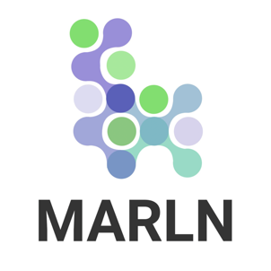

Thank you for the opportunity!

