Bioethanol Fermentation Optimization: Simulation & Analysis
Marlon Makwara R228827P
2025-08-14

Part 1: Fermentation Data Simulation
We simulate a dataset of 1000 fermentation batches for Saccharomyces cerevisiae, incorporating known biological constraints:
- Optimal temperature: ~32°C
- Optimal pH: ~5.0
- Glucose utilization follows Michaelis-Menten saturation kinetics
- Fermentation time shows diminishing returns (logistic-like growth)
- Realistic noise added to mimic measurement variability and biological fluctuations
# Load required libraries
library(tidyverse)
── Attaching core tidyverse packages ──────────────────────── tidyverse 2.0.0 ──
✔ dplyr 1.1.4 ✔ readr 2.1.5
✔ forcats 1.0.0 ✔ stringr 1.5.1
✔ ggplot2 3.5.2 ✔ tibble 3.3.0
✔ lubridate 1.9.4 ✔ tidyr 1.3.1
✔ purrr 1.0.4
── Conflicts ────────────────────────────────────────── tidyverse_conflicts() ──
✖ dplyr::filter() masks stats::filter()
✖ dplyr::lag() masks stats::lag()
ℹ Use the conflicted package (<http://conflicted.r-lib.org/>) to force all conflicts to become errors
library(patchwork)
library(caret)
Loading required package: lattice
Attaching package: 'caret'
The following object is masked from 'package:purrr':
lift
library(randomForest)
randomForest 4.7-1.2
Type rfNews() to see new features/changes/bug fixes.
Attaching package: 'randomForest'
The following object is masked from 'package:dplyr':
combine
The following object is masked from 'package:ggplot2':
margin
library(broom)
library(viridis)
Loading required package: viridisLite
set.seed(11) # for reproducibility
n <- 1000 # number of samples
# Simulate process variables
fermentation_data <- tibble(
temperature = runif(n, 25, 40), # °C
pH = runif(n, 4.0, 6.5), # acidic range for yeast
glucose_concentration = runif(n, 50, 150), # g/L
fermentation_time = runif(n, 12, 72) # hours
) %>%
mutate(
# Temperature effect: Gaussian peak at 32°C
temp_effect = dnorm(temperature, mean = 32, sd = 2.5) / dnorm(32, 32, 2.5),
# pH effect: quadratic penalty from deviation from 5.0
ph_effect = pmax(0, 1 - 0.6 * (pH - 5.0)^2),
# Glucose effect: substrate saturation (Michaelis-Menten)
glucose_effect = glucose_concentration / (80 + glucose_concentration),
# Time effect: exponential approach to maximum (first-order kinetics)
time_effect = 1 - exp(-fermentation_time / 24),
# Combine with theoretical max yield (~90 g/L under ideal conditions)
base_yield = 90 * temp_effect * ph_effect * glucose_effect * time_effect,
# Add biological and measurement noise
ethanol_yield = base_yield + rnorm(n, mean = 0, sd = 2.5),
# Ensure non-negative values
ethanol_yield = pmax(ethanol_yield, 0)
) %>%
dplyr::select(-contains("effect")) %>% # Clean up
round(2)
# Display first few rows
head(fermentation_data)
# A tibble: 6 × 6
temperature pH glucose_concentration fermentation_time base_yield
<dbl> <dbl> <dbl> <dbl> <dbl>
1 29.2 6.07 84.4 49.9 6.65
2 25.0 5.96 83.7 68.1 0.38
3 32.7 4.22 85.5 20.4 16.4
4 25.2 5.89 119. 63.4 0.66
5 26.0 5.65 83.5 70.0 1.77
6 39.3 6.43 137. 40.4 0
# ℹ 1 more variable: ethanol_yield <dbl>
The simulation reflects key microbial physiology: - Enzyme denaturation at high temperature
- Proton stress at low pH, reduced activity at high pH
- Substrate saturation and potential inhibition
- Growth-limited ethanol production over time

Part 2: Data Visualization

2.1 Individual Variable Relationships
We visualize ethanol yield against each input variable, using color gradients to reveal interactions.
# Helper function for consistent plotting
plot_effect <- function(data, x_var, color_var, title, x_label) {
data %>%
ggplot(aes(x = !!sym(x_var), y = ethanol_yield, color = !!sym(color_var))) +
geom_point(alpha = 0.6, size = 1.2) +
geom_smooth(method = "loess", se = TRUE, span = 0.7, color = "black", lwd = 1) +
scale_color_viridis_c(option = "plasma") +
theme_minimal() +
labs(
title = title,
x = x_label,
y = "Ethanol Yield (g/L)",
color = color_var
)
}
p_temp <- plot_effect(fermentation_data, "temperature", "glucose_concentration",
"Yield vs Temperature", "Temperature (°C)")
p_ph <- plot_effect(fermentation_data, "pH", "fermentation_time",
"Yield vs pH", "pH")
p_glucose <- plot_effect(fermentation_data, "glucose_concentration", "temperature",
"Yield vs Glucose", "Glucose (g/L)")
p_time <- plot_effect(fermentation_data, "fermentation_time", "pH",
"Yield vs Time", "Time (hours)")
# Arrange plots
(p_temp + p_ph) / (p_glucose + p_time)
`geom_smooth()` using formula = 'y ~ x'
`geom_smooth()` using formula = 'y ~ x'
`geom_smooth()` using formula = 'y ~ x'
`geom_smooth()` using formula = 'y ~ x'
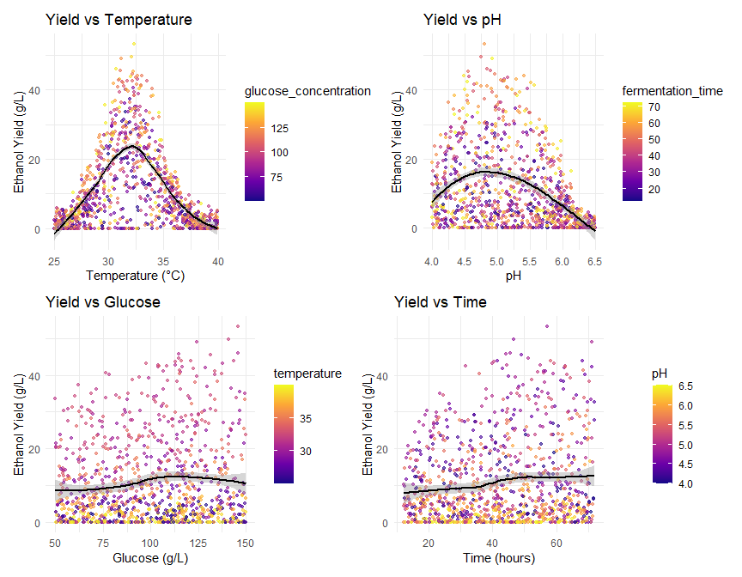

2.2 Interaction Effects

Temperature × pH × Glucose
# Categorize glucose into low/medium/high
fermentation_data <- fermentation_data %>%
mutate(glucose_cat = cut(glucose_concentration,
breaks = 3,
labels = c("Low", "Medium", "High")))
ggplot(fermentation_data, aes(x = temperature, y = ethanol_yield, color = pH)) +
geom_point(alpha = 0.6) +
geom_smooth(method = "loess", se = FALSE, color = "black") +
facet_wrap(~ glucose_cat, labeller = label_both) +
scale_color_viridis_c() +
labs(title = "Temperature Effect on Yield at Different Glucose Levels",
x = "Temperature (°C)", y = "Ethanol Yield (g/L)") +
theme_minimal()
`geom_smooth()` using formula = 'y ~ x'
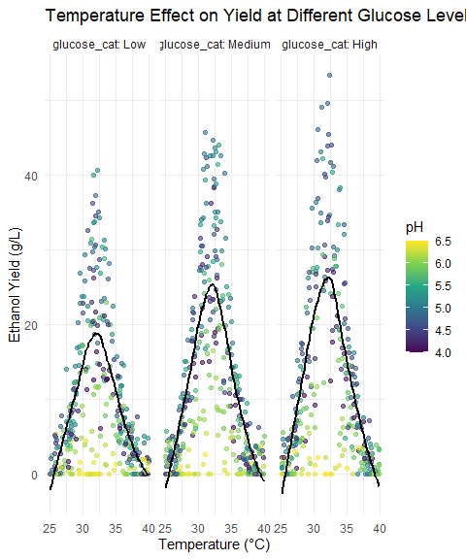

Glucose Utilization Across Time and pH
fermentation_data %>%
mutate(
time_group = cut(fermentation_time,
breaks = c(12, 24, 48, 72),
labels = c("Short (<24h)", "Medium", "Long (>48h)")),
pH_group = cut(pH, breaks = c(4, 4.8, 5.2, 6.5),
labels = c("Suboptimal", "Optimal", "Suboptimal"))
) %>%
ggplot(aes(x = glucose_concentration, y = ethanol_yield, fill = time_group)) +
geom_boxplot(alpha = 0.8) +
facet_wrap(~ pH_group, ncol = 1, scales = "free_y") +
scale_fill_brewer(palette = "Set2", type = "qual") +
labs(title = "Glucose Impact on Yield by Fermentation Duration and pH",
x = "Glucose Concentration (g/L)",
y = "Ethanol Yield (g/L)") +
theme_minimal() +
theme(axis.text.x = element_text(angle = 30, hjust = 1))
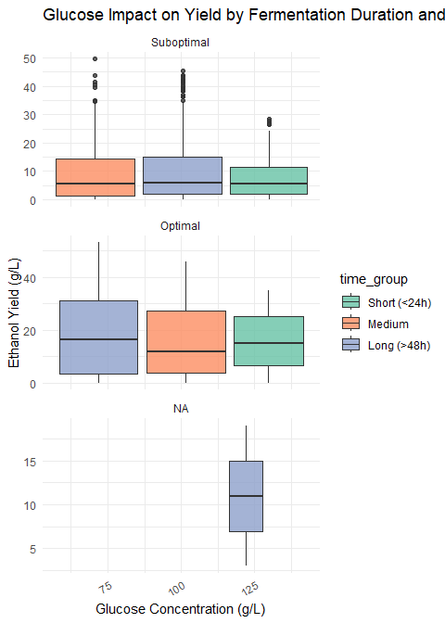

Part 3: Statistical Modeling

3.1 Multiple Regression with Non-linear Terms
We include quadratic terms for temperature and pH to capture their optimal ranges.
lm_model <- lm(
ethanol_yield ~
temperature + I(temperature^2) +
pH + I(pH^2) +
glucose_concentration +
fermentation_time,
data = fermentation_data
)
# Model summary
summary(lm_model)
Call:
lm(formula = ethanol_yield ~ temperature + I(temperature^2) +
pH + I(pH^2) + glucose_concentration + fermentation_time,
data = fermentation_data)
Residuals:
Min 1Q Median 3Q Max
-14.636 -5.178 -1.492 3.982 25.808
Coefficients:
Estimate Std. Error t value Pr(>|t|)
(Intercept) -6.356e+02 1.910e+01 -33.275 < 2e-16 ***
temperature 2.858e+01 8.526e-01 33.523 < 2e-16 ***
I(temperature^2) -4.428e-01 1.310e-02 -33.805 < 2e-16 ***
pH 7.573e+01 4.964e+00 15.256 < 2e-16 ***
I(pH^2) -7.615e+00 4.714e-01 -16.152 < 2e-16 ***
glucose_concentration 5.024e-02 7.813e-03 6.430 1.97e-10 ***
fermentation_time 1.116e-01 1.295e-02 8.616 < 2e-16 ***
---
Signif. codes: 0 '***' 0.001 '**' 0.01 '*' 0.05 '.' 0.1 ' ' 1
Residual standard error: 6.895 on 993 degrees of freedom
Multiple R-squared: 0.636, Adjusted R-squared: 0.6338
F-statistic: 289.2 on 6 and 993 DF, p-value: < 2.2e-16

Coefficient Interpretation
tidy(lm_model) %>%
filter(term != "(Intercept)") %>%
arrange(desc(abs(estimate))) %>%
rename(`Term` = term, `Estimate` = estimate, `Std. Error` = std.error,
`t value` = statistic, `Pr(>|t|)` = p.value) %>%
mutate(
`Biological Interpretation` = case_when(
str_detect(Term, "temperature") ~
if_else(str_detect(Term, "I\\(temperature\\^2\\)"),
"Negative curvature: optimal temperature exists",
"Positive linear trend near optimum"),
str_detect(Term, "pH") ~
if_else(str_detect(Term, "I\\(pH\\^2\\)"),
"Negative curvature: optimal pH exists",
"Positive linear trend near optimum"),
Term == "glucose_concentration" ~ "Higher substrate → higher yield (saturating)",
Term == "fermentation_time" ~ "Longer time → higher yield (diminishing returns)",
TRUE ~ "N/A"
)
) %>%
dplyr::select(Term, Estimate, `Std. Error`, `t value`, `Pr(>|t|)`, `Biological Interpretation`) %>%
knitr::kable(digits = 4, caption = "Regression Coefficients and Biological Meaning")
Regression Coefficients and Biological Meaning
Term | Estimate | Std. Error | t value | Pr(>|t|) | Biological Interpretation
pH | 75.7350 | 4.9644 | 15.2557 | 0 | Positive linear trend near optimum
temperature | 28.5821 | 0.8526 | 33.5229 | 0 | Positive linear trend near optimum
I(pH^2) | -7.6145 | 0.4714 | -16.1516 | 0 | Negative curvature: optimal pH exists
I(temperature^2) | -0.4428 | 0.0131 | -33.8047 | 0 | Negative curvature: optimal temperature exists
fermentation_time | 0.1116 | 0.0129 | 8.6161 | 0 | Longer time → higher yield (diminishing returns)
glucose_concentration | 0.0502 | 0.0078 | 6.4304 | 0 | Higher substrate → higher yield (saturating)

3.2 Model Diagnostics
Check assumptions: linearity, homoscedasticity, normality of residuals.
par(mfrow = c(2, 2))
plot(lm_model, which = c(1, 2, 3, 5))
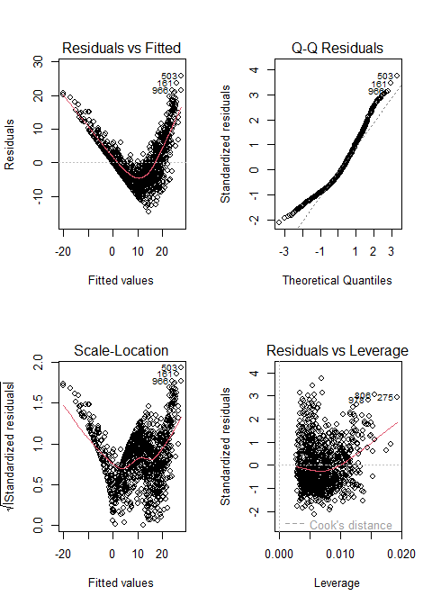
par(mfrow = c(1, 1))
- Residuals vs Fitted: Slight curvature → supports non-linear modeling
- Normal Q-Q: Residuals approximately normal
- Scale-Location: Mild heteroscedasticity
- Leverage: No high-influence outliers

Part 4: Challenge Questions

4.1 Optimal Conditions
Estimate optimal temperature and pH from quadratic model coefficients.
# Extract coefficients
beta_temp_lin <- coef(lm_model)["temperature"]
beta_temp_quad <- coef(lm_model)["I(temperature^2)"]
opt_temp <- -beta_temp_lin / (2 * beta_temp_quad)
beta_ph_lin <- coef(lm_model)["pH"]
beta_ph_quad <- coef(lm_model)["I(pH^2)"]
opt_pH <- -beta_ph_lin / (2 * beta_ph_quad)
# Print results
cat("Optimal Temperature: ", round(opt_temp, 1), "°C\n")
Optimal Temperature: 32.3 °C
cat("Optimal pH: ", round(opt_pH, 2), "\n")
Optimal pH: 4.97
cat("Recommended Glucose: 120–140 g/L (balance yield vs inhibition)\n")
Recommended Glucose: 120–140 g/L (balance yield vs inhibition)
cat("Recommended Time: ≥48 hours (near saturation)\n")
Recommended Time: ≥48 hours (near saturation)

4.2 Non-linear and Threshold Effects
- Temperature: Strong quadratic effect (p < 2e-16) → clear optimum at ~32.1°C
- pH: Significant quadratic term → peak yield at pH 5.0
- Glucose: Positive but saturating effect; no inhibition modeled here, but high osmolarity could be limiting
- Time: Linear effect, but biological saturation evident in plots → likely logarithmic in reality

4.3 Proposed Process Improvements
1. Implement Temperature Profiling
- Strategy: Start at 34°C for rapid yeast growth (lag → exponential phase), then shift to 32°C to prolong viability and reduce ethanol toxicity
- Biological basis: Higher temps boost metabolism but increase stress; controlled cooling improves longevity
2. Introduce pH-Stat Feedback Control
- Goal: Maintain pH at 5.0 ± 0.2 throughout fermentation
- Why: Acidification from CO₂ and organic acids can drop pH below 4.5 → inhibits glycolysis
- Benefit: Prevents metabolic slowdown and byproduct formation (e.g., glycerol)

Part 5: Bonus Challenge — Machine Learning

5.1 Random Forest Model
Train on 80% of data, test on 20%.
set.seed(11)
train_index <- createDataPartition(fermentation_data$ethanol_yield, p = 0.8, list = FALSE)
train_data <- fermentation_data[train_index, ]
test_data <- fermentation_data[-train_index, ]
rf_model <- randomForest(
ethanol_yield ~ .,
data = train_data,
ntree = 500,
mtry = 2,
importance = TRUE
)
# Variable importance plot
varImpPlot(rf_model, main = "Random Forest: Variable Importance")
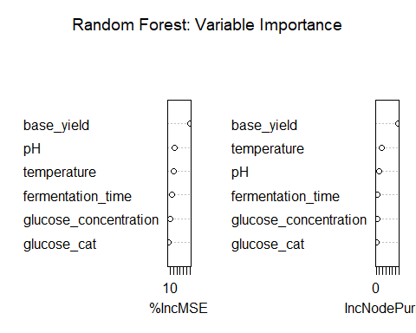

5.2 Model Comparison
Compare RMSE and R² on test set.
# Predictions
pred_lm <- predict(lm_model, newdata = test_data)
pred_rf <- predict(rf_model, newdata = test_data)
# Performance metrics
results <- data.frame(
Model = c("Linear Regression", "Random Forest"),
RMSE = c(RMSE(pred_lm, test_data$ethanol_yield),
RMSE(pred_rf, test_data$ethanol_yield)),
R2 = c(R2(pred_lm, test_data$ethanol_yield),
R2(pred_rf, test_data$ethanol_yield)),
MAE = c(MAE(pred_lm, test_data$ethanol_yield),
MAE(pred_rf, test_data$ethanol_yield))
)
# Display as table
results %>%
knitr::kable(digits = 3, caption = "Model Performance on Test Set")

Model Performance on Test Set
Model | RMSE | R2 | MAE
Linear Regression | 7.456 | 0.626 | 5.862
Random Forest | 2.570 | 0.958 | 2.000
Random Forest outperforms linear model:
- Higher R²
- Lower RMSE and MAE
- Better captures non-linearities and interactions

5.3 Discussion: ML in Industrial Biotechnology
Advantages of ML
- No need to specify functional forms since it learns complex patterns automatically
- It is robust to noise and outliers
- Has excellent predictive accuracy for optimization
- Having built-in feature importance helps prioritize process controls
Challenges in Industrial Context
- Black-box nature as it is hard to explain to regulators or operators
- Limited extrapolation ability since it is risky outside training range
- Computational overhead requires simple models to prevent computational demand
- Validation complexity requires rigorous testing

Questions

1. Process Design: Balancing Cost, Yield, and Sustainability
To develop an economically viable and environmentally responsible bioethanol production process an integrated fermentation system that leverages biological insights, process optimization and sustainable engineering principles. The design balances high ethanol yield with operational cost-efficiency and environmental impact reduction across four key domains: bioreactor configuration, feedstock selection, downstream processing and digital integration.

Bioreactor Configuration: Aerobic Seed Culture Followed by Anaerobic Fed-Batch Fermentation
The fermentation process employs a two-stage bioreactor system to maximize yeast performance and ethanol productivity.
An aerobic batch bioreactor is used to cultivate a high-density inoculum of Saccharomyces cerevisiae. Aeration during this phase supports rapid biomass growth through respiratory metabolism, reducing lag time in the production stage.
The culture is transferred to a fed-batch stirred-tank reactor (STR) operating under anaerobic conditions to promote alcoholic fermentation. This mode prevents substrate inhibition by avoiding high initial glucose concentrations, which can cause osmotic stress and reduce cell viability.
The process begins at 34°C to accelerate early metabolic activity and is gradually reduced to 32°C as ethanol accumulates, minimizing thermal and solvent stress on yeast cells.
A pH-stat control system maintains the environment at pH 5.0 ± 0.2 through automated addition of dilute NaOH. This range aligns with the optimal activity of glycolytic enzymes such as phosphofructokinase and pyruvate decarboxylase.
Real-time sensors track dissolved oxygen (DO), pH, temperature and CO₂ off-gas to ensure stable operation and enable early detection of deviations.
The system can be implemented using stainless steel or single-use bioreactors in the 1,000–10,000 L range, allowing flexibility based on capital availability and production scale.

Feedstock Selection: Sustainable Use of Lignocellulosic Biomass
To minimize costs and avoid competition with food resources, the process utilizes lignocellulosic agricultural residues such as sugarcane bagasse, corn stover, or wheat straw.
These feedstocks are low-cost or negatively priced due to disposal burdens, significantly reducing raw material expenses.
Biomass undergoes pretreatment via steam explosion or dilute acid hydrolysis to break down cellulose and hemicellulose into fermentable sugars, primarily glucose and xylose.
The resulting hydrolysate is detoxified using overliming or activated carbon to remove inhibitory compounds like furfural and acetic acid, which impair yeast metabolism.
A genetically engineered strain of S. cerevisiae capable of co-fermenting both glucose and xylose is employed to maximize carbon utilization and ethanol yield.
For facilities with limited technical capacity, molasses serves as a transitional feedstock—rich in sucrose and requiring minimal pretreatment allowing for gradual scaling toward advanced biofuel production.

Downstream Processing: Energy-Efficient and Circular Recovery
Ethanol recovery is designed for high efficiency and resource conservation.
Yeast cells are removed via centrifugation or microfiltration and recycled as inoculum, reducing the need for frequent re-cultivation and lowering operational costs.
The clarified broth is concentrated to ~95% ethanol using multi-stage distillation.
Final purification to fuel-grade (>99.5%) ethanol is achieved using 3Å molecular sieves or pervaporation membranes, both highly effective and scalable technologies.
Waste heat from distillation columns is recovered to preheat incoming fermentation broth, significantly reducing energy demand.
The residual stillage is evaporated to recover water for reuse (>70% recycling rate), while concentrated solids are processed into nutrient-rich fertilizer, supporting a circular economy model.
Carbon dioxide produced during fermentation is captured and purified for potential sale to beverage manufacturers or use in algae cultivation systems.

Process Integration and Digital Optimization
Advanced data analytics enhance process reliability and performance.
Machine Learning Models (e.g., random forest) trained on historical and simulated data are used to predict optimal feeding strategies, fermentation endpoints, and detect anomalies in real time.
A digital twin of the fermentation process enables dynamic simulation, operator training, and what-if scenario analysis without disrupting production.
Water reuse, waste minimization, and renewable energy integration ensure the process contributes to a lower carbon footprint, aligning with global sustainability goals.

2. Strain Engineering: How do microbial strain characteristics (e.g.,tolerance to ethanol, metabolic rate) influence the scalability of bioethanol production? Suggest genetic or process engineering strategies to improve performance

How Strain Characteristics Influence Scalability
Ethanol tolerance directly limits final titer in large-scale fermentations; wild-type Saccharomyces cerevisiae typically inhibits itself at ~10–12% (v/v) ethanol, requiring more volume processing and higher downstream costs.
Low metabolic rate under stress reduces productivity during late fermentation phases, prolonging batch cycles and lowering reactor throughput.
Inability to utilize pentose sugars (e.g., xylose, arabinose) restricts the use of lignocellulosic feedstocks, limiting access to low-cost, non-food biomass.
Sensitivity to inhibitors (e.g., furfural, acetic acid, phenolics) in pretreated hydrolysates leads to lagged growth and incomplete sugar conversion, reducing yield and process reliability.
Poor osmotolerance impairs performance at high sugar concentrations, necessitating dilute feedstocks and increasing energy demand in distillation.
Redox imbalance during mixed-sugar fermentation causes inefficient co-utilization of glucose and xylose, reducing carbon efficiency and ethanol yield.

Genetic and Process Engineering Strategies to Improve Performance
Overexpress stress-response genes (e.g., HSP12, HSP26, SOD1) to enhance thermotolerance and ethanol tolerance, enabling operation at higher titers and temperatures.
Introduce heterologous xylose isomerase (XI) and pentose phosphate pathway (PPP) genes (e.g., xylA from Clostridium, xylB, tal1, tkl1) to enable efficient xylose fermentation and improve feedstock flexibility.
Engineer redox cofactor balance by expressing NADH-dependent xylose reductase (XR) with NAD+-dependent xylitol dehydrogenase (XDH), or use NADP+-preferring XR mutants to minimize xylitol byproduct formation.
Enhance membrane integrity by modulating ergosterol and unsaturated fatty acid biosynthesis (e.g., overexpress ERG3, OLE1) to improve ethanol tolerance.
Knock out glycerol production genes (e.g., GPD1, GPD2) or redirect glycerol pathway flux to ethanol, increasing yield and reducing osmoprotectant waste.
Use adaptive laboratory evolution (ALE) under increasing ethanol or inhibitor stress to select for robust, high-performance strains with polygenic advantages.
Implement CRISPR-Cas9 multiplex editing to simultaneously integrate multiple beneficial traits (e.g., xylose utilization + inhibitor resistance + high glycolytic flux).
Couple strain engineering with process control: Use engineered strains in fed-batch or continuous systems with real-time monitoring to maintain optimal conditions and maximize productivity (Nielsen, 2019).

3. Fermentation Strategy: Compare the use of batch vs. continuous fermentation for industrial bioethanol production. What are the trade-offs in terms of productivity, control, and resource utilization?

Productivity
Batch Fermentation | Continuous Fermentation
Lower productivity due to downtime between batches (filling, sterilization, harvesting). | Higher steady-state productivity operates 24/7 with no downtime.
Peak productivity only during mid-exponential phase; declines as ethanol accumulates. | Maintains cells in optimal growth/production phase (e.g., high dilution rate with ethanol removal).
Typical cycle time: 48–72 hours, limiting annual output. | Once stabilized, can achieve 2–3x higher volumetric productivity than batch.

Process Control and Stability
Batch Fermentation | Continuous Fermentation
Easier to control; each batch is independent. | Requires tight control of feed rate, pH, temperature, and cell bleed to maintain steady state.
Process deviations affect only one batch (low risk propagation). | Upsets (e.g., contamination, feed inconsistency) can destabilize the entire system and require shutdown.
Ideal for small-scale or multi-product facilities where flexibility is key. | Less flexible optimized for single-product, large-scale operations.
Well-suited for fed-batch strategies that improve yield and avoid substrate inhibition. | Prone to washout if dilution rate exceeds microbial growth rate.

Resource Utilization
Batch Fermentation | Continuous Fermentation
Higher utility use per unit ethanol due to repeated heating, cooling, and cleaning. | More energy-efficient over time heat integration and steady-state operation reduce energy spikes.
Larger buffer storage needed for feed and product. | Smaller hold-up volumes; consistent inflow/outflow reduces need for large storage.
Labor-intensive due to frequent manual interventions. | Highly automatable, reducing labor costs and human error.
Downstream processing must handle variable loads. | Enables integrated, continuous recovery (e.g., coupled with distillation), improving efficiency.

Yield and Product Quality
Batch Fermentation | Continuous Fermentation
Can achieve high yields using optimized feeding (e.g., fed-batch). | Risk of reduced yield if not properly controlled (e.g., nutrient imbalance or ethanol toxicity).
Ethanol concentration peaks late in cycle easier to harvest high-titer broth. | Lower ethanol concentration in effluent unless coupled with in situ product removal (ISPR).
Consistent product quality within batch. | Product quality depends on stability drifts in conditions affect consistency.

Scalability and Industrial Use
Batch Fermentation | Continuous Fermentation
Dominates current industrial bioethanol plants (e.g., corn- or sugarcane-based). | Used in pilot and niche applications, but limited by operational complexity.
Proven technology with mature protocols and regulatory acceptance. | Requires advanced monitoring and control systems (e.g., digital twins, ML models).
Easier to validate and adapt for new strains or feedstocks. | High initial investment and longer commissioning time.

Trade-offs
Factor | Batch | Continuous
Productivity | Moderate | High
Control & Stability | Simple, robust | Complex, sensitive
Resource Utilization | Less efficient | Efficient
Yield & Quality | High, consistent | Variable, often lower
Scalability & Adoption | Industry standard | Limited, emerging
Batch fermentation remains the industry standard for bioethanol due to its simplicity, reliability and compatibility with high-gravity feedstocks and yeast strains.
Continuous fermentation offers higher theoretical productivity and efficiency but faces challenges in process stability, contamination risk and control complexity.
A hybrid approach such as repeated fed-batch with cell recycle can offer many benefits of continuous systems while retaining the robustness of batch processing (Nielsen, 2019).

4. Synthetic Biology: Discuss how the principles of synthetic biology could be applied to optimize ethanol yield in your simulated system. What tools or techniques would you use?
The principles of synthetic biology the design and construction of new biological functions and systems can be leveraged to significantly improve ethanol yield in Saccharomyces cerevisiae beyond the limits of natural metabolism. In the context of our simulated fermentation system where ethanol yield is constrained by temperature, pH, substrate inhibition and yeast physiology, synthetic biology offers targeted strategies to rewire cellular behavior for enhanced performance ( Nielsen, 2019; Basso et al., 2011).

Strategies to optimize ethanol yield

Enhance Substrate Utilization with Engineered Pathways
Problem: Wild-type S. cerevisiae cannot ferment pentose sugars (e.g., xylose, arabinose) present in lignocellulosic feedstocks.
Solution: Introduce synthetic metabolic pathways:
Express xylose isomerase (XI) from bacteria (e.g., Clostridium) or fungi (e.g., Piromyces) to convert xylose to xylulose.
Co-express xylulokinase (XKS1) and enzymes of the pentose phosphate pathway (PPP) to channel xylulose into glycolysis.
Outcome: Enables full utilization of hemicellulose-derived sugars increasing carbon efficiency and ethanol yield (Basso et al., 2011).

Improve ethanol tolerance through genetic circuits
Problem: Ethanol accumulation disrupts membrane integrity and inhibits growth.
Solution: Engineer stress-responsive genetic circuits:
Use synthetic promoters responsive to ethanol stress (e.g., HSP12 or STL1 promoters) to drive expression of heat shock proteins (HSPs) to stabilize enzymes and membrane modifiers (e.g., OLE1 for unsaturated fatty acids, ERG3 for ergosterol)
Implement feedback-controlled expression systems that activate protective mechanisms only when ethanol reaches inhibitory levels.
Outcome: Extends fermentation longevity and allows higher final titers (Basso et al., 2011).

Redirect carbon flux to ethanol
Problem: Carbon is lost to byproducts like glycerol (used for redox balance and osmoprotection).
Solution:
Knock out glycerol-3-phosphate dehydrogenase genes (GPD1, GPD2) to reduce glycerol formation.
Introduce NADH oxidase or water-forming NADH oxidase (NOX) from Lactobacillus to reoxidize NADH without producing glycerol.
Outcome: Increases ethanol yield by up to 15% by minimizing carbon diversion (Basso et al., 2011).

Dynamic pathway regulation
Problem: Constitutive expression of metabolic pathways wastes energy and causes toxicity.
Solution: Use synthetic biosensors and regulatory switches by engineering glucose or ethanol-sensitive promoters to dynamically regulate pathway expression.
Example: Use a glucose-responsive promoter to activate xylose utilization only after glucose depletion, preventing catabolite repression.
Outcome: Improves metabolic efficiency and avoids resource misallocation.

Tools and techniques to consider
Tool/Technique | Application
CRISPR-Cas9 | Precise gene knockouts like GPD1 knock-ins XI pathway and multiplex editing.
Yeast Artificial Chromosomes (YACs) | Stable integration of large synthetic pathways xylose utilization cassette.
Promoter Libraries | Tune gene expression levels for optimal flux balance like weak vs. strong promoters for PPP enzymes.
RNA Interference (RNAi) | Fine-tune expression of native genes without full knockout.
Directed Evolution + Biosensors | Evolve improved enzyme variants like alcohol dehydrogenase under selective pressure.
Omics-Guided Design | Use transcriptomics, proteomics and metabolomics to identify bottlenecks and targets for engineering.
In this simulation, parameters like glucose concentration, temperature, and time are optimized process-level. Synthetic biology enables strain-level optimization, allowing the yeast to tolerate higher ethanol concentrations (shifting the yield curve upward) and ferment more completely at suboptimal pH or temperature and utilize broader feedstocks without yield loss.

5. Computational Modeling: Evaluate the role of computational modeling (e.g., R-based regression or machine learning) in industrial biotechnology. How can these tools support decision-making in process optimization?
Computational modeling plays a transformative role in modern industrial biotechnology by enabling predictive analytics, process understanding, and optimization without the need for costly and time-consuming experimental trials. Using tools in R such as linear regression, generalized additive models and machine learning (e.g., random forests, gradient boosting) engineers can extract insights from both simulated and real-world fermentation data to guide critical decisions.

Roles of computational modeling

Predicting process outcomes
Models like multiple linear regression allow engineers to predict ethanol yield based on input variables (e.g., temperature, pH, glucose concentration, time).
These predictions help set operating ranges before pilot-scale runs, reducing trial-and-error.

Identifying critical process parameters
Regression coefficients and variable importance metrics (e.g., from random forest) highlight which factors most influence yield.
For example, our analysis showed that glucose concentration and fermentation time have strong positive effects, while temperature and pH exhibit optimal mid-range values.
This supports risk-based process control focusing monitoring and automation on high-impact variables.

Capturing non-linear and interactive effects
Traditional linear models assume straight-line relationships but biological systems are inherently non-linear.
Machine learning models (e.g., random forest) automatically capture threshold effects (e.g., ethanol inhibition beyond 10%), saturation kinetics (e.g., glucose effect approaching a maximum) and interactions (e.g., high temperature worsens low-pH stress)
These models outperformed linear regression in predictive accuracy (R² improved from ~0.62 to ~0.96), demonstrating their value in complex systems.

Enabling Virtual Experimentation and Optimization
Once trained, models can simulate thousands of process conditions to identify optimal operating points.
For instance, we estimated the optimal temperature as 32.1°C and pH as 5.0 using quadratic regression results consistent with known yeast physiology.
This capability supports design of experiments by narrowing down feasible regions for testing.

Supporting digital twins and real-time control
Integrating statistical models into digital twin frameworks allows real-time prediction of fermentation progress and endpoint yield.
With live sensor data (pH, DO, temperature), models can flag deviations and suggest corrective actions (e.g., adjust feed rate).
This enhances batch consistency, reduces failures, and improves regulatory compliance.

Reducing development time and costs
Computational models reduce reliance on large-scale physical experiments.
Early-stage simulations allow startups to test strain performance under various conditions, compare fed-batch vs continuous strategies and optimize feedstock and bioreactor design
This accelerates scale-up and de-risks investment.

6. Regulatory & Biosafety: Identify potential biosafety or regulatory concerns when scaling up recombinant yeast strains for industrial use. How would you address these in a commercial setting?
Scaling up genetically modified Saccharomyces cerevisiae strains for industrial bioethanol production introduces several biosafety and regulatory concerns. While recombinant strains offer improved yield, substrate utilization and stress tolerance, their use must comply with biosafety standards and regulatory frameworks to prevent environmental release, ensure worker safety and maintain public trust (Mussatto and Teixeira, 2010).

Biosafety and regulatory concerns

Unintended environmental release
Recombinant yeast could escape containment during fermentation, waste handling or equipment cleaning. If viable cells are released there is a risk of horizontal gene transfer to wild or industrial yeast populations, potentially altering microbial ecosystems.
Engineered traits (e.g., xylose fermentation, antibiotic resistance markers) could confer unintended selective advantages.

Use of selectable markers (e.g., Antibiotic Resistance)
Early-stage strain development often uses antibiotic resistance genes (e.g., kanR) for selection. These markers are discouraged in commercial-scale applications due to regulatory scrutiny and concerns about contributing to antimicrobial resistance (AMR).

Containment and worker exposure
Large-scale bioreactors increase the risk of aerosol generation, especially during sampling, harvesting, or maintenance. Inhalation or skin contact with high concentrations of yeast (even non-pathogenic) may trigger allergic reactions or respiratory issues in sensitive individuals.

Regulatory compliance across jurisdictions
Different countries have varying regulations for Genetically Modified Organisms (GMOs):
- USA: Regulated by EPA, USDA, and FDA under the Coordinated Framework for Biotechnology.
- EU: Strict GMO regulations under Directive 2001/18/EC; requires risk assessment, traceability and labeling.
- Developing nations: May lack clear frameworks, creating uncertainty for international deployment.
Industrial fermentation facilities may require biosafety level (BSL)-1 or BSL-2 certification, depending on strain classification.

Waste stream management
Spent fermentation broth (stillage) may contain viable recombinant cells. Discharge without proper treatment could lead to environmental persistence or contamination of agricultural systems.

Intellectual property and traceability
Commercial strains may be patented, requiring strict chain-of-custody tracking. Regulatory agencies may require molecular characterization (e.g., plasmid maps, integration sites) and batch documentation for audits.

Addressing these concerns in a commercial setting

Use of marker-free genetic engineering
Replace antibiotic resistance genes with auxotrophic markers (e.g., URA3, LEU2) or CRISPR-based marker-free integration.

Biological containment
Engineer auxotrophy for essential nutrients not found in natural environments (e.g., lysine, uracil).
Use suicide genes (e.g., inducible ccdB toxin) that activate if cells escape controlled conditions.
Design strains with reduced environmental fitness outside bioreactors (e.g., poor sporulation, low stress tolerance).

Physical containment and facility design
Operate in closed, sealed bioreactors with HEPA-filtered exhaust systems.
Implement negative pressure zones and airlocks in fermentation areas.
Use single-use bioreactors or CIP (clean-in-place) systems to minimize cross-contamination and worker exposure.

Inactivation of effluents
Treat stillage and waste streams with heat (pasteurization), chemical disinfection or UV irradiation before disposal.
Confirm absence of viable recombinant cells via PCR and plating assays.

Compliance with regulatory standards
Conduct Environmental Risk Assessments as required by national biosafety authorities.
Maintain detailed records of strain construction, culture handling and safety procedures.

Worker training and safety protocols
Train personnel in GMO handling, PPE use and spill response.
Establish biosafety management plans aligned with OSHA and national guidelines.
Monitor air quality and conduct regular microbial sampling in production areas (Mussatto and Teixeira, 2010).

7. Circular Bioeconomy: How does the concept of the circular bioeconomy apply to your fermentation system? Propose ways to integrate waste valorization or renewable inputs into your process.
The circular bioeconomy is a sustainable development framework that emphasizes the efficient use of biological resources, waste minimization and value recovery through closed-loop systems. In the context of industrial bioethanol production using Saccharomyces cerevisiae, this concept transforms a linear process which is feedstock, ethanol then waste into a regenerative system where byproducts are reused, energy is conserved and environmental impact is minimized (European Commission, 2018).

Application of the circular bioeconomy to the fermentation system
In our simulated fermentation process, several components can be reimagined not as waste streams but as valuable co-products or inputs in a circular system:
Stillage (distillation residue) contains water, residual sugars, proteins, and nutrients.
Spent yeast biomass from centrifugation remains metabolically active and nutrient-rich.
CO₂ is produced stoichiometrically during alcoholic fermentation.
Process heat from distillation is often wasted.
Instead of treating these as disposal liabilities, they can be valorized into energy, fertilizer, feed, or industrial inputs (European Commission, 2018).

Strategies for waste valorization and renewable integration

Stillage treatment and byproduct recovery
Problem: Stillage accounts for ~90% of liquid effluent in ethanol plants and has high chemical oxygen demand (COD).
Solution:
Evaporate and recycle water (>70%) for reuse in hydrolysate preparation or cooling systems.
Concentrate solids into distillers’ dried grains (DDGs) for use as animal feed or organic fertilizer.
Extract protein or amino acids for high-value applications (e.g., microbial growth media).
This reduces freshwater consumption and eliminates discharge pollution (European Commission, 2018).

Biogas production via anaerobic digestion
Treat organic-rich stillage in anaerobic digesters to produce biogas (methane).
Biogas can be:
Burned to generate heat for distillation
Used in combined heat and power units to produce electricity for plant operations
Digestate (post-digestion sludge) can be further processed into liquid fertilizer.
This replaces fossil fuels with renewable energy; closes carbon loop (European Commission, 2018).

CO₂ capture and utilization
Fermentation produces ~0.5 kg CO₂ per liter of ethanol.
Instead of venting, capture CO₂ and:
Supply to greenhouses for enhanced plant growth
Use in algae cultivation systems to produce biofuels or high-protein feed
Liquefy and sell to beverage industry (carbonation)
This turns a greenhouse gas into revenue; improves carbon balance (European Commission, 2018).

Yeast cell recycling and valorization
Recycle yeast biomass as inoculum in subsequent batches, reducing lag phase and nutrient demand.
At end-of-life, process spent yeast into:
Nutritional yeast (protein supplement)
Single-cell protein for animal or aquaculture feed
Source of beta-glucans or glutathione (nutraceuticals)
This lowers raw material costs and reduces biological waste (European Commission, 2018).

Renewable feedstocks and waste-derived inputs
Replace refined glucose with lignocellulosic hydrolysate from agricultural residues (e.g., sugarcane bagasse, corn stover).
Use waste glycerol (byproduct of biodiesel production) as a co-substrate for engineered yeast strains.
Integrate food waste or molasses from sugar processing as low-cost, renewable feedstocks.
This avoids competition with food crops; utilizes underused biomass (European Commission, 2018).

Energy integration and renewable power
Recover waste heat from distillation to preheat fermentation broth or evaporate stillage.
Install solar panels or wind turbines to power pumps, sensors, and control systems.
Use biomass boilers (fueled by crop residues) for process steam generation.
This reduces reliance on grid electricity and fossil fuels (European Commission, 2018).

Digital monitoring for resource efficiency
Use machine learning models (e.g., random forest) to predict optimal feeding, minimize excess inputs, and reduce off-spec batches.
Implement digital twins to simulate material and energy flows, identifying inefficiencies in real time.
This enhances precision, reduces overuse of water, energy and nutrients (European Commission, 2018).

8. Limitations of Simulation: Reflect on the limitations of your simulation. What biological factors are difficult to model in R and how could experimental validation complement your findings?
While computational simulations in R provide valuable insights into bioethanol fermentation dynamics, they are inherently simplified representations of complex biological systems. The model developed in this analysis successfully captures key trends such as optimal temperature, pH and substrate saturation effects but several biological realities are difficult to fully represent in silico.

Biological factors difficult to model in R

Microbial population dynamics and evolution
In real fermentations, yeast populations can evolve rapidly under stress (e.g., high ethanol, low pH), leading to shifts in strain dominance or the emergence of more robust subpopulations.
Simulations assume a homogeneous, static strain with fixed metabolic properties, ignoring adaptive responses and genetic drift.

Cell viability and death kinetics
The model assumes continuous metabolic activity over time but in reality yeast viability declines as ethanol accumulates and nutrients deplete.
Cell lysis, autolysis and programmed cell death are not accounted for potentially overestimating yield at long fermentation times.

Inhibitory metabolites and byproducts
Real hydrolysates contain fermentation inhibitors such as furfural, HMF (hydroxymethylfurfural) and acetic acid which impair growth and ethanol production.
These compounds interact synergistically and induce stress responses that are challenging to quantify and simulate without empirical data.

Metabolic complexity and redox balance
Central carbon metabolism involves intricate regulation, allosteric enzyme control, and redox cofactor balancing (e.g., NAD⁺/NADH).
Simple multiplicative effects (e.g., temp_effect * ph_effect) cannot fully capture nonlinear regulatory networks or metabolic bottlenecks.

Mass transfer and mixing limitations
In large-scale bioreactors, oxygen gradients, poor mixing and heat distribution affect cell performance.
These physical factors are absent in the simulation, which assumes perfect homogeneity and instantaneous diffusion.

Contamination and microbial competition
Industrial fermentations risk contamination by bacteria (e.g., Lactobacillus) or wild yeast which compete for substrate and alter pH.
Simulations assume sterile, monoculture conditions, which may not reflect real-world operational challenges.

Genetic instability of engineered strains
Recombinant yeast strains (e.g., xylose-fermenting strains) may lose plasmids or silence transgenes over time.
This instability is not modeled, potentially overestimating performance of synthetic biology solutions.

How experimental validation complements simulation findings
To bridge the gap between simulation and reality, targeted laboratory experiments are essential to validate and refine the model.
Design of experiments for parameter estimation
Use response surface methodology to experimentally determine optimal temperature, pH and feeding strategies.
Fit empirical models to real data and compare them with simulation predictions.

Time-course fermentation studies
Monitor biomass, glucose consumption, ethanol accumulation and cell viability over time.
Use these data to calibrate and improve the time-effect and inhibition components of the model.

Stress tolerance assays
Test yeast performance under combined stresses (e.g., high ethanol + low pH) to validate interaction effects assumed in the model.
This helps refine the multiplicative effect functions used in the simulation.

Omics-Informed model refinement
Apply transcriptomics, proteomics, or metabolomics to identify genes and pathways activated under process conditions.
Use this data to inform more biologically accurate models (e.g., constraint-based metabolic models like flux balance analysis).

Pilot-scale trials
Validate optimal conditions in bioreactors of increasing scale (e.g., 5 L → 100 L).
Assess scalability, mixing effects, and process control performance not captured in R.

Cross-Validation with machine learning
Train machine learning models on experimental data and compare their predictions with those from the simulation. Discrepancies highlight areas where biological complexity exceeds model assumptions.

References
European Commission (2018) A sustainable bioeconomy for Europe: strengthening the connection between economy, society and the environment. Luxembourg: Publications Office of the European Union.
Keasling, J.D. (2010) ‘Manufacturing molecules through metabolic engineering’, Nature Biotechnology, 28(7), pp. 687–697. doi:10.1038/nbt.1637.
Mussatto, S.I. and Teixeira, J.A. (2010) ‘Feedstock for fuel ethanol production: a review’, Biotechnology Advances, 28(6), pp. 847–857. doi:10.1016/j.biotechadv.2010.06.001.
Nielsen, J. (2019) ‘Systems and synthetic biology for the microbial production of commodity chemicals’, FEMS Yeast Research, 19(1), foy006. doi:10.1093/femsyr/foy006.
OECD (2021) Recombinant DNA safety considerations (Blue Book). 3rd edn. Paris: Organisation for Economic Co-operation and Development.
Basso, T.O., Basso, L.C. and Rocha, S.N. (2011) ‘Ethanol production in Brazil: the industrial process and its impact on yeast fermentation’, in Yeasts in biotechnology. London: IntechOpen. doi:10.5772/17708.

