

**Building a mobile robot with ROS**

**Written by**: Marlon Gwira – M00539673

**Supervised by**: Dr Zhijun Yang

**Faculty**: School of Science and Technology

**Department**: Design Engineering & Mathematics

**Course**: BEng Design Engineering

8th February 2018

**Contents**

1. Introduction
2. Literature review
   1. Mobile robots

2.2. The ROS frameworks

2.3. Commercially available mobile robots

2.4 Robots for educational purposes.

2.5 Robots for educational purpose

1. Project planning
2. Budget
3. Risk Assessment
4. References

**Introduction**

Mobile robotics is an exponentially growing field in the Robotic community. Up to date, there are various companies that are working to implement the philosophy into cars to give them the capability of moving around autonomously, as they recognize that after its establishment it will have a good economic and social impact. One of the main reasons engineers are pursuing autonomous navigation is because autonomous vehicles would cause less accidents on the roads, as a result of a more controlled environment (Bertoncello).

ROS (Robot Operating System), is one of the main platforms where the automation of mobile robots from their navigation to tasks like, the pick and place problem, are studied to build fundamental algorithms for generic robots. This project aims to replicate and build a mobile robot with ROS and its currently available packages. Furthermore, a robot manipulator will be added to the mobile robot, to study the combined interaction of a mobile and fixed robot to the world.

Differential drive(fig.1) will be the footprint of the design of the mobile robot, as the kinematics involved are less articulated compared to other configurations of wheel drive (the Ackermann drive in fig. 1.1 for example). The robot will have two casters, which will move the centre of mass at the centre of the robot (like shown in figure 1.2); this will influence the positioning of the circuitry and other components on the robot. Figure 1.3 illustrates a draft of the layout of the circuitry.

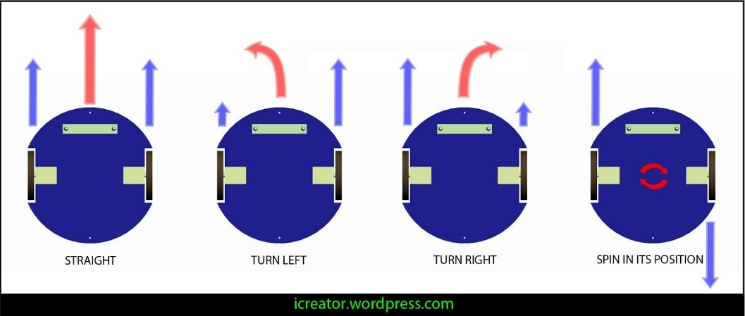

Figure 1: Differential drive

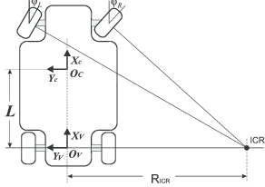

Figure 1.1: Ackermann drive

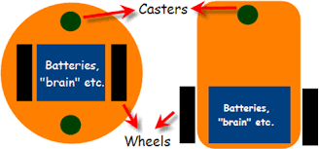

Figure 1.2: types of differential steering configurations

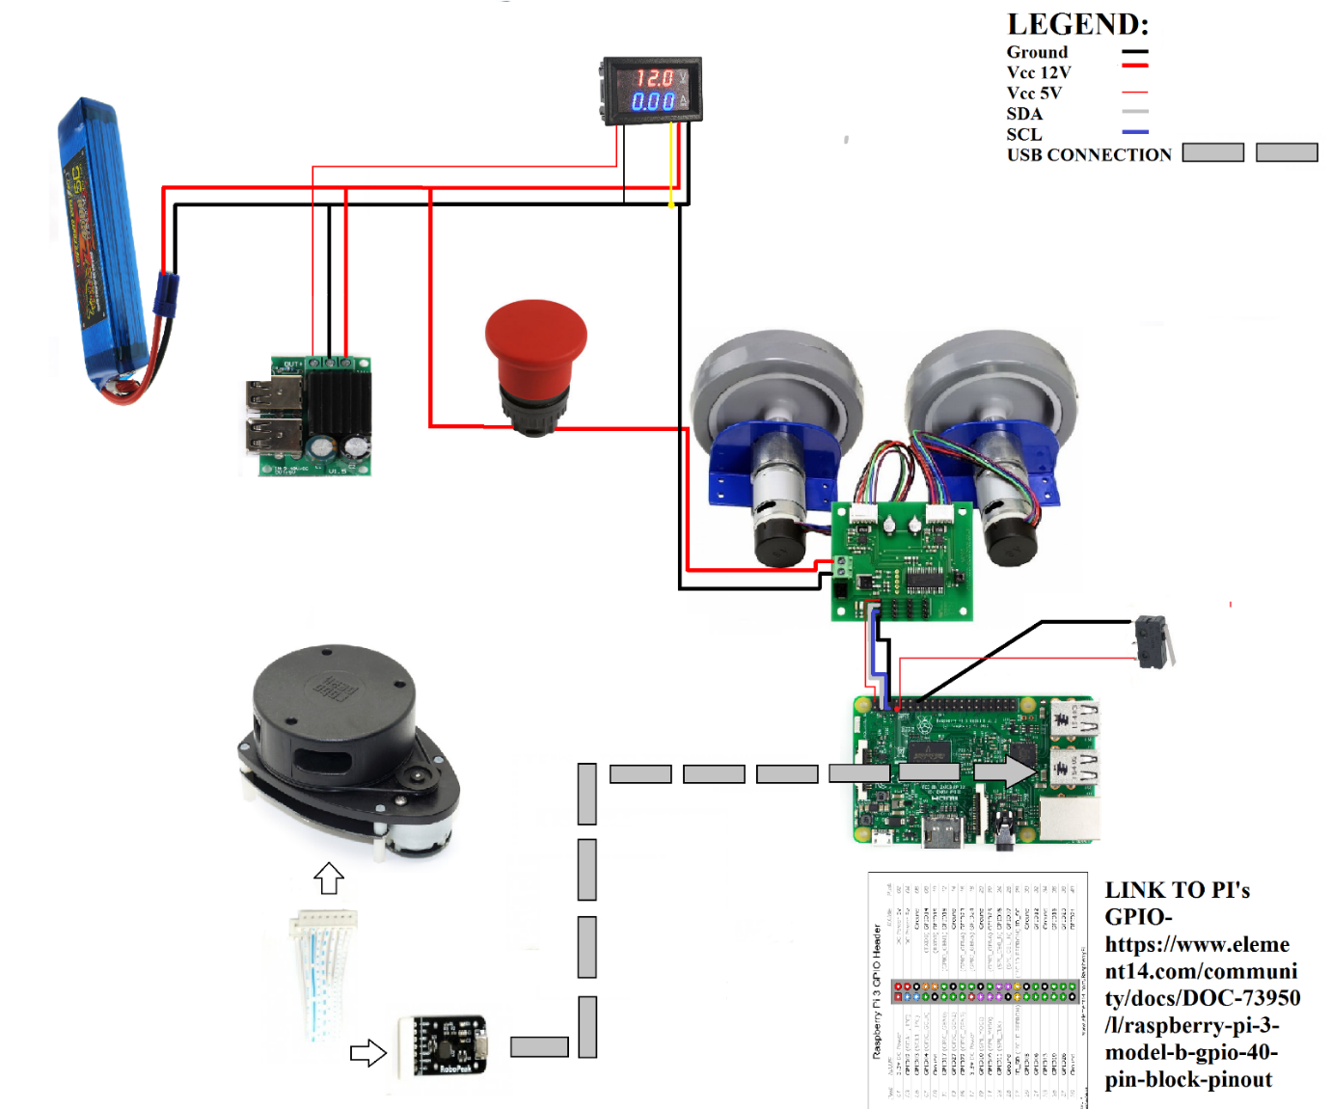

Figure 1.3: draft of the circuitry

Automated machines are slowly becoming, more and more, part of our everyday life; as such, the need to teach about Robotics is increasing. The goal of this project is to educate young people who might have an interest in the world of robot autonomation. Thus, a pc or mobile software application will be built to enhance the robot with features that will be user friendly, allowing the user to have an idea of the basic functions of the mobile robot.

**Literature review**

**Mobile robots**

After the advent of robot manipulators in industries, there came the need for robots to be able to move around, without being fixed to a physical location that is where mobile robots came to be. Mobile robots, are machines capable of mobility and are mainly classified by two branches which are:

* *The environment they travel in*

Robots are referred with different names depending on where they are deployed. An example could be the UGVs (Unmanned Ground Vehicles) which are known to be land or home robots.

* *The mechanism they use to move*

Mainly wheeled robots, human-like or animal like robots, robots with tracks are under this classification.

How does a mobile robot navigate? There are many types of mobile robot navigations. Hereafter a study of the types of mobility will be carried out to be able to understand the differences between the types of navigation which will consequently give more insight on what autonomous navigation is. Below are the main types of robot navigation systems:

**Tele-op**

The robot is remotely controlled usually with a joystick but also with other devices.

**Guarded tele-op**

Mobile robots that are guarded tele-operated are normally driven by an operator but can also move around by detecting and avoiding obstacles.

**Line-following robot**

The line-following robot is one of the first Automated Guided Vehicles (AGVs). These robots could follow a visual path created on the floor and could only detect obstacle, hence they did not have the skill to circumnavigate an obstruction to their path.

**Autonomously randomized robot**

These types of robots detect obstacle by colliding with them, after which they correct their orientation to ultimately avoid the obstacle.

**Autonomously guided robot**

An autonomous guided robot has an idea of its location and can reach various goal within the known environment. It can localize itself with the aid of sensors such as encoders lasers and global positioning systems which are often controlled by algorithms like the Monte-Carlo localization.

**Sliding autonomy**

These robots incorporate various types of mobile navigation. The helpMate hospital robot is an example of a sliding autonomy robot which can switch from manual mode to autonomous guided robot.

**The ROS frameworks**

Software developers still come across notable challenges whilst building programmes for robots. The **Robot Operating System** (ROS) platform sets up the stage to ease some of these hardships. What is ROS?

ROS is an open-source, meta-operating system for your robot. It provides the services you would expect from an operating system, including hardware abstraction, low-level device control, implementation of commonly-used functionality, message-passing between processes, and package management. It also provides tools and libraries for obtaining, building, writing, and running code across multiple computers (http://wiki.ros.org/, n.d.).

**Commercially available mobile robots**

Mobile robots available in the market, are mostly built for industrial settings. Hence the range of customers is quite narrow. However, there are robots like the Cosmo which price and features make it so that is it available for a wider range of customers. Autonomous navigation in vehicles, is still a topic of research thus it is not in the market yet. Competitions over the years, like the DARPA (Defence Advanced Research Projects Agency) Grand Challenge, have incited the creation of new ideas and technologies to make the dream of self-driving cars come closer

to reality. Companies like Waymo (under Google) have encountered some milestones in the subject. Today their self-driving car is in the testing phase and is being tested in public roads.

**Robots for educational purposes**

Robots will have a great impact in the future our society and as such the need to educate the upcoming professionals in the subject is growing even more. There are various tools available that allow the study of technology with user friendly interaction. The Mirto robot is an example (Raimondi, n.d.), where students learn to build and program a mobile robot.

One of the robots in the market that educates the user in programming and gives insight in robotics is Anki Cosmo the robot. It has algorithms that gives it a behaviour making it fun for the user to interact with. Another robot used for educational purposes is the Bee-Bot and which has an easy to use software Scratch that allows faster and easy to learn programming.

This project will attempt to educate the user in ROS showing the basics of the platform in a simpler way. An idea that hasn’t been implemented yet, is to programme from the rqt graph making connection between already made nodes by clicking on them which would generate topics automatically and so looking at the communication interface of ROS in a visually.

**Project Planning**

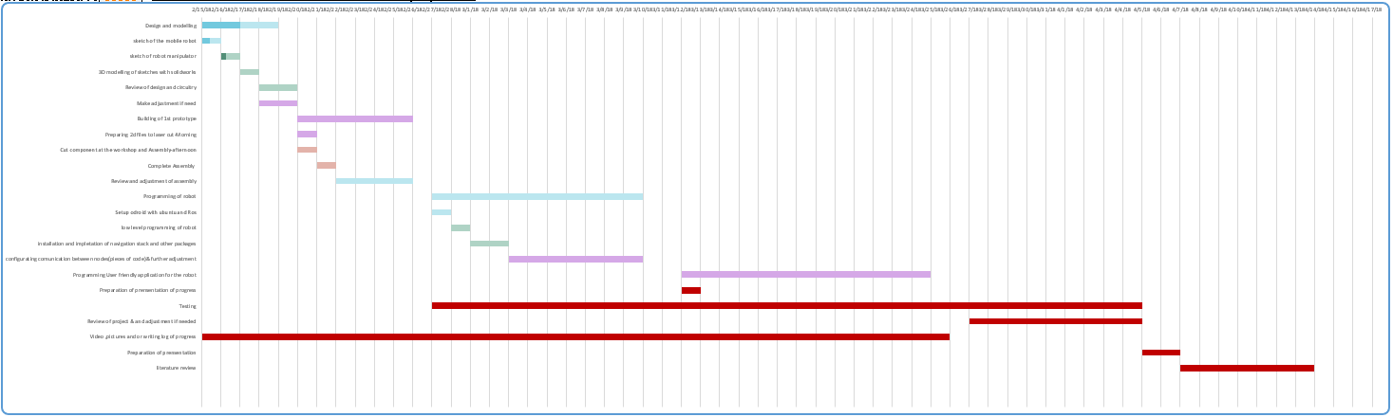

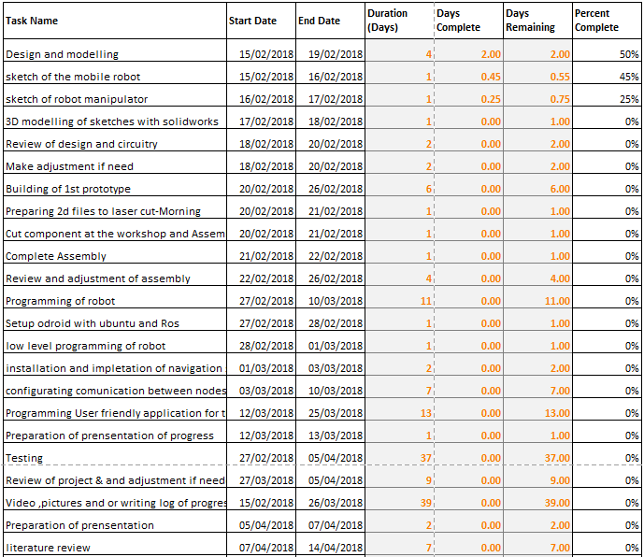

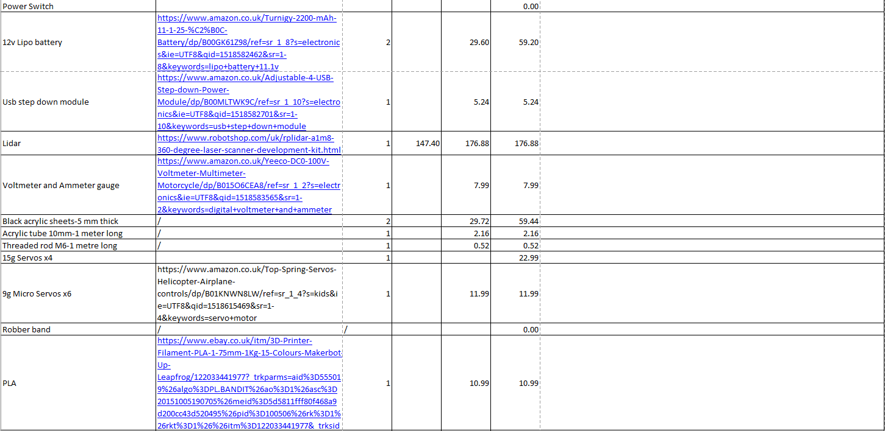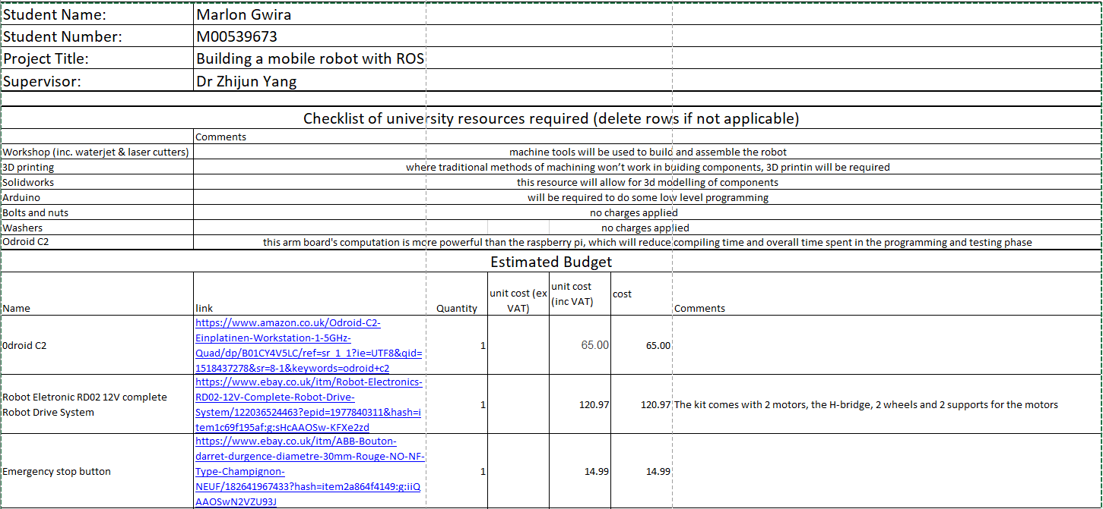**Budget**

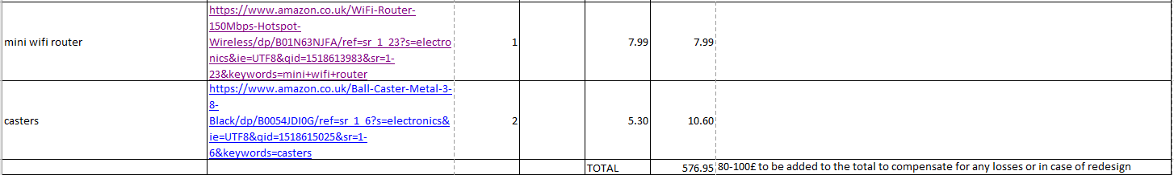

|  |  |
| --- | --- |
|  | **MIDDLESEX UNIVERSITY SCHOOL OF DESIGN ENGINEERING AND MATHMATICS**  **RISK ASSESSMENT** |

|  |  |
| --- | --- |
|  |  |
| Department/School | Science & Technology, Design Engineering and Mathematics |
| Project | New Boat Propulsion system |
| Location/s | The Ritterman Building Hendon |
| Date or period this Risk Assessment covers | 8th February 2018, 23rd May 2018 |
| Persons Involved | Programme leader – Dr Vaibhav Gandhi  Technical Supervisor- Neil Melton  Supervisor – Dr Zhijun Yang  Student – Marlon Gwira |
| Principal Location address and Contact No. | Middlesex University, Hendon central, London, NW4 4BT  Tel: +44 2084115000 |

|  |  |  |  |  |  |
| --- | --- | --- | --- | --- | --- |
| **HAZARD - Pre-Vetted Contractors - attach specific assessment** |  | **HAZARD** |  | **HAZARD** |  |
| Aircraft / “special" flying **\*** |  | Access/egress |  | Machinery |  |
| Armourers **\*** |  | Animals |  | Manual handling (attach specific assessment) |  |
| Costume/Make-Up Vehicle |  | Audience/Public |  | Mines/excavations/caves/tunnels/quarries |  |
| Diving Operations **\*** |  | Communication Failure |  | Noise (attach specific assessment) |  |
| Explosives/Pyrotechnics/ Fire effects **\*** |  | Compressed gas/cryogenics |  | Person with special needs |  |
| Flying Ballet **\*** |  | Confined spaces |  | Physical exertion |  |
| Hydraulic Hoists (Cherry Pickers) **\*** |  | Derelict Buildings/dangerous structures |  | Radiation ionising/non-ionising |  |
| Lasers **\*** |  | Electricity or gas |  | Speed |  |
| Location Catering |  | Fire/Flammable material |  | Tropical Diseases (e.g. Malaria - attach details of medical arrangements e.g. prophylactics, local hospitals and evacuation plan) |  |
| Location Lighting Services **\*** |  | Fight sequence |  | Vehicles/off road driving |  |
| Hire of Lighting Equipment |  | Glass |  | Violence/ Public disorder |  |
| Scaffolds **\*** |  | Hazardous substances/ chemicals/ drugs micro-organisms (attach specific -assessment) |  | Water |  |
| Smoke Effects **\*** |  | Heat/cold |  | Weather |  |
| Stunts **\*** |  | Hostile Environment: (attach confirmation of clearances from Senior Management) |  | Working patterns/working hours |  |
| Physical Effects |  | Inexperienced performer or children **N.B.** for children, risk assessment must be provided to parents or guardian. |  | Working at heights |  |
|  |  | Lifting appliances/ machinery |  | Other |  |
| **Experts Engaged**  List experts used, including pre-vetted contractors. Each pre-vetted contractor should be required to provide the significant findings of their risk assessment in writing. This information should then be included in or appended to this form and reviewed with other activities and arrangements to check effective co-ordination. | | | | | |

|  |  |
| --- | --- |
| **Details of Activity**  *Briefly Describe what is intended. For clarity, this may include sketches/story board/diagrams/checklists*  The activity will consist in building a mobile robot. The robot will have a differential drive and it will be electrically powered with a lithium battery. The battery is the main cause of concern as it is highly inflammable. It has 12V and 9 Ah and will be used and charged in a fire bag. | |
| **Hazards Identified and Risks Arising**  *Identify and list what could reasonably cause harm. Against each identify who is at risk, i.e. who could be harmed and how. Ignore the trivial, concentrate only on those hazards that could result in serious harm or affect several people.*  Communication failure(H)  Electricity or Gas (L)  Locations (L)  Machinery (M)  First Aid | **Risk Assessment and Proposed Precautions**  *For each of the above, evaluate the risks and decide whether existing precautions are adequate or more needs to be done. Take into account information from contractors, premises management, resource providers, and others about the risks and controls. List the proposed controls for each significant hazard and identify any contingency plans in place for emergencies or failures of safety critical arrangements, e.g. miss fire of explosive effect or stunt; car going off road; member of public being door stepped, turning violent.* ***Include fire and first aid and welfare arrangements.***  Communication between the robot and the laptop will be via laptop through WIFI. In case of communication failure, the robot will carry the last command sent. An emergency stop button has been fixed on top of the robot to seize the robot’s movement to avoid the possibility of it causing harm to other people or whiles running or damaging itself.  The robot will go through a thorough supervision to ensure wiring to the battery and to the circuit boards are properly connected, before each use.  All wiring will be organised and made visible to be able to easily detect any malfunctions and avoid short circuits.  The activity will take part in the following locations:   * The Ritterman building in Middlesex University, Hendon Campus. * In the student’s house 2 minutes from university.   Most of the testing will be done in the Ritterman building which has safe and healthy measures to contain, in the worst-case scenario, a fire outbreak that may be caused by any device related to the robot.  A first aid kit will be in the vicinity just in case the likelihood of an injury may occur. |
| **N.B. THIS MUST BE SIGNED BEFORE THE EVENT CAN GO AHEAD**  I have read the above and am satisfied that:   1. It constitutes a proper and adequate risk assessment in respect of the programme activity and that the precautions identified above are sufficient to control the risks. 2. Adequate arrangements are in place to communicate the risk assessment findings and to co-ordinate the safety arrangements of all those affected, e.g. site owners, engineers, contractors, freelances, resources, etc. | |
| **Signature of Head of Department/Project Leader** ………………………………………………………**Name Dr Vaibhav Gandhi**  **Date: 7 May 2013**  **Details of Safety Training received**  Interactive  Other (give details below) | |
| **Signature of person conducting this assessment**  …………....…………………………………………**Name Mr Nick Weldin**  **Date: 8th February 2018**  **Signature of person with designated responsibility for safety co-ordination**  ....…………………………………………**Name Neil Melton**  **Date: 8th February 2018**  **Review Date; Two-time event** | |

# References

Bertoncello, M. (n.d.). Ten ways autonomous driving could redefine the automative world. *https://www.mckinsey.com/industries/automotive-and-assembly/our-insights/ten-ways-autonomous-driving-could-redefine-the-automotive-world*.

*http://wiki.ros.org/*. (n.d.).

Raimondi, F. (n.d.). *http://www.rmnd.net/middlesex-robotic-platformo-mirto/*.