ProntoPCR

Handbook

**Contents**

**Overview** 2

**Instructions for Use** 2

**Local Access (Recommended)** 2

**Online Access** 3

**How to Use** 3

**Data Input** 3

**Calculations** 5

**Statistics** 10

**Versions** 10

**R Packages** 10

**References** 10



# **Overview**

ProntoPCR is a software application that aims to efficiently and automatically perform routine qPCR calculations, such as averaging the housekeeper genes, calculating ΔCq, ΔΔCq, relative fold-change (2^-ΔCq), and fold-change (2^-ΔΔCq) of the target gene. It also provides the user with options to perform statistics and graphing of the data. ProntoPCR is an open-source, R shiny (reference Shiny) software application available both online and locally as an R package (reference R), making it accessible to users with minimal programming experience. It is also designed to be compatible with the output generated by PCR machines, such as the Quantstudio 5 (Thermo Fisher Scientific) enabling the user to get instant results. Users only require a comma separated values (.csv) file of the raw data, including the quantification cycle (Cq) values, the target (gene) and sample name to get started.

# **Instructions for Use**

ProntoPCR has been designed to operate both online and locally. Whilst we aim to maintain online availability, the hosted platform may change or become unavailable. Therefore, it is recommended to rely on the local version, which functions with the same features as the online option. The local version also does not require internet access once installed.

To run the application locally, the user needs to download R: <https://cran.r-project.org/> and RStudio: <https://posit.co/downloads/>. A step-by-step guide on how to install the ProntoPCR application locally is available below, as well as this video. The guide is aimed at users with minimal programming expertise.

We request that users of ProntoPCR cite the associated journal article if the application has been used in analysis. The citation is as follows:

## **Local Access (Recommended)**

1. Download R and RStudio.

* <https://rstudio-education.github.io/hopr/starting.html>

1. Open RStudio
2. Within the Console, type:

install.packages(“ProntoPCR”)

1. Once installed, this will appear in your console:
2. To run the app, inside the console section, type:

run_app(ProntoPCR)

1. The ProntoPCR Interface will now appear in a separate window.

## **Online Access**

Access to ProntoPCR is available here: <https://marniem.shinyapps.io/ProntoPCR/>

## **How to Use**

An example data file can be directly downloaded from the ProntoPCR app. All example outputs given in the below images have come from the example data .csv file.

### **Data Input**

1. Collate all PCR Cq values into one .csv file. It must be in the following format:

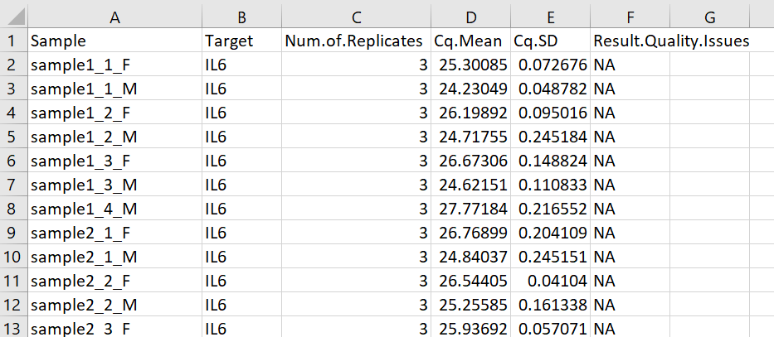

Checklist:

* CSV file containing PCR data with the formatting given above?
* Column names have capital letters when specified?
* Column names have full-stops . when specified?
* There are no spaces present in the column names?
* There are no gaps between rows in your dataset. Each row should have at least one measurement.
* If you have 'undetermined' amplification i.e. no amplification, 0 has been entered in your dataset for those instances. Any NA values will be disregarded.
* All Sample names have no spaces, and are using underscores (_) in the naming system. Note the format is given by group1_biologicalReplicateNumber_group2. If there is no second group, write NIL. E.g. sample2_1_NIL.
* All non-template controls (NTC) and no reverse transcriptase controls (-RT) have been removed.

Note: This file format is compatible with the output given by the QuantStudio5 PCR machine (ThermoFisher Scientific). To do this, set up the plate format similar to below: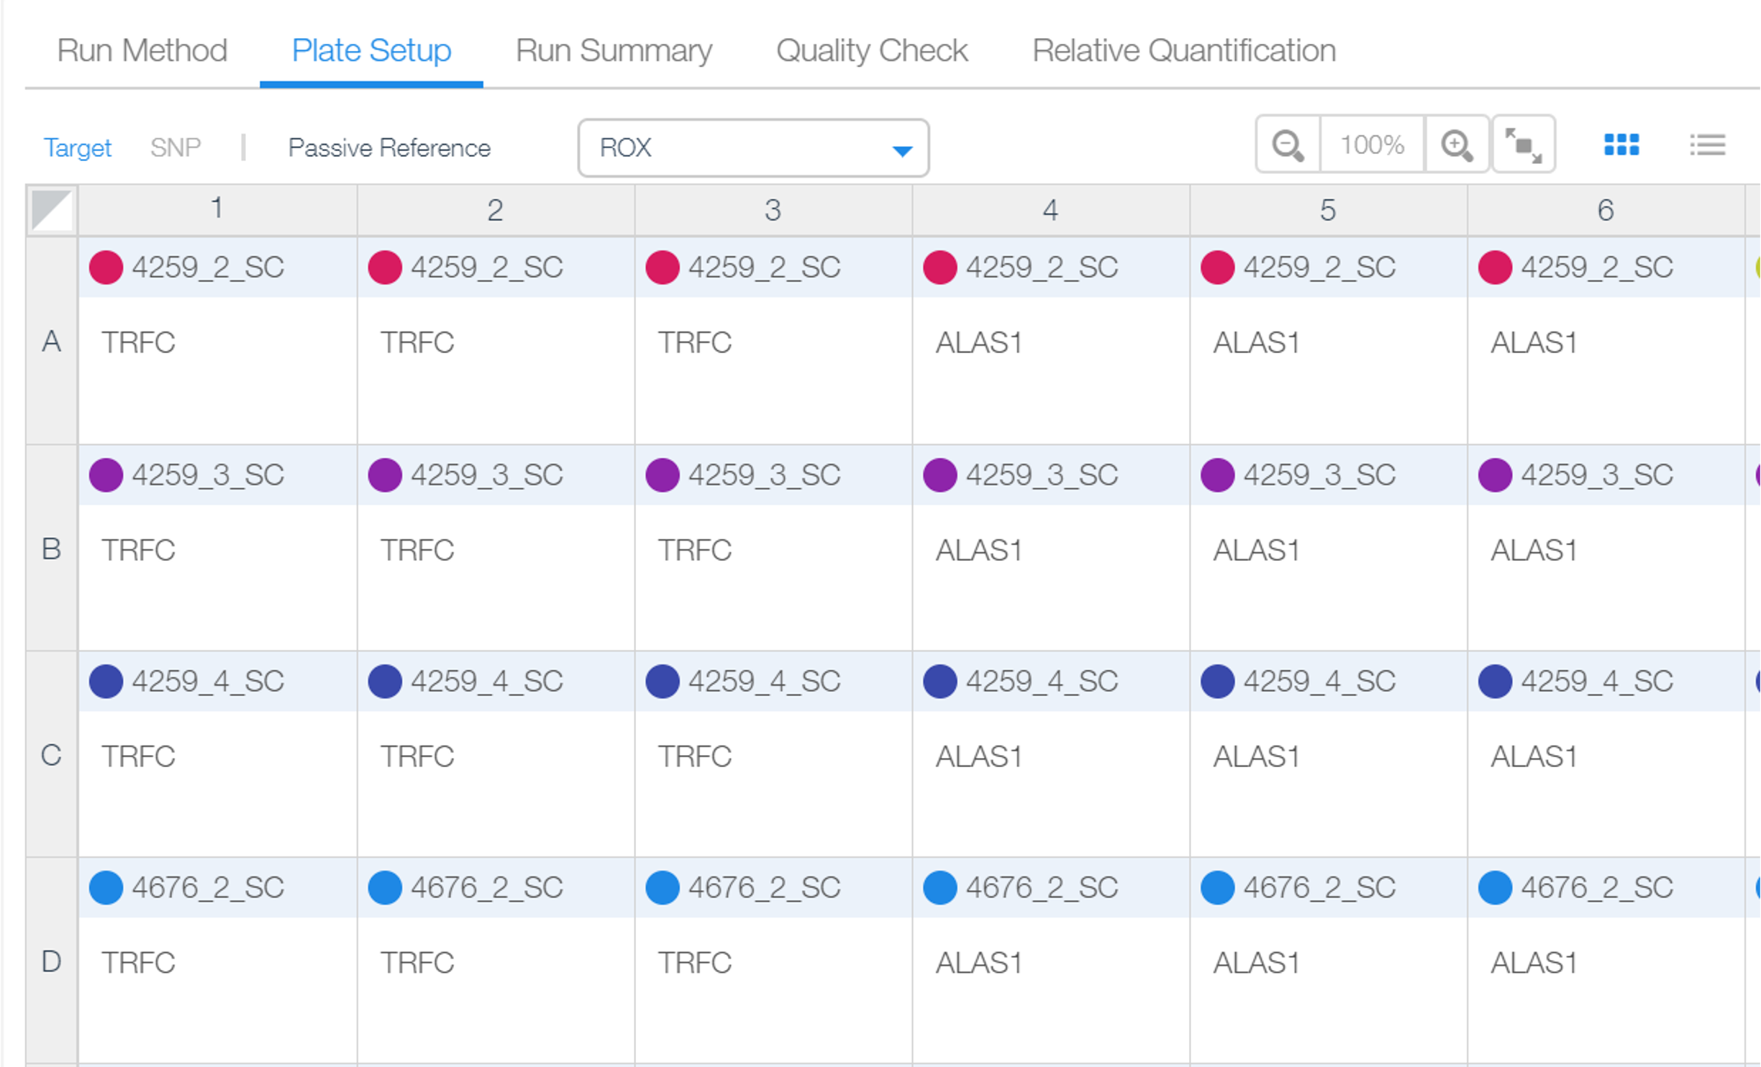

To export the results go to the Quality Check tab 🡪 Replicate Group 🡪 Export:

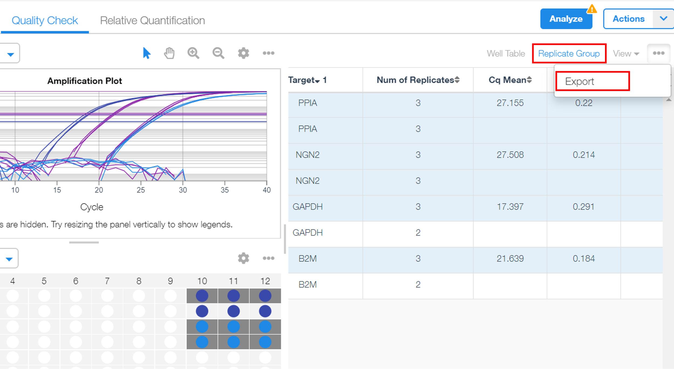

1. Open ProntoPCR and select the Input Data Tab.
2. Insert .csv file of PCR data by clicking on Browse…
3. Enter how many housekeeping genes to normalise the data to.
4. Enter the name of the housekeeping gene – exactly as it appears in the .csv file.

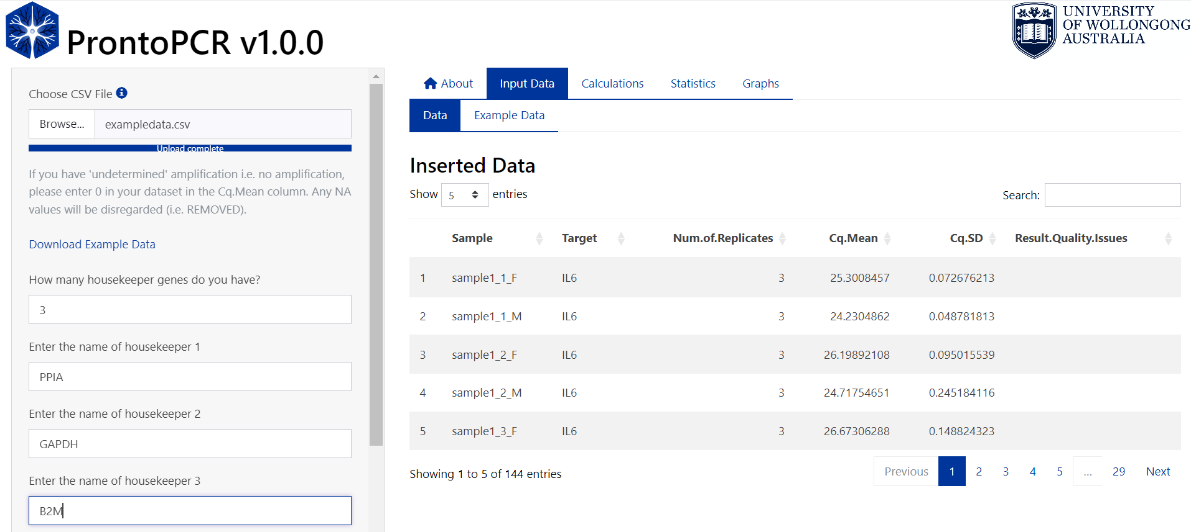

1. Save the names of the housekeeper genes by selecting the ‘Save housekeeper names’ button. An error message will appear if the housekeeper's name is incorrect or not found. If the names of the housekeepers are correct, they will be displayed below the button:

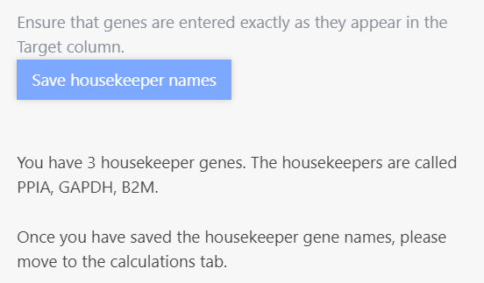

### **Calculations**

1. Select the Calculations Tab. The average of the housekeeper genes will automatically be calculated using arithmetic mean. This will be displayed as the mean_hk column on the right. E.g. the mean_hk for sample1_1_F is calculated as follows:

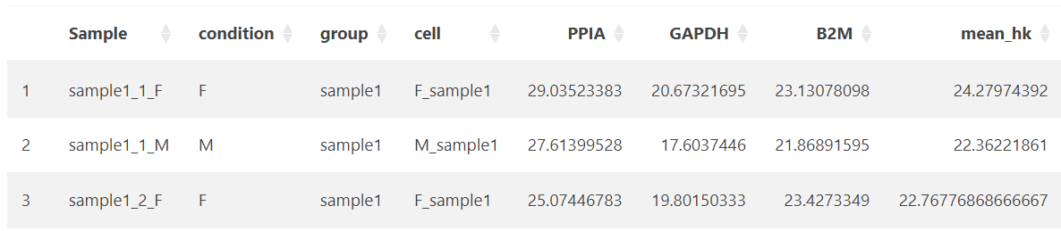

1. To use geometric mean, select this option on the side panel:

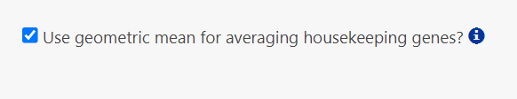

The geometric mean is calculated as follows for sample1_1_F:

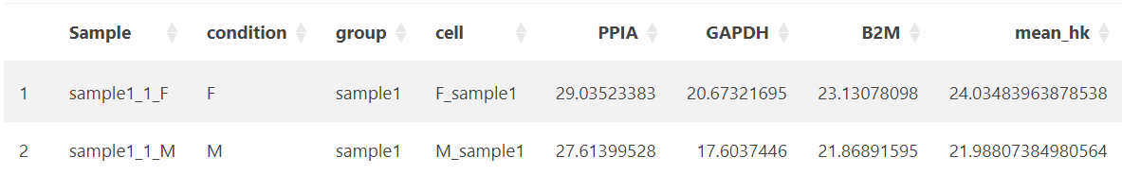

1. The ΔCq is calculated as follows:

The ΔCq is displayed as dcq_geneName within the table on the right. E.g. for the gene IL6, the ΔCq (dcq_IL6) is calculated by:

25.3008457 – 24.0348396 = 1.2660060…

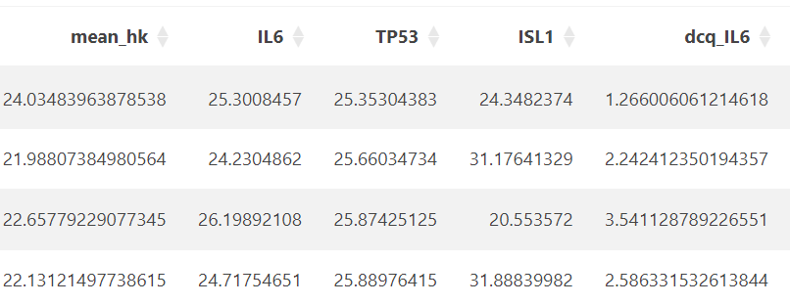

1. Relative fold change (2^(- ΔCq)) is automatically calculated and given as fc_dcq_gene within the table:

E.g. the relative fold change of IL6 (fc_dcq_IL6):



1. To save the relative fold change data, press the download processed data button:

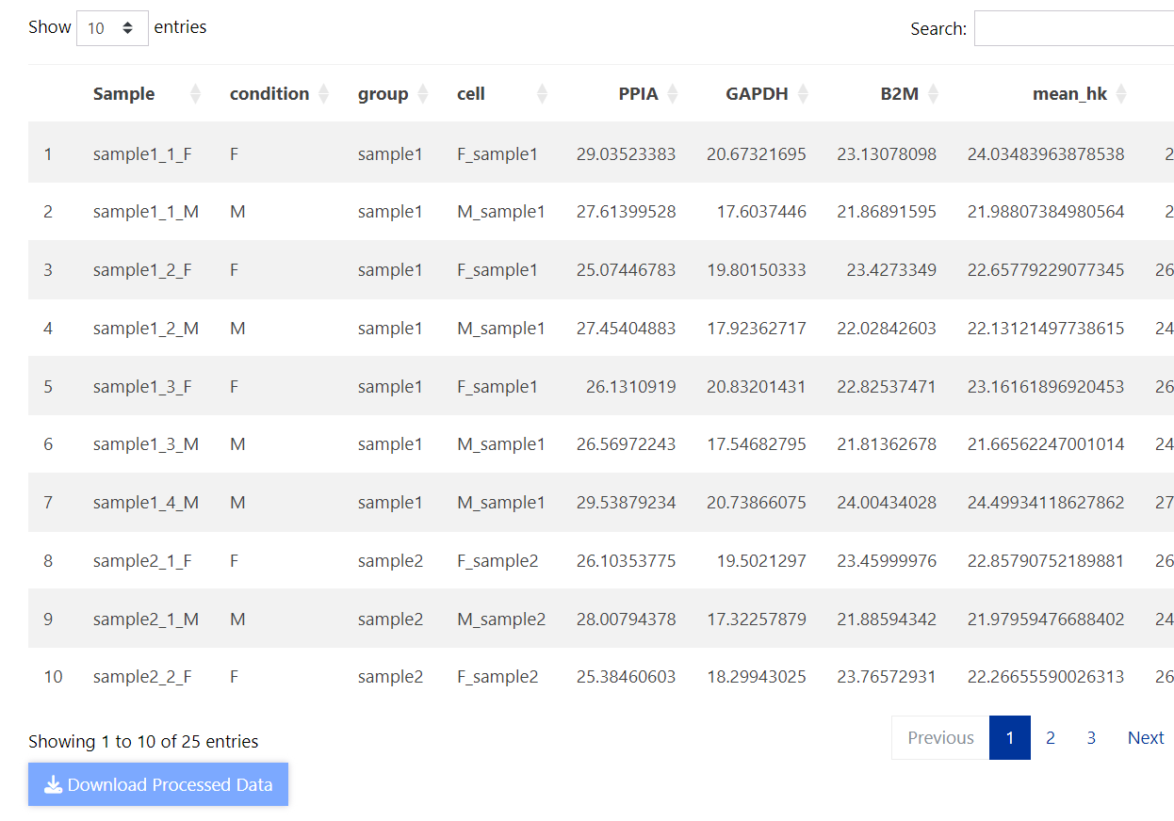

1. To save biological replicate average values from the 2^(- ΔCq) method, select the Biological Replicate tab and press the ‘Download Replicate Average Data’ Button.

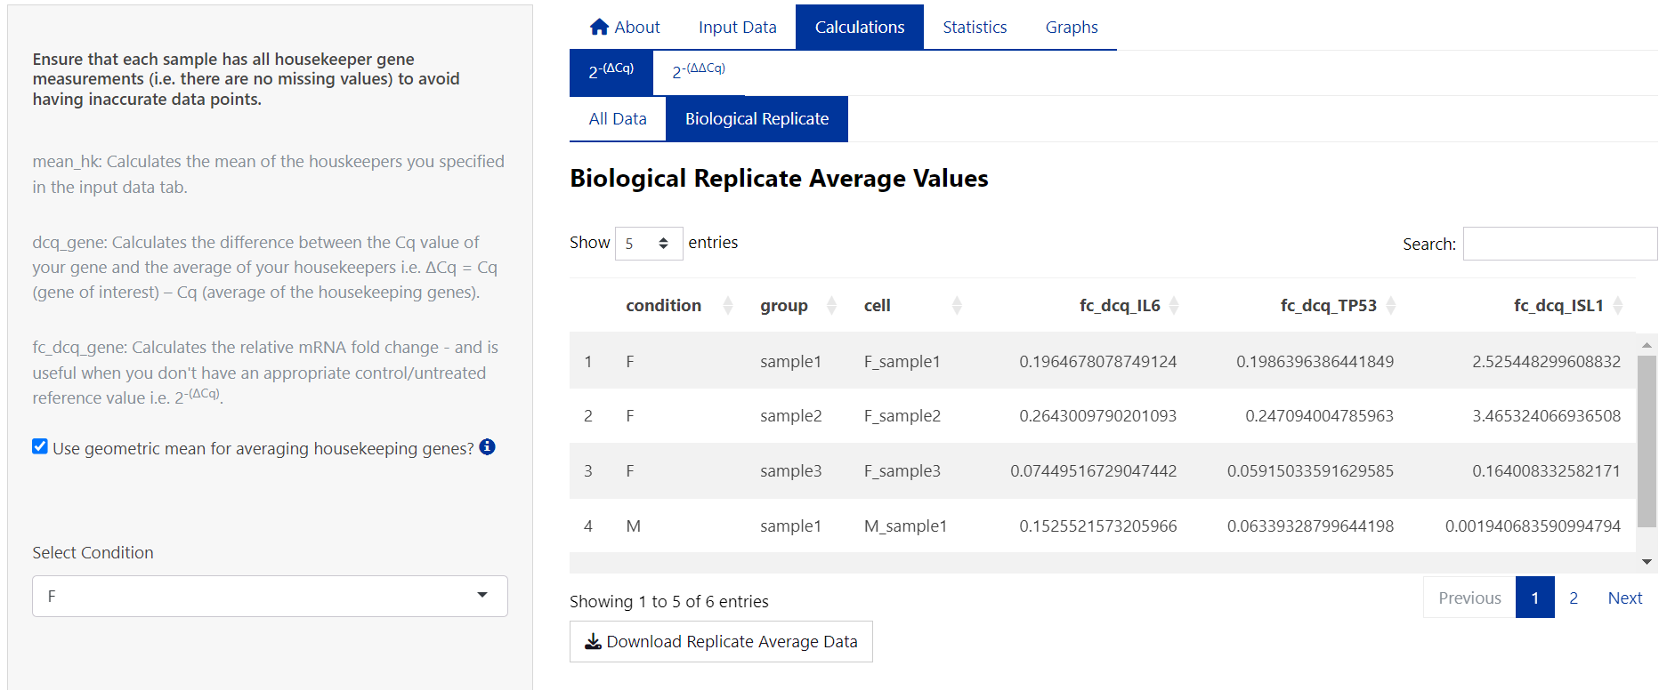

1. For calculations using the 2^(- ΔΔCq) method, proceed to the 2- ΔΔCq tab.
2. Select the sample/group to be used as the control/reference sample. E.g. F_sample1:

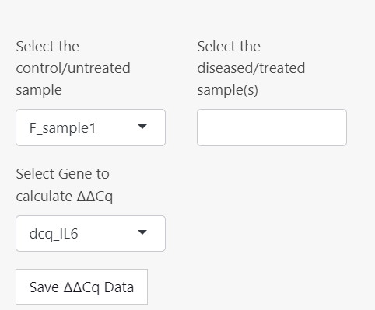

1. Select the remaining groups, and the gene/target to perform the calculation on:

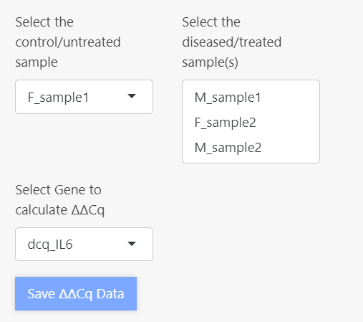

1. Save the 2^(- ΔΔCq) data set within the ProntoPCR environment by pressing the ‘Save ΔΔCq Data’ button. It will appear light blue if it has been saved. This is important to do if performing statistics and/or graphing.
2. 2^(- ΔΔCq) is calculated as follows:

Average the ΔCq values of the control group. This will appear as dcq_ctrl_avg, and the same number will be displayed down the column of the table. E.g. the dcq_ctrl_avg for the control sample (F_sample1) is calculated by:

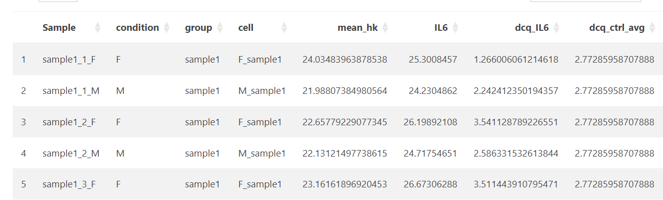

Then perform ΔΔCq (ddcq) by calculating the difference between the ΔCq of your gene of interest and the average of the control group (dcq_ctrl_avg):

E.g. the ΔΔCq for IL6 and sample1_1_M is:

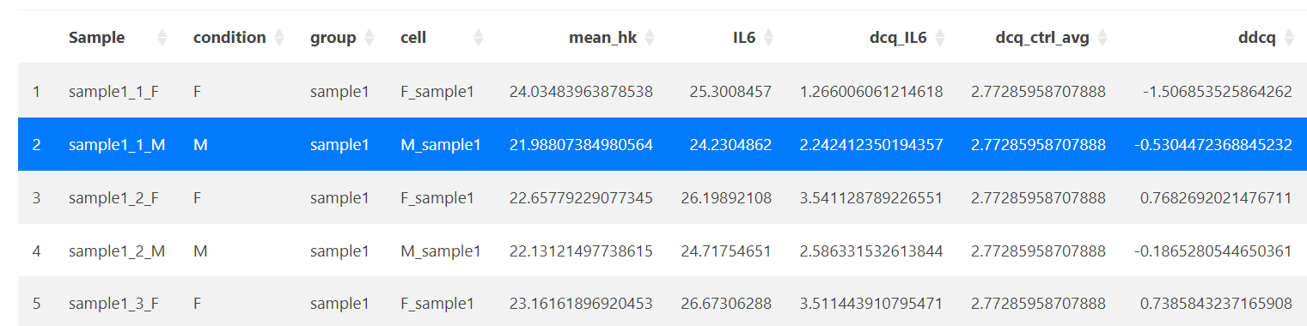

Therefore the fold change (fc_ddcq) 2^(- ΔΔCq):

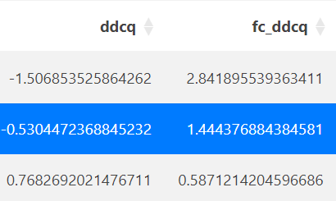

1. Press the ‘Download Processed Data’ Button to save the fold change data.
2. The biological replicate average data is displayed in the ‘Biological Replicate’ tab and can be saved using the ‘Download Replicate Data’ button.

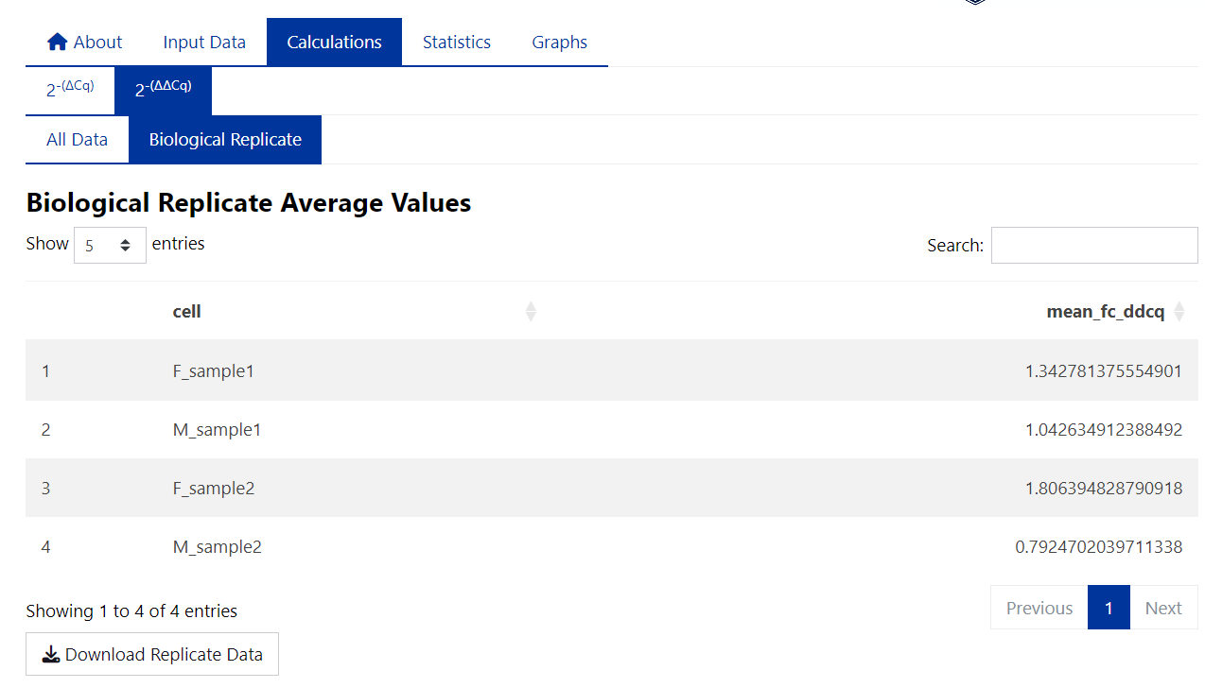

### **Statistics**

Note: There is no one-size-fits-all approach to statistical analysis. The statistical tests given within ProntoPCR are not exhaustive. It may be more appropriate to use another statistical program in conjunction with ProntoPCR.The p-value significance is denoted as follows, with the default α = 0.05: *** for *p*-values ≤ 0.001, ** for *p*-values ≤ 0.01, * for *p*-values ≤ 0.05, and ‘ns’ (not significant) for *p*-values > 0.05.

#### **Selecting the Data**

Statistics can be performed on the 2^(- ΔCq), 2^(- ΔΔCq) or housekeeper gene mean values.

1. Select the data to be used for statistics:
   1. If 2^(- ΔCq) is selected, choose the gene and samples to perform statistics on:

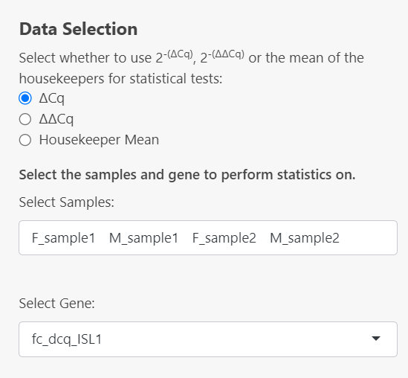

* 1. If 2^(- ΔΔCq) is selected, the gene will automatically be inputted based on the selected options in the calculations 🡪 2^(- ΔΔCq) tab. Select your samples in the dropdown menu. If you don’t see a sample in this section, it must be added to the dataset created in the Calculations 🡪 2^(- ΔΔCq) tab: 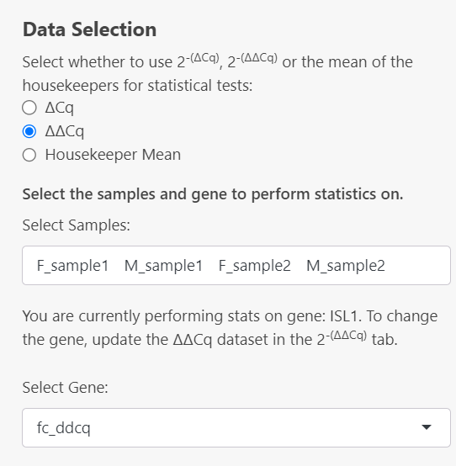

If the 2^(- ΔΔCq) dataset has not been created yet, this error message will be displayed:

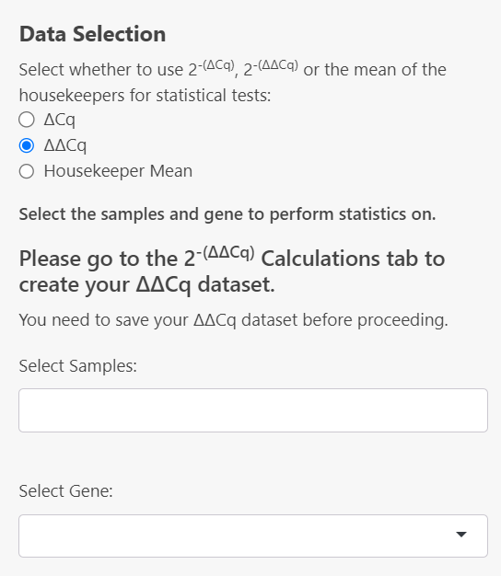

* 1. If Housekeeper mean is selected, the mean_hk column will be used as the ‘Gene’ to perform statistics on:

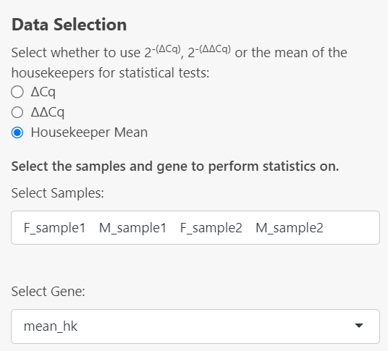

#### **Descriptive Statistics**

From this point onwards, all output given has been performed on the 2^(- ΔCq) dataset for the gene *ISL1* from the example data.

1. Descriptive Statistics can be computed by selecting the checkboxes in the side panel. Descriptive statistics available include:
   1. Sample size:

* Calculated by counting the number of valid (non-missing) data points within each specified group for that gene.
  1. Mean:
* The mean values are calculated for each specified group by averaging the valid (non-missing) data points using the arithmetic mean for that gene.
  1. Geometric Mean:
* The geometric means are calculated for each specified group by taking the exponent of the average of the logarithms of the valid (non-missing) data points.
  1. Median:
* The median values are calculated for each specified by finding the middle value of the sorted valid (non-missing) data points within each group.
  1. Standard Deviation:
* The standard deviations (SD) are calculated for each specified group by measuring the spread of the valid (non-missing) data points around the mean within each group.
  1. Standard Error:
* The standard errors (SE) are calculated for each specified group by dividing the standard deviation (SD) of the valid (non-missing) data points by the square root of the number of valid observations in each group (i.e. Sample Size (*n*)).
  1. 95% Confidence Interval of the Mean:
* Confidence intervals (CI) are calculated for each group by first determining the standard error based on the standard deviation and sample size, then applying either the Z-score for large samples (*n* ≥ 30) or the t-score for smaller samples to compute the lower and upper bounds of the interval around the mean. These intervals provide a range where the true population mean is likely to fall with a specified level of confidence (95%).
* For large samples (*n* ≥ 30):
  + - * is the sample mean.
      * is the standard deviation.
      * is the sample size.
      * is the Z-score corresponding to the confidence level (i.e. 1.96 for 95% confidence).
* For smaller samples (*n* < 30):
  + - * is the sample mean.
      * is the standard deviation.
      * is the sample size.
      * is the t-score corresponding to the desired confidence level and degrees of freedom ().
* In both cases, the confidence interval is expressed as:
  1. Variance:
* The variances are calculated for each specified group by measuring the average of the squared differences between each valid (non-missing) data point and the group mean. This provides a measure of how spread out the data points are within each group.
  + - * is the sample variance.
      * ∑ denotes the summation over all observations.
      * represents each individual observation.
      * is the mean of the observations.
      * is the number of observations in the sample.
      * represents the degrees of freedom.
  1. Minimum/Maximum:
* The minimum and maximum values are determined for each group by identifying the smallest and largest valid data point for that gene.

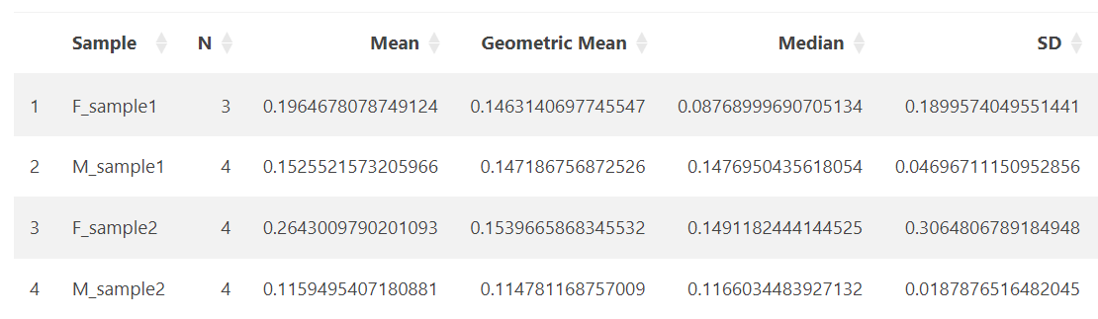

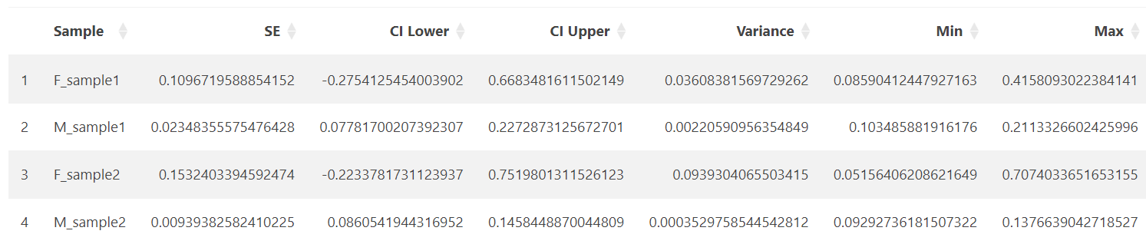

#### **Normality Testing**

The normality of data can be tested using a Shapiro-Wilk test, QQ plots and density plots in ProntoPCR. By default, the normality is tested per group on the raw data. If one-way ANOVA is selected, the normality tests will be performed on the residuals, not the raw data. A Residuals vs Fitted plot will also be displayed if One-way ANOVA and a normality test are both selected. The raw values are the default if no comparison of groups test, or any other group comparison tests are selected. Note that normality testing is usually considered to be unreliable for small sample sizes.

1. A Shapiro-Wilk test can be performed by selecting the checkbox on the side panel. It is computed using `stats::shapiro.test` in R.

* Raw data:

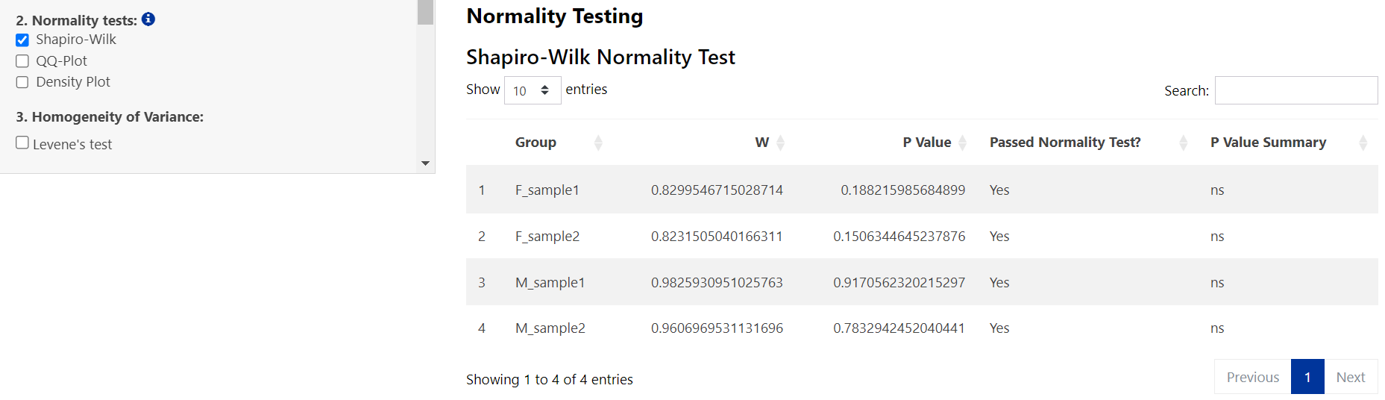

* Residuals:

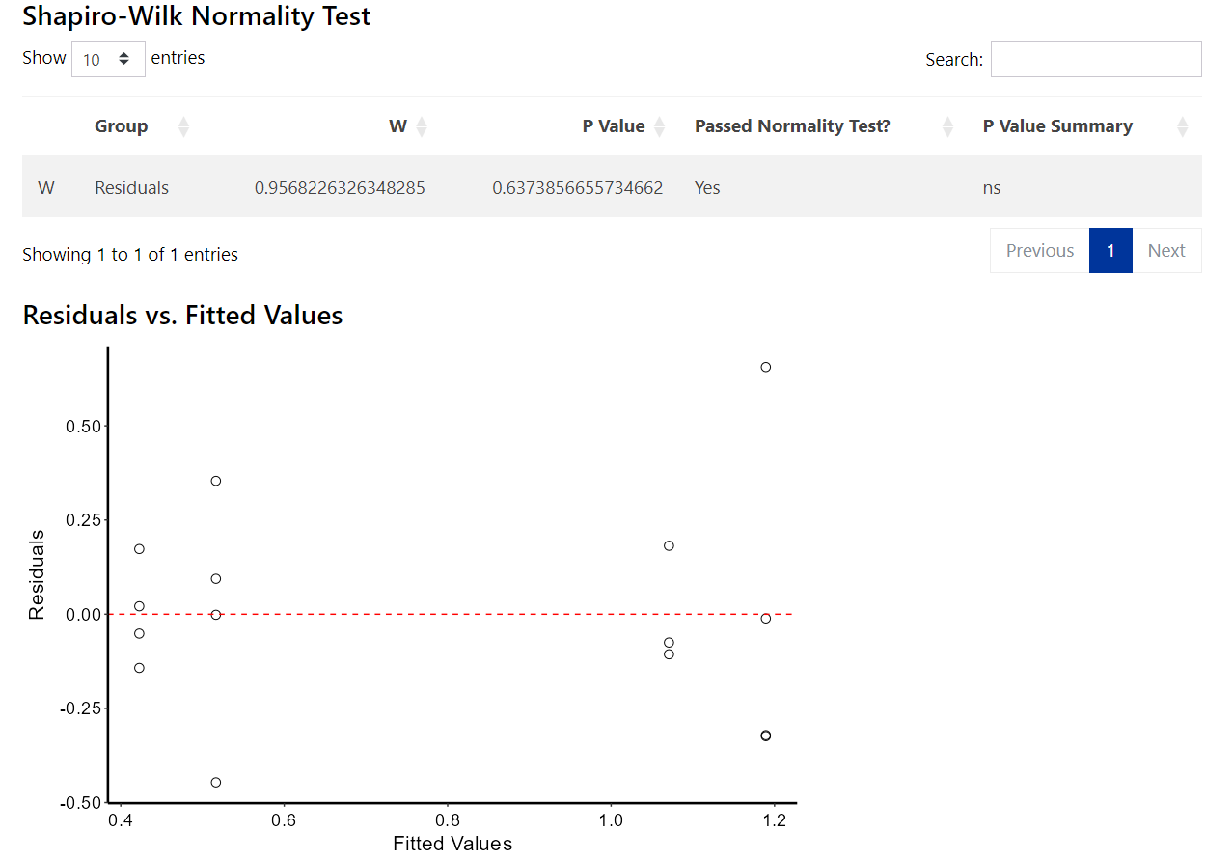

1. A QQ Plot will be generated by selecting the checkbox on the side panel. It is computed using:



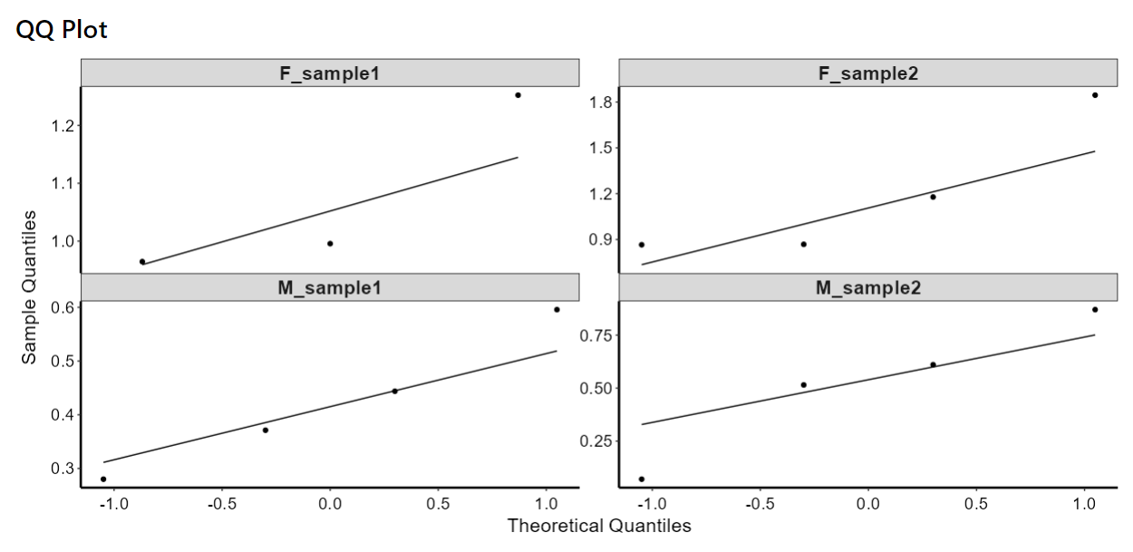

1. A density plot will be generated by selecting the ‘Density Plot’ checkbox on the side panel. It is computed using:



# **Versions**

# **R Packages**

# **References**