**Unity app to view the 3D map of a location**

**Preparatory steps:**

1. Creating a GitHub Repository: <https://github.com/MaroClay155/3D-Maps-in-Unity.git>

2. Sharing the GitHub Repo with ***iliesaya***

3. Adding a .gitignore file to discard unwanted files while pushing the project files

**Technical Steps:**

1. Creating a new 3D unity project.

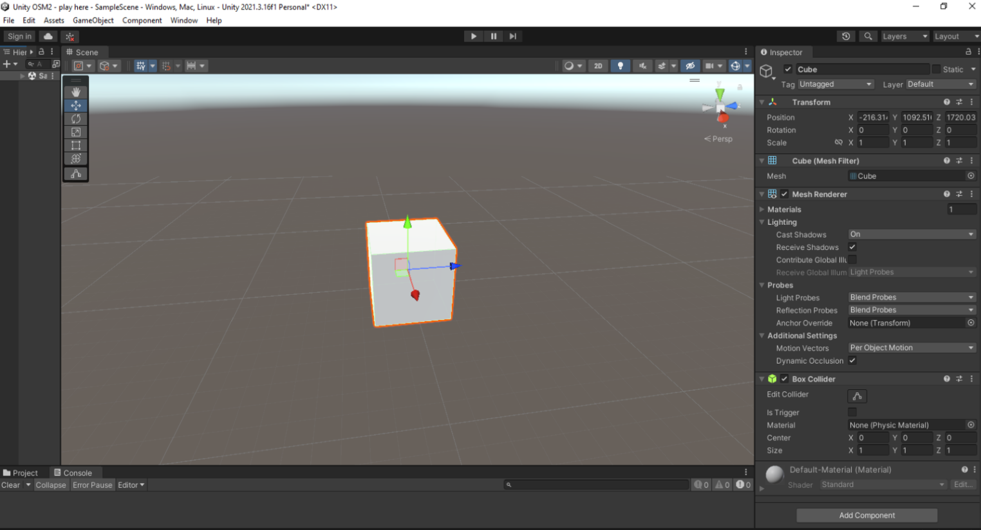

1. Creating a Dropdown menu with 3 different location to view.

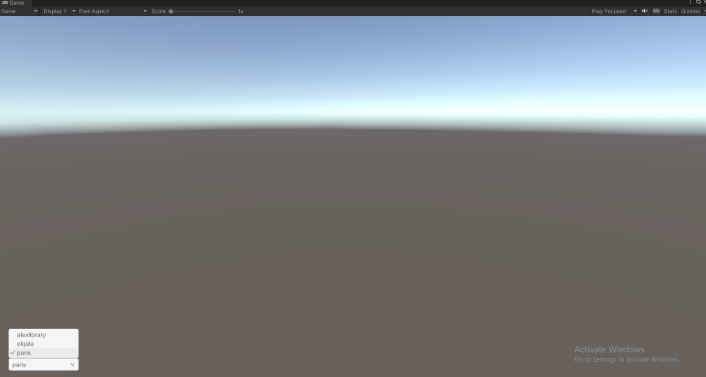

1. Creating a [Location Handler](https://github.com/MaroClay155/3D-Maps-in-Unity/blob/f1a5f943f321ab24bcecddf31cf2afc952d2bbd8/Assets/Scripts/LocationHandler.cs) class in order to expose the selected location as a public value.

(Attach the class to the Dropdown object).

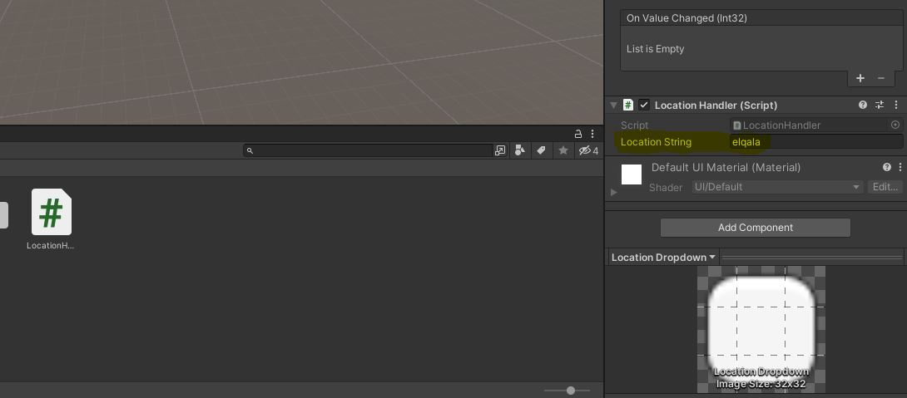

1. Exporting Open Street Maps [OSM](https://www.openstreetmap.org/#map=17/31.21243/29.88353) for 3 different locations.

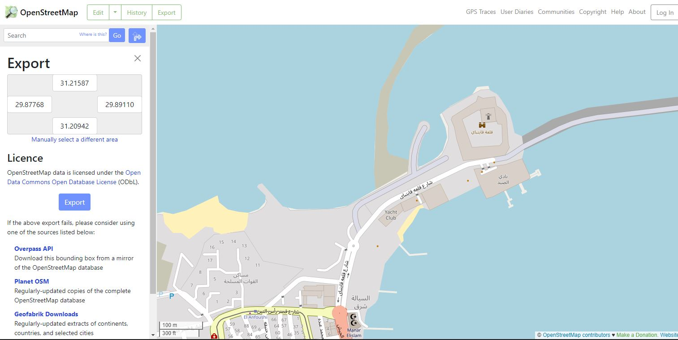

1. Creating the Map from the exported files.
   1. Creating an Empty Object named Map.
   2. Creating a [Map Reader](https://github.com/MaroClay155/3D-Maps-in-Unity/blob/f1a5f943f321ab24bcecddf31cf2afc952d2bbd8/Assets/Scripts/MapReader.cs) class to parse each node in the XML file of the selected location.
   3. Creating a [Road Maker](https://github.com/MaroClay155/3D-Maps-in-Unity/blob/f1a5f943f321ab24bcecddf31cf2afc952d2bbd8/Assets/Scripts/RoadMaker.cs) class to create the roads.
   4. Creating a [Building Maker](https://github.com/MaroClay155/3D-Maps-in-Unity/blob/f1a5f943f321ab24bcecddf31cf2afc952d2bbd8/Assets/Scripts/BuildingMaker.cs) class to create the roads.

(Attach the three classes to the Map object).

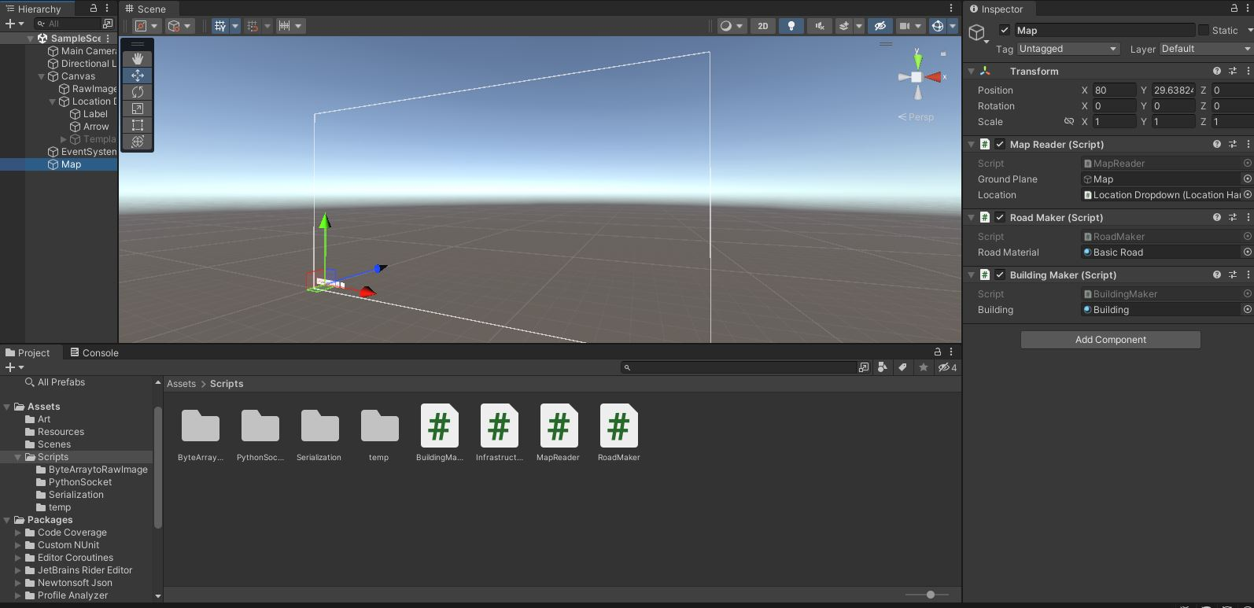

1. Creating a [Camera Control](https://github.com/MaroClay155/3D-Maps-in-Unity/blob/f1a5f943f321ab24bcecddf31cf2afc952d2bbd8/Assets/Scripts/CameraControls.cs) class allow the user to rotate / zoom / move in the map.

(Attach the class to the Camera).

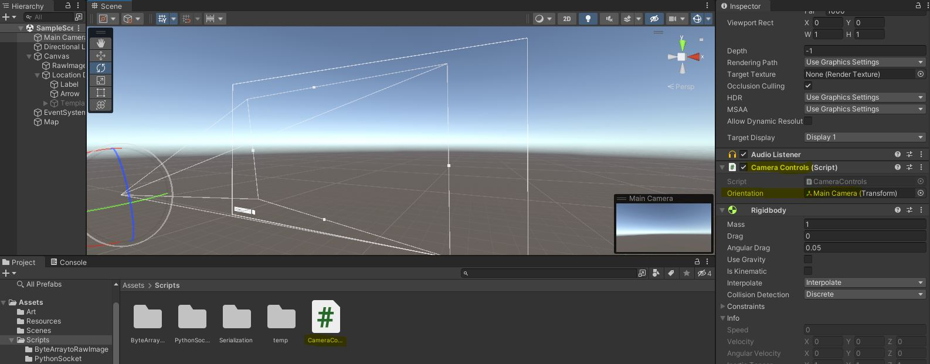

1. Creating a [Python](https://github.com/MaroClay155/3D-Maps-in-Unity/blob/f1a5f943f321ab24bcecddf31cf2afc952d2bbd8/Assets/Scripts/PythonSocket/sinwaveSocket.py) app with an UDP client to send a sine wave at 10Hz as a graph.
2. Creating a [Receiver](https://github.com/MaroClay155/3D-Maps-in-Unity/blob/f1a5f943f321ab24bcecddf31cf2afc952d2bbd8/Assets/Scripts/PythonSocket/SinewaveReceiver.cs) class with a UDP server to receive the sine wave graph.
3. Creating a Raw Image and attach the received image to it.

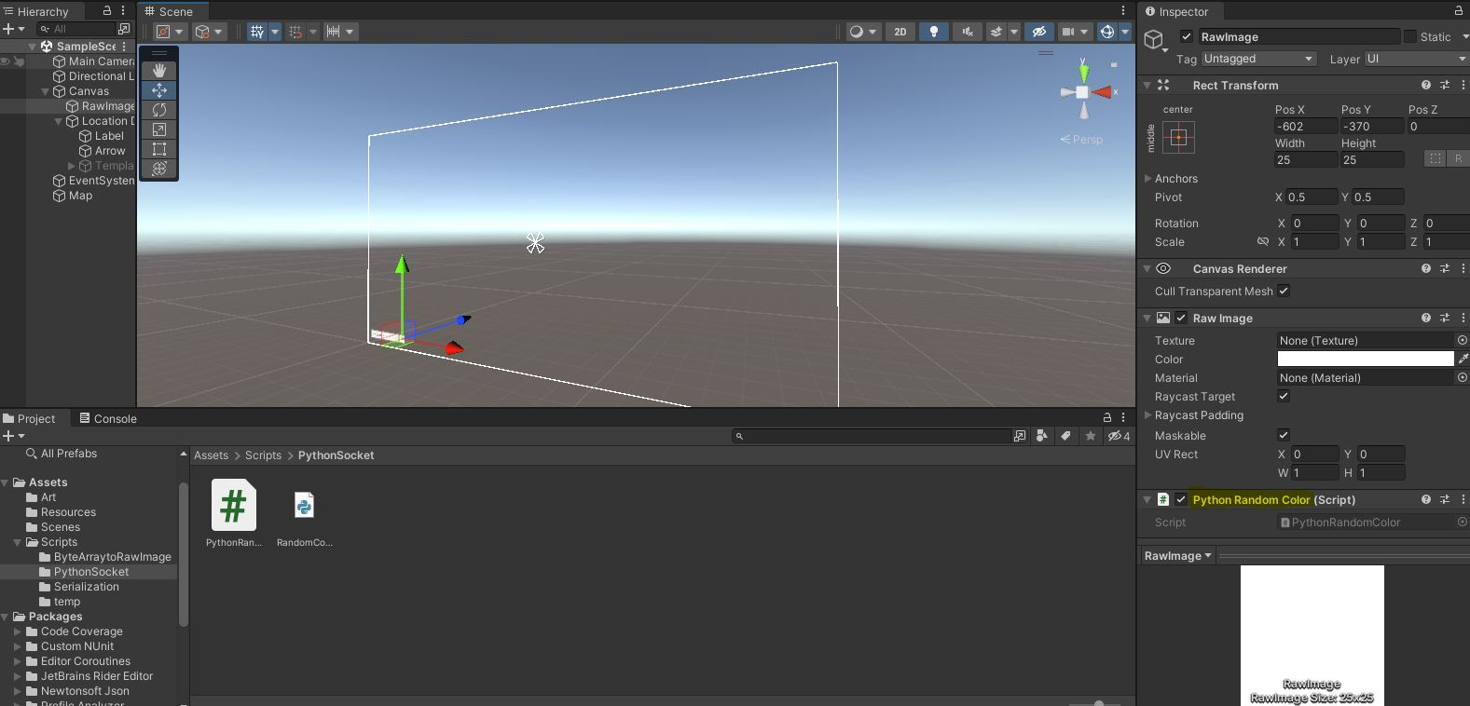

Figure 1:( Hint: The attached Receiver class receives a random color for a testing purposes)

1. Creating an Altitude class to expose the height of the camera.

(Attach the class to the camera, Attach the Text object to the public altitude value)

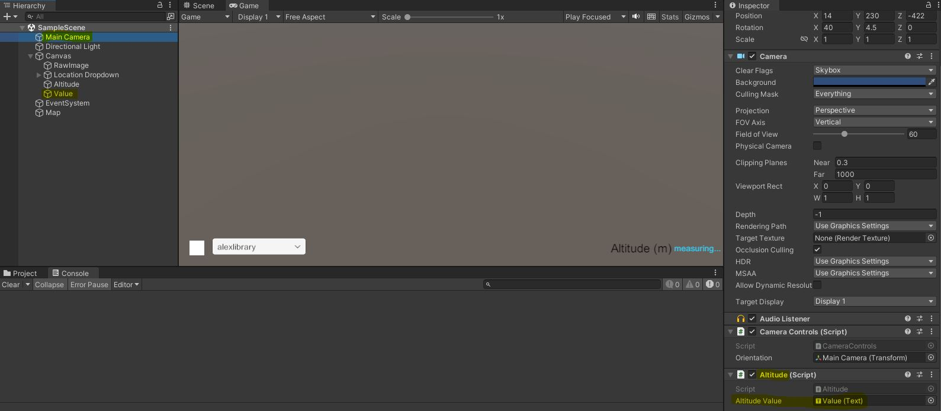

1. Dockerizing the [Python](https://github.com/MaroClay155/3D-Maps-in-Unity/tree/master/DockerizePythonApp) app and uploading the files to the Repo.

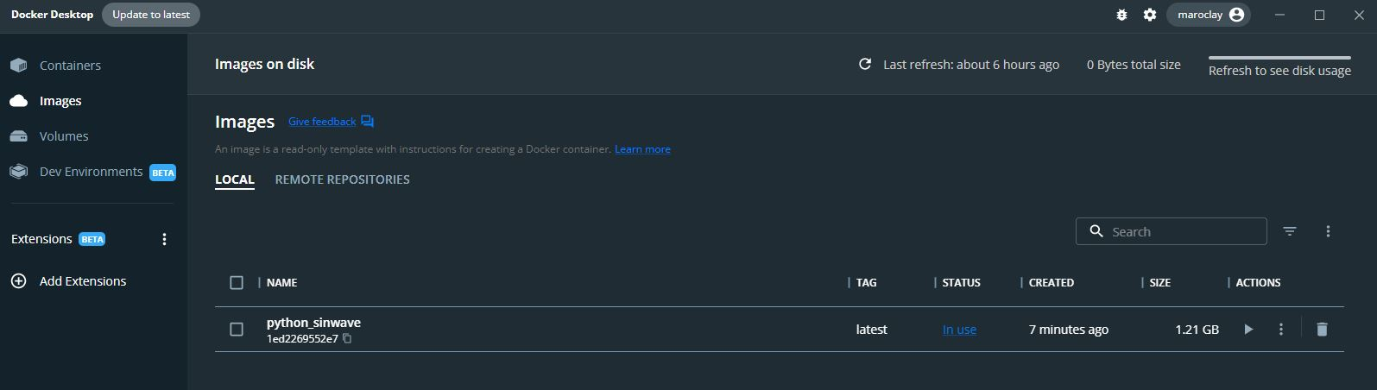

1. Running the final version.
   1. Viewing Alex library as selected from the Dropdown.
   2. Showing the altitude of the camera.
   3. Listening to IP: Port for the incoming data.

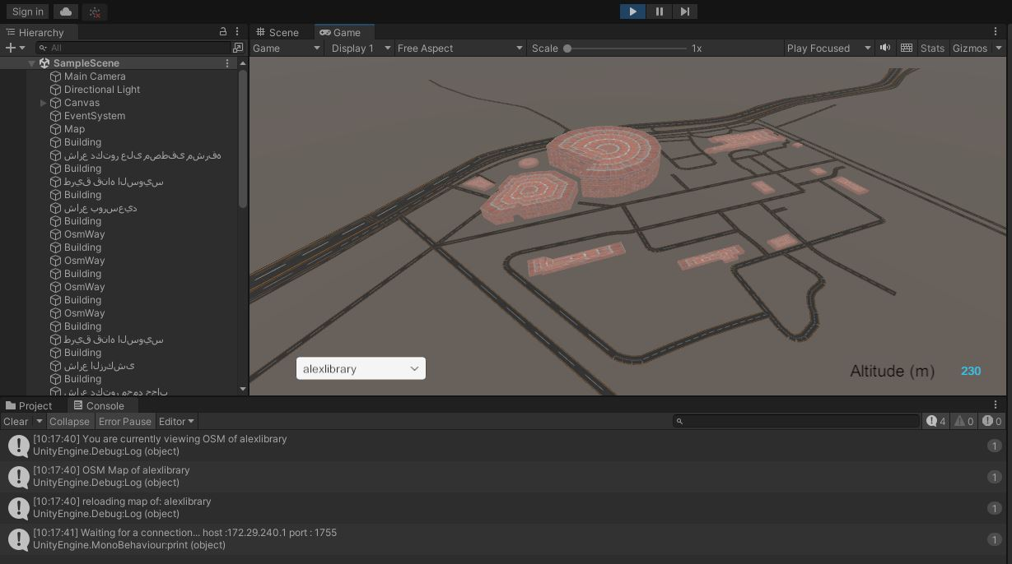

1. Demo of the received data as Random Colors

(Showing the altitude of the camera).

