Safaricom lab
COMPLEXITY OF CALL SET-UP
OBJECTIVE
The student take a trip up the OSI Reference Model, and learn what this mysterious thing is all about. The network stack is of great significance, but not so much.
Mapping of the SS7 in the OSI Layer including its content
GSM Protocol stack and The Radio Technology
Call set-up between two users and the signaling protocol
OSI 7 LAYER MODEL AND SS7 MODEL
The OSI, or Open System Interconnection, model defines a networking framework for implementing protocols in seven layers. Control is passed from one layer to the next, starting at the application layer in one station, and proceeding to the bottom layer, over the channel to the next station and back up the hierarchy.
Application (Layer 7); This layer supports application and end-user processes. Communication partners are identified, quality of service is identified, user authentication and privacy are considered, and any constraints on data syntax are identified. Everything at this layer is application-specific. This layer provides application services for file transfers, e-mail, and other network software services.
Presentation (Layer 6); This layer provides independence from differences in data representation (e.g., encryption) by translating from application to network format, and vice versa. This layer formats and encrypts data to be sent across a network, providing freedom from compatibility problems. It is sometimes called the syntax layer.
Session (Layer 5); This layer establishes, manages and terminates connections between applications. The session layer sets up, coordinates, and terminates conversations, exchanges, and dialogues between the applications at each end. It deals with session and connection coordination.
Transport (Layer 4); This layer provides transparent transfer of data between end systems, or hosts, and is responsible for end-to-end error recovery and flow control. It ensures complete data transfer.
Network (Layer 3); This layer provides switching and routing technologies, creating logical paths, known as virtual circuits, for transmitting data from node to node. Routing and forwarding are functions of this layer, as well as addressing, internetworking, error handling, congestion control and packet sequencing.
Data Link (Layer 2); At this layer, data packets are encoded and decoded into bits. It furnishes transmission protocol knowledge and management and handles errors in the physical layer, flow control and frame synchronization. The data link layer is divided into two sublayers: The Media Access Control (MAC) layer and the Logical Link Control (LLC) layer. The MAC sublayer controls how a computer on the network gains access to the data and permission to transmit it. The LLC layer controls frame synchronization, flow control and error checking.
Physical (Layer 1); This layer conveys the bit stream - electrical impulse, light or radio signal -- through the network at the electrical and mechanical level. It provides the hardware means of sending and receiving data on a carrier, including defining cables, cards and physical aspects.

OSI OSI 7 Layer Model
7. Application Layer - DHCP, DNS, FTP, HTTP, IMAP4, NNTP, POP3, SMTP, SNMP, SSH, TELNET and NTP
6. Presentation layer – SSL, WEP, WPA, Kerberos,
5. Session layer – Logical Ports 21, 22, 23, 80 etc…
4. Transport - TCP, SPX and UDP
3. Network - IPv4, IPV6, IPX, OSPF, ICMP, IGMP and ARPMP
2. Data Link- 802.11 (WLAN), Wi-Fi, WiMAX, ATM, Ethernet, Token Ring, Frame Relay, PPTP, L2TP and ISDN-ore)
1. Physical-Hubs, Repeaters, Cables, Optical Fiber, SONET/SDN,Coaxial Cable, Twisted Pair Cable and Connectors

SS7 MODEL
Signaling System No. 7 (SS7) is a set of telephony signaling protocols developed in 1975, which is used to set up and tear down most of the world's public switched telephone network (PSTN) telephone calls. It also performs a number of translation, local number portability, prepaid billing, short message service (SMS), and other mass market services.
In North America it is often referred to as CCSS7, abbreviated for Common Channel Signaling System 7. In the United Kingdom, it is called C7 (CCITT number 7), number 7 and CCIS7 (Common Channel Interoffice Signaling 7). In Germany it is often called N7 (Signaling system Number 7).
The only international SS7 protocol is defined by ITU-T's Q.700-series recommendations in 1988 of the many national variants of the SS7 protocols, most are based on variants of the international protocol as standardized by ANSI and ETSI. National variants with striking characteristics are the Chinese and Japanese (TTC) national variants.
The Internet Engineering Task Force (IETF) has defined level 2, 3, and 4 protocols compatible with SS7 which use the Stream Control Transmission Protocol (SCTP) transport mechanism. This suite of protocols is called SIGTRAN.
The layers of the SS7 protocol stack and how they relate to the layers of the OSI Model.

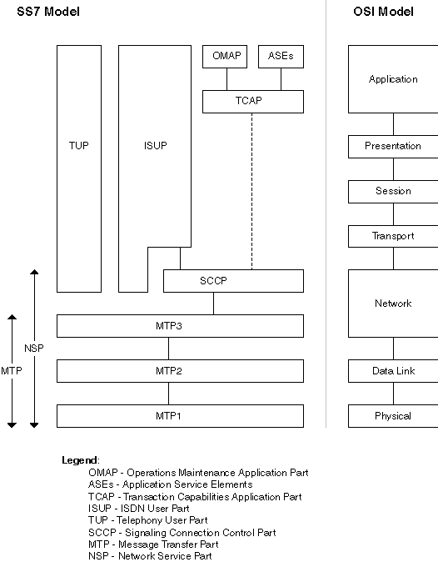
The hardware and software functions of the SS7 protocol are divided into functional abstractions called levels. These levels map loosely to the Open Systems Interconnect (OSI) 7-layer reference model defined by the International Standards Organization (ISO). This model describes the structure for modeling the interconnection and exchange of information between users in a communications system. The figure above shows how the SS7 model relates to the OSI model.
The lowest three levels of the SS7 architecture, called the Message Transfer Part (MTP), provide a reliable but connectionless (datagram or packet style) service for routing messages through the SS7 network. This service is used by the various user parts described below.
The MTP is subdivided into three parts as follows:
- MTP1, also called the signaling data link layer, is concerned with the physical and electrical characteristics of the signaling links. MTP1 corresponds to the physical layer of the OSI model.
- MTP2, also called the signaling link layer, is a data link control protocol that provides for the reliable sequenced delivery of data across a signaling data link. MTP2 corresponds to the data link layer of the OSI model.
- MTP3, also called the signaling network layer, provides for routing data across multiple STPs from control source to control destination. MTP3 corresponds to a part of the network layer of the OSI model.
The connectionless nature of the MTP provides a low-overhead facility tailored to the requirements of telephony. However, the MTP does not provide all the services of the corresponding OSI Network layer. To support Integrated Services Digital Network (ISDN) applications such as network management that requires expanded addressing capability and reliable message transfer, a separate module is provided:
- Signaling Connection Control Part (SCCP) defines a wide variety of network-layer services. SCCP corresponds to part of the network layer of the OSI model.
The MTP and the SCCP together form the Network Service Part (NSP). The resulting split in OSI network functions between MTP and SCCP has the advantage that the higher-overhead SCCP services can be used only when required, and the more efficient MTP services can be used in other applications.
The remaining parts of the SS7 protocol stack are concerned with the actual contents of the SS7 messages and are sometimes called application layers. These include:
- ISDN User Part (ISUP), provides the signaling needed for basic ISDN circuit-mode bearer services as well as ISDN supplementary services having end-to-end significance. ISUP is the protocol that supports ISDN in the Public Switched Telephone Network. It corresponds to the transport, session, presentation, application layers and part of the network layer of the OSI model.
- Telephony User Part (TUP), an ISUP predecessor in providing telephony signaling functions. TUP has now been obsolete by ISUP in most countries and in the international network. The TUP corresponds to the transport, session, presentation, application layers and part of the network layer of the OSI model.
- Transaction Capabilities Application Part (TCAP), provides the mechanisms for transaction-oriented (rather than connection-oriented) applications and functions. The TCAP corresponds to the application layer in the OSI model. TCAP is often used for database access by the SS7 switches but has many other applications through the network.
- Operations and Maintenance Application Part (OMAP), specifies network management functions and messages related to operations and maintenance. The OMAP corresponds to the application layer in the OSI model.
- Application Service Elements (ASEs), represent user parts that are highly application-specific, for example:
  - Intelligent Network Application Part (INAP)
  - Mobile Application Part (MAP), provides the signaling functions necessary for the mobile capabilities of voice and non-voice applications in a mobile network
  - Customizable Applications for Mobile Enhanced Logic (CAMEL)
  - IS41, an ANSI signaling standard used in cellular networks
For any application, all three MTP layers and at least one application layer are required. Typically, the word "user" in modules such as ISUP, TUP and so on explicitly identifies the module as a user of the transport mechanism MTP.

GSM - Protocol Stack
GSM architecture is a layered model that is designed to allow communications between two different systems. The lower layers assure the services of the upper-layer protocols. Each layer passes suitable notifications to ensure the transmitted data has been formatted, transmitted, and received accurately.
The GMS protocol stacks diagram is shown below:
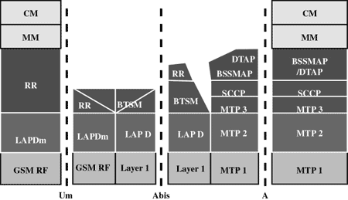

MS Protocols
Based on the Um interface, the GSM signaling protocol is assembled into three general layers:
- Layer 1: The physical layer. It uses the channel structures over the Um air interface. The physical layer, i.e., Layer 1, consists of a 2-Mb/s PCM30 link. This is based on ITU-T G.703 specifications. A PCM30 link consists of 32 multiplexed 64-Kb/s timeslots. Thirty timeslots carry speech or user data, and the remaining two timeslots are used for synchronization and signaling purposes. Most of the vendors support further division of each 64b/s timeslot into four 16-Kb/s timeslots. It also enables mapping of traffic channels at the Um interface directly to Abis. The traffic channels at the Um interface have almost the same data rates. A transcoder rate adoption unit (TRAU) is required to
- Layer 2: The data-link layer. Across the Um interface, the data-link layer is a modified version of the Link access protocol for the D channel (LAP-D) protocol used in ISDN, called Link access protocol on the Dm channel (LAP-Dm). Across the A interface, the Message Transfer Part (MTP), Layer 2 of SS7 is used.
- Layer 3 : GSM signaling protocol’s third layer is divided into three sub layers:
  - Radio Resource Management (RR),
  - Mobility Management (MM), and
  - Connection Management (CM).

Radio Resource (RR) Management Sublayer
The RR management sublayer terminates at the BSS and performs the functions of establishing physical connections over the radio for the purpose of transmitting call-related signaling information such as the establishment of signaling and traffic channels between a specific mobile user and the BSS. The RR management functions are basically implemented in the BSS.
Mobility Management Sublayer (MM)
The MM sublayer is terminated at the MSC and the related messages from or to the MS are
relayed transparently in the BSS using the DTAP process. The MM sublayer provides functions
that can be classified into three types of procedures. These are called the MM specific procedures, the MM common procedures, and the MM connection-related procedures.
Connection Management Sublayer (CM)
The CM sublayer terminates at the MSC and contains entities that currently consist of CC including call-related supplementary services, SMS, and call independent supplementary services support (SS). Once a MM connection has been established, the CM can use it for information transfer. The CC entity uses the CCITT Q.931 protocol, with minor modifications, for the communication of call control-related messages between the MS and the MSC. The SMS is a GSM-defined service that provides for speedy packet mode (“connectionless”) communication
of messages up to 140 bytes between the MS and a third party service center. These messages can be sent or received by the mobile station while a voice or data call is in the active or inactive state. It is acceptable; however, if the service is aborted while a call is in a transitional state such as handover or busy to-idle. The service center is responsible for the collection, storage, and delivery of short messages, and is outside the scope of GSM.

MS to BTS Protocols
The RR layer is the lower layer that manages a link, both radio and fixed, between the MS and the MSC. For this formation, the main components involved are the MS, BSS, and MSC. The responsibility of the RR layer is to manage the RR-session, the time when a mobile is in a dedicated mode, and the radio channels including the allocation of dedicated channels.
The MM layer is stacked above the RR layer. It handles the functions that arise from the mobility of the subscriber, as well as the authentication and security aspects. Location management is concerned with the procedures that enable the system to know the current location of a powered-on MS so that incoming call routing can be completed.
The CM layer is the topmost layer of the GSM protocol stack. This layer is responsible for Call Control, Supplementary Service Management, and Short Message Service Management. Each of these services are treated as individual layer within the CM layer. Other functions of the CC sublayer include call establishment, selection of the type of service (including alternating between services during a call), and call release.

BSC Protocols
The BSC uses a different set of protocols after receiving the data from the BTS. The Abis interface is used between the BTS and BSC. LAP-D is the data link layer that is used at the A-bis interface (BTS-BSC). All other interfaces in the GSM system use SS7/C7s MTP2 at the data link layer. At this level, the radio resources at the lower portion of Layer 3 are changed from the RR to the Base Transceiver Station Management (BTSM). The BTS management layer is a relay function at the BTS to the BSC.
The RR protocols are responsible for the allocation and reallocation of traffic channels between the MS and the BTS. These services include controlling the initial access to the system, paging for MT calls, and the handover of calls between cell sites, power control, and call termination. The BSC still has some radio resource management in place for the frequency coordination, frequency allocation, and the management of the overall network layer for the Layer 2 interfaces.
To transit from the BSC to the MSC, the BSS mobile application part or the direct application part is used, and SS7 protocols is applied by the relay, so that the MTP 1-3 can be used as the prime architecture. The air interface (MS-BTS) and the Abis interface (BTS-BSC) do not have a network layer. All other interfaces in the GSM system use SS7/C7s MTP3 and SCCP at the network layer.

MSC Protocols
At the MSC, starting from the BSC, the information is mapped across the A interface to the MTP Layers 1 through 3. Here, Base Station System Management Application Part (BSS MAP) is said to be the equivalent set of radio resources. The relay process is finished by the layers that are stacked on top of Layer 3 protocols; they are BSS MAP/DTAP, MM, and CM. This completes the relay process. To find and connect to the users across the network, MSCs interact using the control-signalling network. Location registers are included in the MSC databases to assist in the role of determining how and whether connections are to be made to roaming users.
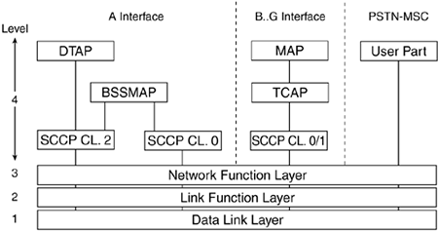
The transport, session, and presentation layers are not used in SS7/C7—these functions are grouped together at the application layer, which is known as Level 4 in SS7/C7. GSM interfaces to fixed-line networks using ISUP or TUP (TUP is never used in North America).
All of the interfaces around the MSC use SS7/C7-based protocols. The B, C, D, F, and G interfaces are referred to as MAP interfaces. These either connect the MSC to registers or connect registers to other registers. The E interface supports the MAP protocol and calls setup protocols (ISUP/ TUP). This interface connects one MSC to another MSC within the same network or to another network's MSC.

BSSAP (DTAP/BSSMAP)
On the A interface, an application part known as the BSSAP is used. BSSAP can be further separated into the base station subsystem management application part (BSSMAP) and the direct transfer application part (DTAP).
Neither the BTS nor the BSC interpret CM and MM messages. They are simply exchanged with the MSC or the MS using the DTAP protocol on the A interface. RR messages are sent between the BSC and MSC using the BSSAP.
BSSAP includes all messages exchanged between the BSC and the MSC that the BSC actually processes—examples include PAGING, HND_CMD, and the RESET message. More generally, BSSAP comprises all messages that are exchanged as RR messages between MSC and BSC, and messages that are used for call-control tasks between the BSC and the MSC.
The DTAP comprises all messages that the subsystem of the NSS and the MS exchange. DTAP transports messages between the MS and the MSC, in which the BSC has just the relaying function.

Mobile Application Part (MAP)
The MAP is an extension of the SS7/C7 protocols that are added to support cellular networks. It defines the operations between the MSC, the HLR, the VLR, the EIR, and the fixed-line network. It comes in two incompatible variants: GSM-MAP and ANSI-41 MAP. While GSM-MAP only supports GSM, ANSI-41 supports AMPS, NAMPS, D-AMPS/TDMA, CDMA (cdma One and cdma 2000), and GSM. GSM-MAP is the international version, while ANSI-41 is the North American version.
The MAP is used to define the operations between the network components (such as MSC, BTS, BSC, HLR, VLR, EIR, MS, and SGSN/GGSN in GPRS). This involves the transfer of information between the components using noncircuit-related signaling. MAP signaling enables location updating, handover, roaming functionality, authentication, incoming call routing, and SMS. MAP specifies a set of services and the information flows between GSM components to implement these services. MAP can be considered an extension of the SS7/C7 protocol suite created specifically for GSM and ANSI-41 networks.
MAP uses TCAP over SCCP and MTP. TCAP correlates between individual operations. The TCAP transaction sublayer manages transactions on an end-to-end basis. The TCAP component sublayer correlates commands and responses within a dialog. "Transaction Capabilities Application Part (TCAP),"
MAP protocols are designated MAP/B–MAP/H, according to the interface on which the protocol functions. For example, the MAP signaling between the GMSC and the HLR is MAP/F.
MAP allows implementation of functions such as location updating/roaming, SMS delivery, handover, authentication, and incoming call routing information. The MAP protocol uses the TCAP protocol to transfer real-time information (between NSS components).
- MAP provides the functionality to route calls to and from the mobile subscribers—it has the mechanisms necessary for transferring information relating to subscribers roaming between network entities in the PLMN.
- The U.S. version is known as ANSI-41-MAP (standardized by EIA/TIA).
- The international version is known as GSM-MAP (standardized by ITU/ETSI).
MAP only makes use of the connectionless classes (0 or 1) of the SCCP.
Each GSM MS user is given a HLR that in turn comprises of the user’s location and subscribed services. VLR is a separate register that is used to track the location of a user. When the users move out of the HLR covered area, the VLR is notified by the MS to find the location of the user. The VLR in turn, with the help of the control network, signals the HLR of the MS’s new location. With the help of location information contained in the user’s HLR, the MT calls can be routed to the user.
Signaling is transferred using the packet-switching facilities afforded by SS7. These packets are called signal units (SUs). The Message Transfer Part (MTP) and the Signaling Connection Control Part (SCCP) provide the transfer protocols. MTP is used to reliably transport messages between nodes, and SCCP is used for noncircuit-related signaling (typically, transactions with SCPs). The ISDN User Part (ISUP) is used to set up and tear down both ordinary (analog subscriber) and ISDN calls. The Transaction Capabilities Application Part (TCAP) allows applications to communicate with each other using agreed-upon data components and manages transactions.

RADIO TECHNOLOGIES
OBJECTIVE
On completion of this section you will be able to know about the following radio technologies:
- GMSK Modulation techniques
- Power control
- VAD, DTX and DRX
- Diversity
- Frequency hoping
MODULATION TECHNIQUES
It is well known that there are three methods of modulating a signal so that it may be transmitted over the air:
- Amplitude Modulation (AM)
- Frequency Modulation (FM)
- Phase Modulation (PM)
The modulator causes the amplitude, frequency or phase of an RF carrier to be varied in proportion to the signal it is going to carry. GSM uses a digital air interface. It means that digital signals are transmitted on the radio channel. Digital signals can use any of the modulation methods but phase modulation provides the best noise tolerance.
Gaussian Minimum Shift Keying, GMSK, is a form of modulation used in a variety of digital radio communications systems. It has advantages of being able to carry digital modulation while still using the spectrum efficiently. One of the problems with other forms of phase shift keying is that the sidebands extend outwards from the main carrier and these can cause interference to other radio communications systems using nearby channels.
In view of the efficient use of the spectrum in this way, GMSK modulation has been used in a number of radio communications applications. Possibly the most widely used is the GSM cellular technology which is used worldwide and has well over 3 billion subscribers.
MSK (MINIMUM SHIFT KEYING) AND GMSK (GAUSSIAN MINIMUM SHIFT KEYING) MODULATION TECHNIQUES
It covers GMSK modulator and GMSK demodulator based on QPSK modulation method.

MSK Modulation
GMSK is the derivative of MSK modulation scheme and MSK is derived from Offset QPSK modulation. In MSK modulation scheme instead of rectangular pulse wave; half cycle sine wave is used. Frequency of logical zero and logical one differs by half of data rate. Modulation index is 0.5 here. MSK modulation mathematical equation is outlined below.
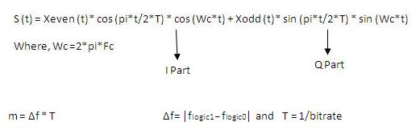
MSK Equation
MSK modulation waveform is depicted below in figure for NRZ data signal.
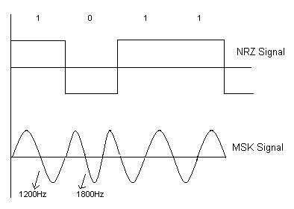
MSK modulation signal in time domain
GMSK (GAUSSIAN MINIMUM SHIFT KEYING) modulation techniques
GMSK modulation is based on MSK, which is itself a form of continuous-phase frequency-shift keying. One of the problems with standard forms of PSK is that sidebands extend out from the carrier. To overcome this, MSK and its derivative GMSK can be used.
MSK and also GMSK modulation are what is known as a continuous phase scheme. Here there are no phase discontinuities because the frequency changes occur at the carrier zero crossing points. This arises as a result of the unique factor of MSK that the frequency difference between the logical one and logical zero states is always equal to half the data rate. This can be expressed in terms of the modulation index, and it is always equal to 0.5.
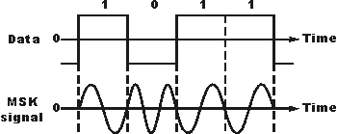
Signal using MSK modulation
A plot of the spectrum of an MSK signal shows sidebands extending well beyond a bandwidth equal to the data rate. This can be reduced by passing the modulating signal through a low pass filter prior to applying it to the carrier. The requirements for the filter are that it should have a sharp cut-off, narrow bandwidth and its impulse response should show no overshoot. The ideal filter is known as a Gaussian filter which has a Gaussian shaped response to an impulse and no ringing. In this way the basic MSK signal is converted to GMSK modulation.

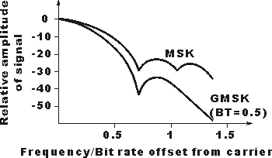

Generating GMSK modulation
There are two main ways in which GMSK modulation can be generated.
- It is to filter the modulating signal using a Gaussian filter and then apply this to a frequency modulator where the modulation index is set to 0.5. This method is very simple and straightforward but it has the drawback that the modulation index must exactly equal 0.5. In practice this analogue method is not suitable because component tolerances drift and cannot be set exactly.

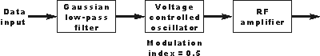
Generating GMSK using a Gaussian filter and VCO
- A second method is more widely used. Here what is known as a quadrature modulator is used. The term quadrature means that the phase of a signal is in quadrature or 90 degrees to another one. The quadrature modulator uses one signal that is said to be in-phase and another that is in quadrature to this. In view of the in-phase and quadrature elements this type of modulator is often said to be an I-Q modulator. Using this type of modulator the modulation index can be maintained at exactly 0.5 without the need for any settings or adjustments. This makes it much easier to use, and capable of providing the required level of performance without the need for adjustments. For demodulation the technique can be used in reverse.
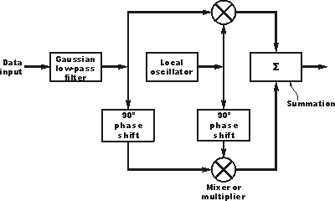
Block diagram of I-Q modulator used to create GMSK

Advantages of GMSK modulation
There are several advantages to the use of GMSK modulation for a radio communications system.
- Improved spectral efficiency when compared to other phase shift keyed modes.
- The signal it can be amplified by a non-linear amplifier and remain undistorted. This is because there are no elements of the signal that are carried as amplitude variations. This advantage is of particular importance when using small portable transmitters, such as those required by cellular technology. Non-linear amplifiers are more efficient in terms of the DC power input from the power rails that they convert into a radio frequency signal. This means that the power consumption for a given output is much less, and this results in lower levels of battery consumption; a very important factor for cell phones.
- None of the information is carried as amplitude variations. This means that is immune to amplitude variations and therefore more resilient to noise, than some other forms of modulation, because most noise is mainly amplitude based.

POWER CONTROL
POWER CONTROL is a feature of the GSM air interface which allows the operator to not only compensate for the distance from mobile to BTS as regards timing, but can also cause the BTS and mobile to adjust their power output. This feature saves radio battery power at the mobile, and helps to reduce co -channel and adjacent channel interference. Both Uplink and Downlink power settings can be controlled independently and individually. Initial power setting for the MS is set by the information provided on Broadcast Control Channel (BCCH) for a particular cell. The BSS controls the transmit power of both the mobile and the BTS .The received mobile power is monitored by the BSS and the receive BTS power is monitored by the mobile and then reported to the BSS. Using these measurements the power of both mobile and BTS can be adjusted accordingly.

VAD, DTX and DRX
VOICE ACTIVITY DETECTION - VAD is a mechanism whereby the source transmitter equipment identifies the presence or absence of speech. VAD implementation is effected in speech mode by encoding the speech pattern silences at a rate of 500 bit/s rather than the full 13 Kbit/s. This results in a data transmission rate for background noise, which is regenerated in the receiver, known as "comfort" noise. Comfort noise is necessary. Because without "comfort" noise the total silence between the speech would be considered to be disturbing by the listener. DISCONTINUOUS TRANSMISSION - DTX increases the efficiency of the system through a decrease in the possible radio transmission interference level. It does this by ensuring that the Mobile Station does not transmit unnecessary message data. DTX can be implemented, as necessary on a call, its' effects will be most noticeable in communications between two Mobile Stations. When implemented at the mobile station DTX also result in considerable power saving. If the mobile does not transmit during 'silences' there is a reduction in the overall power output requirement. The function of DTX may be selected by the system operator and there are different specifications applied for different types of channels.
DISCONTINUOUS RECEPTION – DRX allows the mobile station to effectively "switch -off" during times when reception is deemed unnecessary. After initially locking on to a BCCH, MS will monitor BCCH, FCCH and SCH. The Mobile is aware of the Frame Number and repetition format for frame synchronization. Therefore, it can determine when next relevant information is to be transmitted. This allows the mobile to 'go to sleep and listen -in only ‘. This is called DRX. It also effectively saves in power usage. VAD, DTX and DRX result in battery use time being considerably extended and can reduce the effective battery size needed.

MULTIPATH FADING
Multi path fading results from a signal traveling from a transmitter to a receiver by a variety of routes. This is caused by the signal being reflected from objects, or being influenced by atmospheric effects as it passes, for example, through layers of air of varying temperatures and humidity. The received signals will therefore arrive at different times and not be in phase with each other, they will have experienced time dispersion. When the receive antenna is moving, the exact phase of each path changes and consequently the combined signal-strength is also continually changing. GSM offers many techniques, which combat multi-path fading effects.

DIVERSITY
Signals arrive at the receive antenna from multiple paths. The signals are therefore received by the antenna are at different phases, some at a peak and some at trough. This means that some signals will add together to form a strong signal while others will subtract causing a weak signal; when diversity is implemented, two antennas are situated at the receiver. These antennas are placed several wavelengths apart to ensure minimum correlation between the two receive paths .The two signals are then combined, this ensures that a low signal strength is less likely to occur

FREQUENCY HOPING
Frequency hopping means each time the BTS or mobile transmits a burst on a different RF carrier frequency. In one way, Frequency hopping brings the security benefit to GSM system. The other main reason is to reduce multi path fading effects. The hopping must use a predetermined sequence so that both transmitter and receiver must hop in synchronization. This sequence is stored in a 'frequency hopping table'. Care should be taken so that BCCH is not frequency hopped and it is always transmitted at the same frequency. This is because the BCCH in any cell must be transmitted on a dedicated RF carrier, otherwise mobiles would be unable to find and decode it. There are two methods of frequency hopping:
- Synthesizer Hopping
- Baseband Hopping.
Both are slow frequency hopping techniques. This means that the frequency of the transmission only changes once every time a burst is transmitted.
In Synthesizer Hopping, each time slot on a given transceiver can transmit at a different frequency. The transceiver retunes between time slots. This is an efficient method for small sites with few transceivers.
In SFH each frame unit is connected to one carrier unit. Hopping is performed by changing the carrier unit by changing a synthesizer. As the communication is not hopping between the carrier units but the carrier unit frequency itself is hopping. So many frequencies can be used as hopping frequencies. In SFH, TRX returns in every time slot to a different frequency. Thus the TCH remains on the same TRX but the frequencies of that TCH hops.
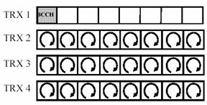

In Baseband Hopping, each transceiver stays at the same frequency and data is switched to the appropriate .The numbers of hopping frequencies is limited to the number of transceivers.
In this type of hopping, only frequencies used by the TRXs can be allocated to the FHS (Frequency Hopping Sequence).The BCCH supporting Time Slot cannot hop. TS 0 of the BCCH TRX is always transmitting on the BCCH frequency. Other timeslots can use other frequencies unless the BCCH frequency is transmitted by any other TRX at the same time.
The major advantage of the BBH is the time TS 1 to TS 7 of the BCCH frequency containing TRX is allowed to perform hopping. But Frequency Hopping performs best with at least 4 hopping frequencies. So cells need at least 4 TRXs and it is the disadvantage of this system.
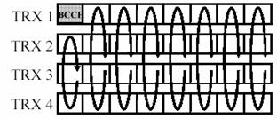

CALL SET-UP
Mobile Subscriber Call SET-UP (MS1 and MS2 connection)

When a MS1 dials a number the following process flows till the connection is done through the different mobile equipments, interfaces, channels and protocols.
  - Channel Request: The MS requests for the allocation of a dedicated signaling channel to perform the call setup.
  - After allocation of a signaling channel the request for MS call setup, included the TMSI (IMSI) and the last LAI, is forwarded to the VLR
  - The VLR requests the AC via HLR for Triples (if necessary).
  - The VLR initiates Authentication, Cipher start, IMEI check (optional) and TMSI Re-allocation (optional).
  - If all this procedures have been successful, MS1 sends the Setup information (number of requested subscriber and detailed service description) to the MSC.
  - The MSC requests the VLR to check from the subscriber data whether the requested service number can be handled (or if there are restrictions which do not allow further proceeding of the call setup)
  - If the VLR indicates that the call should be proceeded, the MSC commands the BSC to assign a Traffic Channel (i.e. resources for speech data transmission) to the MS2
  - The BSC assigns a Traffic Channel TCH to the MS2
  - The MSC sets up the connection to requested number (called party).

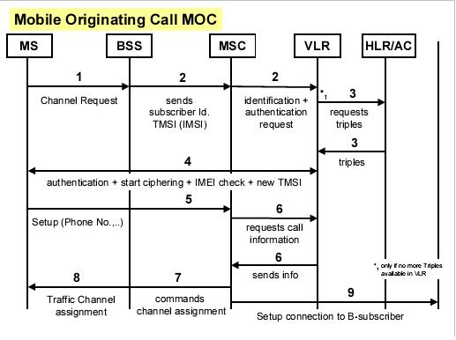The ring indicator of MS2 starts blinking to indicate the handling-in of the call and the buzzer will ring with the same rhythm. Pressing the ANSWER button will accept and enable the call.

