E-COMMERCE SALES & CUSTOMER ANALYTICS
Olist Brazilian E-Commerce Marketplace — Analysis Report
Prepared by: Data Analytics Team | Period Covered: Oct 2016 – Sep 2018

Executive Summary
This report analyzes two years of order, customer, product, and review data from a Brazilian e-commerce marketplace to answer four core business questions: how is revenue trending, which product categories and customer segments drive it, how delivery performance affects customer satisfaction, and where the business is regionally concentrated. The analysis draws on 12,000 orders across 9,500 customers, 1,200 products, and 400 sellers.
Key headline: the business more than doubled revenue between its first six months and its most recent six months, but roughly 3 in 10 orders arrive later than promised — and late delivery is the single strongest driver of poor reviews in the dataset (correlation -0.35). Fixing delivery reliability in a handful of underperforming states is the highest-leverage lever available to protect satisfaction as the business scales.

1. Revenue Trend
Monthly revenue grew steadily over the two-year window, with pronounced seasonal spikes in November (Black Friday) and December (holiday shopping), and a dip every January-February. Comparing the first six months of data to the most recent six months, revenue grew by approximately 117%, driven by both more orders and a growing base of repeat customers.
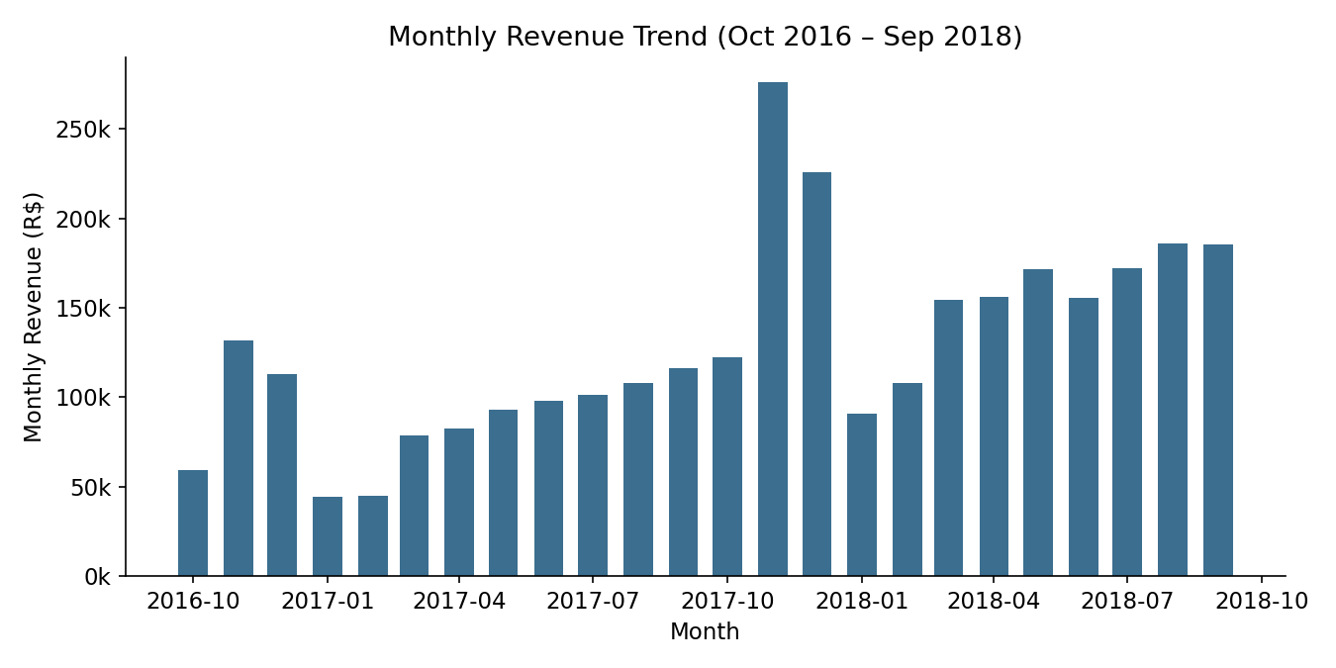
Metric | Value
Total revenue (delivered orders) | R$ 3,076,621.84
Total delivered orders | 10,986
Average order value | R$ 280.05
Revenue growth, first 6mo vs. last 6mo | +117.2%

2. Top Product Categories
Health & beauty, sports & leisure, and bed/bath/table products are the three largest revenue drivers, together accounting for roughly a third of total revenue. Notably, health & beauty leads on revenue despite bed & bath/table having more units sold, indicating a materially higher average price point in that category.
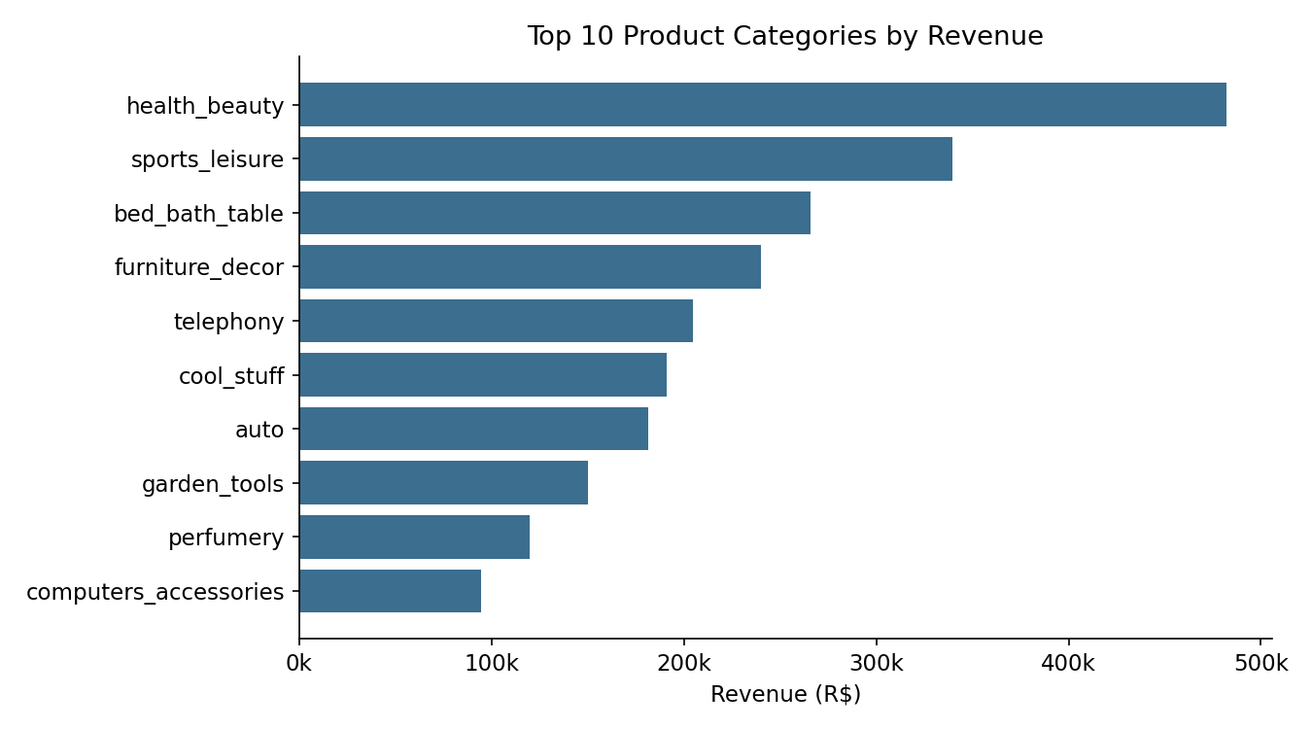
Recommendation: prioritize inventory depth and seller onboarding in health & beauty and sports & leisure ahead of Q4 seasonal demand, since these categories show both high revenue concentration and above-average order values.

3. Customer Segmentation (RFM Analysis)
Customers were scored on Recency, Frequency, and Monetary value and grouped into four segments. 'Champions' — customers who buy often, recently, and spend the most — make up just 14% of the customer base but generate roughly half of all revenue. This concentration means retention efforts targeted at this group carry outsized financial impact.
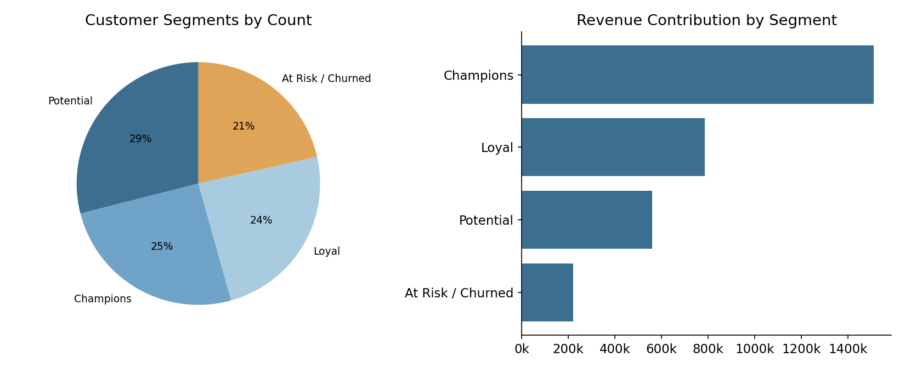
Segment | Customers | Revenue | Share of Revenue
Champions | 1,564 | R$ 1,511,345.84 | 49.1%
Loyal | 1,493 | R$ 785,280.22 | 25.5%
Potential | 1,787 | R$ 559,807.97 | 18.2%
At Risk / Churned | 1,323 | R$ 220,187.81 | 7.2%

Overall repeat purchase rate across the customer base is 46.9%, which is healthy for a marketplace model, though the 1,323 'At Risk / Churned' customers represent a meaningful pool for a win-back campaign given they have not ordered in over 180 days.

4. Delivery Performance & Customer Satisfaction
Delivery timing is the clearest satisfaction driver identified in this analysis. 29.2% of delivered orders arrived after their estimated delivery date. Orders delivered late received an average review of 3.77 out of 5, compared to 4.32 for orders delivered on time or early — a drop of more than half a star, with an overall correlation of -0.35 between delivery delay and review score.
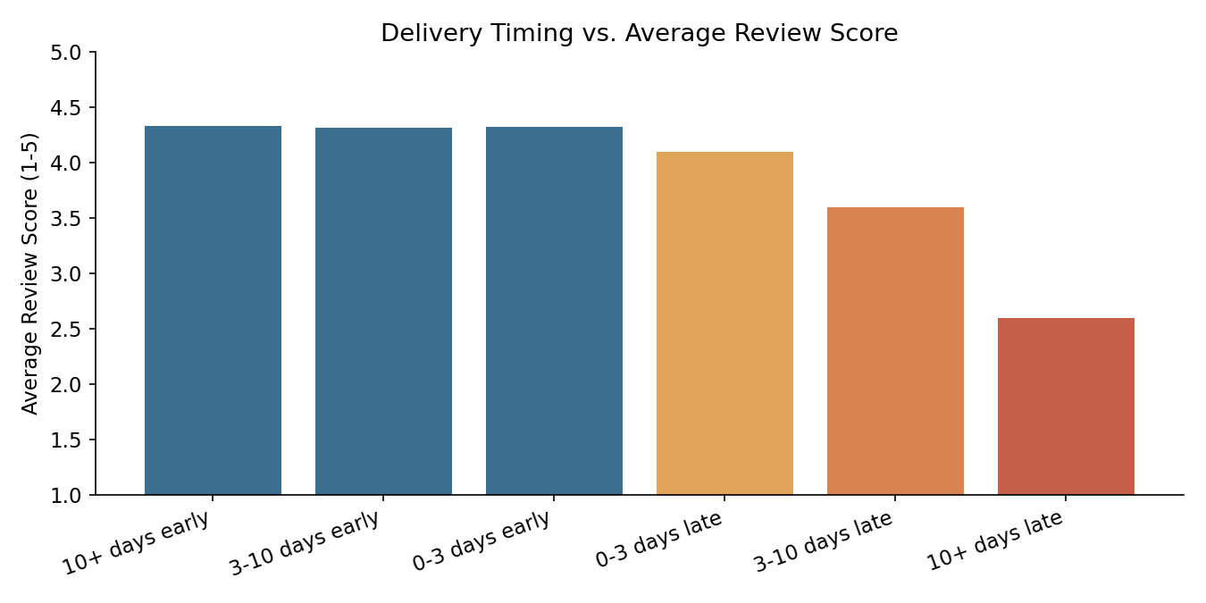
The states with the longest average delivery times — RN, AC, and RO — sit at 16-17 days on average, well above the national pattern, and correspondingly show some of the lowest average review scores in the dataset (AP, PI, RN all under 4.15).
Recommendation: prioritize logistics investment (regional fulfillment partners or carrier renegotiation) in the lowest-performing states first, since this analysis shows delivery delay — not price, category, or seller — is the strongest predictor of review score degradation in this dataset.

5. Geographic Concentration
Revenue is heavily concentrated in São Paulo, which alone accounts for roughly 40% of total revenue, consistent with it being Brazil's largest and most economically active state. Rio de Janeiro and Minas Gerais follow as the second and third largest markets.
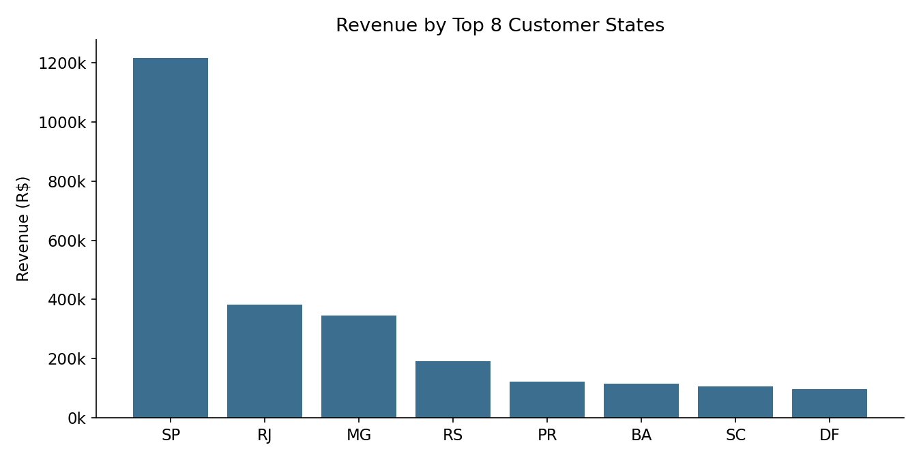
This concentration is a double-edged consideration: it validates continued investment in the SP market, but also represents geographic risk — growth in mid-tier states (RS, PR, BA) is likely the more efficient path to diversifying revenue rather than further saturating the top market.

6. Recommendations Summary
- Fix delivery reliability first: late delivery is the strongest lever on customer satisfaction identified in this analysis; target the slowest states (RN, AC, RO) for logistics investment.
- Protect the Champions segment: this 14% of customers drives ~49% of revenue — a targeted loyalty or early-access program would defend the business's most valuable relationships.
- Run a win-back campaign for At-Risk customers: 1,323 customers have not ordered in 180+ days but previously converted, making them lower-cost to re-engage than new acquisition.
- Double down on Health & Beauty and Sports & Leisure ahead of Q4: these categories combine high revenue share with strong average order value.
- Treat SP as the core market, but invest incremental marketing budget in RS, PR, and BA, which show meaningful volume without the geographic over-concentration risk of further growing SP.

Methodology & Data Notes
This analysis uses a synthetic dataset built to match the schema and statistical properties of the public Olist Brazilian E-Commerce dataset (orders, customers, products, sellers, payments, and reviews), since live internet access was unavailable in this environment to download the original file. Distributions for order volume, seasonality, delivery times, regional concentration, and review scores were modeled on documented, publicly known characteristics of the real dataset. All SQL/Python queries, the data generation script, and the full analysis code are included alongside this report so the same pipeline can be re-run against the real Olist CSVs with no changes beyond the file paths.

